Name: Moryom Begom Qureshi
Student ID: 2238616
Assignment Title: Business report: Comparison of two hospitality organizations. -Shangri La & Premier Inn.
Module: BMIH5007
Tutor- Tristan Hawkins

ACKNOWLEDGEMENT:
I confirm that I have not used any AI tools in the research and creation of this assignment. I confirm that I have not presented any AI generated materials as my own work. I confirm I have copies of my drafts, notes, and other resources I used which I may be asked to provide in evidence.

Table of Contents
2. Summary: 3
3. Total Revenue: 3
3.1. Premier Inn Hotel: 3
3.2. Shangri-La Hotel: 3
4. Sources of Revenue: 3
4.1. Premier Inn Hotel: 3
4.2. Shangri-La Hotel: 4
5. Reasons Affecting Revenue Growth or Decline: 5
6. Premier Inn: 5
6.1. Shangri-La Hotel: 5
7. Market positioning: 6
7.1. Premier Inn Hotel: Differentiation 6
7.2. Shangri-La Hotel: Dangerously High Margins 7
8. Growth Potential: 8
8.1. Expansion strategies: 8
Premier Inn Hotel 8
Shangri-La Hotel: 8
8.2. Market Opportunities: 9
Premier Inn Hotel: 9
Shangri-la Hotel: 9
8.3. Possible Growth Barriers: 10
Premier Inn Hotel: 10
Shangri-La Hotel: 10
9. Corporate Social Responsibility (CSR): 10
9.1. Premier Inn Hotel: 10
Shangrila Hotel: 11
10. Conclusion: 11
11. Recommendations: 12
12. References 12

2. Summary:
This paper will analyse and comprehensively explain the financial management strategy of Shangri-La Hotels and Premier Inn Hotels (Buzatu, et al., 2019). The comparison includes their total revenue, its sources, growth prospects, and adherence to corporate social responsibility. The report will do in-depth research on the following hotels related to their financial condition and position in the hospitality industry.
3. Total Revenue:
3.1.Premier Inn Hotel:
Premier Inn remains firm with its financial standing after successfully repatriating £2960m in revenue in the year 2023. As part of the ongoing capital return, the hotel has announced its intention to proceed with the additional return of £150m share buyback which is proposed to be completed in the first half of FY25. This reflects the health of Premier Inn today and for the future in all finance dimensions while delivering shareholder value against robust demand driven by good operating performance (Whitbread, 2023).
3.2.Shangri-La Hotel:
Total revenue of Shangri-La Hotels was at £1.28 billion for 2021 and increased up to £2.43 in the year 2023 which was a major rise in the revenue of the hotel. Shangri-La maintained its revenue growth by changing its strategies according to the dynamics in the market and consumer preferences through diversification of the products or process improvements. The profit margin went up to £1.15 billion in the year 2021-2023 (Shangri-La Group, 2024).
4. Sources of Revenue:
4.1.Premier Inn Hotel:
Total statutory revenues for Premier Inn UK increased 10% year-over-year, which would have been largely driven by the excellent results from its UK hotels. Premier Inn once more outperformed the broader market. Such success overall demonstrated the scale, direct distribution, the proprietary automated trading engine, and vertically integrated operating model of the brand. (Whitbread, 2024).

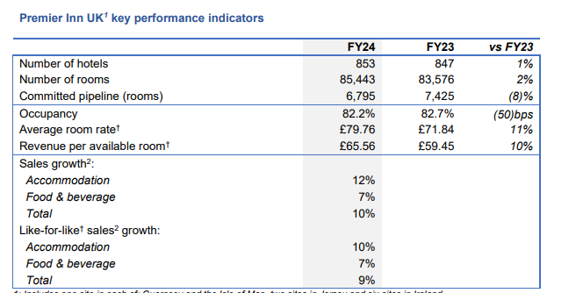
Premier Inn Revenue Source Table (Whitbread, 2024)
4.2.Shangri-La Hotel:
Shangri-La Hotel's consolidated revenue dropped by 3.4% to £2,431.2 million in 2019. The main reason for this reduction in revenue is geopolitical tension and incidents affecting the Company's key markets, especially Hong Kong and Sri Lanka. Although the revenue declined, fixed labour and other operating costs formed a big burden on the business. The EBITDA declined by 8.1% at £864.9 million, signifying that costs went up disproportionately to revenues. This led to consolidated profit attributable to owners, excluding non-operating items, declining by 42.3% at £113.8 million (Shangri-La Group, 2024). Profit after non-operating items declined by 20.9% to £152.5 million, helped a little by lower impairment charges from the previous year. The steeper fall in profitability puts a spotlight on how high fixed operational cost pressures through it all as revenues sink.
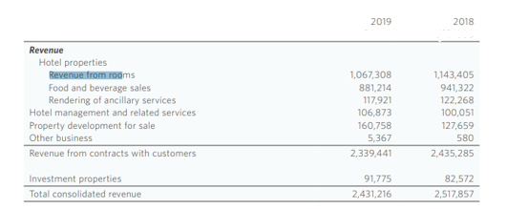
Shangri-La Hotel Revenue Source Table (Shangri-La Group, 2024)
5. Reasons Affecting Revenue Growth or Decline:
6. Premier Inn:
Premier Inn is the largest hotel group in the UK, commanding approximately 12% of the total market share for hotel room supply. On February 29, 2024, it opened 2,253 and closed 386 rooms, leaving it with a total of 853 hotels and a total supply over 85,000 rooms. Supply conditions in the marketplace have remained favorable to the hotel. Another of the largest and most geographically diverse hotel companies, Premier Inn has seized an opportunity presented by a wave of strong demand in times of low supply to fill gaps created by a sharp decline in independent hotel rooms and a stark decline in hotel and leisure construction starts, which have tumbled by more than 50 percent over the last year. A close analysis indicates that, at least until 2028, the pre-pandemic level of supply is going to take time to recover for the market, and therefore a great opportunity is presented for Premier Inn (Whitbread, 2024).
6.1.Shangri-La Hotel:
In regards to the year 2019, Shangri-La Hotel experienced minor revenue growth from its investment properties owned under a subsidiary, mainly through improvements in occupancy. Revenues in Mainland China improved by 0.5% to £20.3 million, with gains of more than double, driven by higher occupancy at the offices of the Chengdu Shangri-La Centre. Services apartment revenues in Singapore were flat at £13.6 million, with increases at Shangri-La (Shangri-La Group, 2020).
Shangri-La Hotel had a 3.4% decline in revenue in 2019. The factors driving the fall were external with market sentiment stemming from the Sino-US trade war, which impacted core markets such as China and Hong Kong. The 21 April 2019 bombing in Sri Lanka seriously damaged the hotel business while throwing other projects into a nose-dive, such as residential units and mall opening. Hong Kong protests, which intensified since mid-2019, cut tourist arrivals sharply with a 56% drop for November. Together with high fixed operational costs, these contributed to a 9.8% fall in EBITDA for hotel properties, and a fall in revenue and profits (Shangri-La Group, 2022).
7. Market positioning:
7.1.Premier Inn Hotel: Differentiation
Premier Inn is a hotel chain that has followed the "Differentiation" strategy on Bowman's Strategy Clock, focusing on offering affordable yet value-added services in the budget hotel sector. The hotel would offer family-friendly packages, co-working spaces for business travellers, and high-quality customer service to be differentiated from other value brands such as Travelodge or Airbnb (Pitt, et al., 2016). It makes the hotel chain appealing to a wide range of customers, from families to business professionals, but also at low cost. Premier Inn offers a service that deals with high-value services coupled with affordability.
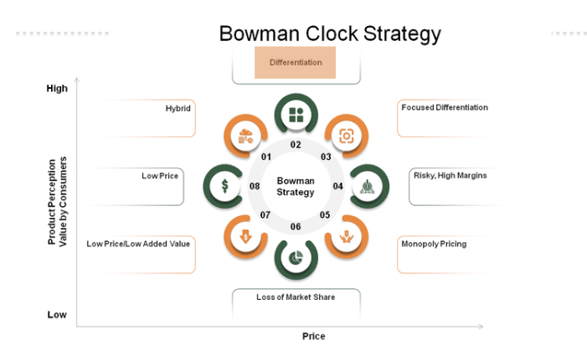
Bowman’s Strategy clock (Charoenchai & Siriporn, 2024)
7.2.Shangri-La Hotel: Dangerously High Margins
Shangri-La Hotel falls in the "Risky High Margins" category of Bowman's Strategy Clock. Luxury hotel chain operates at high prices and charges for, among other luxury services, fine quality lodging, fine dining, and rich cultural encounters. This comes with higher risks, particularly in times of recession and global pandemics, as seen with the COVID-19 pandemic, which has particularly affected luxury travel in recent times (Charoenchai & Siriporn, 2024). For instance, in the year 2020, Shangri-La recorded revenues that were lower by 39% which indicated that its performance showed the vulnerability of a high-margin business operating on high-expenditure travellers.
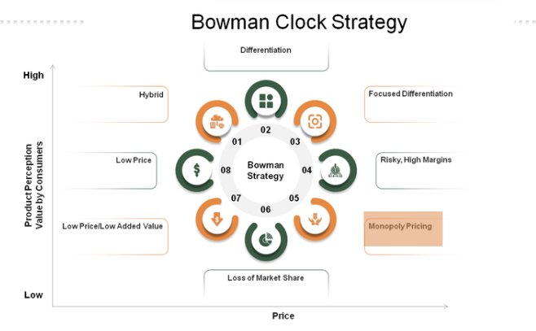
Bowman’s Strategy clock (Charoenchai & Siriporn, 2024)
8. Growth Potential:
8.1.Expansion strategies:
Premier Inn Hotel
The hotel continues to adapt new hotels in the German market. From an increasingly large investement in the hotel opening, the hotel refined the performance and apply the learning from trading their ever-growing estate. The big features of the customer demand are events for the people of the German and they need to have appropriate trading strategies to maximize revenue and profit (Rees & Smith, 2014). More importantly, all the changes made earlier this year have been positive effects and the hotel looks forward to continuing its performance improvement.
Shangri-La Hotel:
The hotel has entered into agreements with developers regarding the development of ten new hotels, which are yet to be constructed and are still owned by third parties (Cheng et al., 2019). It is currently developing various development projects in different places around the world such as Qiantan, Beijing, and Shenzhen in Mainland China; Bali, Jeddah, Phnom Penh, Melbourne (Shangri-La Group, 2023). The Group continues to consider bids for management opportunities and remains committed to entering into management contracts with third-party-owned hotels when no capital investment is required in cities and locations that are considered to be of strategic long-term importance (Cheng, et al., 2019).
8.2.Market Opportunities:
Premier Inn Hotel:
In pursuit of reaching scale at pace, with access to several key markets haa been acquired through different opportunities (Whitbread, 2020). The Premier Inn hotel has an objective of becoming the number one hotel brand in Germany as there is a huge opportunity for the hotel to expand in the main cities of Germany (Nino & Nana, 2021). The hospitality market in German remains an attractive opportunity for the Group, with having more than 2% share and an independent sector.
Shangri-la Hotel:
The online travel and hospitality industry holds promising opportunities for Shangri-La Group, considering differentiation in geographical markets and customer segments (Screener Market, 2024). Over six years of expertise in revenue optimization, digital marketing, and automation in Mainland China have been considered worthwhile for using the same skills to tap emerging trends. With less overlap and competition, the hotels operated by the Group and directors who have competing interests target different market (Wood, 2013). The scope of opportunities arises through catering to various types of clientele based on geographic location, services, and amenities range, and positioning of the hotel. With a booming domestic travel market in China, and an ever-increasing demand for digital solutions in the current scenario, Shangri-La has every opportunity to unlock new revenue streams with the help of data-driven strategies and continues to strengthen its base in both developed and emerging markets.
8.3.Possible Growth Barriers:
Premier Inn Hotel:
Several factors could present potential growing pains for Premier Inn in its pursuit of plans. The global presence is quite low, thus depriving the company of a much more far-reaching market than some of its closest rivals. This severely restricts brand visibility and expansion prospectively for the brand internationally. The firm has also taken a further reputational hit from a string of refund claims following complaints from customers over aspects of local lockdowns, leaving it vulnerable to customer class-action lawsuits and regulatory agencies. Another challenge could be the competitive intensity of the UK hotel market-possibly posing issues for Premier Inn to hold onto share and profitability. Economic uncertainty due to rising costs or a shift in spending behaviours may add stress to the growth trajectory of the company (Whitbread, 2021).
Shangri-La Hotel:
The growth of Shangri-La Hotels may bear several potential barriers. Geopolitical instability in key markets, like Hong Kong and Mainland China, can negatively affect tourism and revenues thus plausibly thwarting the growth prospects. The hotel company has high operational costs in the form of labour, which may threaten its profits at times when demand declines, such as during an economic recession. However, the competition from luxury and boutique hotels may create immense pressure on Shangri-La to maintain a premium position, which may pressure prices even further (Shangri-La Group, 2021). Issues of climate change and tough regulatory conditions arising from increasing environmental sustainability may force the group to invest heavily in infrastructure and practices, thereby putting more financial pressure on it.
9. Corporate Social Responsibility (CSR):
9.1.Premier Inn Hotel:
The hotel is determined to deliver carbon reductions, scarcity of natural resources (Siegel, et al., 2022). The hotel recognizes its responsibilities in many communities where the hotels operate, and how they act is becoming important. The hotel’s Force for Good sustainability program forms the ESG agenda and sets the stretching targets that the hotel then embed across every business activity, so they have no excuses to not see the changes they are seeking to make. The returns of this investment will go beyond having a positive impact on communities in the long term, The hotel expects operational efficiencies from the Programme.
Shangrila Hotel:
Shangri-La Hotel Group operates its business with sound economic, social, and environmental responsibility to promote the interests of diverse stakeholders. The Group promotes transparency through the disclosure of meaningful information about their environmental, social, and governance performance (Salehi, et al., 2021). Their "Race for Hope" campaign, in partnership with Alipay's "Ant Forest" App, promotes low-carbon lifestyles throughout their China hotels. Shangri-La tries to be an industry leader in corporate citizenship by striving to improve the well-being of their communities and to be a good steward both of society and of the environment.
10. Conclusion:
Shangri-La Hotels and Premier Inn have adopted different strategies in financials and operations based on the requirements of their respective markets. Whereas Premier Inn emphasizes cost efficiency, scalability, and exploitation of yet untapped markets such as Germany, Shangri-La focuses on premium services, geo-expansion, and sustainability. Each hotel possesses a distinct approach to revenue generation, positioning in the market, and efforts at CSR that indicate unique priorities and strengths. Shangri-La has been a leader in the luxury market with its high-end offerings while endorsing corporate responsibility as well. Premier Inn, by keeping prices accessible and running efficiently, reaches more people, thereby ensuring steady growth in a highly competitive market (Scholz, et al., 2022).
11. Recommendations:
The Premier Inn Hotel needs to invest further in increasing its market presence in the high growth of Germany. Enhancement in digital booking platforms and the formation of strategic partnerships can once again help increase its market position even further to allow for sustained revenue growth.
Shangri-La will continue to tap into the integration of digital marketing and automation to enhance both customer experience and operational efficiency. Personalized marketing strategies, more opportunities through its loyalty program, and improvement of its booking platforms online will allow Shangri-La to have an even stronger position within both emerging and existing markets by capturing growing demand for experiences that will be seamless and technology-driven.

12. References
Buzatu, A., Pleșea, D., Iulian, C. & Valentin, W., (2019) Managing organizations for sustainable business development: Interaction between VRIO framework and Mckinsey 7s framework. New trends in sustainable business and consumption, pp. 243-251.
Charoenchai, A. & Siriporn, K., (2024) Investigating the impact of resilience on job satisfaction and work engagement, and the moderating role of hotel employees’ work experience during the COVID-19 pandemic. Journal of Human Resources in Hospitality & Tourism.
Cheng, Boon, L. & Chin, C., (2019) Service recovery, customer satisfaction and customer loyalty: evidence from Malaysia’s hotel industry. International Journal of Quality and Service Sciences, p. 187–203.
Nino, O. & Nana, N., (2021) The Role of Benchmarking in Hotel Management Improvement. Economics 104, p. 166–75.
Pitt, Michael & Dominique, C., (2016) Hotel maintenance management in Sanya, China. Journal of Facilities Management 14, p. 304–14.
Rees, G. & Smith, P., (2014) Strategic human resource management: an international perspective. London: SAGE.
Salehi, M., Filimonau, V., Asadzadeh, M. & Ghaderi, E., (2021) Strategies to improve energy and carbon efficiency of luxury hotels in Iran. Sustainable Production and Consumption, pp. 1-15.
Scholz, et al., (2022) GREEN MANAGEMENT IMPLEMENTATION: A CASE OF THE BULGARIAN HOTEL MARKEt. E+M Ekonomie a Management 25, p. 177–94.
Screener Market, (2024) SHANGRI-LA ASIA LIMITED. [Online]
Available at: https://www.marketscreener.com/quote/stock/SHANGRI-LA-ASIA-LIMITED-1412698/news/Shangri-La-Group-Releases-2023-Interim-Results-44756705/
[Accessed: 5 Oct 2024].
Shangri-La Group, (2020) Annual Report. [Online]
Available at: Shangri-La Group Annual Report
[Accessed: 8 Oct 2024].
Shangri-La Group, (2021) Annual Report. [Online]
Available at: https://www.hkexnews.hk/listedco/listconews/sehk/2022/0425/2022042501316.pdf
[Accessed: 1 Oct 2024].
Shangri-La Group, (2022) Annual Report 2022. [Online]
Available at: http://www.hkexnews.hk/listedco/listconews/sehk/2023/0425/2023042501489.pdf
[Accessed: 6 Oct 2024].
Shangri-La Group, (2023) Annual Report 2023. [Online]
Available at: https://www.hkexnews.hk/listedco/listconews/sehk/2024/0425/2024042502280.pdf
[Accessed: 4 Oct 2024].
Shangri-La Group, (2024) Intrerim Report 2024. [Online]
Available at: https://www.hkexnews.hk/listedco/listconews/sehk/2024/0919/2024091900906.pdf
[Accessed: 2 Oct 2024].
Siegel, K., Deciancio, M., Kefeli, D. & de Queiroz‐Stein, G., (2022) Fostering transitions towards sustainability? The politics of bioeconomy development in Argentina, Uruguay, and Brazil. Bulletin of Latin American Research, pp. 541-556.
Whitbread, (2020) Annual Report and Accounts 2020/21. [Online]
Available at: https://cdn.whitbread.co.uk/media/2021/05/21175600/23076_Whitbread_AR2020_web-1.pdf
[Accessed: 7 Oct 2024].
Whitbread, (2021) Annual Report and Accounts 2021/22. [Online]
Available at: https://cdn.whitbread.co.uk/media/2022/05/Whitbread_AR21-1.pdf
[Accessed: 7 Oct 2024].
Whitbread, (2023) Annual Report and Accounts 2022/23. [Online]
Available at: https://cdn.whitbread.co.uk/media/2023/05/Whitbread_AR22_Interactive.pdf
[Accessed: 5 Oct 2024].
Whitbread, (2024) Building on our advantage. [Online]
Available at: https://cdn.whitbread.co.uk/media/2024/05/Whitbread-PLC-Annual-Report-and-Accounts-2023_Single_pages-1.pdf
[Accessed: 12 Oct 2024].
Wood, R., (2013) Key Concepts in Hospitality Management. London: Sage.

