Effective Team Working and Communication
Module code: BMSW4002 Contribution
Lecturer:
Dami Pokubo
Obinna Nkwocha
Hafiz Rahman
Yohan Mendis
Akash Puranik
Muhammad Islam
Joanne Davies
Abdi Rahman

Assignment Title: Component 1 Report
Effective Team working Team success.
By Ani Dimova ID 2119452

Table of content.
1.........................................................................Introduction
2.......................................Definition of Team and Teamwork
3...........................................................Model of Team Roles
4.......................................Roles For Creating Effective Team
5....................................The Impact of Effective Team Work
6............................................................................Conclusion

Executive summary.
Every company want to have a good and successful team, but how to get there? Swarming an effective team takes time and effort, and it doesn’t always work. Getting different individuals to work together for a common goal requires good calculation, strategy and resources. In order to have an effective team, it is not necessary to have only specialists or only programmers, it is necessary to have different skills and characters that complement each other for the common good.

- Introduction
The current report aims to shed light upon on the strategic practices and approaches of management to achieve commitment and efficiency at teamwork. Also give some ideas and reconstruction of work processes to achieve fruitful relationship during teamwork. This paper reassures the reader that changes in work procedures and flexible working conditions can also lead to success and good professional relations.

Definition of team and teamwork.
Teamwork is a task that is done through a group of members who have a common goal, although each of them develops their tasks individually to achieve it. https://en.m.wikipedia.org/wiki/Teamwork Teams are set up to provide knowledge, share information, criteria and achieve a common goal through the tasks performed by each member. The goal to be achieved when working in a team is to combine efforts and skills, maximize them and reduce the time to complete the tasks. The greater the understanding and cohesion between all team members, the better results will be obtained with the performance of their worth.
“Teamwork suggest that people work in an atmosphere of mutual support and trust” (The happy Manager 2022)
Characteristics of teamwork: There is some points of team characteristic.
Share goals: Be clear about what you want to achieve with teamwork.
Ready for collaboration: If a member is not aware that collaboration is essential to successful teamwork, then there may be problems. Each member must do their job and maximize their tasks, but they must also be aware of the rest and show interest in helping each other if necessary.
Positive visualization of goals: they must have a positive mind, visualize success and try to achieve it. Different and varied opinions are welcome, but it is ideal to point out a path to be followed by all members of the team and to follow this in order to achieve the desired success.
Fluid communication: It is important to emphasize this concept, as the ability to communicate openly will be essential for its proper functioning. Expressing opinions, assessments, questions, doubts and all kinds of questions will be welcomed by the common good.
Share skills: This will add value to the work done. If someone is good at something in particular and another member needs help with it, sharing information and help will increase the value of the team.

2.0. Model of teamwork – How can you develop a team.
Bruce Tuckman described 4 phases of team formation: Forming, Storming, Norming and Performing. We cannot expect a new team to perform as well as it has just assembled. More is needed to get a team to perform well. The first sprint is still uncomfortable and there are many learning moments. Forming as a team takes time, and team members often go through recognizable stages when they go from strangers to a dense group with a common goal. It is important to understand and apply the Tuckman model, that will help managers or a lieders to be prepared for all that stages that is about to come in a new team. ( Emma Lois 2021) https://www.thecoachingtoolscompany.com/author/elelsey/
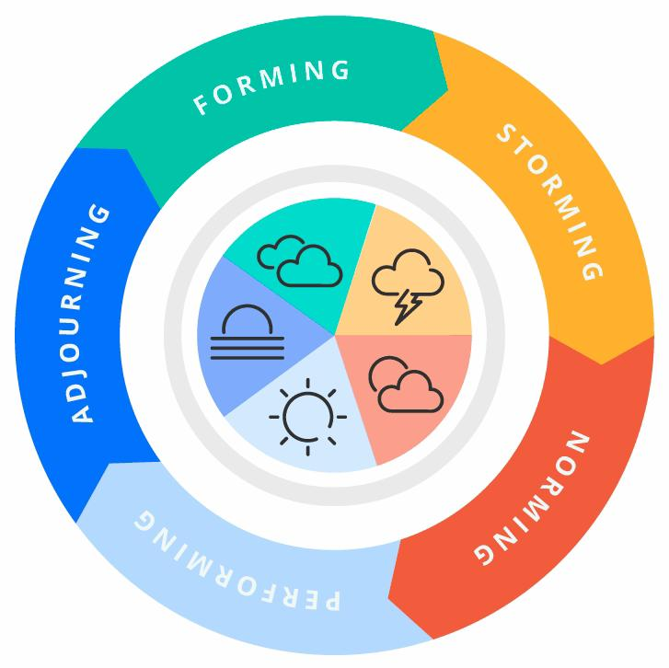

Forming: In this phase, most team members still have a positive attitude and are good to each other.
Storming: “This is difficult time for all” (Culture at work) The storm phase is the phase where many teams fail. The tasks and boundaries of each team member were set in the training stage and now they want to move them. Everyone wants to work in their own way and take on more responsibility.
Norming: The team is gradually entering the standardization phase. This is when team members begin to resolve differences among themselves. They now appreciate the strengths of their colleagues and respect authority as a leader.
Performing: After the Storming phase, the team reaches the Implementation stage. Hard work and little friction lead to the team’s sprint goals of It is possible that in the meantime some team members will be exchanged and those who are still well prepared. The structures and processes that have since crystallized support the team’s work well. In this four stages of team model it shows clearly the opposition and the progress that comes across in any teamwork.

“I think we’ve always been striving to find a way of helping people to work together. When people work in effective combinations they achieve so much more than when they’re working alone. But to do that, we need a language, and it needs to be a language which is shared and enables people to communicate with one another.” (Dr Meredith Belbin)

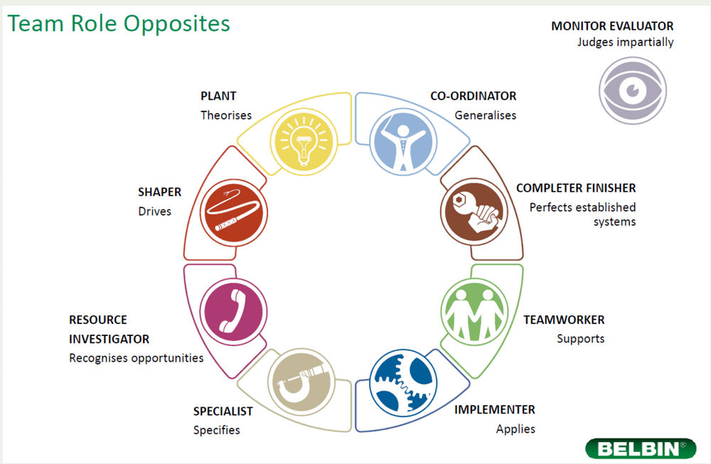

For a successful team need more than one model of team development. The theory of Belbin is highly useful in teams mostly in larges teams between 7 to 9 people, it is essential every one in a team to have clear understanding of which is their role.
Both theories are well-known and highly effective. In Tuckman’s theory more attention is paid to what the new team will go through, the stages and their development, this it is very important for a leader or manager to know what to expect and what the new team will go through. Belbin’s theory, in turn, provides key factors for what kind of people to include when forming a team. Every one has their different personality, their strong and weak side. In swarming a good team, it need at least two selection models and a good analysis of the weak and strong points of the members, because in a good and productive team there should be complements to each other. (annafbd15)

3.0. Role for creating effective teams.

In a team that has achieved success, with a high degree of probability, each member is assigned an individual role and duties corresponding to that role. And to maximize the performance of each individual team member, people must pursue both personal and collective goals. But it happens that even competent setting of goals and distribution of roles do not give the team a positive result due to objective reasons. (University of Cambridge)
Participants do not have the flexibility to adapt to changing circumstances. People focus on details, missing the opportunity to see the whole picture. One of the team members experiences negative emotions (annoyance) regarding the other participants and their activities
According to Belbin’s team model for a effective team to be successful need nine main points. Shaper, Implementer, Completer Finisher, Co-ordinator, Team worker, Resource Investigator, Plant, Monitor Evaluator and Specialist. (Matthew Channell Octomber 2021)
What are the roles:
The Plant.
Positive qualities: genius, imagination, intelligence, knowledge, solves difficult problems Permissible Weaknesses: Hovers in the clouds, tends to be oblivious to practical details or protocol.
Resource Investigator.
Positive Qualities: explores new opportunities, connects with helpful people, responds to challenges Permissible Weaknesses: lose interest after initial euphoria, can be overly optimistic and uncritical.
Co-ordinator.
Positive qualities: clear sense of purpose, treat all potential contributors for their contributions without prejudice Acceptable.
Weaknesses: Not possessing exceptional intelligence or creative abilities.
Shaper.
Positive qualities: enterprising, ability to challenge inertia, inefficiency, etc.
Permissible weaknesses: impatient, prone to provocation, irritable, hurt the feelings of others.
Monitor Evaluator.
Positive qualities: judgment, discretion, stubbornness Permissible weaknesses: lack of enthusiasm or ability to motivate others, somewhat cold-blooded, stubborn.
Implementer.
Positive Qualities: Emotional Intelligence complete task quickly.
Acceptable Weaknesses: Indecisiveness. Often avoiding listening to another ideas.
Completer Finisher.
Positive qualities: keep their word, perfectionists Acceptable Weaknesses: Worries excessively, reluctance to order, can be petty.
Specialist.
Positive qualities: provide knowledge and skills where they are needed Acceptable Weaknesses: Contribute on a narrow front, miss the big picture.
Team working.
Positive qualities: organizational skills, common sense, hardworking, disciplined Acceptable weaknesses: lack of flexibility, difficult to respond to new ideas, resist change
Belbin’s theory defines the positive and weak sides of each role and this enables the Leader how to best swarm the team, what characters to bring together for better effect.
It is necessary for every team that each member clearly knows his duties and what exactly he is responsible for.
“Teams tend to work more cohesively if the members recognize their individual roles” ( Chron Contributor December 2020)

4.0. Impact of effective teamwork on team.
“There has to be an ‘us’ as well as an ‘I’ in a successful team.” Kerrie Unsworth, Professor of Organisational Behaviour, Leeds University Business School December 2019) After all, a key indicator of a solid collaboration is that the ultimate goal shared by all is their commitment to achieve each project or task. The quality of the work, the passion behind the project, the process of concretizing an abstract idea – these should be the motivating factors that lead to success. When everyone on a collaborative team is headed in the same direction, the bottom line becomes clear—especially when the team has seen the project grow from start to finish. Good collaboration among the team has positive impact in productivity in a company, leads to more profitability and increasing the profit.
Advantages of teamwork.
- Alignment stabilizes and a sense of corporateness develops.
- Enthusiasm increases through joint efforts to accomplish the work task.
- Members skills are complentary.
- A flexible division of labor leeds to productivity fruits.
Disadvantages .
- Communication Problems.
- Coordination Problems.
- Group Mentality restrict freedom of movement.
- Social laziness ( let another do the job)
The barriers to teamwork.
The barriers in teamwork have a different nature and are possible at every stage of its functioning. Some of the main problems are: (Michael A West, John Wiley & Sons, 2012)

- Inappropriate choice of organizational form (if a team is needed, why form it?).
- Unclear about the nature and goals of the team (if the team does not produce results, why exist?).
- Inappropriate working conditions of the team (if there is teamwork in the team, for example due to remoteness, how to achieve the goal?).
- There is no developed system for evaluating the results of the team’s work (if only the results achieved by the participants are evaluated, how to measure the team’s success?).
- Absence of a team reward system (if only the individual contributions of each participant are rewarded, how will ideas be shared and how will team collaboration take place?).
- Organizational culture is conservative (if the culture does not encourage ethical behaviour, risk-taking and is not built on the principle of trust, how will team members cooperate and support each other?).
- Ineffective communications (if there is no understanding and conflicts grow, how will open relationships be achieved?).
In order to prevent or solve these and other problems in a timely manner, knowledge and skills on the dominant issues of teamwork and self-improvement in the specific practice are necessary. (Kamel Mellahi, David G Collings Journal of World Business 45 (2), 143-149, 2010)

5.0. Conclusion/Recommendation
In conclusion for a successful team and teamwork it need to paid attention to details and clear communication between each another. Manager and lieders needs to create good relationships with the team by introduce everyday meetings by software application like zoom, Microsoft teams or other. To make face to face video connection with individuals in term to increase the value of each worker -to do surveys in a short period of time and analysing them to better understanding of workers opinions
To be included different activities outside of the working duties, which will be increase the workers emotional well being
Also, more action will be taken during the specific situations, and we do not have to forget that there is no exact formula for strategic and everything is depend of the company types of business and changes in a different time of periods. Every company have to play with strategic approaches, engagement drivers and diagnostic tools (systems) to improve satisfaction in both prospects – from employees ‘s performance to organisational profitability.

6.0. Reference List – minimum of 8 references using Harvard referencing style.
Nibusinessinfo.co.uk. 2022. Advantages of effective teamwork | nibusinessinfo.co.uk. [online] Available at: https://www.nibusinessinfo.co.uk/content/advantages-effective-teamwork [Accessed 2 July 2022].

2022. [online] Available at: https://scholar.google.co.uk/scholar?hl=en&as_sdt=0,5&as_vis=1&q=what+are+barriers+to+effective+teamwork+in+business#d=gs_qabs&t=1656827679159&u=%23p%3Ddm_NTcfaAqkJ [Accessed 3 July 2022].

Ifm.eng.cam.ac.uk. 2022. Belbin’s team roles. [online] Available at: https://www.ifm.eng.cam.ac.uk/research/dmg/tools-and-techniques/belbins-team-roles/ [Accessed 2 July 2022].

Scholar.google.co.uk. 2022. Google Scholar. [online] Available at: https://scholar.google.co.uk/scholar?hl=en&as_sdt=0,5&as_vis=1&q=what+are+barriers+to+effective+teamwork+in+business#d=gs_qabs&t=1656828276293&u=%23p%3Dt2jwyCAKpGgJ [Accessed 3 July 2022].

Leeds, U., 2022. There is no ‘I’ in team – or is there? | University of Leeds. [online] Leeds.ac.uk. Available at: https://www.leeds.ac.uk/news-business-economy/news/article/4519/there-is-no-i-in-team-or-is-there [Accessed 2 July 2022].

Small Business – Chron.com. 2022. The Importance of Recognizing Roles in a Team. [online] Available at: https://smallbusiness.chron.com/importance-recognizing-roles-team-31499.html [Accessed 2 July 2022].

Belbin.com. 2022. The Nine Belbin Team Roles. [online] Available at: https://www.belbin.com/about/belbin-team-roles [Accessed 2 July 2022].

Stanwick.be. 2022. Tuckman and Belbin go hand in hand | Stanwick. [online] Available at: https://www.stanwick.be/en/blog/tuckman-and-belbin-go-hand-hand [Accessed 2 July 2022].

Businessballs.com. 2022. Tuckman: Forming, Storming, Norming, Performing model. [online] Available at: https://www.businessballs.com/team-management/tuckman-forming-storming-norming-performing-model/ [Accessed 2 July 2022].

