Student Name: Catalina Gabriela Dumitru  Student ID: 2209716  Module Title: Foreign Languages & Cultural Awareness  Module Code: BMIH5003  Lecturer: Lisa Bassler  Date: 25/02/2024 | 
ASSIGNMENT 1: PORTFOLIO
(4 Components)

Component 1: Professional Reflection (500 words +/- 10%)

Weighting: 25%
Topic: Reflection on cultural misunderstandings
Module Title: Foreign Languages & Cultural Awareness BMIH5003
Lecturer’s Name: Lisa Bassler
Student’s Name: Gabriela Catalina Dumitru
Student ID: 2209716
Date: 25/02/2024
Wordcount: 514 words

During my placement as a receptionist at the Premier Inn front desk, I encountered a situation where a colleague, while speaking to a Japanese visitor, affirmed he is Chinese, erroneously presuming the visitor was Chinese, and even referred to him as such. The visitor, clearly annoyed, corrected the mistake, stating his Japanese nationality. My coworker apologised, and fortunately, the situation did not escalate, though it had the potential to worsen under different conditions. Confusing a Japanese visitor for Chinese represents a significant cultural mistake, which can be seen as offensive. Japan and China are separate nations with distinct cultures, languages, and historical backgrounds. Such a blunder may come across as ignorance of cultural awareness and insensitivity.
What led to this mistake? The receptionist likely assumed wrong based on the guest's physical appearance or name. Jumping to conclusions about someone's nationality or ethnic background can result in false identifications and cultural misunderstandings. The receptionist might have lacked awareness of the differences between Japanese and Chinese cultures or may not have received sufficient training in cultural sensitivity (Ling, 2003). Occasionally, these errors are the result of negligence or inattention during guest interactions. This kind of mistake is perceived as disrespectful and careless.
How should one rectify this situation? Promptly admitting the error and offering an apology to the visitor is crucial. Show genuine remorse for the misunderstanding caused. Politely inquire about the guest's actual nationality or heritage, for instance, by saying, "I'm sorry for the error. May I know your nationality?" Allow the guest to express any grievances or thoughts. Listen attentively and demonstrate empathy. If possible, offer to make amends. For example, if the guest was misinformed about local sites due to the nationality assumption, provide correct information or aid. Fundamentally, working in a hotel reception requires a deep-seated cultural empathy to interact with individuals from various national and cultural backgrounds. After resolving the issue, suggest cultural sensitivity training for the staff to prevent future incidents.
How can such situations be avoided in the future? Rather than assuming a guest's nationality or ethnic background, it is advisable to ask if they are willing to share this information. For instance, you might say, "May I inquire about your nationality or cultural background?" Ensure that all front desk personnel undergo cultural sensitivity training to enhance their understanding of different cultures and respectful interaction with guests from varied backgrounds. Motivate staff to cultivate cultural awareness and staff sensitivity (Tim, 2011). Provide them with materials or guidelines for mitigating cultural differences and potential issues. Advocate for the use of respectful and impartial language when addressing guests, preferring to use their names or titles instead of assuming their nationality. Encourage an inclusive workplace atmosphere, conducive to multicultural acceptance. Such practices can aid the hotel in continuously refining its service quality and cultural sensitivity.
Cultural misunderstandings are not uncommon, yet with appropriate training, consciousness, and a dedication to respectful communication, these incidents can be significantly reduced and effectively managed, because “A greater understanding of cultural differences in non-verbal communications and body language will help improve interpersonal relationships.” (Mullins, 2019, p.154)

References:

Ling, C. and Masako, I. ‘Intercultural Communication and Cultural Learning’, The Howard Journal of Communications, vol. 14, 2003, pp. 75– 96.
Mullins, Laurie, and Jacqueline E. McLean. Mullins: Organisational Behaviour in the Workplace, Pearson Education, Limited, Harlow, 2019
Timm, A. Intercultural problems in the tourism industry, first ed., Grin Verlag, Munich, 2011

Component 2: Presentation

Weighting: 25%

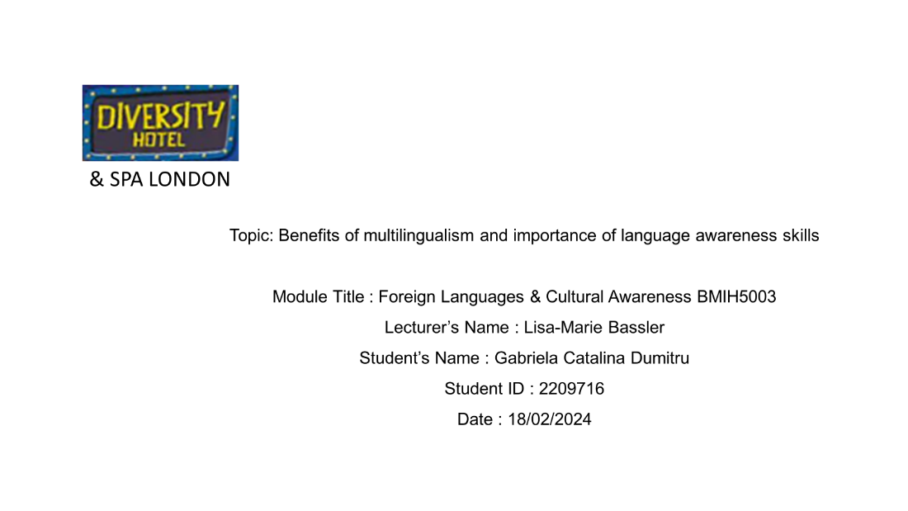
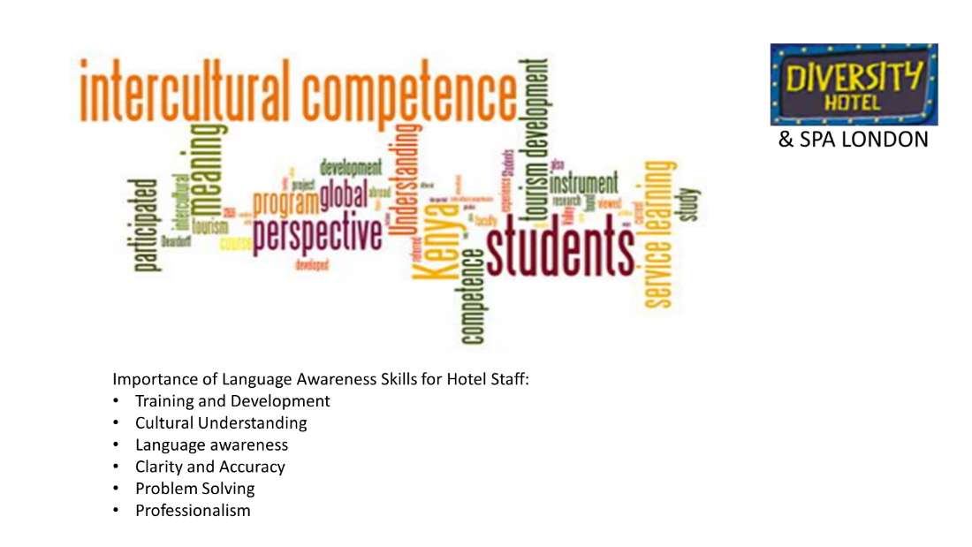
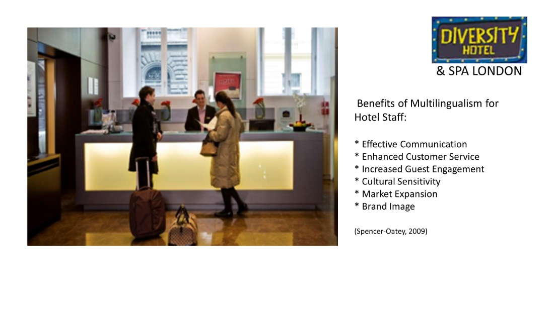
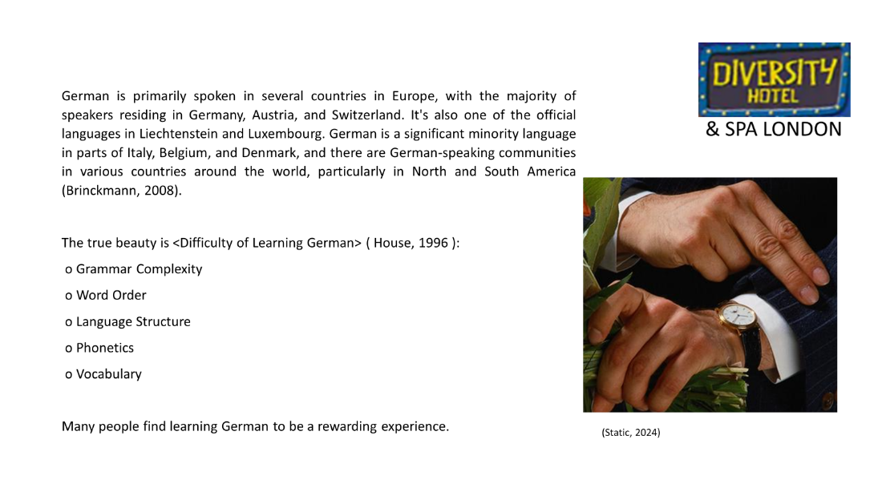
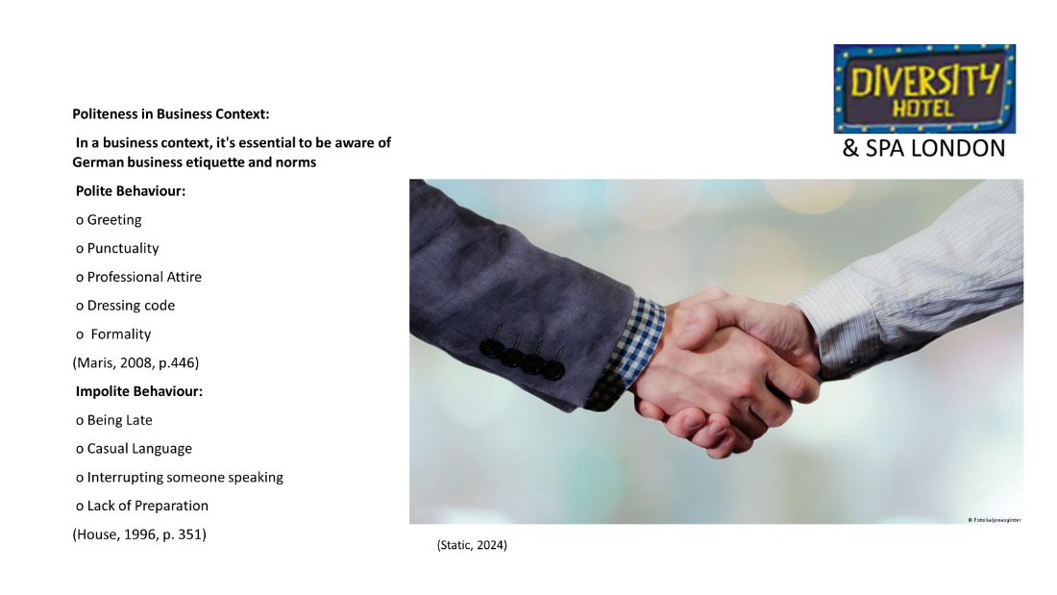

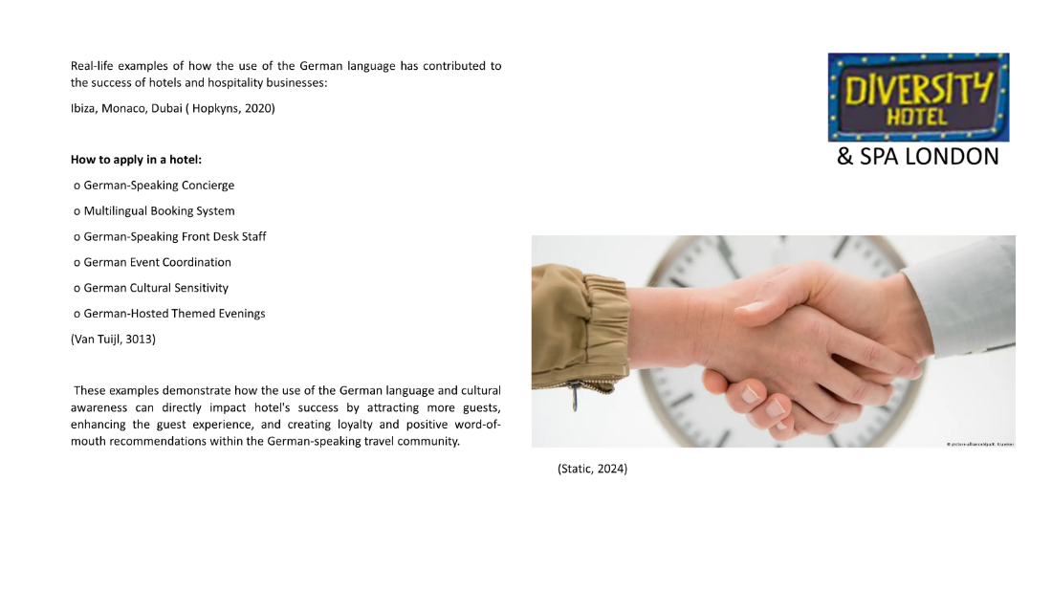
References (no screenshots):
Brinckmann, C., Kleiner, S., Knöbl, R., & Berend, N. (2008). German Today: an areally extensive corpus of spoken Standard German. In Proceedings 6th International Conference on Language Resources and Evaluation (LREC 2008). Marrakesch, Marokko (pp. 3185-3191). European Language Resources Association (ELRA).
Hopkyns, S. (2020). 13 Multilingualism and linguistic hybridity in Dubai. Multilingual global cities: Singapore, Hong Kong, Dubai, 248.
House, Juliane (1996) “Contrastive Discourse Analysis and Misunderstanding: the Case of German and English.” Contrastive Sociolinguistics. Ed. Hellinger, M & Ammon, U. New York: Mouton de Gruyter, 1996. 345-361. Print.
Marris, E. (2008) Language: The language barrier. Nature 453, 446–448 available at: https://doi.org/10.1038/453446a
Schaefer, L. (2019) An expert offers tips on how to master German manners available at: https://www.google.co.uk/url?sa=i&url=https%3A%2F%2Fwww.dw.com %2Fen%2Fhow-to-handle-german-directness-an-experts-guide-to-mastering-manners%2Fa-47967311&psig=AOvVaw06av80eMNWDE3BIq5250E0&ust= 1708370258753000&source=images&cd=vfe&opi=89978449&ved=0CBQQjhxqFwoTCOjr_anNtYQDFQAAAAAdAAAAABAE https://static.dw.com/image/16866425_605.jpg
Spencer-Oatey, H., and Franklin, P. (2009) Intercultural Interaction: A Multidisciplinary Approach to Intercultural Communication. Basingstoke: Palgrave Macmillan, 2009.
van Tuijl, S.P.M., (2013). The Language of Tourism and Hospitality: An Exploration of Intercultural Communication Issues in Hotels in the Netherlands thesis
Static (2024) Image available at: https://static.dw.com/image/
Component 3:

LIVE PRESENTATION (no links need to be submitted here)
Component 4: Student Self-Reflection (500 words +/- 10%)

Weighting: 25%
PERSONAL REFLECTION ON SELF DEVELOPMENT

Student Name
Catalina Gabriela Dumitru
Student ID number
2209716
MODULE
FOREIGN LANGUAGE & CULTURAL AWARENESS BMIH5003
Lecturer
LISA-MARIE BASSLER
Wordcount : 542 words

On the journey of personal growth, there are pivotal moments. I wish to share insights from the past few weeks when I realised the significance of acquiring German as a third language, with Romanian being my mother tongue and English as my second language. Last year, my focus was on mastering marketing, management, leadership, and teamwork. However, recently, it became apparent that honing communication skills is a key milestone in the quest for the comprehensive skill set of a hotel manager. Enhancing personal communication abilities, notably through learning an additional language such as German, is crucial for those in the hotel sector for numerous reasons, including improving guest experiences through proficient communication. When hotel personnel can engage with guests in their native language, it fosters a sense of warmth, builds connections, and ensures a welcoming environment; in today's globalized world, hotels cater to an increasingly diverse clientele from different regions and cultural backgrounds. “Language plays an important role in the way we perceive and communicate with the world” (Mullins, 2019, p.230). Mastery of a second language, like German, enables me to interact with a broader spectrum of guests, making them feel appreciated and understood. Possessing this capability on my CV will broaden my professional horizons, as the ability to communicate effectively in multiple languages provides a competitive edge in the hotel industry. Multilingualism can unlock additional career opportunities and facilitate professional progression (Mullins, 2019). It also enhances trust and rapport with guests, where effective communication builds confidence and fosters lasting relationships, encouraging repeat business and positive referrals. Proficient communication can also streamline the resolution of concerns and complaints, particularly with German-speaking guests, transforming potential negatives into positive outcomes. Learning German broadens my perspective and cultivates cultural sensitivity, aligning with the latest trends in a globalized context, “tourism has become a mediator in intercultural and interpersonal communication” (Grobelna, 2015, p.3). Speaking German will be beneficial wherever I choose to work in the future, enabling adaptation to market trends, such as catering to an increasing number of German tourists, thereby giving a hotel a competitive advantage. Proficiency in a second language is sometimes crucial for adhering to local regulations and potential requirements. Beyond the professional benefits, learning German promises personal growth, offering a fulfilling personal journey that enhances self-esteem and cognitive abilities. It presents an enjoyable avenue to explore global cultural diversity, “intercultural experience proved to be significant” (Kenesei,2017 p.7).
During creating the presentation about multilingualism, I had the chance to find out where the German is spoken, who are the speakers, how hard is to learn, also some particularities of German cultural etiquette, the similarities and differences with English. Also learned that developing personal communication skills, particularly through learning a language like German, is imperative in the hotel industry for delivering outstanding guest services, accommodating a varied clientele, and unlocking doors to career advancement and professional growth. It aids in establishing trust, resolving issues, and adapting to market changes (Mullins, 2019). Moreover, acquiring German as a second language, especially in roles that entail interaction with international guests, like working at the hotel front desk, offers numerous benefits such as enhanced guest service, a competitive stance in the job market, personal and cultural growth, and the potential for professional advancement within the hospitality sector.

References:
Grobelna, A., et al. (2015) Intercultural challenges facing the hospitality industry. Implications for education and hospitality management. Journal of Intercultural Management, 7.3: 101-117.
Kenesei, Z. and Stier, Z. (2017) ‘Managing communication and cultural barriers in intercultural service encounters: Strategies from both sides of the counter’, Journal of vacation marketing, 23(4), pp. 307–321.
Mullins, L., and McLean, J. E. (2019) Organisational Behaviour in the Workplace, Pearson Education, Limited, 2019.

