University of Wales Trinity Saint David
London Campus

ASSESSMENT DATABASE DESIGN AND IMPLEMENTATION

Lecturer: Fahad Ahmed Student: Virgil Stanciu ID number: 2411552 Modul code: ACCA5026 Databases and Application Development

Contents
PART A 1
Introduction 1
1. Database Design 2
1.1 Requirements Analysis and Identification of System Components 2
1.2 Conceptual and Logical Model Design - ERD 3
1.3 Normalisation to Third Normal Form (3NF) 4
1.3.1 First Normal Form (1NF) 5
1.3.2 Second Normal Form (2NF) 5
1.3.3 Third Normal Form (3NF) 6
2. Implementation Design 8
2.1 Implementation Tables 8
2.2 Database, Tables and Implementation (Creation SQL) 10
2.3 Database Implementation (SQL) 17
3. Stored Procedure and Transactional Scenario 20
4. Conclusions 23
PART B 24
Database Design & Setup 24
SQL Injection (SQLi) 31
Potential Weaknesses & Improvements 31

PART A

Introduction
MedAssist Clinic is a private medical clinic operating in the United Kingdom, offering a range of outpatient medical services including general consultations, diagnostics, and referrals to specialists. Supported by a dedicated team of doctors, specialists, and administrative staff, the clinic is committed to delivering high-quality care to its registered patients. As the practice grows, it aims to modernize its operations by digitizing patient records, appointment scheduling, and treatment history tracking.
To enhance service efficiency and patient management, MedAssist Clinic intends to implement a central database system that will store and manage patient information, medical staff rosters, appointment bookings, and service feedback. The solution must be secure, user-friendly for multiple concurrent users, and designed in full compliance with data integrity principles.
In healthcare, accurate and secure information management is a foundational component of safe and effective care. Decentralised, inconsistent, or inadequately protected data storage increases the risk of errors, data loss, unauthorised access, and regulatory non-compliance. Furthermore, health data constitutes a special category of personal data subject to enhanced protection requirements, meaning the system architecture must be designed from the outset to satisfy both operational and regulatory obligations. Accordingly, a relational database design delivers structure, consistency, oversight, and auditability, enabling authorised personnel to retrieve required information promptly while upholding full confidentiality standards.

Database Design

1.1 Requirements Analysis and Identification of System Components

In the first stage, clinical workflows and business processes were analysed in detail. All information categories requiring storage were catalogued, and the core entities, the primary objects about which information is held were identified as follows: Patient, Doctor, Department, Appointment, Treatment, Feedback. Each entity was defined according to observed clinical workflows to ensure comprehensive coverage of all documented data flows.

For each entity, attributes were identified and systematically categorised into distinct groups: personal data (name, contact details, identifiers), professional data (specialty, grade, departmental affiliation), and activity data (appointment dates, diagnoses, clinical recommendations, patient evaluations). This separation supports logical organisation and enables appropriate safeguards to be applied proportionately.

Every entity has been assigned a unique identifier like a primary key in the form of a standardised code (e.g. patient_id, doctor_id) to eliminate ambiguity, prevent duplication, and ensure consistent referencing across the entire system. A key business rule was established: at any given time, a doctor belongs to exactly one department, whereas a department may employ multiple doctors. A constraint subsequently reflected in relationship cardinality.

Relationships between entities were defined and their cardinality established: one patient may have multiple appointments, but each appointment relates to exactly one patient; one doctor may hold multiple appointments, but each appointment is assigned to exactly one doctor; one department contains multiple doctors, but each doctor is assigned to one department; each completed appointment corresponds to exactly one treatment record; one patient may submit multiple feedback entries, but each submission originates from exactly one patient.

Supplemental domain-specific rules were formulated to serve as system constraints: medical data may only be accessed by authorised personnel; appointments may not be recorded with a date prior to the current date, treatment records may only be created following confirmation of patient attendance, all modifications to medical records are logged and timestamped for audit, personal data is retained only for the period necessary to fulfil the stated processing purpose.

1.2 Conceptual and Logical Model Design - ERD

Building upon the requirements analysis, the conceptual model was developed to describe data at its semantic level, independent of technical implementation details. This model documents entities, attributes, primary keys, and inter-entity relationships using standardised notation.
Relationship types and cardinality were explicitly defined: one-to-many from Patient to Appointment, one-to-many from Doctor to Appointment, one-to-many from Department to Doctor, one-to-many from Patient to Feedback, and one-to-one from Appointment to Treatment. The one-to-one relationship between Appointment and Treatment reflects clinical practice, whereby every attended consultation generates exactly one corresponding clinical record. Furthermore, this relationship is conditional: a treatment record may only be created once the associated appointment has been marked as attended.
Additional business rules were specified to prevent logical inconsistencies: appointments may only be scheduled within the doctor’s documented availability, no overlapping appointments may exist for the same doctor, clinical data is entered once and referenced exclusively to its originating appointment. Patient feedback contains general evaluations and suggestions but excludes detailed clinical information.
Finally, validation confirmed that all documented business processes are represented within the model, that no unused entities or relationships exist, and that all specified constraints are accurately reflected in the logical structure.

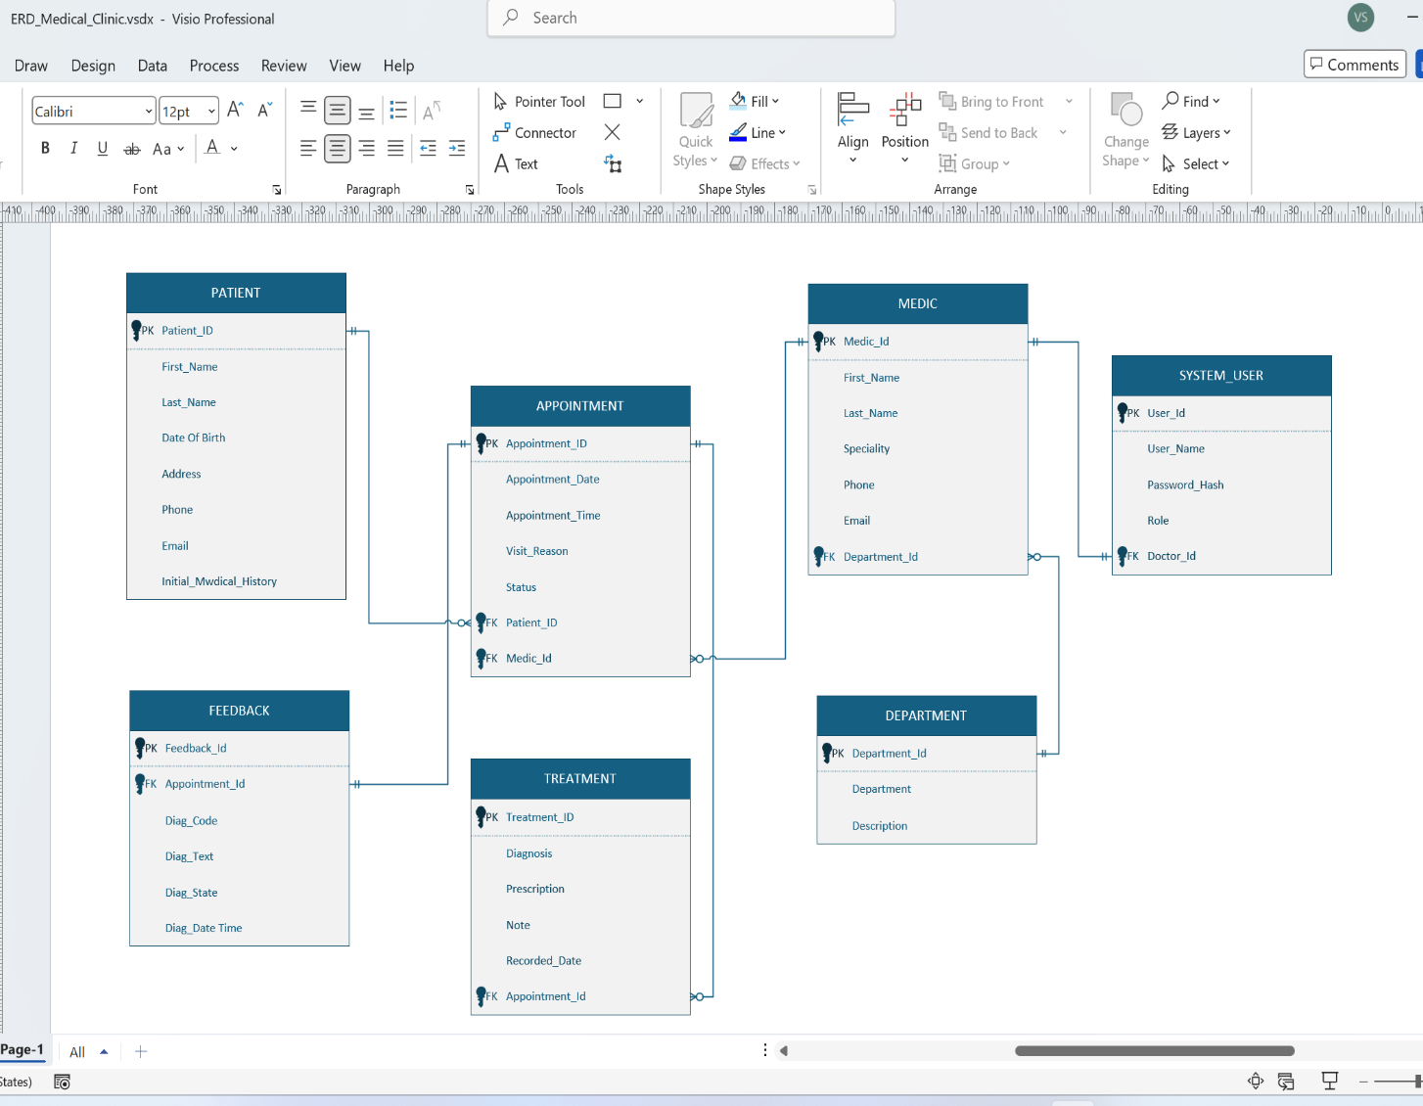

Entity Relation Diagram

1.3 Normalisation to Third Normal Form (3NF)
Normalisation is the systematic application of successive design rules intended to eliminate data redundancy, prevent insertion, update, deletion anomalies and produce a maintainable, adaptable database structure.

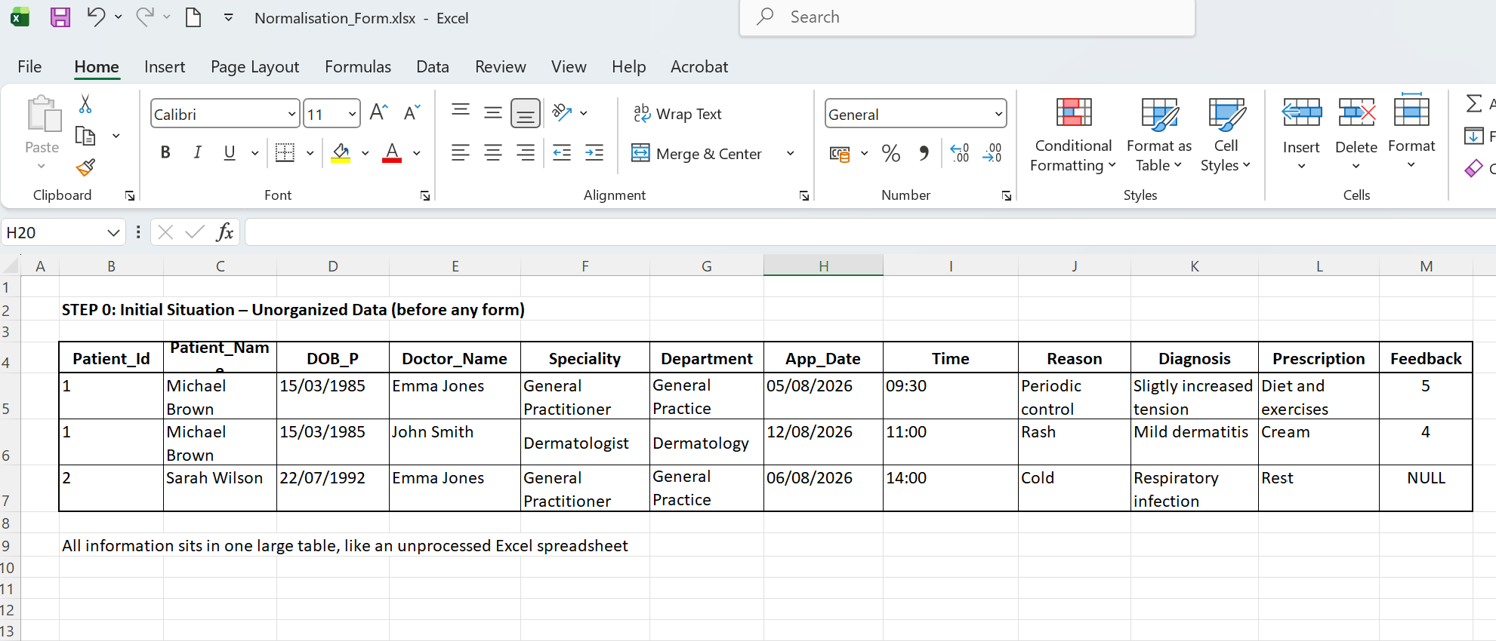

1.3.1 First Normal Form (1NF)
Enforces atomicity every field contains exactly one value, no lists or multi-valued collections are stored within a single attribute, every record is unique, and every entity possesses a defined primary key. For example, multiple telephone numbers or separate medical conditions are not concatenated into a single field but are stored in appropriately structured related records.
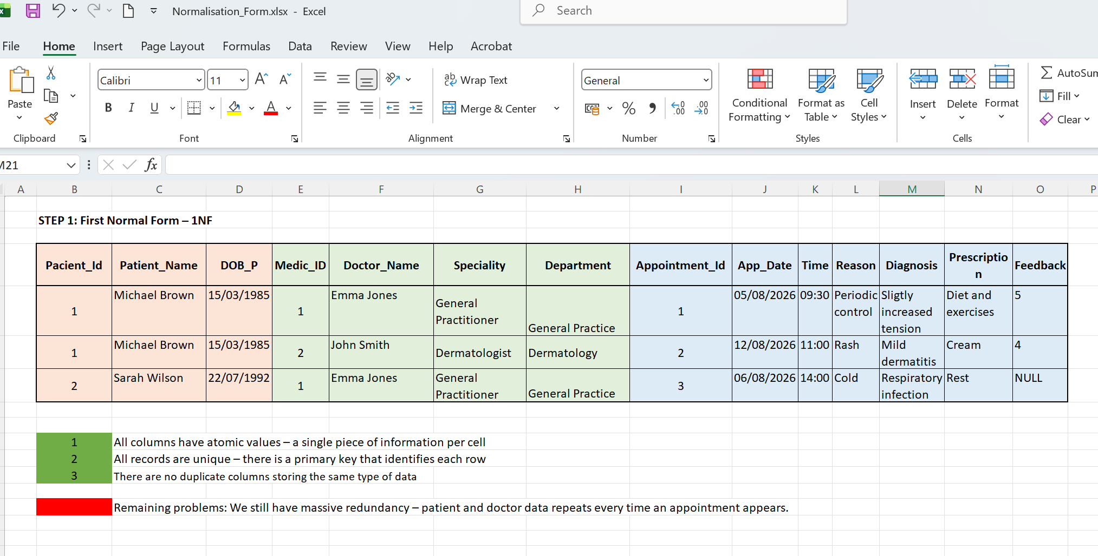

1.3.2 Second Normal Form (2NF)
Maintains full compliance with 1NF and additionally eliminates partial dependencies every non-key attribute depends upon the entire primary key, not merely a portion of it. Attributes describing only part of a composite identifier are extracted into separate tables, thereby avoiding redundant repetition of static values across many records.

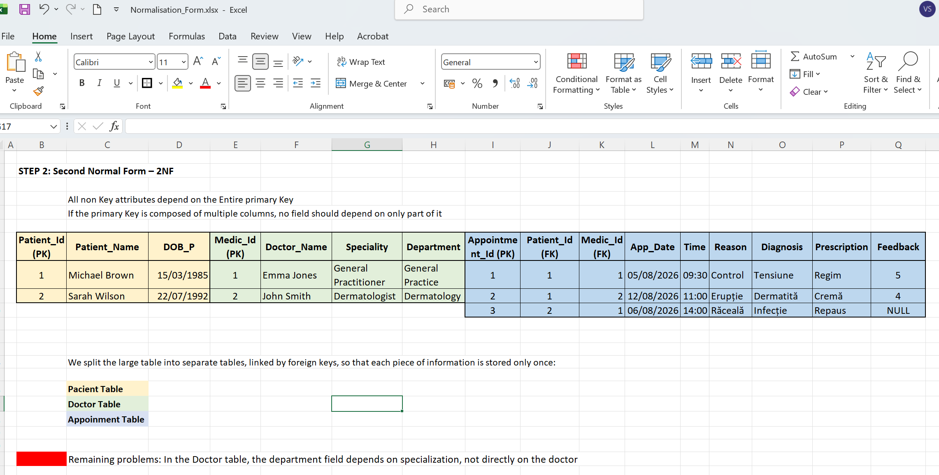

1.3.3 Third Normal Form (3NF)
Maintains full compliance with 2NF and eliminates transitive dependencies no non-key attribute depends upon another non-key attribute. For example, department names are not stored directly alongside doctor records, only a department_id foreign key is retained, and the department name is resolved through a reference lookup. Similarly, patient names and personal identifiers appear only in the Patient table and are never duplicated in Appointment records. The `patient_id` reference is used instead.
Successive application of these rules substantially reduces data duplication, ensures consistency, updates occur in exactly one location and enhances security: sensitive data is stored once and referenced by codes rather than reproduced throughout the system, thereby reducing opportunities for unauthorised exposure.
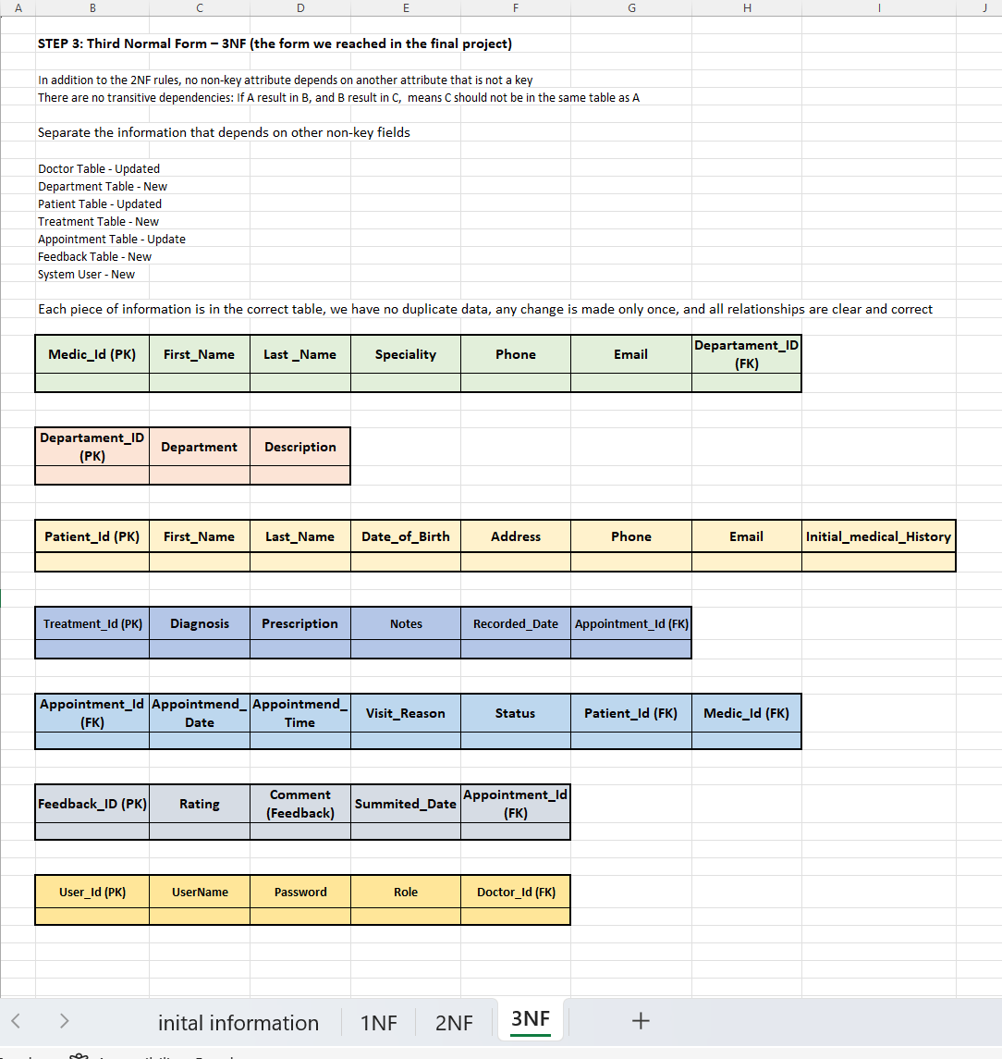

Implementation Design

2.1 Implementation Tables
At this stage, the normalised logical model is translated into concrete relational structures suitable for implementation within a database management system. Definitions include table names, column specifications, appropriate data types, and all integrity constraints.
We have identified 7 core entities, structured to eliminate redundancy and ensure full data integrity:

- Department Table:
- Department_Id (PK)
- Department Name
- Description
Relationship: 1 to many, employs multiple doctors;
- Doctor
- Doctor_Id (PK)
- First_Name
- Last_Name
- Speciality
- Phone
- Email
- Department_ID (FK)
Relationship: 1 to many, assigned to one department,
Relationship: many to 1, has multiple appointments;
- Patient
- Patient_id (PK)
- First_name
- Last_name
- Date_of_birth
- Address
- Phone
- Email
- Iinitial_medical_history
Relationship: 1 to many, has multiple appointments and treatment records;
- Appointment
- Appointment_id (PK)
- Appointment_date
- Appointment_time
- Visit_reason
- Status
- Patient_id (FK)
- Doctor_id (FK)
Relationship: many to 1: linked to one patient and one doctor;
Relationship: 1 to 1: has one treatment record and one feedback entry
- Feedback
- Feedback_id (PK)
- Rating, comment
- Submitted_date
- Appointment_id (FK)
Relationship: many to 1: submitted only against an existing appointment
- System_User
- User_id (PK)
- Username
- Password_hash
- Role
- Doctor_id (FK, nullable for admin)
Controls access levels: admin, reception_staff, doctor

Primary keys are specified to uniquely identify every record, and foreign keys enforce referential integrity between tables with explicit rules defined governing the cascading behaviour of updates and deletions. Validation constraints are formalised: mandatory fields prevent incomplete records, selected fields enforce unique values across the dataset and check constraints enforce logical rules.
For instance, an appointment date must not be earlier than the current date. Integrity Rules:
- A doctor cannot be booked for two appointments at the same date and time
- A patient cannot have overlapping appointments with the same or different doctors
- Treatment records and feedback can only be added if the appointment exists and is marked as completed
A role-based access control mechanism is implemented through a dedicated User Roles table, distinguishing between administrative staff, clinicians, department heads, and system administrators. Each user is assigned one role, and permissions to view, insert, modify, or delete data are derived exclusively from that role. This separation supports flexible permission management and adheres to the “principle of least privilege”, users receive access only to the information strictly necessary to perform their duties.
Given the exceptionally sensitive nature of clinical data, supplementary safeguards are mandated: all access to health records is automatically logged, treatment report modifications require documented justification while preserving prior versions and personal data is encrypted at rest. Consistent with current ICO cybersecurity recommendations.

2.2 Database, Tables and Implementation (Creation SQL)

/*Database Creation */
CREATE DATABASE MedAssistClinic;
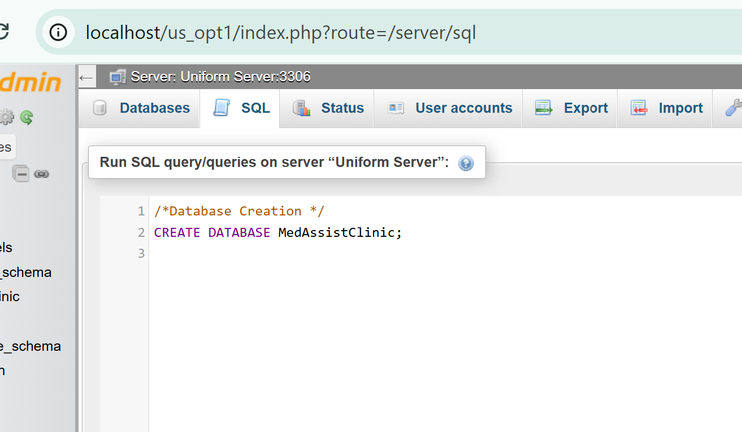

/*Table Creation 1. Departments*/
CREATE TABLE Department (
department_id INT PRIMARY KEY AUTO_INCREMENT,
department_name VARCHAR(100) NOT NULL UNIQUE,
description TEXT NULL
);
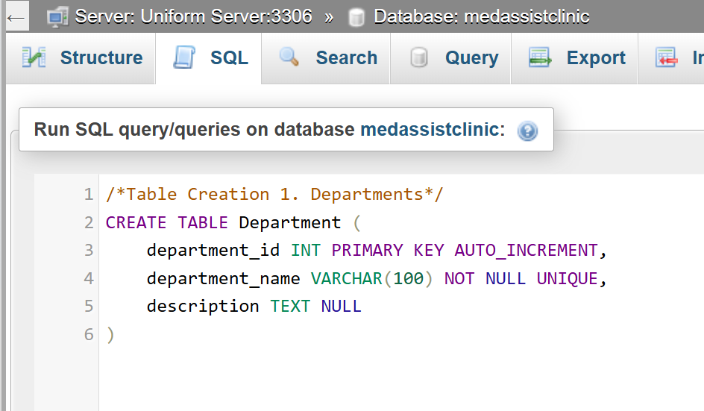

/*2. Doctors */
CREATE TABLE Doctor (
doctor_id INT PRIMARY KEY AUTO_INCREMENT,
first_name VARCHAR(50) NOT NULL,
last_name VARCHAR(50) NOT NULL,
specialty VARCHAR(100) NOT NULL,
phone VARCHAR(20) NOT NULL UNIQUE,
email VARCHAR(100) NOT NULL UNIQUE,
department_id INT NOT NULL,
FOREIGN KEY (department_id) REFERENCES Department(department_id)
ON UPDATE CASCADE ON DELETE RESTRICT
);
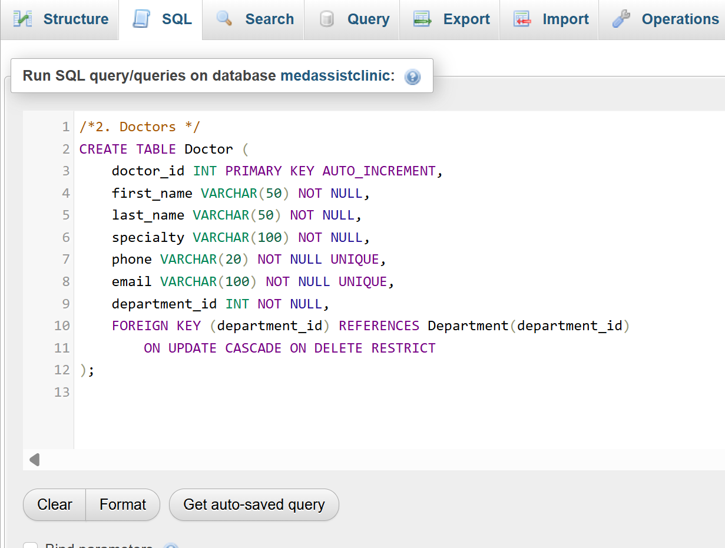

/* 3. Patients */
CREATE TABLE Patient (
patient_id INT PRIMARY KEY AUTO_INCREMENT,
first_name VARCHAR(50) NOT NULL,
last_name VARCHAR(50) NOT NULL,
date_of_birth DATE NOT NULL,
address TEXT NULL,
phone VARCHAR(20) NOT NULL UNIQUE,
email VARCHAR(100) NOT NULL UNIQUE,
initial_medical_history TEXT NULL
);
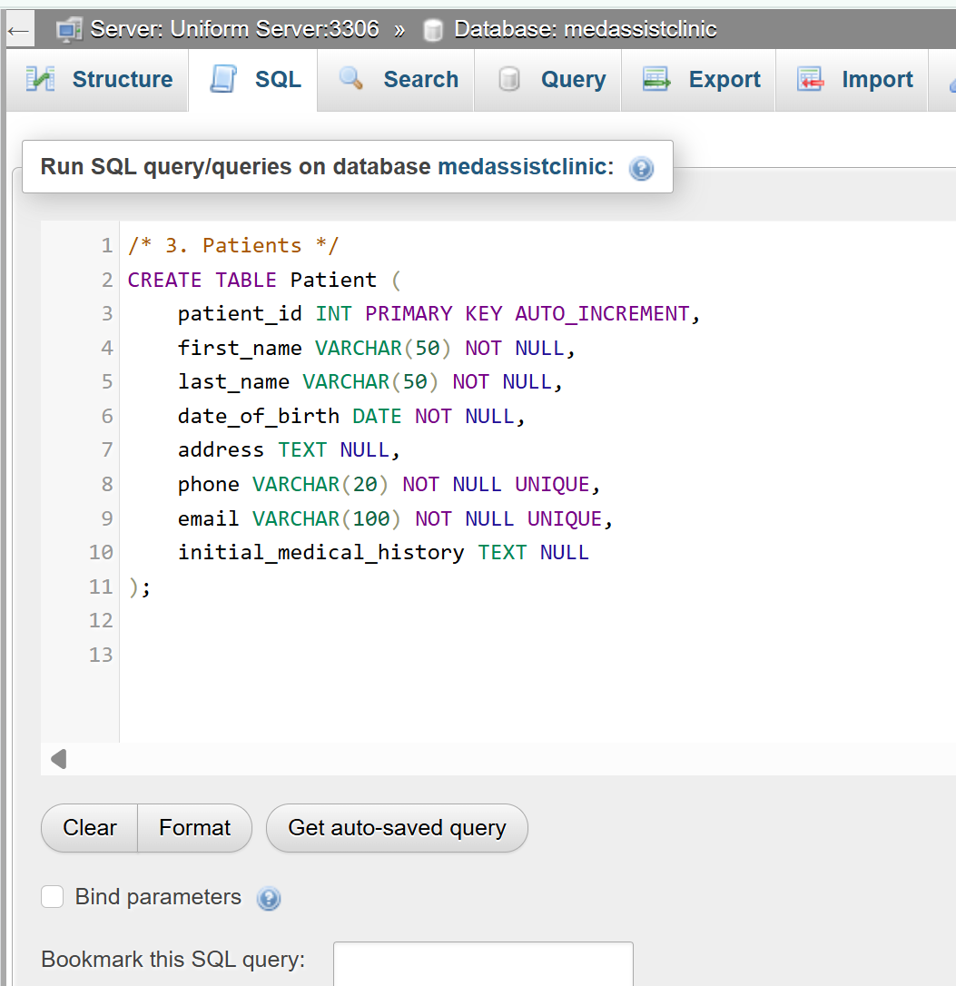

/* 4 Appointments */

CREATE TABLE Appointment (
appointment_id INT PRIMARY KEY AUTO_INCREMENT,
appointment_date DATE NOT NULL,
appointment_time TIME NOT NULL,
visit_reason TEXT NOT NULL,
status ENUM('scheduled', 'completed', 'cancelled') DEFAULT 'scheduled',
patient_id INT NOT NULL,
doctor_id INT NOT NULL,
FOREIGN KEY (patient_id) REFERENCES Patient(patient_id) ON UPDATE CASCADE ON DELETE RESTRICT,
FOREIGN KEY (doctor_id) REFERENCES Doctor(doctor_id) ON UPDATE CASCADE ON DELETE RESTRICT,
/*Prevent double booking*/
UNIQUE (doctor_id, appointment_date, appointment_time),
UNIQUE (patient_id, appointment_date, appointment_time)
);
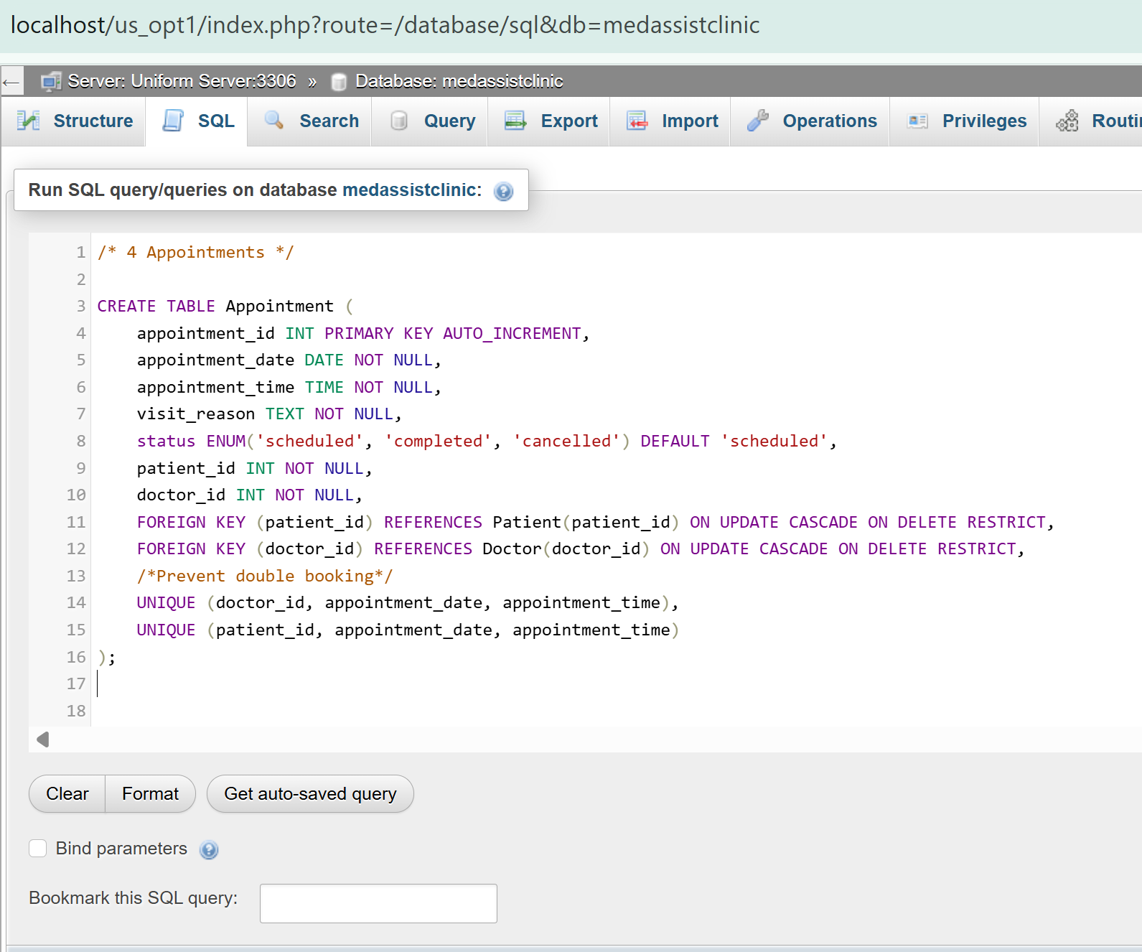

/* 5. Treatments */
CREATE TABLE Treatment (
treatment_id INT PRIMARY KEY AUTO_INCREMENT,
diagnosis TEXT NOT NULL,
prescription TEXT NULL,
notes TEXT NULL,
recorded_date DATETIME DEFAULT CURRENT_TIMESTAMP,
appointment_id INT NOT NULL UNIQUE,
FOREIGN KEY (appointment_id) REFERENCES Appointment(appointment_id) ON UPDATE CASCADE ON DELETE RESTRICT
);
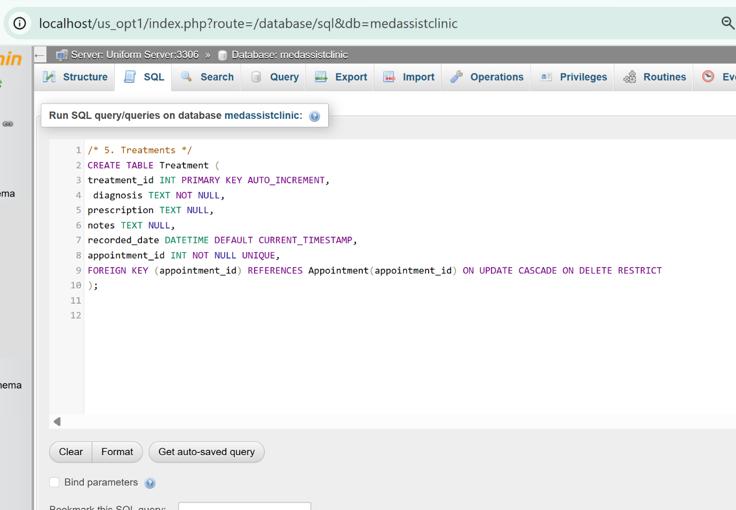

/* 6. Feedback */
CREATE TABLE Feedback (
feedback_id INT PRIMARY KEY AUTO_INCREMENT,
rating INT NOT NULL CHECK (rating BETWEEN 1 AND 5),
comment TEXT NULL,
submitted_date DATETIME DEFAULT CURRENT_TIMESTAMP,
appointment_id INT NOT NULL UNIQUE,
FOREIGN KEY (appointment_id) REFERENCES Appointment(appointment_id) ON UPDATE CASCADE ON DELETE RESTRICT
);
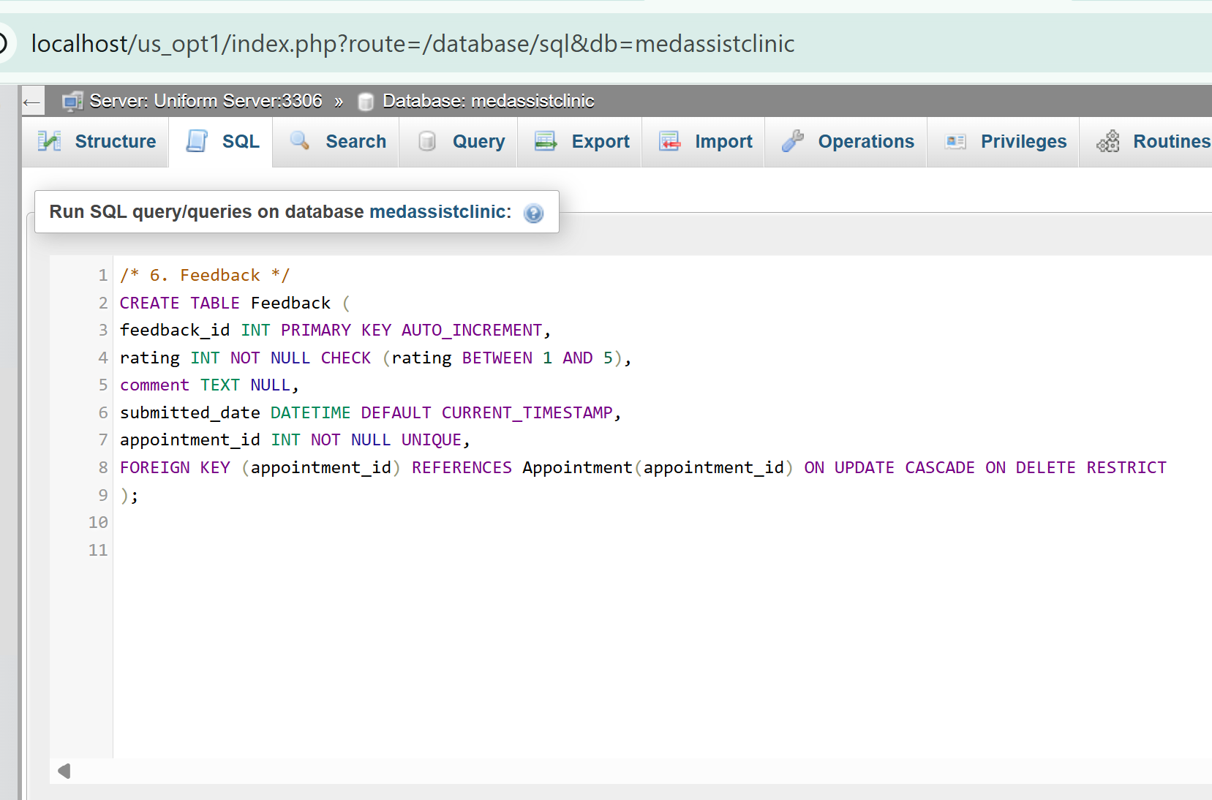
/* 7. System Users (Security & Access Control) */
CREATE TABLE System_User (
user_id INT PRIMARY KEY AUTO_INCREMENT,
username VARCHAR(50) NOT NULL UNIQUE,
password_hash VARCHAR(255) NOT NULL,
role ENUM('admin', 'reception_staff', 'doctor') NOT NULL,
doctor_id INT NULL UNIQUE, FOREIGN KEY (doctor_id) REFERENCES Doctor(doctor_id) ON UPDATE CASCADE ON DELETE RESTRICT
);

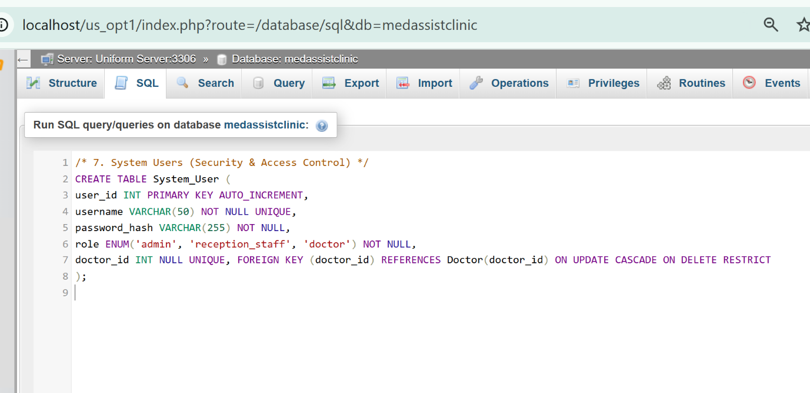

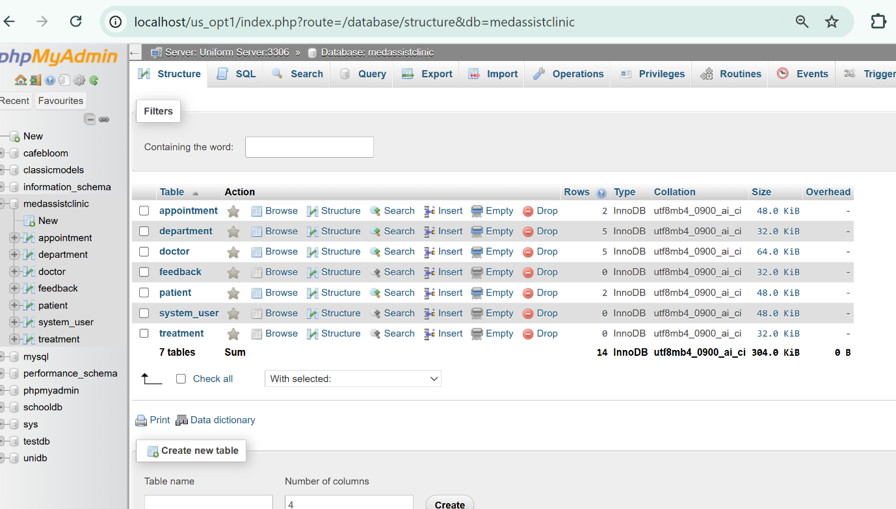

Database Implementation (SQL)

After creating the tables, we can populate them with record data using SQL queries.

/* Departments */
INSERT INTO Department (department_name, description) VALUES
('General Practice', 'General consultations and referrals to specialists'),
('Dermatology', 'Skin conditions and dermatological treatments'),
('Physiotherapy', 'Rehabilitation and physical therapy'),
(‘Cardiology’, ‘Diagnoses, heart and blood vessel disorders’),
(‘Padiatrics’, ‘Provides medical care for infants, children, and teens’);

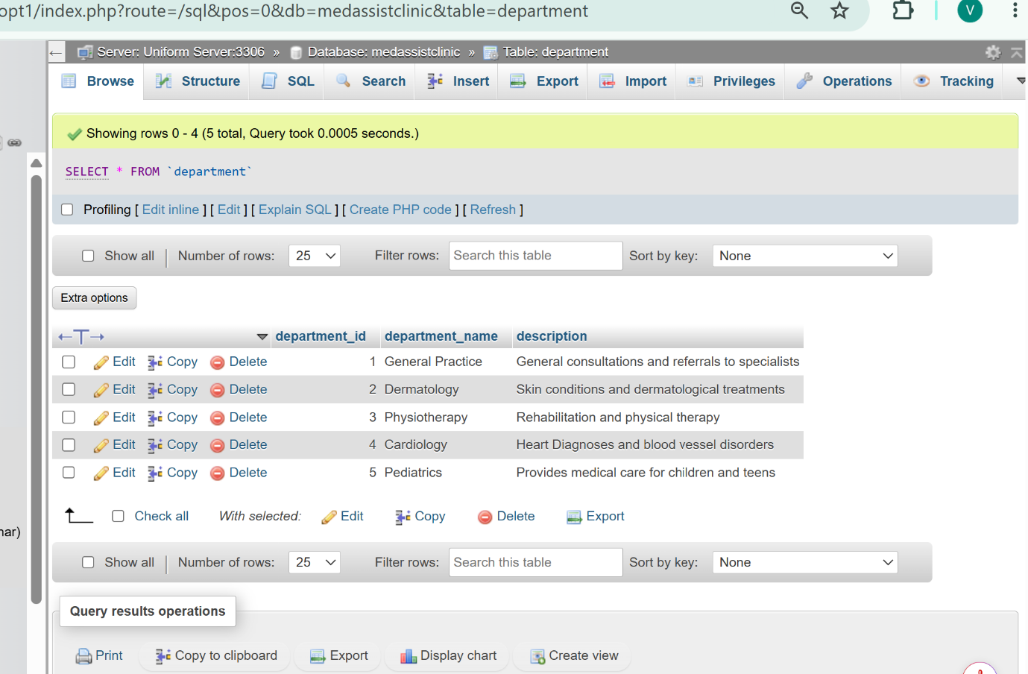

We can add a new recording:
INSERT INTO Department (department_name, description) VALUES
('Orthopedics', ' medical specialty focused on the diagnosis, treatment, and prevention of conditions involving the musculoskeletal system');

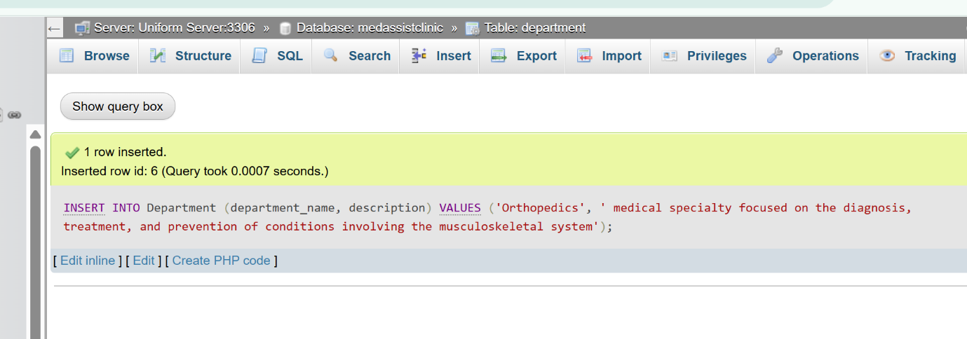

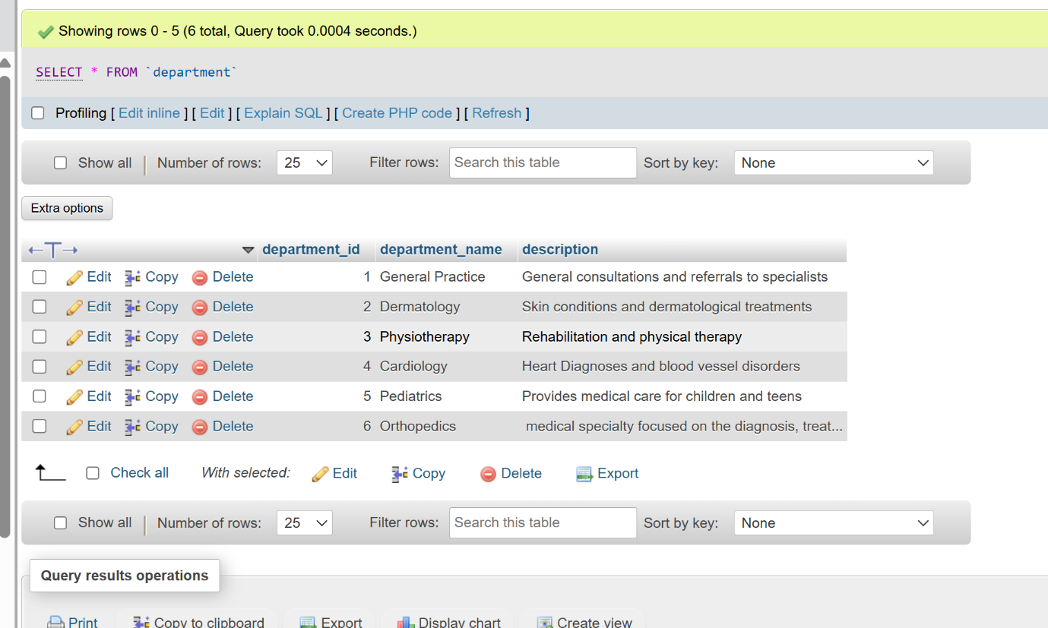

We will continue with the other tables as well.

/* Doctors */
INSERT INTO Doctor (first_name, last_name, specialty, phone, email, department_id) VALUES
('John', 'Smith', 'General Practitioner', '0712345678', 'j.smith@clinic.co.uk', 1),
('Emma', 'Jones', 'Dermatologist', '0723456789', 'e.jones@clinic.co.uk', 2),
('David', 'Lee', 'Physiotherapist', '0734567890', 'd.lee@clinic.co.uk', 3),
(‘Sophia’, ’Patterson’, 'Dermatologist', '0726456251', ‘s.patterson@clinic.co.uk', 5)
(‘Diane’, ’Murphy', ‘Cardiology’, ‘0745862021’, ‘d.murphy@clinic.co.uk’, 4);

/* Patients */
INSERT INTO Patient (first_name, last_name, date_of_birth, phone, email, initial_medical_history) VALUES
('Michael', 'Brown', '1985-03-15', '0745678901', 'm.brown@email.com', 'No chronic conditions'),
('Sarah', 'Wilson', '1992-07-22', '0756789012', 's.wilson@email.com', 'Penicillin allergy');

/* Appointments */
INSERT INTO Appointment (appointment_date, appointment_time, visit_reason, patient_id, doctor_id) VALUES
('2026-08-05', '09:30:00', 'Routine check-up', 1, 1),
('2026-08-06', '14:00:00', 'Skin rash', 2, 2);

Stored Procedure and Transactional Scenario

To ensure secure, efficient, and maintainable system operation, supplementary mechanisms are defined alongside the core table structure: transactions, stored procedures, automated triggers, and an indexing strategy.
Transactions: a related sequence of operations must succeed completely or be entirely rolled back. For example, recording a treatment involves three coordinated steps: documenting the clinical record, marking the appointment as attended, and updating the patient’s clinical history. If any single step fails, all changes are reversed and the system reverts to its prior state. Thereby preventing partial updates and logical inconsistency.
Stored Procedures: encapsulate frequently performed workflows, registering a patient, scheduling an appointment, recording a treatment into precompiled routines stored within the database. Benefits include: consistent execution logic, reduced human error, restricted direct table access, and guaranteed enforcement of data protection safeguards during every operation.
SQL:
DELIMITER //
CREATE PROCEDURE Add_Appointment(
IN p_patient_id INT,
IN p_doctor_id INT,
IN p_date DATE,
IN p_time TIME,
IN p_reason TEXT,
OUT p_result VARCHAR(100)
)
BEGIN
DECLARE EXIT HANDLER FOR SQLEXCEPTION
ROLLBACK;
INSERT INTO Appointment (appointment_date, appointment_time, visit_reason, patient_id, doctor_id)
VALUES (p_date, p_time, p_reason, p_patient_id, p_doctor_id);
COMMIT;
SET p_result = 'SUCCESS: Appointment booked correctly';
END //
DELIMITER ;

Automated Audit Triggers: log significant events to an immutable audit trail: every diagnosis modification, user identity, timestamp of access to sensitive records, and account creation event.
SQL:
CREATE TABLE Audit_Log (
audit_id INT PRIMARY KEY AUTO_INCREMENT,
table_name VARCHAR(50) NOT NULL,
action_type ENUM('INSERT', 'UPDATE', 'DELETE') NOT NULL,
performed_by VARCHAR(50) NOT NULL,
action_date DATETIME DEFAULT CURRENT_TIMESTAMP,
details TEXT NOT NULL
);

DELIMITER //
CREATE TRIGGER Log_Patient_Update
AFTER UPDATE ON Patient
FOR EACH ROW
BEGIN
INSERT INTO Audit_Log (table_name, action_type, performed_by, details)
VALUES ('Patient', 'UPDATE', CURRENT_USER(),
CONCAT('Updated patient ID ', OLD.patient_id,
': Old name: ', OLD.first_name, ' ', OLD.last_name,
'New name: ', NEW.first_name, ' ', NEW.last_name));
END //
DELIMITER ;

Indexing Strategy: is applied selectively to columns frequently used for filtering, sorting, or joining data, such as patient names, appointment dates, and department identifiers. While indexes accelerate query performance, they also degrade write performance. Consequently, indexes are created only where query benefits outweigh update overhead.

Conclusions
This project presents a rigorous, structured approach to designing an information system for clinical use, progressing systematically from requirements analysis and entity identification through to performance planning and documentation. Consistent application of normalisation principles through to Third Normal Form yields a logical architecture that is clear, minimally redundant, and capable of preserving data integrity, consistency, and security.

A defining characteristic of this design is the integration of data protection safeguards from the earliest conceptual phase, fully aligned with the United Kingdom’s current regulatory framework. Data categorisation, role-based access controls, comprehensive audit trails, and strict data minimisation collectively establish compliance with law enforcement expectations and published regulatory best practice.

The resulting architecture is suitable for implementation within any standard relational database management system. Its modular, well-defined structure permits future expansion, including online booking interfaces, reporting dashboards, or interoperability with external systems, without compromising structural integrity or existing security safeguards.

PART B

Medical Appointment Management System
The Medical Appointment Management System is a fully functional, database-driven web application developed using PHP and SQL, designed to streamline the organization and administration of medical appointments, doctors, patients, and system users.
Built in strict accordance with all specified requirements, this project features a properly normalized database structure comprising four core tables with clearly defined foreign key relationships to ensure data integrity and consistency. The system includes a secure PHP database connection, comprehensive search and filtering capabilities, and complete Create, Read, Update, and Delete (CRUD) functionality across all modules.
Security and reliability are prioritized throughout the implementation: the system incorporates robust user authentication and input validation mechanisms, alongside effective safeguards against SQL injection attacks. To support administrative oversight and decision-making, the application also generates the required summary reports. This solution delivers a practical, secure, and user-friendly platform for managing medical scheduling and related records efficiently.

Database Design & Setup

For the project, we will use the MedassistClinic database created in the first part, and we will focus on the Doctor, Patient, Department, and system_user tables. We will insert a new record into the Department table.
Department
INSERT INTO Department (department_name, description) VALUES
('Orthopedics', ' medical specialty focused on the diagnosis, treatment, and prevention of conditions involving the musculoskeletal system');

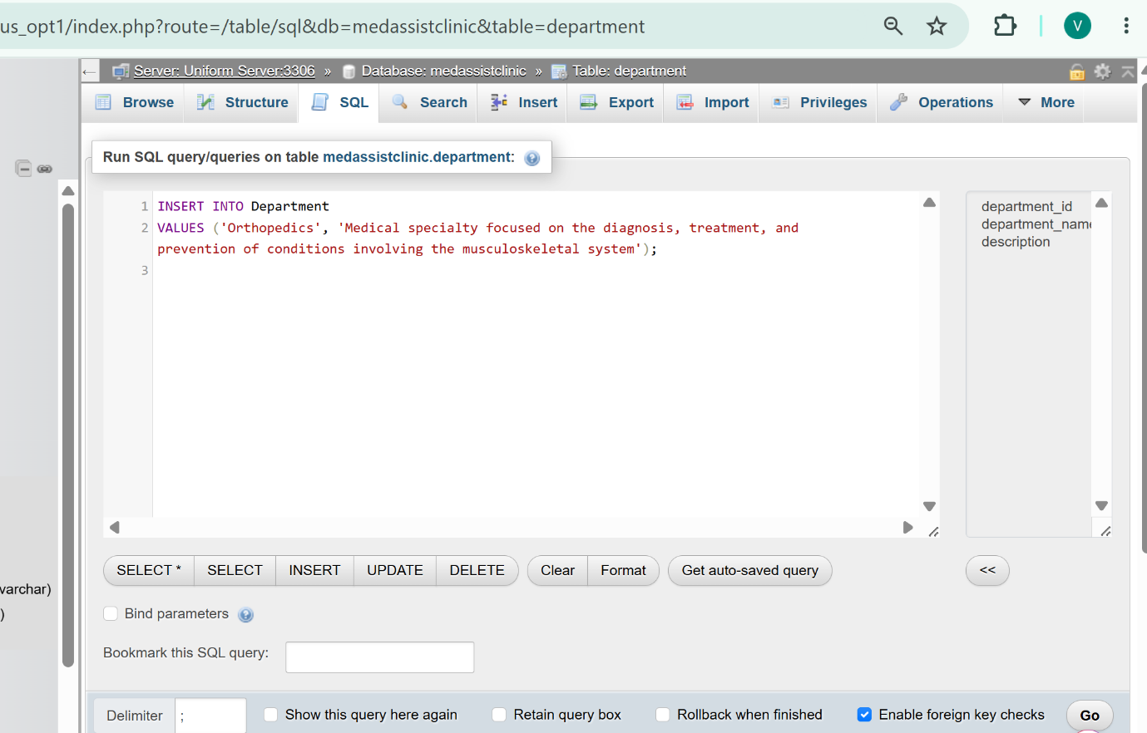

And results is:

MAClinic.html
<html>
<head>

</head>
<body>
<h2>Insert new row to Doctor Table: </h2>
<form method="POST" action="SentToMAC.php">
ID:
<input type="number" name="doctor_id"> <br/><br/>
First Name:
<input type="text" name="first_name"> <br/><br/>
Last Name:
<input type="text" name="last_name"> <br/><br/>
Speciality:
<input type="text" name="speciality"> <br/><br/>
Phone:
<input type="text" name="phone"> <br/><br/>
Email:
<input type="text" name="email"> <br/><br/>
Department:
<input type="number" name="Department_Id"> <br/><br/>

<input type="submit" value="Send to Database!"> <br/><br/>
</form>
</body>
</html>

SendToMAClinic.php

<?php

$host="localhost";
$user="root";
$pass="root";
$db="medassistclinic";
// Connect to the MySQL database
$conn = new mysqli($host, $user, $pass, $db);
// Check the connection
if ($conn->connect_error) {
die("Connection failed: ".$conn->connect_error);
}
if ($_SERVER["REQUEST_METHOD"] == "POST")
{
$ID = $_POST["doctor_id"];
$firstname = $_POST["first_name"];
$lasttname = $_POST["last_name"];
$speciality = $_POST["speciality"];
$phone = $_POST["phone"];
$email = $_POST["email"];
$department = $_POST["department_id"];

$sql = "Insert into Doctor values ('$ID','$firstname','$lasttname','$speciality','$phone','$email','$department')";
if ($conn->query($sql) === TRUE) {
echo "New record created successfully";
} else {
echo "Error: " . $sql . "<br>" . $conn->error;
}

}
else
{
echo "Please submit the form first.";
}

$conn->close();

?>

ViewDatabaseDoctor.php

<?php
$host="localhost";
$user="root";
$pass="root";
$db="MAClinic";
// Connect to the MySQL database
$conn = new mysqli($host, $user, $pass, $db);

// Check the connection
if ($conn->connect_error) {
die("Connection failed: ".$conn->connect_error);
}

// Query the table
$sql = "SELECT * FROM Doctor";
$result = $conn->query($sql);
// Display the results
if ($result->num_rows > 0) {
echo "<h2>Doctor Table</h2><table border='1'><tr><th>ID</th><th>Firt_Name</th><th>Last_Name</th><th>Speciality</th><th>Phone</th></tr><th>Email</th><th>Department</th>";
while ($row = $result->fetch_assoc()) {

echo "<tr><td>".$row["doctor_Id"]."</td><td>".$row["first_name"]."</td><td>".$row["last_name"]."</td></tr>".$row["speciality"]."</td></tr>".$row["phone"]."</td></tr>".$row["email"]."</td></tr>".$row["department_id"]."</td></tr>";

}
echo "</table>";
} else {
echo "No records found.";
}

$conn->close();
?>

Insert a new record refer to Doctor
befor
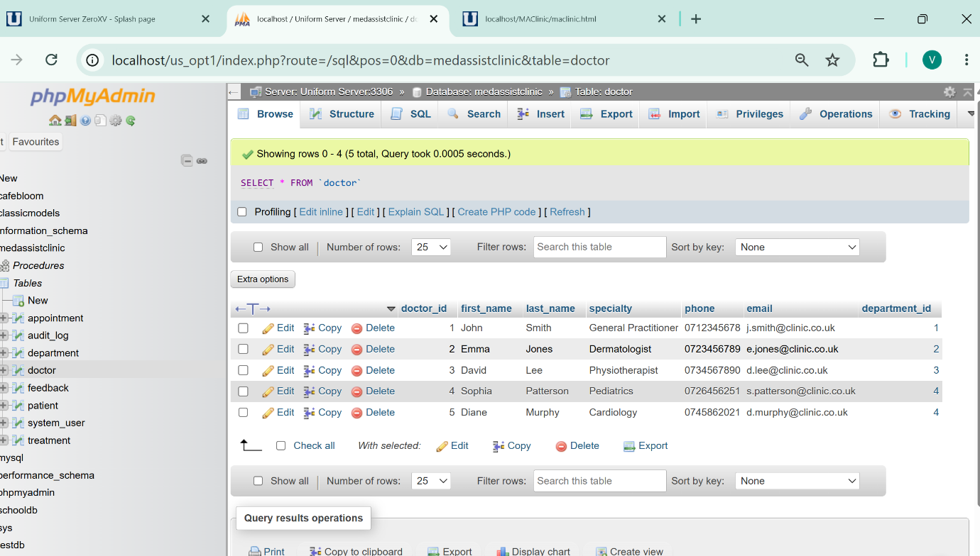

After insertion
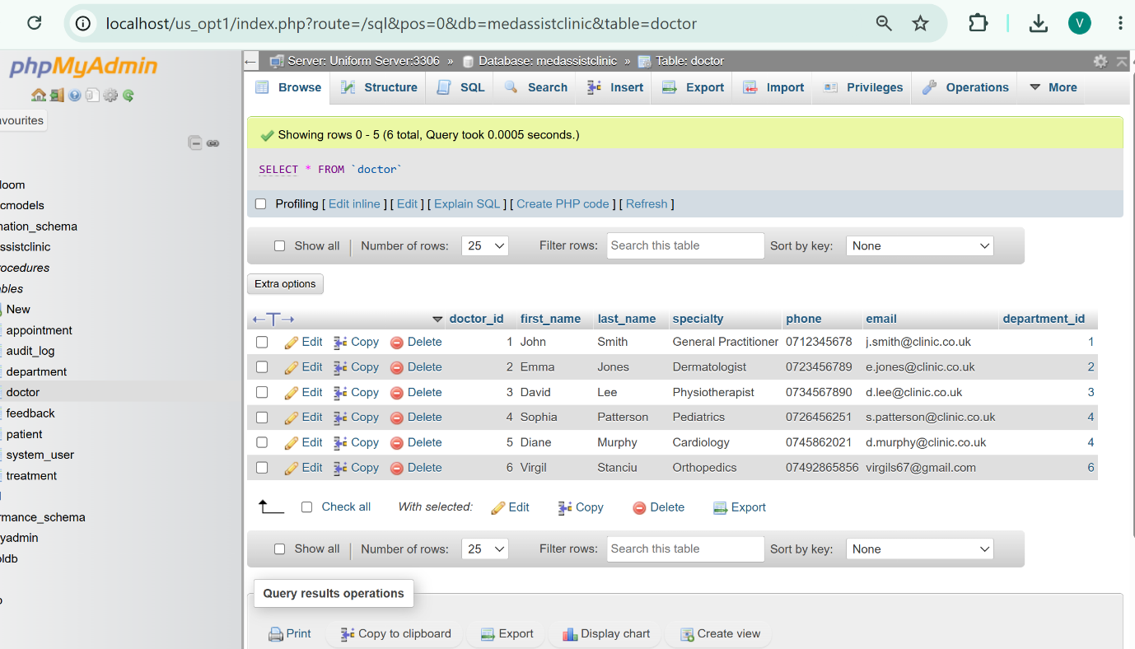

SQL Injection (SQLi)

Is a critical web security vulnerability that allows an attacker to interfere with the database queries an application makes. It occurs when user input is inserted directly into SQL statements without proper sanitization or escaping, enabling an attacker to alter the query logic, view data they cannot normally retrieve, modify, or delete database content, and in some cases take over the server.

SQLi is one of the oldest, most common, and most dangerous web vulnerabilities. It is a problem because:
- **Data Breach**: Attackers can extract sensitive data such as usernames, passwords, personal details, medical records, or credit card information.
- **Data Loss or Corruption**: Attackers can issue `DELETE`, `DROP`, or `UPDATE` commands to destroy or alter the database.
- **Authentication Bypass**: Attackers can log in without knowing valid credentials by manipulating login queries.
- **System Compromise**: In some configurations, successful SQLi can lead to remote code execution on the web server.

Potential Weaknesses & Improvements

Potential areas for improvement include:
- Dynamic column/table names: If the code ever allows users to choose column names dynamically (e.g., sort by name/date), placeholders cannot be used for identifiers, in such cases, strict whitelisting of allowed values would be required.
- Role-based permission enforcement: Currently any logged-in user can edit or delete records; production code should check `$_SESSION['role']` to restrict actions (e.g., only admins may delete).
- Rate limiting and input length limits: Login and search forms could be protected against brute-force and overly long inputs.

