Name: Nurjahan Begum
Student number: 1912210
Master of Business Administration
Human resource management
Task one: individual report
Module code: LCMB 7000
Lecturer: Professor Dennis Pepple

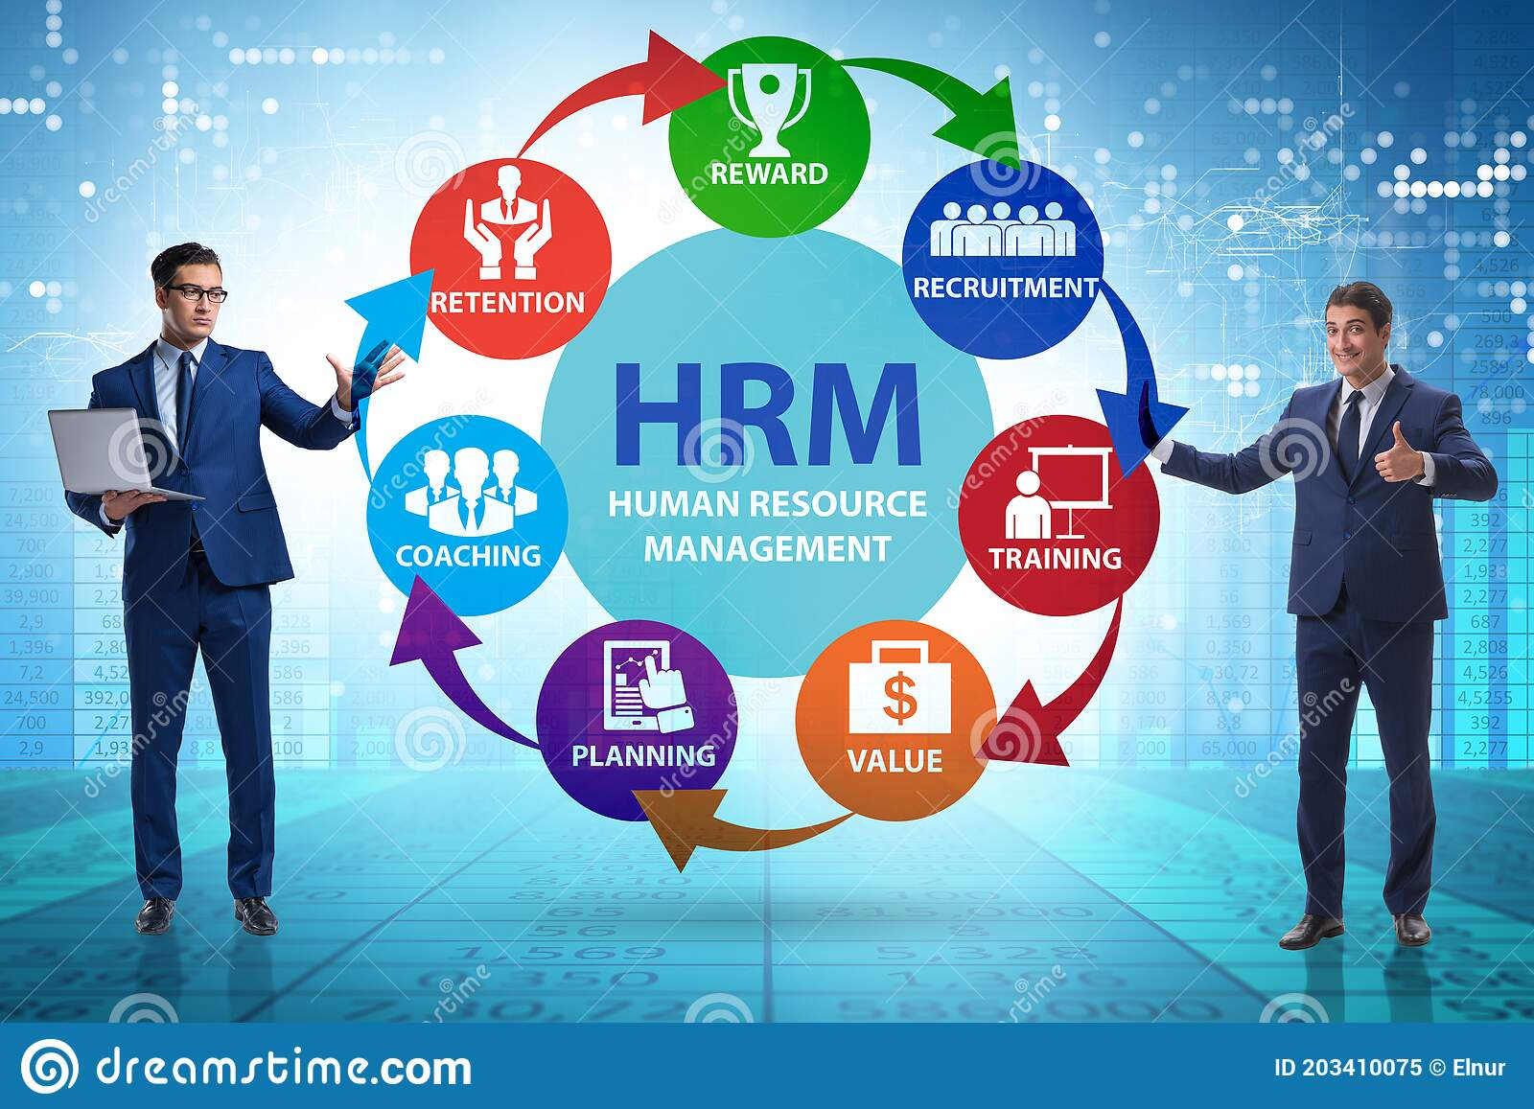
Source: Dreamstime, (2023)

Contents
1: Introduction…......................................................
2.0: An assessment of how the roles of HR (Human Resources) have evolved over time: .....................
2.1: Personal management roles and functions: ................................................................
2.3: Sustainable HRM roles and functions: ......................................................................
3: An assessment of how the context is influencing the global adoption of sustainable HRM................................................................................
4: An examination of the sustainability agenda's viability........................
5: Conclusion..........…....................................... .............
6.Personal reflection
7: References.................................................................
8: Appendix...............................................................
(1) Introduction
(Mohiuddin et al 2022) is adamant that sustainable human resource management (HRM) is important for developing a successful organisational culture, job security, health promotion, flexibility, participatory leadership, sustainable competitive advantage, a value-added economy, self-responsibility, and work-life balance.
Human resource management (HRM) topic is important to me because I would like to follow onto the career path of human resource management and find employment in this area of HR. To enable my future goal to progress I would like to be able to understand and learn more about the development of HRM strategic techniques on how to recruit, train, and develop workers, an essential asset for an organization and their goals. As a learner I feel I could master the key traits of a good hiring manager through the learning of this module of HRM. I believe a written report and reflection will further my knowledge and gaps that need filling in order for me to fully understand and gain the necessary skills. And techniques to become a HR manager. I will be authoring a report and evaluating on four key areas such as, how the roles of HR has changed overtime, how context is affecting the implementation of sustainable HRM globally, a critical discussion on how to sustain the sustainability agenda and my final part of my report will be finalised through a conclusion and my own personal reflection.
. 192

(2.0) An assessment of how the roles of HR have evolved over time.

According to (Piwowar, 2021) the definition of sustainable human resources management is "adoption of HRM strategies and practises that aid in the success of financial, social, and ecological goals, with an impact in the inner and outer part of the organisation and over a long period of time,while controlling for unintended side effects and bad response" (Ehnert, Parsa, Roper, Wagner, & Muller-Camen, 2016, p. 90).

According to Cross & Swatt (2022), there have been significant changes in the workplace (Cappelli & Keller, 2013). (2017) Spreitzer et al. In the face of technological disruption, globalisation, and demographic changes, organisational boundaries are shifting, organisational forms are getting more diverse, and people are picking to work at whole different level. (Kalleberg, 2009). 2014 (Swart & Kinnie). But concerns have arised that the HR industry is not developing quickly enough to keep up with the complexity of the environment, for instance HR is just one form in a network or ecosystem of stakeholders (Butterick & Charlwood, 2021; Camuffo & De Stefano, 2019; Harney & Collings, 2021; Kinnie & Swart, 2020). 2019 (Snell & Morris).

According to Hamouche (2021), COVID-19 was an uncommon health disaster that severely affected the entire planet and sent it into a state of intense uneasiness and unease. Communities, economies, workers, and organisations have all been significantly impacted. hence making it challenging for managers and human resource management (HRM) specialists to offer original results to sustain survival within the firms and support workers in coping with this exceptional issue.67
According to Przytula et al. (2020), COVID-19 is a global external factor that compelled HR organisation practises to move quickly and, in summary, embrace new guidelines, policies, and tools to aid workers in adapting to the changing environment while also pursuing corporate goals. A task that would have taken them years to complete was completed in a matter of months: all the plans and tactics that had been developed even a year before to the pandemic had to be amended, altered, and reshaped. Most importantly, HR must put in place plans to keep employees motivated, engaged, and productive. The future of work will be influenced by a wide range of factors. There will be some unanticipated adjustments. Others are anticipated and envisioned. These include environmental factors, social changes, automation, and artificial intelligence. improvements in technology and the workplace. These components interact and merge; they are not independent of one another. 136
Furthermore, HRM has distinct roles, and these roles of HR department has changed and evolved. The expansion of the Labor Union (1790) was a crucial development in the Industrial Revolution. The employees who worked in factories or industries had to put in a lot of overtime for very little pay. Workers began protesting around the world as unrest grew, which prompted the creation of labour organisations. The Industrial Relations Department was created as a result of the Personnel Management Department's need for political and diplomatic skills to deal with management difficulties at one end of the spectrum and labour issues at the other. Below a timeline of the time that gave HRM a completely new meaning and significanceIs presented below, 107
According to Obedgiu (2017), the Chartered Institute of Personnel and Development, known to be the number one professional human resource associations, which established itself in England in 1913 as the Welfare Workers' Association. A decade later, it changed its name to the Institute of Industrial Welfare Workers, and then a decade later was known as Institute of Labor Management. (CIPD, 2011). Similarly, in the United States, Cornell University established the School of Industrial and Labor Relations in 1945, known as the number one institution of higher learning in the world devoted to workplace studies (Cornell, 2010). The number of union members fell precipitously in the second half of the 20th century, but workforce management continued to gain power within businesses. Many businesses started making reference to the field as personnel administration, while the terms "industrial relations" and "labour relations" was referenced to concerns involving collective representation. The American Society for Personnel Administration (ASPA), which would later grow to become the largest professional human resource group, was established in 1948. (SHRM, 2011). Communications and transportation developments in the twenty-first century made it easier for workers to move around and collaborate. Employees were no longer seen by businesses as simply cogs in the machine, but as assets. As a result, the term "human resources management" (HRM) became widely used to refer to the role; in 1998, ASPA even changed its original name to SHRM (SHRM, 2011). 220
End of the 1990s saw the emergence of sustainable HRM in Germany [60], Switzerland [41,61], and Australia [62]. In the German approach, which was established in the context of sustainable resource management, organisations are referred to as open systems, resource-dependent systems that "depend on a steady influx of resources to be alive, serve their purposes, and achieve their goals" [14]. (p. 54). This method is based on an interpretation of sustainability that considers economic considerations, arguing that since environments are "sources of resources," it is economically sensible for businesses to invest in relationships with them in order to balance the consumption and reproduction of human resources. Based on this comprehension, it should come as no surprise that Müller-Christ and Remer [60] defined Sustainable HRM is "what enterprises themselves have to do in their contexts to have durable access," according to Müller-Christ and Remer [60].
(Stankevičiūtė, Ž.& Savanevičienė, A,2018), towards the end of the 1990s, sustainable HRM emerged in Germany [60], Switzerland [41,61], and Australia [62]. Under the German method, which known to be made in the context of sustainable resource management, organisations are referred to as open systems, resource-dependent systems that "depend on a steady influx of resources to be live, succeed in their purposes, and achieve the objective [14]. (p. 54). This strategy is based upon interpretation of sustainability which considers economic considerations, contending that since environments are "sources of resources," it is economically sensible for businesses to invest in relationships with them in order to balance the consumption and reproduction of human resources. The definition of sustainable HRM by Müller-Christ and Remer [60] to what enterprise done by themselves in their settings to have durable access to talented human resources" follows naturally from this concept (p. 76). (Stankeviit & Savanevien, 2018). .121
(2.1) Personal management roles and key functions:
Ahammad (2017) asserts that the history of people management began with the emergence of welfare officers, often known as "welfare secretaries," towards the close of the 19th century. They were female and primarily interested in the safety of ladies and little girls. Their development was a response to the harshness of the industrial environment, as well as demands from the expansion of the franchise, the labour movement's influence, and the campaigns of progressive employers, sometimes Quakers, for what was referred to as "industrial betterment."
According to Mackinova et al. (2015), human resource management is complemented by features of management of personnel, such as the manager's character, effective communication, dispute resolution, praise, criticism, and team building. Duties of personnel management include:
- Personal marketing
- Personnel strategy and planning
- Staffing
- social consensus
- Career advancement (Gladkij et al., 2003). 140

(2.2) Sustainable HRM roles and functions
According to Paramedicine and Stankeviciute (2014), "Sustainable HRM is known to be a pattern of planned or developing HR policies and practises intended to enable the attainment of financial, social, and ecological goals while simultaneously reproducing the HR base over a long duration." It aims to reduce the negative effects on the environment, people, and communities, and it recognises the crucial facilitative role played by CEOs, middle and line managers, HRM specialists, and staff members in delivering messages that are distinctive, consistent, and reflect consensus among decision-makers (p.1084).
According to Paramedicine and Stankeviciute (2014), Sustainable HRM is a form of a planned or evolving HR policies and practises designed to facilitate the acquirement of financial, social, and ecological goals while also replicating the HR base over an extended period of time. It recognises the crucial facilitative role played by CEOs, middle and line managers, HRM specialists, and staff members in delivering information which would be quite distinctive, regular, and reflect agreement upon all that is needed to make a decision. It aims to reduce the negative effects on the environment, (p.1084)
.3.0 Starbucks HR in Singapore
Starbucks Company is a coffee company and chain of coffee shops in the United States. Starbucks opened in Seattle, Washington, in 1971. The organisation is known to control 28,218 sites globally around 2018. (Sakal, 2018). Starbucks stores sell a wide range of drinks, including hot and cold drinks, whole-bean coffee, instant coffee, espresso, teas, and other beverages.
Jerry Baldwin, Gordon Bowker, and Zev Siegl established Starbucks, which debuted its first location in Seattle in 1971. But Starbucks was eventually sold to Howard Schultz in the 1980s. One person, one cup, and one neighbourhood at a time: that is the Starbucks mission: to inspire and nurture the human spirit. During this period (Starbucks) is known to be the world's largest roaster and retailer of special coffee, with more than 32,000 locations in 80 countries.” And with each cup, we work to both honour our history and deliver a remarkable experience.”
According to Liew, (2022), "We are in the people business selling coffee and human interaction is the answer to everything - we passionately believe in investing in our people," said Patrick Kwok, general manager of Starbucks Singapore, to HRM Asia. going above and beyond to strengthen relationships and encourage open, honest communication, which is a cornerstone of the welcoming environment we try to foster. They use the HRM techniques indicated below.
- To allow employees to take time off to promote charitable causes and spend time with their families and loved ones, Starbucks Singapore offers CSR parental leave, family care leave, and National Service (NS) leave. To promote and emphasise the importance of balancing work and personal life, this is done.

- encourages staff well-being, In order to reflect the purpose, beliefs, and culture of the firm, Starbucks Singapore periodically examines and improves its staff engagement policy.(Liew,2022).

- Starbucks Singapore has implemented additional initiatives to increase employee morale and retention, such as using technology to cut back on manual tasks and duplication of effort.
- The fundamental medical benefits of Starbucks Singapore have been expanded to include more mental wellness programmes, and the business intends to educate and certify managers to provide peer and staff members with mental health support.
- (Liew, 2022)235
3.2 Starbucks HR in China
Planning human resources: Starbucks' China headquarters uses a strategic control strategy and a combined production and sales business model to strengthen the brand and guarantee output. Starbucks sells products as an exclusive agent. The development of models is utilised annually to forecast staff needs by producing precise calculations and expert experience estimates.
(2) The organisation uses campus recruiting, social recruitment, internal employee referral, among other methods, for allocation and recruitment. Campus recruiting carries out management training programmes, and regular employee positions are paired with social recruitment to advance employees to the post of deputy store manager in a year's time.so that all workers need are satisfied, which is directed by the inner staff.
(3) Training and development: Within the first month of employment, new hires will get a minimum of 96 hours of training. Corporate culture, a variety of job abilities, and customer service skills are all included in the training projects. There are also specific management training programmes that provide in-depth instruction for leadership and service levels.
(4) Performance management involves conducting regular performance reviews and giving back a response, setting ambitious acheivements and finding a different avenue to boost partners instinctive, imagination, utilising performance management tools to support management, and inspiring and motivating partners and group memebers to meet the required performance indicators.
(5) Pay and benefits administration: For full-time or part-time employees who match the necessary criteria, Starbucks (China) offers a variety of preferential items, including health and disability insurance. Also, it aids staff in resolving issues with their families. Comparatively speaking to other businesses, Starbucks employs part-timers. Despite having high input costs, Starbucks now has a comparatively low average welfare cost as compared to its rivals, (Xu,2020).
Starbucks HRM in the UK (United Kingdom)

(4) An examination of the sustainability agenda's viability

Personal Reflection
Before enrolling in this module in human resource management, I had little experience with HRM. The only thing I knew about HRM was that it supported workers in the workplace, and I assumed that was about all that they did. Nevertheless, I have since discovered that the HR department is one of the most crucial elements of any business and is in charge of matters such as labour and employee relations, compensation and benefits, workplace safety and health, and talent development. I discovered that the human resources division consists of a wide range of specialised functions, including hiring and selection, training and development, performance management, payroll, and so forth. Also, it greatly aids in achieving business objectives by attracting and retaining talented employees. I also learned that staff tastes and trends are constantly shifting.therfore HR must come up with fresh ideas to accomadate the changes.
My analysis has lead me to understand that recruiting in the modern world lays emphasis on technology. HR technology aids in workforce administration, enhance workforce management, and recruiting, retaining, and enhancing workers and giving managers the necessary tools needed for more knowledgeable decisions about HR. Now that I am aware of the type of reaction the recruiter is seeking, I will be better prepared for and able to react to interview questions thanks to the material I gained from this lesson. The knowledge I acquired from this module will be useful. I think I understand human resource management and how to motivate employees in a fair and efficient manner. Overall, I am confident that all the information of human resource management learnt from my lecture will aid in the path that I choose. My end report concludes that the knowledge and skills gained from this module will make me successful when an organisation chooses to recruite me, only then will I be able to perform my obligations and exercise my rights as an HR.

Conclusion
After analysing and evaluating HR i can conclude that to achieve a competitive edge over their rivals and accomplish their goals and objectives, organisations must manage their workforce effectively and efficiently. Human resources management is essential to this process. For an organisation to succeed, develop, expand, and grow on the global market, HRM practises must be put into place

References
Ahammad, T., (2017). Personnel management to human resource management (HRM): How HRM functions. Journal of Modern Accounting and Auditing, 13(9), pp.412-420.Available at:Personnel_Management_to_Human_Resource_Management_ (1).pdf (Accessed: 3rd February 2023).
CIPD (2021) Sustainable HR: a 'green' fad, or a realistic model for change? [Internet] Available at:Sustainable HR: a 'green' fad, or a realistic model for change? | CIPD(Accessed: 28th January 2022).
Cross, D. and Swart, J., (2022). The (ir) relevance of human resource management in independent work: Challenging assumptions. Human Resource Management Journal, 32(1), pp.232-246. [Google scholar} Available at:The (ir)relevance of human resource management in independent work: Challenging assumptions (wiley.com)(Accessed: 4th February 2023).
Dreams time (2023) [Internet image] Available at:https://www.dreamstime.com/hrm-human-resource-management-concept-businessman-hrm-human-resource-management-concept-businessman-image203410075 (Accessed:17^{th,} January 2023).
Hamouche, S. (2021) ‘Human resource management and the COVID-19 crisis: implications, challenges, opportunities, and future organizational directions’, Journal of management & organization, pp. 1–16. Available at: https://doi.org/10.1017/jmo.2021.15.
HRDictionaryblog.com, Evolution of human resource management [ Internet image] Available at:Evolution of Human Resource Management – HRDictionary (hrdictionaryblog.com) (Accessed: 10th February 2023).
Katarzyna,Piwowar-Sulej,(2021) Core functions of Sustainable Human Resource Management. A hybrid literature review with the use of H-Classics methodology. Available at:.Core functions of Sustainable Human Resource Management. A hybrid literature review with the use of H‐Classics methodology - Piwowar‐Sulej - 2021 - Sustainable Development - Wiley Online Library (Accessed: 14th February 2023).
Shawn Liew, (2022) HRM Asia, Starbucks brews up work-life integration [Internet] Available at:Starbucks brews up work-life integration | HRM Asia : HRM Asia (Accessed: 16th February 2022).
Mackinova, M., Slovak, P. and Keketiova, J., 2015. Personal Management in Social Care in the Slovak Republic. [Google scholar] Available at: IMR XI.pdf (unios.hr) (Accessed: 12th February 2023).
Mohiuddin, M., Hosseini, E., Faradonbeh, S. B., & Sabokro, M. (2022). Achieving Human Resource Management Sustainability in Universities. International Journal of Environmental Research and Public Health, 19(2), [internet article] Available at:https://doi.org/10.3390/ijerph19020928 Achieving Human Resource Management Sustainability in Universities - PMC (nih.gov) (Accessed: 29th January 2023)
Obedgiu, V., 2017. Human resource management, historical perspectives, evolution, and professional development. Journal of Management Development [Google scholar]. Available at:Human resource management, historical perspectives, evolution and professional development (e-tarjome.com) (Accessed: 6th^{th} February 2023).
OECD (2017) future of work and skills, [internet] Available at: https://www.oecd.org/els/emp/wcms_556984.pdf (Accessed: 3rd January 2023
Piwowar-Sulej, K. (2021) Core functions of Sustainable Human Resource Management. A hybrid literature review with the use of H-Classics methodology. Sustainable Development. 2021; 29: 671– 693. [google scholar] available at: https://doi.org/10.1002/sd.2166 (Accessed: 27th January 2023).
Piwowar-Sulej, K. (2021) Core functions of Sustainable Human Resource Management. A hybrid literature review with the use of H-Classics methodology. Sustainable Development. 2021; 29: 671– 693. [google scholar] available at: https://doi.org/10.1002/sd.2166 (Accessed: 27th January 2023).
Thomas (2015) evolution of HRM [internet image] Available at:Evolution of HRM | anjuthomas@bims (wordpress.com) (Accessed: 27^{th,} January 2023)
Przytula, S., Strzelec, G. and Krysińska-Kościańska, K., 2020. Re-vision of future trends in human resource management (HRM) after COVID-19. Journal of Intercultural Management, 12(4), pp.70-90. [Google scholar] Available at:Przytula_Strzelec_Krysinska-Koscianska_Re-vision_Of_Future_Trends.pdf (Accessed: 10th February 2023).
Sakal, D.V., 2018. Company analysis of Starbucks Corporation. [Google scholar] Available at:Starbucks-Company-Analysis.pdf (finance.hr) (Accessed: 17th February 2023).

Savaneviciene,A. & Stankeviciute,Z (2014). THE DISCLOSURE OF SUSTAINABILITY AND HUMAN RESOURCE MANAGEMENT LINKAGE. Human Resources Management & Ergonomics, 8(1).9 [google scholar] Available at:2014_1_07.pdf (uniza.sk) (Accessed: 27th January 2022)
Stankevičiūtė, Ž. and Savanevičienė, A, [2018]. Designing sustainable HRM: The core characteristics of emerging field. Sustainability, 10(12), p.4798.[Google scholar] Sustainability | Free Full-Text | Designing Sustainable HRM: The Core Characteristics of Emerging Field (mdpi.com)(Accessed: (28th January 2023).
Stankevičiūtė, Ž. and Savanevičienė, A, [2018]. Designing sustainable HRM: The core characteristics of emerging field. Sustainability, 10(12), p.4798.[Google scholar] Sustainability | Free Full-Text | Designing Sustainable HRM: The Core Characteristics of Emerging Field (mdpi.com)(Accessed:(28th January 2023).
Starbucks, learn about our history, Available at: About Us | Starbucks [Internet] (Accessed: 17th February 2023).
Thomas, (2015) evolution of HRM [internet image] Available at:Evolution of HRM | anjuthomas@bims (wordpress.com) (Accessed: 27^{th,} January 2023)
Živile Stankeviciute & Asta Savaneviciene (2018) Designing Sustainable HRM: The Core Characteristics of Emerging Field, [Internet article] Available at: sustainability-10-04798 (3).pdf (Accessed:5th February 2023).
Mashala, Y.L. (2018a) 'Green human resource management and environmental sustainability in Tanzania: A review and research agenda', International Journal of Academic Multidisciplinary Research, 2(12), pp. 60-68. Available at:
https://www.researchgate.net/profile/MashalaYusuph/publication/332607647_Green_Human_Resource_Management_and_Environmental_Sustainability_in_Tanzania_A_Review_and_Research_Agenda/links/5cc0553a299bf120977c54ee/Gree (Accessed:

Xu, D., 2020. Cross-cultural Human Resource Management Research by the Case of Starbucks (China). Academic Journal of Humanities & Social Sciences, 3(9), pp.132-141. [Google scholar] Available at:https://www.researchgate.net/profile/Dongpeng-Xu/publication/345974079_Crosscultural_Human_Resource_Management_Research_by_the_Case_of_Starbucks_China/links/6154a14c14d (Accessed: 17th February 2023).

Appendix:

Figure:
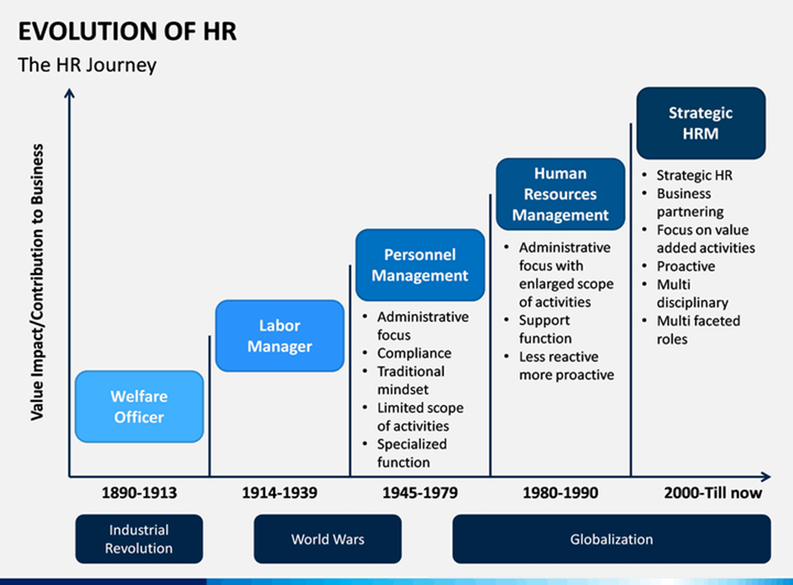
Source:

