Module Title: Academic and Employability Skills
Module Code: BMSW4001
Student Name: Somota Torofdar
Student ID:1818669
Sylvia Hoffman

Table of Contents
Introduction 1
Learnings throughout the term 2
Writing a cover letter 2
Writing a CV 2
Public speaking and presentation 3
Challenges I had to overcome 4
How I would use these experiences in future 5
Conclusion 6
Appendex 1 7
References……………………………………………………………………………. 9

Introduction
I will be writing my personal experiences and the events that took place during completing a task is called reflective writing. Reflective writing includes analysis of both real and imaginary situations and discusses the ways the job has helped the person in terms of leanings and understandings (Buck, 2013). In this assignment, I will focus on the leanings I had during the completion of the module employability and academic skills. I will focus on three skills those I learnt during this term which is writing a cover letter, writing a CV, and public speaking and presentation.

Leanings throughout the term
I have learnt many things throughout this term. Those have helped me develop an understanding of the workplaces and how the workplaces need those skills. I had the basics of some of those skills. Some skills were fully new to me. Among those skills, I will discuss the development of three skills in myself and how those helped me develop my employability skills.

Writing a cover letter
A cover letter is a statement which is attached with a CV or a resume in the of sending it to an employer. A cover letter includes an introduction, basic information, objectives, and motivation of the applicant. A cover letter is also known as a motivation letter or letter of motivation because it depicts the reason a person is motivated to apply for a certain post (Bennet, 2014). Throughout this term, I have developed a good understanding of the cover letter. I have learnt the basics and things to avoid while writing a cover letter. A cover letter bears importance to an employer if that is asked for. During writing a cover letter, I have to the company in what ways I can help them. I need to talk about the skills I have. I have to bear in mind that only the relevant skills are to be mentioned in the letter. This customisation has to be well-aligning with the job requirements. In the cover letter, I have to be honest and should not add any made-up things. A peer review can make the cover letter better for the applicant. Alongside this, I have also learnt what I should not do during preparing a cover letter. A common mistake during writing a cover letter is repeating the resume. The cover letter should not be a wordy one and include everything that is given in the CV. Rather it should include things that are not in the CV. The presentation should be in a way which would help the employer understand within a glance. Grammatical errors are strictly unacceptable in a cover letter. This creates a negative impression of the applicant (Gallo, 2014). Also, I should not present any excuse for the skills I do not have. The cover letter must not be too long. Also, all these have to be written in simple words.

Writing a CV
The CV stands for curriculum vitae which is a Latin word for 'course of life'. A CV is an overall record of a person in terms of career. In a CV, an overview of the skills, achievements, education, career choices is included. It is a complete record of someone's career (Innes, 2012). It is used by an applicant when approaching an employer for a job. Though I had the basics of preparing a CV, during this term I learnt relevant things regarding a CV. This includes how I can be short yet sufficient in terms of words in the CV and impress the employers. I learnt things that I need to follow while preparing a CV and those I must avoid. The first lesson regarding a CV is making it within 2 pages. It must not exceed 2 pages. The CV has to be customized according to the job I am applying for. I have to put only those skills which are relevant. The CV has to be made using the right CV format. The right font has to be used in the CV. The CV should not look messy . The claims have to be supported by specifics. The professional qualifications have to be included. The first thing to avoid in a CV is lying. Irrelevant information should not be included in the CV. No reference should be included which are unnecessary in nature. Also, there is no necessity of explaining the gaps in work history (Gallegher, 2010). As a rule of thumb, all grammatical mistakes have to be avoided.

Public speaking and presentation
Public speaking is the task of delivering a speech in front of the audience. This has to be a live speech. Public speaking is a must-have skill in today's workplaces. A very good public speaking skill is an indicator of very good communication skill. Public speaking and presentations have been very demanding skills for people who are looking for a job nowadays (Chen, 2014). Before getting before the audience, I need to understand my audiences and their knowledge level. I should plan my speech before the speech. In a public speech, I should try to tell a story to the audience to grab their undivided attention. The speech should start and end within the allotted time. Also, the speaker should not try anything out of the ordinary. Rather being a natural speaker helps more. I should not read out the slides during the presentation (Beebe, 2010). I must not use too much animation in the slides. Using jargon to impress the audiences is not a good idea for the speaker. I should not rush during a presentation. There should not be too many fonts in the slides. The slides should be as simple as possible. During this term, I have developed my public speaking and presentation skills. This has increased my level of understanding regarding this skill. I had a few problems regarding public speaking before this term. But completing this term, I have overcome most of those shortcomings. I hope to overcome the rest of the shortcomings in a short time. The overall employability skills also increased since it boosted my confidence regarding developing a skill.

Challenges I had to overcome
The leanings and understanding of different skills did not come without any struggle. I faced some challenges during the term and completion of task 1. But the challenges were not tough enough to stop me from where I am standing now. So, I was able to overcome all the challenges. The challenges I faced during learning and working on the assignment on academic and employability skills are as follows:
- I was having problems regarding public speaking and presentations. Though I could understand all the lessons on public speaking and presentation, I could not apply that knowledge since I get nervous in front of audiences at times forgetting to breathe!! Or taking it slow, which made delivering a presenting an natural speech hard.
- While working on cover letter and CV, I could not distinguish the importance of a cover letters. I find myself putting less information in covering letters and find it hard to sale myself. C.V I understood easily but cover letters not so much. Also, I made some additional mistakes that I mentioned in the previous section.
3.Making an action plan for my personal development was not an easy task. I had to estimate time limits to achieve those skills being a mother of three this was new and challenging. It was difficult for a student to estimate a time limit to develop some skills. Because the nature of the skills has a direct impact on the time needed. This also took some time and effort from me.
- In the assignment, I had to find relevant published articles to have a theoretical base. I started looking for those in various online sources. But I had to wait to have articles those are both relevant and accessible.
- The skill of critical thinking was completely new to me at the beginning of the term. First, I could not catch up with some terms and lessons which was provided regarding this. An abstract and soft skill like this is always quite challenging in the first few days especially for someone like me who has return to studying after many years .

How I would use these experiences in future
I would use this leanings and experiences in future if a similar situation comes. The way I would use those are as follows:
- Planning presentations: Before a presentation, I will plan everything I would do during the presentation. The story I will tell, the time I will take, the time each slide would take, the possible questions I might face will be planned and worked out before the presentation. This will make the presentation more lively and engaging. Also, this would reduce the possibility of anything going wrong.
- Drafting assignments: When starting an assignment, I will read all the instructions and the guidelines carefully. This would develop a clear understanding of the report and what I am supposed to do. Every content that is needed to be included in the assignment has to be thought and planned. Also, the type of literature necessary should be planned before starting an assignment. I will plan the contents with the words I want to put in every section of the assignment.
- Reviewing CV and cover letter: Before sending a cover letter or a CV, I will ensure that the CV or the cover letter is peer-reviewed. This would reduce the chance of any mistake going unnoticed. Peer reviewing is a very effective solution to errors regarding a CV or a cover letter. Sending a CV or a cover letter with errors will have a negative impression on the employers' mind.
- Setting goals: Before starting any plan for developing skills, I will make an overall goal for that. I will try and understand what I want to learn and what outcomes I want from the that. Breaking the task into small section and taking my time to understand what I want to achieve and gain. This would make the tasks more clearly to me.

Conclusion
The leanings and the challenges during this term have increased the employability of me. Because with these challenges, I have learnt how to overcome those. I have learnt systematic approaches to develop a new skill. I can carry these leanings and approaches to the next phases of my academic and professional life. I will learn more things which I have not learnt but I have hints and understanding of how those are needed to increase employability skills.

Appendix 1
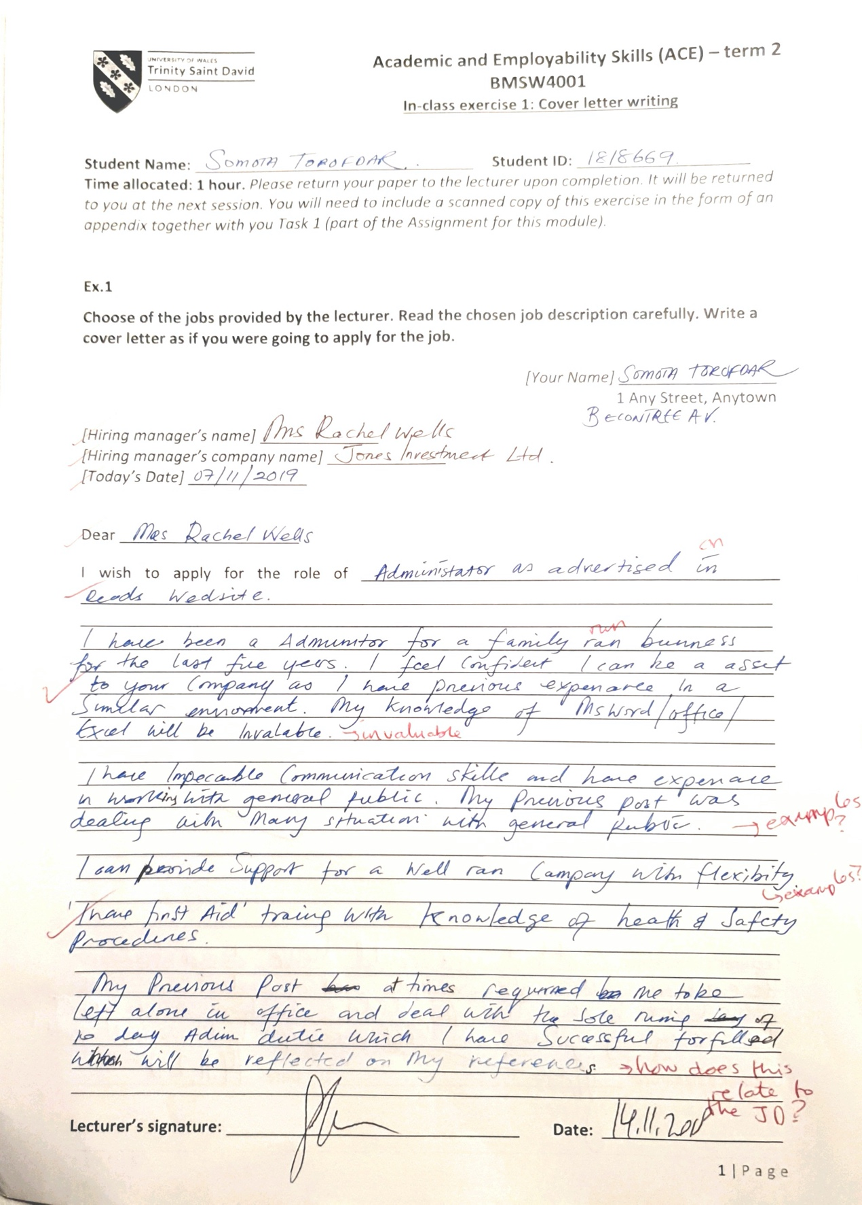

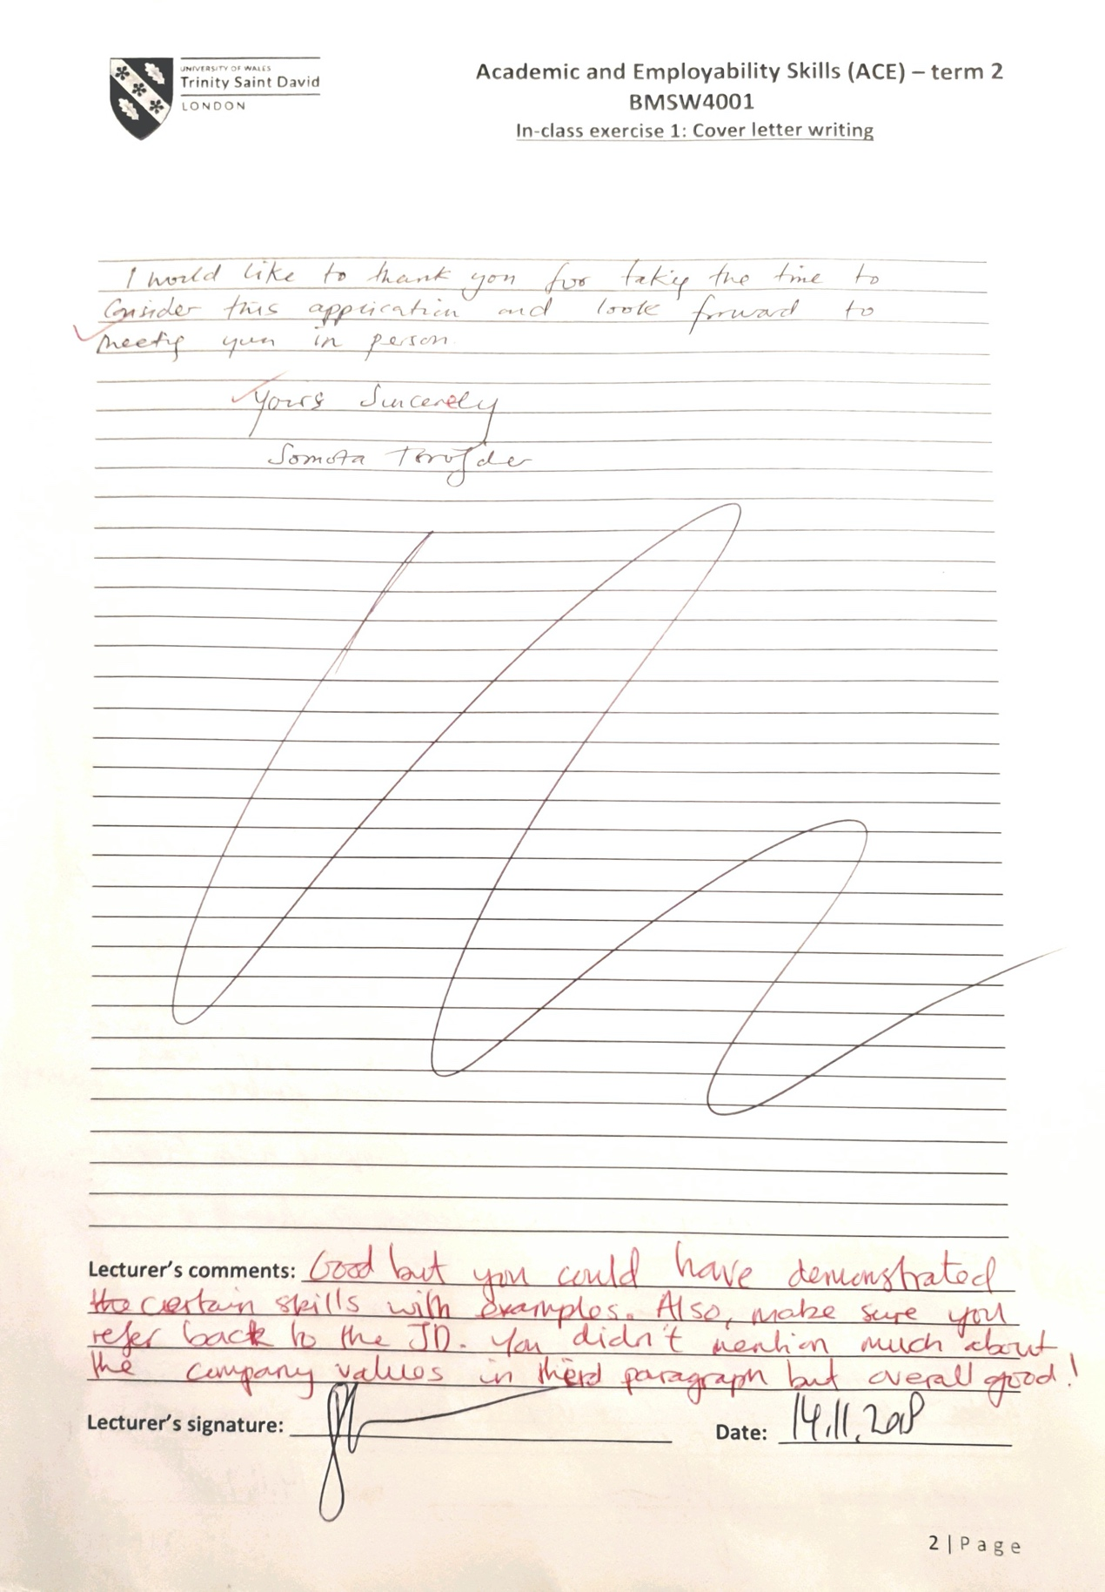

References
Beebe, S. A., & Beebe, S. J. (2010). Public speaking handbook. Allyn & Bacon.
Bennett, S. (2014). The elements of résumé style: Essential rules for writing résumés and cover letters that work. Amacom.
Buck, A., Sobiechowska, P., & Winter, R. (2013). Professional experience and the investigative imagination: The art of reflective writing. Routledge.
Chen, L., Feng, G., Joe, J., Leong, C. W., Kitchen, C., & Lee, C. M. (2014). Towards automated assessment of public speaking skills using multimodal cues. In Proceedings of the 16th International Conference on Multimodal Interaction. ACM.
Gallagher, J. C., & Wodlinger Jackson, A. M. (2010). How to write a curriculum vitae. American Journal of Health-System Pharmacy.
Gallo, A. (2014). How to write a cover letter. Harvard Business Review.
Innes, J. (2012). The CV Book 2nd edn: Your definitive guide to writing the perfect CV. Pearson UK.

