MODULE:
ACBA4001

ASSIGNMENT:

DOMESTIC NEW BUILD

AUTHOR:
MERYL LYNNE JONES

STUDENT NUMBER:
1810816

DATE:
30/04/2019

Contents

DOMESTIC NEW BUILD 1
QUESTION 1 3
FOUNDATION AND SUBSTRUCTURE 3
QUESTION 2 8
i) GROUND FLOOR DETAILING 8
ii) FIRST FLOOR DETAILING 11
iii) EAVES DETAILING & ROOF COVERING 13
iv) ROOF STRUCTURE 17
QUESTION 3 19
ROOF STRUCTURE – ATTIC TRUSSED RAFTERS 19
ROOF STRUCTURE – CUT ROOF 20
QUESTION 4 22
i) CONDENSATION – CAUSES AND SOURCES 22
ii) VENTILATION METHODS IN THE DWELLING 24
iii) REDUCING THE AMOUNT OF CONDENSATION IN THE DWELLING 34
References 35
Bibliography 36

QUESTION 1

FOUNDATION AND SUBSTRUCTURE

Findings:
Site investigations have been completed for this domestic new-build and a summary of the findings are:
- 450mm depth of topsoil
- Subsoil is firm with a low clay content
- Water table is below the subsoil

Based on these findings along with the knowledge of the dwelling’s specification and location, we will be able to determine the most suitable foundation and substructure.

Factors to consider for the foundations:
For low rise buildings, such as our project, the load will be considerably less than a high rise or heavy commercial use building.
Subsoils containing a high clay content, can expand considerably with water and shrink with lack of moisture, meaning the foundation on such soils would need to factor in such movement. However, the subsoil identified on our site, is firm with a low clay content indicating its ability to expand / shrink is minimal.
The investigations confirm that the subsoil is above the water table, meaning there is a higher risk of water penetration to the foundations applied. As long as this fact is known, appropriate remedies can be introduced to protect the integrity of the foundations.
Guidance on protection of water from the ground can be found in the British Standards document BS 8102:2009.
(British Standards, 2009)

Guidance on the structural design of low rise buildings can be found in British Standards document BS 8103-1:2011.
(British Standards, 2011)

Suggested foundations with substructure
I have identified 2 possible foundation styles for this project, which are suitable for the type of building and subsoil.
Both styles of foundation can have a waterproof membrane applied to them to protect them from water damage.
The leaves specification for this build is standard block and block cavity wall with partial fill cavity insulation.
Therefore, standard concrete blocks are to be used (dimensions 440x215x100mm) with a rigid 50mm insulation (taped at joints).
The total width of the substructure will be 310mm, made up as follows:
- 100mm block width of external leaf
- 60mm cavity width
- 50mm insulation width (adhered to internal leaf)
- 100mm block width of internal leaf

Foundation style 1:
CONCRETE STRIP FOUNDATIONS WITH BLOCK & BLOCK CAVITY WALL
Strip foundations are simple and traditional, along with being cost efficient.
A trench is excavated along the perimeter of the planned building, then filled with concrete. An advantage of this is style is that it is quick to fill with a low material cost for the concrete.
The depth of the concrete strip foundation, must be a minimum of 150mm in firm / non-hazardous soils and a maximum of 500mm. The width is to be twice the intended walls width. A disadvantage of this style is that there is the requirement for several courses of brick / blockwork to be erected below ground level, meaning higher labour and material costs.
(TheConstructor.org, 2019)

A sketch of a strip foundation with block and block leaves cross section is seen overleaf.

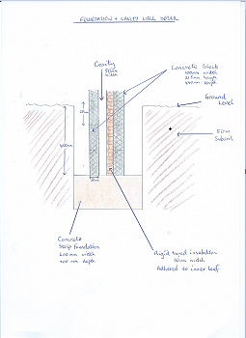

Foundation style 2 (Recommended due to time & cost efficiency):
CONCRETE TRENCH FILL FOUNDATIONS WITH BLOCK & BLOCK CAVITY WALL
Trench fill foundations are similar to strip foundations, where the foundation will run the perimeter of the building, but they are a deeper fill of 500mm minimum, up to 150mm below ground level.

With the foundation’s surface being closer to ground level, it negates the requirement for more courses of brick / blockwork to be erected below ground. This has an advantage of cost and time savings.

They require a narrower excavation because they do not need the width for bricklayers to erect courses that start a considerable depth below ground level. This is a safer working method by having narrower excavated areas as the trench will only be open for a short time before filled.
(Concrete.org.uk, 2019)

A sketch of a trench foundation cross section is seen overleaf.
(Greeno, 2016)

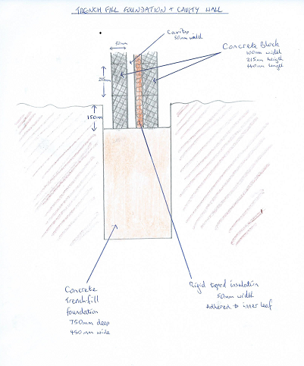

QUESTION 2

i) GROUND FLOOR DETAILING

The specification for the dwelling’s ground floor, is suspended timber.
Such specification means that there will be a void between the timber floor and the sub floor making it essential that ventilation is present.

Approved Document A of the Building Regulations is the relevant guidance for this part of the build. (Welsh Government, 2010)

The sub floor required is a concrete slab / oversite (to prevent any growth of organic items from subsoil), upon which ‘sleeper walls’ can be erected at regular intervals, to support the timber joists and will transfer the load. The sleeper walls will be standard bricks (215 x65 x 102.5mm).

In order to achieve ventilation in the void, ventilation bricks must be used in the inner and outer leaves, and the sleeper walls must be erected in a honeycomb style.

The span of the joists will be appropriate to their strength. A span table can be found in BS 8103. The joists will be fixed to the inner leaf by treated steel hangers. The joists themselves will be treated against rot and insect attack.
(British Standards, 2011)

Overleaf are sketches of a ground floor detailing the suspended timber joists, the sleeper walls, plus the inner & outer leaf.

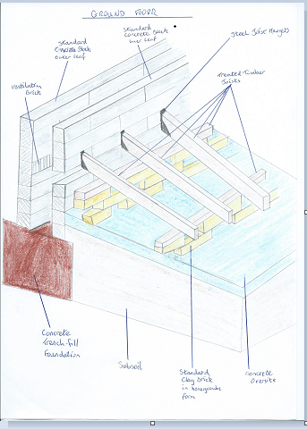
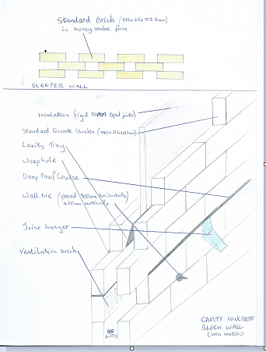

ii) FIRST FLOOR DETAILING

The specification for the dwelling’s first floor is solid timber with tongue & groove softwood flooring.

BS 8103-3:1996 is the Code of practice for timber floors and roofs for housing.
(British Standard, 2009)

First floor flooring joists will need additional bracing for rigidity to prevent movement and creaking.

Approved Document A of the Building Regulations is the relevant guidance for this part of the build. (Welsh Government, 2010)

The treated timber joists will be fixed to the internal block leaf using galvanised mild steel masonry supported joist hangers, measuring 100 x 2 x 75 mm. (BS EN 845-1 2013) Every fixing must be installed whether it be treated nail or screws. (British Standard, 2016)

Trimming joists will be required and fixed appropriately for the opening required for the stairs. (British Standards, 2011)

The first floor flooring spec is tongue and grove softwood. Such boards can be nailed or screwed directly onto the timber joists. They can then be sanded and stained, or an additional covering can be applied on top of them, such as underlay & carpet

A sketch of first floor solid timber joists adjoining the inner leaf, plus herringbone timber bracing (for stability) can be seen overleaf.

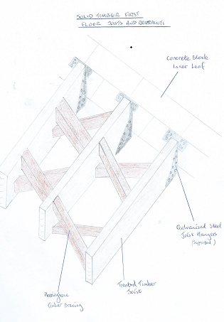

iii) EAVES DETAILING & ROOF COVERING

As the building has closed eaves, this means that the rafters that overhang the walls externally, are ‘boxed in’ meaning there is no opening where rafter meets wall. Open eaves can lead to nesting of birds / bats which can be detrimental to the building.
In order to achieve closed eaves, facia and soffit boards are needed. Essential ventilation of the roof space is achieved through installing soffit ventilators to meet BS 5250. In addition to the soffit ventilators, a ribbed roof ventilator board can be placed over the insulation so the flow of air is unimpeded into and out of the roof space.
(Maybery-Thomas, 2013)

A sketch of the closed eaves with ventilation cross section is overleaf.

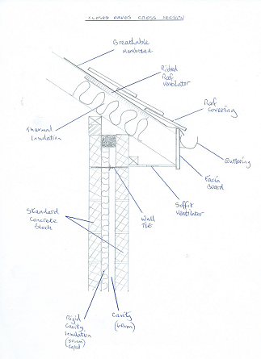

The roof covering of natural slate falls under BS EN 12326-1 Slate and Stone for discontinuous roofing. It is very durable with a very long life-span.
Slates are classified into A through to F. Classification A is the most suitable and preferred type to use on buildings whether it be a new build or historic building.
(The National Federation of Roofing Contractors Ltd, 2015)

The head lap for tiles on a pitched roof of 40⁰ is 60mm in areas of moderate weather exposure and 80mm in areas of severe exposure.
(Slatescape, 2019)
It is preferred to centre nail the slate tile onto the roofing batten rather than head nailing because the ‘rattling’ is reduced and there is less chance of the fixing nails being prised out of the battens in high winds.
Battens spacing is termed gauge. To calculate the gauge, the following formula is used:
Gauge = length of slate – (head lap + 25mm)
2
(Maybery-Thomas, 2013)

Slate fixings were previously galvanised steel nails, but copper nails are now used as they are more durable.
A sketch of a roof with slates in successive courses is overleaf.
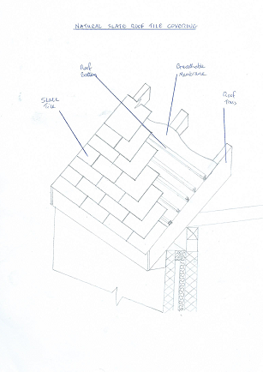

iv) ROOF STRUCTURE

The relevant standards for timber in roofing structures as per Approved Document A of the Building Regulations are:
- BS 5268-2:2002 Code of practice for permissible stress design, materials and workmanship
- BS 5268-3:1998, Code of practice for trussed rafter roofs
- BS 8103-3:1996 Structural design of low-rise buildings, Code of Practice for timber floors and roofs for dwellings
(Welsh Government, 2010)

The specified roof structure is trussed rafters at 40⁰ pitch. The drawings indicate the construction to be attic trussed rafters, meaning the specification allows enough height and width in the attic space for a possible habitable room, whilst maintaining enough strength to hold the load of the roof covering.
The three main timber elements of attic truss rafters are:
- Rafters
- Vertical struts
- Ceiling tie (aka ceiling joist)
These elements are prefabricated and connected together with nail plates as sketched overleaf.
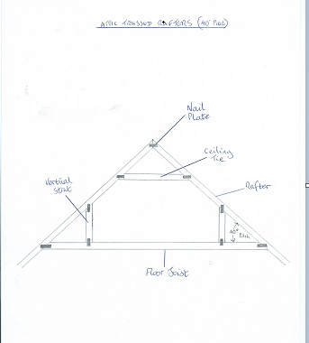

QUESTION 3

ROOF STRUCTURE – ATTIC TRUSSED RAFTERS

The given specification of 40⁰ trussed rafters in this build has many advantages as well as some disadvantages.

ADVANTAGES
- Standardised timber grading set out in Building Regulations meaning choice of product for the project is widely available from suppliers
- Prefabricated rafters and joists meaning purchase cost is reduced, product quality has been controlled and alteration during construction is eliminated / minimised
- Period of time to get building weather tight is reduced due to the speed of constructing with prefabricated rafters
- Minimal skill set required for roofers / labourers
- Floor area is maximised in the attic space
- Less need for internal load bearing walls

DISADVANTAGES
- The timber must be treated against rot and infestation
- Due to design, alteration is strongly not recommended as it will affect performance and may not be passed by Building Control
- Integrity of the trusses may be affected from transportation from factory, handling and storage

ROOF STRUCTURE – CUT ROOF

An alternative roof construction with rafters is a cut roof.
This is where every element of the roof is cut and constructed on site.
Elements of a cut roof are:
- Ridge board
- Ridge collar
- Rafters
- Purlins
- Struts
- Hangers
- Joist

ADVANTAGES
- Adaptable (can be converted into a living space in the future)
- All materials are readily available on site and in excellent condition (providing stored correctly)
- Very strong structure for roof covering load

DISADVANTAGES
- Not a speedy process
- High skill set required
- Costly due to time, volume of materials and labour
- Only suitable for roofs of 35⁰ pitch or more

Sketch of a cut roof cross section is overleaf.
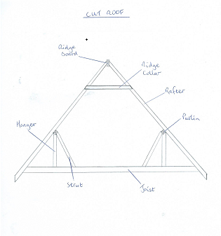

QUESTION 4

i) CONDENSATION – CAUSES AND SOURCES

What is condensation?
Condensation is the conversion of a vapour into a liquid.
If the air is humid (water vapour within the atmosphere), and it meets a cold surface, it condensates the vapour into liquid.

Sources of humidity?
- Humans & animals breathing
- Cooking
- Showering
- Washing & drying laundry

Causes of condensation?
The air’s atmosphere contains vapour from the sources listed above.
Relative humidity is the percentage of water vapour the atmosphere is holding.
Normal relative humidity levels are 40% to 60%.
The lower the %, the dryer the air is and the higher the %, the wetter the air is.
When the water vapour meets a cold surface, the vapour turns into liquid. This is known as surface condensation.
Examples of where this happens, is in a poorly ventilated house, where a lot of cooking and laundry occurs. Without adequate ventilation, the vapour cannot escape into the outside atmosphere, so when it meets a surface which is cold, such as glazing, ceramic tiles or a wall, it will condensate into liquid.

Effects of condensation in a building?
Where condensation occurs on cold surfaces such as walls and windows, a fungus can grow. That fungus is mold. Mold thrives in moist warm conditions.
Mold can be harmful to health, especially to people with existing allergies and asthma.
Mold must be treated with appropriate cleaning materials and methods, which will assist with prevention of its re-growth.
However, ventilation is the number one prevention of such growths where the moist air will be replaced by drier air thus reducing the moisture element that mold requires to grow.
Interstitial condensation is less visible compared to the surface condensation mentioned previously.
Interstitial condensation is where vapour condenses into liquid on the materials of the building’s structure.
The water from vapour condensing, could be absorbed by materials such as timber and insulation.
If insulation were to absorb the condensed water, its thermal resistance value will be reduced making it a poor insulator.
If timber were to absorb the condensed water, it will be more susceptible to fungal decay.
(Maybery-Thomas, 2013)

ii) VENTILATION METHODS IN THE DWELLING

Ventilation methods for the building can be natural, passive and mechanical.
- Soffit vents
These vents will ventilate the roof space. The roof will be a warm deck because the attic is a usable space. Soffit vents will ensure the insulation will avoid absorbing moisture, thus maintaining its thermal qualities.

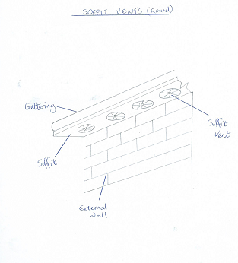

- Ventilation bricks
These bricks, known as air bricks are placed on the internal and external leaf.
The telescopic version, is where the air brick on the external leaf, is on a higher course than the one on the internal leaf, with a telescopic shaped plastic vent that ‘joins’ the two.
The internal leaf air bricks will be below the suspended ground floor level where there is a void, enabling airflow through the void.

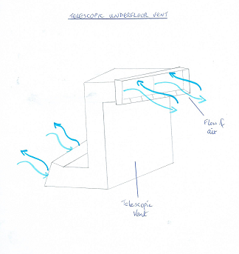

- Window trickle vents
These vents allow air flow through a vent in your window’s UPVC panel, and door’s UPVC panel at a reasonable rate, so as you will not feel a change in the temperature.
The dwelling has 18 windows and 3 doors meaning there is a lot of opportunity for this type of ventilation.

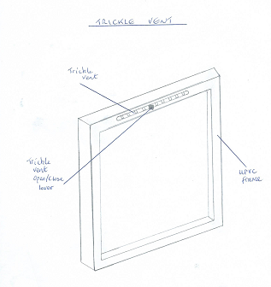

- Wall extractor fans
These fans are mechanically operated and should be installed on external walls in rooms where a lot of moisture is created, such as kitchens, bathrooms and utility rooms.
The fan will extract air with a high level of humidity, to the outside atmosphere. Dryer air will be drawn in from other areas such as an open window / wall vent.
The dwelling has 5 rooms in which a mechanical extractor fan will be required.

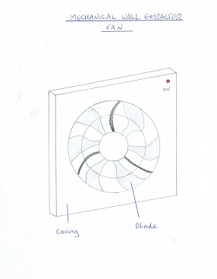

- Cooker extractor fans
These fans are installed above cookers, in order to extract the moisture laden air as a result from cooking, and extracting it to the outside atmosphere.

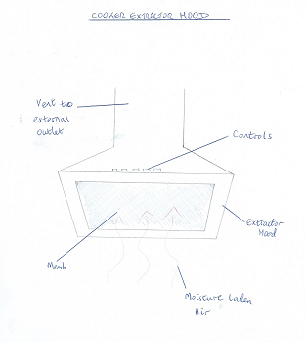

iii) REDUCING THE AMOUNT OF CONDENSATION IN THE DWELLING

The vapour in the air, will condensate when it meets a cold surface.
By taking measures to ensure surfaces are at their least coldest, will reduce the condensation levels.
Such measures are quality (and correctly installed) insulation.
Insulation boards can be applied to the internal leaf within the cavity wall. The insulation can be 50mm thickness, and its joints taped to prevent any reduction in its thermal resistance.
Insulation in the roof (warm deck) will help keep the upper most ceilings of the house (ie. the attic space’s ceiling) to be ‘warm’.
Insulation in the floors will also help reduce condensation by keeping the floors ‘warm’.
End users of the build, must be well informed and educated with regard to the need for ventilation in the dwelling, to prevent future problems with mold, and decay of building materials.
The importance of natural ventilation by way of regular window opening along with use of mechanical & passive ventilation is imperative knowledge for the end user.

References
British Standard, 2009. Code of practice for timber floors. [Online]
Available at: http://www.ihsti.com.ezproxy.uwtsd.ac.uk/tempimg/1AA96D1-CIS888614800291284.pdf
[Accessed 24 03 2019].
British Standard, 2016. BS EN 845-1 2013. [Online]
Available at: http://www.ihsti.com.ezproxy.uwtsd.ac.uk/tempimg/382E436-CIS888614800315354.pdf
[Accessed 24 03 2019].
British Standards, 2009. BS 8102:2009. [Online]
Available at: http://www.ihsti.com.ezproxy.uwtsd.ac.uk/tempimg/4231EA1-CIS888614800291234.pdf
[Accessed 23 03 2019].
British Standards, 2011. BS 8103-1:2011. [Online]
Available at: http://www.ihsti.com.ezproxy.uwtsd.ac.uk/CIS/document/299331?PreviousPage=search%3ff%3dAll%26t%3dBS%2b8103-1%253a2011%26sqm%3dAllTerms
[Accessed 23 03 2019].
Concrete.org.uk, 2019. Trench-fill Foundations. [Online]
Available at: http://www.concrete.org.uk/fingertips-nuggets.asp?cmd=display&id=350
[Accessed 23 03 2019].
Greeno, R. C. a. R., 2016. Building Construction Handbook. 11th ed. Abingdon: Routledge.
Maybery-Thomas, C., 2013. Fundamental Building Technology. Second ed. Abingdon: Routledge.
Slatescape, 2019. Head Laps. [Online]
Available at: http://slatescape.co.uk/head-laps/
[Accessed 19 04 2019].
The National Federation of Roofing Contractors Ltd, 2015. Selecting Natural Slates for Roof Covering. [Online]
Available at: https://www-ihsti-com.ezproxy.uwtsd.ac.uk/tempimg/55CA886-CIS888614800312499.pdf
[Accessed 19 04 2019].
TheConstructor.org, 2019. What are the Thickness Requirements of Strip Foundations. [Online]
Available at: https://theconstructor.org/structural-engg/thickness-of-strip-foundations/21009/
[Accessed 23 03 2019].
Welsh Government, 2010. Approved Document A. [Online]
Available at: https://www.labc.co.uk/sites/default/files/EXT.Approved-Document-A-Structure.JMCN_.v1.030417.pdf
[Accessed 23 03 2019].

Bibliography
British Standard, 2009. Code of practice for timber floors. [Online]
Available at: http://www.ihsti.com.ezproxy.uwtsd.ac.uk/tempimg/1AA96D1-CIS888614800291284.pdf
[Accessed 24 03 2019].
British Standard, 2016. BS EN 845-1 2013. [Online]
Available at: http://www.ihsti.com.ezproxy.uwtsd.ac.uk/tempimg/382E436-CIS888614800315354.pdf
[Accessed 24 03 2019].
British Standards, 2009. BS 8102:2009. [Online]
Available at: http://www.ihsti.com.ezproxy.uwtsd.ac.uk/tempimg/4231EA1-CIS888614800291234.pdf
[Accessed 23 03 2019].
British Standards, 2011. BS 8103-1:2011. [Online]
Available at: http://www.ihsti.com.ezproxy.uwtsd.ac.uk/CIS/document/299331?PreviousPage=search%3ff%3dAll%26t%3dBS%2b8103-1%253a2011%26sqm%3dAllTerms
[Accessed 23 03 2019].
Concrete.org.uk, 2019. Trench-fill Foundations. [Online]
Available at: http://www.concrete.org.uk/fingertips-nuggets.asp?cmd=display&id=350
[Accessed 23 03 2019].
Greeno, R. C. a. R., 2016. Building Construction Handbook. 11th ed. Abingdon: Routledge.
Maybery-Thomas, C., 2013. Fundamental Building Technology. Second ed. Abingdon: Routledge.
Slatescape, 2019. Head Laps. [Online]
Available at: http://slatescape.co.uk/head-laps/
[Accessed 19 04 2019].
The National Federation of Roofing Contractors Ltd, 2015. Selecting Natural Slates for Roof Covering. [Online]
Available at: https://www-ihsti-com.ezproxy.uwtsd.ac.uk/tempimg/55CA886-CIS888614800312499.pdf
[Accessed 19 04 2019].
TheConstructor.org, 2019. What are the Thickness Requirements of Strip Foundations. [Online]
Available at: https://theconstructor.org/structural-engg/thickness-of-strip-foundations/21009/
[Accessed 23 03 2019].
Welsh Government, 2010. Approved Document A. [Online]
Available at: https://www.labc.co.uk/sites/default/files/EXT.Approved-Document-A-Structure.JMCN_.v1.030417.pdf
[Accessed 23 03 2019].

