

SERVICE IMPROVEMENT REPORT
Quality Management in Health & Social Care: Learning from Bristol

Root Causes, Policy Failures and Recommendations from the Bristol Royal Infirmary Children's Heart Surgery Inquiry (1984–1995)

Student Name : Sanjana Chauhan
ID: 2505065
Lecturer Name : Dilhara Mampitiya
Module code: LCHS7006
Table of Contents
- Introduction
- Main Body
2.1 Choosing the frameworks
  - Root cause analysis: the Fishbone Diagram
  - The 5 Whys
  - The Donabedian Model
  - SWOT and PESTLE: the wider context
- Recommendation
- Conclusion
- References

List of Abbreviations
Abbreviation | Full Term
BRI | Bristol Royal Infirmary
CQC | Care Quality Commission
DMAIC | Define, Measure, Analyse, Improve, Control
NHS | National Health Service
PDSA | Plan–Do–Study–Act
PDCA | Plan–Do–Check–Act
PESTLE | Political, Economic, Social, Technological, Legal and  Environmental
RCA | Root Cause Analysis
SWOT | Strengths, Weaknesses, Opportunities and Threats
WHO | World Health Organization

Introduction
Quality management in health and social care rests on a simple premise: the care a patient receives should not depend on luck. Yet system failures keep happening, and they keep following the same pattern - a problem that was visible to someone, somewhere, long before it reached a public inquiry. The Bristol Royal Infirmary (BRI) children's heart surgery case is one of the clearest illustrations of this pattern in NHS history, and it remains a standard reference point in UK quality improvement teaching for that reason (Kennedy, 2001).
Between 1984 and 1995, BRI carried out complex paediatric cardiac surgery with mortality rates for some procedures well above those seen at comparable centres elsewhere in England (Kennedy, 2001). An anaesthetist, Dr Stephen Bolsin, began raising concerns about outcomes around 1990, but these were not acted on urgently for several years (Kennedy, 2001). The situation only changed after the death of a child, Joshua Loveday, during surgery in 1995 prompted the unit to stop complex open-heart operations. A General Medical Council hearing in 1998 found three senior clinicians guilty of serious professional misconduct (Dyer, 1998), and a public inquiry chaired by Professor Sir Ian Kennedy ran from 1998 to 2001, eventually producing 198 recommendations for the wider NHS (Kennedy, 2001).
What makes Bristol useful as a case study is that the harm was not caused by one negligent act. It was produced by a combination of ordinary, individually explicable weaknesses - overstretched staff, unclear accountability, a culture where raising concerns was costly, and a complete absence of any national system for comparing surgical outcomes (Walshe and Offen, 2001). None of these weaknesses alone would have been catastrophic. Together, they were.
This report builds on the Component 1 presentation, which used James Reason’s Swiss Cheese Model as an initial lens on the failure, showing how weaknesses in several independent defensive layers lined up to let harm through (Reason, 1990; Reason, 2000). That model has been questioned for how literally its “holes” should be read (Perneger, 2005), so this report moves to more structured diagnostic tools. It applies the Fishbone Diagram and 5 Whys technique to trace the root causes of the high mortality rate, and uses the Donabedian Model to evaluate how weaknesses in structure and process at Bristol translated into poor outcomes. A SWOT analysis, supported by a brief PESTLE scan, places these root causes in their wider organisational and policy context. The report then draws on this analysis to propose recommendations, framed around quality improvement methods including PDSA, Lean and Six Sigma, aimed at preventing a recurrence of the same failure pattern in health and social care organisations today.
The purpose is not simply to describe what went wrong at Bristol, as this is well covered by the Kennedy Inquiry and subsequent commentary (Walshe and Offen, 2001; Scally and Donaldson, 1998). Instead, Bristol is used as a worked example of how quality theory can identify root causes in a real organisation and translate them into practical recommendations. This matters beyond the historical case: unclear accountability, weak outcome monitoring, and resistance to challenge continue to appear in health and social care failures.

Main Body

Choosing the frameworks
This report uses four frameworks rather than one, and the choice is deliberate rather than a matter of covering the syllabus, in line with general guidance that improvement tools should be matched to the specific diagnostic question being asked rather than applied as a generic checklist (Health Foundation, 2013). The Fishbone Diagram and 5 Whys were selected because Bristol was, by the Inquiry's own account, a multi-cause failure rather than a single error, and single-cause tools such as a basic incident timeline would have flattened that complexity (Vincent, 2010). The Donabedian Model was added because root cause tools describe why a failure happened but say little about its measurable effect on care quality; Donabedian's structure-process-outcome chain gives a way of connecting the causes identified through the Fishbone Diagram to the actual survival outcomes reported by the Inquiry. SWOT and PESTLE were included last, to move the analysis beyond the hospital itself and ask what in the surrounding policy and regulatory environment allowed those internal weaknesses to persist unchallenged for over a decade. Used in sequence, the four frameworks answer four different questions - what went wrong, why it went wrong, what it did to patients, and what allowed it to continue - rather than four versions of the same question.

Root cause analysis: the Fishbone Diagram
Root Cause Analysis (RCA) is built on the assumption that adverse events in complex organisations rarely have a single cause; they are usually the product of several contributing factors that combine at a particular moment (Vincent, 2010). The Fishbone, or Ishikawa, diagram is one of the most widely used RCA tools because it forces this multi-causal thinking onto a single page, sorting possible contributing factors into standard categories such as People, Culture, Management, Process, and Environment/Resources (Ishikawa, 1990).
Applied to Bristol, the Fishbone Diagram organises the case in a way that a narrative account tends to obscure. Under People, a junior surgeon was operating with limited senior supervision while working in a chronically overstretched team (Kennedy, 2001). Under Culture, the Inquiry described what it called a "club culture" in which concerns were not welcomed, and the clinician who did raise them, Dr Bolsin, was effectively pushed out of the NHS (Kennedy, 2001). Under Management, there was no single clearly accountable lead for the unit, with clinical and managerial lines of authority running in parallel rather than meeting at one point of responsibility. Under Process, there was no agreed threshold at which unsafe surgery should be paused, and record-keeping and audit were weak. Under Environment and Resources, the hospital had no dedicated paediatric intensive care unit and was chronically understaffed for the complexity of the work being carried out (Kennedy, 2001).
The strength of the Fishbone Diagram here is that it stops the analysis collapsing into a single culprit. Bristol was not simply "a surgeon who should have stopped operating" or "a manager who should have listened." It was a set of failures across five categories that reinforced one another, which is exactly the kind of multi-cause problem the tool is designed to surface (Walshe and Offen, 2001). Its main limitation is that it is descriptive rather than diagnostic: it maps where the weaknesses sat but does not, by itself, explain why they were allowed to persist for over a decade. That question is better answered using the 5 Whys.
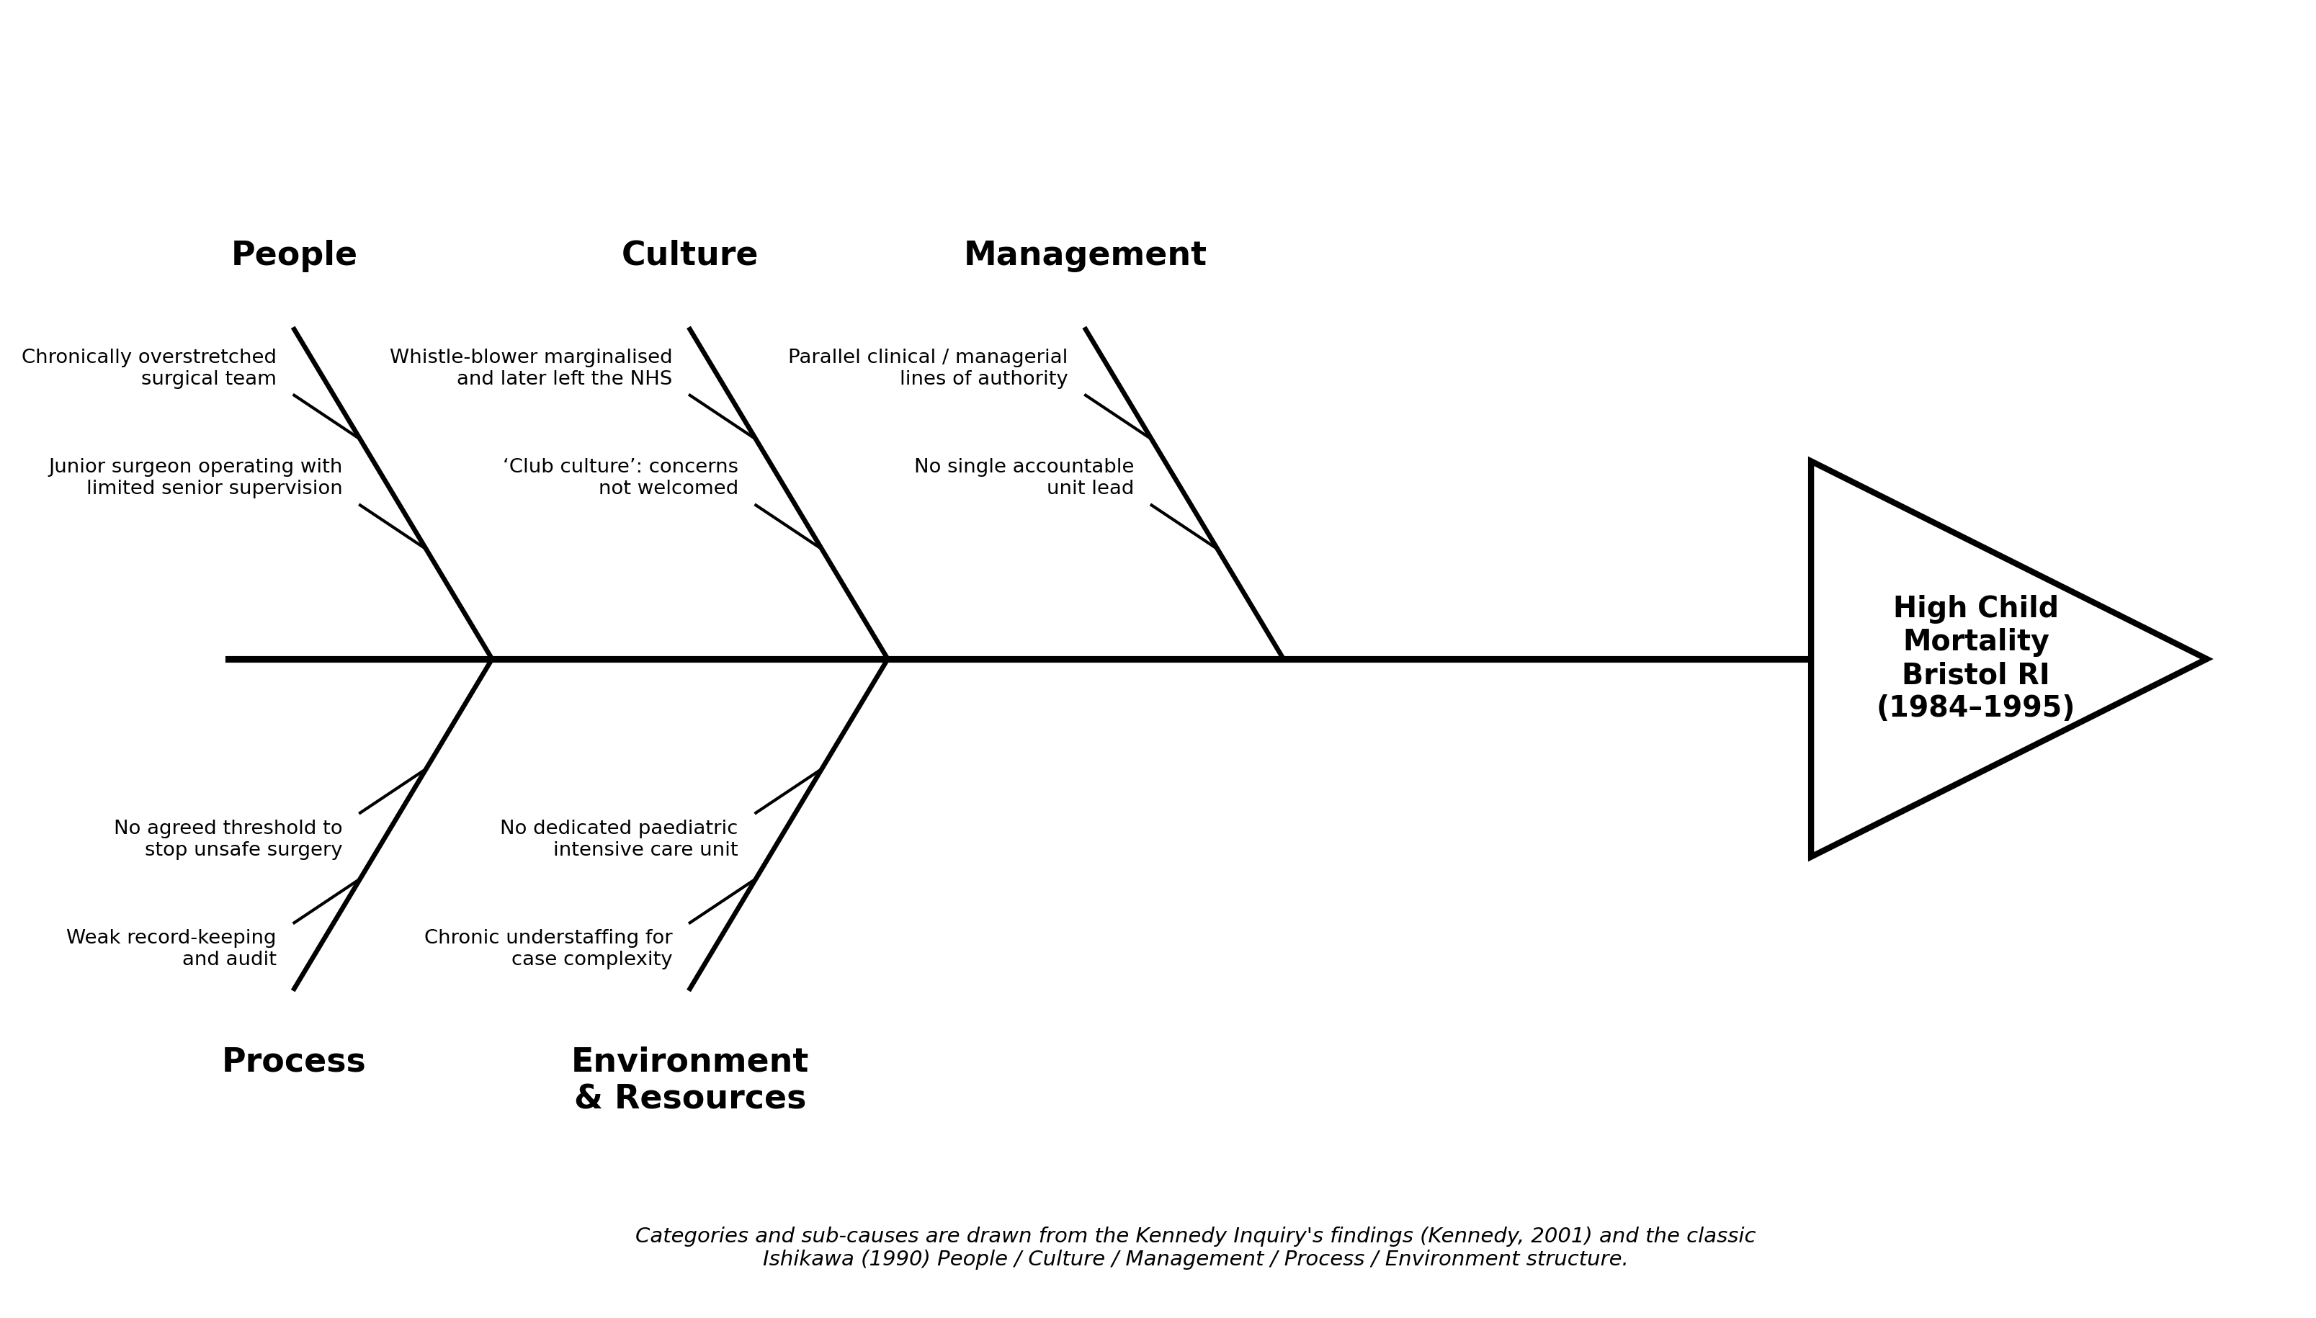
Figure 1: Fishbone (Ishikawa) diagram of the root causes of high child mortality at Bristol Royal Infirmary

The 5 Whys
The 5 Whys technique asks "why" repeatedly, usually five times, to move from a surface-level symptom to an underlying systemic cause (Serrat, 2017). Applied to Bristol: children were dying at higher rates than elsewhere - why? Because surgery was continuing despite known poor outcomes. Why did it continue? Because concerns raised locally were not escalated or acted upon. Why weren't they acted upon? Because there was no clear individual or body responsible for reviewing surgical performance, and raising concerns carried a personal cost. Why was there no such body? Because no national system existed for collecting or comparing outcome data across hospitals, so there was no external benchmark against which Bristol's figures looked exceptional. Why did no such system exist? Because professional self-regulation at the time relied on doctors monitoring doctors, with almost no external audit requirement (Scally and Donaldson, 1998).
This chain lands on a genuinely structural root cause rather than an individual one: the absence of mandatory, comparable outcome data at national level, combined with a self-regulatory model that had no mechanism to detect or act on outlier performance. That conclusion matters for the recommendations section, because it shifts the focus from "which individual should have acted differently" to "what system was missing that would have made individual failures visible and correctable."

The Donabedian Model
Where the Fishbone and 5 Whys explain how the failure arose, the Donabedian Model is useful for evaluating its consequences for care quality. Donabedian's framework separates quality into three linked elements: structure, the setting in which care is delivered, including staffing, skills and facilities; process, what is actually done in delivering care; and outcome, the result for the patient (Donabedian, 1988). Donabedian's central claim, and the reason the model has remained influential, is that these three elements are causally linked - poor structure tends to produce poor process, which tends to produce poor outcomes.
Donabedian first proposed this way of evaluating medical care in 1966, and the three-part structure has proved durable enough to still underpin most NHS and Care Quality Commission quality frameworks today (Donabedian, 1966). At Bristol, the structural weaknesses were concrete and traceable: too few trained paediatric cardiac surgeons and nurses, and no dedicated paediatric intensive care unit (Kennedy, 2001). These structural gaps fed directly into process failures - unclear decision-making about when to stop or refer a case, weak teamwork, and repeated operations that in hindsight should not have proceeded. The outcome was measurable in stark terms: children treated at Bristol had a materially lower chance of survival than children with comparable conditions treated elsewhere in England, a difference attributable to where they happened to be treated rather than to their clinical presentation (Kennedy, 2001). This is a clean illustration of Donabedian's structure-process-outcome chain operating exactly as the model predicts.
The model is not without limitations, however. It has been criticised for implying a more linear, mechanical relationship between its three elements than usually exists in practice, and for saying relatively little about how cultural or behavioural factors - such as the "club culture" identified at Bristol - fit into the chain (Mainz, 2003). A further limitation is that Donabedian's framework was developed with individual episodes of care in mind, and applying it to a whole surgical programme over an eleven-year period requires some adaptation, since structure and process at Bristol were not static across that time. Used alongside the Fishbone Diagram, though, the two tools are complementary: Donabedian shows where in the care pathway quality broke down, while the Fishbone shows why it broke down there (Donabedian, 1988). Neither tool, on its own, would have generated the recommendations later proposed in this report; it is the combination of a causal map and an outcome framework that makes the case for specific, testable interventions rather than general calls for "better culture" or "more resources."

SWOT and PESTLE: the wider context
A SWOT analysis (Humphrey, 2005) situates these clinical root causes within the organisation's broader position. Internally, Bristol's strengths included committed, technically skilled clinical staff and a genuine ambition to run a leading paediatric cardiac programme. Its weaknesses were the flip side of the same coin: that ambition ran ahead of the resourcing and governance needed to support it, producing overstretched teams, unclear accountability, and a culture resistant to challenge (Kennedy, 2001). Externally, the case sat within a period of opportunity, in the sense that clinical governance reform was already being discussed nationally in the early 1990s and could plausibly have been accelerated by earlier action on Bristol's data. The corresponding threat was that, absent such reform, the same structural gaps - no comparative outcome data, weak whistleblower protection, and self-regulation with limited external check - left every comparable specialist unit exposed to an equivalent failure (Walshe and Offen, 2001).
A brief PESTLE scan, a development of Aguilar's (1967) original environmental scanning framework, adds the policy dimension. Politically, the case unfolded against a backdrop of NHS reorganisation, giving the eventual Kennedy recommendations institutional momentum. Legally, the near-total absence at the time of any duty of candour or mandatory reporting requirement meant Bristol's outcomes could go unchallenged for years. Socially, the parents involved were often given incomplete information before consenting to surgery, undermining an assumption the system was otherwise built on: that patients or their families could act as an informal check through informed consent (Kennedy, 2001). Taken together, the SWOT and PESTLE analyses confirm what the Fishbone and 5 Whys already suggested - Bristol's failure was enabled as much by the absence of external structures as by anything that happened inside the hospital itself. This is the point at which root cause analysis becomes strategic rather than purely clinical: fixing Bristol's internal weaknesses without also closing the external policy gaps would have left the wider system exposed to the same failure recurring at a different hospital.

Recommendation
The root cause analysis points toward two connected problems: a lack of comparable outcome data that would have made poor performance visible earlier, and a culture and governance structure that discouraged concerns from being raised and acted upon. Recommendations are grouped accordingly, and each is paired with a quality improvement method suited to testing and embedding it in a real organisation rather than simply mandating it from above.

Recommendation 1: mandatory outcome monitoring, tested through PDSA
The single clearest lesson from the 5 Whys analysis is that Bristol's mortality rates were only recognisable as exceptional once compared against other centres, and no mechanism existed to make that comparison routinely. A health or social care organisation carrying out complex, high-risk procedures should implement a standardised outcome dataset, reported at a fixed interval to a body independent of the unit being assessed, with results benchmarked against comparable providers.
Rather than introducing this as a single, organisation-wide mandate on day one, the Plan-Do-Study-Act (PDSA) cycle offers a more realistic route to implementation (Langley et al., 2009). In the Plan stage, one clinical team defines the outcome measures, the reporting interval, and who reviews the data. In the Do stage, that single team pilots reporting for a defined period, for instance one quarter. In the Study stage, the pilot team and an independent reviewer assess whether the data revealed anything actionable and whether the reporting burden was proportionate to what was learned. In the Act stage, the process is adjusted based on what the pilot showed, before being rolled out to further units in a second cycle. Repeated PDSA cycles allow the reporting system itself to be improved iteratively, rather than imposing a rigid national dataset that risks being resisted or gamed, as happened to some degree with early NHS performance indicators (Bevan and Hood, 2006). This fits Deming's broader argument that quality comes from continuous improvement rather than one-off inspection (Deming, 1986; Berwick, 1989), and evidence that published performance data changes behaviour only when clinicians see it as fairly benchmarked (Marshall et al., 2000).
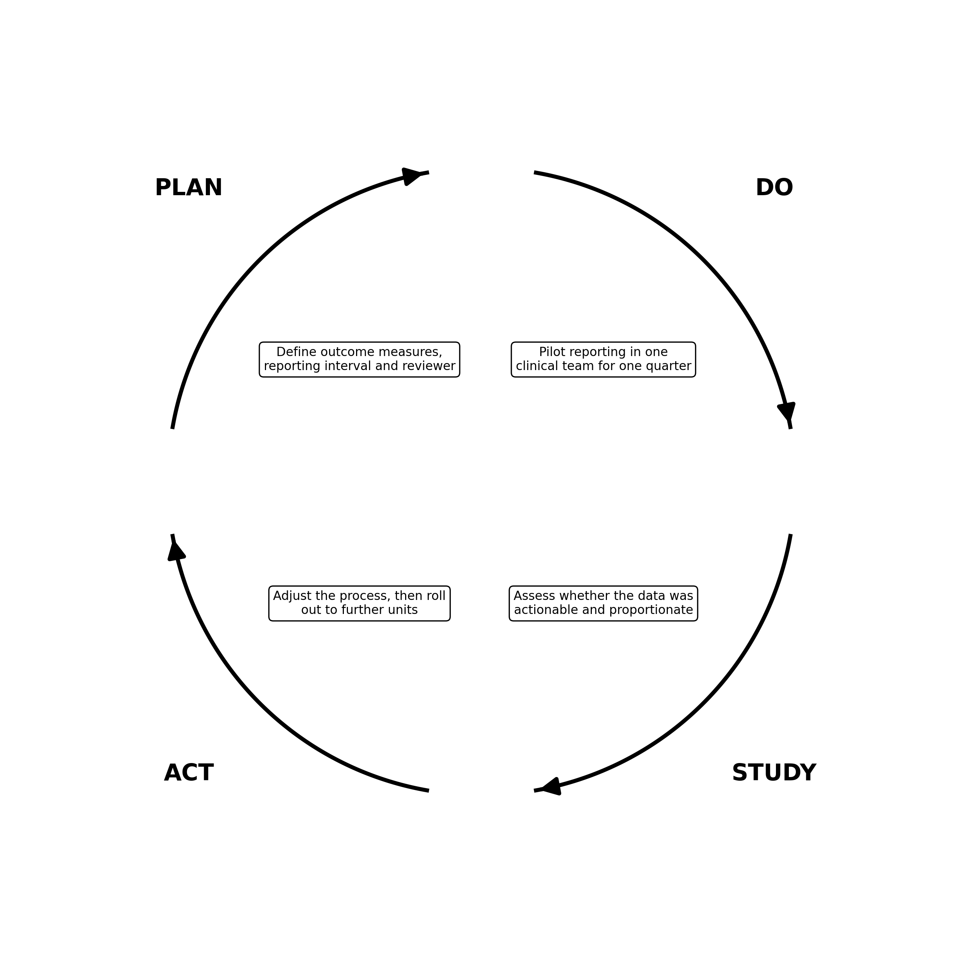
Figure 2: The PDSA cycle applied to outcome-monitoring reform at Bristol

Recommendation 2: reducing variation in surgical and care pathways through Six Sigma
Where PDSA is suited to testing whether a new monitoring process works, Six Sigma is better suited to the underlying clinical problem the 5 Whys analysis identified: unexplained variation in outcomes between broadly comparable patients and teams. Using the DMAIC structure - Define, Measure, Analyse, Improve, Control - a cardiac surgery unit would first define an acceptable outcome range for a given procedure, measure current performance against it, analyse where and why cases fall outside that range, implement standardised protocols to reduce unwarranted variation, and then hold the improved process in place through ongoing statistical monitoring (George, 2002; Pyzdek, 2003). Applied retrospectively to Bristol, this would have meant treating a mortality rate significantly above the expected range not as an isolated statistic but as a signal requiring formal investigation under a pre-agreed threshold, rather than something that could be explained away informally within the department, as happened for several years (Kennedy, 2001). The same logic underpins simpler tools such as the WHO Surgical Safety Checklist, which cut complication rates once standardised across teams (Haynes et al., 2009; World Health Organization, 2009).

Recommendation 3: removing waste from escalation pathways using Lean
Lean thinking targets waste in a process, and one of the clearest forms of waste identified in the Bristol case was the time and effort lost when Dr Bolsin's concerns were raised repeatedly without producing a decision (Kennedy, 2001). A Lean-informed value stream map of the escalation pathway, from a frontline clinician raising a concern through to a final organisational decision, would make visible exactly where the process stalled and who was accountable for each step (Womack and Jones, 1996). For Bristol, this would likely have shown concerns being raised, discussed, and then absorbed without a documented outcome at multiple points, rather than being blocked at one obvious gatekeeper. A similar mapping approach has been used within NHS wards to strip out non-value-adding steps and free up direct patient contact time (NHS Institute for Innovation and Improvement, 2008). Mapping this pathway and setting a maximum turnaround time for each stage would convert an informal, culture-dependent process into one with visible accountability.

Recommendation 4: embedding culture change and monitoring sustainability
None of the above will hold if the underlying culture is unchanged, since Bristol shows that data and process alone did not surface the problem while the "club culture" persisted. Alongside the technical recommendations, organisations should introduce structured psychological safety training for clinical teams and a formalised, protected whistleblowing route independent of the local management chain (Walshe and Offen, 2001), reinforced by an explicit duty of candour requiring staff to disclose harm to patients and families as a matter of course rather than only when asked (Care Quality Commission, 2015). Sustainability should be monitored through a rolling PDCA (Plan-Do-Check-Act) cycle at board level, with outcome data, escalation pathway performance, and staff survey results on psychological safety reviewed together at fixed intervals, so that a decline in any one measure is picked up before it compounds into the kind of multi-layered failure seen at Bristol.
Taken together, these four recommendations map directly onto the root causes identified earlier: PDSA addresses the missing outcome data, Six Sigma addresses unexplained variation in results, Lean addresses the stalled escalation pathway, and the culture and governance measures address the "club culture" that let the first three problems go unchallenged. Implementing them as a single unconnected policy document would repeat one of Bristol's own mistakes, treating governance as a one-off exercise rather than a continuous cycle; embedding them instead as linked, iterative processes gives an organisation a realistic chance of detecting a comparable problem years earlier than Bristol did.

Conclusion
The Bristol Royal Infirmary case shows that serious quality failures in health and social care rarely stem from a single decision. The Fishbone analysis identified weaknesses spread across people, culture, management, process and resourcing; the 5 Whys traced these back to a structural root cause, the absence of mandatory comparative outcome data; and the Donabedian Model demonstrated how weak structure and process translated directly into worse survival outcomes for children treated at Bristol rather than elsewhere. The SWOT and PESTLE analysis showed that these weaknesses were reinforced by an external policy environment that offered almost no check on self-regulating professional performance at the time.
The recommendations in this report follow directly from that diagnosis rather than being generic quality improvement advice retrofitted to the case. PDSA offers a realistic route to introducing outcome monitoring without imposing an untested system all at once. Six Sigma addresses the specific problem of unexplained variation in outcomes. Lean targets the wasted effort in an escalation pathway that repeatedly failed to produce a decision. None of these tools, used alone, would have prevented Bristol; used together, and paired with genuine culture change and protected whistleblowing, they address the root causes identified across the report rather than only its symptoms.
The wider relevance of Bristol is that its root causes--unclear accountability, limited
comparative data and a culture that discouraged concerns—were not unique to 1990s cardiac surgery. The Kennedy Report led to reforms that strengthened clinical governance across health and social care. Similar failures later appeared at Mid Staffordshire (Francis, 2013), highlighting continuing patient safety concerns. Bristol therefore remains relevant to current NHS practice, with better data, clear accountability and an open safety culture continuing to be essential.

References
1. Aguilar, F.J. (1967) Scanning the Business Environment. New York: Macmillan.
2. Alaszewski, A. (2002) 'The impact of the Bristol Royal Infirmary disaster and inquiry on public services in the UK', Journal of Interprofessional Care, 16(4), pp.371–378.
3. Berwick, D.M. (1989) 'Continuous improvement as an ideal in health care', New England Journal of Medicine, 320(1), pp.53–56.
4. Bevan, G. and Hood, C. (2006) 'What's measured is what matters: targets and gaming in the English public health care system', Public Administration, 84(3), pp.517–538.
5. Care Quality Commission (2015) Regulation 20: Duty of Candour. Newcastle upon Tyne: CQC.
6. Deming, W.E. (1986) Out of the Crisis. Cambridge, MA: MIT Press.
7. Department of Health (2002) The Government's Response to the Report of the Public Inquiry into Children's Heart Surgery at the Bristol Royal Infirmary. Cm 5363. London: HMSO.
8. Donabedian, A. (1966) 'Evaluating the quality of medical care', Milbank Memorial Fund Quarterly, 44(3), pp.166–206.
9. Donabedian, A. (1988) 'The quality of care: how can it be assessed?', JAMA, 260(12), pp.1743–1748.
10. Dyer, C. (1998) 'Bristol doctors found guilty of serious professional misconduct', BMJ, 316, p.1924.
11. Francis, R. (2013) Report of the Mid Staffordshire NHS Foundation Trust Public Inquiry. London: The Stationery Office.
12. George, M.L. (2002) Lean Six Sigma: Combining Six Sigma Quality with Lean Speed. New York: McGraw-Hill.
13. Haynes, A.B. et al. (2009) 'A surgical safety checklist to reduce morbidity and mortality in a global population', New England Journal of Medicine, 360(5), pp.491–499.
14. Health Foundation (2013) Quality Improvement Made Simple. London: The Health Foundation.
15. Humphrey, A. (2005) 'SWOT analysis for management consulting', SRI Alumni Newsletter, December, pp.7–8.
16. Institute of Medicine (2001) Crossing the Quality Chasm: A New Health System for the 21st Century. Washington, DC: National Academies Press.
17. Ishikawa, K. (1990) Introduction to Quality Control. Tokyo: 3A Corporation.
18. Kennedy, I. (2001) Learning from Bristol: The Report of the Public Inquiry into Children's Heart Surgery at the Bristol Royal Infirmary 1984–1995. Cm 5207. London: The Stationery Office.
19. Kohn, L.T., Corrigan, J.M. and Donaldson, M.S. (eds) (2000) To Err Is Human: Building a Safer Health System. Washington, DC: National Academies Press.
20. Langley, G.J., Moen, R., Nolan, K.M., Nolan, T.W., Norman, C.L. and Provost, L.P. (2009) The Improvement Guide: A Practical Approach to Enhancing Organizational Performance. 2nd edn. San Francisco: Jossey-Bass.
21. Mainz, J. (2003) 'Defining and classifying clinical indicators for quality improvement', International Journal for Quality in Health Care, 15(6), pp.523–530.
22. Marshall, M.N., Shekelle, P.G., Leatherman, S. and Brook, R.H. (2000) 'The public release of performance data: what do we expect to gain? A review of the evidence', JAMA, 283(14), pp.1866–1874.
23. NHS England (2022) NHS Patient Safety Strategy. London: NHS England.
24. NHS Institute for Innovation and Improvement (2008) The Productive Ward: Releasing Time to Care. Coventry: NHS Institute for Innovation and Improvement.
25. Perneger, T.V. (2005) 'The Swiss cheese model of safety incidents: are there holes in the metaphor?', BMC Health Services Research, 5, p.71.
26. Professional Standards Authority (2021) The Bristol Inquiry – 20 Years On. Available at: https://www.professionalstandards.org.uk/news-and-updates/news/bristol-inquiry-20-years (Accessed: 20 July 2026).
27. Pyzdek, T. (2003) The Six Sigma Handbook. New York: McGraw-Hill.
28. Reason, J. (1990) Human Error. Cambridge: Cambridge University Press.
29. Reason, J. (2000) 'Human error: models and management', BMJ, 320(7237), pp.768–770.
30. Scally, G. and Donaldson, L.J. (1998) 'Clinical governance and the drive for quality improvement in the new NHS in England', BMJ, 317(7150), p.61.
31. Serrat, O. (2017) 'The five whys technique', in Knowledge Solutions. Singapore: Springer, pp.307–310.
32. Vincent, C. (2010) Patient Safety. 2nd edn. Oxford: Wiley-Blackwell.
33. Walshe, K. and Offen, N. (2001) 'A very public failure: lessons for quality improvement in healthcare organisations from the Bristol Royal Infirmary', Quality in Health Care, 10(4), pp.250–256.
34. Womack, J.P. and Jones, D.T. (1996) Lean Thinking: Banish Waste and Create Wealth in Your Corporation. New York: Simon & Schuster.
35. World Health Organization (2009) WHO Guidelines for Safe Surgery 2009. Geneva: WHO.

