
ZARA
Critical analysis and evaluation

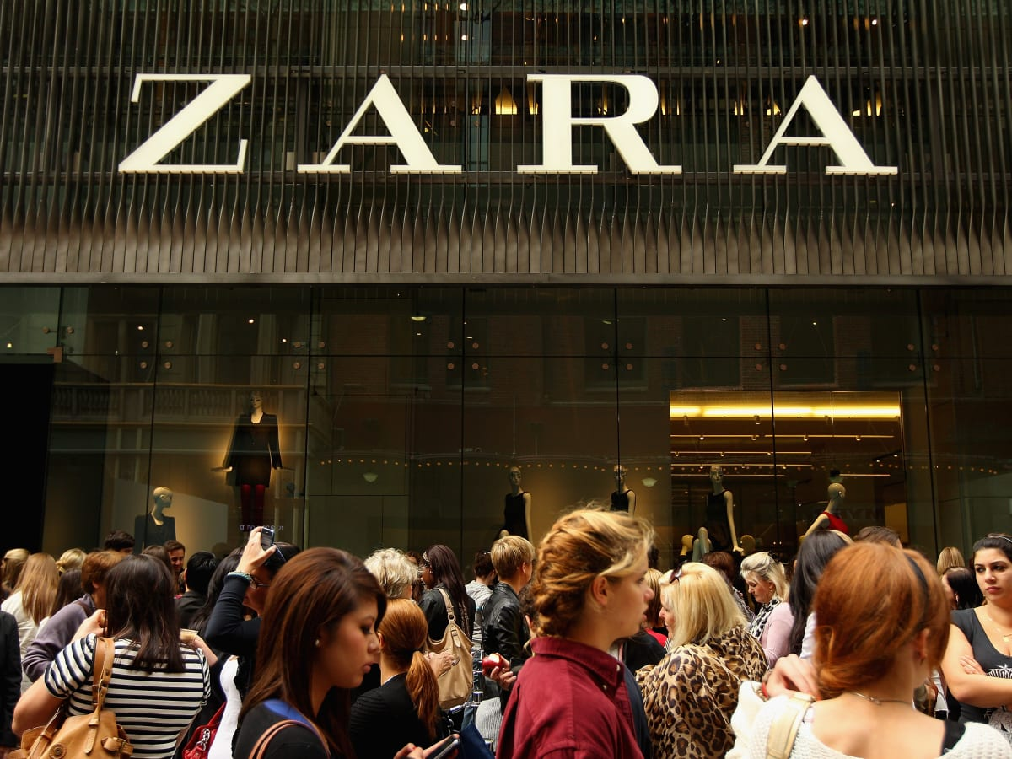
March 31, 2023
By Deyana anachkova
Word count:1958


History
Amancio Ortega opened the first Zara store in 1975. His company's current headquarters may be found in the historic district of A Corua, Galicia, Spain, where he first opened his shop.
Since October 2019, ZARA has been one of the top three corporations worldwide and Spain's most popular fashion brand. "(Chunling, 2020)" The Spanish apparel label Zara is owned by the InditexGroup, the world's biggest and best-known fashion retail conglomerate. This clothing retailer is the owner of many well-known labels, including Massimo Dutti, Pull & Bear, Bershka, Stradivarius, Oysho, Zara Home, and Uterqüe. Now, there are 2213 Zara stores spread over 93 markets, in addition to 39 online markets.

Zara’s Market Segmentation
Zara is well-known among both those who seek high fashion and the general public. Men's, women's, and children's apparel are all available. Clothes, including jeans, trousers, shirts, skirts, jumpers, T-shirts, footwear, handbags, and jewellery. All of these factors have a role in Zara's product strategy and marketing mix. Whether a client prefers to shop online or in-store is up to them, but they can find all of the options they need here. The constant need for new clothing lines from consumers is a major inspiration for Zara's annual release of hundreds of new styles. Zara, which mostly sells items in modern fashions, assures its customers that they will never run out of options. Sustainable development is a priority for Zara, and the company is dedicated to reducing waste. Even the hang tags and safety seals are reused. Zara packages its goods for delivery in paper or bio - plastic bags. Zara employs natural materials and other environmentally ingredients in the creation of some of their items. These items stand out from the competition because to their unique labeling. Sevic,Popovic. N., Others (2021).

Zara’s Targeting Strategy
Customers between ages of eighteen and forty who have stable employment and a moderate to high income make up the bulk of Zara's clientele. This demonstrates that consumers are making impulsive purchases, and it supports Zara's approach of updating its shops often in the hope that customers won't have time to shop elsewhere for better options. The fact that these goods are often offered at more affordable rates than their rivals further increases their marketability. The company's Undifferentiated segmentation strategy places heavy emphasis on its younger clients since they tend to buy new clothes more often.
Zara’s Positioning Strategy
The company's slogan is "Fast cheap fashion," and their rapid imitation approach emphasises the speediest possible reaction to market demand in terms of design, production, and sales. Zara has a massive positioning strategy, aiming its clothes towards consumers aged 18 to 35 who are fashion-conscious but lack the means to shop at high-end retailers.

Product strategy
While the term "fast fashion" wasn't used until much later, Zara has always been a rapid fashion retailer, putting out styles that are immediately in sync with current trends.
The majority of the fashion industry operates according to seasonal designs, with changing fashion options for each season, using the weather to inform consumer decision of what to wear at the time, and then disposing off whatever hasn't sold at a reduced price. Zara has a unique stance on the matter. Because of the high demand and little availability, the company consistently releases new styles throughout the year. Customers place a high value on this marketing strategy because of the scarcity it generates: there won't be many other people who wear it if there are only a limited number available. Rather than outsourcing, Zara produces everything in-house. This guarantees that it has total control over the quality of its apparel and shortens the production process' overall duration noticeably. Bussinessinsider.com (2018)

Price strategy
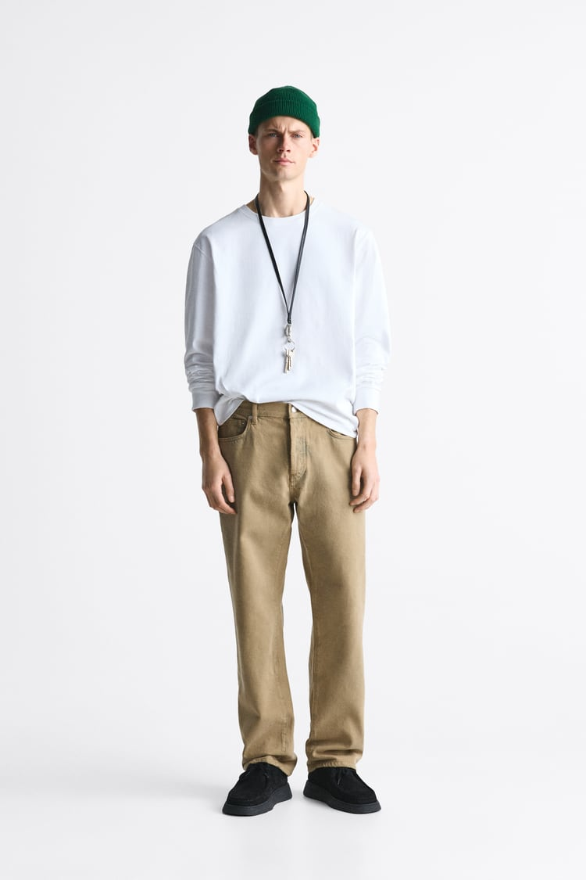
Even though though Zara is one of the most stylish companies in the world, the expensive prices it charges for its clothing make it out of reach for the average shopper. Nonetheless, the company is mindful towards the average shopper looking for a more modern and current look since it develops many of its own products instead of outsourcing them.. Wondershare.com (2021)
Regular Men’s Jeans £49.99GBP

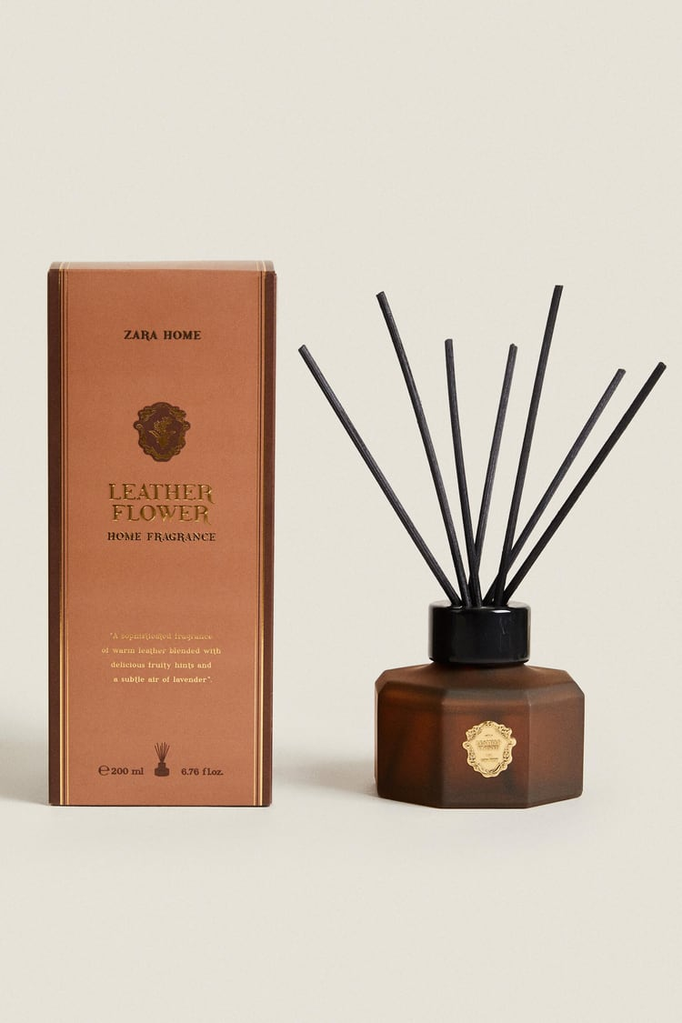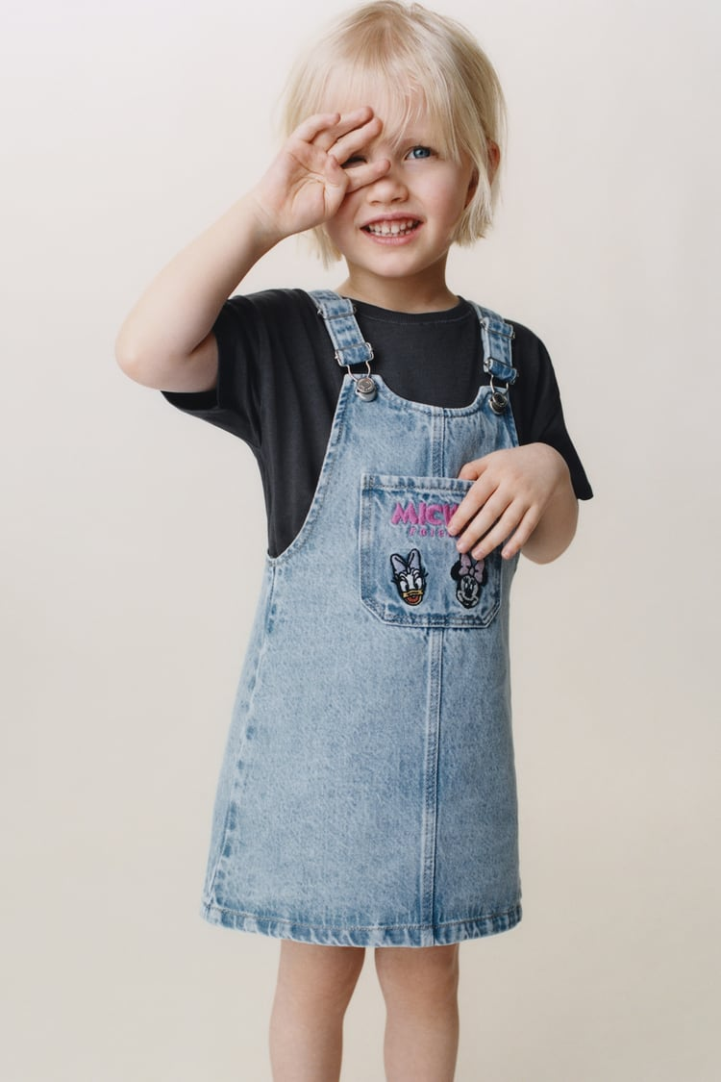
Diffuser £29.99GBP Kid’s Dress £22.99GBP

Woman’s dress £49.99GBP Kids T-shirt £22.99GBP
Place strategy
Zara's entrance into other markets was a slow process. Stores were initially introduced to the nearby countries of Portugal and India. Nonetheless, it subsequently saw explosive growth in many significant markets and nations, including the United States, the United Kingdom, Italy, France, Russia, Japan, South Korea, and others.
Zara now has 2,242 shops in 96 different countries, and its worldwide expansion is continuous.
Zara's physical footprint is massive, but the company is also deeply involved with its buyers through a wide range of digital platforms. This boosts the company's exposure to new consumers and, notably among millennials.

Promotion Strategy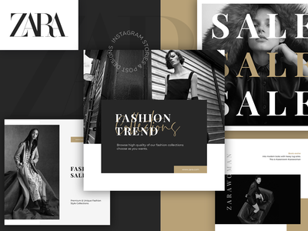
Zara does not market its goods on television, in contrast to many of its rivals.
The corporation is making significant investments in cutting-edge methods. Zara could easily promote a new product or collection by posting images on its social media platforms and banking on the influence of the brand's many followers. Not only does this kind of advertising guarantee sales, but it also encourages interaction between the brand and its existing clientele and any possible new ones. Zara also stands out from the competition since its brand isn't included on any of its items. The company views the practise as superfluous and instead invests the money saved towards expanding into new locations. Sevic (2021)

Marketing Strategy
The Spanish company has swiftly become the market leader. Zara's ability to provide customers what they want is a crucial factor in the company's success and appeal. Their supply chain and technology-based approach has helped them achieve remarkable success.
The firm's geographical strategy is a key component to the growth of the company. Zara is self-assured enough to regularly expand its shop portfolio by closing down charity-run locations, penetrating new markets, and expanding its sibling brands inside existing ones.
In September of 2010, Zara launched its online shop. The website's first launch markets were Spain, the U.k, Portugal, Italy, Germany, and France. In the same year, in November, the service was expanded to five other countries: Austria, Ireland, the Holland, Belgium, and Luxembourg. In 2011, it opened its virtual doors in the United States; in 2013, it expanded to Russia and Canada; in 2014, to Mexico; in 2016, to South Korea; and in 2017, to Romania.
Internet marketing is continually evolving as a new field of marketing theory and practice, with the Internet serving as the primary route for the application of optimum marketing models.
Customers are in a position to voice their opinions on brands and businesses. When developing effective marketing strategies that are considerably different from conventional ones, it is important to consider how the power and allure of the Internet environment have changed how consumers behave. In this sense, online marketing has entirely changed from what it was previously understood to be, making traditional marketing techniques less efficient and more expensive (Kotler & Keller) 2011). It is of utmost importance that companies keep up with the changes relating to Internet marketing in order to effectively gain an advantage in the competitive online market.
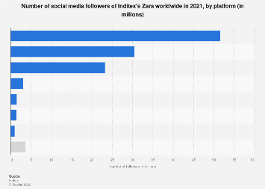 Zara has social media accounts on Facebook, Twitter, Instagram, YouTube, Pinterest, and LinkedIn. Instagram and Facebook serve as their main social media platforms since photographs and videos are so important in the fashion industry.
Influencer marketing
 Zara, like many of its competitors in this day and age has dipped into the modus operand of advertising its products using famous people like celebrities and influencers. Sevic (2021)
Considering the Facebook data that Zara’s main customer base is primarily women, the marketing team issues new products and designs using primarily female models, celebrities and influencers.
Visual aspects
Among fashion brands, Instagram is often regarded as the most successful social media site. By regularly posting new and interesting content featuring in-demand designs, Zara is able to keep its audience interested and engaged. Whenever it comes to capturing the attention of consumers, nothing is more crucial than the aesthetic aspect, says Sevic (2021). Nonetheless, it is evident that continuous updates and involvement among fans and users is a major aspect in deciding whether a business is not just successful but also loved and respected, and this is true regardless of the number of online postings the firm makes.
Consumer targeting
Given the beneficial correlation between customer participation and subsequent sales, Zara employs certain novel approaches and services for its clientele. In order to maintain a positive and dynamic reputation as a brand actively engaged in communicating with its fans and promoting its designs, Zara, among other things, encourages its customers and potential customers to compete with one another by posting photos of themselves dressed in Zara garments (according to the subject and rules) on its Zara People website.
In a different ad campaign called "Timeless," Zara cast models aged 40 and above. Veterans of the fashion business were there. The campaign was well received by consumers, which boosted the label's credibility in the fashion world. Consistency in both content and publication frequency is crucial to building a strong brand.
According to studies, Zara's online marketing approach on social networking sites has resulted in increased sales and helped the company gain a sizable and devoted following among consumers of all ages.
The Covid 19 Pandemic

For the clothing company Zara, developing a new digital strategy amid the COVID-19 crisis is crucial. Zara's revenues decreased 44% year over year in the first quarter of 2020 due to the COVID-19 issue, which was largely responsible for the closure of the company's global stores. 482 million dollars loss in revenue was reported by the company in the first quarter of 2020. Inditex Annual Report (2020). Inditex announced that it would be closing stores from the range of 1000 to 1200 focusing mainly in Europe and Asia. Even though online sales saw a rise by 50% in the same timeframe, it wasn’t enough to soften the blow the company would experience. That being said, there weren’t any major store closures up until late December same year even if Inditex announced it.
The lesson
When it comes to integrating its physical and online environments to facilitate faster shipment and real-time product monitoring, Amancio Ortega plans to invest $ 2 billion by 2022. This is on top of the $ 1.1 billion it plans to spend on improving its networking and online initiatives. At least 25percent of total revenues should come from online channels. It can only be accomplished by a whole new approach to its online marketing strategy on social media, rather than just in its online businesses.

Conclusion
The Zara company is customer-centric because it understands, anticipates, and satisfies its customers' needs in relation to current fashion trends while maintaining reasonable prices. The company's ability to tailor product designs to individual customers, along with a streamlined production and distribution process, gives them a leg up on the competition. Zara's worldwide success may be attributed, in part, to the company's ethos and its recognition that the client is the only true source of trend inspiration. Zara's online brand community has attracted even more consumers by using the most successful digital marketing tool, all while appreciating the concept of mutual trust and facilitating lively dialogues and the sharing of opinions and experiences.

REFERENCES

Šević, Nevenka Popović;Jeremić, Anja;Slijepčević, Milica;Ilić, Milena (2021), Marketing Focused on The Online Brand Community – The Example of Zara., Marketing (0354-3471). 2021, Vol. 52 Issue 1, p32-42. 11p

Chuning, L., (2020), Analysis on the Marketing Strategy of Fast Fashion Brand Zara Based on 4c Theory, Francis Academic Press, UK

Wondershare, Zara Segmentation, Targeting, and Positioning

Inditex Annual Report (2020)
Businessinsider.com

