

Programme Name: Master of Business Administration
Name and Code of the Module: International Marketing: Principles and Practices LCMB7026

Title: International Marketing: Principles and Practices- BMW
Lecturer’s Name: TusharaBalendran
Name and ID of the Student
Word Count: 5526
Submission Date:

TABLE OF CONTENTS
Introduction 3
Brand overview 3
Comparison of the socio-cultural context of the USA and Australia 5
PESTLE 5
Similarity and dissimilarity 11
Cultural factors based on Hofstede’s six dimensions 12
Favourable and Unfavourable condition of cultural model 14
Advantages and Disadvantages of Hofstede Model 14
Comparison of Brand’s STP strategies in the USA and Australia 16
STP Analysis in Australia 16
STP Analysis in the USA 18
Similarities and differences 21
Comparison of Marketing Mix Strategies in the USA and Australia 22
Marketing mix comparison 22
Market Entry Method 26
Similarities and differences 28
Evaluation of the performance of marketing strategies 29
USA’s performance 29
Australia’s performance 30
Similarity and differences 32
Evaluation of marketing ethics practice 32
Ethical issues in adaptation, pricing, advertising and treatment of local employees 32
Overall ethical judgement 34
Recommendation and Conclusion 34
Recommendations 34
Conclusion 35
Reference List 37
Appendices 43
Appendix 1: Comparison of Socio-Cultural Context (PESTLE) – BMW in Australia vs the USA 43
Appendix 2: Comparison of BMW’s STP Strategies in Australia and the USA 44
Appendix 3: Ethical issues in treatment of local employees 45
Appendix 4: Implication of theory towards market segmentation 45
Appendix 5: Hofstede’s cultural dimensions 45
Appendix 6: Company store images 47

Introduction
International marketing principles and practices is a book that dwells upon the way global businesses develop and execute marketing plans to cover the various needs of consumers in different countries. The multinational brands cannot afford not to adapt to local dynamics without sacrificing global uniformity in the current globalised business environment. This report analyses the international marketing of BMW, one of the best manufacturers of premium automobiles in the world, through a comparison of its activities in the United States and Australia. The two countries are both developed markets, although consumer culture, economic size, and automotive energy vary. The study provides a critical analysis of the BMW international marketing strategies in the framework of the PESTLE, STP, and 7Ps profiles, which emphasises the way the brand adapts to the socio-economic and cultural environment of a particular country. It also analyses the performance of these strategies, which is backed by actual market statistics in terms of sales performance, customer preferences and brand positioning. Lastly, the report delves into the ethical dimensions of the marketing practice by BMW and offers factual suggestions to enhance its future competitive marketing practices around the world and ensure that its competitiveness remains sound and sustainable.
The decision to use BMW and the chosen geographical markets of the United States and Australia is significant, because these two markets represent two separate and diverse but also important automotive markets. The United States currently is BMW's largest global market with over 360,000 BMWs sold in 2023 indicating that BMW is in a very strong competitive space (BMW Group, 2024). Australia represents a smaller market but is a market that is rapidly changing in luxury and electric vehicle segments. In terms of this, BMW is demonstrating ability to adapt to changing consumer preferences with models such as the iX and the i4 (BMW Group, 2024).

Brand overview
The fact can be depicted that BMW, founded in the year of 1916, is an iconic German automaker that manufactures luxury automobiles and motorcycles, and is in competition with Mercedes-Benz, Audi, Lexus, etc. As a German-based automaker, BMW's two main international markets are Australia and the USA (BMW Annual Report, 2024). The company's strategy for penetrating these new market opportunities was to establish wholly-owned subsidiaries and/or dealerships based on their desire to achieve increased market share and global brand exposure. BMW initially entered the USA due to the high demand for luxury vehicles, while it entered Australia because it wanted to enter a mature and stable market. BMW's steady growth follows an evolutionary approach outlined in the Uppsala internationalisation model, where it first entered markets that were culturally familiar to it (Western Europe) before expanding into other parts of the world (BMW Annual Report, 2024). BMW Group, the company in question, was founded in 1916 in Munich, Germany, and it is one of the competitors in the world of the premium-automobile segment. BMW is known as a historical luxury automobile maker from Germany and has manufacturers across different parts of the world with Australia and the United States serving as its key initial host nations as they have entered BMW via its subsidiaries due to their global growth strategies based on the gradual Uppsala model (BMW Group, 2025).
This international size gives the brand power, international research and development and upscale positioning, which forms the foundation of its activities in both the US and Australia.

Figure 1: Logo of the Entity
(Source: BMW Annual Report, 2024)
BMW is a globally recognised brand due to its commitment to innovation, safety, and driving enjoyment. Through the continuation to invest in advanced technology including intelligent connectivity and autonomous vehicle technology as well as producing environmentally sustainable products, BMW continues to grow its market presence. Additionally, BMW uses significant portions of its profits to support research centres around the world to further enhance their product design and manufacturing efficiencies (BMW Group, 2024). BMW's global manufacturing capabilities are enhanced by the company operating multiple manufacturing facilities located throughout Europe, North America, South America, Asia, and Australia. BMW employs creative strategies to create a premium, sporty lifestyle through its marketing, sponsorships and partnerships with sports and cultural events. Customer experience plays an essential role at BMW. Therefore, BMW provides custom services, mobile apps, and flexible transportation solutions to customers (BMW Group, 2024).
Therefore, the global luxury brand image of the BMW brand facilitates its activities in both countries, adapting to local volume and model demand and electrification trends.

Comparison of the socio-cultural context of the USA and Australia

PESTLE
In a case of a global brand as BMW, the Political, Economic, Social, Technological, Legal, and Environmental analysis of the country conditions in both Australia and the USA shows how national policies, cultures, and technologies can impact its strategies, operations and ethical marketing practices in different markets.(Refer to appendix 1).
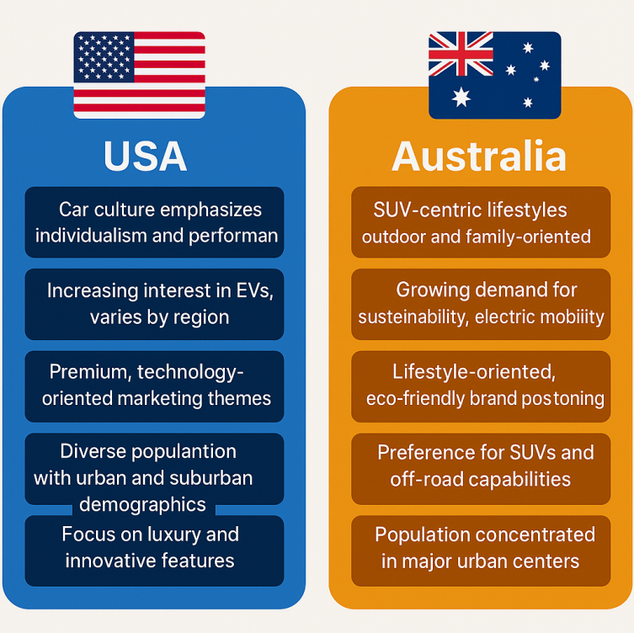
Figure 2: Comparison of the socio-cultural context of the USA and Australia
(Source: Self-Created)
Political Factors
Australia
The stable government and open trade policy of Australia serve the foreign auto manufacturers such as BMW. The New Vehicle Efficiency Standard (NVES) came into effect in 2024 and takes effect in July 2025. and it is expected to reduce vehicle emissions by 60% by 2030 (BMW Annual Report, 2024). This is a positive aspect of BMW i4 and iX electric models, which are in line with the global sustainability objectives of the company. Tariffs and logistics, however, also present cost challenges as all cars are imported by BMW. Federal initiatives like Future Fuels and Vehicles Strategy are also encouraging low-emission automobiles, which can be seen as a positive contribution to the ethical marketing approach of BMW to clean technology and long-term environmental pledges.
USA
The USA has a politically favourable climate for manufacturing and EV innovation. The 2023 Inflation Reduction Act and the 2024 Multi-Pollutant Standards by the EPA encourage cleaner vehicles and local manufacturing. Its Spartanburg, South Carolina, plant manufactures more than 400,000 vehicles each year, and this gives BMW a stronger market presence and stability in terms of supply (BMW Annual Report, 2024). The National Electric Vehicle Infrastructure (NEVI) Programme, funded by the government that assists BMW in increasing the number of EVs sold, helps the company improve the accessibility of charging, an aspect that serves to strengthen its market presence based on its purpose and its sustainability-focused approach.
Favourable and Unfavourable
The stable political environment is favourable for BMW as it will support it decreasing operational risk for the organisation. Further, the shift in government priorities can be unfavourable to the organisation as it can lead to uncertainty for long-term EV strategy.
Economic Factors

Australia
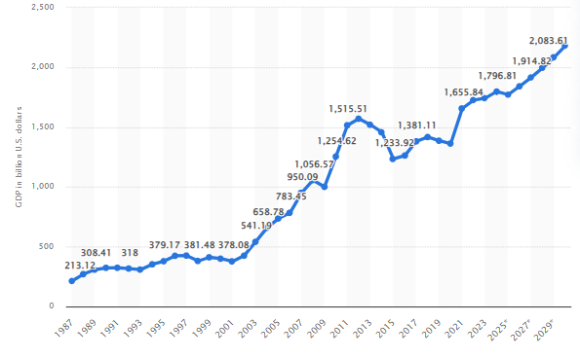
Figure 3: Gross domestic product (GDP) of Australia 2030
(Source: Statista, 2025a)
The statistic depicts Australia's gross domestic product (GDP) from 1987 to 2024, with projections up until 2030. In 2024, GDP in Australia amounted to about 1.8 trillion US dollars (Statista, 2025a). Sales of BMW increased by 9.1% annually to 13,641 units, owing to the growth in X-series factory-made SUVs and electric vehicles (BMW Annual Report, 2024). Their market is based on high-quality imports, and the higher the tariffs, the higher the price of cars. Nevertheless, the luxury demand is maintained by low unemployment and unstable growth. The premium brand image of BMW can be preserved in the context of economic stability and consumer confidence, as well as qualifying electrification as an aspirational trend.
USA
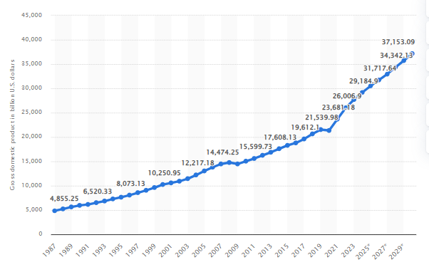
Figure 4: Gross domestic product (GDP) of the United States at current prices from 1987 to 2030
(Source: Statista, 2025b)
The statistic shows the gross domestic product (GDP) of the United States from 1987 to 2024, with projections up until 2030. The gross domestic product of the United States in 2024 amounted to around 29.18 trillion U.S. dollars (Statista, 2025b). It is perfect with premium products because it is characterised by high disposable income, developed financing and developed competition. In 2024, BMW sold 371,346 vehicles with 50,981 EVs, which is an average annual growth of 2.5% (BMW Annual Report, 2024). The healthy auto credit system favours leasing and financing, giving more access to luxury cars.
Favourable and Unfavourable
The growth in the GDP and high disposable income is favourable to the company as it indicates a strong customer purchasing power to invest on premium brands. Also, it will help in increasing the production capacity of the firm. On the other hand, higher tariffs are unfavourable to the company as it will make the firm vulnerable to price hikes due to logistics costs and tariffs.
Social Factors
Australia
Smart Australian consumers appreciate practicality, safety and sustainability. Statistics of the government indicate that more than 55% of all vehicles are sold in the form of SUVs, indicating that the BMW X-series is successful. The values associated with the culture are the focus on equality and living outside, which makes BMW promote itself as a luxurious lifestyle brand (BMW Annual Report, 2024). The change towards sustainability increases the interest in EVs such as iX1, as it represents the changing perceptions of contemporary luxury.
USA
Cars are an embodiment of freedom and status in the USA. The Ultimate Driving Machine slogan of BMW rather adheres to the American individualism and aspiration. The Electric and hybrid vehicles are in demand due to increasing environmental awareness and, in particular, among millennials. Instagram and other social media platforms are effective in fostering emotions, and this is why BMW USA can address various audiences by using performance, technological, and sustainability stories.
Favourable and Unfavourable
The increasing SUV popularity and EV trend is favourable for the organisation as it will support in building strong customer base and invest more in eco-friendly vehicles. Income inequality can be unfavourable to BMW as it limits the access of lower-income consumers to luxury vehicles.
Technological Factors
Australia
The National EV Strategy 2023 of Australia has a target of installing 100,000 public chargers by 2030, which would enhance EV preparedness. BMW incorporates a high level of technology, such as the MyBMW App and AI-assisted technology, to improve user experience. Although EV infrastructure development is still lagging in comparison with the USA, the increase in awareness of the concept of innovation provides BMW with an opportunity to become the first company to digitalise the market.
USA
The USA has the greatest number of automotive research and development and EV infrastructure in the world. A super-network of more than 180,000 public charging points is available, and cooperation with the charging points of the Tesla Supercharger network gives EVs convenience. The Spartanburg plant of BMW utilises robotics and AI-related programmes, pays attention to digitalisation, connected mobility, and smart manufacturing (BMW Annual Report, 2024).
Favourable and Unfavourable
Advanced EV infrastructure is favourable to BMW as it will support the firm’s consumers to conveniently charge their EV vehicles, thereby, building strong brand image. High innovation pressure is unfavourable to certain extent as it demands upgradation on a constant level, thereby, increasing operational and R&D expenses.
Legal Factors
Australia
The NVES Act 2024 will involve more stringent carbon policies, which will affect the import portfolio of BMW and the cost of compliance. They guarantee ethical use of data and advertisement transparency through the Privacy Act 1988 and the Australian Consumer Law. These legislations influence (Manwaring, 2022) BMW in terms of ethical marketing communication and reinstates its image of responsible business conduct.
USA
The EPA Emission Standards (2027-2032) and the California ZEV Programme are very aggressive in terms of their targets. BMW will have to comply to maintain brand credibility and not to suffer fines. The privacy laws, such as the California Consumer Privacy Act (CCPA), affect BMWs connected-car data processing, which shapes its online marketing and customer trust philosophy (Yang and Leon, 2023).
Favourable and Unfavourable
Following consumer protection and privacy laws are favourable as it will help BMW to maintain long-term trust with the consumers and strengthen stakeholder relationships. Aggressive emission standards and stricter carbon policies are unfavourable for BMW as it will increase compliance costs and require rapid innovation.
Environmental Factors
Australia
The Climate Change Act 2022 of Australia is bound to a 43% reduction of emissions in 2030 and net-zero in 2050. BMW contributes to it with carbon-neutral logistics, recycling, and EV promotion. BMW's eco-marketing campaign positively reacts to the climate-conscious consumers, who react to sustainability campaigns as an ethical requirement in the Australian market, which is environment-driven (BMW Annual Report, 2024).
USA
The USA aims to achieve net-zero emissions by 2050, and state and federal funding increases the adoption of EVs. The American climate goals are in line with the sustainability strategy of BMW, which is responsible sourcing, circular economy practices, and 17.4% of 2024 global sales of EVs (BMW Annual Report, 2024). The environmental friendliness of BMW and its ethical and transparent attitude towards emissions make the company competitive in a green-minded market.
In this comparison, Australia as well as the USA, presents BMW with profitable and distinct business environments. The USA is large-scale, has an infrastructure and a policy incentive to promote innovation-based marketing, whilst Australia has an import market and a sustainability agenda that encourages eco-luxury branding. The success of BMW relies on the ability to create a balance between global efficiency and local cultural, regulatory and environmental responsibility.
Favourable and Unfavourable
Eco-conscious market is favourable to the company as it will enable BMW to focus strongly on manufacturing eco-friendly automobile and contribute to sustainable environment. On the other hand, competitive pressure can be unfavourable as it will create pressure on BMW to attain aggressive climate goals, thereby, increasing operational costs.

Similarity and dissimilarity
It is to be pointed out that stable political systems, strong sustainability agendas, wealthier consumers, and a developing interest in EV are effective for running business smoothy. These factors indicate that markets are appealing to increase production and meet the demands for the customers.Apart from that, scale of manufacturing, extensive EV charging infrastructure, and sales volume indicate advantage to BMW as it can support in meeting market needs and provide convenience to customers and increase sales revenue.
In context to dissimilarity, it can be indicated that legal frameworks differ in complexity, which can increase the compliance costs for the organisation. In addition, product restrictions vary on the basis of local legislation, thereby, can create issue to align business policies with the rules set by the governments.
Social Factor Advantage and Disadvantage
There is an increasing demand of luxury and eco-friendly vehicles among customers as it not only provides comfort but also ensure safety. This helps the organisation in boosting sales. In addition, social media platforms significantly support the organisation to emotionally connect with diverse customers. On the other hand, high competition from different luxury brands create pressure on BMW to control customer switching costs. Also, urban mobility shift is a disadvantage as customers would have less car ownership.

Cultural factors based on Hofstede’s six dimensions
Through the application of the six-dimensional model that Hofstede created, it can be realised that both countries are highly rated on Individualism (the USA has 91, Australia has 90), but the implications are dissimilar. For instance, according to The Culture Factor (2020), in the USA, the culture of individualism promotes consumerism based on self-expression and high-status symbols. Individualistic tendencies are largely the same in Australia. However, over exaggerated status display is supported by the egalitarianism of Australian culture. Regarding Masculinity, the two nations have competitive and achievement-oriented cultures (USA 62, Australia 61) (The Culture Factor, 2020).(Refer to Appendix 2).
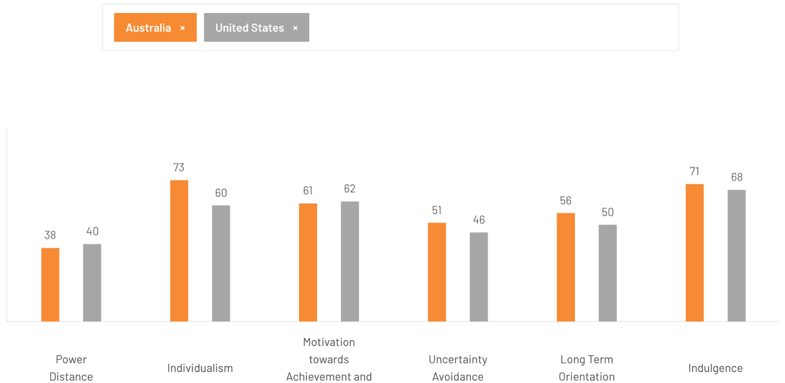Figure 5: Country comparison
(Source: The Culture Factor, 2020)
In turn, sport sedans and high-performance cars offered by BMW have a stronger appeal to the US market, whereas SUVs and crossovers, including X-series, are, in fact, more compatible with the Australian taste. In Power Distance (USA 40, Australia 36), it becomes more apparent that differences arise. Both societies anticipate relatable luxury, although Australia scores lower, which increases the demand for openness and unofficial communication. In response, BMW is taking a more simplified service experience in Australia as opposed to the more premium service expectations in the USA. Uncertainty Avoidance, the USA is slightly lower (46) in comparison with Australia (51), which shows that Americans are more open to technological change. According to IwanKoerniawanet al. (2024), this facilitates the rapid adoption of the electric vehicles of the BMW in the USA, as the Australian consumers need more assurance. Regarding Long-Term Orientation, the two countries are highly inclined towards short-termism (USA 26, Australia 21). BMW hence focuses on instant performance, convenience, and experience in both markets. Lastly, Indulgence is high (USA 68, Australia 71), which facilitates high demand for luxurious experiences. BMW takes advantage of this in both countries and emphasises lifestyle-oriented luxury more in Australia.
Similarities and differences
The United States and Australia have many cultural similarities, including high levels of Individualism and Masculinity. This indicates that both countries place importance on personal choice, self-expression, accomplishment, and comfort. Both cultures are also classified as having high levels of Indulgence, which means there is a demand for luxury goods in both markets. However, there are a number of differences between these two cultures (Country Navigator, 2021). The Power Distance Index is slightly lower in Australia, so customers in Australia will expect informal communication and a simpler way of doing business than in the United States. Additionally, the Uncertainty Avoidance Index is higher in Australia, so consumers will need a greater degree of assurance when trying new technology such as electric vehicles. In contrast, because the United States is more accepting of new ideas, it is easier for a consumer in the United States to embrace BMW's new advanced and high-performance models (Country Navigator, 2021).

Favourable and Unfavourable condition of cultural model
BMW experiences favourable cultural circumstances as both countries scored comparatively high on Individualism (USA 91, Australia 90). This usually supports demand for premium brands, customised features, and performance vehicles. The high scores of Indulgences in both countries encourage the purchase of luxury vehicles as lifestyle enhancements. Unfavourable cultural conditions stem from some aspects of culture (BMW Group Careers, 2025). Furthermore, Australia has a strong egalitarian value orientation, which can limit acceptance of apparent status signalling, and it requires careful brand positioning by BMW. Additionally, Australia scored slightly higher than the USA on Uncertainty Avoidance (51), which may slow down the rate of adoption of EV's in the country (Padleyet al., 2022).

Advantages and Disadvantages of Hofstede Model
The cultural dimensions model by Hofstede has some strengths, one of them being that it brings about a systematic approach in the comparison of cultures, and the perception of how the cultural value system is applied in shaping consumer behaviour, management behaviour and communication approaches. According to Poulovaet al. (2024), it can be stated that the reason why it is widely used is that it is clear and can be used in situations related to international business. Nevertheless, the model is limited, as well. It is a simplification of complex cultural identities as it presupposes that national cultures are homogeneous and fixed. The data set in its initial form is not very current and relies on a limited sample, which makes it less relevant nowadays. In addition to this, the model can be reinforcing stereotypes as it groups whole groups of people into set dimensions of culture, which restricts its usefulness in multi-dimensional and dynamic societies.

Comparison of Brand’s STP strategies in the USA and Australia

STP Analysis in Australia
Segmentation
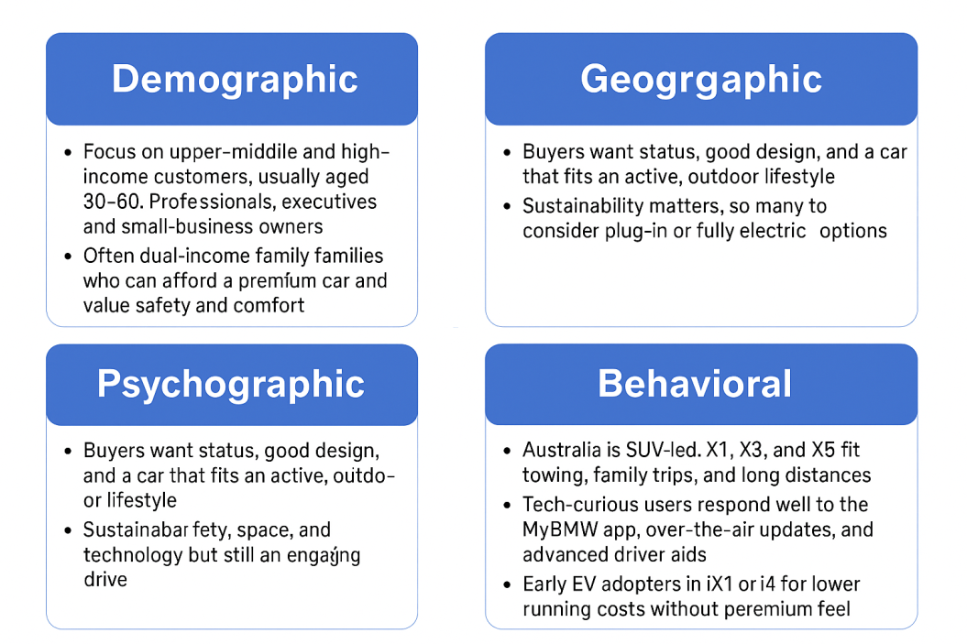
Figure 6: Market Segmentation in Australia
(Source: Self-Created)
- Demographic Segmentation: BMW targets customers on the upper-middle and high-income brackets and is typically aged between 30 and 60. They consist of professionals, executives and small business owners who have well-paying positions that are stable, such as finance, technology, and consulting. There are numerous two-earner families which can afford the models of the premium without having to struggle economically. The social status and prestige that come with the luxury brands are also appreciated by these customers.
- Geographic Segmentation: The large demand is concentrated in the urban areas and affluent suburbs such as Sydney, Melbourne, Brisbane, Perth and Adelaide. According to the Australian Bureau of Statistics, these cities comprise the majority of the luxury vehicle registrations (ABS, 2021). BMW dealerships are located strategically in these locations so that the areas are convenient and their services are proper. Other regional corridors that are seeing growth include Newcastle, the Gold Coast and Canberra, where infrastructure and fast-charging networks are growing according to the National Electric Vehicle Strategy 2023.
- Psychographic Segmentation: Australian customers of BMW are sophisticated yet realistic. They correlate the brand with contemporary style, luxury and security. The brand is targeted at customers who are interested in innovation yet seek the opportunities of long-distance drives and family usage. The national culture includes outdoor lifestyles, travelling at weekends, long road trips, etc; this is why the X-series SUVs (X1, X3, X5) are leading in the local sales.
- Behavioural Segmentation: Australia is still an SUV market. Space, practicality, and towing capacity are important to the customers. BMW SUVs are oriented towards making long trips and rougher roads, giving it an adventure feeling (Newsteadet al., 2024). Australian buyers are also becoming tech-curious, behaviourally, with connective-car technologies, remote diagnostics, and driver-assist systems gaining acceptance among them (Autotalk, 2024).
(Refer to Appendix 2)
Targeting
Through the use of differentiated marketing strategies, BMW in Australia is targeting some very specific segments such as Luxury Professionals, Families, Tech-Savvy Young Buyers and Eco-Conscious Drivers. Each segment has its own messaging, products/models and unique digital experiences that meet their specific lifestyles and preferences (Autotalk, 2024).
BMW is aimed at the wealthy, urban, educated and affluent professionals and families that require performance and practicality. Australian marketing strategies centre around the imagery of lifestyle, such as coastal driving, family leisure and outdoor adventure. They need to engage digitally, and BMW Australia use online configurators and virtual showrooms to appeal to younger buyers who are technologically advanced. Another segment of the target market that the company aims to attract is eco-conscious drivers who will be able to purchase its electric i-series models with the help of government incentives and the growing charging infrastructure.
Positioning
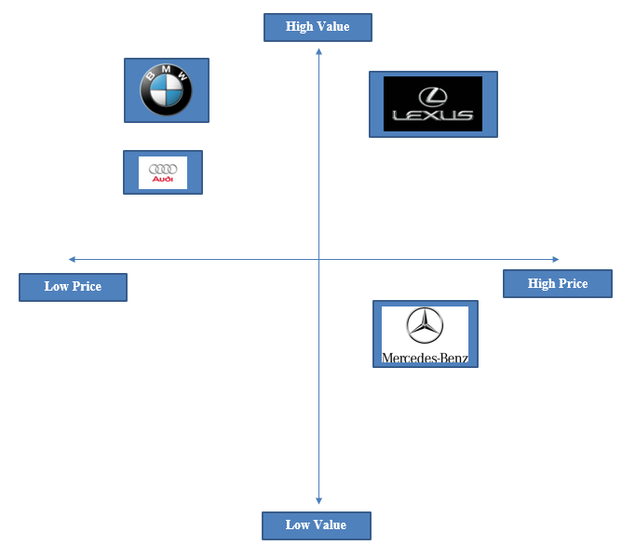
Source 7: Positioning Map
(Source: Self-Created)
BMW positions itself as high-end performance tuned to Australian ways of life. The brand image will be a combination of German engineering fineness and lifestyle flexibility. BMW competes directly against Mercedes-Benz, Audi, and Lexus, with the differentiation of its lively on-the-road experience and wide product range. Mercedes-Benz is associated with beauty and comfort, but the performance-based BMW design is more attractive to those drivers who also like to engage. Lexus is reliable and efficient, but it is concentrated on refinement and hybrids and not on dynamic excitement. Audi, despite its success in the fields of design and digital interiors, is weak in relation to the emotions that drive BMW.

STP Analysis in the USA
Segmentation
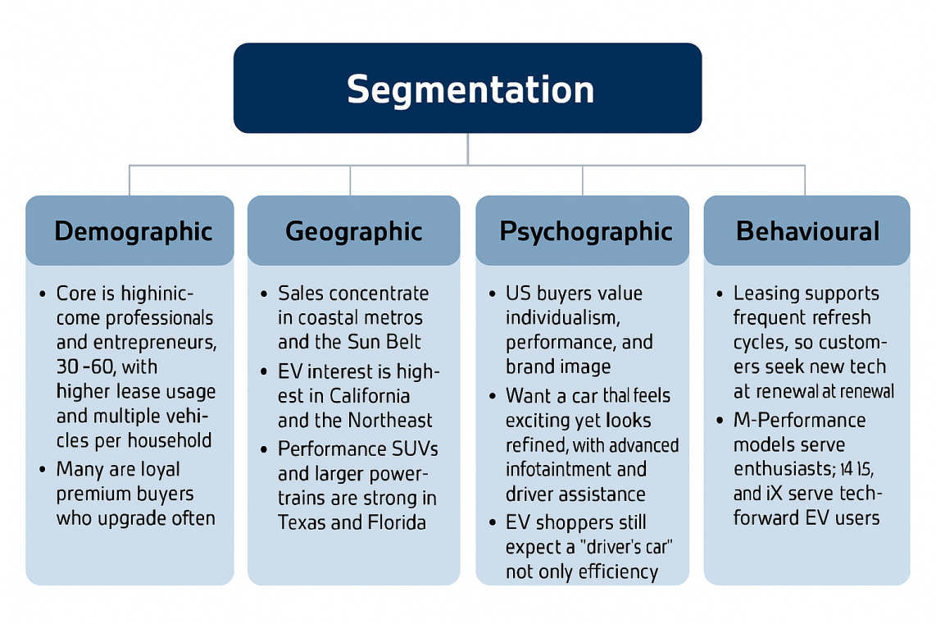
Figure 8: Segmentation in the USA
(Source: Self-Created)
- Demographic Segmentation: The US market of BMW is focused on professionals, business owners, and entrepreneurs between the ages of 30 and 60 that are having a good income. They tend to be the managers or executives and early adopters of technology. Most of them are multi-car families, with a combination of performance, SUV, and EV cars. Long-term reliability, prestige and personalisation are some of the values that these customers appreciate.
- Geographic Segmentation: The areas where the BMW has the strongest coverage are coastal states and large metropolitan areas, including California, New York, Texas and Florida. State incentives and environmental consciousness have seen California and the Northeast dominate the EV sales, and the Sun Belt territories, especially Texas and Florida, exhibit a higher demand for powerful SUVs and M-performance models, which are perceived as a result of the road conditions and consumer preferences.
- Psychographic Segmentation: The American consumers appreciate individuality, freedom and performance. The brand has a long-running slogan of The Ultimate Driving Machine that is directly related to this state of mind (BMW Annual Report, 2024). BMW customers view the company as a symbol of success and self-identification. High-tech infotainment systems, voice acknowledgement and AI-driven driver assistance appeal to consumers who value both technology and luxury, as well as innovation.
- Behavioural Segmentation: In the USA, the dominance of premium vehicle consumption is made up of leasing. BMW clients enjoy upgrading the leasing period to 36-48 months which enables them to frequently upgrade to the new technology. This action is advantageous to the unrelenting innovation and application of software at BMW. The M-performance range attracts enthusiasts, and the i4, i5, and iX appeal to the technology-oriented customers. Virtual service options, online retailing, and digital showrooms improve customer interaction due to the aversion to inconvenience and the desire to be digital by the US consumer.
Targeting
BMW focuses on high-income, high-tech and experience-sensitive clients, who value performance, prestige and technology. The US marketing strategy is centred around emotion and aspiration- the combination of visuals of a luxurious lifestyle and cutting-edge innovation. Diverse leasing options, favourable residual value and built-in online services make accessibility to repeat buyers easier.
BMW has a differentiated marketing strategy in the United States, with a target market based upon consumers' lifestyles, income levels, performance preference, and openness to new technology. Consumers who buy from BMW are mainly enthusiastic about high-performance fast cars and also tend toward being among the first to purchase electric vehicles (BMW Group, 2024). Consumers looking for high-performance vehicle buyers typically desire a solid reputation, advanced technology features, and the ability to express their personal identity through the car they drive. BMW wants to be perceived in the United States as a premium, high-performance, technology-oriented automaker, emphasising innovation, high-speed capabilities, and luxuriousness in their high-performance vehicle models and expanding EV portfolio. This strategy of targeting niche groups with a high degree of loyalty allows BMW to attract these customers, but it may also limit the company's ability to mass-market products due to the lack of targeting for all segments of the automotive market (BMW Group, 2024).
Positioning
In the US, BMW markets itself as The Ultimate Driving Machine- future refined. The brand combines sportiness with luxury and is currently sustainable. It has three large competitors in Mercedes-Benz, Tesla, and Cadillac. Mercedes-Benz is superior in terms of comfort and presentation of luxury, but it does not possess the balanced handling and sport orientation of BMW. Tesla has the strongest EV technology and lacks the after-sales quality and interior polish as BMW.
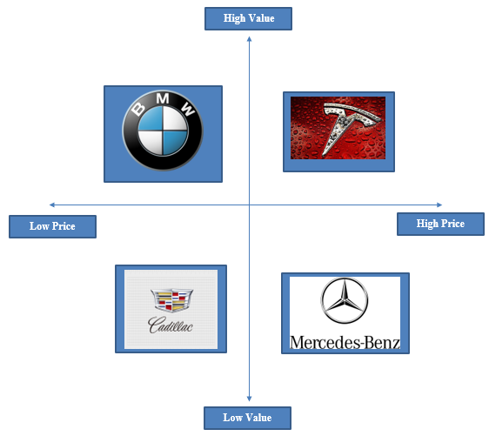
Figure 9: Positioning Map
(Source: Self-Created)
The luxury positioning of Cadillac has also been enhanced, although it is more value-based and does not have the prestige of BMW on a global scale. This inherent equilibrium of passion, digital connectivity, and sustainability is the ingredient that solidifies BMW as the most holistic luxury brand to American customers who need both feeling and functionality.

Similarities and differences
BMW employs comparable segmentation strategies in Australia and the United States, focusing on affluent professionals between the ages of 30 and 60, multi-car families, and buyers. The regions are similar in contexts surrounding high-income urban areas and attracting buyers who are interested in new and exciting technologies. However, differences appear in relation to lifestyle and behavioural preferences including the emphasis on practical use, outdoor lifestyles (BMW Group, 2024). Furthermore, growing demand for SUVs in Australia and the concentration in the USA on performance-driven buyers developed a greater appetite for EV models and M-models.

Comparison of Marketing Mix Strategies in the USA and Australia

Marketing mix comparison
According to Feed Digital (2020), the 7Ps of marketing mix include Product, Price, Place, Promotion, People, Process, and Physical Evidence. These Ps enable businesses to position offers effectively and it leads to customer experience improvements.
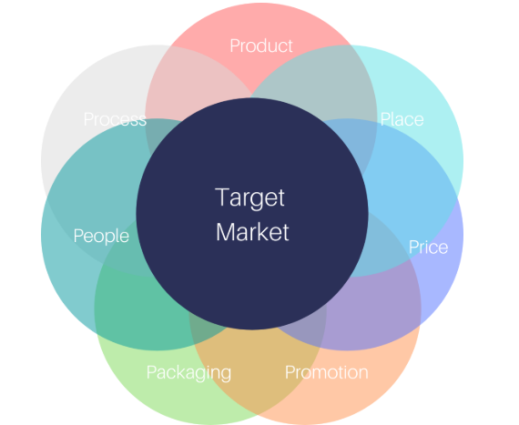
Figure 10: 7Ps of marketing mix
(Source: Feed Digital, 2020)
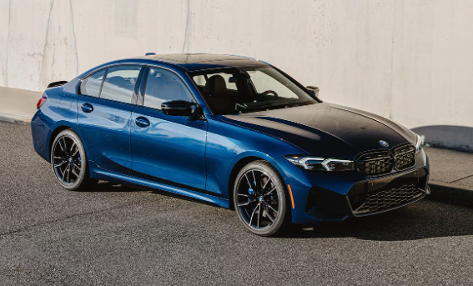
Figure 11: BMW USA
(Source: BMW Group, 2024)
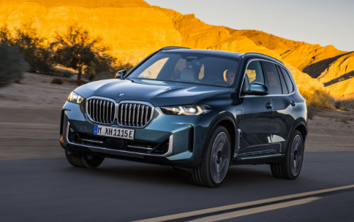
Figure 12: BMW Australia
(Source: BMW Group, 2024)
1. Product
BMW’s core product, premium performance, German engineering, and automotive technology is identical in both markets. Packaging attributes includes vehicle design, logo, digital interfaces, manuals, operating instructions, and safety communication (BMW Group, 2024).
Product Width
Australia has a narrower product width but a deep line-up of SUV models catering to the strong preference for X-series vehicles throughout Australia. Furthermore, Australia features a strong emphasis on the X-series (X1, X3, X5), which represented 55% of BMW's sales in 2024, indicating an SUV market preference (Davis, 2025). It is to be pointed out that BMW has similar product lines in both Australia and USA such as Sedans, Coupes/Convertibles, SUVs, Performance (M), Plug-in-Hybrids. However, Electric (i Series) in Australia includes iX1, iX3, i4 and iX whereas in the US, there is only i4 and iX electric series.
Product Depth
Considering depth of BMW in Australia, it is identified that there are 6 variants of 3 series whereas in the US, it has 7 variants. Considering Electric i4, BMW in Australia has 2 variants (M50, eDrive40) and in the US, it has 3 variants (M50, eDrive40, eDrive35).
2. Price
BMW implements a premium pricing strategy in USA and Australia, though purchasing behaviours differ (Lau, 2025). It has been identified that BMW models in Australia such as 1 series price starts at $58100-$84100, 5-series between $116,900 - $136,900 (Drive, 2025). For the USA market, BMW charge $39600-$49500 for BMW 2 Series Gran Coupe, $75150-$111500 for 2026 BMWiX (US News, 2025).
3. Place (Distribution)
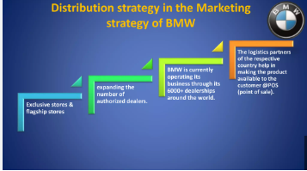
Figure 13: Distribution strategy in BMW
(Source: Davis, 2025)
BMW uses direct dealerships and indirect partners like leasing firms. The USA applies more intensive direct distribution, offering wider dealer access and faster availability across major states.
BMW sells its vehicles through both direct dealers and leasing companies that serve as indirect partners. In the United States, BMW sells directly to several dealers that allow for greater dealer access to vehicles, as well as greater product availability, since many states in the United States are large in area and have many BMW dealerships (Davis, 2025).
Channel Intensity: The USA has a high-density population of dealerships in each of the major states. However, there is a smaller ratio of dealerships in Australia and in Sydney, Melbourne, Brisbane, and Perth (Davis, 2025).
Channel Length: Both countries have direct dealerships, but the USA has BMW Financial Services as a key intermediary for the leasing structure (Davis, 2025).
Physical Distribution: The USA is well-positioned to benefit from a large volume of domestic manufacturing at its Spartanburg plant and is more cost-efficient (BMW Group, 2024). The sale of BMW in both the USA and Australia is based on the principle of direct exportation and retention of its own subsidiaries, which enables the company to have full control over branding, dealerships, and quality of services. The main advantage in this regard is lie in that the brand remains constant and more profits remain with the company (Lau, 2025). The disadvantage in both country cases is that it is costly to operate, there is a duty on imports in Australia, and maintaining a costly network requires a huge investment.
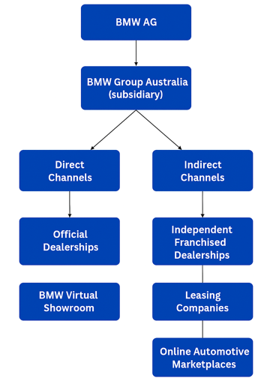
BMW of USA
Direct Channels
Indirect Channels
BMW Online Sales
Official Dealerships
Online marketplaces
Independent Dealerships
Figure 14: Channel of Distribution between Australia and USA
(Source: Self-Created)
Further, in context to indirect channels, it is to be indicated that BMW has authorised dealers and franchise networks, fleet partnerships and regional distributors in Australia. In the USA, BMW has large dealer networks, certified pre-owned programs and third-party leasing and rental companies. It is assed that while the organisation is a premium brand, its indirect channels are intensive within the luxury automobile category. The organisation ensures that it covers nationwide dealership in both Australia and the USA.

Market Entry Method
USA: In the USA, BMW has a strategy of intensive direct distribution through a large dealer network combined with the intermediary service of BMW Financial Services. The benefits of this strategy are that BMW can achieve a wide market reach, provide quicker access to their products and services and realise greater cost efficiencies through the production of vehicles within the United States (Holt, 2025). On the downside, the high level of competition between BMW dealers creates challenges for BMW with respect to maintaining control over pricing and exclusivity for their brand.
4. Promotion
In the USA, the organisational promotion objective is positioning the company as a performance-driven and premium brand appealing to tech-savvy and aspirational customers (BMW Group, 2025). BMW heavily utilise traditional and digital platforms to advertise about the brand. In addition, emotional and aspirational appeal is considered to drive buying intention amongst targeted customers. Apart from that, as a part of sales promotions, the company emphasises on providing seasonal offers and incentives. Moreover, press events are conducted for creating awareness about new vehicles or models and also personalised email campaigns are done for promoting the products.
In Australia, BMW focuses on creating its image as reliable and luxurious brand that aligns with lifestyles of customers in the country. In the Australian market, the organisation significantly uses digital channels, outdoor billboards in urban regions and print in auto magazines for advertising range of vehicles. On the other hand, lifestyle and rational appeal is considered by BMW and use trade-in bonuses and end-of-financial-year deals as sales promotion techniques. Further, dealer outreach, loyalty programs and different sponsorships are used to promote new models. In both markets, adaptation is used in promotional activities to connect with customers.
5. People
BMW's training is globally standardised, as with service expectation, there are local differences. American audiences generally expect premium service and elaborately constructed personalisation (BMW Group Careers, 2025). Australia's service preferences lean towards transparency, approachability, and straightforward communication as honouring a more significant cultural norm grounded in egalitarianism. BMW Manufacturing in Spartanburg is the largest BMW location in the USA of all the locations globally. It employs more than 11,000 people. BMW Group has a total workforce amounting to 159,100 (BMW Group, 2024). In fact, BMW Group Australia estimates approximately a number of 152 workers (IBISWorld, 2024).
In context to staff training programs, it is to be indicated that the organisation considers different programs in Australia such as BMW #NextTech Apprenticeship Program, OEM Technical Training (I-Car Australia, 2025) whereas in the USA, it has BMW STEP (Service Technician Education Program), BMW Scholars Program and BMW FastTrack Program (BMW Group, 2025). On the other hand, different motivational strategies used in BMW Australia such providing competitive pay, making strong investment in management development and technical training and using structured feedback systems. In the case of BMW USA, the organisation use advanced leadership programs, create performance-driven and inclusive workplace culture and regular performance reviews for motivating staff.
6. Process
Both markets are experiencing the use of digital tools including the My BMW App, online configurators, and virtual showrooms. The USA market continues to have a much larger reliance on digital conversion, as car buying and leasing systems are more widely devoured (BMW Group, 2024b). Consumers in Australia rely on digital tools mostly for research and the final transaction is made within the dealership experience. BMW no longer uses the traditional advertising but campaign that is focused on emotion, performance, motorsport associations, and lifestyle stories. The messages are reconfigured to suit the markets and target consumer expectations that are in the transformation (Lau, 2025).
In the USA, within the framework of the customer complaints process, a BMW Representative reads the case after it is submitted over the hotline or a contact form and responds to it within one business day, in general. In the case of safety or recall-related problems, a special call centre known as the Recall Hotline (1-800-525-7417) and BMW permit the customers to obtain free of charge recall repairs at any BMW (BMW USA, 2025). Whereas in Australia, the official process of complaint/feedback is available on the BMW Australia site, but is focused on the financial part mainly, with a general contact us / support option also being available. Complaints about vehicle service or dealer service may well compel you to call your authorised dealer and BMW Customer Support (Complaint Info, 2018).
7. Physical Evidence
Both BMW markets use retail stores to maintain premium physical evidence, but the scale at which each country does so is quite different. In the USA, BMW operates a large network of contemporary dealerships, which have very large showrooms as well as service centers (Refer to Appendix). In Australia, although there are fewer dealerships than in the USA, the stores still adhere to the same luxury design standards (BMW, 2025). Each market also uses a specific website for each country that has features such as online configurations, virtual showrooms, and reservation tools.
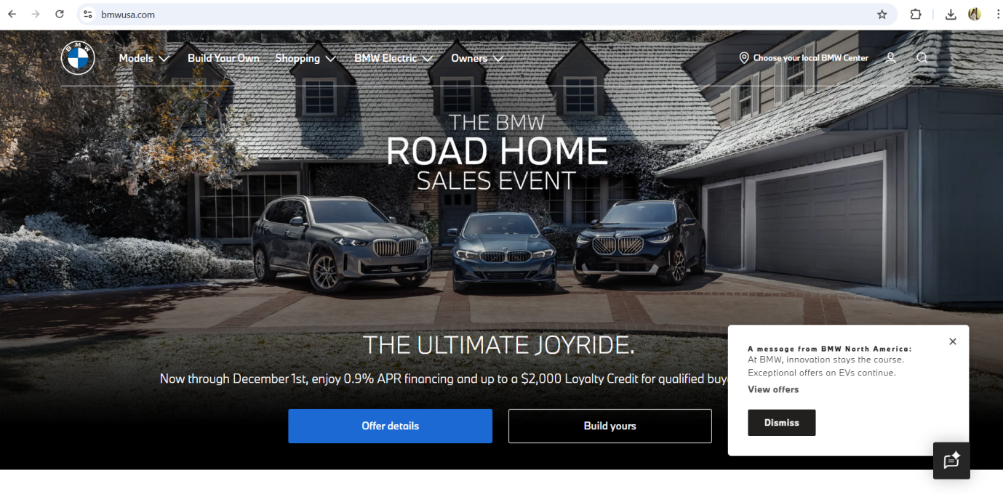

Figure 15: BMW USA Website
(Source: BMW, 2019)
For staff, both markets use the same global uniform guidelines established by BMW, namely, staff must wear a suit in either black, white or navy to reflect the branding of the company as well as to create consistency within the premium brand in each region. There are, however, some regional differences in the staff's uniforms due to local climatic conditions and the design of the dealership's branding (BMW, 2019).
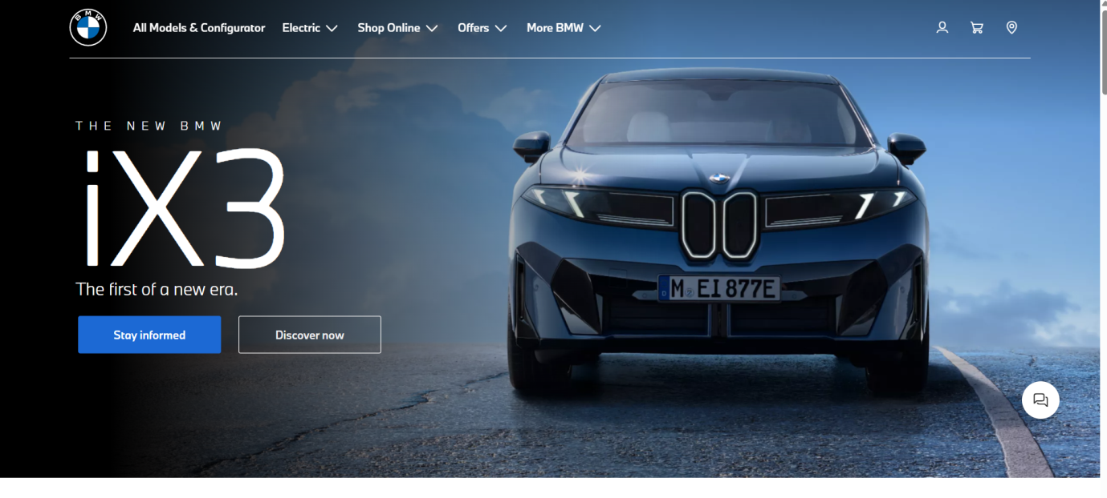
Figure 16: BMW Australia
(Source: BMW, 2025)

Similarities and differences
BMW's strategies regarding the marketing mix in the USA and Australia contain several similarities that derive from the brand's common premium stature on a global scale. In both markets, the brand maintains similar engineering quality standards, as well as luxury positioning (BMW Group, 2024). In both markets, pricing follows a premium model, and it shares strong digital processes that can support direct sales including virtual showroom and an online configurator. However, most notably, significant differences appear in relation to cultural preferences, size of the market, and economic conditions. The U.S. has a much higher volume of sales, as well as the highest rate of EV subscription and purchases (Davis, 2025). Australian market is solely dominated by SUV demand and therefore requires BMW to focus on products related to the X-series and lifestyle marketing.

Evaluation of the performance of marketing strategies

USA’s performance
Analysing the image provided below, it can be stated that the current performance of BMW in the United States is characterised by obvious recovery and a positive trend after previous difficulties with the market. For instance, according to Statista (2024), BMW experienced solid quarter-over-quarter sales growth in the 2021-2023 period and exceeded the results of 2020, which indicates that the company obtained greater demand in the high-end car category.
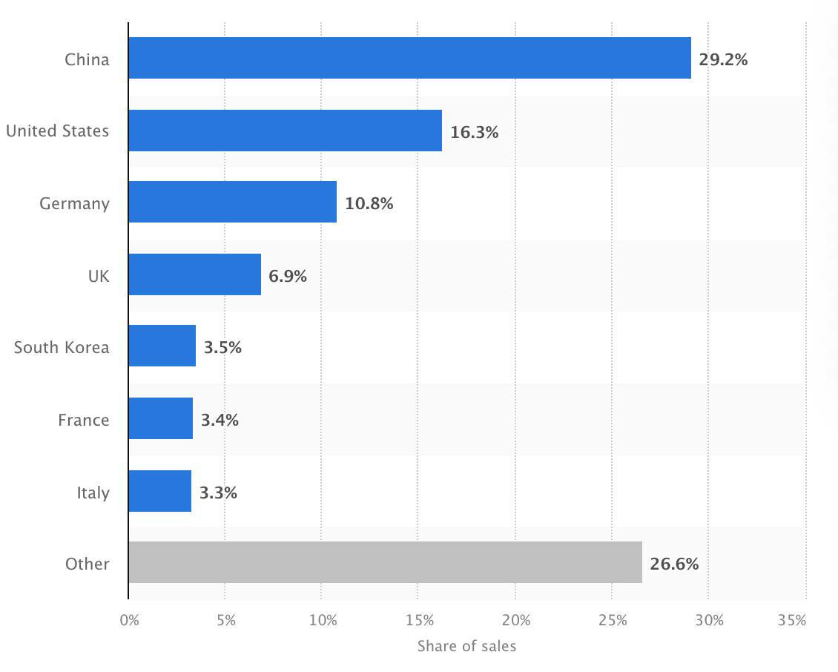Figure 17: Revenue of BMW in the USA
(Statista, 2024)
In May 2019, the sales of MINI were 33.2% less than it was in the same period the year before. Although the growth of revenues in 2020 was modest, and the overall economic situation is questionable, BMW proved to be resilient, and its year-end sales in the U.S. in 2021 improved substantially in 2021 as compared to 2020. This trend persisted and by 2024, the brand had recorded the highest sales in the United States since 2007 (Statista, 2024). In 2024, 371,346 cars were sold in the USA, and there are numerous dealerships nationwide with the aid of cars produced in the USA cars (BMW Group, 2024). Altogether, the performance of BMW suggests well-developed market recovery due to the effective strategy of product positioning, rising SUV demand, and consumer trust in the luxury cars category. Based on a survey conducted by a U.S. consumer-advocacy group, in 2022, BMW was ranked 3rd in a list of most reliable car brands, indicating that the appearance of reliability is generally positive among consumers, albeit not directly equated with being a satisfied customer. BMW has a diversified and broad range of products, including Traditional sedans, SUVs, and Battery-electric cars.
Social Media Engagement and Customer Reviews for BMW USA
BMW USA's performance orientated campaign on social media, collaborating with influencers and motorsport content is proof of their high level of engagement with consumers using these types of campaigns. It is to be further pointed out that different social media platforms such as TikTok, Instagram, YouTube, etc. are leveraged with high performance and high-quality lifestyle content. Consumers in the United States are highly satisfied with BMW’s products, as customer reviews consistently mention powerful engines, advanced technology, and driving dynamics (BMW Group, 2024). BMW has successfully matched its messaging to the expectations of consumers looking for an innovative and high-quality luxury vehicle. However, it is also noted that customers shared problems related to repairs, warranty claims, manufacturing defects, etc. (Trust Pilot, 2025).

Australia’s performance
The 2025 performance of BMW in Australia would mean that it is the dominant player in the market, and the brand has a long life in the premium car market. As per Brogan (2025), it is reported that the sales statistics of H1 2025 will see BMW dominate the premium market by a huge margin compared to other competitors like Mercedes-Benz, Lexus, and Audi.
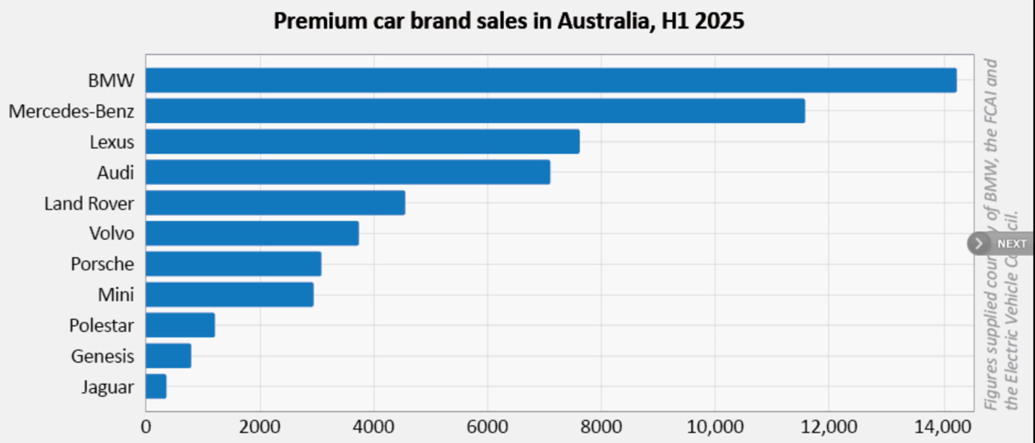Figure 18: BMW sales report in Australia (2025)
(Source: Brogan, 2025)
Nonetheless, according to EV Depreciation (2025), the share of depreciation also indicates the positive market stance of BMW. The model years 2023 and 2024 have a high retention value of 74.8 % and 89.9 %. This announces good resale performance and good brand equity.
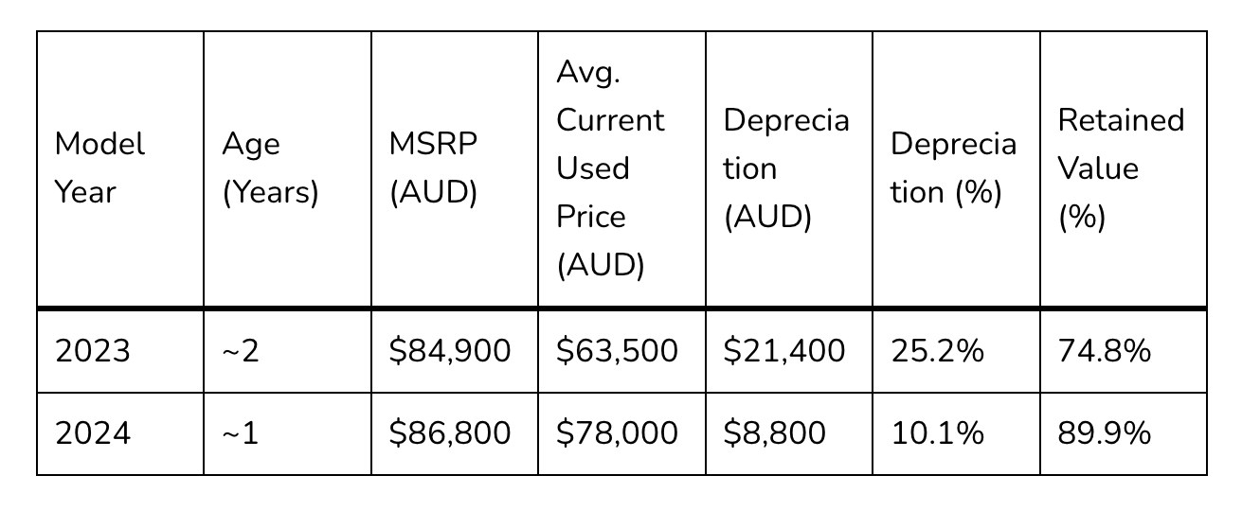Figure 19: Current Depreciation of BMW iX1 xDrive30 M Sport (model year 2025)
(Source: EV Depreciation, 2025)
The comparatively smaller depreciation of the newer models, including the 2024 range, implies the increasing confidence of the consumer, especially in the latest technological advancements and design development at BMW. Australia has less car sales, in the previous year Australians sold 13,641. There are very few models, which are entirely imported, therefore being costly, and this makes the market limited.
Social Media Engagement and Customer Reviews for BMW Australia
BMW Australia’s social media engagement and customer feedback highlight mixed perceptions of the brand. For engaging Australian customers, the organization emphasizes on data-led campaigns using social media platforms. Also, collaboration with different agencies is done through exclusive media collaborations and tailored landing pages. As per Trustpilot (2025), On platforms such as Trustpilot, where BMW Australia holds a low rating of 2.1/5, customers frequently report issues involving service delays, high maintenance costs and poor communication. Apart from that, it is observed that there are 74% negative feedback and less positive feedback, where customers mostly complaints about poor service, deceptive sales tactics (Product Review, 2025).

Similarity and differences
This analysis establishes that in the United States, BMW has been in the recovery phase due to the increasing demand in the luxury SUV market and a stable recovery since previous market instability, which will result in record sales in 2024 (Statista, 2024). Conversely, the Australian market will not only have good sales leadership in 2025 but also high retained vehicle value, which entails a stronger brand equity and consumer confidence (Brogan, 2025). As the U.S is a mirror of performance revival and rising competitiveness, Australia demonstrates dominance in the market with the combination of high resale value and high demand for electrified and all-purpose models.

Evaluation of marketing ethics practice

Ethical issues in adaptation, pricing, advertising and treatment of local employees
According to Mahajan et al. (2023), the Stakeholder Theory may be used to find out the problems and the way they affect the customers, the employees, the regulators and the society. Supply-chain transparency is one of the most critical ethical problems in the operations of BMW in Australia. According to The New Daily (2024), it was reported that there were serious concerns that BMW might have employed parts supplied by forced-labour facilities. Though BMW underlines that its suppliers should adhere to its rigid human-rights policies, critics state that the company still cannot give enough attention to sub-suppliers. This is an expression of the idea of marketing products ethically, in which companies need to make sure that goods are not manufactured under harmful, exploitative, and unsafe conditions (Erdener Kaynak and NedjetDelener, 2019). A failure of procedural justice can be evidenced by the fact that the criticism that BMW has no control over sub-suppliers indicates that the rules and the procedures of monitoring were not applied on all levels of the supply chain. Consumer Rights Theory is used when considering ethical pricing practices by focusing on fairness and informed choice. BMW Marketing (2024) reports that an ethical duty is taken into consideration when BMW requires dealers to conform to the Competition and Consumer Act 2010. Legal cases against BMW Australia Finance, however, are on the issue of misleading conduct. BMW has been rebuked by the regulatory bodies because of promoting unsafe driving.
An advertising campaign in 2024 was shut down upon the discovery of Ad Standards that scenes of skidding and airborne driving violated the FCAI motor-vehicle advertising code. This is indeed indicative of Virtue Ethics because the advertisement did not demonstrate responsible behaviour (Garcia-Ortega, Galan-Cubillo and de-Miguel-Molina, 2022). Since cars affect society's safety, ethical advertising is needed to ensure that there is trust in society. Ethical Problems in Pricing, in particular, the necessity to prevent false or unfair pricing (Erdener Kaynak and NedjetDelener, 2019). But the cases filed against BMW Australia Finance on grounds of misleading conduct show that there is a violation of ethical pricing standards since the cases are similar to the one outlined in the slide on Deceptive Pricing, with a hidden condition or misleading statement, which infringes consumer rights.
From the aspect of BMW’s supply-chain issues in Australia,procedural justice can be related. This indicates inadequate monitoring of sub-suppliers portraying the fact that rules for ethical sourcing were not applied across all levels consistently. This contradicts the justice approach’s requirement for fair and reliable procedures. As per Maiese and Burgess (2016), ethical pricing concerns and misleading conduct cases against BMW Australia Finance indicate violations of distributive justice. Consumers were not treated fairly in terms of truthful and transparent pricing. Although cultural relativism is less central here, societal expectations in Australia for responsible advertising and human-rights compliance demonstrate that BMW failed to align its actions with local ethical norms.

Overall ethical judgement
The general ethical appraisal of the BMW activities in Australia suggests that the company is formally concerned about ethical standards, but its application is inconsistent and, at some points, inadequate. As suggested by Sakyiet al. (2024), the accusations of supply-chain connections to forced labour are a grave violation of the deontological ethical duties, as they do not align with the declared human-rights and transparency focus by BMW(Refer to Appendix 3). This policy to practise disjuncture undermines credibility and underscores the shortcomings of supply-chain management. Pricing-wise, according to Goldfarb and Que (2023), BMW adheres to the Competition and Consumer Act, which implies that the Consumer Rights Theory is respected, but the past legal disputes on misleading practices indicate that human pricing has not been a priority in all cases. Equally, the regulatory fine due to unsafe advertisement shows a lack of conformity with Virtue Ethics since the campaign did not instil the socially responsible behaviour. In general, therefore, it can be concluded that the ethical behaviour exhibited in Australia by the BMW company can be considered as partially ethical, though inadequate in terms of ethics.

Recommendation and Conclusion

Recommendations
Recommendation 1: Reinforce ethical supply-chain governance and consumer assurance mechanisms in Australia
- BMW must enhance its ethical supply-chain governance and consumer assurance measures by adopting an independent third-party audit model on all Tier-2 and Tier-3 suppliers who are in operation in Australia. This is a direct reaction to the forced-labour parts allegation and corresponds to the Stakeholder Theory, as it focuses on the transparency of the regulators, consumers, and employees (Jain, Courvisanos and Subramaniam, 2021).
- MMW needs to launch Australian-focused ethical communication campaigns that would underline responsible sourcing, sustainability, and adherence to AANA and FCAI advertising codes. Since Australia has a medium Uncertainty Avoidance (51), ensuring that people get informed about the clear, risk-averse news regarding EV safety, battery sources, and environmental advantages would help make people trust the product more and ensure brand legitimacy in the long term.
Recommendation 2: Enhance ethical consumer-centric pricing and communication practices in the USA
- In the case of the USA, BMW needs to improve on ethical consumer-centric pricing and communication understanding by improving disclosure mechanisms in its financing and leasing businesses. This is vital in a market that is characterised by high individualism and common leasing behaviour, where informed choice is the main focus of ethical pricing in the Consumer Rights Theory (Antoninaet al., 2024).
- BMW needs to move to an open digital pricing platform that explains the interest rates, leasing rates and total ownership to avoid claims of the misleading-conduct. At the same time, the U.S. communication approach must emphasise performance, customisation, and technological innovation, the most important drivers of the American consumers, and incorporate a clear safety communication message to prove that it is in compliance with Virtue Ethics and changing FTC standards of advertising.

Conclusion
In conclusion, it could be stated that the success of the international marketing of BMW in the USA and Australia lies in the power of this company to strike a balance between global brand identity and adaptation to the market locally. As it has been compared, the difference in socio-cultural and economic and regulatory environments plays a key role in defining the STP and marketing mix strategies of BMW. Whereas the USA is a technology-focused, performance-based and EV-prepared market, Australia is a country with a more practical, style-and-fits-lifestyle and rising sustainability needs.

Reference List
ABS. (2021) Motor Vehicle Census, Australia, 31 Jan 2021 (2021). [online] Available at: https://www.abs.gov.au/statistics/industry/tourism-and-transport/motor-vehicle-census-australia/latest-release. (Accessed 28 October 2025).
Antonina, S. et al. (2024) ‘Corporate Social Responsibility communication from multinational chocolate companies’, Sustainable Futures, 7, p. 100151. Available at: https://doi.org/10.1016/j.sftr.2024.100151.
Antonio (2025) New & Used BMW Car Dealer | Principle BMW of San Antonio,Bmwofsanantonio.com. Available at: https://www.bmwofsanantonio.com/ (Accessed: 25 November 2025).
Autotalk. (2024) BMW Australia achieves 9.1% sales increase in first half of 2024 (2024). [online] Available at: https://autotalk.com.au/industry-news/bmw-australia-achieves-9-1-sales-increase-in-first-half-of-2024. (Accessed 28 October 2025).
BMW (2025) ‘Sheer Driving Pleasure’: BMW slogan history | BMW.com, Bmw.com, BMW, [online] Available at: https://www.bmw.com/en/automotive-life/the-history-of-the-bmw-slogan.html? (Accessed 1 December 2025).
BMW Annual Report.(2024) Annual Report 2024. [online] Available at: https://www.annualreports.com/HostedData/AnnualReports/PDF/OTC_BAMGF_2024.pdf (Accessed 28th October 2025).
BMW Group (2024) Plant Spartanburg, Bmwgroup-werke.com, [online] Available at: https://www.bmwgroup-werke.com/spartanburg/en.html? (Accessed 1 December 2025).
BMW Group (2024a) A successful 2023: BMW Group posts record sales, meets ambitious e-mobility growth targets, www.press.bmwgroup.com. Available at: https://www.press.bmwgroup.com/global/article/detail/T0438999EN/a-successful-2023:-bmw-group-posts-record-sales-meets-ambitious-e-mobility-growth-targets?language=en (Accessed: 22 November 2024).
BMW Group (2024b) BMW Group Connected Car Technology, www.bmwgroup.com. Available at: https://www.bmwgroup.com/en/innovation/connected-car.html (Accessed: 22 November 2025).
BMW Group (2025) BMW Group, www.bmwgroup.com. Available at: https://bmwgroup.com/ (Accessed: 1 December 2025).
BMW Group (2025). Start your future with one of our apprenticeship programs. Available at: https://www.bmwgroup.jobs/us/en/opportunities/apprenticeship.html (Accessed 8 December 2025).
BMW Group (2025a) BMW Ranked #1 in Social Media Aptitude by Digital Innovation Think Tank L2, www.press.bmwgroup.com. Available at: https://www.press.bmwgroup.com/usa/article/detail/T0111993EN_US/bmw-ranked-1-in-social-media-aptitude-by-digital-innovation-think-tank-l2?language=en_US (Accessed: 22 November 2025).
BMW Group (2025b) Respect for Human Rights at BMW Group, www.bmwgroup.com. Available at: https://www.bmwgroup.com/en/sustainability/human-rights.html (Accessed: 22 November 2025).
BMW Group Careers (2025) Our Culture & Values | BMW Group Careers, www.bmwgroup.jobs. Available at: https://www.bmwgroup.jobs/in/en/culture.html (Accessed: 22 November 2025).
BMW Group. (2024) Woodcliff Lake, NJ – January 3, 2025… BMW of North America today reported Q4 2024 and full year 2024 sales results for the BMW and MINI brands in the U.S..[online] Available at: https://www.press.bmwgroup.com/usa/article/detail/T0447290EN_US/bmw-of-north-america-reports-q4-2024-u-s-sales-results-sets-new-benchmarks-for-annual-sales-and-bev-sales?language=en_US. [Accessed 28th October 2025]
BMW Marketing (2024) 2024 BMW MARKETING GUIDELINES.BMW AUSTRALIA AND NEW ZEALAND. 2024 BMW Marketing Guidelines V1.0, pp. 1–104. Available at: https://marketinghub.bmw.com.au/wp-content/uploads/bmw-retail-marketing-handbook-2024.pdf?(Accessed: 22 November 2025).
BMW USA (2025) Contact us, Bmwusa.com, [online] Available at: https://my.bmwusa.com/contact-form.html? (Accessed 1 December 2025).
Brogan, M. (2025) Market Insight: BMW Group tops H1 sales chart, GoAuto. Available at: https://www.goauto.com.au/news/market-insight/market-insight-2025/market-insight-bmw-group-tops-h1-sales-chart/2025-07-14/96845.html# (Accessed: 22 November 2025).
Canterbury BMW (2025) Canterbury: BMW. Available at:https://www.canterburybmw.com.au/ (Accessed: 25 November 2025).
Compliant Info (2018) BMW Customer Complaints Australia - ComplaintInfo.com, Complaintinfo.com, [online] Available at: https://complaintinfo.com/b-complaints/bmw-customer-complaints-australia.html? (Accessed 1 December 2025).
Country Navigator (2021) 14 Cultural Differences between the USA and Australia - Country Navigator, Countrynavigator.com. Available at: https://www.countrynavigator.com/blog/usa-and-australia (Accessed: 1 December 2025).
Davis, B. (2025) BMW continues as best-selling premium brand in Australia, Q1 2025, Driving Enthusiast. Available at: https://drivingenthusiast.com.au/2025/04/bmw-continues-as-best-selling-premium-brand-in-australia-q1-2025/ (Accessed: 22 November 2025).
Department of Foreign Affairs and Trade (2021) Australia-India ECTA benefits for Australia (overview), Australian Government Department of Foreign Affairs and Trade. Available at: https://www.dfat.gov.au/trade/agreements/in-force/australia-india-ecta/outcomes/australia-india-ecta-benefits-australia-overview (Accessed: 22 November 2025).
Drive (2025). BMW Australia. Available at: https://www.drive.com.au/showrooms/bmw/ (Accessed 8 December 2025).
Erdener Kaynak and NedjetDelener (2019) Ethical Issues in International Marketing, Routledge.
EV Depreciation (2025) BMW iX1 Depreciation in Australia 2025 Review - EV Depreciation, EV Depreciation. Available at: https://evdepreciation.com/bmw-ix1-depreciation-in-australia-2025-review/ (Accessed: 22 November 2025).
Feed Digital (2020) The 7P’s In Marketing | What are they & how are they used? | Feed, Feed Digital. Available at: https://www.feeddigital.com.au/7ps-in-marketing/ (Accessed: 22 November 2025).
Garcia-Ortega, B., Galan-Cubillo, J. and de-Miguel-Molina, B. (2022) ‘CSR and CEO’s Moral Reasoning in the Automotive Industry in the Era of COVID-19’, SAGE Open, 12(2), p. 215824402210973. Available at: https://doi.org/10.1177/21582440221097377.
Goldfarb, A. and Que, V. (2023) ‘The Economics of Digital Privacy’, SSRN Electronic Journal [Preprint].Available at: https://doi.org/10.2139/ssrn.4364686.
Harris Poll (2023) BMW closes out 2022 with high marks from consumers, Harris Poll, [online] Available at: https://theharrispoll.com/briefs/bmw-closes-out-2022-with-high-marks-from-consumers/ (Accessed 1 December 2025).
Holt, N. (2025) BMW’s smart logistics strategy at Debrecen for next-gen vehicle manufacturing, Automotivemanufacturingsolutions.com. Automotive Manufacturing Solutions. Available at: https://www.automotivemanufacturingsolutions.com/smart-factory/inside-bmws-smart-logistics-strategy-at-debrecen/1245553 (Accessed: 1 December 2025).
IBISWorld (2024) BMW Australia Ltd - Company Profile, Ibisworld.com, [online] Available at: https://www.ibisworld.com/australia/company/bmw-australia-ltd/6129/? (Accessed 1 December 2025).
I-Car Australia (2025). BMW Training. Available at: https://i-car.com.au/bmw-oem-training/ (Accessed 8 December 2025).
IwanKoerniawanet al. (2024) ‘Cultural Dimensions and Ethical Decision-Making: A Case Study of Multinational Corporations Operating in Indonesia’, Journal of Management and Informatics, 3(2), pp. 328–400. Available at: https://doi.org/10.51903/jmi.v3i2.49.
Jain, A., Courvisanos, J. and Subramaniam, N. (2021) ‘Localisation of the Sustainable Development Goals in an emerging nation’, Public Administration and Development [Preprint].Available at: https://doi.org/10.1002/pad.1960.
Lau, S. (2025) BMW Pricing Strategy Analyzed: Balancing Luxury and Affordability - NewswireJet, NewswireJet. Available at: https://newswirejet.com/bmw-pricing-strategy/ (Accessed: 22 November 2025).
M.A. Quaddus (2002) ‘Explaining Cultural Differences in Decision Conferencing – Communications of the ACM’, Acm.org [Preprint].Available at: https://doi.org/10.1145//545151.545157.
Mahajan, R. et al. (2023) ‘Stakeholder Theory’, Journal of Business Research, 166(1). Available at: https://doi.org/10.1016/j.jbusres.2023.114104.
Maiese, M. and Burgess, H. (2016) Types of justice, Beyond Intractability. Available at: https://www.beyondintractability.org/essay/types_of_justice (Accessed: 9 December 2025).
Manwaring, K. (2022) ‘Click here to (dis) agree’: Australian law and practice in relation to informed consent. Global Privacy Law Review, 3(3).
Newstead, S., Rampollard, C., Budd, L., Keall, M.D. and Cameron, M. (2024) Vehicle safety ratings estimated from police-reported crash data: 2024 Evaluation-Australian and New Zealand crashes during 1987-2022.
Padley, J. et al. (2022) ‘Contemporary Australian socio‐cultural factors and their influence on medical student rural career intent’, Australian Journal of Rural Health, 30(4).Available at: https://doi.org/10.1111/ajr.12866.
Poulova, P. et al. (2024) ‘Impact of Hofstede’s cultural dimensions on sustainable competitive advantage: The mediating role of entrepreneurial innovativeness among Malaysian ethnic entrepreneurs’, ActaPsychologica, 251, pp. 104538–104538. Available at: https://doi.org/10.1016/j.actpsy.2024.104538.
Product Review (2025). BMW Australia: Product Review.https://www.productreview.com.au/listings/bmw-dealers (Accessed 9 December 2025).
Sakyi, J.K. et al. (2024) ‘Analysis of Ethical Decision-Making Processes in Multinational Corporations’, Global Multidisciplinary Perspectives Journal, 1(6), pp. 37–50. Available at: https://doi.org/10.54660/gmpj.2024.1.6.37-50.
Saxena, D. (2019) BMW Market Segmentation and Targeting Success Story - Super Heuristics, Super Heuristics. Available at: https://www.superheuristics.com/segmentation-targeting-bmw/ (Accessed: 22 November 2025).
Statista (2024) Key automobile markets of BMW Group 2024| Statista, Statista. Available at: https://www.statista.com/statistics/267252/key-automobile-markets-of-bmw-group/?srsltid=AfmBOoqsp2foO5TInSNRL64FLdTBkum6k2RO7x_9eyeHRGagdlnLFv68 (Accessed: 22 November 2025).
Statista (2025a) Gross domestic product (GDP) of Australia 2030. [online] Available at: https://www.statista.com/statistics/263573/gross-domestic-product-gdp-of-australia/. [Accessed 28th October 2025]
Statista.(2025b) Gross domestic product (GDP) of the United States 2030. [online] Available at: https://www.statista.com/statistics/263591/gross-domestic-product-gdp-of-the-united-states/. [Accessed 28th October 2025]
The Culture Factor (2020) Country comparison tool, Theculturefactor.com. Available at: https://www.theculturefactor.com/country-comparison-tool?countries=australia%2Cunited+states (Accessed: 22 November 2025).
The New Daily (2024) Was your new car made with forced labour?,Thenewdaily.com.au. Available at: https://www.thenewdaily.com.au/finance/consumer/2024/06/03/uyghurs-senate-report?(Accessed: 22 November 2025).
Trust Pilot (2025). BMW USA: Review Summary. Available at: https://www.trustpilot.com/review/bmwusa.com (Accessed 9 December 2025).
Trustpilot (2025) BMW Australia is rated ‘Poor’ with 2.1 / 5 on Trustpilot, Trustpilot. Available at: https://www.trustpilot.com/review/bmw.com.au? (Accessed: 9 December 2025).
US News (2025). BMW US. Available at: https://cars.usnews.com/cars-trucks/bmw (Accessed 8 December 2025).
Yang, B. and Leon, J. (2023). A Study of the Factors Influencing the Sales of Intelligent Connected Cars.In 2023 4th International Conference on Management Science and Engineering Management (ICMSEM 2023) (pp. 672-687). Atlantis Press.

Appendices

Appendix 1: Comparison of Socio-Cultural Context (PESTLE) – BMW in Australia vs the USA
Factor | Australia | USA
Political | Stable democracy; NVES (2024) enforces 60% emission cuts by 2030; supports EV imports via Future Fuels Strategy. | Pro-manufacturing policies; Inflation Reduction Act (2023) and EPA standards encourage local EV production and infrastructure growth.
Economic | GDP: USD 1.75T; 9.1% BMW sales rise in 2024; import tariffs raise prices but demand remains stable. | GDP: USD 29.3T; 371K BMW units sold in 2024; strong financing and leasing system enhance accessibility.
Social | Practical, safety-oriented consumers prefer SUVs; sustainability drives EV interest. | Performance-focused, individualistic buyers value technology, prestige, and innovation.
Technological | EV Strategy 2023 aims for 100,000 chargers by 2030; moderate adoption. | 180,000+ charging stations; AI and robotics in BMW’s Spartanburg plant.
Legal | NVES and the Privacy Act 1988 ensure emission compliance and ethical advertising. | EPA standards and CCPA enforce emission control and digital data privacy.
Environmental | 43% emission reduction by 2030; strong eco-marketing appeal. | Net-zero by 2050; sustainability central to BMW’s US positioning.

Appendix 2: Comparison of BMW’s STP Strategies in Australia and the USA
STP Elements | Australia | USA
Segmentation (Demographic) | Upper-middle to high-income professionals (30–60 years), dual-income families, urban executives in finance and technology. | Affluent professionals, entrepreneurs, and executives (30–60 years) with high income; multi-car owners and tech adopters.
Geographic | Demand centred in major cities — Sydney, Melbourne, Brisbane, Perth, Adelaide; emerging growth in Canberra and Gold Coast. | Strongest presence in coastal states — California, New York, Texas, Florida; EV demand high in California and the Northeast.
Psychographic | Customers value practicality, safety, and outdoor lifestyles; view BMW as stylish, secure, and sustainable. | Consumers value performance, individuality, and technology; see BMW as a symbol of success and self-expression.
Behavioural | Loyal, tech-curious SUV buyers upgrading every 5–7 years; interested in connected car features. | Preference for leasing every 3–4 years; motivated by constant innovation and digital convenience.
Targeting | Wealthy urban families and eco-conscious drivers; focus on lifestyle, digital engagement, and sustainability. | High-income, tech-savvy clients seeking luxury, performance, and innovation; emphasis on aspiration and emotion.
Positioning | “German Engineering for Australian Lifestyle” — performance with practicality and luxury. | “The Ultimate Driving Machine” — a fusion of sportiness, innovation, and sustainability.

Appendix 3: Ethical issues in treatment of local employees
In the Australian marketplace, BMW is experiencing ethical issues related to employee treatment, particularly with respect to transparency, workplace pressures, and fair employment practices. BMW is compliant with the Fair Work Act and publicly emphasises equal opportunity policies, but dealership employees face concerns about pressures (BMW Group, 2025b). These ethical dilemmas are implied in Stakeholder Theory since employees are internal stakeholders that are vital to the service quality and brand perceptions.

Appendix 4: Implication of theory towards market segmentation
In terms of using of segmentation theory, BMW can better align its range of products and marketing approaches with the distinctive needs of the consumer segments from Australia and the USA. The application of demographic and geographic segmentation would ensure that BMW is marketing to affluent. Employing psychographic and behavioural segmentation, BMW can also communicate differently for each market segment (Saxena, 2019). In terms of SUV-oriented consumer segments from Australia, BMW could communicate around lifestyle. In terms of tech-savvy American consumers, BMW would communicate their messaging around performance of the vehicle and its innovations. Through leveraging these segmentation theory principles, BMW can identify the most relevant models that can be prioritised, refine its positioning (Saxena, 2019). This alignment will heighten brand relevance and appeal, foster customer satisfaction, and improve competitive advantage in both markets.

Appendix 5: Hofstede’s cultural dimensions
Hofstede Dimension | Australia | USA | Implications for BMW
Individualism | Very high (90), values independence and equality | It values self-expression along with success parameter | In Australia, BMW leverages lifestyle practicality, while it emphasises personal achievement and customisation in the USA.
Masculinity | Strong focus on performance with practicality | High focus on achievement and bold design | While SUVs appeal to Australians, performance sedans and M-models appeal more to American customers.
Power Distance | Transparent service | Low but slightly higher | It is recognised that BMW offers a more informal approach towards its customers in Australia, while the approach in the USA is more confident, formal, and structured in its customers experience.
Uncertainty Avoidance | Moderate (51), seeks assurance, slower EV adoption | Lower (46), more open to new tech | In Australia, BMW promotes its EVs through education and environmental messaging campaigns. In the USA it acknowledges its innovation through messaging about the technology in its premium EVs.
Long-Term Orientation | Short-term focus | Short-term focus | BMW emphasises immediate benefits performance, convenience, and experience with its vehicles in both markets.
Indulgence | High (71), lifestyle luxury valued | High (68), luxury and enjoyment valued | BMW promotes luxury as a representation of an outdoor-lifestyle in Australia, while luxury is seen in the USA through technology.
Table 1: Cultural Comparison between Australia and USA
(Source: Self-Created)

Appendix 6: Company store images
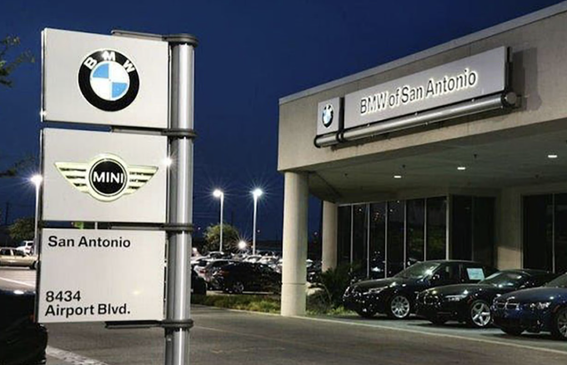
Figure 20: BMW store in the USA
(Source: Antonio, 2025)
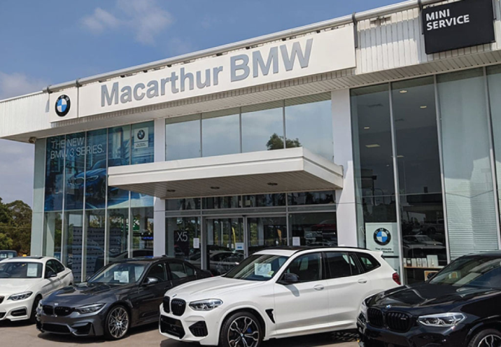
Figure 21:BMW store in Australia
(Source: Canterbury BMW, 2025)

