E-Portfolio Evidence of Learning

Task 1:

Research question:
"How does e-marketing influence consumer purchasing decisions in the fashion industry, and what are the underlying factors that drive these decisions?" is the research question stated for this study.
The fashion sector and the field of e-marketing will benefit greatly from this research. The expanding impact of e-marketing on consumer behavior has been noted in several research studies (Priansa and Suryawardani, 2020). However, in the context of fashion, the sector is still required. This study intends to close this knowledge gap by addressing this research issue and providing insightful information that may guide marketing plans and decision-making procedures.
Consumers increasingly use e-marketing channels to research, assess, and buy fashion items, which has caused the fashion sector to see a notable shift toward online platforms (Waheed and Jianhua, 2018). The influence of e-marketing on customer purchase decisions, however, is complex and impacted by a number of variables, such as digital advertising, social media participation, online reviews, and tailored suggestions (Kaur, Mishra and Mallik, 2021).
To create effective e-marketing strategies that encourage customer involvement and boost sales, fashion firms must thoroughly understand how these aspects interact and affect consumer decision-making processes. This study intends to offer practical insights and suggestions for fashion firms to optimize their online marketing efforts and improve the overall customer experience by examining the underlying elements that influence consumer purchase decisions in the context of e-marketing.

Research Approach
An inductive qualitative research technique was selected to examine how e-marketing affects customer purchase decisions. With the flexible and exploratory exploration of the research issue made possible by the inductive technique, new hypotheses and insights might arise directly from the data (Bazen, Barg and Takeshita, 2021). This strategy aligns with the nature of the study topic, which aims to comprehend and examine the intricate and dynamic connection between consumer behavior and e-marketing methods.
By using an inductive qualitative method, it will be possible to uncover patterns, themes, and trends that reveal how e-marketing affects consumer purchasing behavior. Qualitative data will be gathered and analyzed through sources such as interviews, observations, and textual sources. This method is especially well-suited for drawing deep and nuanced insights from participants' viewpoints, experiences, and behaviors (Armat et al., 2018).
Existing research provides support for using an inductive qualitative method. Bazen, Barg and Takeshita (2021) claimed that an inductive technique is useful when the research aims to produce novel ideas, conceptions, or hypotheses based on the evidence gathered. This study may examine the effect of e-marketing on customer behavior comprehensively and nuancedly without being constrained by preexisting notions or theoretical frameworks using an inductive method.

Data Collection Method
The data-collecting techniques for the secondary qualitative research on the influence of e-marketing on customer purchase decisions will be secondary sources. According to Mazhar et al. (2021), Secondary data refers to information that already exists and has been gathered for various reasons by other researchers or organizations. Examples of secondary data sources include scholarly writing, business reports, case studies, and Internet databases (Ajayi, 2017).
The use of secondary data collecting techniques is appropriate for a number of reasons. For instance, secondary data offers a wealth of information already gathered and examined by subject-matter experts. This enables a thorough investigation of the study issue, drawing from a diverse variety of viewpoints and conclusions. Additionally, compared to what can be gathered through primary research alone, secondary data sources frequently offer a wider and more diversified spectrum of data (Mazhar et al., 2021).
The methods used to obtain secondary data are also time and money efficient. Primary research methods like interviews and surveys can be time-consuming and resource-consuming. The study can be completed more quickly and within the allotted time range if current secondary data sources are used (Ajayi, 2017).

Sample Method and Sample Size
The sampling strategy and sample size are irrelevant to this study because it is based on secondary qualitative research. Hence, the researcher will choose and identify acceptable sources for analysis using a methodical methodology. For example, this might entail performing a thorough literature study, looking through academic databases, and consulting resources unique to the field (Bramer et al.., 2017). Thus, the sources will be chosen based on their applicability, value, and in addition to our understanding of the elements impacting consumer choice in the e-commerce context of the fashion business.
The researcher seeks to incorporate various papers representing various viewpoints and circumstances by using a systematic approach to source selection (Saunders and Lewis, 2017). This strategy guarantees a thorough examination of the qualitative data already available and offers a solid framework for comprehending how e-marketing affects consumer behavior in the fashion sector.

Task 2
The following keywords will be used in secondary research on "The Impact of E-Marketing on Consumer Purchasing Decisions," including e-marketing, digital marketing, online marketing, consumer behavior, and social media marketing. These keywords were chosen to encompass the main ideas of the study's subject and guarantee a thorough investigation of the aspects influencing consumer behavior in the framework of e-marketing in the fashion sector.
The PubMed database will be used for secondary research on "The Impact of E-Marketing on Consumer Purchasing Decisions." According to AlRyalat, Malkawi and Momani (2019), A well-known and reliable database, PubMed focuses mostly on biomedical literature, including articles, reviews, and case studies. Although PubMed is mostly renowned for covering medical and health-related themes, it also covers various multidisciplinary areas, such as marketing and consumer behavior. The researcher can discover pertinent papers that investigate the connection between e-marketing tactics and consumer purchase choices in the setting of the fashion sector by using PubMed. The large number of peer-reviewed journals in the database guarantees the inclusion of top-notch, fact-based research (Zhao et al., 2022). Furthermore, AlRyalat, Malkawi and Momani (2019) added that PubMed offers sophisticated search tools and filters that let the researcher focus and hone the results depending on particular standards, like publication date, study type, and methodology. By utilizing the depth and breadth of the PubMed database, it will be possible to thoroughly review the available literature, improving our knowledge of how e-marketing affects consumer behavior and value generation in the fashion sector.

Task 3

Introduction
E-marketing is more common than ever now due to firms using a variety of online platforms and tactics to engage customers. But it is important to understand how these e-marketing initiatives affect consumers' purchase choices.
The potential for this study to offer insightful information to firms in the fashion sector is what makes it important. Companies may modify their marketing tactics to engage customers successfully by analyzing the effects of e-marketing on consumer behavior. This will ultimately result in more sales and customer satisfaction.

Research Method
I use a secondary qualitative research methodology and conduct a thorough literature review in my study. In order to pinpoint important themes and patterns, this requires analyzing previously published qualitative investigations, scholarly writings, and industry reports. Furthermore, I want to identify the variables that affect customer purchase decisions in response to e-marketing efforts by synthesizing and critically analyzing the qualitative data.

Stakeholder Engagement
As participants in the fashion business, your opinions and suggestions would be tremendously appreciated. Your opinions and knowledge are important in determining the course of this research. Furthermore, your comments will aid me in better understanding the difficulties and possibilities associated with e-marketing and consumer behavior, ensuring that the study is still pertinent and useful in real-world situations.

Conclusion
In summary, the research "The Impact of E-Marketing on Consumer Purchasing Decisions" offers useful tips for fashion industry companies looking to improve their e-marketing strategy. I am eager to hear your thoughts and work with you on this significant study. Together, we can enhance knowledge of e-marketing techniques, improve their effectiveness, and influence consumer choices in the fashion sector.

Elevator pitch link: - Elevator pitch -Ileana Ciricu (2108842).mp4

Task 4
Upon analyzing the data, several key findings and conclusions emerged:

Influence of Online Advertising:
The research revealed that e-marketing, particularly online advertising, significantly impacts consumer purchasing decisions. Online advertisements, including display ads, social media ads, and sponsored content, are crucial in shaping consumer perceptions, creating brand awareness, and influencing purchase intentions. The success of the various e-marketing tactics consumers encounter varies based on elements, including message relevancy, aesthetic attractiveness, and legitimacy (Kaur, Mishra, and Mallik, 2021). However, it is crucial to rigorously assess each sort of internet advertisement's efficacy. For instance, Display and social media commercials might raise brand recognition, but their effects on customers' purchasing patterns can differ. According to Waheed and Jianhua (2018), consumers are becoming more ad-resistant and skeptical, and the success of Internet advertising depends on elements including ad relevancy, believability, and engagement.

Personalization and Targeting:

Personalization and Targeting: The analysis brought attention to how crucial they are in e-marketing. A potent tactic for luring and keeping clients is to cater marketing messages and offerings to specific consumer preferences and demands. Effective e-marketing strategies include personalized recommendations, targeted email campaigns, and product suggestions based on past browsing or purchasing behavior. Customers like personalized interactions because they make browsing more enjoyable overall and are more likely to purchase (Bolos et al., 2016). However, Riantini et al. (2019) evaluated the validity and dependability of online reviews severely. As a result, consumers might be misled and lose faith in businesses due to fake reviews, biased testimonials, and manipulated ratings. As a result, e-marketing tactics should emphasize encouraging real social proof and fostering trust through open and honest business practices.

Trust and Social Proof:

For e-marketing to effectively influence customer purchase decisions, trust emerged as a crucial component. Consumers base their judgement of a brand's and product's reliability and dependability on social evidence, such as online reviews, ratings, and testimonials. Negative reviews or a lack of social evidence might discourage customers from purchasing, but positive reviews and high ratings help foster trust and confidence. Consumer decision-making is significantly influenced by e-marketing tactics that emphasized building trust and social proof (Iblasi, Bader, and Al-Qreini, 2016).

Mobile Influence:
The analysis revealed the growing influence of mobile devices on consumer purchasing decisions. With the widespread use of smartphones and tablets, consumers have easy access to e-marketing channels anytime and anywhere. As a result, mobile-optimized websites, mobile apps, and mobile advertising have become essential components of e-marketing strategies (Priansa and Suryawardani, 2020). Websites and apps that provide seamless and user-friendly mobile experiences can significantly enhance consumer engagement and increase the likelihood of purchase. Therefore, understanding mobile consumers' unique characteristics and preferences is crucial for successful e-marketing campaigns (Sharif and Butt, 2017).

Cross-channel Integration:
The analysis suggests that integrating multiple e-marketing channels can yield better results. Research by Widodo, Yusiana and Anggi (2017) emphasized the benefits of cross-channel marketing, where consistent messaging and seamless experiences across different platforms enhance consumer engagement and purchasing behavior. However, Priansa and Suryawardani (2020) critically evaluated that Inconsistent messaging or disjointed experiences can confuse consumers and undermine the effectiveness of e-marketing campaigns.

Impact on Decision-making Process:
The analysis sheds light on how e-marketing influences the consumer decision-making process. Sharif and Butt (2017) suggested that e-marketing can play a role in various stages, including problem recognition, information search, evaluation of alternatives, and post-purchase behavior. Understanding the specific impact of e-marketing at each stage allows marketers to tailor their strategies and interventions to effectively guide consumers toward making favorable purchasing decisions.
In light of these findings, marketers must critically evaluate and refine their e-marketing strategies to maximize their impact on consumer purchasing decisions. By leveraging the power of online advertising, personalization, trust-building, mobile optimization, cross-channel integration, and understanding the decision-making process, marketers can develop creative and innovative approaches to enhance consumer engagement, foster trust, and ultimately drive value creation for both consumers and businesses.
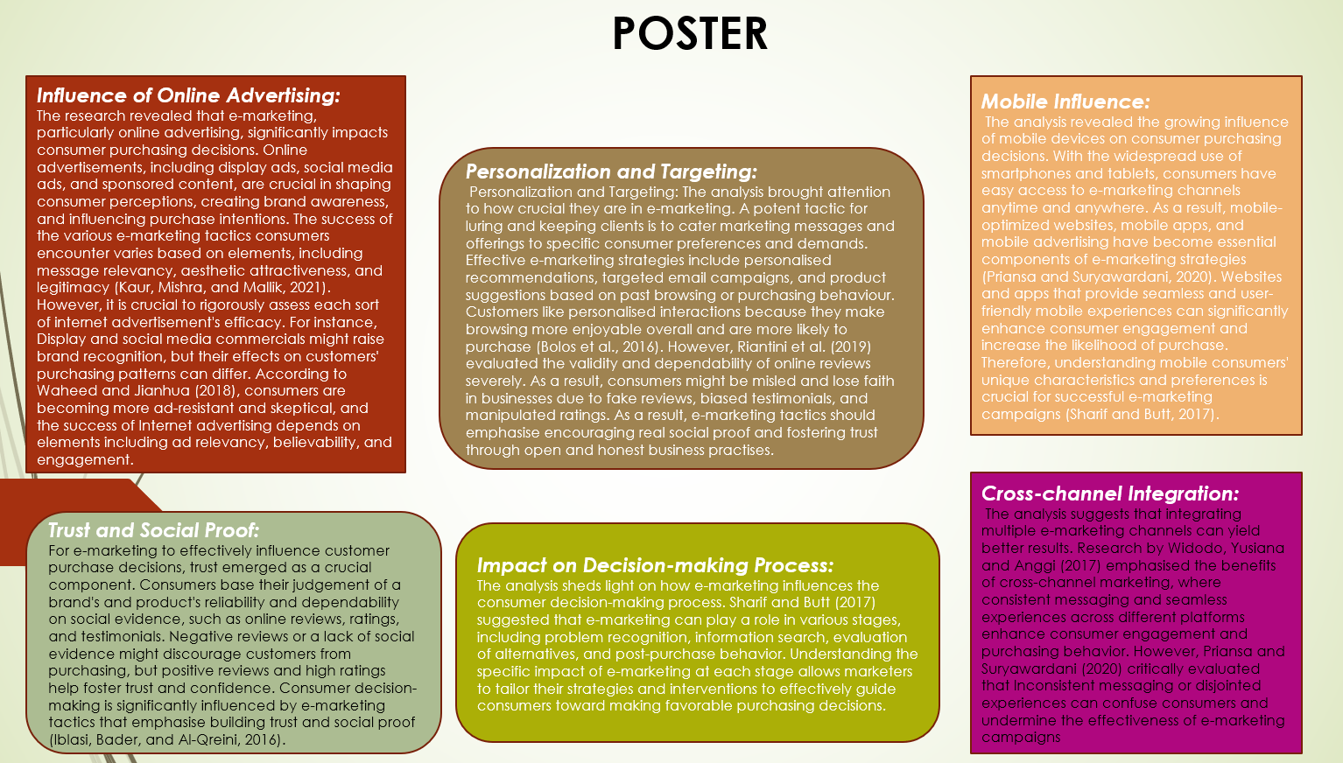

References
Ajayi, V.O., 2017. Primary sources of data and secondary sources of data. Benue State University, 1(1), pp.1-6.
AlRyalat, S.A.S., Malkawi, L.W. and Momani, S.M., 2019. Comparing bibliometric analysis using PubMed, Scopus, and Web of Science databases. JoVE (Journal of Visualized Experiments), (152), p.e58494.
Armat, M.R., Assarroudi, A., Rad, M., Sharifi, H. and Heydari, A., 2018. Inductive and deductive: Ambiguous labels in qualitative content analysis. The Qualitative Report, 23(1), pp.219-221.
Bazen, A., Barg, F.K. and Takeshita, J., 2021. Research techniques made simple: an introduction to qualitative research. Journal of Investigative Dermatology, 141(2), pp.241-247.
Bolos, C., Idemudia, E.C., Mai, P., Rasinghani, M. and Smith, S., 2016. Conceptual models on the effectiveness of e-marketing strategies in engaging consumers. Journal of International Technology and Information Management, 25(4), p.3.
Bramer, W.M., Rethlefsen, M.L., Kleijnen, J. and Franco, O.H., 2017. Optimal database combinations for literature searches in systematic reviews: a prospective exploratory study. Systematic reviews, 6, pp.1-12.
Iblasi, W.N., Bader, D.M. and Al-Qreini, S.A., 2016. The impact of social media as a marketing tool on purchasing decisions (Case study on SAMSUNG for electrical home appliances). International Journal of Managerial Studies and Research, 4(1), pp.14-28.
Kaur, K., Mishra, A. and Mallik, V., 2021. Impact of E-marketing on Consumer Purchase Behaviour: An empirical study. IJRAR-International Journal of Research and Analytical Reviews (IJRAR), E-ISSN, pp.2348-1269.
Mazhar, S.A., Anjum, R., Anwar, A.I. and Khan, A.A., 2021. Methods of data collection: A fundamental tool of research. Journal of Integrated Community Health (ISSN 2319-9113), 10(1), pp.6-10.
Priansa, D.J. and Suryawardani, B., 2020. Effects of E-marketing and social media marketing on E-commerce shopping decisions. Jurnal Manajemen Indonesia, 20(1), pp.76-82.
Riantini, R.E., Andini, S., Florencia, M.M. and Rabiah, A.S., 2019, August. E-Marketing strategy analysis of consumer purchase decision in Indonesia online sports stores. In 2019 International Conference on Information Management and Technology (ICIMTech) (Vol. 1, pp. 426-431). IEEE.
Sanyal, D.K., Bhowmick, P.K. and Das, P.P., 2021. A review of author name disambiguation techniques for the PubMed bibliographic database. Journal of Information Science, 47(2), pp.227-254.
Saunders, M. and Lewis, P., 2017. Doing research in business and management. Pearson.
Sharif, A. and Butt, H., 2017. Online businesses and the influence of e-marketing on customer satisfaction. Journal of Humanities Insights, 1(02), pp.89-93.
Waheed, A. and Jianhua, Y., 2018. Achieving consumers' attention through emerging technologies: The linkage between e-marketing and consumers' exploratory buying behavior tendencies. Baltic journal of management.
Widodo, A., Yusiana, R. and Anggi, S., 2017. How E-marketing and trust influence online buying decision: A case study of mataharimall. com in Bandung. Pertanika Journal of Social Sciences and Humanities, 25, pp.107-114.
Zhao, X., Jiang, H., Yin, J., Liu, H., Zhu, R., Mei, S. and Zhu, C.T., 2022. Changing trends in clinical research literature on PubMed database from 1991 to 2020. European Journal of Medical Research, 27(1), pp.1-11.

