Community Engagement
LCBB4002
Tanja Nathan

Lyuben Eftimov
1913402
BA Business Management (Group 1)
Assessment 1
University of Wales Trinity Saint David
Level 4

Contents
Dr. Martens 2
Sector, Size and Scope 2
Goals, Mission and Values 2
Structure of Dr. Martens 2
Customers 3
SWOT Analysis of Dr. Martens 4
Role of the employees 4
Importance of training and development 1
Role of Production Manager 1
Training and development requirements 2
Conclusion 2
References 4

Table 1 (The Official Board, 2020) 3
Table 2 (Job is Job, 2020) 2
Table 3 (Job is Job, 2020) 2

Figure 1 2
Figure 2 (Business Jargons, 2020) 1
Figure 3 (Business Jargons, 2020) 1


Dr. Martens
Figure 1

Sector, Size and Scope
Dr. Martens is operating as a privet company and it can be classified as a large organization. The history of Dr. Martens is starting back in 1945 with the German soldier Dr. Klaus Maertens, who created the first prototype of boots and present is to his classmate Dr. Herbert Funk. After that the official production starts in 1947 but the brand came in England in 1960 and it was recreating by the Griggs Company (Dr Martens UK, 2020). This was the starts for the iconic brand.
Today Dr. Martens is one of the popular footwear brands in United Kingdom and most preferable working boots. It is a global company in retail industry with big options of footwear from boots to sandals and different accessories. Also is one of the most preferable footwear in United Kingdom.

Goals, Mission and Values
The main goal of company is to create shoes that can be either working type or fashion one but mostly to satisfy the different type of customers as Dr. Martens have a huge range of buyers with own styles and preference. So what the company did is to launch a lot of different collections such as “Made in England”, “The Vintage Collection”, “Vegan Collection”, “Hello Kitty Collection” and many more (James Smith, 2018). The Mission of the company is to make profit as it is a profit organization and to be famous in different subcultures. Also the company is sponsoring and making charity events to support the different campaigns a part from the social responsibilities the company is making their own gigs to promote their self.

Structure of Dr. Martens
Line Organizational Structure is example of Dr. Martens structure. This is one of the simplest type of organization structure. Its authority flows from top to bottom (Creately, 2019). In the chain every department has person in charge and it is taking decisions only for the particular line that this person is responsible. So there is no option for miscommunication between the departments as only the main person for example manager is communicating with managers of other departments. This give the organization benefit of a stability (Creately, 2019). The “Table 1” is exactly the structure with departments in Dr. Martens organization without names.

Table 1 (The Official Board, 2020)

Customers
The customers of Dr. Martens are loyal and supportive to the brand as they believe that the brand is one of a kind and cannot be replaced with other. That is why the company is trying their best to keep the dream alive and give the supporters the best quality and unique models. The product always meets expectation of customers and the feedback that company received is most of the time good feedback. So people who wear Dr. Martens boots are actually the heart of the company because without them the company would not exist.
The music is the other thing that is directly connected with Dr. Materns and customers as the gigs they are organizing to gain more popularity is actually the part that buyers love (Dr Martens UK, 2020). As the company even have concerts right in the store in Camden Town which is a place where you can find most of the Docs lovers.

SWOT Analysis of Dr. Martens

- Strengths
- High quality of products
- Great customer service
- Popular and unique brand name
- Public events
- Charity
- Weaknesses
- High price of products
- Nowadays products are not made in England
- Losing loyal customers
- Opportunities
- Become more global
- Opening more store in UK
- Targeting different customers
- Return to old production
- Threats
- Competitors
- Deficit of row materials
- Less events

Each organisation or business has to deal with both internal and external factors that affect them. By using SWOT analysis the companies can classified the internal factors (Strengths and Weaknesses) and the other two sections (Opportunities and Threats) can help to identify the external factors (Professional Academy, 2020).
This analysis shows that Dr. Martens has already a lot of strengths but if the company wants to remain successful in this industry they should start with fixing the weaknesses. Years ago all boots where made in England but nowadays things change and now the organization moved the production in either China or Thailand to cut the production cost (Alphabet City, 2009). This part really upset the loyal customers that have been shopping in Dr. Martens for years. So the interest of the band goes down and people start to prefer some of the competitors of the company which is a big treat. Even though the quality is still high on the normal products (special collection are still made in England) the customers can find the difference in the boots. On the other hand, the opportunities about going more global is still on the list so the company should really pay attention.

Role of the employees
Company really values the workers in their supplier factories like their own employees and believed that everyone in the chain is important and should be treated well and with respect. A key part of Dr. Martens strategy is to have a long-term relationship with only a few partners and the reason is that this is allows them to have a strong connection and created an environment of trust and transparency (Dr Martens UK, 2020). So every person in the company matters and to feel appreciate Dr. Martens is giving all the employees special discounts and it is become like a characteristic of employees to wear Dr. Martens boots. The company is accepting all type of people are really appreciate the ones with own style because they make the company significant. When customers went in store they can feel this great atmosphere only because of the staff. The chain of Suppliers, Production, Delivering is important but the only part that customers can see and feel is the final product in the store (or online), so the attitude of the person who is greeting them and helping to make the right choice and choose the perfect part of shoe for them.

Importance of training and development
The training and development program is important for the employees as it helping to develop knowledge, skills, and abilities. Raising their level of performance in the specific role they are hired. As for the benefit for the employees it is giving the opportunities for future grow in the company (Business Jargons, 2020).
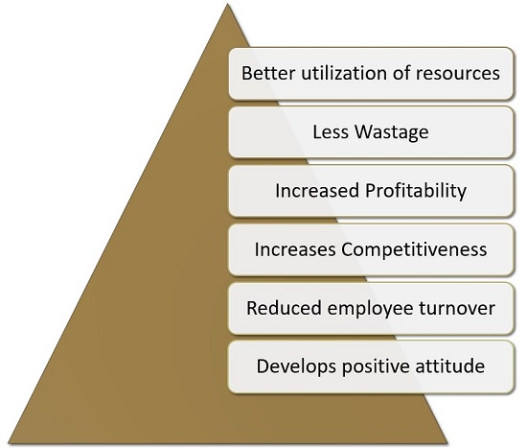
Figure 2 (Business Jargons, 2020)

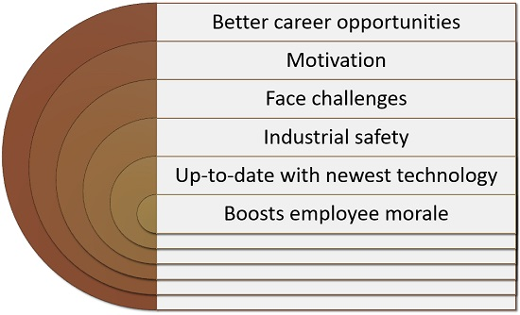
Figure 3 (Business Jargons, 2020)

For organization For Employees

Role of Production Manager
The responsibilities of Production Manager are to ensure and help with plaining, organizing, coordinate and control production in an organization. Also need to make sure that the production of goods and services are the correct cost, quality and quantity. The price of production should match with customers expectation (Job is Job, 2020). In one company with Line Organizational Structure like Dr. Martens the Production Manager is the person that is making the process to deliver the final product. The scope of the job depends on the company size, location and growth. As Dr. Martens is a global company Production Manager are few and distributed one for each continents the company is operating. Some of the tasks that Production Manager is in charge are:
• Motivating workers | • Communicating with staff
• Checking that quality standards are met | • Managing the requests for raw materials
• Being responsible for health and safety | • Attending meetings, trainings and workshops
• Meeting deadlines | • Providing training and staff development opportunities
Table 2 (Job is Job, 2020)
Excellent planning, organisation and negotiating skills are needed, as well as the ability to pay attention to detail. More skills that are useful in this type of job are:
Multitasking | Preparing reports
Professionalism and punctuality | Information technology
People and time management | Communication and presentation

Table 3 (Job is Job, 2020)
A part from all skills that person need to have or develop in the time process is education. With the right education like Bachelors or Masters Degree is easy to find the correct job.

Training and development requirements
The training and development program is always useful in both cases if person is starting directly as Product Manager or some lower position. As this program plan is helping person to understand the tasks, position and responsibilities in the company. It is helpful for the management and the employees with making work process easier and well understand. Other benefit for employee is get the idea of developing himself/herself in the company and that are option for upgrading and promotions.

Conclusion
The company achieve a big success over the year with help mixed things like the high quality and loyal customers. SWOT analysis is helping to see that Dr. Martens remain strong even with the unfortunately change of circumstance of production and new technology. Customers are separated now into two groups, ones that are still loyal to the company and others that did not like this change. Still the well-known brand have a good perspective and it will never go bankrupt as the organization structure is strong and working in great favour to the company. Also the huge scope of working boots and fashion boots is targeting a lot of different customers and even with the changing trend all the time this Iconic brand is always popular not only among the followers. The key department in this company is the Production department because without it the company will not have the goods to sell. But the main point is that this long-lived company is still one of the most preferable footwear brand in United Kingdom based on primary research and for sure it will remain like this.

References
Alphabet City, 2009. Doc Martens: England vs. Thailand vs. China. [Online]
Available at: https://www.alphabetcityblog.com/2009/05/doc-martens-made-in-england-vs-made-in.html
[Accessed 16 May 2020].
Business Jargons, 2020. Training and Development. [Online]
Available at: https://businessjargons.com/training-and-development.html
[Accessed 16 May 2020].
Creately, 2019. Types of Organizational Charts (Organizational Structure Types) for Different Scenarios. [Online]
Available at: https://creately.com/blog/diagrams/types-of-organizational-charts/
[Accessed 16 May 2020].
Dr Martens UK, 2020. About Us | History | Leather Boots, Shoes & Accessories | Dr Martens UK.. [Online]
Available at: https://www.drmartens.com/uk/en_gb/history
[Accessed 16 May 2020].
Dr Martens UK, 2020. Social Responsibility | Leather Boots, Shoes & Accessories | Dr Martens UK.. [Online]
Available at: https://www.drmartens.com/uk/en_gb/social-responsibility
[Accessed 24 April 2020].
James Smith, 2018. Dr. Martens - History, Philosophy, And Iconic Products.. [Online]
Available at: https://www.heddels.com/2018/08/dr-martens-history-philosophy-iconic-products/
[Accessed 24 April 2020].
Job is Job, 2020. Production Manager job description. [Online]
Available at: https://www.jobisjob.co.uk/production-manager/job-description
[Accessed 17 May 2020].
Professional Academy, 2020. MARKETING THEORIES – SWOT ANALYSIS. [Online]
Available at: https://www.professionalacademy.com/blogs-and-advice/marketing-theories---swot-analysis
[Accessed 16 May 2020].
The Official Board, 2020. Dr. Martens. [Online]
Available at: https://www.theofficialboard.com/org-chart/dr-martens
[Accessed 16 May 2020].

