Assessment 4
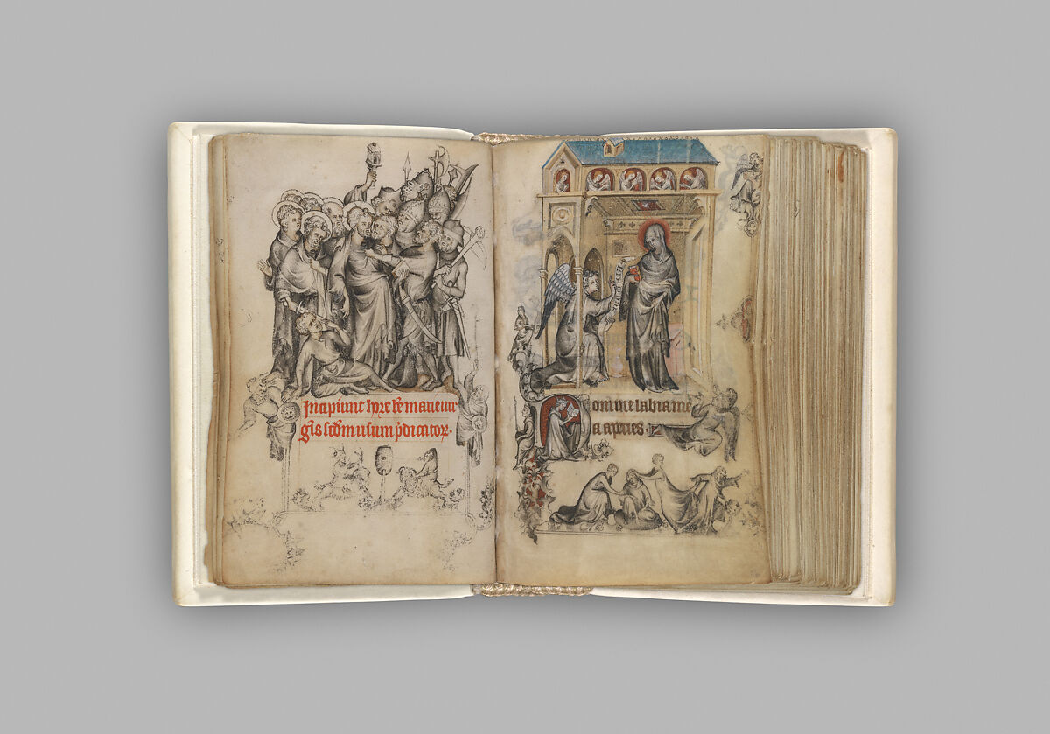
The image under discussion is from The Hours of Jeanne d'Evreux, Queen of France currently displayed at The Metropolitan Museum of Art. The graphic immediately below is enlarged for convenience.

Figure 1 https://collectionapi.metmuseum.org/api/collection/v1/iiif/470309/962227/main-image

The second image below gives a better sense of the size, which is one of its most amazing features. This is the image’s true size (9.2 x 6.2 cm). The book was owned by Jeanne d’Evreux (c.1310–1371) the third wife of Charles IV of France. Jeanne married Charles very young and the book was probably a gift to her from Charles.
It is possible that the book was (physically) adapted by Pucelle to better suit Jeanne’s youth.

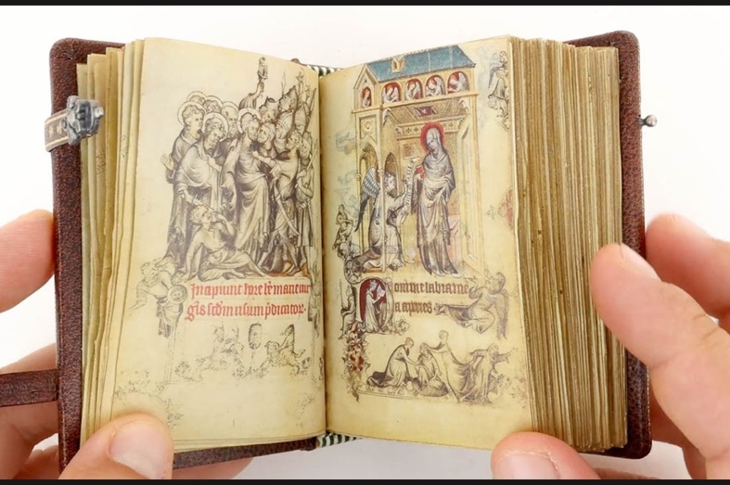
Figure 2 https://www.teachercurator.com/14th-century-art/the-hours-of-jeanne-devreux-queen-of-france/

Books of hours were literally a scaled down psalter intended for private devotions. Interestingly the illustrations in books of hours did not always correspond with the Latin text as not all their owners could read Latin. However, it might be reasonable to suppose that as the illustrations in this particular book of hours match the Latin text and there is no French translation, that the young Queen was functionally literate in Latin.

This book of hours was produced by Jean Pucelle in Paris and is largely regarded as his finest piece. This simple attribution of provenance has not gone unchallenged. It may be that Pucelle was working as part of a workshop and that productions were worked upon by others as well as him. This collaborative possibility interestingly suggests the book as a means to enter into various aspects of the contemporary history. It is interesting to wonder what social, economic and cultural webs brought everyone together to create such a piece. Much is made of the grisaille (grayscale) technique used by Pucelle, and this is mentioned below. In addition to this, interest is shown, for example by Charron, in the workshop scenario to try and determine who was responsible for which parts of production and this is attempted through the analysis of colour use. This is only one road of enquiry possible, using the same entry point of colour might also take an enquiry into the Parisian economic world.

The image shows two of the 209 folios in the book, 15v and 16r. These come at the beginning of the main section of the book, The Hours of the Virgin which was organised into the eight canonical hours. Each of these eight hours has a similar pairing of a scene from the Passion with the Infancy of Christ. Coming at the beginning of the hours, that is, Matins, folio 15v shows the arrest of Christ as the main scene and on 16 r the Annunciation. This arrangement might seem strange as it is a reverse of the chronological order as well as for being paired at all. Such pairing was also not the norm for books of hours, one or the other set being chosen. Possible theological reasons for this juxtaposition have been suggested however, given the book was designed for a young princess these might seem to be post hoc rather than theologically intended by Pucelle or his client. Possibly this pairing was an artistic experiment by Pucelle and if so he was ahead of his time. Whatever the intentions were, it seems clear that the book was carefully constructed for the needs (as seen by Charles) of the young Jeanne which suggests it may have been purposeful. These intentions seem to include a desired attitude of piety, devotion and, given the rest of the book of hours, dynastic devotion to the example of St. Louis and expression of this in charity.

Moving on to the individual elements. Folio 15v has as its main scene the Betrayal of Christ. In the main scene (see below), two groups centre around the Christ figure. Judas, notably without a halo, kisses Christ who has an oddly distended abdomen. The scene is very crowded and although the soldiers are armed their weapons are not ready for action. The poleaxe weapon is facing away from Christ, and the crossbow is over the bearer’s shoulder. The dress of the soldiers is anachronistic and represents the contemporary times rather than Roman. This is also true of some of the weaponry, for example the crossbow does not seem to be Roman. The element at the top of the scene is a (medieval) lantern and may be a reference to John 18:3. It is not difficult to see how this biblical passage has led to the incorporation of a lantern into symbolism of the night time betrayal scene, and become one of the the ‘arma christi’.
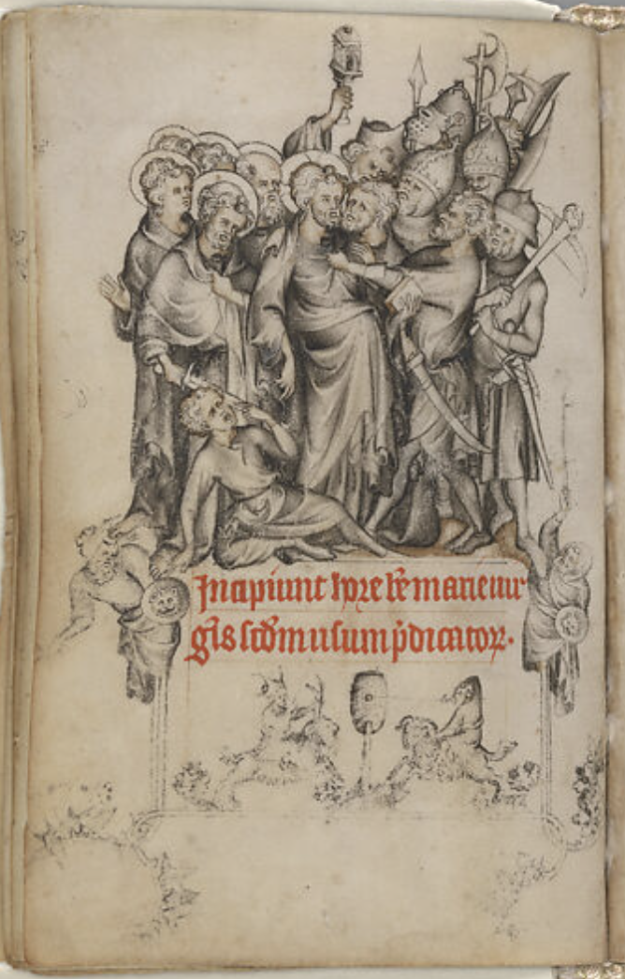
The scene is drawn in the technique grisaille, a gray scale, and this is immediately attractive. It is said to represent the introduction to France by Pucelle of Italian style
Figure 3 folio 15v

into the Gothic style of the day. The beautifully drawn figures are typical of the style according to Sandler:

…there is a typical Pucelle figure…
swathed in rich drapery, graceful in stance, strongly hip-shot,
with head responding to the curve of the body. The arms are
slender and the hands have long, thin fluttering fingers. Heads
are supported by thick, bulging necks that slide smoothly into
narrow, sloping shoulders. The face of the figures are all
broad-browed with deep-set eyes, prominent lips with a down-
ward cast, and a small but square and jutting chin. The head-
types are distinguished from each other by different coiffures.

Beneath the main scene is the red rubrication which introduces the beginning of the Hours. At the sides of the text are two symmetrical figures that seem impaled on the decorative lines together with other marginal figures, and bas de page, such as the two figures mounted on some kind of beasts, under the rubric. Randall argues that these may have more symbolic value than previously thought and that taking them as mere amusements may not be sufficient.

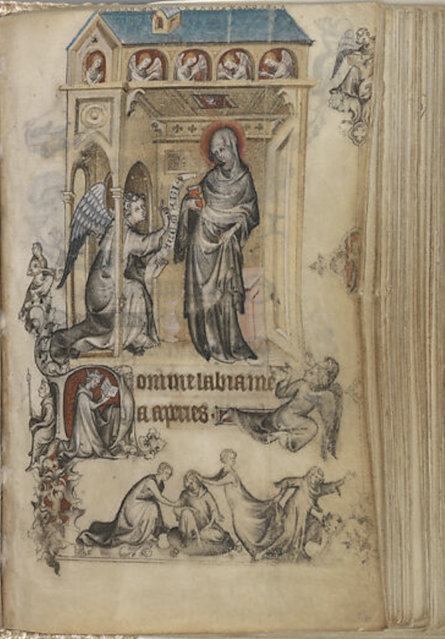
Moving on to the Annunciation page.

This page has more contrast between the grisaille and use of colour from tempera and the use of perspective in the gothic architecture ceiling above Mary’s head is visually very impressive, although Sands rather less generously refers to it as an ‘ad hoc system of perspective’. The main figures are Mary and Gabriel, both in grisaille but now with tinges of colour. The colour of Mary’s halo and book are echoed in the initial which contains Jeanne herself as a model of piety, or certainly the expectation of both piety and perhaps from the marginal animals, fertility. Within her initial she goes about her devotions whilst guarded from any other course. Perhaps she was also being encouraged to avoid the game shown in the bas de page. The text continues from the initial to give a typical recitation for Matins, Domine labia mea aperies, ‘Lord open my lips’.

Overall, there is much explanation and suggestion of meaning for images and symbolism offered by the writers already cited. It is perhaps reasonable to wonder again just how much of that symbolism and imagery would have been intended by Pucelle and recognised by fourteen year old Jeanne. It is also interesting to wonder who might have been involved in forming the brief that Pucelle worked to. We can certainly see Charles IV’s twin concerns for piety and an heir, as has been mentioned above.

The artwork itself is produced on velum using the above mentioned grisaille technique to great effect. Colour is sparingly added using tempera. There was also a complete lack of gold, which was unusual for a royal book of hours and may signify Pucelle’s innovative technique. Discussion of the absence of gold generally speculates that the use of grisaille was in place of gold. However, in the absence of any comment by Pucelle, this is speculative.
As an object of historical interest this book could be said to have different lives which can tell us about various aspects of the contemporary history. In being unusual as a work of art, it gives scope for exploration of early fourteenth century developments in art and culture, particularly the degree of influence and borrowing from Italian sources. The book as a gift reflects the concerns of Jeanne’s royal husband and his dynastic and cultural requirements of her. As Holladay writes, the gift was commissioned by Charles IV for his new bride and, ‘it reflects the king’s concerns and intentions for his wife as well’.

These concerns are focused on the theme of dynastic continuation and charity. This may provide a window into the religious belief, or cosmology of the time that Jeanne’s piety and her ability to have a son were connected. In this pair of folios this may be most apparent in the Annunciation scene where Jeanne is pictured below Gabriel and Mary at a critical moment in that particular birth story.

As a gift it was very successful and stayed with Jeanne her whole life before being mentioned in her will. It was a personal and valued devotional text which firmly grounded her devotions within the dynastic attitude to piety (and its purposes). A further aspect is the wider economic network that production of such artworks involved. There are also people wishing to control such lucrative networks, such as the university in Paris, who themselves became part of this wider network. So, from one book of hours there are clues to a whole potential and multi-faceted world which can be teased out.

In conclusion two folios from the Book of Hours belonging to Jeanne d'Evreux, Queen of France have been discussed. She was a very young queen when she was given this gift, commissioned for her by her husband, Charles IV, who was putting tremendous effort into making a political marriage alliance that would (hopefully) continue his line. As befits such an undertaking he shows concern through the design of the book to inculcate ‘appropriate’ devotional attitudes in Jeanne. However, Charles IV died soon after and it was Jeanne’s story that went on and the book of hours continued with her to be eventually passed on through her will to Charles V.

Its journey offers much to comment on, from innovative artistic technique and its place in the development of French artistic culture, to obscure arrangement of images which we can only suppose was intentional. The book offers insight into the worlds and values of the French court, the Paris cultural scene and even a trade network of materials to keep the artists and their workshops supplied. Finally, this book of hours offers unsolved mysteries and perhaps an invitation to a more qualitative than quantitative side of history which can engage with the lives and hopes of Jeanne d'Evreux and Charles IV.

Bibliography
Benton, Janetta Rebold, Materials, Methods, and Masterpieces of Medieval Art (Westport, CT: Praeger Publishers, 2009) [e-book]

Bible Gateway, ‘John 18:3 (New International Version)’ <https://www.biblegateway.com/passage/?search=john%2018:3&version=NIV> [accessed 5 December 2025].

Charron, Pascale, ‘Color, grisaille and pictorial techniques in works by Jean Pucelle’ (2013), HAL-SHS <https://shs.hal.science/halshs-00949845> [accessed 6 December 2025].

Harvard College Library, ‘Structure – Picturing Prayer: Books of Hours in Houghton Library’ <https://library.harvard.edu/sites/default/files/static/collections/picturingprayer/structure.html> [accessed 4 December 2025].

Holladay, Joan A., ‘The Education of Jeanne d’Évreux: Personal Piety and Dynastic Salvation in her Book of Hours at the Cloisters’, Art History, 17 (1994), 585–611 <https://doi.org/10.1111/j.1467-8365.1994.tb00597.x>.

'The Hours of Jeanne d'Évreux, Queen of France', The Metropolitan Museum of Art [accessed 7 December 2025]

Pucci, Paloma, ‘Medieval Book Production: Manufacturing Manuscripts’ (Paris: Bibliothèque nationale de France, 2023) [PDF] < https://www.bnf.fr/sites/default/files/2023-08/medieval_book_production_manufacturing_manuscripts.pdf > [accessed 6 December 2025].

Randall, Lilian M. C., ‘Games and the Passion in Pucelle’s Hours of Jeanne d’Évreux’, Speculum, 47 (1972), 246–57 <https://doi.org/10.2307/2856691> [accessed 5 December 2025].

Sand, Alexa, Vision, Devotion, and Self-Representation in Late Medieval Art (Cambridge: Cambridge University Press, 2014), pdf

Sandler, Lucy Freeman, ‘A Follower of Jean Pucelle in England’, The Art Bulletin, 52.4 (December 1970), 363–72 [accessed 5 December 2025]

Tastes of History, ‘Arcuballista: A Late Roman Crossbow’ <https://www.tastesofhistory.co.uk/post/arcuballista-a-late-roman-crossbow> [accessed 5 December 2025].

Tolley, Thomas, ‘Visual Culture’, in Gentry Culture in Late-Medieval England, ed. by Raluca Radulescu and Alison Truelove, vol. 33 (Manchester: Manchester University Press, 2005), Available at: <https://moodle.uwtsd.ac.uk/course/section.php?id=102192> [Accessed: 2 December 2025].

Tradition in Action, ‘Christi, the “Weapons of Christ” or Instruments of His Passion’ <https://www.traditioninaction.org/religious/f039_Arma.htm> [accessed 5 December 2025].

Wieck, Roger S., Painted Prayers: The Book of Hours in Medieval and Renaissance Art (New York: George Braziller in association with the Pierpont Morgan Library, 1997). Ebook (PDF).

'The Hours of Jeanne d'Évreux, Queen of France', The Metropolitan Museum of Art <https://www.metmuseum.org/art/collection/search/470309> [accessed 7 December 2025]. The choice was quite subjective; I immediately liked the grayscale drawings on the left which reminded me of Gustav Dore and graphic novel artwork.
Ibid.
Janetta Rebold Benton, Materials, Methods, and Masterpieces of Medieval Art (Westport, CT: Praeger Publishers, 2009) [e-book], p. 16
‘a small book for small hands’ Emma Dillon, ‘Praying with Sound: The Hours of Jeanne d’Evreux and Walters Art Museum W 102’, in The Sense of Sound: Musical Meaning in France, 1260–1330 (Oxford: Oxford University Press, 2012) [e-book], p. 245
Thomas Tolley, ‘Visual Culture’, Gentry Culture in Late-Medieval England, ed. by Raluca Radulescu and Alison Truelove, vol. 33 (Manchester: Manchester University Press, 2005), p. 172 <https://moodle.uwtsd.ac.uk/course/section.php?id=102192> [accessed 2 December 2025].
Ibid.
Lilian M. C. Randall, ‘Games and the Passion in Pucelle’s Hours of Jeanne d’Évreux’, Speculum, 47 (1972), 246 <https://doi.org/10.2307/2856691> [accessed 4 December 2025].
Kathleen Morand, ‘Jean Pucelle: A Re-Examination of the Evidence’, The Burlington Magazine, 103 (1961), 206–11 <http://www.jstor.org/stable/873322> [accessed 6 December 2025]. Morand lists some of the dissenting voices but ultimately concludes Pucelle was indeed a ‘creative genius’.
Pascale Charron, ‘Color, grisaille and pictorial techniques in works by Jean Pucelle’ (2013), HAL-SHS <https://shs.hal.science/halshs-00949845> [accessed 6 December 2025].
Charron, ‘Color, grisaille and pictorial techniques’ HAL-SHS <https://shs.hal.science/halshs-00949845> [accessed 6 December 2025]. For some reason there are no page numbers in the article, so I have quoted the relevant passage: “The study of color in Pucelle's works cannot be isolated from the question of a workshop and collaborators behind the manuscript paintings attributed to the artist. This subject has been treated in depth by Kathleen Morand and François Avril, whose research has made it possible to better distinguish the various hands at work in the manuscripts.”
Amazingly, if Pucelle’s workshop had used aquamarine it would have had to come all the way from Afgahnistan! Paloma Pucci, ‘Medieval Book Production: Manufacturing Manuscripts’ (Paris: Bibliothèque nationale de France, 2023) [PDF] < https://www.bnf.fr/sites/default/files/2023-08/medieval_book_production_manufacturing_manuscripts.pdf> [accessed 6 December 2025].
Randall, ‘Games and the Passion’, p. 247 <https://doi.org/10.2307/2856691> [accessed 4 December 2025].
It was a frustrating search trying and failing to find sources that addressed any more than the fact of the juxtaposition and it being unusual. The non chronological order does not seem to be addressed, nor does anything definite appear about the intention of the pairing.
“This traditional infancy cycle is sometimes replaced, especially in manuscripts produced in fifteenth-century England, Flanders and the Netherlands, by another cycle which depicts the Passion of Christ. “ There were later examples of this pairing. Harvard College Library, Structure – Picturing Prayer: Books of Hours in Houghton Library <https://library.harvard.edu/sites/default/files/static/collections/picturingprayer/structure.html> [accessed 4 December 2025].
Joan A. Holladay, ‘The Education of Jeanne d’Évreux: Personal Piety and Dynastic Salvation in her Book of Hours at the Cloisters’, Art History, 17 (1994), p.585 <https://doi.org/10.1111/j.1467-8365.1994.tb00597.x>.
Ibid.
I was unable to discover anything definite about this strange rendering of Christ.
Romans did have crossbows but they were rare. The style of Roman crossbow is shown here: Tastes of History, ‘Arcuballista: A Late Roman Crossbow’ <https://www.tastesofhistory.co.uk/post/arcuballista-a-late-roman-crossbow> [accessed 5 December 2025]. The image in the folio is closer to a medieval French crossbow.
Bible Gateway, ‘John 18:3 (New International Version)’ <https://www.biblegateway.com/passage/?search=john%2018:3&version=NIV> [accessed 5 December 2025].
Tradition in Action, ‘Christi, the “Weapons of Christ” or Instruments of His Passion’ <https://www.traditioninaction.org/religious/f039_Arma.htm> [accessed 5 December 2025].
Lucy Freeman Sandler, ‘A Follower of Jean Pucelle in England’, The Art Bulletin, 52.4 (December 1970), p. 363 < https://www-jstor-org.ezproxy.uwtsd.ac.uk/stable/3048763?if_data=e30%3D&seq=1 > [accessed 5 December 2025] It is not certain whether Pucelle actually went to Italy.
Ibid. I am not sure I would agree with the ‘thick bulging necks’ but overall this does seem to represent the Passion scene in the folio.
Randall, ‘Games and the Passion’, pp. 247-8 < https://www-jstor-org.ezproxy.uwtsd.ac.uk/stable/2856691?seq=1> [accessed 4 December 2025]. Randall does not go on to make very clear what the symbolism she suggests might mean.
Alexa Sand, Vision, Devotion, and Self-Representation in Late Medieval Art (Cambridge: Cambridge University Press, 2014), pdf, p.236.
I can agree with Sand that the initial shows a certain isolation but not to the extent suggested by Caviness, who is cited by Sand, that , ‘“The marginalia are so invasive and aggressive that the only safe havens from the nightmarishness of the pages’ shivaree the tiny places assigned to Jeanne d’Evreux for prayer.” Caviness, Madeline. “Patron or Matron? A Capetian Bride and a Vade Mecum for Her Marriage Bed,” Speculum 68, no. 2 (1993): 333–362. Cited in Sand, Vision, Devotion, p.236
One example would be Mary’s lowered gaze could be taken to denote consent. This may well have been a reinforcement of Charles’s agenda for Jeanne, but it could also be she is looking down towards the angel and there may not need to be any deeper meaning.
The Metropolitan Museum of Art, ‘The Hours of Jeanne d’Evreux, Queen of France’ <https://www.metmuseum.org/art/collection/search/470309> [accessed 5 December 2025].
Joan A. Holladay, ‘The Education of Jeanne d’Évreux: Personal Piety and Dynastic Salvation in her Book of Hours at the Cloisters’, Art History, 17 (1994), p.601 <https://doi.org/10.1111/j.1467-8365.1994.tb00597.x>. [accessed 7 December 2025]
Holladay, ‘The Education of Jeanne d’Évreux’, p. 604 This connection between piety, or charity, which was a feature of this book of hours and focused on the example of joint ancestor Louis, is a widely found belief, not only in the medieval world but also today. The basic principle is, ‘reap what you sow’ and that implied an obligation to do good deeds and a culpability if misfortune occurred.
Holladay, ‘The Education of Jeanne d’Évreux’, p. 585
Paloma Pucci, ‘Medieval Book Production: Manufacturing Manuscripts’ (Paris: Bibliothèque nationale de France, 2023) [PDF] < https://www.bnf.fr/sites/default/files/2023-08/medieval_book_production_manufacturing_manuscripts.pdf> [accessed 6 December 2025]. The comment on university control comes in the text for figure 2.
Unsolved mysteries: Quite subjectively these are some things I became curious about during the writing of this assignment. In no particular order: Did Pucelle use aquamarine? Amazingly it had to come from the mountains of Afganistan ! Why has the Christ figure in the Annunciation portfolio got such a distended abdomen? Whose decision was it not to use gold, and why? How much of the book of hours was Pucelle’s choice and how much was given? Why did Pucelle juxtapose the Passion and the Infancy and whose idea was it to do so? What would Jeanne have understood about that?

