Trinity by The Sea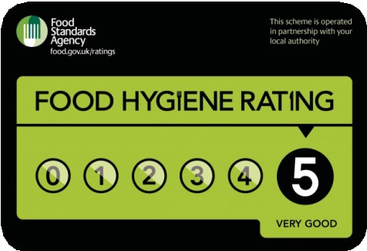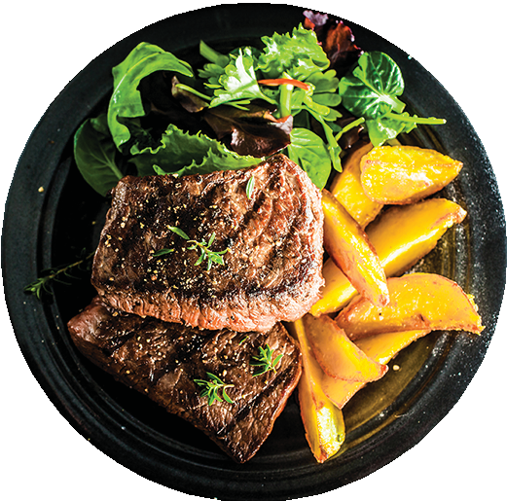

Starters
Creamy Garlic Mushrooms 6.50
Topped with Melted Mozzarella
Crispy and Salted Belly Pork Squares 7.50
with Bourbon Glaze and Dates Puree
Grilled Marinated Chicken Skewers,
Spanish Chickpea Salad 6.95
Meatballs in a Homemade Tomato Sauce 6.95
Homemade Pork & Chorizo Croquettes 6.50
Served with Fresh Aioli
...........................................................

Main Course
8oz Fillet Steak 25.95
Served with Spanish Pisto & Thyme Roasted Tomato.
We recommend a glass(or two) of our amazing Cabernet Sauvignon red wine for a real taste buds pleasure
Grilled Fillet Steak Medallions 25.50
(Choose Peppercorn Sauce or Blue Cheese & Port)
Slow Cooked Belly Pork Basque Style 16.95
(Pears and Cider Sauce)
Lamb Shank 17.50
Served with Red Wine & Rosemary Sauce
Butterflied Chicken Breast 15.95
Served with A Creamy Peppercorn Sauce, perfectly enjoyed with our Escarpment Chardonnay white wine
...........................................................

Desserts
Welsh Amber Pudding 8.50
served with a generous amount of fresh cream from our local farms, best enjoyed with a glass of our port wine
Warm apple charlotte 7.50
with apricot coulis and apricot sorbet
Homemade delicious ice cream 5.50
(please ask for flavours) drizzled with dark chocolate or caramel sauce
...........................................................

Soft Drinks
Coca cola 330ml 3.50
Fanta orange 330ml 3.50
Still water 500ml 2.50
Sparkling water 500ml 3.00
Fresh Smoothies 450ml 6.00
...........................................................

Red Wines
Taylor’s Fine Ruby Port. Rich, robust and
fruity 750ml bottle 35.00
Journey's End Sir Lowry Cabernet Sauvignon Packed with rich, dark plum flavours 750ml bottle 42.00
Valdivieso Merlot Winemaker Gran Reserva.
Top class Merlot from one of the best Chilean winemakers 750ml bottle 28.00

White wines
Escarpment Chardonnay 38.00
Exceptional Martin borough Chardonnay in the Burgundian style 750ml bottle
Secret Cellar Pinot Grigio 27.00
Delicate and floral with apricot notes 750ml bottle

“Food allergies and intolerances - please speak to our staff about the ingredients

in your meal when making your order”

…………………………………………………………......Opening Hours

Monday to Friday from 13:00pm - 21:30pm Saturday and Sunday from 14:00pm - 23:00pm

You can contact us directly to place your order or use one of our delivery partner’s apps

...........................................................

Contact details:
Mumbles Road, Brynmill, Swansea, SA2 0AY
Telephone number:

01792 439220

Delivery fee depends on the distance from our restaurant to your home address.
Minimum charge is 2.50 for 2 miles radius

