A critical evaluation and the identification of next teaching and learning steps focusing on a case study of an individual learner or a group of learners, based on an observed critical incident.
Introduction:
This essay is going to explore what a critical incident within education is and how critical incidents can impact teaching and learning (Tripp, 2011). The importance of using reflective practice within teaching will be critically discussed to evaluate how it can facilitate teachers to improve and develop their teaching practice (Kuh, 2016; Sellars, 2017). As well as how reflective practice links with education reforms (OECD: Pisa, 2021; Tripp, 2011; New Curriculum for Wales, 2022). A critical incident is any interaction that can happen between teachers and their pupils, or amongst pupils. A critical incident can positively or negatively impact on teaching and learning, which is why it is essential for teachers to have knowledge and understanding within this field (Tripp, 2011). With teachers gaining knowledge and understanding of critical incidents, it can facilitate effective teaching and learning through using reflective practice (Mohammed, 2016).
For this essay observations were carried out within a primary school classroom, with a year two and three split class to identify critical incidents. One critical incident will be critically evaluated to consider teaching and learning steps using reflective practice. The areas of research that the observed critical incident links with are well-being, reflective practice, routines, behaviour management and transferable skills within the classroom (Mental Health Foundation, 2015; Sellars, 2017; Gardiner, 2018; Cowley, 2003; Nagele and Stalder, 2017). How these factors link in with key theorists such as Pavlov’s classical and operant conditioning, Vygotsky’s and Piaget’s work on child development and learning will be explored (Gray and Macblain, 2012; Doyla, 2007; Keenan, Evans and Crowley, 2016). The impacts that behaviour management, routines, reflective practice, well-being, inclusive teaching and learning have within the classroom will be critically discussed (Welsh Government, 2018; Fook, 2015; Stough, Montague, Landmark and Williams-Diehm, 2015; Tripp, 2011; UNICEF, 2021).

The role of critical reflection:
Within this section critical reflection will be examined and how it facilitates teachers and trainee teachers to develop their teaching practice (Sellars, 2017; Tripp, 2011). Reflective practice within education is when teachers take the time to think about what happened during the lesson, what went well and what could be improved, this type of reflection links with Schon’s reflection-on-action as this process takes place after an event (Campbell and Norton, 2007). Through thinking critically about their teaching practice this can facilitate teachers to pinpoint areas for improvement, Dewey viewed the reflective practice as a part of problem solving (Roffey-Barentsen and Malthouse, 2017). Reflecting on teaching and learning is an important factor to take responsibility for one’s professional development (Tarrant, 2017). A teacher can deliver a lesson to one class, and it could be effective, however, it may not be as effective with a different class depending on how they learn and behaviour management strategies (Hansen, 2017). By using reflective practice regularly, it can facilitate improving teaching practice as it can reduce barriers to learning from critically thinking about what works for the current pupils being taught (Hansen, 2017).
Reflective practice can therefore help teachers to become more adaptable with their teaching practice to use strategies that suit the current class which will enable them effectively to manage the learning environment (Rushton and Suter, 2012). The more experience a teacher has with reflective practice, delivering lessons, evaluating and reviewing critical incidents can further inform and develop their teaching practice and professional judgement (Tripp, 2011). Using reflective practice to develop professional judgement and teaching practice is seen as good practice with Estyn (2019) as it shows ongoing progression and development. When evaluating and reviewing curriculums, attainment levels and school performance reflective practice is used to try and pinpoint areas for improvement (Miller and Macpherson, 2019). Curriculums and ways of teaching in different countries could also be reviewed and evaluated against the levels of school performance and attainment levels, to enable comparisons to be made between the high and low achieving education systems (La Londe and Verger, 2020). This process can highlight differences in educational outcomes across countries which can help inform educational reforms and curriculum updates, with the overall aim to improve; one example of this could be the Pisa Results (OECD: Pisa, 2021). However, these are not the only factors to consider for education, the happiness and well-being of the learners must also be taken into consideration (Bethune, 2018; Buchanan, 2018). Through educational professionals in Wales using reflective practice, the New Curriculum for Wales (2022) has a focus on well-being and individual needs which should facilitate pupils to reach their potential in the progression steps. Teachers play a central role in curriculum reforms as they are the ones who reflect on current provision and implement curriculums within classrooms (OECD, 2020).
Observation School & Class Context:
The British Educational Research Association (BERA) carry out educational research nationally and internationally (BERA, 2021). BERA are the leading authority in educational research within the UK, who also provide ethical guidelines for educational research (BERA, 2018). This essay will be following the BERA (2018) ethical guidelines to ensure the primary school attended for this critical incident observation, the staff and pupils will be kept anonymous. A primary school within Neath Port Talbot council area was attended to carry out observations over a two-day period. The purpose of this two-day placement was to observe what was happening within the classroom throughout the school day to identify critical incidents (Tripp, 2011).
This placement provided experience and knowledge of critical incidents within education, as well as developing critical reflection and critical thinking skills. This primary school has a percentage of their students eligible for free school meals which is within the national average range, and around 25% of pupils with additional learning needs (Estyn, 2015). The school is an English medium school which is split into different buildings for the younger and older years, it also has an additional learning needs (ALN) unit (Crynallt Primary School, 2021; My Local School, 2021). In 2015 over 80% of the pupils said they really enjoy PE lessons which suggests that the school does well to make physical activity engaging (My Local Primary School, 2021). The report on the primary school from Estyn (2015) showed that the current performance of the school was ‘Good’ overall. The observation that will be critically discussed within this essay was carried out within a year two and three split class, please refer to notes written during observation (Appendix A).
This particular observation was at the end of the school day, after tidy up time the pupils were instructed to sit on the carpet area in a circle. The teacher then asked all the pupils to think of one person who had impressed them that day, but to also consider the reason why. The teacher gave the pupils a couple of minutes to think and then asked the first pupil who they were going to nominate, there was a discussion between the teacher and the pupil about why they had nominated that person. All the other pupils were listening to each other when they were explaining why they had nominated someone. Every time a pupil was nominated it had an instant positive impact on them as they would start smiling, look proud, sit up straighter and be eager to hear the reason why. The teacher recorded who had been nominated and how many times if they were chosen more than once.
At the end of the activity the teacher praised all the pupils for the kind things they had said, and everyone who had been nominated for doing something nice. However, the teacher did also remind everyone that if they had not been nominated today that they always have the chance to do something kind, nice, positive or helpful the following day. The teacher also reminded them that they had probably already done something kind that day, but that because each pupil can only nominate one person each, it is not always possible for everyone to be nominated.
Successful Futures (2015) by Donaldson has four key purposes which the New Curriculum for Wales (2022) includes. This critical incident links with one of the four purposes within the New Curriculum for Wales (2022) ‘healthy, confident individuals who are ready to lead fulfilling lives as valued members of society’ (Donaldson, 2015). The purpose of this activity was focused on the well-being of pupils and developing their confidence (Mind, 2021; NSPCC Learning, 2021; Stirling and Emery, 2016). Through the pupils completing this activity it also developed their reflection, thinking, reasoning, communication and listening skills by engaging with this task. This activity lastly developed the pupils’ skills to follow instructions and enabled the teacher to manage the learning environment with organisation and behaviour management techniques (Welsh Government Teaching Standards, 2018). Young Minds’ (2021) mental health statistics show that one in eight children have a diagnosable mental health condition, and that only 1% of the NHS budget is allocated for children and young people’s mental health services. Through schools promoting good well-being this could help reduce the number of children who struggle with poor mental health (Welsh Government, 2021).
Literature Review:
The importance of using routines within primary education will be examined and how this facilitates maintaining classroom organisation and manages behaviour. These aspects link with the teaching standards within the pedagogy section, where the teacher is leading and managing the learning environment (The New Curriculum for Wales, 2022). Within the observed critical incident, the teacher was meeting this teaching standard by getting the pupils to follow instructions with ease through using routines (Professional Teaching Standards for Teaching and Leadership, 2018). This was due to the pupils knowing the routine and understanding what the teacher was expecting and asking them to do, in preparation for the reflective activity. Cowley (2003) discusses the importance of the teacher being clear and explaining to the pupils what their expectations are to help manage classroom organisation and behaviour.
Skinner and Pavlov were behaviour theorists who researched what influences people’s behaviour and if it can be controlled or predicted (Zhou and Brown, 2015). Behaviourism facilitates classroom management for teaching and learning to enable pupils reach their potential (Postholm, 2013). Routines within the classroom link with Pavlov’s classical conditioning to manage and control behaviour (Basri, Amin, Mirsa, Mukhlis and Irviani, 2020). Skinner expanded on this research with reward and punishment factors, which have also been embedded within education to encourage desirable behaviour (Cherry, 2019). Routines are explained and practised until the pupils perfect them to what the teacher is expecting, this process is facilitated using praise when the routine is done correctly (Harper and O’Brien, 2015). Praising the pupils for good behaviour to follow a routine clearly shows the desired behaviour which links with Skinner and conditioning to help establish routines (Cherry, 2019).
Vygotsky researched into how children learn and develop and found that children have a Zone of Proximal Development (ZPD) where they can learn from others by scaffolding their understanding to complete tasks, which can help establish routines in the classroom (Doyla, 2007; Abtahi, 2018). The routines must be made age appropriate to ensure they are suited to the development level the pupils are currently at, otherwise they would not be able to comprehend the instructions. Piaget is another key theorist in child development, within his work he illustrated his stage theory with there being a range of development levels (Carey, Zaitchik and Bascandziev, 2015). Piaget suggested that for learning to take place children would build on previously acquired knowledge to help them understand new concepts (Branden, 2021). This links with the process of establishing routines within the classroom and each step being built upon for the routine to be successfully established and effective.
When critical incidents happen in a positive way through using routines this can create a good environment for teaching and learning, which can help build rapport between the teacher and the pupils (Hannah, 2013). Therefore, developing and maintaining routines within primary education can improve classroom organisation and in turn facilitate good behaviour management (Chandra, 2015). These factors have been linked with effective classrooms for teaching and learning to take place through providing structured, positive and motivating learning environments for pupils (Obaki, 2017; Chandra, 2015). Positive learning environments can encourage collaboration, group work and supporting peers for an inclusive classroom (Dornyei and Muir, 2019; Dewsbury, and Brame, 2019). However, poor managing of the learning environment and behaviour can impede teaching and learning (George, Sakirudeen and Sunday, 2017). With taking these factors into consideration although routines can be challenging for the teacher to first establish with their pupils’ they will be beneficial for teaching and learning once they have been successfully developed, as classroom management can impact pupils’ attitudes towards learning and academic achievement (Egeberg, McConney and Price, 2016).
The observed critical incident could help improve pupil well-being by boosting self-esteem of the pupils who are nominated, due to them hearing the nice thing they did being appreciated (Lawrence, 2006). It facilitated all pupils maintaining good levels of well-being through developing positive attitudes towards each other and developing characteristics to be kind and help others (Mental Health Foundation, 2021). Literature suggests that when pupils feel they are in a positive and safe feeling learning environment this can increase their motivation to learn (Sieberer-Nagler, 2016). Literature suggests that learners who have higher levels of motivation can increase their academic attainment (Filgona, Sakiyo, Gwany and Okoronka, 2020). This highlights how important it is to build self-esteem and support pupils, as this can develop resilience to believe they are capable even if they are finding something challenging (Banerjee et al, 2016). This illustrates how promoting good levels of well-being can develop positive attitudes towards lifelong learning, therefore, reducing barriers to learning.
Activities that build pupils’ confidence and self-esteem can improve levels of well-being by developing growth mindsets (Dweck, 2008). People who have growth mindsets are more likely to be able to challenge themselves as they do not have the fear of failure, they see everything as a part of learning and that mistakes can be learnt from to further improve (Heggart, 2015). Literature suggests that growth mindsets can improve motivation, engagement, confidence and self-esteem which promotes resilience (Zeng, Hou and Peng, 2016). Whereas a person with a fixed mindset could feel that their intelligence is set and unchangeable which could decrease confidence, self-esteem and motivation, which can all decrease levels of well-being and attainment (Zeng, Hou and Peng, 2016; Dweck, 2008). One way well-being can be defined is how a person feels about themselves and their life overall taking into consideration their emotional, physical and mental state, these aspects are intertwined to contribute to good or bad levels of well-being (Mental Health Foundation, 2015; Rowan House: Health and Well-being 2018). Therefore, it is important for education to incorporate well-being into activities which can contribute to pupils reaching their academic potential (Bucker et al, 2018).
This observed reflective task developed pupils’ well-being, self-esteem and confidence which links with The New Curriculum for Wales (2022), well-being now has its own area for learning (AOL) to be implemented within teaching and learning. This activity links with one of the four main purposes: healthy, confident individuals who are ready to lead fulfilling lives as valued members of society (Donaldson, 2015). As it develops the pupils’ awareness of emotions and how their actions can affect themselves and others, social skills are important for personal life and employment (Gershon and Pellitteri, 2018). Having good awareness and development of emotional and social skills can improve attainment, building healthy relationships, sustaining employment and being a valued member of society through recognising that our behaviour can impact ourselves and others (Esen-Aygun and Sahin-Taskin, 2017; Halle and Darling-Churchill, 2016). The observed reflective activity also developed pupils’ critical thinking, reasoning and communication skills as it required the pupils to consider why they are nominating someone. These are valuable transferable skills for the pupils to develop for lifelong learning as they can be used in a range of situations or subjects (UNICEF, 2019; OECD, 2021).
Reflection/Evaluation and Next Steps:
Through researching reflective practice Tripp, Schnon and Dewey were key theorists studied in order to develop my own reflective practice skills (Tripp, 2011; Campbell and Norton, 2007; Roffey-Barentsen and Malthouse, 2017). The observation notes were helpful to read and connect with memories of the critical incident in order to reflect and think critically (Appendix A). Linking with Schnon’s reflection-on-action module, what happened and how it happened was considered, then the bigger question was to consider why (Campbell and Norton, 2007). Going through the reflective process helped to consider why this activity was used, what was the purpose of it and what skills was it helping the pupils to develop, which linked in with Dewey’s views on reflection and problem solving (Roffey-Barentsen and Malthouse, 2017). The last part of the reflective process was to consider if it worked well or if it could be improved (Tarrant, 2017; Hansen, 2017). The observed critical incident worked very well with the pupils; it was a creative way to engage pupils in a reflective task that was linked to many aspects of well-being.
Upon reflection of the observed critical incident, it was developing a range of skills that linked with well-being, self-esteem and confidence; as well as pupils’ communication and listening skills; critical thinking and reflection (Mental Health Foundation, 2015; NSPCC Learning, 2021; Stirling and Emery, 2016; Gershon and Pellitteri, 2018). All these aspects are important factors for teachers to understand and embed within lessons as these are transferable skills for pupils to develop (UNICEF, 2019; OECD, 2021). These aspects also contribute to improving or maintaining good levels of well-being, as building confidence and self-esteem are linked with growth mindsets through developing self-belief (Dweck, 2008; Banerjee et al, 2016). This links in with reducing pupils’ fear of being wrong and learning that it is all right to make mistakes, Robinson (2006) felt that education can unintentionally kill creativity if children fear making mistakes. The opportunity to experience critical incidents over the two-day placement has enabled ideas for wider research that will help to develop the researcher’s teaching practice (Appendix A; Appendix B; Appendix C; Appendix D).
Having the opportunity to reflect upon the chosen critical incident has enable me to consider what aspects it links with in the New Curriculum (2022), Successful Futures (2015), the four purposes and teaching standards. My next steps are to further familiarise myself with these documents for all the AOL, now that I have had some time to study the documents and understand how they link (The New Curriculum for Wales, 2022). This essay has also led to wider research developing knowledge and understanding of the importance of routines, and how these in turn help to manage behaviour and classroom organisation (Cowley, 2003; Harper and O’Brien, 2015; Zhou and Brown, 2015). Through studying a range of literature for this essay it has highlighted how many aspects within teaching and learning are interwoven and can have knock on effects that could be positive or negative (Tripp, 2011; Cowley, 2003). Ways to incorporate well-being into other lessons will be explored and researched to ensure it is embedded within my lesson planning (New Curriculum for Wales, 2022; Professional Teaching Standards for Teaching and Leadership, 2018). This acquired awareness will improve my teaching practice through considering all areas that could be impact on learners’ attainment which could be their emotional, physical or mental well-being.
This essay has helped to develop critical thinking skills by evaluating aspects of Piaget, Dewey and Vygotsky’s theories which are linked to child development, teaching and learning (Silalahi, 2019; Blake, 2015). Through considering Piaget, Dewey and Vygotsky’s work it has informed my teaching practice by acquiring new knowledge and understanding of theories which underpin key concepts that can facilitate learning as an individual or group within education (Schrader, 2015). Through researching, it is evident how experiential and hands on learning links with the New Curriculum for Wales (2022) which is focused on developing independence while learning through a variety of experiences (Talebi, 2015). Ensuring individual learning needs are considered by using a range of teaching methods for an inclusive classroom is important to become a good teacaher (Dornyei and Muir, 2019; Dewsbury, and Brame, 2019). A key factor that has been learnt from completing this assignment is that within a single lesson plan it is possible to develop a range of skills, intertwined across the AOL (The New Curriculum for Wales, 2022). This last factor will most certainly inform my lesson planning and teaching practice, to consider the opportunities to develop a variety of skills.

Conclusion:
To conclude this essay has developed knowledge and understanding of what a critical incident is, with a key factor being that a critical incident can be positive or negative (Tripp, 2011). The role of reflective practice within education is of importance as it enables teachers to evaluate critical incidents and good practice (OECD, 2020; Estyn, 2019). Through using reflective practice with critical incidents, it can facilitate pinpointing what worked well and where improvements can be made (Miller and Macpherson, 2019). Through using reflective practice, the chosen critical incident that was broken down to consider: what was the purpose of the activity; what skills did it develop in the pupils and what worked well or could use improvement (Tarrant, 2017; Hansen, 2017; Appendix A). This led to wider areas of research to explore why routines are used within the classroom and incorporating well-being activities. Literature suggests that fully establishing routines within the classroom can facilitate classroom organisation and manage behaviour (Cowley, 2003; Zhou and Brown, 2015; Cherry, 2019; Chandra, 2015). The reflective activity was linked with well-being as it built confidence and self-esteem, as well as develop positive attitudes towards each other by learning to be kind and helpful (Lawrence, 2006; Mental Health Foundation, 2021). The critical incident also developed a range of other skills such as reflective thinking, social, listening and communication skills which are valuable transferable skills (UNICEF, 2019; OECD, 2021; Gershon and Pellitteri, 2018).
Through having the opportunity to carry out observations, learn about critical incidents and develop reflective practice skills these have helped to develop and inform my own teaching practice (Tripp, 2011; (Campbell and Norton, 2007; Sellars, 2017; Roffey-Barentsen and Malthouse, 2017). The importance of becoming a reflective practitioner in Wales and the Professional Standards for Teaching and Leadership will facilitate developing skills for life-long, transferable skills and continuous development in teaching and learning (The New Curriculum for Wales, 2022).
Reference List:
Abtahi, Y. (2018) Pupils, tools and the Zone of Proximal Development. Research in Mathematics Education, 20(1), pp.1-13. [Online]
https://www.researchgate.net/profile/Yasmine-Abtahi/publication/322660438_Gradual_Change_of_Perception_Signs_Tools_and_Meaning-Making_of_Fractions/links/5f26f05092851cd302d56893/Gradual-Change-of-Perception-Signs-Tools-and-Meaning-Making-of-Fractions.pdf
(Accessed on: 10th October 2021).
Branden, N. (2021) The power of self-esteem. Health Communications, Inc: USA. [Online]
http://dspace.vnbrims.org:13000/jspui/bitstream/123456789/5039/1/The%20Power%20of%20Self-Esteem.pdf
(Accessed on: 10th October 2021).
Buchanan, M. (2021) Happy Pupils Preform Better in School and in Life. [Online]
https://www.tes.com/news/happy-pupils-perform-better-school-and-life
(Accessed on: 16th October 2021).
Basri, H, Amin, S, Mirsa, U, Mukhlis, H and Irviani, R. (2020) Learning theory of conditioning. Journal of Critical Reviews, 7(8). [Online]
https://repository.unja.ac.id/17244/1/Learning%20Theory%20of%20Conditioning.pdf
(Accessed on: 9th October 2021).
Banerjee, R, McLaughlin, C, Cotney, J, Roberts, L and Peereboom, C. (2016) Public Policy Institute for Wales: Promoting Emotional Health, Well-being and Resilience in Primary Schools. [Online]
https://dera.ioe.ac.uk/32543/1/PPIW-Report-Promoting-Emotional-Health-Well-being-and-Resilience-in-Primary-Schools-Final.pdf
(Accessed on: 13th October 2021).
Bethune, A. (2018) Why Children’s Happiness Matters. [Online]
https://www.actionforhappiness.org/news/why-childrens-happiness-matters
(Accessed on: 16th October 2021).
Bucker, S, Nuraydin, S, Simonsmeier, B, A, Schneider, M and Luhmann, M. (2018) Subjective well-being and academic achievement: A meta-analysis. Journal of Research in Personality, 74, pp.83-94. [Online]
https://www.uni-trier.de/fileadmin/fb1/prof/PSY/PAE/Team/Schneider/BueckerEtAl2018.pdf
(Accessed on: 16th October 2021).
Blake, B. (2015) Developmental psychology: Incorporating Piaget’s and Vygotsky’s theories in classrooms. [Online]
https://people.wm.edu/~mxtsch/Teaching/JCPE/Volume1/JCPE_2008-01-09.pdf
(Accessed on: 17th October 2021).
Cherry, K. (2019) What is operant conditioning and how does it work. How reinforcement and punishment modify behaviour. Verywell Mind. [Online]
https://lah.elearningontario.ca/CMS/public/exported_courses/HSP3C/exported/HSP3CU02/HSP3CU02/HSP3CU02A02/_teacher/verywell.com-WhatIsOperantConditioninganHowDoesItWork.pdf
(Accessed on: 9th October 2021).
Chandra, R. (2015) Classroom management for effective teaching. International Journal of Education and Psychological Research, 4(4), pp.13-15. [Online]
https://www.researchgate.net/profile/Ritu-Chandra-2/publication/313889949_Classroom_Management_for_Effective_Teaching/links/59c682e6aca272c71bc2c58c/Classroom-Management-for-Effective-Teaching.pdf
(Accessed on: 12th October 2021).
Campbell, A and Norton, L. (2007) Learning, teaching and assessing in higher education: developing reflective practice. Exeter, England: Learning Matters. [Online]
https://web-a-ebscohost-com.ezproxy.uwtsd.ac.uk/ehost/ebookviewer/ebook/bmxlYmtfXzQxMTYyNl9fQU41?sid=0ce1daeb-679a-4162-b9d6-159c46369cd6@sdc-v-sessmgr03&vid=0&format=EB&rid=1
(Accessed on: 17th October 2021).

Carey, S, Zaitchik, D and Bascandziev, I. (2015) Theories of development: In dialog with Jean Piaget. Developmental Review, 38, pp.36-54. [Online]
http://citeseerx.ist.psu.edu/viewdoc/download?doi=10.1.1.727.4641&rep=rep1&type=pdf
(Accessed on: 10th October 2021).
Crynallt Primary School. (2021) [Online]
https://crynallt-primary-school.j2bloggy.com/
(Accessed on: 8th October 2021).
Cowley, S. (2003) Getting the Buggers to Behave 2. 2nd ed. Continuum: London.
Doyla, G. (2007) Vygotsky in the Early Years: The ‘Key to Learning’ Curriculum. Routledge: London.
Dewsbury, B and Brame, C, J. (2019) Inclusive teaching. CBE-Life Sciences Education, 18(2), p.fe2. [Online]
https://www.lifescied.org/doi/pdf/10.1187/cbe.19-01-0021
(Accessed on: 12th October 2021).
Dornyei, Z and Muir, C. (2019) Creating a motivating classroom environment. Second handbook of English language teaching, pp.719-736. [Online]
https://www.researchgate.net/profile/Christine-Muir/publication/346011528_Creating_a_motivating_classroom_environment/links/5fb59995299bf104cf5ac18b/Creating-a-motivating-classroom-environment.pdf
(Accessed on: 12th October 2021).
Estyn. (2019) Supporting Professional Learning. [Online]
https://www.estyn.gov.wales/effective-practice/supporting-professional-learning
(Accessed on: 16th October 2021).
Egeberg, H, M, McConney, A and Price, A. (2016) Classroom Management and National Professional Standards for Teachers: A Review of the Literature on Theory and Practice. Australian Journal of Teacher Education, 41(7), pp.1-18. [Online]
https://ro.ecu.edu.au/cgi/viewcontent.cgi?article=3239&context=ajte
(Accessed on: 12th October 2021).
Esen-Aygun, H and Sahin-Taskin, C. (2017) Teachers' Views of Social-Emotional Skills and Their Perspectives on Social-Emotional Learning Programs. Journal of Education and Practice, 8(7), pp.205-215. [Online]
https://files.eric.ed.gov/fulltext/EJ1137527.pdf
(Accessed on: 16th October 2021).
Estyn. (2015) Crynallt Primary School. [Online]
https://www.estyn.gov.wales/system/files/2020-08/Crynallt%2520Primary_0.pdf
(Accessed on: 8th October 2021).
Fook, J. (2015) Reflective practice and critical reflection. Handbook for practice learning in social work and social care, 3, pp.440-454. [Online]
https://lifeadjustmentcounselling.com.au/wp-content/uploads/2021/01/Article-Critical-Reflection.-Extract-by-Fook-in-Lishman-et-al-2015-chapter-26.pdf
(Accessed on: 27th September 2021).
Filgona, J, Sakiyo, J, Gwany, D, M and Okoronka, A, U. (2020) Motivation in learning. Asian Journal of Education and Social Studies, pp.16-37. [Online]
file:///C:/Users/Student/Downloads/30273-Article%20Text-56757-1-10-20200909.pdf
(Accessed on: 10th October 2021).
Gardiner, J, B. (2018) Classroom Management in Primary Education: A Report Based on Observations Focussing on the Classroom Rules and Routines Teachers’ Adopt to Represent Their Expectations, Manage Social Behaviour and Support the Conditions for Pupils’ Engagement with Learning. [Online]
https://www.researchgate.net/profile/Joshua-Gardiner/publication/332849309_Classroom_Management_in_Primary_Education_A_Report_Based_on_Observations_Focussing_on_the_Classroom_Rules_and_Routines_Teachers'_Adopt_to_Represent_Their_Expectations_Manage_Social_Behaviour_and_Suppo/links/5d4ad5b24585153e59416666/Classroom-Management-in-Primary-Education-A-Report-Based-on-Observations-Focussing-on-the-Classroom-Rules-and-Routines-Teachers-Adopt-to-Represent-Their-Expectations-Manage-Social-Behaviour-and-Suppo.pdf
(Accessed on: 27th September 2021).
George, I, N, Sakirudeen, A, O and Sunday, A, H. (2017) Effective classroom management and students' academic performance in secondary schools in Uyo local government area of Akwa Ibom state. Research in Pedagogy, 7(1), pp.43-56. [Online]
https://search.informit.org/doi/pdf/10.3316/informit.913405327808158
(Accessed on: 12th October 2021).
Gershon, P and Pellitteri, J. (2018) Promoting Emotional Intelligence in Preschool Education: A Review of Programs. International Journal of Emotional Education, 10(2), pp.26-41. [Online]
https://files.eric.ed.gov/fulltext/EJ1197563.pdf
(Accessed on: 16th October 2021).
Gray, C and Macblain, S. (2012) Learning Theories in Childhood 2nd ed. SAGE: London.
Harper, J and O’Brien, K. (2015) Classroom Routines for Real Learning: Daily Management Exercises that Empower and Engage Students. Pembroke Publishers: Canada. [Online]
https://www.google.co.uk/books/edition/Classroom_Routines_for_Real_Learning/_8bHDgAAQBAJ?hl=en&gbpv=1&dq=establishing+routines+in+the+classroom&printsec=frontcover
(Accessed on: 9th October 2021).
Halle, T, G and Darling-Churchill, K, E. (2016) Review of measures of social and emotional development. Journal of Applied Developmental Psychology, 45, pp.8-18. [Online]
https://www.sciencedirect.com/science/article/pii/S0193397316300065
(Accessed on: 16th October 2021).
Hansen, A. (2017) Reflective learning and teaching in primary schools. First edition. Thousand Oaks, CA: Sage Publications. [Online]
https://sk-sagepub-com.ezproxy.uwtsd.ac.uk/books/reflective-learning-and-teaching-in-primary-schools
(Accessed on: 17th October 2021).
Hannah, R. (2013) The effect of classroom environment on student learning. [Online]
https://scholarworks.wmich.edu/cgi/viewcontent.cgi?article=3380&context=honors_theses
(Accessed on: 12th October 2021).

Heggart, K. (2015) Developing Growth Mindsets in Teachers and Staff. [Online].
https://www.edutopia.org/discussion/developing-growth-mindset-teachers-and-staff
(Accessed on: 13th October 2021).
Kuh, L, P. (2016) Teachers talking about teaching and school: collaboration and reflective practice via Critical Friends Groups. Teachers and Teaching, 22(3), pp.293-314. [Online]
https://d1wqtxts1xzle7.cloudfront.net/53024579/Teachers_Talking_About_Teaching_and_School-with-cover-page-v2.pdf?Expires=1632739494&Signature=Y4wnJXy1htTxrALpbC7HB4NV0r8XSLiR2DF2uv9mqlDf7mENOfAstU6SUiZpAclFIfDQqltR3hQAgyJbw~6aW~zd-lqYs9cvIVYBQBROnQrarX~g82E~HK-d8CnG1ub8tWwC9OGnhVYNFUsxWociu7xdddbiFrUJ4op82HZuDWPxYpa~b5H9VGRaXirrM7X6iBKrjhil~KMMkEbqHn057hKUIn8iT5nCIhtUlODmId-qn11~clmeyiC0t6PhRYDzUuNTt2I630IXIPc9svJenn1s0aeyruH4zF8pznz0uTOCCDx9vMuvzqOkZmjNozpl1XmfvQmkDFL2Bg6RU7-hVA__&Key-Pair-Id=APKAJLOHF5GGSLRBV4ZA
(Accessed on: 27th September 2021).
Keenan, T, Evans, S and Crowley, K. (2016) An Introduction to Child Development. 3rd ed. Sage: London.
La Londe, P, G and Verger, A. (2020) Comparing high-performing education systems: understanding Singapore, Shanghai, and Hong Kong. Discourse: Studies in the Cultural Politics of Education, pp.1-14. [Online]
https://d1wqtxts1xzle7.cloudfront.net/64109422/Comparing%20high%20performing%20education%20systems%20understanding%20Singapore%20Shanghai%20and%20Hong%20Kong.pdf?1596700656=&response-content-disposition=inline%3B+filename%3DComparing_high_performing_education_syst.pdf&Expires=1634489442&Signature=HGbyhqPegS7e1Xp5VGnB~QJLeX3TvU~g1SpS4Vrnk2hgYrvvSYKbcmMBwTdBHVjOTGYwQa0RXC6EuXAAB~6Na8fEG4XmIKVRrD7PrLqZ67KmavCqCSytnMU5phEIo2MgBq-R8ULjgpBtejLhTzexAQ0vmsdNKOJoD1m5-7ecfUXVfhLbN8YxFXhCYpzTfsmd9PsBQP~bgngrZXfXCnaFIdPMgeFB4Rt5Yk24j7VKg02SMBBxD3iYuvBUgleat6zGwBO2bgknTgjnfhVz78ePsOMOPJ4hazMwRUcu1-aH8xFxHBlZwW1UKecHKzIcDLvHITLyyaKGUobcQ6MheCZcgA__&Key-Pair-Id=APKAJLOHF5GGSLRBV4ZA
(Accessed on: 17th October 2021).
Lawrence, D. (2006) Enhancing Self-Esteem in the Classroom. 3rd ed. Paul Chapman Publishing: London.
Mental Health Foundation. (2015) What is Well-being, How Can we Measure it and How Can We Support People to Improve it? [Online]
https://www.mentalhealth.org.uk/blog/what-wellbeing-how-can-we-measure-it-and-how-can-we-support-people-improve-it
(Accessed on: 27th September).
Mental Health Foundation. (2021) Kindness Matters Guide. [Online]
https://www.mentalhealth.org.uk/campaigns/kindness/kindness-matters-guide
(Accessed on: 13th October 2021).
Mental Health Foundation. (2015) What is Well-being, How Can We Measure it and How Can We Support People to Improve it? [Online]
https://www.mentalhealth.org.uk/blog/what-wellbeing-how-can-we-measure-it-and-how-can-we-support-people-improve-it
(Accessed on: 16th October 2021).
Mohammed, R. (2016) Critical Incident Analysis: Reflections of a Teacher Educator. Research in Teacher Education. Vol 6, pp. 25-29. [Online]
https://repository.uel.ac.uk/download/99868ff150915e7d9321b5d5980f3c6f3545df66f25eefd33969d0ed0806c51e/447954/RITE%20MAY%2016%20-%20Mohammed.pdf
(Accessed on: 27th September 2021).
Impact. (2020) Curriculum Reform and Teacher Agency: How National Policy Translates to the Classroom. [Online]
https://impact.chartered.college/article/curriculum-reform-teacher-agency-how-national-policy-translates-classroom/
(Accessed on: 17th October 2021).
My Local Primary School. (2021) Crynallt Primary School. [Online]
https://mylocalschool.gov.wales/School/6712236?lang=en#0
(Accessed on: 8th October 2021).

Mind. (2021) How to Improve Your Mental Well-being. [Online]
https://www.mind.org.uk/information-support/tips-for-everyday-living/wellbeing/wellbeing/
(Accessed on: 16th October 2021).
Nagele, C and Stalder, B, E. (2017) Competence and the need for transferable skills. In Competence-based vocational and professional education (pp. 739-753). Springer, Cham. [Online]
https://www.researchgate.net/profile/Christof-Naegele/publication/307942989_Competence_and_the_Need_for_Transferable_Skills/links/5fbd3d5d458515b797695ba8/Competence-and-the-Need-for-Transferable-Skills.pdf
(Accessed on: 7th October 2021).
NSPCC Learning. (2021) Promoting Mental Health and Well-being. [Online]
https://learning.nspcc.org.uk/child-health-development/promoting-mental-health-wellbeing
(Accessed on: 16th October 2021).
OECD. (2020) Curriculum Reform: A Literature Review to Support Effective Implementation. [Online]
https://www.oecd.org/officialdocuments/publicdisplaydocumentpdf/?cote=EDU/WKP(2020)27&docLanguage=En
(Accessed on: 17th October 2021).
Obaki, S, O. (2017) Impact of Classroom Environment on Children's Social Behavior. International Journal of Education and Practice, 5(1), pp.1-7. [Online]
https://files.eric.ed.gov/fulltext/EJ1209957.pdf
(Accessed on: 12th October 2021).
OECD. (2021) Learning for Life. [Online]
https://www.oecd.org/education/oecd-skills-outlook-e11c1c2d-en.htm
(Accessed on: 16th October 2021).

Postholm, M, B. (2013) Classroom Management: what does research tell us? European Educational Research Journal, 12(3), pp.389-402. [Online]
https://journals.sagepub.com/doi/pdf/10.2304/eerj.2013.12.3.389
(Accessed on: 9th October 2021).
Rowan House. (2018) Health and Well-being. [Online]
https://www.rowanhousecentre.co.uk/wellbeing/
(Accessed on: 16th October 2021).
Roffey-Barentsen, J and Malthouse, R. (2017) Reflective practice in the lifelong learning sector. Second edition. Thousand Oaks, CA: Sage Publications. [Online]
https://ebookcentral.proquest.com/lib/trinity/reader.action?docID=1138490
(Accessed on: 17th October 2021).
Robinson, K. (2006) Do Schools Kill Creativity? [Online]
https://www.ted.com/talks/sir_ken_robinson_do_schools_kill_creativity
(Accessed on: 17th October 2021).
Rushton, I and Suter, M. (2012) Reflective practice for teaching in lifelong learning. Maidenhead: McGraw-Hill Education/Open University Press. [Online]
https://web-b-ebscohost-com.ezproxy.uwtsd.ac.uk/ehost/ebookviewer/ebook/bmxlYmtfXzQ1MDYxOV9fQU41?sid=7d997019-bfe0-4056-96fb-ade891c21654@sessionmgr103&vid=0&format=EB&rid=1
(Accessed on: 17th October 2021).
Sellars, M. (2017) Reflective Practice for Teachers. 2nd ed. Sage: London.
Sieberer-Nagler, K. (2016) Effective classroom-management & positive teaching. English Language Teaching, 9(1), pp.163-172. [Online]
https://files.eric.ed.gov/fulltext/EJ1087130.pdf
(Accessed on: 10th October 2021).

Schrader, D, E. (2015) Constructivism and learning in the age of social media: Changing minds and learning communities. New Directions for Teaching and Learning, 2015(144), pp.23-35. [Online]
https://www.researchgate.net/profile/Dawn-Schrader/publication/286903658_Constructivism_and_Learning_in_the_Age_of_Social_Media_Changing_Minds_and_Learning_Communities/links/5aea1181aca2725dabb640bc/Constructivism-and-Learning-in-the-Age-of-Social-Media-Changing-Minds-and-Learning-Communities.pdf
(Accessed on: 17th October 2021).
Stirling, S and Emery, H. (2016) A whole school framework for emotional well-being and mental health. London: National Children’s Bureau. [Online]
https://www.ncb.org.uk/sites/default/files/uploads/files/NCB%20School%20Well%20Being%20Framework%20Leaders%20Tool%20FINAL.pdf
(Accessed on: 16th October 2021).
Stough, L, M, Montague, M, L, Landmark, L, J and Williams-Diehm, K. (2015) Persistent Classroom Management Training Needs of Experienced Teachers. Journal of the Scholarship of Teaching and Learning, 15(5), pp.36-48. [Online]
https://files.eric.ed.gov/fulltext/EJ1080523.pdf
(Accessed on: 27th September 2021).
Silalahi, R, M. (2019) Understanding Vygotsky’s zone of proximal development for learning. Polyglot: Jurnal Ilmiah, 15(2), pp.169-186. [Online]
file:///C:/Users/Student/Downloads/1544-5069-1-PB.pdf
(Accessed on: 17th October 2021).
Tarrant, P. (2017) Reflective practice and professional development. First edition. Thousand Oaks, CA: SAGE Publications. [Online]
https://web-b-ebscohost-com.ezproxy.uwtsd.ac.uk/ehost/ebookviewer/ebook/bmxlYmtfXzEzNjY4NDdfX0FO0?sid=cfe5fb6d-2004-462a-92ea-f430867b3984@sessionmgr102&vid=0&format=EB&rid=1
(Accessed on: 17th October 2021).

Talebi, K. (2015) John Dewey--Philosopher and Educational Reformer. Online Submission, 1(1), pp.1-13. [Online]
https://files.eric.ed.gov/fulltext/ED564712.pdf
(Accessed on: 17th October 2021).
The British Educational Research Association. (2021) About. [Online]
https://www.bera.ac.uk/about
(Accessed on: 27th September 2021).
The British Educational Research Association. (2018) Ethical Guidelines for Education Research. [Online]
https://www.bera.ac.uk/publication/ethical-guidelines-for-educational-research-2018
(Accessed on: 27th September 2021).
Tripp, D. (2011) Critical Incidents in Teaching and Learning: Developing Professional Judgement. Routledge: London.
UNICEF. (2021) Inclusive Education. [Online]
https://www.unicef.org/education/inclusive-education
(Accessed on: 7th October 2021).
UNICEF. (2019) Global Framework on Transferable Skills. [Online]
https://www.unicef.org/media/64751/file/Global-framework-on-transferable-skills-2019.pdf
(Accessed on: 16th October 2021).
Welsh Government. (2021) Whole-School Approach to Mental Health and Well-being Framework Guidance: Impact Assessment. [Online]
https://gov.wales/whole-school-approach-mental-health-and-wellbeing-framework-guidance-impact-assessment-html
(Accessed on: 16th October 2021).

Welsh Government. (2018) Practical Approaches to Behaviour Management in the Classroom: A Handbook for Teachers in Primary Classrooms. [Online]
https://gov.wales/sites/default/files/publications/2018-12/practical-approaches-to-behaviour-management-in-the-classroom-a-handbook-for-classroom-teachers-in-primary-schools.pdf
(Accessed on: 27th September 2021).
Welsh Government. (2018) Professional Teaching Standards for Teaching and Learning. [Online]
https://hwb.gov.wales/api/storage/19bc948b-8a3f-41e0-944a-7bf2cadf7d18/professional-standards-for-teaching-and-leadership-interactive-pdf-for-pc.pdf
(Accessed on: 9th October 2021).
Welsh Government. (2021) New Curriculum for Wales 2022. [Online]
https://hwb.gov.wales/curriculum-for-wales
(Accessed on: 16th October 2021).
Zhou, M and Brown, D. (2015) Educational learning theories. [Online]
https://oer.galileo.usg.edu/cgi/viewcontent.cgi?article=1000&context=education-textbooks
(Accessed on: 9th October 2021).
Zeng, G, Hou, H and Peng, K. (2016) Effect of growth mindset on school engagement and psychological well-being of Chinese primary and middle school students: The mediating role of resilience. Frontiers in psychology, 7, p.1873. [Online]
https://www.frontiersin.org/articles/10.3389/fpsyg.2016.01873/full
(Accessed on: 13th October 2021).

Appendix A:
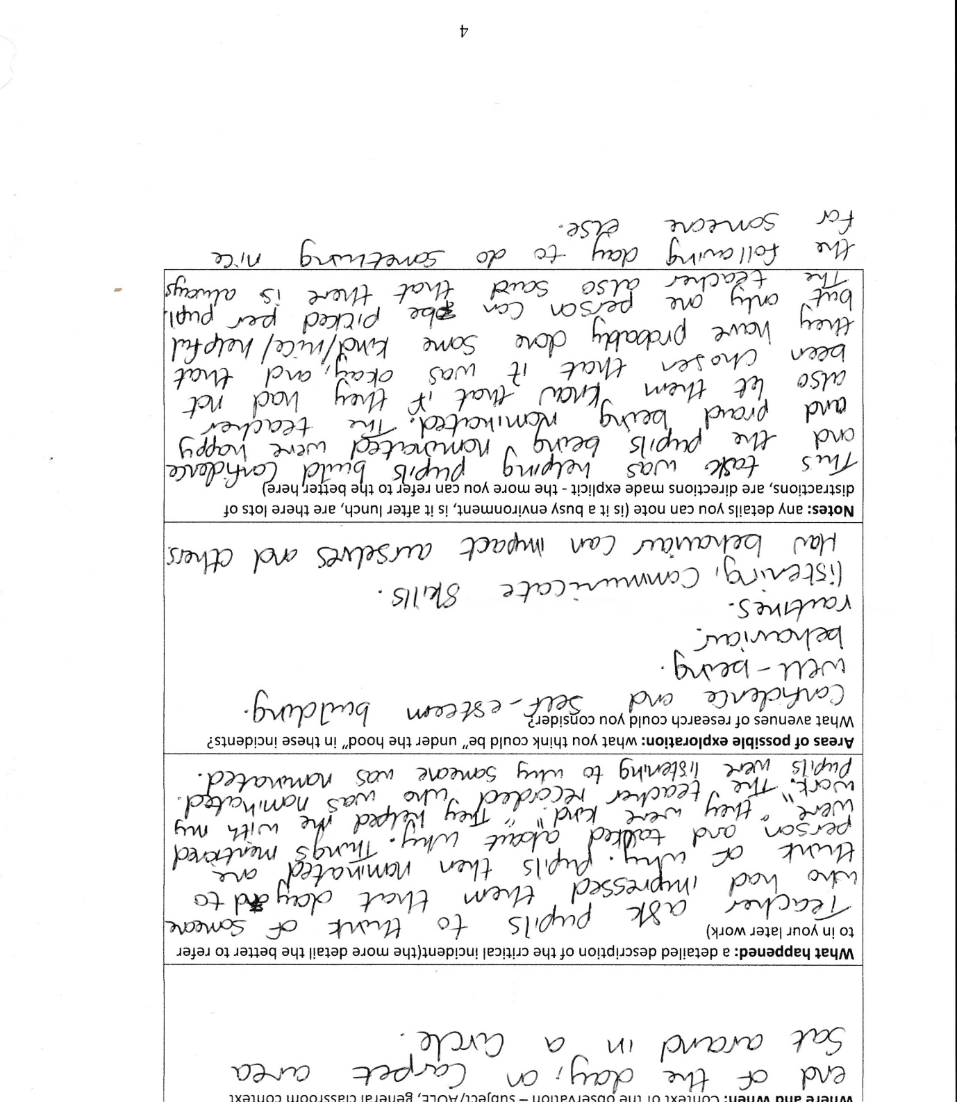

Appendix B:
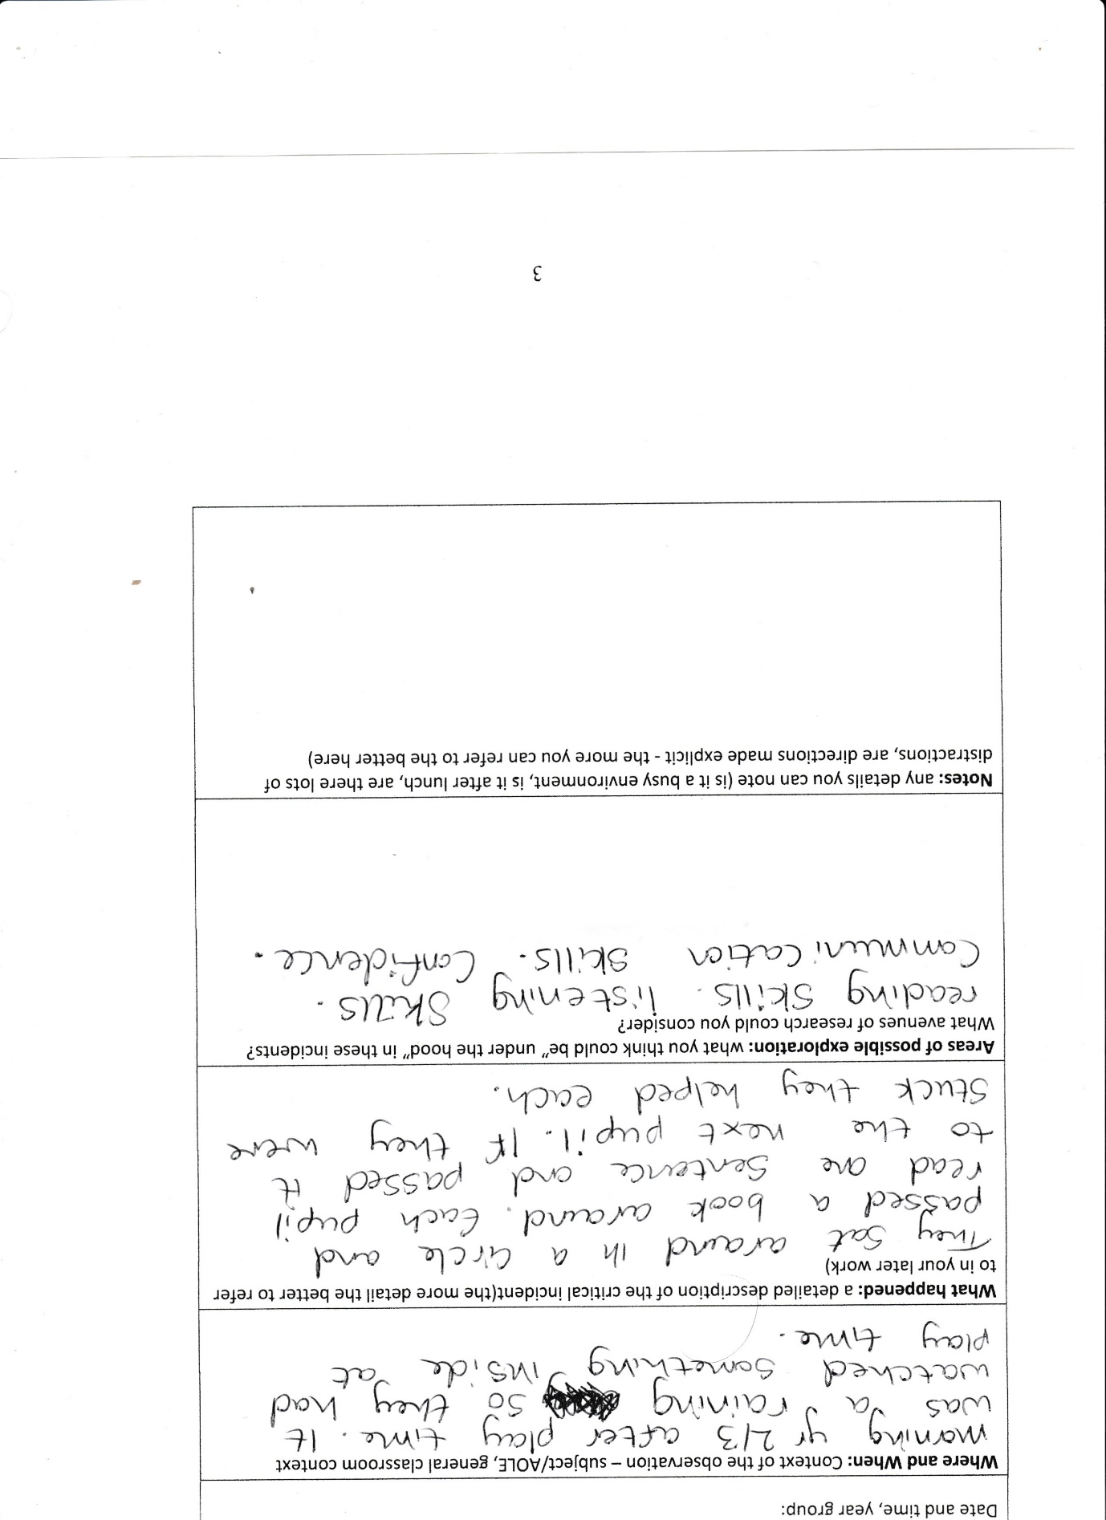

Appendix C:
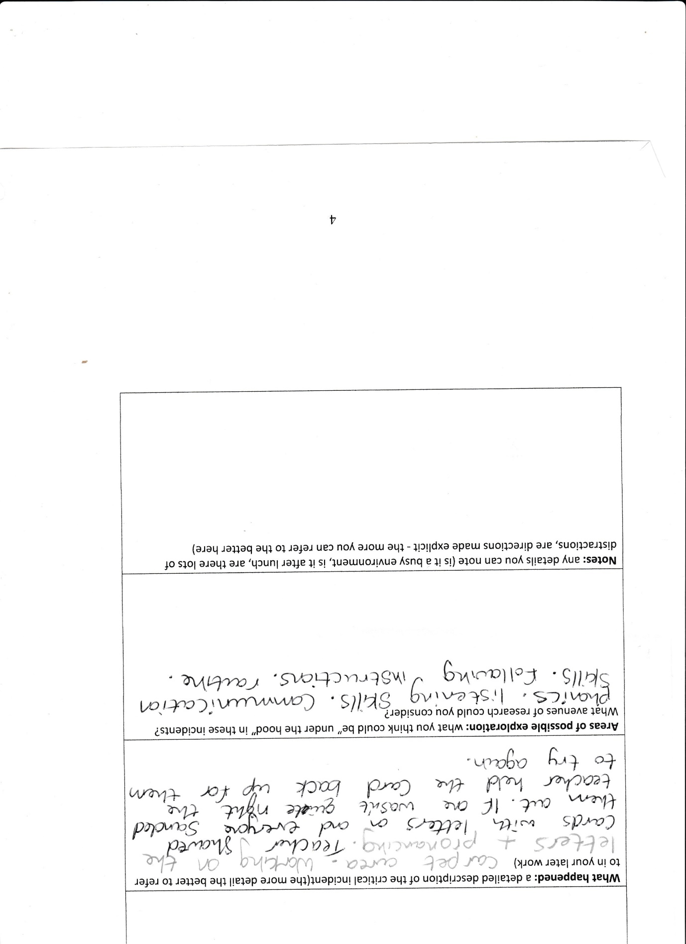

Appendix D:


