Student Name: Christian White
Student Number: 1900194
Programme of Study: Automotive Design
Module: ADAD4018

Tasks in the order I received them:
Task One: Manifesto (Julia Task) = 610 words
Task Two. (Jon Task) = 543 words
Task Three: Semiotic Analysis (Ryan task) = 471 words

8 Design belief statements in my practice, Automotive design.
- Car designs were true purity in the 1960s.
- Form and function must work harmoniously when deigning an automobile.
- Automotive design should be inspired by nature in a process called biomimicry.
- All senses should be considered when designing a car to be truly successful.
- Car design is a language and should connect with the public.
- The client should always be refereed back to during the designing process.
- Design should be iterative.
- Design movements have been reflected into automotive design through the eras.

- Car design was at its purest in the 1960s.

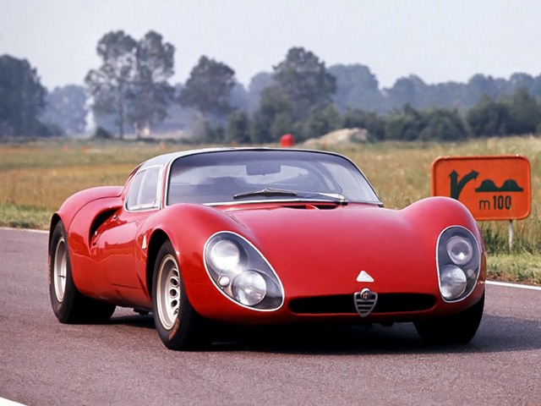
Key Word: Purity.

Figure 1: Alfa Romeo Tipo 33

The word purity according to the Oxford Dictionary (2019) is “freedom from adulteration or contamination” which relates to 60s designs. This was the era where manufacturing was starting to advance and car bodies were made by hand, therefore complex curvature in materials such as aluminium could be achieved using an English wheel for example. A car’s design was to look like it was aerodynamic however the technology was not accessible to test this. Therefore, resulting in pure forms that are aesthetic and visually sleek rather than scientifically aerodynamic which created a form over function outcome where the cars body is free from adulteration by Naca Ducts or other practical attributes resulting in pure forms. These views are backed by many automotive connoisseurs such as L. Greggio who describes the Italian Design of the 60s as “The hegemony of Italian design” (2018, p93) and A. Nedelea in the article “car design peaked in the 1960s” where he states
ugly and soulless modern cars are, when compared to the great classics of the 60s… All modern car manufacturers are so keen to make money, that they forget what cars really mean to people (2012, p.1)
which very much supports my statement as trends move from bespoke, handmade craftsmanship to a consumerist, throwaway society that is encouraging soulless mass-produced car designs. The passion and design purity will never be matched again.

3. Automotive design should be inspired by nature in a process called biomimicry.


Key word: Biomimicry
Figure 2 Japanese Bullet train. Available at: https://www.wakingtimes.com/2015/10/05/3-things-nature-can-teach-us-about-idea-sharing/ (Accessed on 13th December 2019)
According to The Biomimicry Institute “Biomimicry is an approach to innovation that seeks sustainable solutions to human challenges by emulating natures time-tested patterns and strategies” (2019). This should be used in the automotive and transport industry to achieve truly original designs and to lead innovation. Such as the Japanese bullet train above that has taken inspiration from a King Fishers aerodynamic beak on the trains nose. Enabling the train to achieve high speeds and stay stable. This approach is also used in the McLaren P1 hyper car.
McLaren’s designers applied the same texture as the scales of the sailfish to the inside of the ducts that lead into the engine…This increased the volume of air going into the engine by 17%, improving the car’s efficiency…
(Chawla, 2014, p. 1) Biomimicry is helping designers and engineers achieve greater performance from their designs such as straight-line speed which benefits the overall experience of the automobile. Therefore, biomimicry is a great inspiration and should be used in the automotive and transport world.

- Design movements have been reflected into automotive design through the eras.

Key word: Design Movements.
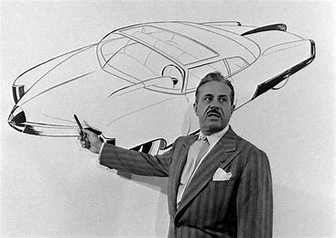

Figure 3: Raymond Loewy
Design movements are the change in styles, tastes and consumer demands over a time period. There have been many automotive designs that have been influenced by these movements such as the art deco and streamlining movement that began in the 1930s. The image above of Raymond Loewy is a famous industrial designer that very much influenced automotive and transport design into the streamlining and art deco aesthetic. Streamlining was favoured in the 30s because “When cars, trains, and airplanes began moving fast enough to incur air resistance, streamlining found its way into popular designs…”(Lienhard, 2002) Therefore, becoming incorporated into transport design in the 30s. many automotive journalists such as T. Lewin think that the art deco era for cars was the ‘golden age’ (2017a, p17) For example, T. Lewin called these design “art deco masterpieces”. (2017b, p17) Bauhaus has also been incorporated in German car design such as the beetle, one of Ferdinand Porsches designs. And this design ethic 1continued into his own Porsche products “The Bauhaus style would nevertheless play a major role for the Porsche company”. (Lund, 2019) These examples clearly show how design movements have inspired automotive and car design through the eras to innovate and create truly iconic pieces of work that are true to their times.
Chawla, D (28th August 2014) The car designer who turned a sailfish into a supercar, Available at: https://www.bbc.com/future/article/20140828-how-a-fish-inspired-a-supercar (Accessed: 16th November 2019)
Lewin, T. (2017) Speed Read Car Design, Minneapolis: Motorbooks
Lienhard, J. (2002) No. 1759: RAYMOND LOEWY, Available at: https://uh.edu/engines/epi1759.htm (Accessed: 16th November 2019).
Lund, M (February 5, 2019) Bauhaus & Car Design, Available at: https://viaretro.com/2019/02/bauhaus-car-design/ (Accessed: 16th Novemeber 2019).
Nedelea, A (2nd June 2012) Car Design Peaked in the 1960s, Available at: https://www.autoevolution.com/news/car-design-peaked-in-the-1960s-45706.html (Accessed: 16th November 2019).
The Biomimicry Institute (2019) What is Biomimicry? Available at: https://biomimicry.org/what-is-biomimicry/ (Accessed: 16th November 2019).
Figure 1: Available at: http://oldconceptcars.com/1930-2004/alfa-romeo-tipo-33-stradale-1967/, (Accessed 13th December 2019)
Figure 2: Available at: https://www.wakingtimes.com/2015/10/05/3-things-nature-can-teach-us-about-idea-sharing/ (Accessed on 13th December 2019)
Figure 3: Available at: https://ryancash.net/post/155628788235/raymond-loewy (Accessed: 13th December 2019)

The Morris Mini
The Morris Mini was created in 1959 (Mead, 1982). The creation of the Morris Mini was down to Sir Alec Issigonis’s who was employed by the British motor car company in 1955 to create a series of new models. However due to the Suez oil crisis, petrol was scarce creating a great demand for small, economical family cars. Therefore, the development of the Morris mini was made priority. Sir Alec Issigonis’s was an experienced and respectable automobile engineer and also created the Morris Minor. A car with huge success, the first British car to ever exceed 1 million sales. (Wilkinson, L, 2013)
The Morris Mini proved to be hugely successful. It stayed in production for 41 years with only minor safety and engine modifications and over 5.3 million units having been made. This success was down to many reasons. The car was very innovative, it was the first car to have a transverse, front engine, front wheel drive layout which was revolutionary at the time creating more leg room within the cabin due to not requiring a transmission tunnel. (Wilkinson, L, 2013) Therefore, being the smallest yet most spacious car in its class proving popular with many families. Sales were also boosted by celebrity endorsement for example each member of the Beatles owned one which further pushed sales and increased the perceived value to customers. Paul McCartney’s Mini has recently sold at auction too.
Ever wanted to drive a Mini once owned by a member of The Beatles? Well, you’re too late: this Radford-modified example originally owned by Paul McCartney has just sold for more than £182,000.” (Jupp, 2018)
Minis have also featured in many movies. The most famous appearance was in the Italian job Using three Mini Coopers. Used for their good handling, light weight and compact structure meant car stunts were easy too. This manoeuvrability was also recognised in rally racing and was used in many championships.
The Cooper S was piloted to victory in the Monte Carlo rally twice more, first in 1965 with Timo Mäkinen at the wheel and again in 1967, driven by Rauno Aaltonen. (Autocar, 2019)
which further enhanced the MINIs desirability due to its success in such prestigious rally events and driven by well-known successful rally drivers. Today the mini is still a desirable car with collectors, the modified scene, racing and much more. Keeping the value of early cars high. Some people regard the mini as the best handling car of all time. The minis clever front engine front wheel drive layout revolutionised the small and city car industry due to the added benefits of extra cabin space front wheel, front engine cars also benefitted from extra traction on snow and other slippery mediums.
BMCs brilliant engineer Alec Issigonis refusal to allow stylists near his 1959 mini resulted in a plain but highly effective car that went on to become an icon- a great accidental example of form following function.” (Lewin, T, 2017, p 32)
Which is why I think the mini was such a great success and why I long for a classic mini. Its simplicity, cute looks, innovative layout created a car with a strong personality and became a style icon, a global fashion. Very much like the Apple iPhone. Everyone wanted one.

Autocar (26 January 2014) Mini Cooper S at the Monte Carlo rally - picture special, Available at: https://www.autocar.co.uk/car-news/motoring/mini-cooper-s-monte-carlo-rally-picture-special (Accessed: 15 November 2019).
Jupp, E (September 3, 2018) Can’t buy me love: ex-Paul McCartney Mini sells for £182,000 , Available at: https://www.motoringresearch.com/car-news/beatles-paul-mccartney-mini-sells/ (Accessed: 15 November 2019).
Lewin, T (2017) Speed Read Car Design, Minneapolis: Motorbooks
Mead, J (1982) Mini Owners Workshop Manual: England: Haynes publishing group.
Wilkinson, L (18 Nov 2013) Mini: a brief history, Available at: https://www.telegraph.co.uk/motoring/car-manufacturers/mini/10456893/Mini-a-brief-history.html (Accessed: 15 November 2019).

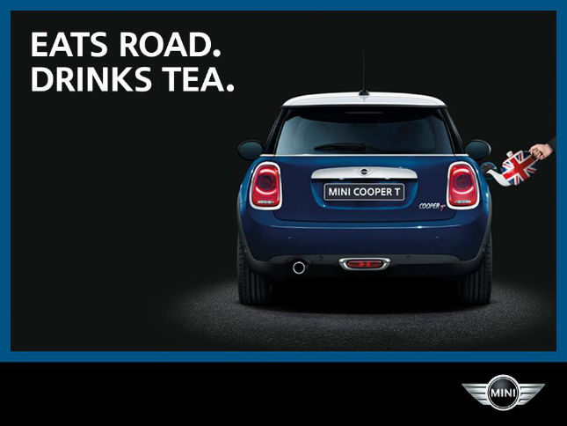
Ryans Task

Here I will be analysing an advertising campaign on the Mini Cooper. This advertising campaign was produced for the British market. When analysing the image, it is clear how the advertising campaign has been tailored for the British consumer. The image states “EATS ROAD. DRINKS TEA” This is a form of metaphor as suggested by Lakoff and Johnson ‘the essence of metaphor is understanding and experiencing one kind of thing in terms of another’ (Chandler, 2002, p. 127) In this case then mini advertising campaign is trying to express how British the car is as Minis have also been produced in the UK and before BMW ownership the mini was quintessentially British, Just like English Tea. The fact the car is drinking tea gives the car a personality of which is very British in nature. The Fact the car is eating the road suggests that the car Thrives on the road and suggests the car is very capable on tarmac. The metaphor theme is also continued visually where the teapot is fuelling the car and the car has been called the “Cooper T” which is metaphorically referring to the English Tea. According to the book “the basics semiotics” it could also be referred to as ‘negotiated reading’ where
Negotiated reading: The reader partly shares the texts code and broadly accepts the preferred reading but sometimes resists and modifies it in a way that reflects their own position, experiences and interests. (Chandler, 2002, p. 127)
Therefore, British people that have experience of the local culture will understand this metaphor. Outsiders such as non-native people may not understand if they do not know of this culture or they have not had this experience.
The Advert also creates an importance to the image. Such as placing a spotlight over the car to make the car stand out and add to is glamour and puts the short punchy statements in capitals to grab the attention of the viewer and to further increase the importance of the advert “The goal of capital letters is to…Catch the reader’s attention” ( which is ideal for an advertising campaign as the aim is to catch as many people’s attention in order to increase sales for the company and therefore these attention grabbing methods are essential to create a successful advertising campaign.

The Colour Scheme of Red, white and blue also enhances the British theme as the British flag is of course red, white and blue and this will be recognised via the association theory “states that concepts are learned by simple, reinforced connections between a stimulus and a desired response” which may not be recognisable at first in this image as its not explicitly shown but will be subconsciously recognised as it’s not the main focus which further enhances the British nature of the product in the advertising campaign
Alley Dog, (2020), Available at: https://www.alleydog.com/glossary/definition.php?term=Association%2520Theory (Accessed: 5th January 2020).
D, Chandler (2002) the basics semiotics, Abingdon: Routledge.
Handwriting Graphology, (13th August 2016), Available at https://www.handwriting-graphology.com/handwriting-analysis-capital-letters/ (Accessed: 5th January 2020).

