INTERCULTURAL COMPETENCE REPORT

Student Name: Ancuta Mariana Racovita
Student ID: 2208682
Module Name: Foreign Language and Cultural Awareness BMIH5003
Lecturer Name: Lisa Bassler
Word Count: 1026

Table of Contents
1. Introduction 4
2. Main body 4
2.1 Cultural overview 4
2.2 Globe Project Country Analysis 6
2.3 Importance of cultural intelligence and sensitivity in hotel business 7
3. Recommendations 8
4. Conclusion 8
References 9
Appendices 11
Appendix 1: Germany Globe Project 11
Appendix 2: England Globe Project 12

1. Introduction
The report is going to discuss cultural competence within the hotel industry. In this study, the selected organisation that will expand its business overseas has to face some cultural barriers. The Diversity Hotel and Spa which is situated in London wants to expand its business to Germany. In this case, the cultural competence that the hotel business may face needs to be analysed. The report will discuss the country analysis of Germany while providing some possible recommendations to mitigate the cultural barriers.

2. Main body

2.1 Cultural overview
The Diversity Hotel and Spa has decided to expand its business to Germany. In this case, the culture, society and customs are completely different between the home and the hot country. It is significantly important to analyse the host country’s culture and customs before establishing the business. Analysing the host country’s culture will provide a clear insight into their target audience, competitors and product designs.
Cultural Overview of England: The Home country, England in this case is a much diverse society and an amalgamation of several cultures (Orlin, 2020). UK people value tradition, however, they adopt new trends and ideas quickly. England has advanced education and healthcare systems (Wood, 2020). People of England value entertainment along with balancing work and life (Wahyuni et al. 2019). England is more adaptable to fast food culture [referred to appendix 2].
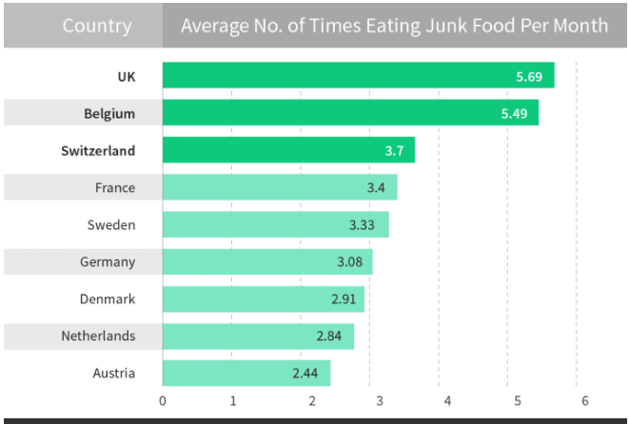
Figure 1: Fast Food consumption of UK
(Source: Newfoodmagazine, 2023)
Cultural Overview of Germany: On the other hand, Germany is a country that is less diverse in comparison to the UK. German people are workaholics and they do not give much scope to entertainment (Schilling, 2022). Germany has a predominantly Christian society and they prefer having less spiced food (Jefferies, 2020). In this case, German people prefer to have breads, potatoes, meat and plenty of green vegetables. German language is the official language of Germany. German people love to play sports as a form of entertainment. German people are not very digitally advanced in comparison to England (Garcia et al. 2020) [referred to appendix 1].
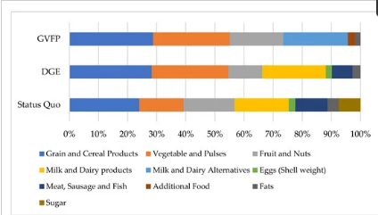
Figure 2: German Eating Habits
(Source: Seubeltet al. 2022)
Hence, it can be inferred that the culture of the home and the host country is significantly different. In this case, the Diversity Hotel and Spa needs to conduct a country analysis to know more about the culture of Germany.

2.2 Globe Project Country Analysis
Criteria | England | Germany
Uncertainty Avoidance: | The society of England is more open and easily adopt the new changes and uncertainty | The German society is more into traditional values and slow in adopting the changes and trends
Assertiveness: | The people of England are more assertive and dominant | The German people are less assertive but usually are aggressive than the People of England
Gender Differentiation/Egalitarianism: | The Society of England has still not fully accepted gender equality as gender pay disparity is still predominant there (Globalproject, 2023) | German society is more adaptable to gender equality and promotes women's education and equal payment (Globalproject, 2023)
Performance Orientation: | The England people are performance-oriented and give much importance to rewards as a form of encouragement (Globalproject, 2023) | The people of Germany are more performance-oriented but they do not give much importance to rewards as a medium of encouragement
Humane Orientation: | The people in the UK are not much humane-oriented as they are not very concerned about others. | The people of Germany give much importance to kindness and care (Globalproject, 2023)

2.3 Importance of cultural intelligence and sensitivity in hotel business
The hotel business mostly targets customer satisfaction as a tactic to generate more revenue and profit. In this case, knowing the needs and preferences of the customers is important to provide a better service (Koc, 2021). Different countries have different beliefs and traditions to follow. In this case, a hotel business that has subsidiaries in different countries needs to adopt different tactics for each country they are operating. Cultural sensitivity can help an organisation to control its human resources (Hossain et al. 2021). In this case, the hotel business must provide the same dignity and respect to their staff irrespective of their cultural backgrounds. Cultural sensitivity can also help a hotel business to know the needs of its target audience in a host country (Koc, 2019).
Giving priority and respect to the cultural values of the host country is called cultural intelligence. The Diversity Hotel and Spa that is going to establish its business in Germany needs to prioritise the cultural values and beliefs of the German people in order to build a market reputation and brand image for their business in the host country. The hotel business needs to focus on the food habit of the German people and need to introduce a new food menu for the host country. The hotel business can incorporate sports and games as form of activities and entrainments for the German guests. The hotel business needs to recruit people who are efficient in speaking German language. Cultural intelligence would also help the staff of the hotel to provide better service to the customers. For example, the German people’s food habits are different from the people of England. The German people usually eat less spiced meals (LiveScience, 2023). In this case, the hotel business needs to modify its food menu according to the taste of the German people.

3. Recommendations
- The Diversity Hotel and Spa needs to recruit local people from the host country to understand their cultural values and principles
- The hotel business needs to incorporate an equal pay system for each employee irrespective of gender as per the pay system of Germany.
- The hotel business needs to modify its services according to the preferences of the German people.

4. Conclusion
It has been found that the diverse Hotel and Spa needs to analyse the cultural society of Germany in order to successfully run their business there. In this case, The Globe Project cultural analysis has presented several dimensions that can help the hotel business understand the preferences and needs of the customers. In this case, the cultural customs, religious beliefs, food habits, education and healthcare systems need to be analysed to provide better service to the customers of Germany.

References
Garcia, F., Serra, E., Garcia, O.F., Martinez, I. and Cruise, E., 2019. A third emerging stage for the current digital society? Optimal parenting styles in Spain, the United States, Germany, and Brazil. International Journal of Environmental Research and Public Health, 16(13), p.2333.
Globalproject, 2023. Globe Project. Available at:https://globeproject.com/. (Accessed: 7th November, 2023)
Hossain, M.S., Kannan, S.N. and Raman Nair, S.K.K., 2021. Factors influencing sustainable competitive advantage in the hospitality industry. Journal of Quality Assurance in Hospitality & Tourism, 22(6), pp.679-710.
Jefferies, M., 2020. Imperial Culture in Germany, 1871-1918. Bloomsbury Publishing.
Koc, E., 2019. Service failures and recovery in hospitality and tourism: A review of literature and recommendations for future research. Journal of Hospitality Marketing & Management, 28(5), pp.513-537.
Koc, E., 2021. Intercultural competence in tourism and hospitality: Self-efficacy beliefs and the Dunning Kruger Effect. International Journal of Intercultural Relations, 82, pp.175-184.
LiveScience, 2023. German Culture. Available at:https://www.livescience.com/44007-german-culture.html.(Accessed: 7th November, 2023)
Newfoodmagazine, 2023. Fast Food Consumption of the UK. Available at:https://www.newfoodmagazine.com/news/142469/junk-food-europe/.(Accessed: 7th November, 2023)
Orlin, L.C., 2020. Private matters and public culture in post-Reformation England. Cornell University Press.
Schilling, H., 2022. Religion, Political Culture, and the Emergence of Early Modern Society: Essays in German and Dutch History (Vol. 50). Brill.
Seubelt, N., Michalke, A. and Gaugler, T., 2022. Influencing factors for sustainable dietary transformation—A case study of German food consumption. Foods, 11(2), p.227.
Wahyuni, Y.D., Rizkanisa, N., Samad, I.A. and Daud, B., 2019. Experiencing English: A textbook evaluation on the cultural loads. Al-Ta lim Journal, 26(3), pp.254-266.
Wood, E., 2020. Learning, development and the early childhood curriculum: A critical discourse analysis of the Early Years Foundation Stage in England. Journal of Early Childhood Research, 18(3), pp.321-336.

Appendices

Appendix 1: Germany Globe Project
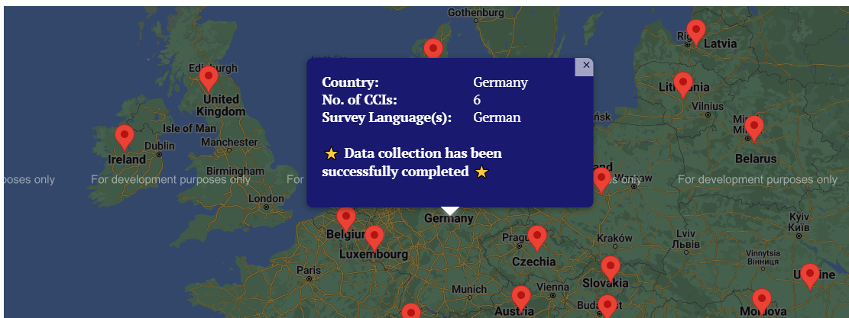
(Globalproject, 2023)

Appendix 2: England Globe Project
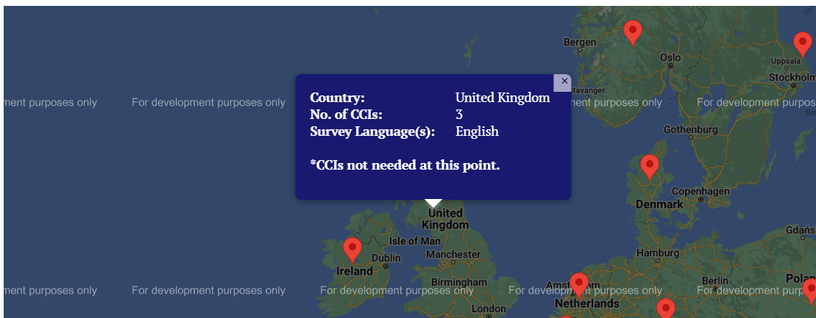
(Globalproject, 2023)

