University of Wales Trinity Saint David

The contribution of Vodafone mobile device and bespoke app for South Central Community First Responder activity.

Marin Dimitrov Karakolev ID 2029731
Community Engagement (LCBB4002_BIRM)
Dale Clark
Due date: 5th March 2022

Introduction

The South-Central Ambulance Service NHS Foundation Trust is the ambulance service that cover Hampshire, Oxfordshire, Buckinghamshire, and Berkshire. The SCAS NHS Trust is founded on 1 of July 2006 by the merger of 4 ambulance services: Oxfordshire Ambulance NHS Trust, Hampshire Ambulance service NHS Trust, Royal Berkshire Ambulance Service NHS Trust, and part of Two Shires Ambulance NHS Trust. On 1 of March the trust acquired the status of a foundation.
In June, the SCAS NHS Trust was nominated for the best performing ambulance service in the England. The area that they serve has a population of over 7 million. They have over 103 sites across the south-central area. They have Patient Transport Service Centre in Sussex and Headquarters in Oxfordshire, Otterbourne, Bicester and Hampshire. All these sites have Co-ordination centres to receive calls from 999 and NHS 111. The main functions of SCAC are: 1. To respond to 999 calls and to provide rapid emergency service with vehicles and air ambulances. 2.To respond to NHS 111 calls. This is the non –emergency number that offer medical help and advice. This service is for not a life-threatening situation. They tried to help by phone and if is required they can transfer calls to 999 service 3.Non-emergency Patient Transport Service. They provide transport for patients who are unable to use public transport, because these patients have some illness. This service provides safety transport from patient's home to hospital. SCAS have a community first responder that support the Trust. They are trained to be able to help the people. They have a logistic and courier service as well to move parcels, mail, passengers, and specimens.
This report will highlight how Vodafone mobile device and their app improve community responder engagement activity. This work will identify who are the users of this service and what service can provide community responders. How important their role is. What training they must acquire and the skills and knowledge they need for this role.

Discussion

The South-Central Ambulance Service NHS Foundation Trust serve over seven million people in four counties. 1200 volunteers also help them like a community first responder. They assist the Trust service by attending emergency calls. SCAS NHS Foundation Trust needed a better communication solution to help first responders to act quickly and to get all the information that they needed. This solution could improve communication between ambulance control centre and first responders to allow them to respond rapidly and easily to emergency calls. The SCAS Foundation Trust needed a solution that will allow them to track responders' location and to connect the nearest responder to the patient location.
Vodafone provided 400 smartphones to the Trust to support First responders in South Central Region. Before volunteers used 3 devices to carrying on their job. Now they use only one device. Vodafone provided an application for first responders that enable them to sign in and confirm when they are available to work. When the ambulance receives a call for an emergency, the app finds the nearest responder, provide him the exact location and the fastest route. With this application and new smartphones ambulance control centre can see the nearest available responders, to send them to the incident location and to give them details of the incident. Same time the responder can inform the ambulance centre for patients' condition. The controlling room can see where the responders are and to know that they are safe, and the patient receive the treatment. Using this app first responders save time to reach the patient and to help him as soon as possible. Using this digital technology South Central Ambulance Service NHS Foundation Trust improve patient care and efficiencies. The feedback from patients that been treated from first responders has been highly positive. Nic Morecroft, operations and training manager for community engagement at SCAS NHS Foundation Trust, said: “Our partnership with Vodafone highlights how implementing technology solutions can have an immediate and real impact on the service we offer to patients.” (Vodafone connects South Central Ambulance Service First Responders to boost patient response, 2022)’4
Community first responders are volunteers available to accept a call from ambulance control centre and to attend a medical emergency in their local area. They are trained to provide early life saving treatment until an ambulance arrive. They can arrive fast, because they are nearer and can provide early intervention in the critical first minutes of an emergency. They deal with a specific list of emergencies and can help the patients and their families as well. They are trained to provide help to people with cardiac arrest when patient heart has stopped beating and is likely to become irreversible. First responders could be members of staff of shopping centres or other public places, first aid organisations. Those who respond are send in immediate life-threatening situations. Sometimes the control centre can restrict the type of service that responders can attend by a detailed check of call from Emergency Dispatch Centre. This is because first responders do not have the appropriate levels of training or the necessary equipment, that increasing risk. The type of emergency that responders are not asked are drugs problems, domestic violence, harassment issues, and dangerous scene like a traffic collision. They role is to stabilise the patient and provide the necessary care until highly skilled ambulance crew reach the scene. The first step of first responder is to assess the scene and to ensure that it is safe. Second step is to assess victim's airway, to check breathing and vascular circulation.

The first responders are especially important part of SCAS emergency service. Their main advantage is that they are close to the scene of the accident and can react immediately and get there very quickly. Arriving there, they can assess what is the condition of the patient and provide first aid to him by stabilizing the patient and sending information for the patient's condition to the controlling room and requesting emergency assistance if needed.
The participation of the First Respondents in SCAS NHS Trust ambulance activities saves lives, give better opportunities, and improve healthcare standards. Working together with local organizations, they have the opportunity to take responsibility and contribute to the health system and the collective well-being of their region. First responders are important when people need them. They can really change the outcome of many emergencies that occur. Sometimes in an emergency may be there are not a free ambulance to take over the case immediately. Then comes the importance of this additional emergency part-Community first responders. Having all these people available in all regions who can respond quickly to an emergency call and visit a patient who needs urgent care significantly faster and to provide life-saving care, number of patients taken to hospital decrease and reduce impact on ambulance capacity, like that patient feel better by staying in their home. A Community first responders’ scheme has benefits for both patient and ambulance service. So, ambulance have been released to attend more emergencies. CFR been sent to people who have fallen without injury or need a welfare check. Daily South-Central Ambulance Service receives around 180 calls relating this type of patients. The main benefits of being an Emergency First Responder are: they save lives, builds confidence, and reduce recovery time. SCAS Community First Responders team has won the award: ‘Outstanding volunteering team of year’. This award recognizes the tremendous contribution of each of the First Responders team has made. 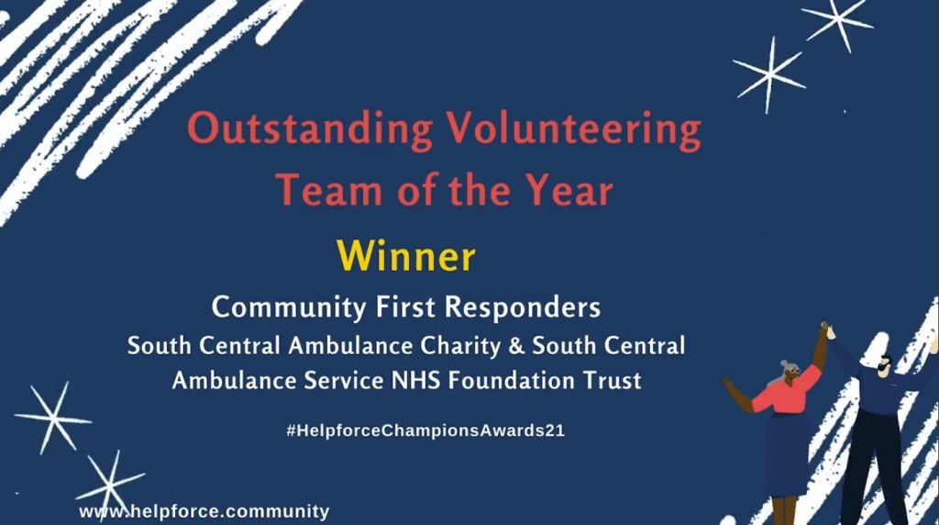
Source;(www.helpforce.community).

“We know the last year has provided many new and different challenges, but it has also shown the true loyalty, resilience and passion of our volunteers – on behalf of everyone at SCAS we thank them all for their continued support and hard work.” said Vanessa Casey, Chief Executive of South-Central Ambulance Charity. (Volunteer responders win national ‘Team of the year’ award, 2022)’6
The first responders must be trained to help in cases of: Heart attack, cardiac arrest, breathing difficulties, stroke, choking, Serious injuries, chest pain, traumatic injuries, diabetic emergencies.
They get training for using an automated external defibrillator (AED), basic airway management and oxygen therapy, and cardiopulmonary resuscitation.
First responder has specialized training, hi can arrive first and provide firs aid at the scene of an emergency. First aid skills and cardiopulmonary resuscitation for first aid specialists or those who are being trained to become first aid workers. The course teaches model patient assessment, cardiopulmonary resuscitation, bleeding control and care for various acute and chronic conditions.
Community First Responders undergoes a dynamic course including a lecture, video, simulated emergencies, discussion, and practical skills based on national educational standards.
SCAS is foundation trust that mean that they receive a charity to support SCAS work. The Charity is for improving services and equipment throughout the trust. The charity operates in Berkshire, Buckinghamshire, Hampshire, and Oxfordshire, and supports patient transport services in Surrey and Sussex. They received £410K from charity, part of it is used to deliver pioneering training programs for Community First Responders. Before becoming a respondent, they complete a five-day training program, in addition they have a refresher program every six months, engage in minimum 20 hours per month, can cover a radius of 5 miles from his home or work. These skills will allow improved First responders to provide to controlling room more detailed information about status of patient in advance and help ambulance to decide the best way to care for patient.

“According to Vanessa Casey, CEO of South Central Ambulance Charity: The additional funds will allow us to increase the support we are able to give to our CFRs through life-saving equipment and additional training to develop the program, as well as support our staff with important equipment such as LUCAS " (South Central Ambulance Service NHS Foundation Trust, 2022)’5 LUCAS CPR system is to give continuous chest compressions in safe and effective way that keep blood circulation at a regular level, while the patient is transferred to an ambulance.

Conclusion

The Community First Responders are a very important part of the South-Central Ambulance Service NHS Foundation Trust. Their close location gives them the advantage to reach the patient significantly faster and provide first aid, so they save lives, increases opportunities, and raises healthcare standards. The new Vodafone application and new smartphones enable them to log in and report if they are available to respond. When an incident occurs, the app finds the nearest responder, provide him the exact location and the fastest route. With this application and new smartphones ambulance control centre can see the nearest available responders, to send them to the incident location and to give them details of the incident. A Community first responders' scheme has benefits for both patient and ambulance service.

References
1.Buildingbetterhealthcare.com. 2022. Vodafone helps ambulance service improve response times. [online] Available at: <https://www.buildingbetterhealthcare.com/news/article_page/Vodafone_helps_ambulance_service_improve_response_times/147966> [Accessed 27 February 2022].
2.Medic Outpost. 2022. Medic Outpost. [online] Available at: <https://www.medicoutpost.org/> [Accessed 27 February 2022].
3.Plan, N., 2022. Community First Responders – making a difference. [online] NHS Long Term Plan. Available at: <https://www.longtermplan.nhs.uk/case-studies/community-first-responders/> [Accessed 27 February 2022].
4.South Central Ambulance Service NHS Foundation Trust. 2022. Vodafone connects South Central Ambulance Service First Responders to boost patient response. [online] Available at: <https://www.scas.nhs.uk/vodafone-connects-south-central-ambulance-service-first-responders-to-boost-patient-response/> [Accessed 27 February 2022].
5.South Central Ambulance Service NHS Foundation Trust. 2022. Search results for "first responders training" | South Central Ambulance Service NHS Foundation Trust. [online] Available at: <https://www.scas.nhs.uk/?s=first+responders+training> [Accessed 27 February 2022].
6.South Central Ambulance Service NHS Foundation Trust. 2022. Volunteer responders win national ‘Team of the year’ award. [online] Available at: <https://www.scas.nhs.uk/south-central-ambulance-service-volunteer-responders-win-national-team-of-the-year-award> [Accessed 27 February 2022].
7.South Central Ambulance Service NHS Foundation Trust. 2022. Community and Co-Responders. [online] Available at: <https://www.scas.nhs.uk/our-services/community-and-co-responders/> [Accessed 27 February 2022].
8.Swast.nhs.uk. 2022. Welcome to SWASFT - What we do. [online] Available at: <https://www.swast.nhs.uk/welcome/community-first-responders/community-first-responders-information> [Accessed 27 February 2022].
9.Vodafone.co.uk. 2022. [online] Available at: <https://www.vodafone.co.uk/business/media/document/1508876228830/south_central_ambulance_service_-_case_study.pdf> [Accessed 27 February 2022].

Training and equipping the world’s remote first responders.

Training and equipping the world’s remote first responders.

