Group Task
Incident Scenario Sheet 1


It is 14:30 hours. You receive a call from the Force Communication Centre to attend a property at High Street. There has been a report of a burglary.

Q. What further information do you need whilst ‘en-route’ to the call?

Group Task
Incident Scenario Sheet 2

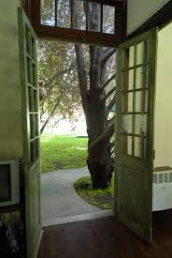
You are told that the owner of the property is a Mrs Dora Jones who reported that when returning home from a shopping trip, she saw a dark haired figure who ran across the back garden and out of the property.
Mrs Jones went to the rear of the house and realised that the back door was open.
The incident happened twenty minutes ago.
There are no other units available.
Mrs Jones is not injured but sounded a little upset.
She lives at No. 18, High Street. There is no record of previous occurrences at the address.

You now have all the information that is available at this time.
Q1. What options do you have in relation to attending the scene?

Q2. What are your considerations upon arrival at the scene?

Group Task
Incident Scenario Sheet 3

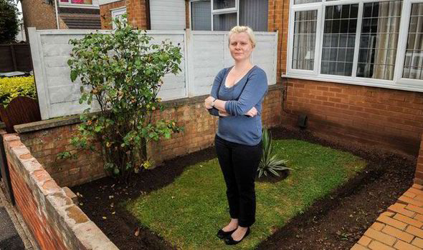
You arrive at the scene and find Mrs Jones in the front garden.

Q. What are your initial thoughts and actions?

