Emily Lowe - 2116273
MA Professional Practice (Voice Pedagogy)

Independent Study

BMPF7013

Creating gender-inclusive voice lessons: Can we do better?

Table of Contents
Glossary of Terms 3
Introduction and Rationale 4
Planned Programme of Study 7
Literature Review Process 9
Critical Reflection – The learning Process 12
The Literature Review 17
Creating Gender-Inclusive voice lessons: Can we do better? 17
References 32
Appendices 44

Glossary of Terms

For the reader's knowledge, I have provided the following glossary of terms which will be used within this paper:
Gender expansive – is an adjective that can describe someone with a more flexible gender identity than might be associated with a typical gender binary (Wamsley, 2021)
Trans*+ - (pronounced; “trans star/Asterix plus”). The “* and + more broadly references the ever-evolving non-cisgendered gender identities, which are identified as, but certainly not limited to, (a)gender, cross-dresser, bigender, genderfluid, genderf**k, genderqueer, non-binary, non-gender, third gender, trans man, trans woman, transsexual, and two-spirit. How the term trans*+ continues to take form will evolve as identities and theories morph in indeterminate ways.” (Miller, 2016, p.2)
LGBTQIA+ - is an abbreviation for lesbian, gay, bisexual, transgender, queer or questioning, intersex, asexual, and more. These terms describe a person’s sexual orientation or gender identity (Defining LQBTQIA+, 2023)
Ambient belonging – is feeling comfortable in a space — like you are accepted, valued, and included there (Warren, 2018).
Hegemony refers to the process in which individuals willingly conform to a system of beliefs and practices that are harmful to their own well-being but serve the interests of those who hold power over them (Hall, 1997; Brookfield, 2005).
Classroom – I will be referring to “classroom” as a larger space used for whole class tuition.
Practice room – meaning smaller spaces in school used for one-to-one tuition or small groups.
Creating gender-inclusive voice lessons; Can we do better?

Introduction and Rationale: 1382
I am a voice teacher who works predominantly with adolescents aged between eleven and eighteen. Since returning to face-to-face lessons after the pandemic, I have become aware of a growing proportion of my adolescent pupils beginning to experiment with their gender. For the last decade, the internet has provided a haven for people to experiment with their gender (Gross, 2004). Emerging research suggests that access to the internet for adolescents increased during the pandemic, with particular emphasis on social media (Paschke, 2021). The pandemic has presented an opportunity for more adolescents to explore their gender, which may not have been as accessible before, due to increased exposure to the internet and prolonged time at home. With more gender-expansive pupils presenting at clinics and practices throughout the industry (Azul and Quoresimo, 2022), ensuring a supportive and safe environment for pupils to experiment with their gender during and beyond puberty will remain at the forefront of my practice. This means ensuring awareness of the biological considerations regarding effective pedagogy during lesson delivery and creating meaningful connections between teachers and their pupils to further this journey together (Peters, 2003).

The majority of my workload involves leading one-to-one lessons and I often find myself as being the first point of contact for pupils to disclose their desire to try alternate pronouns and names. I consider this a privilege and will always support them while being mindful of safeguarding regulations and school policies such as Gov.uk, UNICEF guidelines and OFSTED (Office for Standards in Education, Children's Services and Skills) (Ofsted, 2023) guidance. Based on personal experiences, I identified gaps within existing guidelines, which motivated my previous research project. The aim of the project was to explore the need for a new teaching strategy specifically designed for gender-expansive and trans*+ voices. This led to the conclusion that our existing practices must be updated to be inclusive for all. These findings align with a study conducted by Palkki and Caldwell in 2018, which highlights the experience of LGBTQIA+ (lesbian, gay, bisexual, transgender, queer or questioning, intersex, asexual, and more – Defining LQBTQIA+, 2023) students feeling invisible within school. The research also emphasises that the music department can serve as a safe space for these students. My initial findings were similar to those of Palkki and Caldwell (2018) and pointed to a gap in resources and guidance for teachers to help encourage inclusivity for pupils. To encourage development within music education, this paper will look towards national guidance and legislation on gender inclusivity. Furthermore, this paper will argue in favour of widening that search to include the spaces where we lead our lessons to ensure pupils feel they have a space where they can belong (Palkki and Caldwell, 2018). I intend to begin this process by examining my practice and experiences to highlight gaps within my skill set.

Standardisation of Teaching spaces
In the eight schools where I work, I have observed that each music department has its own style of practice rooms. These range from big open spaces with full band setups, including drum kits and sound systems encouraging amplified rehearsals, to small box rooms, which are often used for other lessons and catch-up sessions. This provides pupils with different acoustic and ambient experiences over which, as a visiting tutor, I have very little control. Pupils have reported that the rooms can encourage sensory overload or feelings of overwhelm, which are often traits associated with neurodiversity. Emerging data trends suggest a strong and increasing link between neurodiversity and gender expansivity (Dattaro, 2022), which can often be overlooked when allocating rooms in which voice lessons take place. Doing so can alienate pupils who experience neurodiversity, including those from the gender-expansive community, although it must be noted that not all gender-expansive pupils are neurodiverse, thus emphasising the need for our practices to be inclusive for all.

These early thoughts led me to seek guidance or clarification regarding the standardisation of teaching spaces. However, I was unable to find any UK-based legislation on this. The Department for Education (2014) provides guidelines for classroom size but lacks specific regulations regarding the contents of the space, making it challenging to create an inclusive environment for everyone. LGBTQIA Health Education (2020) emphasises the importance of considering the teaching space alongside lesson content, yet there is limited information available on how to achieve this. Therefore, my intention is to research the influence of the teaching space on a student's sense of belonging and make recommendations for small but impactful changes to support this research further.

Hegemony and Ambient Belonging
This study will investigate inclusivity in voice lessons focussing on hegemonic gender identity and how stereotypical cues can influence educators' decisions alongside student participation (Cheryan et al.,2009). Hegemony refers to the process in which individuals willingly conform to a system of beliefs and practices that are harmful to their own well-being but serve the interests of those who hold power over them (Hall, 1997; Brookfield, 2005). In my analysis, I will explore the implications of hegemony for students' sense of belonging, particularly focusing on the environments they encounter and the concept of "ambient belonging" (Cheryan et al,, 2009 p1045). Additionally, I will explore strategies aimed at exploring students' feelings of comfort, acceptance, value, and inclusion within these spaces (Warren, 2018). By investigating these aspects, I aim to shed light on the potential effects and impacts of hegemony on voice lessons. The emphasis of this study is to develop my skill set when working with adolescents; however, to do this, I will be looking further than just adolescents and their voices. By analysing the current government guidance and legislation on music education and inclusivity alongside the national curriculum in secondary schools, I hope to provide a balanced, unbiased, critical review of the existing guidelines. Whilst I will be able to make recommendations to some elements of my practice, I am aware that I will not be able to easily implement certain aspects into areas of my work which are governed by external bodies such as GOV.uk, The Office for Standards in Education, Children's Services and Skills (OFSTED, 2023) and individual school policies. To apply any significant findings to my field of research and personal practice, I recognise the need to enhance my knowledge in this area. This will enable me to incorporate relevant insights and information into my work effectively.

I hypothesise that there will be limited literature related to hegemonic gender identity and ambient belonging specific to music and voice education, as previous research on similar topics has yielded minimal results. Therefore, I will need to expand my search to include literature from other fields, including the computer science industry, which is predominantly male dominated (Bridges et al., 2020). I will extrapolate and analyse these findings to create links to my own specialism and create new ideas for further research. The existing literature will need to be carefully analysed and applied to my workplace with thorough consideration as to how it relates to the voice and, ultimately, gender and the voice. I will look to the existing literature to support my theory that there is room for music teachers to create a more inclusive singing space for all voices to be heard, regardless of gender. By considering the viewpoints of others, I intend to develop a new set of thoughts that could potentially lead to further research and the development of new, inclusive strategies (Moule, 2020). I hope to do this by critically analysing hegemony, gender identity and stereotypes as well as exploring new areas of research such as ambient belonging. This is an emerging area of research and is defined as “a feeling of fit in the environment and similarity to the people imagined occupying it” (Cheryan et al.,2009 p1045). By establishing connections between our sense of occupying a space, enjoyment, and creativity, I hope to find new ways to create inclusivity within my own teaching space. By investigating physical spaces within my workplace and engaging with relevant literature to formulate evidence-based recommendations, I aim to develop ways in which to create an inclusive environment that promotes a sense of belonging for all individuals. Furthermore, I aim to create my own ambient belonging spaces with the goal of effecting positive change in the educational experiences of my students. This paper holds the potential to contribute to the continuing development of voice education, potentially leading to the creation of guidelines that can encourage other educators to create inclusive learning environments.

Planned Programme of Study
The aims of this project are:
- To gain a comprehensive understanding of the legislative framework governing inclusivity and its implications for adolescents receiving voice lessons.
- To examine the concept of hegemonic gender identity and the potential of music lessons.
- To explore the potential positive effects of ambient belonging on gender expansive and trans*+ voices participating in singing lessons.
- To evaluate the potential integration of these approaches with existing literature to develop innovative methodologies and practical modifications within practice rooms for voice lessons.
- To expand proficiency in research methodologies to enhance research skills and advance the current body of knowledge.
- To ensure my searches remain focused on inclusivity, hegemony, and ambient belonging but acknowledge that preliminary searches yielded very little specific data and therefore widen the parameters of my searches when needed.

The objectives are:
- To conduct a review of relevant scholarly sources, including books, articles, and websites, to identify the latest research advancements and notable contributors within the chosen topic area.
- To conduct a critical analysis of the identified literature on gender expansive and trans*+ voices to understand if I can make changes in practice.
- To evaluate the strengths and limitations in the available literature.
- Create evidence-based recommendations to be implemented within my personal practice, with the specific aim of acknowledging the influence of gender stereotypes.
- To reflect upon the potential implications of the newfound knowledge and to propose recommendations for future research directions that could develop and enhance voice education.
- Ensure meticulous planning to meet the required deadline for this paper.

Expected Learning Outcomes:
- Demonstrate the ability to identify specific areas for professional growth within personal practice and propose evidence-based strategies to enhance these areas.
- Acquire a comprehensive and advanced understanding of adolescents and voice lessons, incorporating relevant theoretical frameworks and practical applications.
- Develop a heightened awareness of personal biases and their potential impact on teaching practice and apply strategies to mitigate the influence of these biases.
- Apply non-musical-based research to music education to develop and add rigour to my findings.

Literature review process
I will be conducting a narrative literature review. A defining characteristic of a narrative literature review lies in its ability to encourage discussions on significant topics and engage with various theoretical perspectives (Jahan et al., 2016). By creating a research question, I will be able to increase efficiency by narrowing down my research field and using my limited timeframe to obtain and analyse relevant data (Jahan et al., 2016). While a narrative literature review does not require a specific methodology, it can benefit from adhering to a general framework, such as the one proposed by Ferrari (2015), which involves employing targeted keywords during the data search process. These keywords help to define the focus of the review and establish the limitations of the literature search (Ferrari, 2015). Subsequently, relevant studies will be critically analysed using the following criteria:
- Key results
- Limitations
- Suitability of the employed methodologies in testing the initial hypothesis.
- Quality of the results obtained.
- Interpretation of the results
- Impact of the conclusions in the field
(Ferrari, 2015 p232)

Through the utilisation of this analytical approach, I aim to synthesise the data and evaluate its applicability to my professional practice. Additionally, I will identify any potential inconsistencies or gaps within the existing body of knowledge which hold potential for future projects. This framework will allow me to widen my search to an expansive field of literature to gather my data rather than being confined by a single question, which is the hallmark of a well-structured review (Green et al., 2006). Subsequently, I will direct my attention towards qualitative data, drawing upon the works of Erwin et al. (2011) to encourage a connection between my existing knowledge and practical application. By encouraging qualitative data, I hope to represent pupils' behaviours, emotions, beliefs, experiences, and perceptions (Tong et al. 2012; Korhonen et al. 2013; Lachal et al. 2017). By adopting this approach, I aim to maintain a pupil-centred focus, prioritising their individual needs. Narrative reviews are useful in situations characterised by a lack of consensus or agreement within a given field (Ferrari, 2015). This assertion holds true, especially concerning gender expansive and trans*+ voices, which is an emerging area of research (Ekins and King, 2006; Cayari, 2019). The limitations of a narrative literature review include the consideration of the research question and the potential of creating too large a subject matter (Jahan et al. 2016). To mitigate this as much as possible within this paper, I intend to ensure my searches remain focused on inclusivity within music, hegemony, and ambient belonging. However, I am aware that preliminary searches yielded very little specific data meaning I will need to widen my search.

To understand the origins of inclusivity, hegemony, hegemonic gender identity and ambient belonging, I will need to look at past research and critically analyse how each author describes these terms, which will ultimately inform my own opinions. I conducted my preliminary research by exploring papers and articles which included the concepts of "hegemony" within performing arts, as well as "ambient belonging". These keywords appear in articles from The Johns Hopkins University Press, The Journal of Personality and Social Psychology, New Prairie Press and the Journal of Youth and Youth Studies. Whilst these papers are not inclusive of the voice, I intend to explore the qualitative data within them and relate that to my practice and experience. By critically analysing their content, I will be able to apply, to an extent, their content to my own field of expertise and further my research by using this information to form my conclusion.

I will approach this paper with a conscious awareness of the ethical implications it may entail. I will critically examine my personal viewpoints and potential biases and substantiate my findings with robust evidence. In doing so, I aim to minimise any potential ethical concerns that may arise during this study (Waring, 2017). Any papers which are not related to the field of voice education will require further, more in-depth analysis to allow me to understand their content and the extent to which it can be applied to my hypothesis.

To formulate my hypothesis and set clear limitations for my research, I applied Driscoll's (2007) “What, So what, Now What” reflective cycle. Having used this cycle before, I was confident it would allow me to create a clear and concise hypothesis. Understanding the question at the centre of my paper, “What?” allows me to highlight the keywords I will be researching and define my subject area. I generated my reading lists and keywords by using search engines such as Google Scholar and looking at the reference lists of papers I have read. This has provided the following subheadings for this review:

- Why and how we learn focusing on gender, hegemony, gender identities and stereotypes within music.
- Ambient Belonging – creating safe, inclusive, and relevant spaces to work with the voice.
- Inclusivity in the classroom

“So What?” allows for the contemplation of existing knowledge and highlights the gaps which require research. These include looking towards the experiences of teachers and how their bias and vulnerabilities influence their work as well as the experiences of pupils. “Now What?” poses the question of what direction to take the research in and how to ensure it is relevant to my specific research question. Whilst this could lead to multiple outcomes, I will ensure I am referring to my original “What?” to ensure I am keeping within my limitations and hypotheses. “Now what?” also allows me to analyse the validity of the paper and verify that it is relevant to my practice and research. In addition, this approach will not only enable me to manage my time to ensure maximum productivity effectively as well as provide an opportunity for reflection after submission regarding potential areas for improvement in future endeavours.

I have structured my findings around Mark Waring’s (2017) “Me, My, More, Must” value-based reflective model to apply rigour to and organise them to ensure relevancy to my practice. This model allows the practitioner to consider who they are and their value's impact on a certain situation, experience, or incident (Waring, 2017). Each of the four subheadings allows further analysis of my hypothesis but also in-depth consideration of my own experiences. “Me” encourages the consideration of my existing knowledge to be explored alongside my new findings (p271), and “My” considers my own experiences alongside that of those whom my research is focused on. (p271). “More” poses the question of whether the information is relevant and how it can be applied to my practice and the voice (p272). Finally, “Must” identifies what we need to do to ensure this new information continues to be applied to my work (p274). Due to the complex nature of working with the voice, adolescents, gender and qualitative data representative of people's feelings, experiences, thoughts and beliefs, this simplistic approach to analysis has given a clear framework for this study.

Critical Reflection – The learning process

Personal Experiences and Existing Knowledge
After identifying gaps in existing literature and legislation regarding gender-expansive adolescents in my previous research for this Master's degree, the primary objective of this paper was to explore ways to address these gaps and acknowledge whether there is a need to conduct further research. Problem based learning (PBL) is not about solving highlighted problems but about conducting independent self-study and acquiring knowledge to understand the problems defined by our own personal objectives, which are created by gaps in our knowledge (Wood, 2003). Whilst problem-based learning often includes a group element of discussion (Wood, 2003), it was my aim that this paper could lead to further research opportunities and presentations of my findings for further discussion. Capon and Kuhn (2004) argue that PBL is an effective way to deepen our knowledge, learn new information, and increase the ability to recall material and apply it to practice. Utilising Driscoll's (2007) model of reflection, “What, so what, now what?” allowed me to highlight the existing gaps in my knowledge and identify the problems I wished to research. By asking myself, “What” do I already know, I was able to accentuate the gaps to find specific research areas. “So what” allowed for critical analysis of the research terms I would need to fill those gaps and which way to tailor my research for this specific literature review. “Now what” allowed me to create a planned programme of study to complete this project. Whilst using this model of reflection was helpful to begin PBL and highlight areas of study, having used this before and experiencing feelings of limitations to the depth of my reflections and how to relate them to my work, I was keen to find other critical reflective processes to deepen my knowledge and understanding but also to consider how, as an educator, I could use this knowledge to benefit my pupils. Documenting the research process is an invaluable practice when structuring investigative literature reviews (Patwardhan et al., 2020). I began the documentation process by consolidating my existing knowledge and drawing from personal experiences to guide the direction of this paper, allowing considerations of how hegemony and ambient belonging could impact my practice. This process led to writing my introduction and formulating the foundations for this paper which further solidified the direction of my research. To begin gathering data to add rigour to this work, I considered my own bias and values in this area, with specific emphasis on confirmation bias, where one’s own views can interpret new information as confirmation of one's own beliefs and views (Hallihan and Shu, 2013). Waring’s (2017) “Me, My, More and Must” model of reflection provided a springboard of questions (appendix 1 page 43) to begin these considerations. With its roots in healthcare, a field where critical thinking and inclusivity are paramount (Moyo et al., 2016), this model allows the researcher to consider their personal views and values and how these can be extrapolated and further defined by considering their impact on others in a professional capacity.

Ethical Considerations
With my topic of research having a sensitive nature, I was keen to ensure that I was giving ethical consideration to any information I chose to include, as well as general safeguarding considerations. Humans instinctively seek to research, and it is difficult to avoid ethical bias when in search of absolute truths or problem-solving (Hasan, N. et al. (2021). Additionally, it is imperative for researchers to consider ethical standards throughout their entire research project, as ethical considerations may evolve, and new considerations may come to light throughout the research process (Stutchbury and Fox, 2009). This means clearly defining our ethical underpinning before conducting any research in the format of either a literature review or a research project with data collection. According to Middleton (2023), ensuring the ethical nature of work relies upon careful deliberation on the reliability and validity of the research. Reliability refers to the consistency of the research findings, while validity describes the precision of the research and conclusions. When planning my research, I ensured I considered the reliability of the papers as well as the validity of the findings by critically analysing the methodology, approach, and methods of data collection. By doing so, I was able to offer ethically appropriate material for consideration in this paper.

Critical Self-Reflections
In previous academic modules, I have struggled with effectively organising my notes, which is something that extends beyond my academic work. Therefore, I was keen to discover an organisational method that would help improve this skill, given my enthusiasm for academic research and my desire to pursue this path further. Engaging with digital copies of research papers, journals, and articles proved to be time-consuming, as I would often struggle to locate suitable areas for notetaking. Moreover, after a full day of work involving screen-based activities such as reading sheet music and lyrics, my ability to concentrate was significantly lower, particularly when using digital resources. Print reading has been found to offer significant advantages over digital, including better comprehension, the ability to recall and present findings with better efficiency and less fatigue (Perbal, 2017). After printing any relevant papers, I began the analysis process by highlighting important phrases and comments which may be used for citations in my paper. Initially, I stored these both on paper and in digital format via Microsoft Word but found it difficult to organise and locate relevant citations when needed. After consulting with colleagues, I was introduced to Growly notes which enabled me to clearly organise my notes with the correct referencing and colour coding to relevant sections in my paper. I have attached a copy of my Growly (appendix 2 page 44) notes structure to show further insight into my research and reading process. Having also made mistakes in the past with referencing and bibliography order, I was keen to ensure I avoided similar mistakes. I achieved this by keeping a strict and accurate bibliography and reference list during my reading process and when adding citations to my paper. This ensured not only that my work was accurate but also saved me time in my proofreading and editing stage which allowed more time for reading and writing.

Critical reflection and analysis were fundamental to this paper, to ensure I was meeting these criteria, I purchased and read the recommended reading list for this module in advance. However, the vast plethora of approaches to critical reflection and analysis quickly presented a daunting task. To address this challenge, I sought support from a fellow member of my cohort, engaging in a discussion to share my feelings of overwhelm and to create together a problem-solving approach (Blankstein et al., 1992). Fortunately, she was able to offer guidance and shared a document that allowed me to create boundaries for reading and research and ensured critical reflection and analysis were being undertaken.

Using Waring's (2017) "Me, my, more and must" reflective model allowed me to deeply consider myself and contemplate my role and position within the research I conducted. Whilst contemplating the aspect of "me" and “my” identity within the context of this paper, I experienced unexpected doubt and a strong sense of imposter syndrome regarding my gender and sexuality. These feelings persisted and initially affected my approach to the paper. My aim was to provide a positive perspective on inclusive vocal education for gender-expansive and trans*+ adolescents. However, being a cisgender woman, I realised that I am not part of this community. While striving to maintain an unbiased viewpoint and avoid any potentially hurtful or offensive information or terminology, I recognised the importance of consulting members of the community to ensure I was approaching the topic appropriately. To acknowledge these thoughts and feelings and allow consideration of how I can “more” widely use my platform for positivity, I reached out directly to my local LGBTQ+ choir as well as Sheffield and UK-wide charities, including Andro and Eve and Action for Children. This was to seek guidance with regard to appropriate terminology but also to seek reassurance that this area of research needed further researching. I have included, within the appendix of this paper, documents from these charities which may be helpful to other teachers (Appendix 8, p48, and 49. Appendix 9, p50-53). I have subsequently reached out to Andro and Eve to book gender awareness training for all members of staff who work within my Academy to help facilitate gender awareness and inclusivity, ensuring that all staff “must” update their practice and remain current by using appropriate terminology and practices.

Upon reflecting on my own identity and establishing my position to undertake this literature review, I found myself still grappling with academic imposter syndrome. Given my encounters with this during previous research assignments, I anticipated the resurgence of these feelings, particularly when it came to writing academic papers and assessing my own abilities. Imperial College London (2023) defines imposter syndrome as the experience of not belonging, the fear of being exposed as inadequate, or the belief that one's achievements are undeserved. Furthermore, research suggests that imposter syndrome is more prevalent among women in academia (Reynolds, 2021). Having already experienced this struggle, I was familiar with the early warning signs, such as anxiety concerning my research topic and delays in initiating the work. However, I was unprepared to confront imposter syndrome in relation to my gender and sexuality within the context of my paper. To address this issue, I engaged in discussions with my colleagues and tutor, which helped me to persevere with my research but also ensured that I am aware of my personal values and biases when making statements. By critically examining myself and utilising my platform to promote inclusivity, I aim to advocate for the voices of gender-expansive and trans*+ individuals while also acting as an ally and remaining aware of my own sexuality and gender throughout the process.

My research is propelled by the potential of advancing the world of voice education, making an impact, and developing and furthering my career. Through examination of the existing literature, coupled with critical analysis and reflective thinking, I identified gaps within the research regarding gender-expansive adolescents but also within the legislation that aims to support such individuals in education. By providing new ideas and recommendations to implement small changes in our practice, I am to promote meaningful learning by gaining knowledge that can then be implemented to advocate for positive change and development (Michael, 2001). I acknowledge that my area of research is an emerging field (Cayari, 2019) characterised by limited available data and research. Nonetheless, I am excited by these challenges as they present opportunities to create a meaningful impact and offer support to these adolescents.

The Literature Review

Creating Gender-Inclusive voice lessons; Can we do better?
Introduction
This study will explore and critically analyse how our surroundings and education can impact our gender roles and how as educators, we can be aware of and avoid this bias within our practices. The field of voice teaching/coaching is unregulated (British Voice Association, 2018; Voice Study Centre, 2021); therefore, there is no overriding body to ensure our practice is safe, inclusive, and relevant. Throughout my career as a voice teacher over the last eleven years, I have observed educators of all ages and genders adopt varying viewpoints and approaches when it comes to voice lessons, each with their own ideas on the most effective methods for teaching and nurturing singing abilities. However, new evidence suggests that our own vulnerabilities can create barriers within our practices (Malins, 2016). These barriers within our practice can then directly impact our pupils (Garrett and Spano, 2017). This study seeks to enhance my understanding and provide further insight into the ways in which individuals are influenced not only by their education but also by their surrounding environments, with a specific focus on gender inclusivity within voice lessons. Through analysis of relevant literature, I aim to ascertain how these findings can be effectively applied to create teaching spaces that encourage inclusivity and are a welcoming environment for all voices. Furthermore, based on the conclusions drawn from this analysis, I will provide recommendations for further research and exploration to continue developing my understanding of gender-inclusive voice education.

Inclusivity and Queer Theory
I acknowledge that I do not personally identify as part of the gender-expansive (Wamsley, 2021), LGBTQIA+ (Defining LGBTQIA+, 2023), or trans*+ (Miller, 2016, p.2) communities and position myself as an ally in support of these communities. To gain an understanding, I have critically analysed the following literature through the lens of queer theory, which has the potential to provide valuable insights. By using queer theory, I can aim to transform my praxis and actively explore tensions and new insights that emerge (Malins, 2016), whilst potentially empowering individuals to challenge and disrupt these narratives, thus creating meaningful changes that disrupt the continuation of social norms and “new ways of seeing the world” (Malins, 2016, p15).

Initial searches for literature on gender-expansive adolescent voices and their experiences within music yielded limited results. However, Malins' (2016) paper, "How inclusive is 'inclusive education?'" provided profound insights into inclusivity within elementary schools, albeit within the context of the Canadian school system. Whilst it is not based on music education, I explored the relevance of the study's exploration of inclusivity, as it aligns with my experiences and those of my students, warranting its consideration alongside my own experiences. This paper has certain limitations that should be acknowledged. Firstly, the sample size of this study consisted of only five participants, who were deliberately kept uninformed about the true nature of the research by Malins (2016) in an attempt to mitigate potential response bias. It is important to consider the perspective of Mantzoukas (2005), who argues that hiding the true nature of research may potentially further impact personal biases rather than mitigate them. This analysis highlights the importance of obtaining ethical approval and rigorous ethical considerations when undertaking my own research endeavours, particularly when working with adolescents. Although this research is not focused on music education, it was Malins' (2016) description of inclusivity that drove this paper forward. Inclusivity is described as something more than a gesture of including someone and finding ways to share respect for differences and treating people equally whilst also ensuring equitable language is being used when we speak about people's identities (Malins 2016 p129).

When considering inclusivity in this way, applying queer theory can help identify and address societal norms, promoting fluidity in sexuality and gender to counteract oppression and hierarchical structures. However, in voice lessons it is essential to be mindful of stereotypes and focus on the biological sex and sound of the voice as well as a person’s chosen gender. Additionally, Malins (2016) emphasises the significance of not only what is taught in school but also what is omitted, as both have equal importance. By disregarding gender within voice lessons, we inadvertently reinforce the notion that it is not relevant or significant, thereby perpetuating compulsory heterosexuality (Peraino, 2003) and unintentionally reinforcing hegemony.

Hegemony
Hegemony is defined as "the process by which individuals are made subject, and subject themselves, to a system of beliefs and practices that is detrimental to their well-being but supportive of the interests of those in power over them" (Hall, 1997; Brookfield, 2005). According to Brookfield (2005), hegemony is an ongoing process of learning and relearning that penetrates all aspects of our lives. The widespread nature of hegemony can make it difficult to grasp and comprehend the extent of its impact. Goffman (1959) asserts that hegemony significantly influences our identities and how we navigate our lives through our "performance." However, it is important to note that Goffman's analysis lacks consideration for the intersections of race, gender, class, and ethnicity in relation to hegemony. Despite the dated nature of Goffman's perspective, it continues to hold relevance as it has served as a framework for subsequent research and scholars, including Butler (1988) and Brookfield (2005). The notion of "performance" can be understood as the presentation of our identities to others. Furthermore, that our entire identity is constituted by performance; in other words, we are always performing who we are (Butler, 1988). Our bodies are a set of possibilities that can be continually realised (Butler, 1988), and our role as teachers is to ensure pupils are able to nurture these possibilities in a safe environment whilst considering factors such as hegemony which would influence our practice.

When confronted with the potential impact of hegemony in music education and societal norms, teachers may overlook their own biases when delivering inclusive voice lessons. Educators often face challenges in addressing gender-related issues due to a lack of support, including vague guidelines and insufficient training, which can hinder efforts to combat homophobia and transphobia in educational settings (Meyer, 2009; Malins, 2016; Garrett and Spano, 2017). Despite the dated nature of Meyer's (2009) study, contemporary research by Malins (2016) and Garrett and Spano (2017) further confirms the ongoing relevance of these findings. Garrett and Spano's (2017) study, involving three hundred practising music teachers, provided a larger sample for better comparison to my own practice. Both studies highlight discomfort among teachers in incorporating LGBTQ topics, citing limited support and potential parental repercussions as major barriers to inclusive pedagogy (Malins, 2016; Garrett and Spano, 2017). Enhancing support and training for teachers has the potential to bring about transformative change for pupils. The findings from both studies showed continued support for the LGBTQIA+ community; however, the challenge of implementing inclusive strategies in everyday classroom practices remains prominent. Participants in both studies discussed their concerns regarding pupils disclosing personal information and the potential administrative consequences aligned with the findings of Morrison (2001), Adderley et al.(2003), and Bergonzi (2009), whose studies emphasise the importance of a supportive music teacher in establishing a safe and inclusive environment where students can feel a sense of belonging, engage in shared musical experiences and freely express themselves. Although these studies are older, they provide a solid foundation for more recent researchers such as Malins (2016), Garrett and Spano (2017) and Kelley (2021) to build upon. Meyer (2009) and Malins (2016) note the influence of individual teacher biases on attitudes toward LGBTQ communities, both directly and indirectly. The seven-year gap between these papers draws attention to the persistent nature of this issue and emphasises the need for ongoing updates and improvements in our inclusive practices. Considering the potential influence of hegemony in our lessons, it is crucial to move out focus beyond our own practices and examine the learning environments in which we teach to ensure inclusivity. The aforementioned papers consistently address the harmful impact of hegemony in music education (albeit often unintentional), underscoring its role in shaping our personal approaches. Donche and Petegem (2011) emphasise the importance of understanding the connections between what we teach, how and why we learn and the reasoning behind our personal approaches to teaching.

Why and How We Learn
Shlasko (2005) identifies that during infancy, our motivation for learning is to seek pleasure both physically and emotionally. If learning is to seek pleasure, this must continue into adolescence and adulthood (Britzman 2000). This line of thinking poses the question: if learning is pleasurable, how do we create pleasure as an educator for students whose idea of pleasure we may not yet know? Furthermore, how do we continue this when an individual’s idea of pleasure is continually changing? Kelley (2021) argues that gender stereotypes and hegemonic gender roles become deeply ingrained in societal norms during adolescence. Children as young as five years old assign gender labels, like masculine and feminine, to specific aspects of music (Kelley, 2021). Whilst these labels are more noticeable with physical instruments than with the voice, research shows that hegemonic masculinity hampers young (presenting) males' engagement in music-related activities, including those involving the voice (Harrison and O’Neil, 2000). Social norms within music education can perpetuate these gender stereotypes, leading to identity threats which in turn can lead to the discontinuation of certain activities for those who don't conform to the norms (Kelley, 2021).

Kelley's 2021 study involved two hundred and forty-six students in the American schooling system. Although my teaching environment may have some similarities, it is important to acknowledge that participants' values and backgrounds may differ. When extrapolating these findings to voice education, discrepancies between perceived gender and assigned roles can create negative experiences and discourage participation (Harrison and O’Neil, 2000; Kelley, 2021). Educators must address and redefine established social and cultural norms, especially in singing activities. These findings encouraged exploration beyond educators and to consider the impact of learning spaces on emotions and experiences.

Positive musical experiences, both in person and digitally, can help facilitate an environment which ensures pupils feel like they belong (Schäfer and Eerola, 2020). However, gender-expansive pupils and children of gender-expansive or LGBTQIA+ families don’t always experience inclusivity within the classroom, with heterosexual privileges acting as barriers to creating meaningful musical experiences (Garrett and Spano 2017). To understand how to create meaningful musical experiences, I explored further the process of learning, creativity, and enjoyment of these skills. According to Maslow (1958), creativity is an innate and unconscious source of new discoveries. In our early years, we embrace creativity without fear or needing permission; it is a natural process for us. However, as we grow older, our consciousness develops, and we begin to question and consider how others perceive our creativity. Our emotions become intertwined with the creative process (Maslow, 1958). By recognising the influence of societal and cultural gender norms and the transition to a secondary form of creativity, we can understand why some adolescents may feel uncomfortable with music-making and singing. However, by actively challenging this notion in lessons, we have the potential to encourage greater creativity.

The field of voice teaching, specifically in secondary schools, lacks regulation, leading to lessons being conducted in a wide range of environments. These spaces vary from purpose-built music rooms with instruments to makeshift classrooms, such as converted cleaning cupboards used for music lessons once a week. For visual reference, I have included images of the spaces I use regularly in the appendices (Appendix 3, 4, 5, 6, and: p45-47). While I consider myself fortunate to have dedicated spaces to deliver lessons, it is important to note that these rooms are often crowded and not specifically tailored to meet the needs of vocal tuition. Although music teachers are often highly valued by their pupils because they provide and create meaningful musical experiences and opportunities in a learning environment for an increasingly diverse student population (Garrett and Spano 2017), many of these experiences are based upon the teacher and their values. By looking towards the environments where lessons take place, we can consider how pupils feel within these spaces and how they value their lessons accordingly.

Ambient belonging
Various factors, including gender stereotypes and our surrounding environments, influence our sense of belonging. To provide an inclusive environment where everyone feels a sense of belonging, it is important to examine the gender stereotypes associated with these spaces and consider how these stereotypes can shape the environment in which certain activities, such as singing lessons, take place (Cheryan et al., 2009). By making subtle changes to these stereotypes, we can enhance the level of interest and engagement of individuals who may initially feel disconnected from those fields or activities. Cheryan et al.'s (2009, 2011) research primarily focuses on the field of computer science; however, its relevance extends to my own field of work. Akin to music education, the domain of computer science is characterised by hegemonic stereotypes, despite a growing presence of women in the industry (Cheryan et al., 2011). The parallels between these fields highlight the importance of addressing and challenging gender stereotypes to create inclusive environments that encourage wider participation and engagement. Recognising the impact of gender stereotypes and their influence on the environment can lead to transformation within these spaces to be more inclusive, welcoming, and supportive of individuals from diverse backgrounds and identities. Cheryan et al. (2009) note that stereotypes are not only communicated through physical actions but also through cues associated with specific environments, which in return “can act like gatekeepers by preventing people who do not feel they fit into those environments from ever considering membership in the associated group” (p1045). When we make assumptions about strangers based on a single glance, it is easy to categorise them into stereotypes, regardless of accuracy (Cheryan et al., 2009). Comparatively, objects and soft furnishings within a room can be socially symbolic of stereotypes (Raghda et al., 2015), which allow individuals to evaluate whether they prospectively fit with the space. If they feel their identity is incompatible with the space and the associated stereotypes, they can experience a feeling of a “compromised sense of belonging” (Cheryan et al. 2009, p1046), which, in turn, can discourage involvement in certain activities. Cheryan et al. (2009) tested multiple hypotheses, including creating “ambient belonging” environments for women to participate in computer science. Pre-testing of the environments where the study took place involved the participants examining objects present in those spaces and identifying those perceived as stereotypical of male computer scientists. As a result, when these objects were then removed or altered and therefore, the stereotypes associated with computer scientists were also changed and modified. This modification had a significant impact on the motivation and engagement levels of women in the field. They reported feeling more motivated and having a greater sense of active participation.

The study highlights that women often experience a sense of not belonging in environments associated with masculine stereotypes. Modifying the visual cues and elements related to a group's image, such as altering or removing stereotypical objects, has the potential to inspire individuals who previously lacked interest in that field to develop a newfound interest. Overall, the research findings indicate that modifying environments can significantly influence individuals' perceptions and interests. By changing physical cues and challenging stereotypes, inclusive environments can inspire individuals who feel disconnected from a particular group or field to explore new interests and actively engage in new activities. In conclusion, Cheryan et al. (2009) assert:

"Modifying a group's image by altering their environments can serve as a catalyst for individuals who previously showed minimal or no interest in pursuing involvement with the group to develop a newfound interest" (p. 1058).

Drawing upon the insights gained from Cheryan et al.’s (2009) study alongside the pictures of my own working environments, it is important to consider its applicability within the context of the music classroom setting. For instance, when contemplating the physical environment of a practice room, certain elements, such as rock band posters adorning the walls, may not encourage a welcoming atmosphere for gentle-voiced singers. Furthermore, practice rooms equipped with a full band setup, including a drum kit with the snare wire left on, could potentially induce discomfort for neurodiverse pupils. The audible rattle produced by the drum's higher frequencies when the snare wire is not properly dampened may lead to over-sensory stimulation, thereby posing challenges to neurodiverse individuals. The physical attributes and setup of a practice room have the potential to impact the comfort and engagement levels of students. We must give careful consideration to ensure that the environment is supportive and encouraging to the needs of diverse learners, including those within the gender-expansive community. By creating an inclusive and accommodating environment, music educators can create an atmosphere that enables students to engage fully in their voice lessons. To ensure I can attempt to provide the best ambient belonging spaces for my pupils, I widened my search parameters to gather information regarding what made spaces feel welcoming; however, results regarding effective and welcoming learning environments within education, specifically music education, are limited (Upitis, 2004). Furthermore, when attempting to delve deeper into the topic of creating a welcoming classroom environment, it became apparent that much of the literature primarily focuses on academic learning outcomes, with little regard for encouraging creativity and inclusivity. As my research progressed, it became apparent that examining inclusivity in the classroom, specifically focusing on the relevant legislation within the United Kingdom, was crucial. These guidelines and principles form the foundation of my workplace and must be considered to promote further inclusivity in music education, which is the central focus of this paper.

Inclusive Classrooms

Government guidance is clear that schools must tackle discrimination of any sort and this includes where it is because of gender reassignment or sexual orientation.

(Department for Education Media Officer 2016)
The GOV.uk website prides itself upon having the “world’s strongest legislative frameworks in place to prevent and tackle discrimination” (Department for Education Media Officer, 2016); however, when it comes to providing tangible resources to help teachers and schools implement these frameworks, no specific strategies are provided. Instead, GOV.uk takes the stance of trusting schools to determine the most suitable responses to meet the individual needs of their students without providing explicit guidelines or instructions to schools or teachers as to how best to do this (Department for Education Media Officer, 2016). Teachers face challenges in addressing the needs of gender-expansive pupils and LGBTQIA+ individuals within the classroom, as documented in studies by Malins (2016) and Garret and Spano (2017), and concerns regarding potential repercussions from parents and administrative responsibilities further exacerbate these worries. When seeking resources to ensure these worries can be addressed, I discovered a comprehensive fourteen-page document titled "Provisions to Support Transgender Students in Education" (Loft, 2023). The UK parliament provides this document through the House of Commons Library and includes legislation and research regarding transgender pupils in education but, again, does not provide physical resources for teachers and schools to use when they need help. When increasing the parameters of my search wider than official legislation, I found the Inclusive Schooling Movement, which is based upon the following five key tenants:
• Recognise differences
• Interrogating labels
• Preserving student dignity
• Designing sensitive and relevant curricula
• Encouraging advocacy
(Kluth and Colleary, 2002 p108)

These five tenets provided a basis for creating inclusivity for all pupils from all backgrounds. They are designed to allow pupils to explore and express all aspects of themselves (Kluth and Colleary, 2002). This movement is responsible for creating a paradigm shift in education and critical education reform by inspiring teachers to consider differences and inclusivity in all classroom areas (Kluth and Colleary, 2002). Using these tenets as tools to explore inclusivity, we can create classrooms that inspire and engage all pupils; however, my search was yet to yield actual tools and resources for teachers needing further guidance and help. To achieve transformative changes, it is imperative to advocate for better support and training for educators. This requires an understanding of inclusive education, along with the critical analysis of current guidelines and the development of strategies for their practical implementation within our workplace. UNESCO provides the following statement to begin addressing inclusivity and the adaptions we can make to our practice. Inclusivity is:

A process addressing and responding to the diversity of needs of all children, youth and adults through increasing participation in learning, cultures and communities and reducing and eliminating exclusion within and from education. It involves changes and modifications in content, approaches, structures and strategies with a common vision that covers all children of the appropriate age range and a conviction that is the responsibility of the regular system to the education all children.
(UNESCO, 2009, p8-9)

These global guidelines address disabilities and race, but inclusivity extends to all individuals and is therefore considered within this paper. Darrow and Adamek (2018) argue that it is admirable to create inclusive classrooms but often difficult to do. It is my personal reflection that it should not be “admirable” but mandatory to create inclusivity. Along with the UNESCO legislation, Darrow and Adamek (2018) also emphasise disability and race as opposed to gender and identity within their study; however, this further helps to identify a common theme of education not being fully inclusive and highlights a gap within the literature for continued research. Darrow and Adamek (2018) do provide vague strategies on how to make changes to our practice through the definitions of accommodation and modification. These are small changes that can be made within our practices which help increase inclusivity. Accommodation involves supporting pupils whom a teacher believes have the same capabilities as other students but may need additional resources or support (Darrow and Adamek, 2018). In relation to my practice, this could mean ensuring extra stimulants, such as instruments that aren’t being used, being removed or turning the volume down for neurodivergent pupils. Modification is necessary when a pupil is physically unable to participate in the same way as other pupils due to disability (Darrow and Adamek, 2018). Examples of these modifications from my workplace could include allowing a singer to perform their part sitting down and adapting our techniques accordingly. Whilst making small changes such as these can be helpful and increase inclusivity, they also highlight the differences between students and when these are gender-based differences, this can increase awareness of a pupil's gender, potentially creating an environment where they feel uncomfortable or alienated (Lowe, 2023).

As I continued my explorations, the examination of the UK legislation above highlighted the gaps within the literature and consequently, the potential reasons behind education staff feeling unsupported became apparent (Garret and Palki, 2017). With a need for greater inclusivity and support for teachers, the Human Rights Campaign (HRC) Foundation are actively engaged in encouraging inclusivity for the LGBTQ+ community. Their approach involves collaborative efforts with organisations and individuals to bring about "transformational change" (HRC Foundation, 2023) in the lives of individuals. By challenging and reducing gender roles and stereotypes, we can create a gender-expansive environment that affirms all children, enabling them to express themselves and develop confidence in their true identities (HRC Foundation, 2023). To implement these changes, the HRC Foundation suggests prioritising staff Personal Development as the first step. This aligns with Garret and Spano's (2017) recommendation and aims to provide strategies and resources for preventing bullying and promoting inclusive education. By equipping teachers with a toolkit of inclusive language and a deeper understanding of the complexities of gender, we can create a supportive environment for all students. The HRC Foundation also provide a two-page document and checklist with clear steps and approaches to help create and develop an inclusive classroom, which I have attached in the appendix (appendix 8, p48 and 59). This document has the potential to be valuable not only in classroom settings but also in the development of school policies. It was the first example of strategies within my research that could be implemented into my practice. As a self-employed teacher, my work is often governed by the regulations imposed by individual schools, each with its own policies. Through personal experience, I encountered first-hand the barriers that highlight the lack of support for teachers addressing the needs of gender-expansive pupils and their voices. An incident occurred when a student expressed their desire to be referred to by a new pronoun and name within the classroom setting. Subsequently, I relayed this information to the school following the appropriate safeguarding protocols. However, according to the school's policy, the use of the newly chosen name and pronouns could only be used once obtaining parental consent. As the student had not yet had this discussion with their parents, this could not be done. The HRC Foundation suggests open communication between the teacher and parents; however, through personal experience, this can often provide ethical dilemmas, which could “out” a pupil to their family and tarnish the trust they have for you but not disclosing the information could lead to safeguarding implications. Whilst the safeguarding of children will always remain paramount, navigating gender and privacy for pupils must be considered alongside this. Although there is information and legislation for inclusivity, I am unable to find physical resources to use to enable change, which has led me to make the following recommendations.

Currently Available Resources
While there are a number of readily available resources on teaching voice lessons, offering subjective tips, techniques, and strategies from individual teachers, there is a notable lack of documented information on specific physical resources that promote inclusivity and provide effective tools for working with the voice. The most helpful of these resources include the works of Elizabeth Jarman (2018) and Dr Shannon Coates (2023). Jarman (2018) emphasises that inclusive classrooms should reflect diversity, culture, and aspirations. Jarman's articles, such as "Developing a whole school/setting approach" and "Action Research" blogs, provide a general understanding of these topics. However, accessing more in-depth tools requires attending a training course or meeting with Jarman, which may be challenging due to teachers' long hours and financial constraints (NEU, 2023). Dr Sharon Coates, a prominent voice pedagogue, shares valuable voice pedagogy through her Instagram account (Dr Shannon Coates (@voiceped) | Instagram, 2023). Her content focuses on inclusivity and provides practical guidance for creating meaningful and inclusive lessons. Her posts, like "Things that are not in a voice teacher's job" and "The world needs to rethink assessment" (Dr Shannon Coates (@voiceped) | Instagram, 2023) offer concise insights which are instantly applicable to our teaching practices. However, akin to Jarman (2018), for a more extensive exploration and access to additional tools, attending short courses or booking a face-to-face meeting is recommended, which again makes it not as widely accessible to teachers struggling to implement inclusivity. Alternatively, Line Hilton (2019) offers an instantly accessible toolkit on her website, influenced by her training with BAST (Be A Singing Teacher). Her suggestions range from basic items like a five-octave piano and a computer with internet access to more advanced equipment like recording gear, a full-length mirror, and a PA system which again are helpful for our practice but do not discuss inclusivity. Incorporating these lists and free resources by influencers like Jarman and Coates can provide teachers with an instantly implemental toolkit, but to further develop our practices, resources are limited.

Conclusion
The findings of this narrative literature review indicate a clear need for additional research and knowledge development to establish a toolkit of resources aimed at assisting teachers in developing and encouraging inclusivity, particularly for gender-expansive and trans*+ pupils. UK legislation provides sources of guidance to promote inclusivity but reveals a significant gap in addressing the needs of the gender-expansive and trans*+ community. Moving forward, bridging this gap, and providing necessary support are my aims for my future research endeavours. My findings suggest that hegemonic gender identity, despite often unintentional, can have detrimental effects on music lessons, which can be perpetuated by deeply ingrained values and social norms instilled from an early age (Kelley, 2021). I wish to continue my research into ambient belonging as I believe this holds great promise in encouraging inclusive environments for all voices and genders. I intend to use the following principles as a framework to create and encourage a sense of ease and belonging in the classrooms and practice rooms where I currently teach. In doing so, it is my aim that students will feel empowered and able to express themselves authentically in both their personal lives and their voices:

- Facilitating discussions on gender and promoting open narratives about factors contributing to a pupil's sense of welcome.
- Respecting pupils' decisions regarding pronouns, gender identity, and repertoire choices within lessons.
- Adhering to safeguarding guidelines and providing necessary support when required.
- Providing mirrors for pupils to explore their identity while singing and encouraging self-reflection.
- Promoting advocacy and preserving student dignity through discussions and acknowledgement of personal biases.

These guidelines aim to create an inclusive and supportive learning environment, addressing students' unique needs and promoting personal growth.

Throughout the course of this paper, despite limited resources, I have felt restricted by time. Whilst I feel that I have achieved my initial aims, objectives and expected learning outcomes (see pages 7 and 8) for this paper, I feel that the depth of the knowledge acquired is only surface level. Based on the limited data examined, it is evident that ambient belonging extends beyond music education and influences various aspects of life. Building on this knowledge, I intend to investigate the concept of ambient belonging in UK secondary school practice rooms. This will involve conducting a research project to test the effects of ambient belonging within voice lessons and further literature reviews. Additionally, I hope to create appropriate CPD (continued professional development) for staff to ensure they feel comfortable incorporating LGBTQIA+ topics into the classroom (Meyer, 2009; Malins, 2016 and Garrett and Spano, 2017). Improved support and training for teachers are crucial for meaningful change, as implementing inclusive strategies in the classroom remains a challenge despite support for the LGBTQ community shown in studies.

Fundamentally, it currently falls to individuals to ensure they provide safe and inclusive spaces for voice lessons; however, the limited legislation and resources available to encourage and provide these spaces can create challenges for teachers, especially those with limited or no connection to the gender-expansive or trans *+ communities. It is my hope that ongoing research in this field, coupled with updates to legislation, will continue to promote inclusivity for all.

Total Word count: 9735

References

Adderley, C., Kennedy, M., and Berz, W. (2003). “A home away from home”: The world of the high school music classroom. Journal of Research in Music Education, 51, 190–205.

Atkins, S., Lewin, S., Smith, H., Engel, M., Fretheim, A. and Volmink, J. (2008). Conducting a meta-ethnography of qualitative literature: Lessons learnt. BMC Medical Research Methodology, 8(1), pp. 21.

Azul, D. and Quoresimo, L. (2022) “Best Practices for Vocal Pedagogy with Gender Diverse People,” Voice and Speech Review, 16(2), pp. 130–143. Available at: https://doi.org/10.1080/23268263.2022.2042120.

Bergonzi, L. (2009). Sexual orientation and music education: Continuing a tradition. Music Educators Journal, 96(2), 21–25.

Blankstein, K.R., Flett, G.L. and Watson, M.S. (1992). Coping and academic problem‐solving ability in test anxiety. Journal of clinical psychology, 48(1), pp.37-46.

Bridges, D. et al. (2020) “Negotiating gender in the male-dominated skilled trades: a systematic literature review,” Construction Management and Economics, 38(10), pp. 894–916. Available at: https://doi.org/10.1080/01446193.2020.1762906.

Britzman, D. (1998). Is there a queer pedagogy? Or, stop reading straight. In W. F. Pinar (Ed.), Curriculum: Toward new identities (pp. 211–232). New York: Garland.

Britzman, D. (2000). Precocious education. In S. Talburt & S. R. Steinberg (Eds.), Thinking queer: Sexuality, culture, and education. New York: Peter Lang.

Brookfield, S. (2005). The Power of Critical Theory (1st ed.). San Francisco, CA: Jossey-Bass.
Butler, J, (1988). Performative Acts and Gender Constitution: An Essay in Phenomenology and feminist theory. Theatre Journal, 40(4), 519-531

Capon, N. and Kuhn, D. (2004) “What’s So Good About Problem-Based Learning?,” Cognition and Instruction, 22(1), pp. 61–79. Available at: https://doi.org/10.1207/s1532690xci2201_3.

Cayari, C. (2019). Demystifying trans*+ voice education: The transgender singing voice conference. International Journal of Music Education, 37(1), pp.118-131

Cheryan, S., Davies, P., Plaut, V. and Steele, C. (2009). Ambient Belonging: How Stereotypice cues impact gender participation in computer science. Journal of Personality and Social Psychology, 97(6), pp.1045-1060. https://doi.org/10.1037/a0016239

Cheryan, S., Meltzoff, A.N. and Kim, S. (2011). Classrooms matter: The design of virtual classrooms influences gender disparities in computer science classes. Computers and education, 57(2), pp. 1825-1835.

Coates Dr, S. (2022) Voice & The Art Of Teaching (2022) About Shannon Coates - DR SHANNON COATES | VOICE & THE ART OF TEACHING. Available at: https://drshannoncoates.com/about-shannon-coates/. – Accessed 4th June 2023

Darrow, A. & Adamek, (2018). Instructional Strategies for the Inclusive Music Classroom. National Association for Music Education. General Music Today, 31(3), pp.61-65.

Dattaro, L. (2022) “Largest study to date confirms overlap between autism and gender diversity,” Spectrum | Autism Research News, 16 August 2022. Available at: https://www.spectrumnews.org/news/largest-study-to-date-confirms-overlap-between-autism-and-gender-diversity/.

Defining LGBTQIA+ (2023). Available at: https://gaycenter.org/about/lgbtq/.
Department for Education (2014) Area Guidelines for Mainstream Schools https://assets.publishing.service.gov.uk/government/uploads/system/uploads/attachment_data/file/905692/BB103_Area_Guidelines_for_Mainstream_Schools.pdf - Accessed 28th May 2023

Donche,V and Petegem PV (2011) Teacher educators' conceptions of learning to teach and related teaching strategies, Research Papers in Education, 26:2, 207-222, DOI: 10.1080/02671522.2011.561979

Drayton,B and Prins E. (2009) The Enactment of Hegemony through Identity Construction: Insights from The Presentation of Self in Everyday Life Pennsylvania State University

Driscoll, J.J. (2007) Supported reflective learning: the essence of clinical supervision? Chp 2 in Practising Clinical Supervision: A Reflective Approach for Healthcare Professionals (2nd edition). London: Bailliere Tindall. Pp 27-‐50.

Ekins, R. and King, D. 2006. The transgender phenomenon. Sage.

Erwin, E. J., Brotherson, M. J., & Summers, J. A. (2011). Understanding qualitative metasynthesis: Issues and opportunities in early childhood intervention research. Journal of early Intervention, 33(3), 186 200. https://doi.org/10.1177/1053815111425493

Ferrari, R. (2015). Writing narrative style literature reviews. Medical writing (Leeds), 24(4), pp. 230-235.

France, E.F., Uny, I., Ring, N., Turley, R.L., Maxwell, M., Duncan, E.A.S., Jepson, R.G., Roberts, R.J. and Noyes, J. (2019). A methodological systematic review of meta-ethnography conduct to articulate the complex analytical phases. BMC Medical Research Methodology, 19(1), pp. 35.

Garrett, M.L. and Spano, F.P. (2017). An examination of LGBTQ-inclusive strategies used by practicing music educators. Research Studies in Music Education, 39(1), pp.39-56.

Goffman, E. (1959). The presentation of self in everyday life. New York Doubleday.

Grant, M. and Booth, A. (2009). A typology of reviews: an analysis of 14 review types and associated methodologies.* Salford Centre for Nursing. Midwifery and Collaborative Research (SCNMCR), University of Salford, Salford, UK,† School of Health and Related Research (ScHARR), University of Sheffield, Sheffield, UK.

Green, B.N., Johnson, C.D. and Adams, A. (2006). Writing narrative literature reviews for peer-reviewed journals: secrets of the trade. Elsevier BV.

Gross, E.F. (2004) “Adolescent Internet use: What we expect, what teens report,” Journal of Applied Developmental Psychology, 25(6), pp. 633–649. Available at: https://doi.org/10.1016/j.appdev.2004.09.005.

Hall, S. (1997). The local and the global: globalization and ethnicity. Culture, globalization and the world-system, pp.19-39.

Hallihan, G.M. and Shu, L. (2013) “Considering Confirmation Bias in Design and Design Research,” Journal of Integrated Design & Process Science, 17(4), pp. 19–35. Available at: https://doi.org/10.3233/jid-2013-0019. – Accessed 3rd June 2023

Harrison, A. C and O’Neill, S. A. (2000). Children’s gender-types preferences for musical instruments: An intervention study. Psychology of Music, 28(1), 81–97. https://doi.org/10.1177/0305735600281006

Hasan, N. et al. (2021) “Ethical Considerations In Research,” Journal of Nursing Research,Patient Safety and Practise, (11), pp. 1–4. Available at: https://doi.org/10.55529/jnrpsp11.1.4.

“hegemony” (2023). Available at: https://dictionary.cambridge.org/dictionary/english/hegemony. – Accessed 20th April 2023

Hilton, L (2019) “Top 10 essential teaching resources for the new singing teacher - Line Hilton,” Line Hilton - It Begins With Mindset, 6 June. Available at: https://linehilton.com/top-10-essential-teaching-resources-for-the-new-singing-teacher/.

HRC foundation. (2023) Developing a Gender Inclusive School (no date). Available at: https://welcomingschools.org/resources/framework-for-developing-a-gender-inclusive-school. - Accessed 28th April 2023

British Voice Association (2018) Communicating Voice, 19 (1) Available at https://www.britishvoiceassociation.org.uk/newsletters/BVA%20Newsletter%20Summer%202018%20Issue%2019-1.pdf - Accessed 3rd June 2023

Huffaker, D.A. and Calvert, S.L. (2006) “Gender, Identity, and Language Use in Teenage Blogs,” Journal of Computer-Mediated Communication, 10(2), p. 00. Available at: https://doi.org/10.1111/j.1083-6101.2005.tb00238.x. – Accessed 3rd June 2023

Imposter Syndrome (2023). Available at: https://www.imperial.ac.uk/students/success-guide/pgr/professional-development/imposter-syndrome/ - Accessed 20th Apirl 2023

Jahan N, Naveed S, Zeshan M, et al. (2016) How to Conduct a Systematic Review: A Narrative Literature Review. Cureus 8(11): e864. doi:10.7759/cureus.864

Jarman, E (2018) Welcome to ELIZABETH JARMAN® - Elizabeth Jarman®. Available at: https://elizabethjarman.com/.- Accessed 30th April 2023

Jennings, R.(2023) Gender Identity in Schools Available at: https://www.educationconferencesuk.co.uk/virtual-online-courses/gender-identity. – Accessed 3rd June 2023

Kelley, J. (2021). Activating gender: How identity affects students’ perceptions of music activities. Research studies in music education, 43(2), pp. 273-288.

Kluth, P. and Colleary, K. P. (2002) ‘“Talking about inclusion like it’s for everyone”: Sexual diversity and the inclusive schooling movement. In R. M. Kissen (Ed.)’ Getting Ready for Benjamin: Preparing Teachers for Sexual Diversity in the Classroom. (pp. 105–118). Maryland: Rowman & Littlefield Publishers, Inc.

Korhonen, A., Hakulinen-Viitanen, T., Jylhä, V. and Holopainen, A. (2013). Meta-synthesis and evidence-based health care: A method for systematic review. Scandinavian Journal of Caring Sciences, 27(4), 1027-1034. https://doi.org/10.1111/scs.12003

Lachal J, Revah-Levy A, Orri M and Moro MR. (2017) Metasynthesis: An Original Method to Synthesize Qualitative Literature in Psychiatry. Front Psychiatry. 2017 Dec 1;8:269. doi: 10.3389/fpsyt.2017.00269. PMID: 29249996; PMCID: PMC5716974.

Leary, H., and Walker, A. (2018). Meta-Analysis and meta-synthesis methodologies: Rigorously piecing together research. TechTrends, 62(5), 525-534. https://doi.org/10.1007/s11528-018-0312-7

Lessley, E. (2017) Teaching Transgender Singers. Available at: https://digital.lib.washington.edu/researchworks/handle/1773/40272. – Accessed 3rd June 2023

LGBTQIA Health Education (2020) Neurodiversity and gender diverse youth an affirming approach to care 2020. Available at: https://www.lgbtqiahealtheducation.org/wp-content/uploads/2020/08/Neurodiversity-and-Gender-Diverse-Youth_An-Affirming-Approach-to-Care_2020.pdf -Accessed: 2nd May 2023

LibGuides( 2023): Systematic Reviews & Other Review Types: What is a Meta-Syntheses? (2023). Alailable at: https://touromed.libguides.com/c.php?g=927240&p=6680720. – Accessed 3rd June 2023

Lockwood, C., Munn, Z. and Porritt, K. (2015). Qualitative research synthesis: methodological guidance for systematic reviewers utilizing meta-aggregation. JBI Evidence Implementation, 13(3). https://journals.lww.com/ijebh/Fulltext/2015/09000/Qualitative_research_synthesis__methodological.10.aspx

Loft, P. (2023) Provisions to support transgender children in schools - House of Commons Library. Available at: https://commonslibrary.parliament.uk/research-briefings/cbp-9078/. – Accessed 3rd June 2023

Lowe, E (2023) “An investigation into the self-identity of adolescents and use of gendered pronouns within vocal lessons” Assignment for BMPF7008, MA Voice Pedagogy, Voice Study Centre. The University of Wales Trinity Saint David. Unpublished.

MacEntee, M. I. (2019). A typology of systematic reviews for synthesising evidence on health care. Gerodontology, 36(4), 303-312. https://doi.org/10.1111/ger.12439

Malins, P. (2016). How inclusive is “inclusive education” in the Ontario elementary classroom?: Teachers talk about addressing diverse gender and sexual identities. Teaching and teacher education, 54, pp. 128-138.

Mantzoukas, S., (2005). The inclusion of bias in reflective and reflexive research: A necessary prerequisite for securing validity. Journal of Research in Nursing, 10(3), pp.279-295.

Maslow, A H. (1958) Emotional Blocks to Creativity Journal of Individual Psychology; Chicago, Ill. Vol. 14, Iss. 1,

Department for Education Media Officer (2016) Gender identity in schools. Available at: https://educationhub.blog.gov.uk/2016/06/22/gender-identity-in-schools/. – Accessed 24th April 2023

Meyer, E. J. (2009). Gender, bullying, and harassment: Strategies to end sexism and homophobia in schools. New York: Teachers College Press.

Michael, J. (2001) “In Pursuit of Meaningful Learning” Advances in Physiology Education, 25(3), pp. 145–158. Available at: https://doi.org/10.1152/advances.2001.25.3.145.

Middleton, F. (2023) “Reliability vs. Validity in Research | Difference, Types and Examples,” Scribbr [Preprint]. Available at: https://www.scribbr.com/methodology/reliability-vs-validity/.

Miller, S. (2016) ‘Trans*+ ing classrooms: The pedagogy of refusal as mediator for learning’, Social Sciences, 5(3), 1–17.

Morrison, S. E. (2001). The school ensemble: A culture of our own. Music Educators Journal, 88(2), 24–28

Moule, P. (2020). Making sense of research in nursing, health and social care. Making Sense of Research in Nursing, Health and Social Care, pp.1-232.

Moyo, M. et al. (2016) “Healthcare practitioners’ personal and professional values,” Advances in Health Sciences Education, 21(2), pp. 257–286. Available at: https://doi.org/10.1007/s10459-015-9626-9.

NEU (2023) Pay up: strike action FAQ Available at: https://neu.org.uk/pay-strike-action-faq?gad=1. Accessed 30th April 2023
Ofsted (2023). Available at: https://www.gov.uk/government/organisations/ofsted/ - Accessed 3rd June 2023

Palkki, J. and Caldwell, P. (2018). “We are often invisible”: A survey on safe space for LGBTQ students in secondary school choral programs. Research studies in music education, 40(1), pp. 28-49.

Paschke, K. (2021) Adolescent gaming and social media usage before and during the COVID-19 pandemic. Available at: https://econtent.hogrefe.com/doi/abs/10.1024/0939-5911/a000694?journalCode=suc. – Accessed 3rd June 2023

Patwardhan B., Desai A., Chourasia A, Nag S and Bhatnagar R. (2020). Guidance Document: Good Academic Research Practices. New Delhi: University Grants Commission.

Peraino, J.A., (2003). Listening to the sirens: music as queer ethical practice. GLQ: a journal of lesbian and gay studies, 9(4), pp.433-470.

Perbal, B. (2017) “Neuroscience and psychological studies sustain the cognitive benefits of print reading,” Journal of Cell Communication and Signaling, 11(1), pp. 1–4. Available at: https://doi.org/10.1007/s12079-017-0379-5.

Peters, A. (2003) “Isolation or Inclusion: Creating Safe Spaces for Lesbian and Gay Youth,” Families in society-The Journal of Contemporary Social Services [Preprint]. Available at: https://doi.org/10.1606/1044-3894.122.

Unesco. (2023) Policy Guidelines on Inclusion in Education (2009) Unesco.org. Available at: https://unesdoc.unesco.org/ark:/48223/pf0000177849. – Accessed 3rd June 2023

Raghda, Hassan and Hareri (2015) AGHDA HASSAN HARERI, 2015. Domestic Living Space Furnishings, Culture Identity, and Media. Journalism and mass communication, 5(1), pp. 1-8.

Reynolds, E. (2021) “Women and early career academics experience imposter syndrome in fields that emphasise natural brilliance,” BPS [Preprint]. Available at: https://www.bps.org.uk/research-digest/women-and-early-career-academics-experience-imposter-syndrome-fields-emphasise. – Accessed 3rd June 2023

Schäfer, K. and Eerola, T. (2020) “How listening to music and engagement with other media provide a sense of belonging: An exploratory study of social surrogacy,” Psychology of Music, 48(2), pp. 232–251. Available at: https://doi.org/10.1177/0305735618795036. – Accessed 17th May 2023

Shlasko, G.D. (2005). Queer (v.) Pedagogy. Equity &amp; excellence in education, 38(2), pp. 123-134.

Stutchbury,K and Fox, A. (2009) Ethics in educational research: introducing a methodological tool for effective ethical analysis, Cambridge Journal of Education, 39:4, 489-504, DOI: 10.1080/03057640903354396

Tong, A., Flemming, K., McInnes, E., Oliver, S. and Craig, J. (2012). Enhancing transparency in reporting the synthesis of qualitative research: ENTREQ. BMC Medical Research Methodology, 12(1), 181-181. https://doi.org/10.1186/1471-2288-12-181

Upitis, R. (2004) “School Architecture and Complexity,” Complicity: An International Journal of Complexity in Education, 1(1). Available at: https://doi.org/10.29173/cmplct8713. – Accessed 3rd June 2023

Voice Study Centre (2023) “What Qualifications Do I Need To Become A Singing Teacher?,” voicestudycentre.com [Preprint]. Available at: https://voicestudycentre.com/news/what-qualifications-do-i-need-to-become-a-singing-teacher/. – Accessed 3rd June 2023

Wamsley, L. (2021) “A Guide To Gender Identity Terms,” NPR, 2 June. Available at: https://www.npr.org/2021/06/02/996319297/gender-identity-pronouns-expression-guide-lgbtq. – Accessed 3rd June 2023

Wareing, M. (2016). Becoming a learner in the workplace: A student’s guide to practice-based and work- based learning in health and social care. London: Quay Books.

Waring, M. (2017). Me, my, more, must: a values-based model of reflection. Reflective practice, 18(2), pp. 268-279.

Warren, A. (2018) “What signals is your office sending about who belongs?,” Medium, 8 June. Available at: https://medium.com/inclusion-insights/what-signals-is-your-office-sending-about-who-belongs-1bc21d59e735. – accessed 3rd June 2023

Watson, K. (2005) “Queer Theory,” Group Analysis, 38(1), pp. 67–81. Available at: https://doi.org/10.1177/0533316405049369. – Accessed 3rd June 2023

What We Do – Andro & Eve (2023). Available at: https://androandeve.com/what-we-do/. – Accsessed 3rd June 2023

Wood, D. (2003) “ABC of learning and teaching in medicine: Problem based learning,” BMJ, 326(7384), pp. 328–330. Available at: https://doi.org/10.1136/bmj.326.7384.328.

Appendices

Appendix 1 - Question framework by Mark Waring (2016) used for critical self-reflection
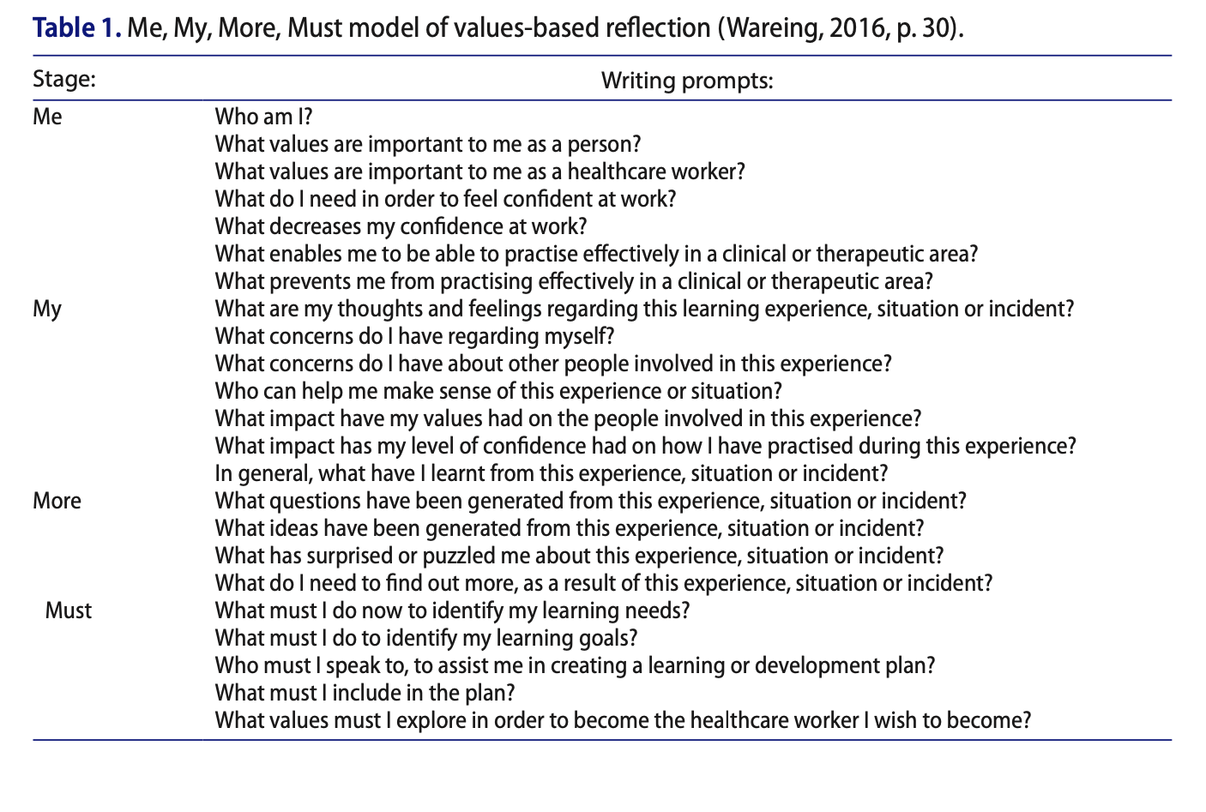

Appendix 2 – Example of Growly Notes Structure
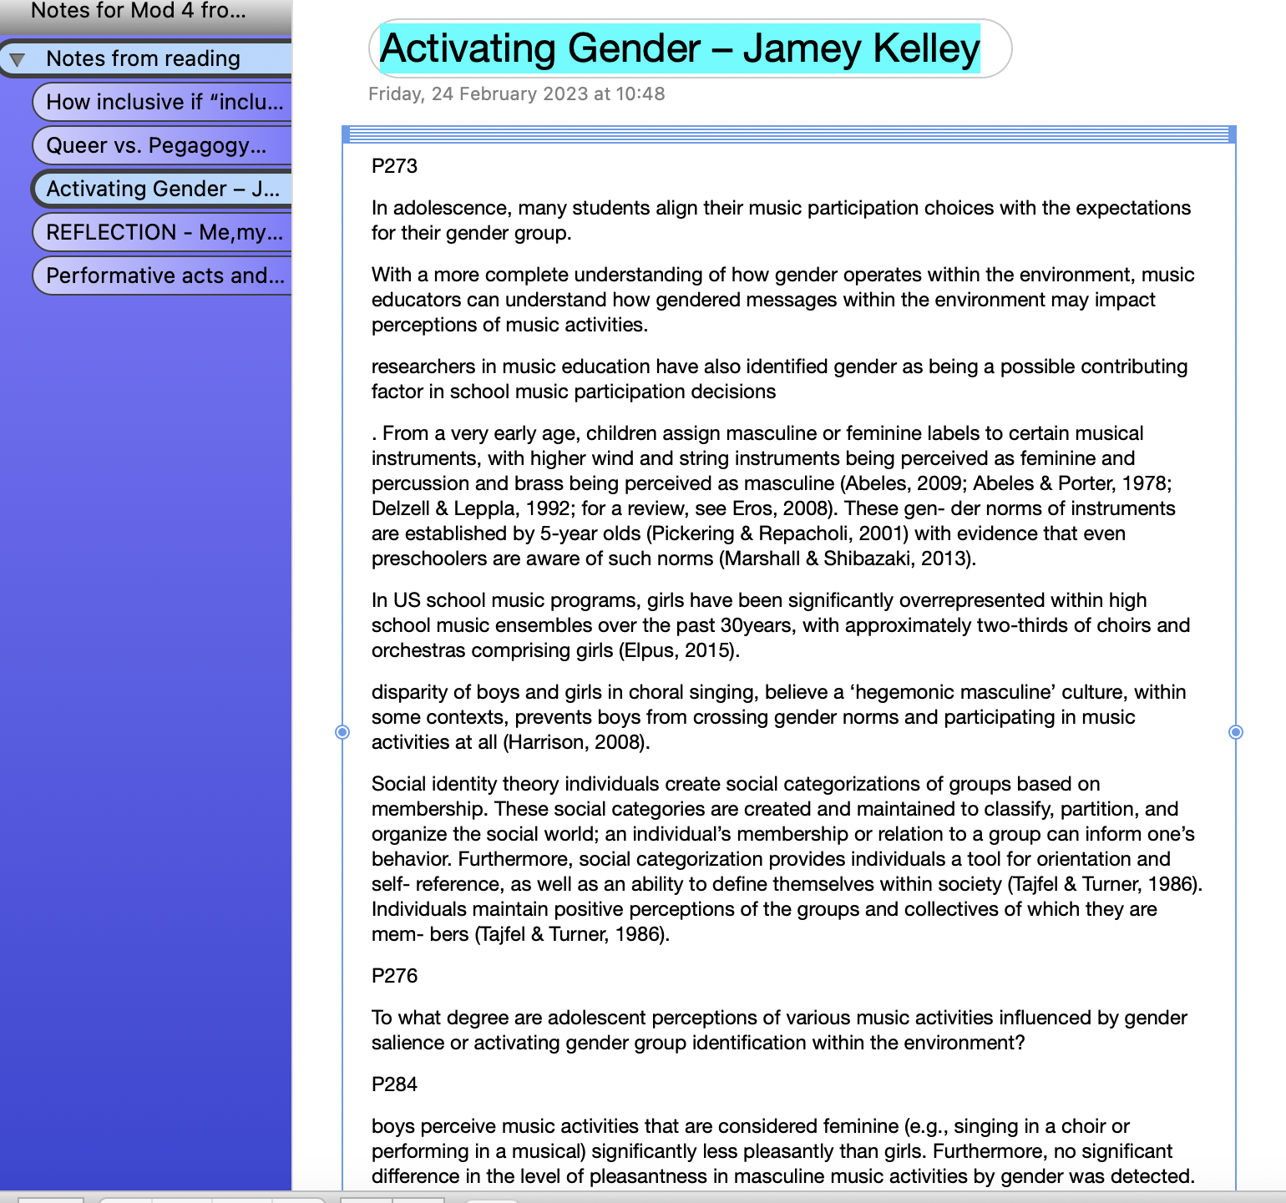

Appendix 3 – Practice room example
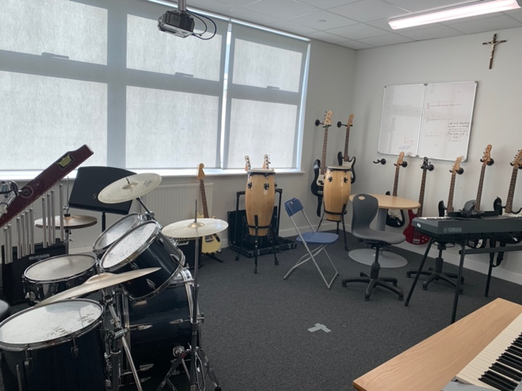

Appendix 4 – Practice room example
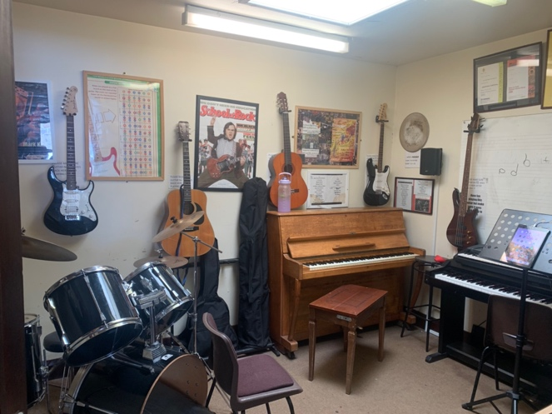

Appendix 5 – Practice room example
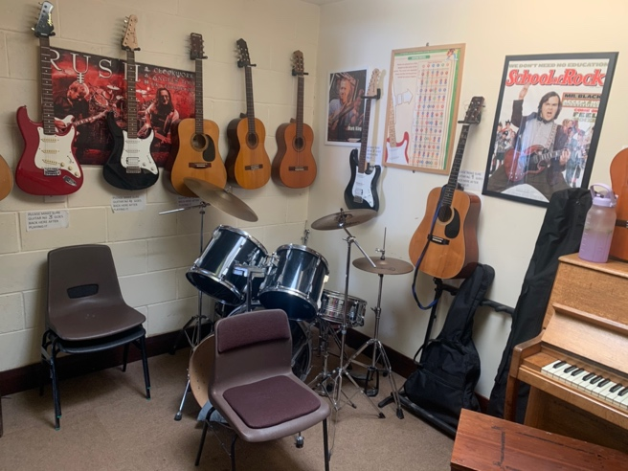

Appendix 6 – Practice room example
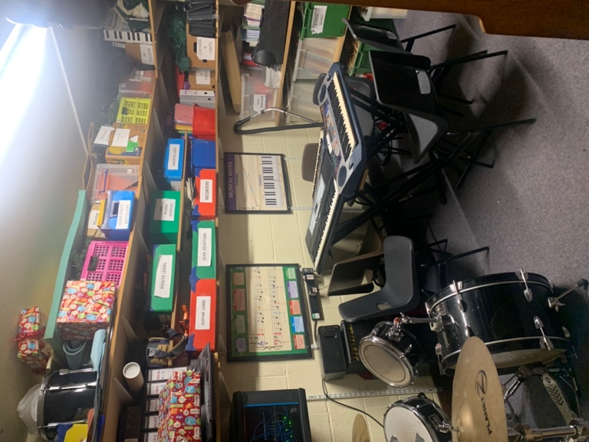

Appendix 7 – Practice room example
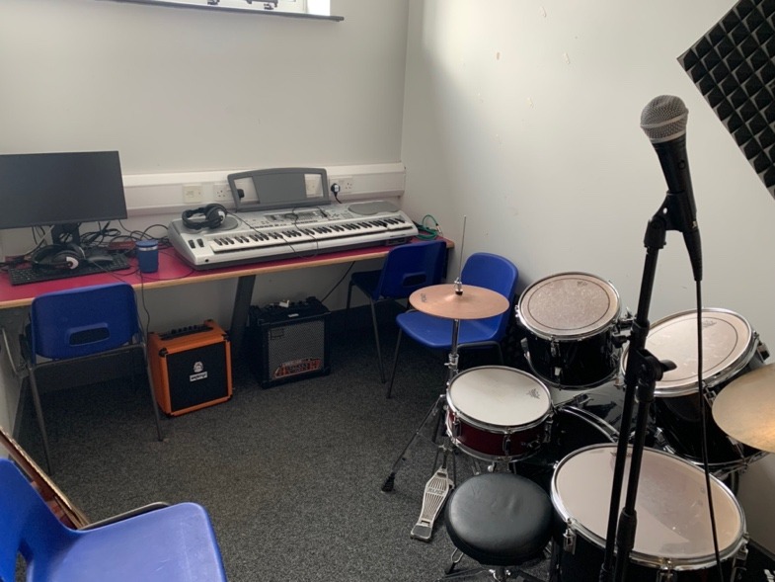

Appendix 8 – Developing a gender inclusive school HRC guidance
https://hrc-prod-requests.s3-us-west-2.amazonaws.com/welcoming-schools/documents/WS_Developing_a_Gender_Inclusive_School.pdf
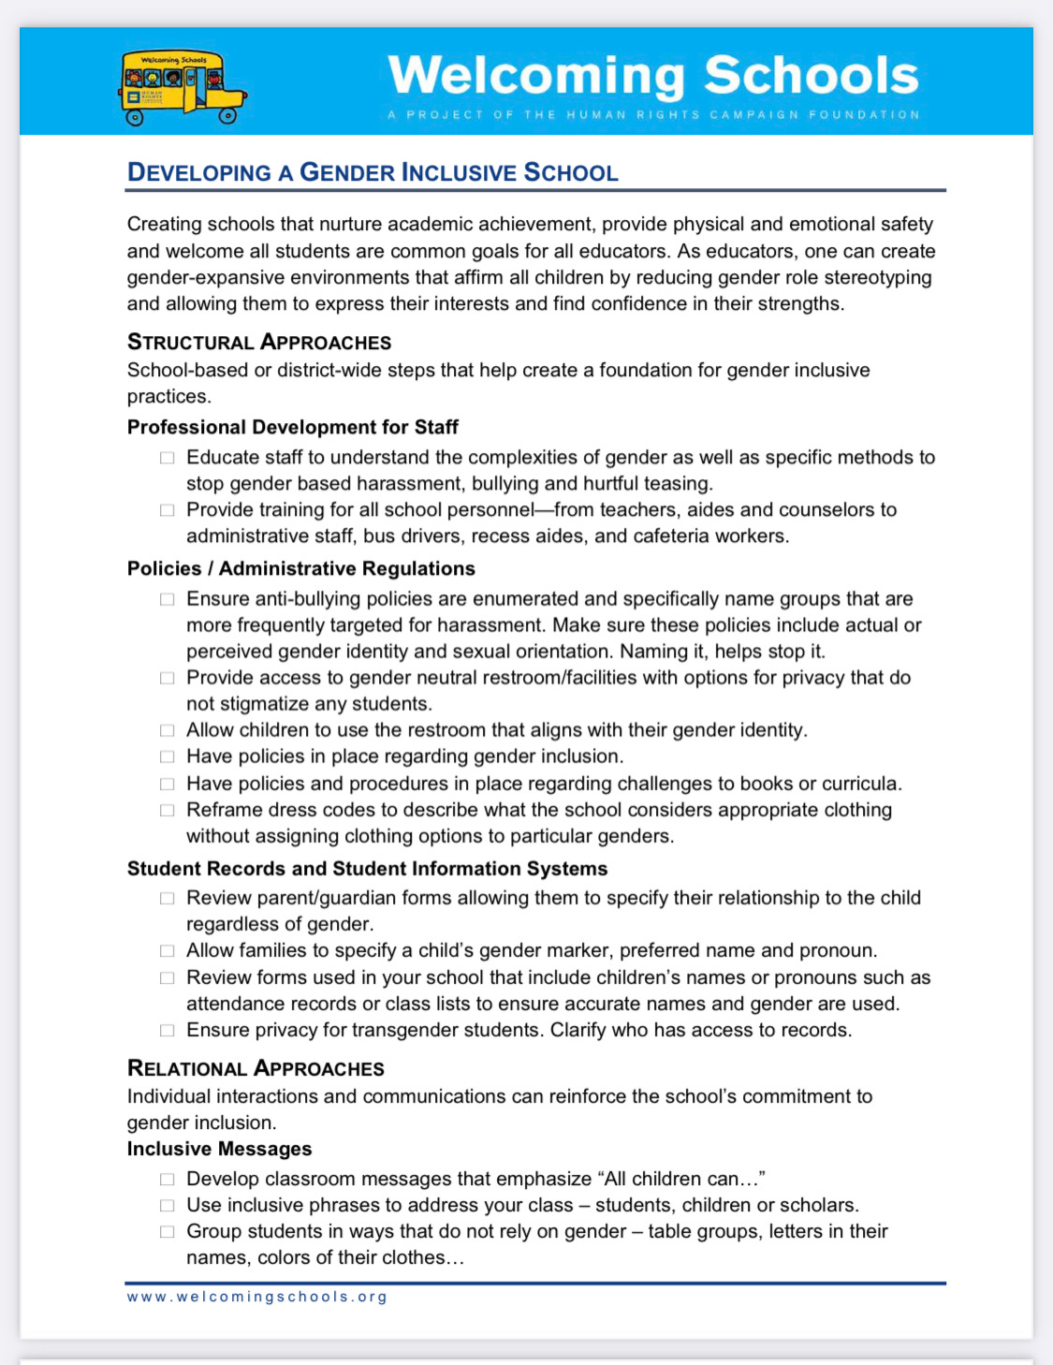
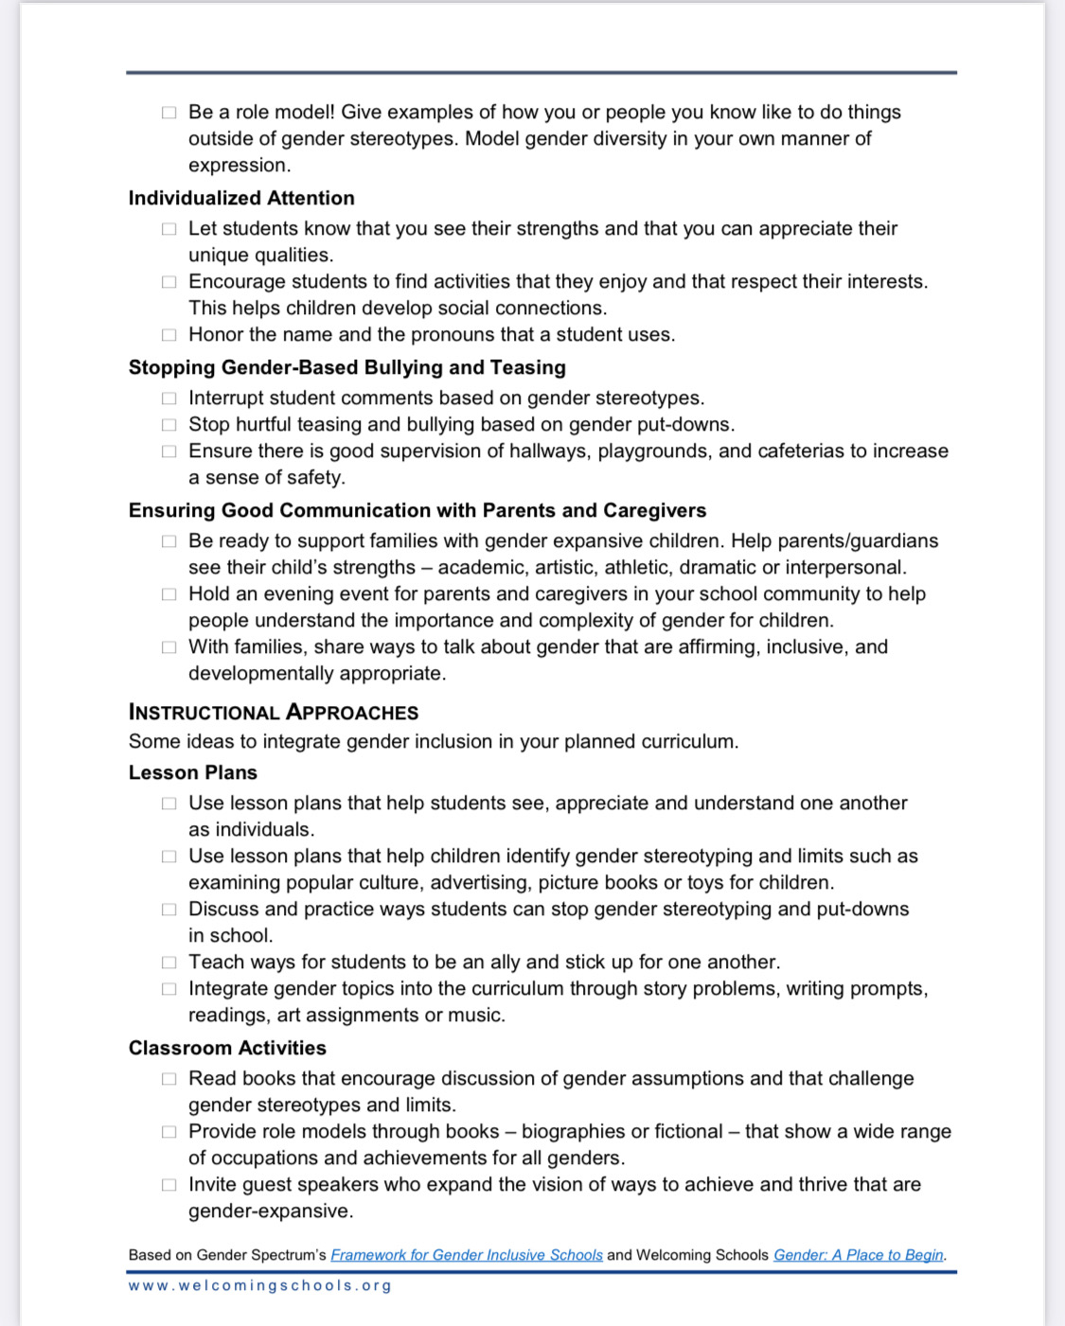

Appendix 9 – Examples from Everyone’s Welcome guide Provided by Mermaids Charity. Full document available here - https://mermaidsuk.org.uk/wp-content/uploads/2020/03/Gender-Identity-Guide-AFC.pdf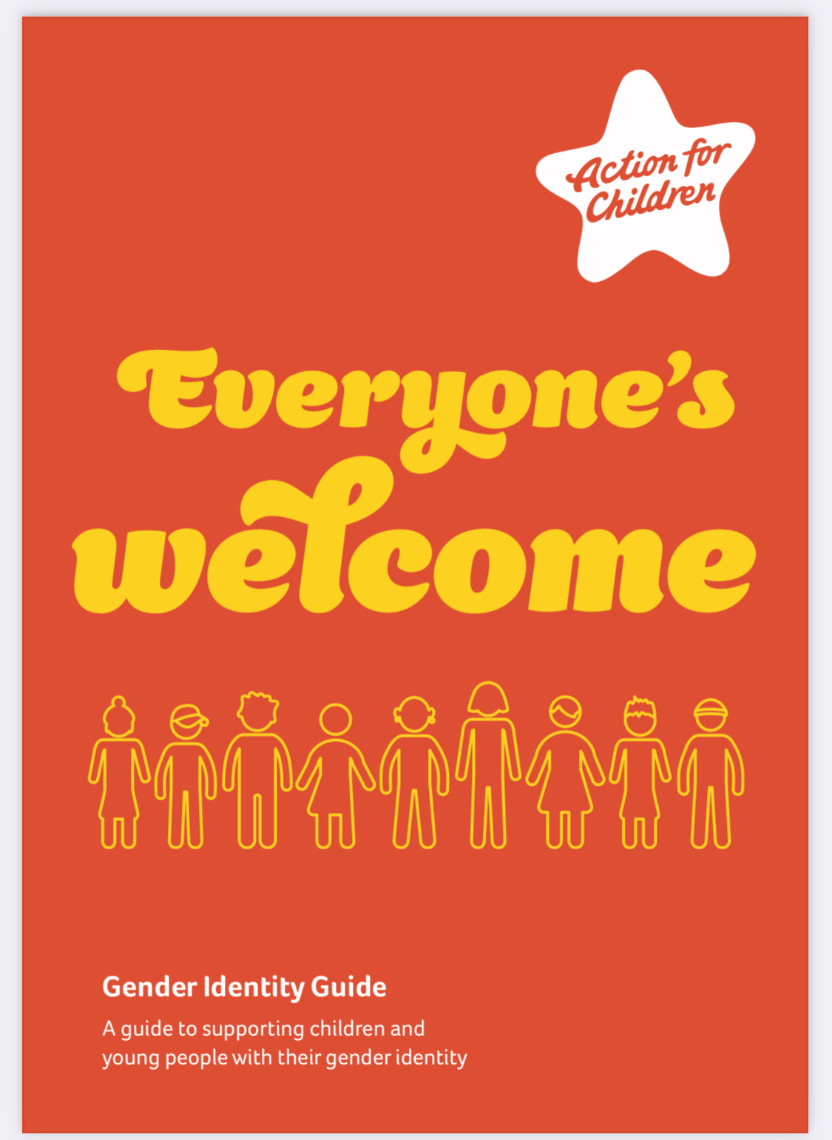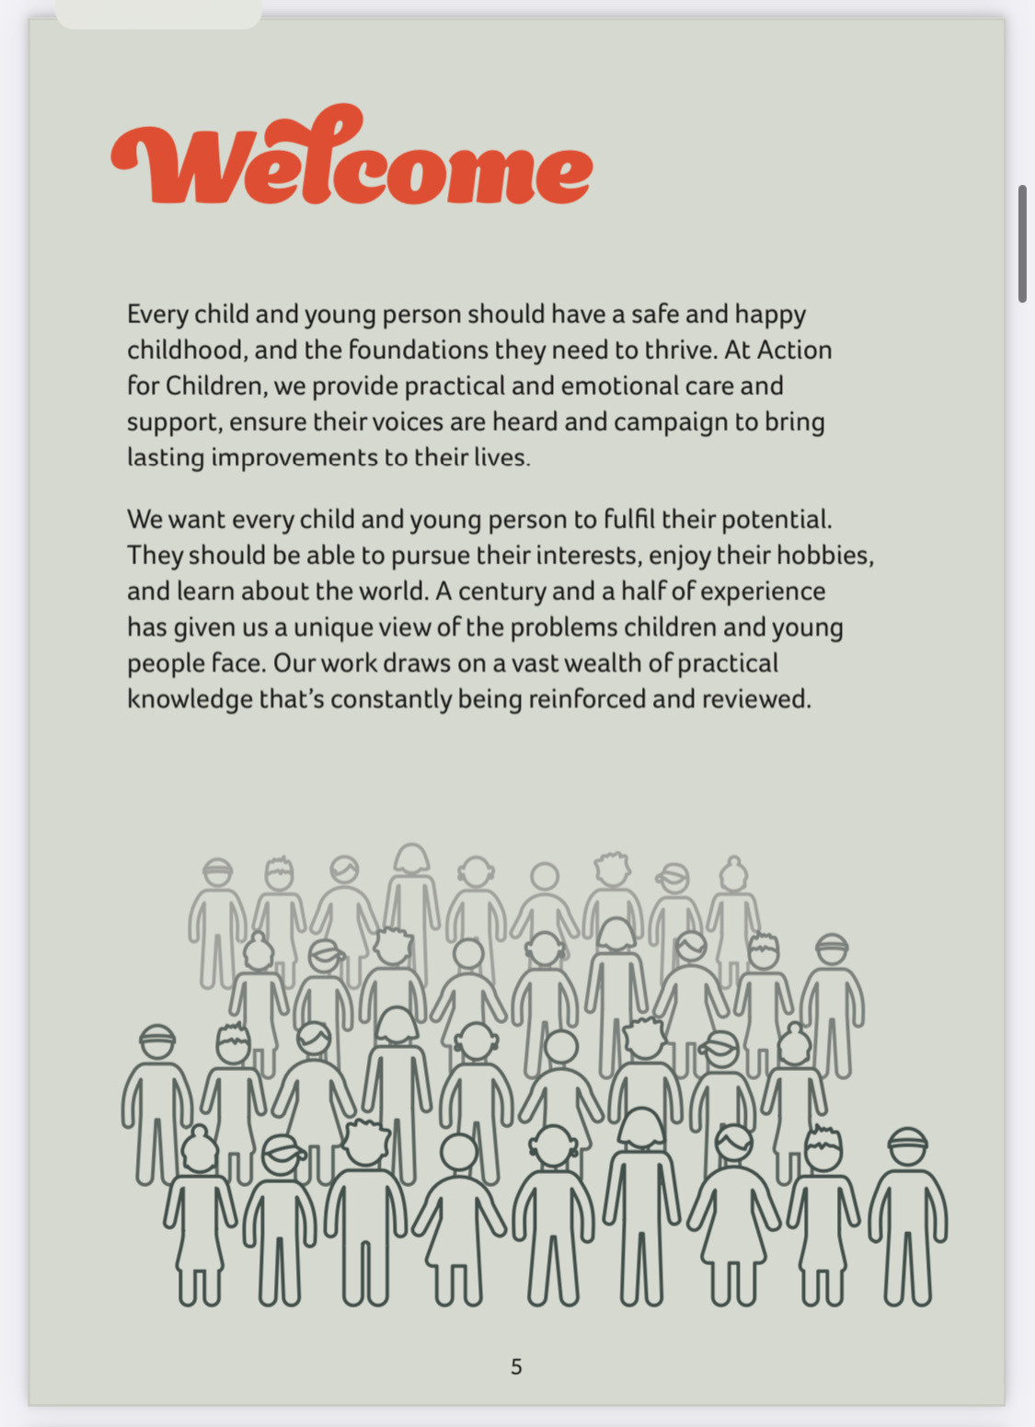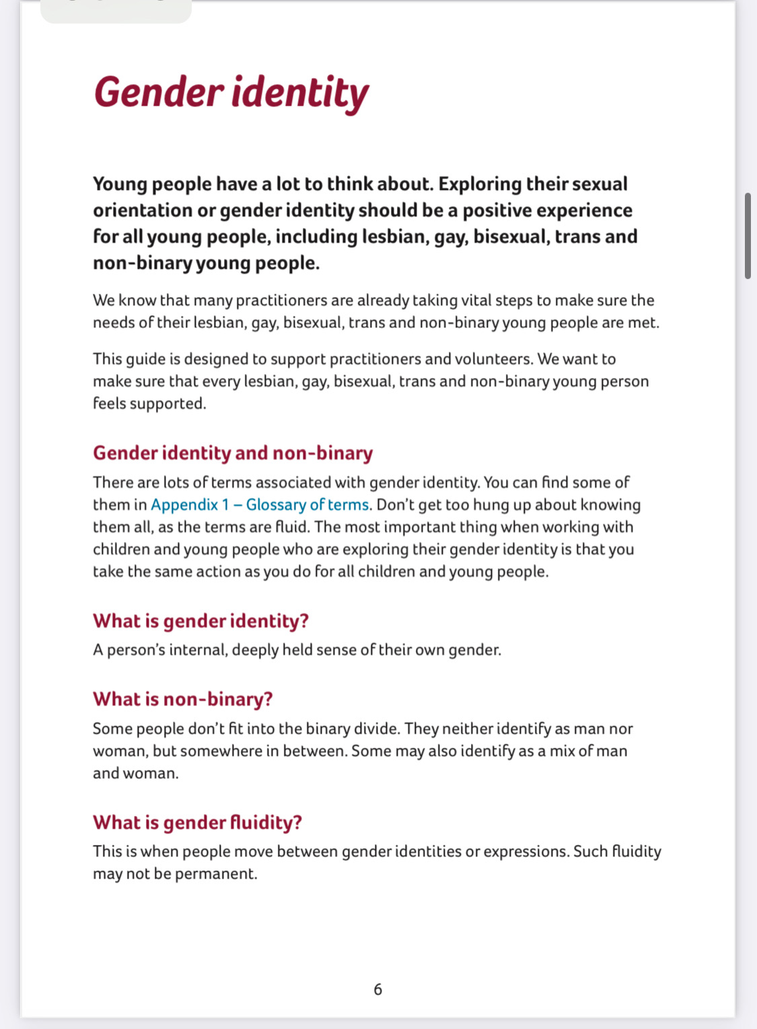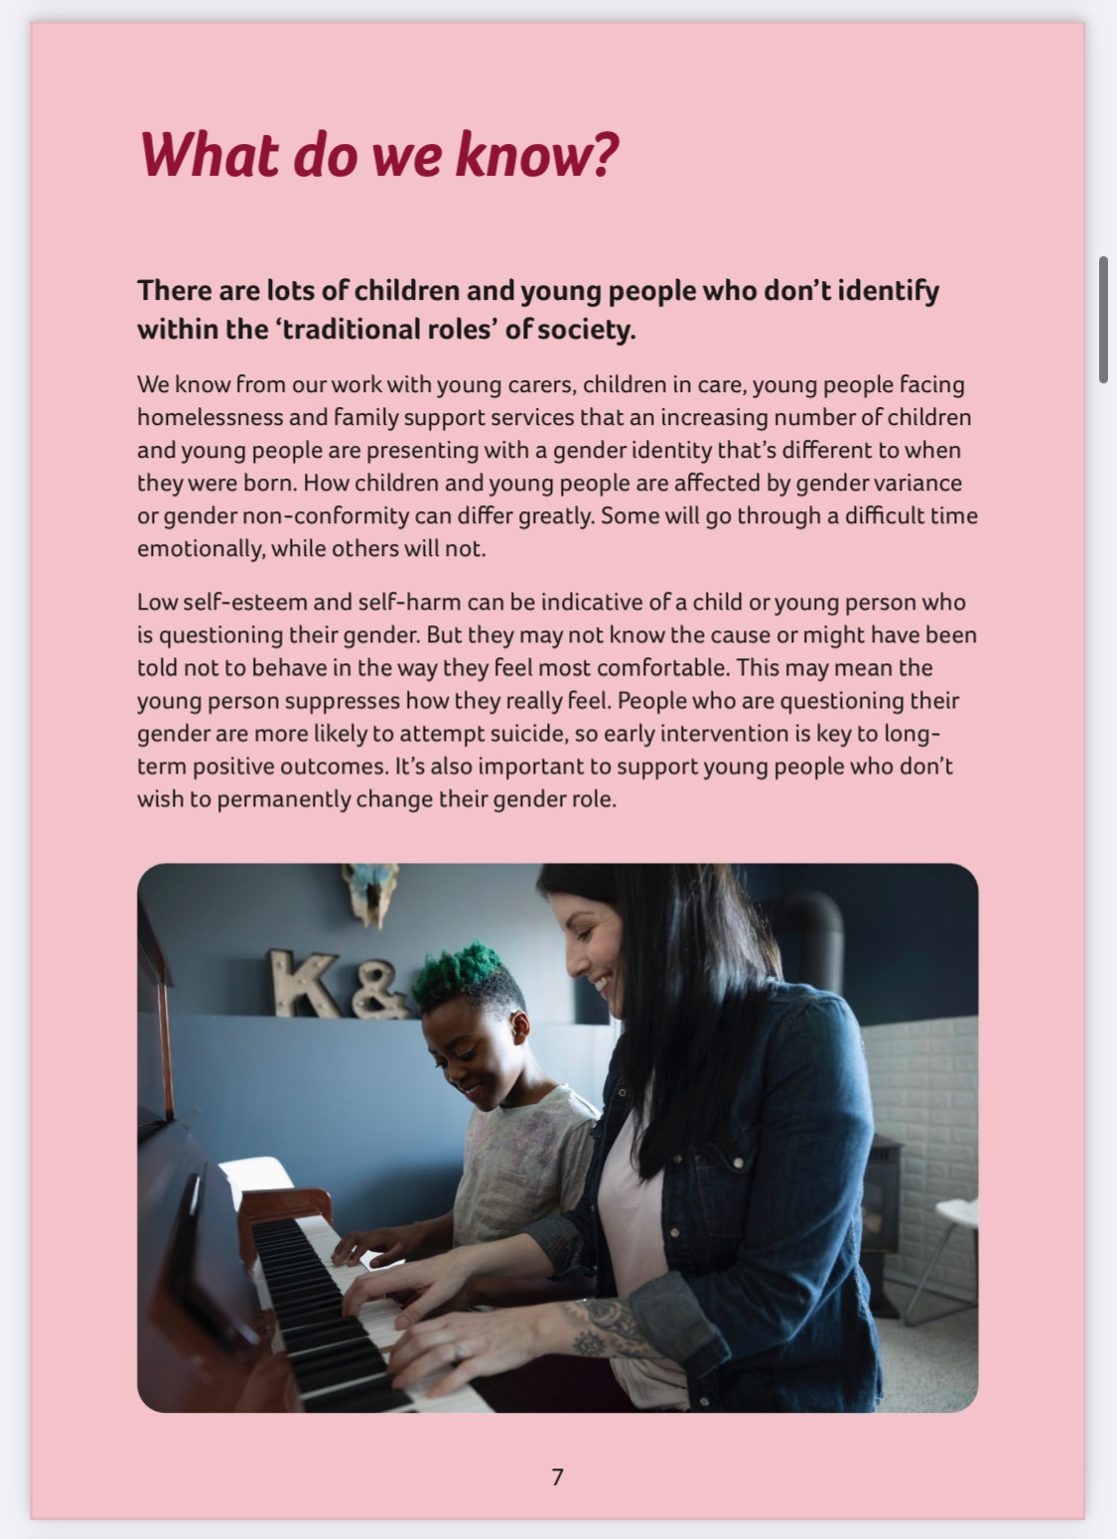

Appendix 10. – Link Government Guidance regarding gender Identity in schools.

https://educationhub.blog.gov.uk/2016/06/22/gender-identity-in-schools/

Appendix 11 - Link to 14 Page guidance regarding Supporting Transgender Students in Schools https://commonslibrary.parliament.uk/research-briefings/cbp-9078/

