  Component One:  What are the key skills required when working in the housekeeping team? 750 words (+/- 10%)  Contribution to Overall Module Assessment: 25% | Student No: | 2208146
 | Module Title: | Operating Hotel Facilities
 | Module Code: | BMIH4006
 | Lecturer: | Lola Villard
In the following student journal, I am going to share my personal experiences through my placement and my previous job at a hotel as a housekeeper and linen porter. I had the chance to investigate the essential skills required for working in a housekeeping team. As a student, I am eager to learn about all aspects of this profession and to gain an understanding of the crucial abilities that are essential to a successful housekeeping team. Here are the essential skills I discovered: Having an acute eye for detail is a fundamental ability in housekeeping. A member of the housekeeping staff must pay close attention to hygiene and ensure that all rooms and common areas are carefully cleaned, organised, and well-maintained (Raghubalan & Raghubalan, 2015). Attention to detail enables the identification and resolution of the most minor issues, thereby assuring a high level of cleanliness. I can remember when the room was cleaned, we usually had the manager came in the room, checked everything is up to the hotel’s standard and if there was even a tiny dust or mark, we were called back immediately to resolve the issue. The next two are the most essential, in my opinion, and in my experience, they took a part in my actual workload by approximately seventy five percent when I cleaned rooms or provided colleagues with clean linen. These abilities are time management and physical stamina. Housekeeping teams frequently face time constraints, particularly in hotels and other high-traffic environments. To complete tasks within allotted timeframes, effective time management skills are crucial (Casado, 2012). It is essential to prioritise tasks, effectively manage resources, and maintain a consistent workflow in order to meet visitors' expectations and maintain a clean environment. As a result, housekeeping is physically demanding work that requires extended periods of standing, walking, and performing routine tasks (Jasimuuddin, 2021). This is especially true when cleaning rooms or changing the sheets on king- or queen-sized duvets that are extremely large and heavy. Physical stamina and endurance are required to perform daily cleansing tasks without sacrificing quality. Regular exercise, a healthy lifestyle, and correct body mechanics all contribute to the physical fitness required for this position. When I first began working as a housekeeper, every day was a challenge because I had a large number of departure rooms that needed to be thoroughly cleaned, and sometimes the rooms looked extremely filthy, and I had a limited amount of time to do them. It was not easy until I had cleaned a large number of rooms and gained some experience, either by myself or from colleagues who gave me some tips to make my job easier and faster. And another essential ability is communication. Working on a housekeeping crew necessitates effective communication with team members, supervisors, and occasionally visitors (Slater,2010). Clear and succinct communication facilitates task coordination, problem reporting, and departmental collaboration. In order to ensure that duties are completed to the required standards, it is also necessary to have excellent listening and instruction-following skills. Also, there are two additional essential skills, which I would say relate to the previously mentioned ones, specifically time management and communication. Problem-solving is one of them (Paech, 2023). The housekeeping staff frequently faces unforeseen obstacles, such as spillage, stains, and maintenance issues. Developing abilities to solve problems is essential for effectively addressing these issues and locating appropriate solutions (Cottrell,2022). Maintaining a clean and effective environment for visitors requires flexibility, creativity, and a proactive attitude. Last, but not least adaptability and flexibility are crucial for housekeeping teams, which operate in environments where priorities may change frequently. It is essential to be adaptable and flexible in order to accommodate shifting schedules, visitor requests, and unforeseen circumstances. A willingness to acquire new cleaning techniques, utilise different equipment, and adapt to changing conditions contributes to the team's overall success. In conclusion, the examination of the skill keys necessary for working on a housekeeping team has yielded valuable insights into this field. A successful housekeeping team requires attention to detail, time management, communication skills, physical stamina, problem-solving skills, and adaptability. As a student, I recognise the significance of cultivating these skills in order to excel in the field of housekeeping and effectively contribute to the success of a team.

Word Count | 694

Component Two:
Contribution to Overall Module Assessment: 25%
In this scenario – You have just been promoted to team leader for a floor within the hotel. A guest complains that on their arrival, their room had not been properly cleaned. Create an action plan and answer the following questions.

Problem | Why did it happen? | What are you going to do? | How will you prevent this from happening in the future? | What measures would you introduce to improve team effectiveness?
The room not cleaned properly. | Miscommunication or inadequate training. The housekeeping staff might not have been trained properly or informed about the specific requirements and standards for cleaning a room. | Offering new option. By offering a new room and some discount off the booking might going to make the guest feel better and might restore some faith. | Talk and train. Having a good team is not enough, but having a good team who are always trained and communicate between each other is the key. A well trained and talkative team will prevent this problem in the future. | Teambuilding trainings and events. By making teambuilding events, such as time off together doing activities and training the team together will make a more effective team.
The guest submitted a complain. | Inappropriate service.  The guest received a dirty, not properly cleaned and inspected room after their arrival and check-in. | Apology and communicate. I am personally going to apologise and offer all the above and offer some other discount to make it up to the guest. | Analysing complaints. By analysing the complaints with the team always gives and idea what went wrong and what leaded to the complaint, I will analyse complaints time by time with the team to reduce bad comments and decrease the number of complaints. | Complaint solving sessions. By giving the opportunity to the employee to take training on complaints and understands them, in the future the team will work together to solve all the complaints as a team and not as individuals.
The hotel’s reputation decreases due to a complain, | Complaint and unsatisfied guest.  Unsatisfied feedback always has an impact on the hotels reputation and brand as their success always depends on reputation | Communicate with the team about reputation. I would talk to the housekeeping team who in charge for this complaint and explain them how important is not to get any complaint as this can impact the hotel’s reputation and with continuous complaints people can lose their job. | Action plan and communication. I am going to make and action plan what can cause bad reputation or what will gain good reputation, by this in charge all the team will know what has impact on the hotels reputation and everybody can make sure everything going right. | Group trainings on reputation with a leader. Being a boss not always build a good workplace but point a leader who has love from other team members and have an impact on sharing thoughts and ideas can increase work morale and increase the hotel’s reputation too.
Guest feeling let down by the hotel after giving faith and book with them to receive a dirty room. | Trust given by guest and being let down with no care. The guest received a dirty room even though the housekeeping manager or anyone in charge should have double checked if the room is ready for arrival. | Offer and communicate. As above mentioned, I will personally offer a new room with some extra features free of charge to restore faith and make the guest honoured to book with our hotel. | Increased customer care. With increased customer care and periodically check-ups, we can completely gain customer trust and good experience as high as the customer expects it when make a booking. | Increased customer care and problem-solving tactics. Giving a group training how to make up guest expectation after a complaint or a bad experience is very important and can help reducing problems or complaints left unsolved.

Component Three:
Contribution to Overall Module Assessment: 50%
Your task is to create and prepare a presentation following the detailed scenario provided below.

As the floor housekeeping manager and given the recent guest complaints you need to put together a basic training presentation for your colleagues within the housekeeping team to get the best out of them, ensure that brand standard is being achieved and that Health and Safety procedures are also being followed.

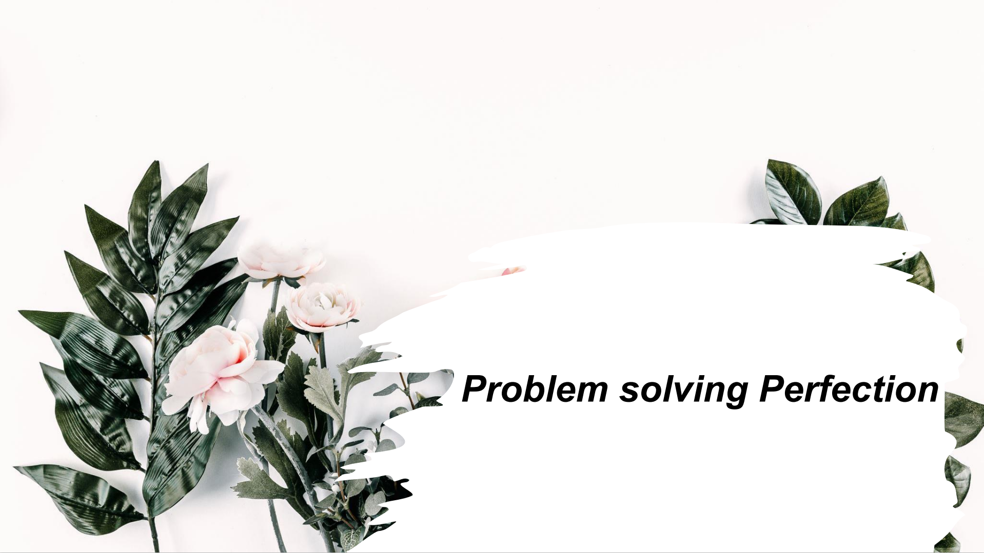
Training Notes:
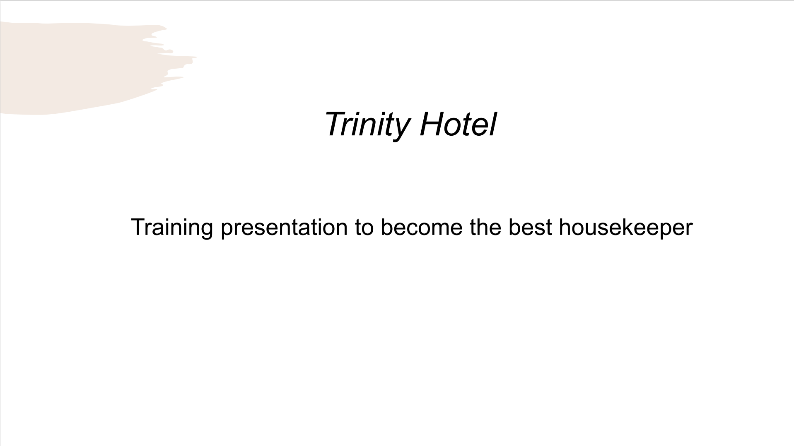

Training Notes:
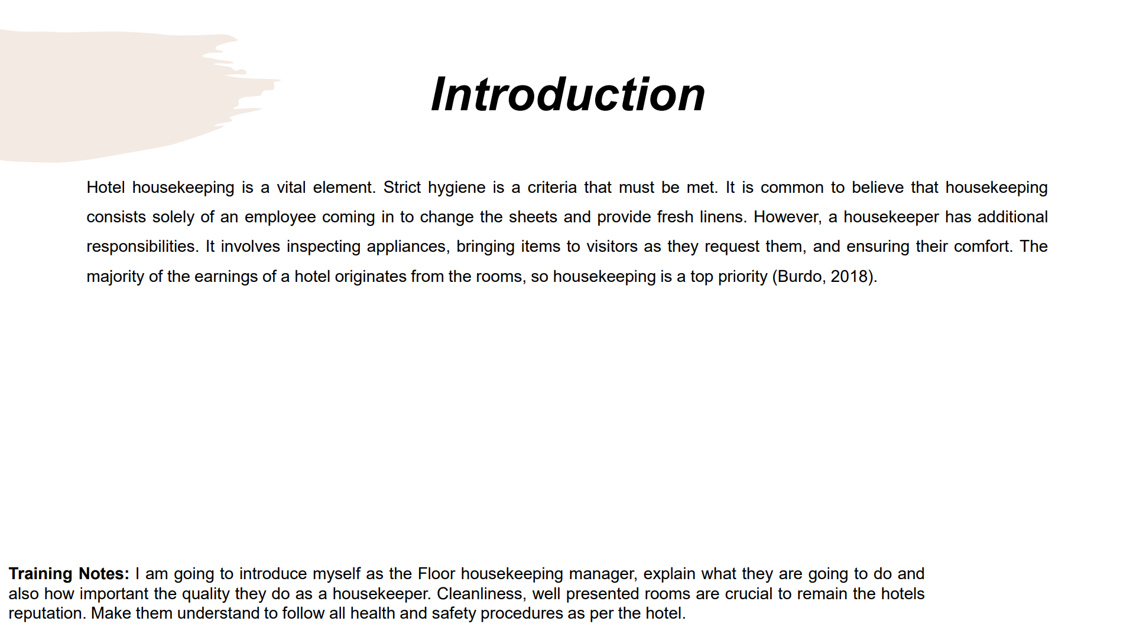

Training Notes:I am going to introduce myself as the Floor housekeeping manager, explain what they are going to do and also how important the quality they do as a housekeeper. Cleanliness, well presented rooms are crucial to remain the hotels reputation. Make them understand to follow all health and safety procedures as per the hotel.
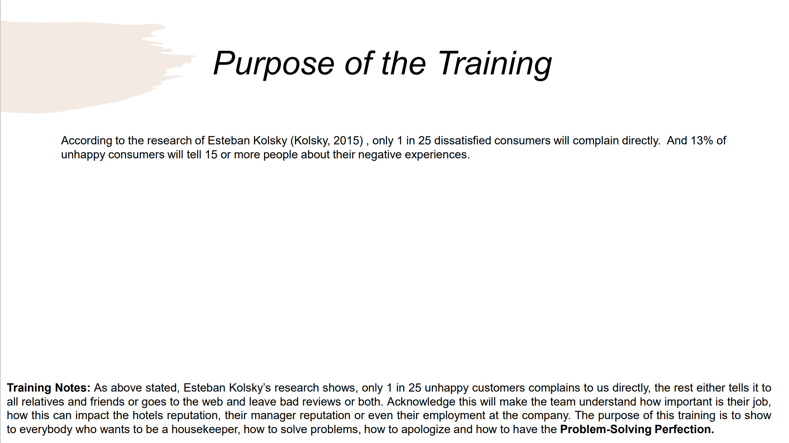

Training Notes:As above stated, Esteban Kolsky’s research shows, only 1 in 25 unhappy customers complains to us directly, the rest either tells it to all relatives and friends or goes to the web and leave bad reviews or both. Acknowledge this will make the team understand how important is their job, how this can impact the hotels reputation, their manager reputation or even their employment at the company. The purpose of this training is to show to everybody who wants to be a housekeeper, how to solve problems, how to apologize and how to have the Problem-Solving Perfection.
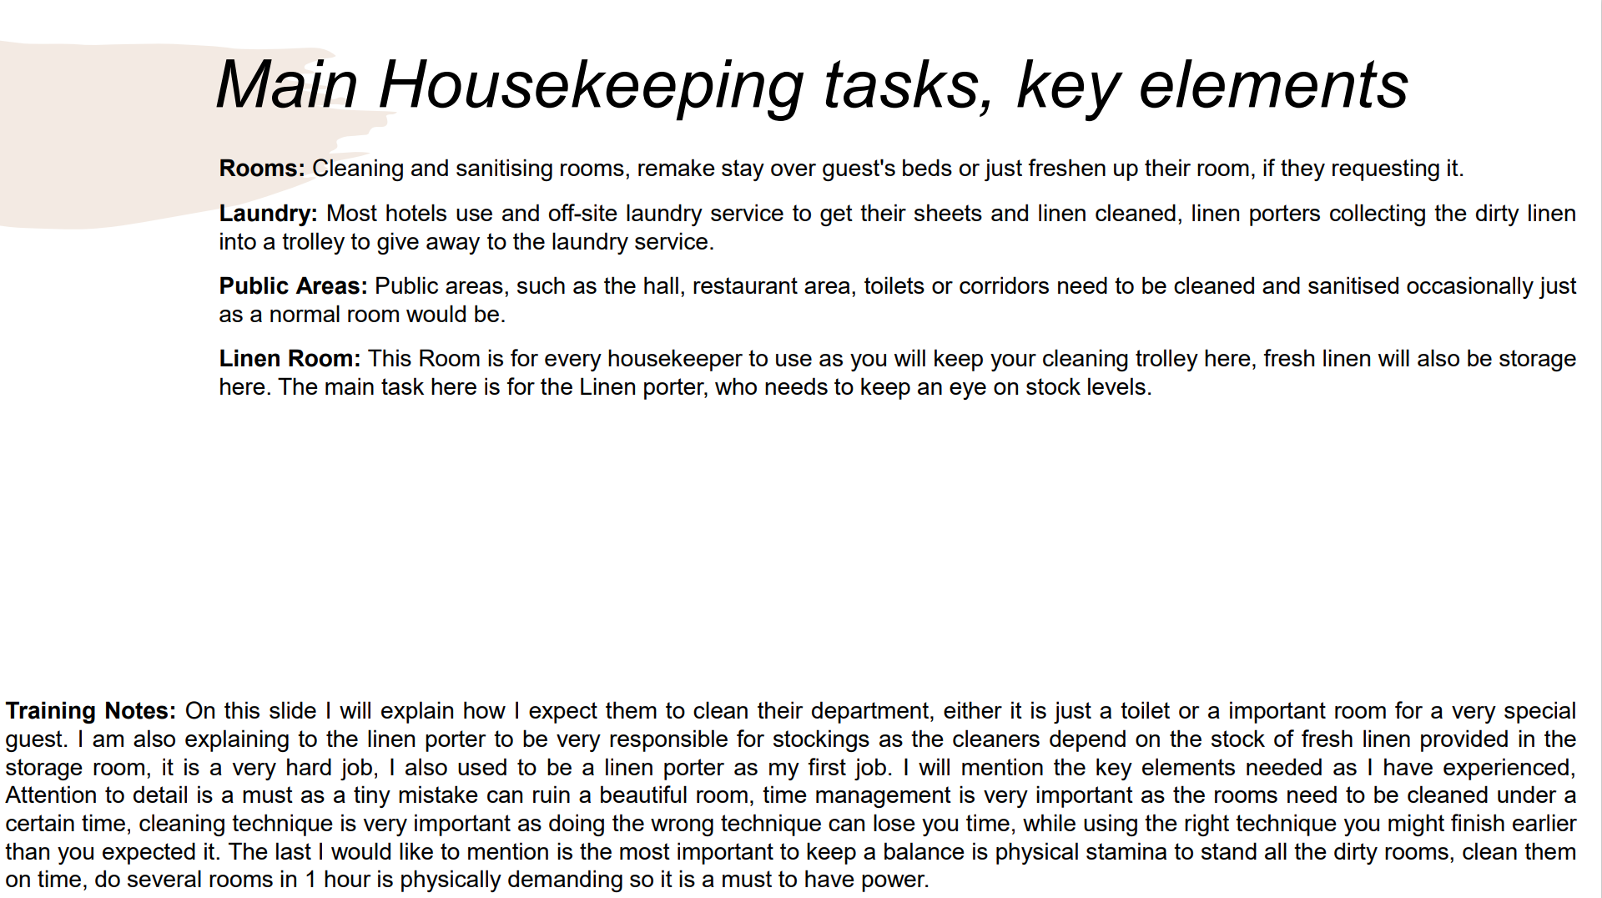

Training Notes: On this slide I will explain how I expect them to clean their department, either it is just a toilet or a important room for a very special guest. I am also explaining to the linen porter to be very responsible for stockings as the cleaners depend on the stock of fresh linen provided in the storage room, it is a very hard job, I also used to be a linen porter as my first job. I will mention the key elements needed as I have experienced, Attention to detail is a must as a tiny mistake can ruin a beautiful room, time management is very important as the rooms need to be cleaned under a certain time, cleaning technique is very important as doing the wrong technique can lose you time, while using the right technique you might finish earlier than you expected it. The last I would like to mention is the most important to keep a balance is physical stamina to stand all the dirty rooms, clean them on time, do several rooms in 1 hour is physically demanding so it is a must to have power.

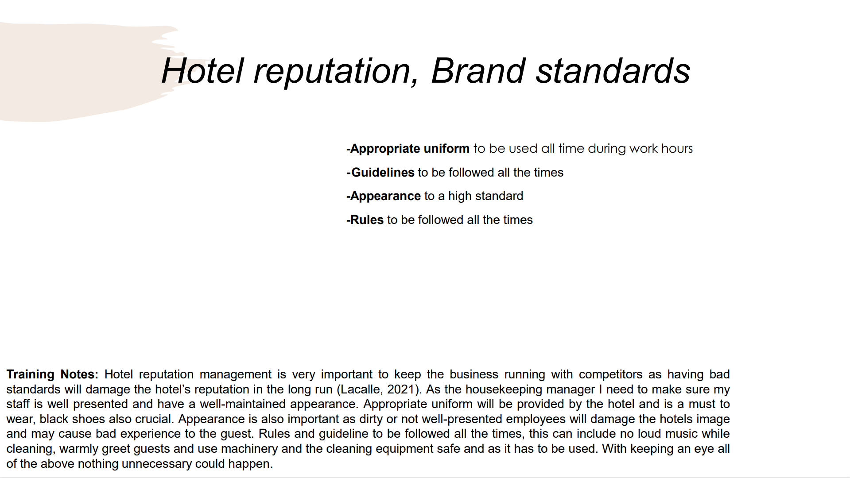

Training Notes: Hotel reputation management is very important to keep the business running with competitors as having bad standards will damage the hotel’s reputation in the long run (Lacalle, 2021). As the housekeeping manager I need to make sure my staff is well presented and have a well-maintained appearance. Appropriate uniform will be provided by the hotel and is a must to wear, black shoes also crucial. Appearance is also important as dirty or not well-presented employees will damage the hotels image and may cause bad experience to the guest. Rules and guideline to be followed all the times, this can include no loud music while cleaning, warmly greet guests and use machinery and the cleaning equipment safe and as it has to be used. With keeping an eye all of the above nothing unnecessary could happen.
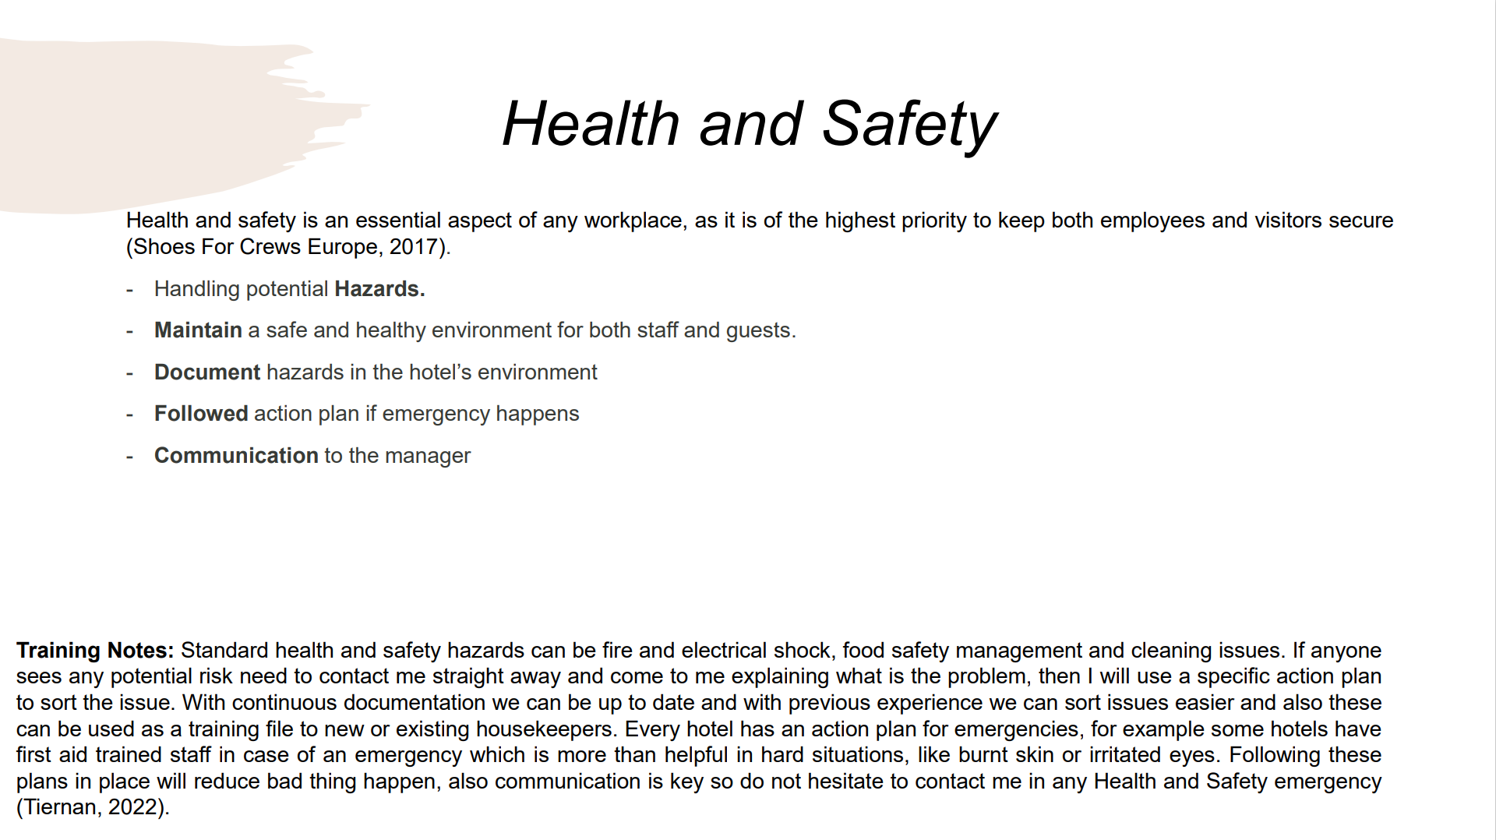

Training Notes: Standard health and safety hazards can be fire and electrical shock, food safety management and cleaning issues. If anyone sees any potential risk need to contact me straight away and come to me explaining what is the problem, then I will use a specific action plan to sort the issue. With continuous documentation we can be up to date and with previous experience we can sort issues easier and also these can be used as a training file to new or existing housekeepers. Every hotel has an action plan for emergencies, for example some hotels have first aid trained staff in case of an emergency which is more than helpful in hard situations, like burnt skin or irritated eyes. Following these plans in place will reduce bad thing happen, also communication is key so do not hesitate to contact me in any Health and Safety emergency (Tiernan, 2022).
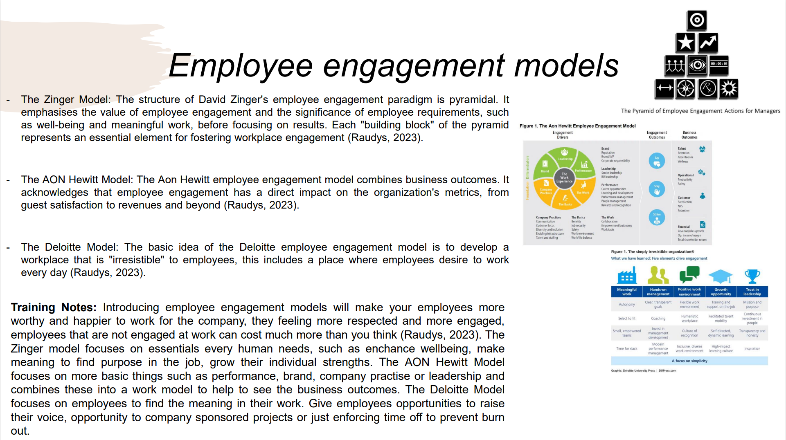

Training Notes: Introducing employee engagement models will make your employees more worthy and happier to work for the company, they feeling more respected and more engaged, employees that are not engaged at work can cost much more than you think (Raudys, 2023). The Zinger model focuses on essentials every human needs, such as enchance wellbeing, make meaning to find purpose in the job, grow their individual strengths. The AON Hewitt Model focuses on more basic things such as performance, brand, company practise or leadership and combines these into a work model to help to see the business outcomes. The Deloitte Model focuses on employees to find the meaning in their work. Give employees opportunities to raise their voice, opportunity to company sponsored projects or just enforcing time off to prevent burn out.
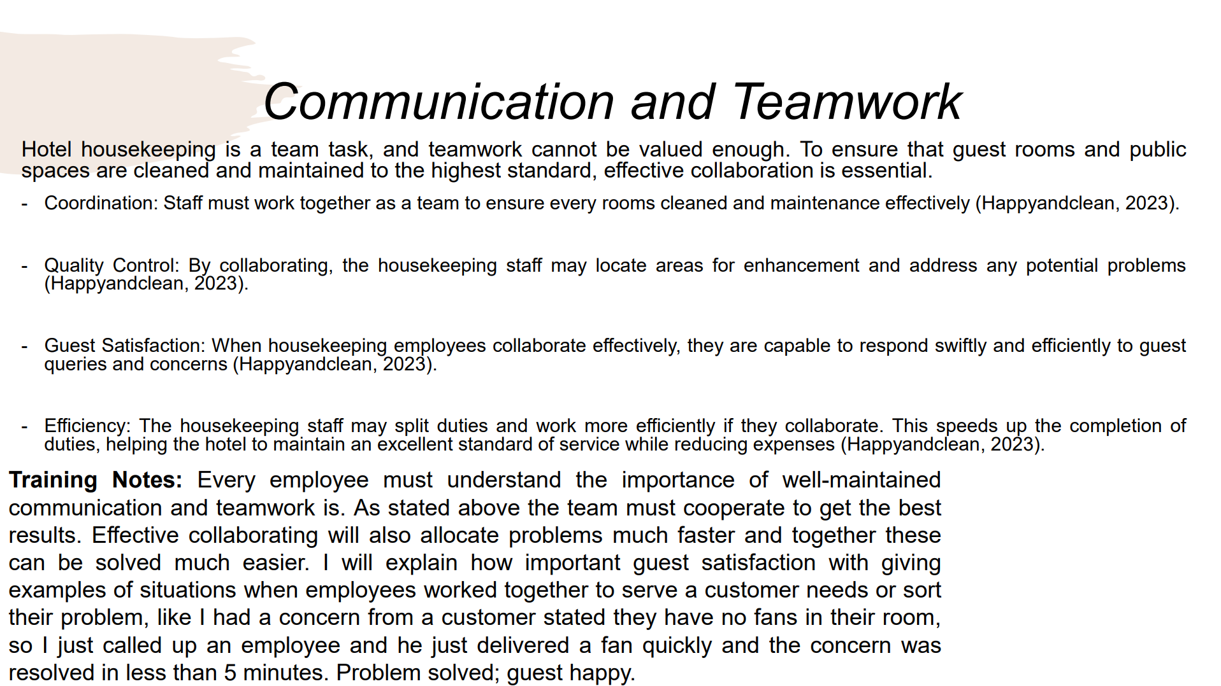
Training Notes: Every employee must understand the importance of well-maintained communication and teamwork is. As stated above the team must cooperate to get the best results. Effective collaborating will also allocate problems much faster and together these can be solved much easier. I will explain how important guest satisfaction with giving examples of situations when employees worked together to serve a customer needs or sort their problem, like I had a concern from a customer stated they have no fans in their room, so I just called up an employee and he just delivered a fan quickly and the concern was resolved in less than 5 minutes. Problem solved; guest happy.
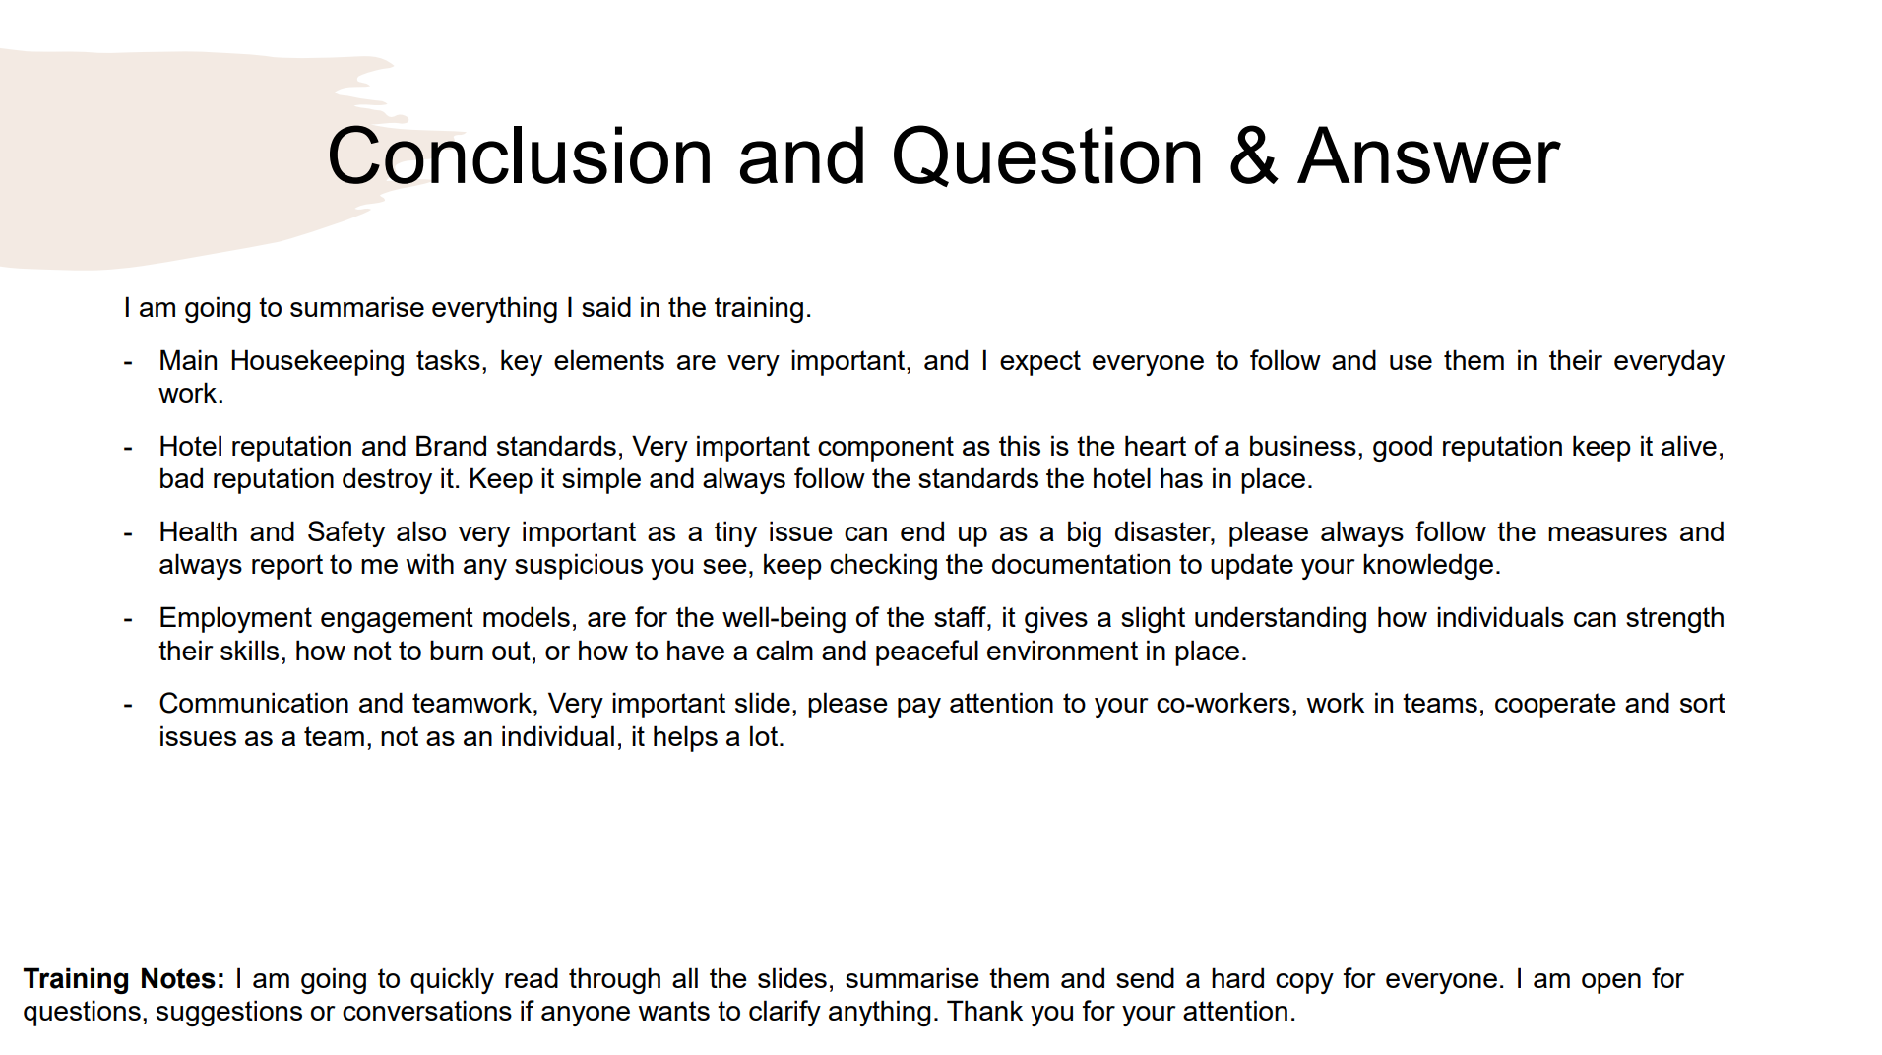
Training Notes: I am going to quickly read through all the slides, summarise them and send a hard copy for everyone. I am open for questions, suggestions or conversations if anyone wants to clarify anything. Thank you for your attention.

References
Burdo, H. (2018) Importance of housekeeping in the hotel industry, Bizfluent. Available at: https://bizfluent.com/about-5553465-importance-housekeeping-hotel-industry.html (Accessed: 18 June 2023).
Casado, M.A. (2012) Housekeeping Management. 2nd edition. Haboken, New Jersey: John Wiley &amp; Sons.
Customer Alliance (2014) Why is hotel reputation management so important for hoteliers today?, Hospitality Net. Available at: https://www.hospitalitynet.org/opinion/4067871.html (Accessed: 18 June 2023).
Happyandclean (2023) The importance of teamwork in Hotel Housekeeping, Happy and Clean. Available at: https://callhappyandclean.com/the-importance-of-teamwork-in-hotel-housekeeping/ (Accessed: 18 June 2023).
Holden, L.A. (2023) The seven steps of action planning, Penn State Extension. Available at: https://extension.psu.edu/the-seven-steps-of-action-planning (Accessed: 18 June 2023).
Hollander, J. (2022) Hotel housekeeping duties: A day in the life - hotel tech report, A day in the life. Available at: https://hoteltechreport.com/news/hotel-housekeeping-duties (Accessed: 18 June 2023).
Jasimuuddin, Md. (2021) What is housekeeping?, LinkedIn. Available at: https://www.linkedin.com/pulse/what-housekeeping-md-jasimuuddin-1e (Accessed: 18 June 2023).
Jiri, P. (2016) How best can you convince an unsatisfied guest at your hotel?, Bayt.com. Available at: https://specialties.bayt.com/en/specialties/q/272323/how-best-can-you-convince-an-unsatisfied-guest-at-your-hotel/ (Accessed: 18 June 2023).
Kolsky, E. (2015) CX for executives, Share and Discover Knowledge on SlideShare. Available at: https://www.slideshare.net/ekolsky/cx-for-executives (Accessed: 18 June 2023).
Lacalle, E. (2021) Hotel Reputation Management: What are the best strategies?, Hotel reputation management | What are the best strateg... | Mews Blog. Available at: https://www.mews.com/en/blog/hotel-reputation-management (Accessed: 18 June 2023).
Mohan, S. (2022) Customer service problem-solving techniques to improve your sales, Kapture CRM. Available at: https://www.kapturecrm.com/blog/whats-really-customer-problem-solving-approach/ (Accessed: 18 June 2023).
Paech, D. (2023) How being adaptable helps you solve work problems and succeed, Loumee. Available at: https://www.loumee.co/blog/how-being-adaptable-helps-you-solve-work-problems-and-succeed (Accessed: 18 June 2023).
Raghubalan, G. and Raghubalan, S. (2015) Hotel Housekeeping: Operations and Management. 3rd edn. New Delhi, New Delhi: Oxford University Press.
Raudys, J. (2023) 3 employee engagement models, theories and Frameworks, ContactMonkey. Available at: https://www.contactmonkey.com/blog/employee-engagement-models (Accessed: 18 June 2023)
Shoes For Crews Europe (2017) Hotel Health and Safety Checklist: What you need to know, Shoes for Crews GB. Available at: https://www.sfceurope.com/uk/blog/hotel-health-and-safety-checklist-what-you-need-to-know (Accessed: 18 June 2023).

Silenaite-Enyed, E. (2019) Guests’ complaints in the hotel: How can you bring the most of them?, SabeeApp. Available at: https://www.sabeeapp.com/blog/hospitality-industry-inside/guests-complaints-in-the-hotel (Accessed: 18 June 2023).
Slater, R. (2010) Collins business secrets: Team management. HarperCollins.
Tiernan, D. (2022) What are health and safety protocols in hotels? - amenitiz blog, Amenitiz. Available at: https://www.amenitiz.com/en/blog/health-and-safety-protocols-in-the-hospitality-industry/?p_a=false (Accessed: 18 June 2023).
Wroblewski, M.T. (2018) Examples of miscommunication at the Workplace, Small Business - Chron.com. Available at: https://smallbusiness.chron.com/examples-miscommunication-workplace-11507.html (Accessed: 18 June 2023).

