
Sports Industry Research
Project Report M6X02100
Assignment 2

Student Name

Martene Morgan

Project Title

Evaluating the barriers and challenges girls face when participating in sport from coaches’ perspectives.

Acknowledgements
The process in completing the dissertation has been a challenge but completion was worked towards by the thanks to friends, family and other sport management students who helped me and encouraged me to completing the work.
A special thanks to:
My mentor: Mark Napieralla for guidance throughout all the data collected and providing useful information throughout the process,
Another lead lecturer and course tutor: Andrew Thomas for giving guidance and feedback on questions regarding the work,
All the of the Physical Activity and Sport Service team in Neath Port Talbot for being kind and patient with me whilst I conducted my research with them.

Abstract
This research project is going to be based upon female participation in sport, and what barriers and challenges there are to prevent it being equal in the gender participation gap. This project will be finding barriers for key stage 3 and key4 girls from sports development officers’ point of view rather than girls themselves, as it provides a new insight into what other factors have not been researched.
The aim of this research project is to critically analyse the challenges that sports development officers in the PASS team identified for key stage 3 and key stage 4 girls to participate physical activity.
The main reason behind this project is, to identify the barriers but mainly find solutions. The solutions will be able to be generalised to all sports coaching and teaching staff, but the knowledge and primary data will come from the sports development officers. The Physical Activity and Sport Service team (PASS) have not had research done about their backgrounds, therefore have not had the chance to say their experiences and possible recommendations for others to try.
Extensive research for this project has been done to find background information about girls’ participation in sport, however no research was found about girls’ participation from a sports coach or Sports Development Officers’ perspective. When girls do not participate, the barriers are not just affecting themselves, but it is also affecting the staff conducting the sessions, and they have to encounter barriers which they will have to overcome. One example is, a girl’s perspective of transport is they will not attend the afterschool club because they cannot get home without bus, so the coach has to find a solution to enable the child to attend the club.
Methodology
All of the primary data that has been collected is from the perspectives of the Sport Development Officers from the PASS team, the secondary data will determine the barriers from the girls’ experience of the barriers.
The methodology that will be used will consist of relativism ontology as the findings will be determined by experiences with the truth evolving and changing. An emic epistemological approach will be used as the researcher will be involved within the study and observing the participants in their natural environment. Quota sampling method will be used, due to the special requirements needed from the participants to be in the PASS team. The methods that will be used for this project will be a questionnaire and a focus group with the PASS team, this will allow qualitative data to be collected.
The secondary data has come from Youth Sport Trust (2017) and the School Sport Survey (2018), where they identified the most popular sports for girls and the barriers that are most common in this target group.
The main conclusion gathered from this report is that there are many ways the Sport Development Officers can adapt their ways to work towards better results such as more training for coaches, however the key barriers that were identified in the literature review, primary data and secondary data was that ks3 and ks4 girls have confidence and body image barriers that are personal so it is a difficult area to find a solution, transport is a barrier with a few recommendations suggested. Mainly the lack of variety in sports and games offered needs to be improved to avoid the girls experiencing boredom in sport.

Contents Page
1.0 Project aim Page 7
1.1 Sport Development Officers Page 7
1.2 PASS Page 7
1.3 Neath Port Talbot Page 7
2.0 Girls Active Survey Page 8
3.0 General barriers Page 8
4.0 Aim Page 8
4.1 Objectives Page 8
5.0 Project overview Page 8
5.1 Project focus Page 9
Literature review
6.0 General barriers Page 10
6.1 Barriers from teacher’s perspective Page 10
6.2 Motivational factors Page 11
6.3 Sports preferred, rankings Page 11
7.0 Participation levels Page 12
7.1 Global Page 12
7.2 UK Page 12
7.2.1 Girls Active Survey Page 13
7.2.2 Muslim Page 13
7.3 Wales- state of nation report Page 13
7.4 Rural Page 14
8.0 Strategies for future Page 14
Methodology
9.0 Introduction Page 15
10.0 Primary data collection Page 15
10.1 The process Page 15
10.2 Focus group Page 15
10.3 Questionnaires Page 15
11.0 Ontology Page 16
11.1 Epistemological approach Page 16
12.0 Qualitative Page 16
12.1 Sampling Page 17
13.0 Reliability Page 17
13.1 Validity Page 17
14.0 Secondary data Page 17
Findings
15.0 Question 1- Figure 1 Page 19
16.0 Question 4- Figure 2 Page 19/20
17.0 Question 5- Figure 3 Page 20
18.0 Question 6 Page 21
19.0 Question 8- Figure 4 Page 21
20.0 Question 9 Page 22
21.0 Question 10 Page 22
22.0 Figure 6 Page 23
23.0 Question 11.1 Page 23
24.0 Figure 7 Page 24
24.1 Figure 8 Page 25
25.0 Secondary data Page 25
25.1 Figure 9 Page 26
25.2 Figure 10 Page 26
Conclusion
26.0 Introduction Page 27
26.1 Objective 1 Page 27
26.2 Objective 2 Page 27
26.3 Objective 3 Page 27
26.4 Objective 4 Page 27
27.0 General barriers Page 27
28.0 Parental support Page 28
29.0 What to offer Page 28
29.1 Lack of variety Page 28
29.2 Preferred sports Page 28
29.3 Dance and football Page 28
30.0 Transport Page 29
31.0 Conclusion Page 29
Recommendations
32.0 Objectives 2 and 3 Page 30
32.1 Objective 4 Page 30
33.0 Parents Page 30
34.0 Lack of variety Page 30
34.1 Football Page 31
35.0 Body image Page 31
35.1 PE kit Page 31
36.0 Core PE Page 31
37.0 Transport Page 32
37.1 Bus pass Page 32
38.0 References Page 33/36

39.0 Appendices Page 37/43

Main body – Introduction
1.0 Project aim
This project aims to provide knowledge on the barriers that sport development officers face when targeting key stage 3 (ks3) and key stage 4 (ks4) girls for participation in sports. This has always been a challenge and is one of the hardest target groups to increase their sports participation. Therefore this project wanted to provide solutions to the barriers that were identified to hopefully equalise the sports participation gender gap.
1.1 Sport Development Officers
The Sport Development Officers (SDO) that will be participating in the project are from the Physical Activity and Sport Service team in Neath Port Talbot area, and they all have extensive knowledge and background experiences on coaching females in key stage 3 and key stage 4 in a variety of sports and schools.
Over the last decade the role of SDO has changed from frontline delivery and focusing on initiatives such as Dragon Sport, 5x60 and PESS, to the SDO planning more of the initiatives to work with schools and hiring coaches to conduct the sessions. There has been a change in philosophy in regard to girls in sport, this has meant that the skill set requirement from SDO has changed from delivery to stakeholder engagement tasks. As a consequence of what the customer/pupils want, there has been a change in what gets delivered, the biggest change is from more traditional sports wanting to be played such as “rugby, basketball” to more modern games such as “dodgeball” to engage a larger number of people, and to make sure they are all happy with the choice of activity.
1.2 PASS
PASS has a future vision of “Promoting better health life through Active Living”. They aim to increase the activity levels of the Authority’s population, having significant health benefits for all in involved (NPT, 2020). PASS also have an Active Young People team which develop and deliver sports across the County Borough. The AYP team are the main source of coaches that work with schools and deliver sports clubs such as 5x60, targeted projects (Us girls) and community sports. PASS is funded by Sport Wales and has many working partnerships with The Sports Council of Wales, Governing bodies of Sport and Voluntary sector sports clubs.
1.3 Neath Port Talbot
State of the Nation report (2019) provides data of Neath Port Talbot’s physical activity levels in 2018-19 (see appendix 1), Neath Port Talbot only has 24% of it’s population participating in sport three times a week or more, in comparison Swansea has 34%, Caerphilly 40% and Newport 36%. Females generally having lower participation levels throughout all ages, especially from either 16-year-olds (from leaving school) to around late 20’s (fulltime work, career change) their participation in any sport deteriorates. Sport Wales have provided information showing participation rates in Wales, and if females from key stage 3 to late teens do not improve physical activity then they will become disengaged when they are adults and will result in adult figures dropping in future. (see appendix 2).
2.0 Girls Active Survey
Youth Sport Trust (2017) Girls Active survey provided statistics on girl’s activity levels in the UK (see appendix 2), a large amount of this survey relates to the primary data that will be carried out in regards to participation levels, motivational factors and activity level spilt across key stages. As girls move through school from key stage 3 to key stage 4, their participation in sport and PE lowers as barriers become more prominent, for example half as many ks4 girls were happy with their body image compared to ks3, 46% of girls at ks4 feel confident comparing to a higher 58% of ks3 girls (see appendix 2 for statistics). These are barriers that are common for all girls to experience and can affect their active lifestyles, trying to find ways to overcome these can make a considerable difference to their future.
3.0 General barriers
Some of the general barriers that this project will aim to find solutions to includes: the impact of teachers/coaches, peer and parental role models, school uniform, transport and lack of variety of sports delivered.
Due to this project providing new information to the public and the sporting community, it will provide an opportunity to reach out and help all schools be able to make sure key stage 3 and key stage 4 girls have an enjoyable experience of sport which can result in a continuation of sport and being active into the future. If we can keep all girls active this can lead to a decrease in obesity levels of this target group which then leads to a decrease of costings to the NHS for obesity related illness such as type 2 diabetes, strokes and coronary heart disease (NHS, 2020).
4.0 Aim:
A critical analysis of the challenges that sports development officers in the PASS team identified for key stage 3 and key stage 4 girls to participate physical activity.
4.1 Objectives:
- Identify why the drop-out rate for sport is apparent from girls transitioning from ks3 to ks4.
- Analysing the challenges and barriers that young girls are facing within participating.
- Discovering what the sport development officers are doing to overcome the barriers and to find solutions.
- Create a plan to suggest sports that are most popular and provide variations that the sports development officers can use to benefit ks3 and ks4 girls.
5.0 Project overview
This project will consist of a literature review to compare research from many authors and to prepare questions for questionnaires based on research found. The methodology will involve deciding which method needs to be used for data collection but also to narrow the focus of the research. The primary data collection will provide all the first-hand information gathered from the focus group and questionnaires. Data analysis will discover if there is a positive correlation between the focus group and the questionnaires, but also if there is a disconnect between PASS and the School Sport Survey in Wales. To conclude this project, an overall final conclusion will be made on what the perspectives of the SDO show and whether the aims and objectives have been met. The recommendations will provide strategies for the PASS team to try and aid the participation levels of ks3 and ks4 girls.
5.1 Project focus
The main aim of this research project is to discover whether the SDO’s opinion on barriers is the same as what girls have said, and to find a solution for the PASS team to use for future clubs and projects. The SDO officers will be updated with current trends that are found and information that will be useful for their targeted groups of female participation.

Main body - Literature Review
6.0 General barriers
Female participation is a problem that sports clubs and schools have faced for many years, with several barriers causing them to drop out after finishing primary/ secondary school or to also not take part at all. The most common barriers mentioned throughout many journal articles are stated below: (Watson, Eliott and Mehta, 2015; O'Reilly, Brunette and Bradish, 2018; Casey et al., 2009; Dagkas, Benn and Jawad, 2011)
- Bullying/ peer teasing
- Lack of skill
- Lack of time
- School uniform
- Cost of training
- Stereotyping
- Teachers
- Interferes with religion
Verloigne et al., (2016) study has discovered that higher parental and peer role models, co-participation and encouragement made a significant positive impact to physical activity amongst adolescent girls. The benefits of self-efficacy, is having fun, being around friends, meeting new people and not being bored. Interventions should include both peers and parents as they have a big influence on girls’ physical activity by creating fun extrinsically and intrinsically by girls’ gaining self-confidence. Comparing to a earlier study by Butcher (1985) as they identified 5 variables that related to participation and created a positive or negative impact: significant others participation/encouragement, movement satisfaction, independent abilities such as skills or knowledge about sport, sports equipment available and preference to be active rather than sedentary lifestyle. Even though Butchers’ study was over 20 years old, it is still making relevant points to what is being said in Verloignes’ study in 2016, proving that we haven’t gained any new knowledge on the barriers to participation.
Wetton et al., (2013) explained how 15-16-year old girls knew the benefits of regular physical activity such as reduced risk of cardiovascular disease, heart attacks and obesity, therefore continues to ask why they aren’t regularly participating. The four barriers that became prominent was internal factors e.g. confidence, self-esteem, existing stereotypes e.g. ‘masculine’ and ‘feminine’ sports, other hobbies or school work taking a priority and teachers as they can either positive influence the girls into trying hard or can negatively influence by creating boredom, no support within lessons, or favouring certain pupils over others.
6.1 Barriers from teacher’s perspective
Okely et al., (2017) findings showed staff’s reasons for girls not participating in physical education or sport was: how the lessons were structured with a lack of variety and choice of activity, lack of resources and the lack of skill/expertise amongst non-PE staff who helped supervise school sport, for example weren’t able to give any tips or feedback. Coaches perceiving themselves as role models can impact physical activity levels, and within this study found that they challenged the girls enough in areas of variability, skill and intensity. However, they noticed poor parental support during training and matches and this showed a major impact in performance, therefore Guagliano et al., (2014) suggested future research on educating coaches to promote physical activity to organised youth sport but the impact of positive parental support. Wetton et al,. (2013) found methods from a teachers perspective on how to overcome these barriers, including: teachers’ changing their attitudes and shifting the focus away from just male competitive sports, to ask girls what sports they would prefer to do during PE and to encourage more girls 15-16-years old to take part.
6.2 Motivational factors
Studies of motivation show that gender plays a part in different motivations and needs for sports (Azzarito and Solmon, 2009; Crosnoe, 2001). The school and type of activities it offers is a significant factor in 15-16-year-old girls, due to boredom of lack of variety. Scraton (1990) found that boys focused on competition whereas girls preferred social interaction and friendship, this has been an issue due punishing girl for speaking in class whereas boys are positively reinforced for competitions making girls less likely to enjoy physical education as an outcome. Azzarito and Solman (2009) also discovered that girls are pressured to participate in “feminine, appropriate” activities.
6.3 Sports preferred
Ranking order from girls for sporting preferences in Wales (Allison, L. Bird and McClean, 2017):
- Dance
- Football
- Basketball
- Gymnastics
- Athletics
- Badminton
- Hockey
- Netball
The results showing that dance was vote top by a high margin shows that majority of girls aren’t supporting the idea of participating in team games, the reasons the girls choose dance was because, they enjoyed improving their own skills, they can practise/ participate individually or in a team and it’s a sport that aims at improving confidence. Correspondingly, Eime et al., (2008) investigated that females physical activity level changes during two life transition points. Females around 23 years old plus, shifted away from competitive team sports and focused towards individual sports such as running, swimming, attending the gym. Kilpatric, Herbert and Bartholomew (2005) indicated that motivation of enjoyment, physical activity and the better health was most important to women whereas men enjoyed sport to compete.
Canada is in complete contrast with research from other countries, in the theory of women preferring individual sports, as seen in the top organised sports for Canadian Females (Statistics Canada, 2013)
Girls (under 18 years)
- Swimming (20%)
- Dance (17%)
- Ballet (9%)
- Gymnastics (9%)
Women
- Golf (15%)
- Football (12%)
- Volleyball (9%)
7.0 Participation level
7.1 Global
The Department of Health and Aging recommends children should take part in 60 minutes of moderate to vigorous physical activity each day, these targets are becoming less frequently reached as age increases and girls are less often to meet the recommendations. Watson, Eliott and Mehta (2015) explained, a study in Australia discovered that school lunch times are the ideal time to maximise children’s physical activity, the research also indicates that girls are consistently less active then boys. The activities were considered ‘gender appropriate’ but bullying and teasing were significant barriers along with a “girls” uniform as it fitted with stereotypes, a unisex uniform would’ve been preferred.
The perception of gender identities has been a problem for sports participation in many cultures, one male stated “young women should ideally spend time helping their mothers cook and family-oreintated” (Walseth, 2006, p.91) There is a minority and majority sports participation gap, for boys there is very little difference, however the minority girls at (12%) had significantly lower participation levels compared to majority girls (25%) (Strandbu, Bakken and Sletten, 2017). Class and socioeconomic resources have explained differences in participation rates between majority and minority groups of youth (Dagkas & Hunter, 2015).
7.2 UK
The findings from O'Reilly, Brunette and Bradish, (2018) align with the sport barriers for females previously stated, sports participation is significantly influenced by support from peers, family and coaches. One response was, certain sports aren’t ‘feminine’ enough, whilst another stated “some girls think sports are for boys as coaches pay more attention to boys during physical education”.
Allison, L. Bird and McClean, (2017) believe that team sports have the potential to increase female participation. Results showed that physical activity interventions can encourage girls into trying new sports but didn’t sustain their participation within these new team sports. Strategies to promote participation included: implementation of peer-leaders, consultations with the girls, strategies for friendship groups. Working with the local governing bodies for their initiatives such as “Sportivate”, “Girls on the move” and “Us Girls”, 60% of PE staff noticed the initiatives increasing participation amongst low active girls, and successfully reaching their target of 30,000 young women engaging in sports. This article also supports previous research that girls feel more confident to take part in sport in a single-sex PE class.
7.2.1 Girls Active Survey
The Girls Active programme aims to create a positive impact by improving girls’ attitudes to school, physical education, confidence and increasing levels of participation in PE, and activities amongst girls. Youth Sport Trust is a programme for providing high quality PE and school sport. Some results from the Girls Active (2017) survey include questions to 11-14-year olds and 14-16 years olds such as: ‘Physical activity is an important part of my life’ – boys 72%, girls 56%, ‘I like when PE lessons are competitive’ – boys ages 14-16 were particularly higher with 63% and girls 40%, whereas the girls aged 11-14 had 52% and boys 71%, this research supports Allison, L. Bird and McClean, (2017) theory of the older girls get the less competitive they become. ‘What stops you participating in physical activity in school?’, the answers the girls said were: I’m not confident, I don’t like people watching me, when I have my period, I’m not good at it and I don’t like boys watching, a lot of these answers were marked highly by 14-16 year olds with 35%, 34% and 45% being the highest. In contrast with the boy’s answers: I’m not good at it, I’m not confident, I have an injury, I don’t enjoy, I don’t like the activities offered, with the highest answer being only 14%. Another pressure girls’ face to stop participating in sports are school commitments, girls aged 14-16 answered 37% whilst only 16% of boys (see appendix 2).
7.2.2 Muslim
Within physical education in England, it’s not the activities that is the causing Muslim girls to not participate, it’s the mandatory dress codes and gender organisations, schools struggle to find the balance of suitable learning environments for participation for everyone. Kirk (2000) defines a pedagogy approach as an aim to assist people to ‘look beyond the obvious’ and is concerned with social change. A factor which is affecting young Muslim women is there traditions and how previous generations are viewing the activities, as states by Evans et al, (2004) there is an association with sport being considered a low value and the ideal of ‘physical culture’ is just to create ‘ideal-bodies’. The tension between sport/physical education and Islamic requirements have included: gender conscious groupings, modesty and religious practises such as fasting in Ramadam (Sarwar, 1994; Benn, 2000; Dagkas, Benn, 2006; Muslim Council of Britain, 2007).
7.3 Wales - State of nation report
Sport Wales (2019) stated that 32% of adults participated 3 times a week or more in a sporting activity, comparing to 49% not participating in over a week. Comparing to previous research from Allison, L. Bird and McClean, (2017); Statistics Canada, (2013) it states both males and females have 35% walking over 2 miles, 17% of females and 15% of males go to the gym, 13% of females compared to 9% of males go swimming, 8% of females go jogging in comparison to 13% of males. The latent demand for sport states that 50% of adults would like to do more sport if it was available, including the highest in demand for females is: 16% indoor swimming, 11% gym/fitness class, 8% walking, 7% dance and 7% cycling. In Wales, females aren’t participating in sport has frequently as males and the report shows 42% of females participating 3 or more times a week comparing to males 58%, they also have higher rates of no participation with 55% of females and 45% of males. The most common area people are participating is in local areas with 84%, such as parks to go dog walking, walking, running etc. Sport centres receive around 56% of the 540,000 people in wales.
7.4 Rural
Casey et al (2009), research found that rural adolescence girls were positively influenced by fun physical activities and being involved with friends, also with support from families and teachers providing positive feedback. This article insisted that sport and physical activity needs to be focused on developing appropriate activities for fun purposes and offering single-sex classes to avoid peer teasing, and most importantly to encourage non-competitive and self-discovering activities.
8.0 Strategies for future
In Australia, an important part of sustaining sports participation within teams are healthy welcoming environment, including factors of knowing someone at the club, friendliness of the coach, friendliness of the club, day and time of competition, experience/skill of coach as research by Casey et al., (2017). All of these factors were stated to have a positive impact on the players, a new statement which has also proven effective is to stop/ limit parents/spectators drinking alcohol and smoking whilst watching the match with 55.5% of the children saying it’s better. This club created a welcoming environment, so adolescent girls didn’t feel shy and they felt ready to participate, it also stated to have created a positive environment for girls from rural backgrounds with the 2 healthy environment practises (smoke/alcohol free and injury free).
In conclusion, there are many authors that are stating the same factors and barriers affecting participation. Wetton et al,. (2013) and Verloigne et al., (2016) are both stating how important peer and parental support and encouragement is for girls to continue in sport and physical activity. Peer teasing and bullying needs to be addressed more harshly in secondary schools as it can lead to major effects such as avoiding physical activity all together or mental health issues. The other main barriers that were identified from the Girls Active survey (2017) was that girls wanted single-sex groups or given the option to be in one, from all research looked into it, it’s been prominent that girls want to take part in sport if they can be with friends in a welcoming social environment. Some strategies for overcoming these barriers were to focus on a welcoming approach so girls felt happy from the first experience with a club but Statistics Canada (2013) providing examples of: providing training to female coaches so there are more available to work with adolescent girls, launch and promote free/low cost girls only sports clubs within the community and most importantly to get all the girls to socialise together focusing on the fun, pleasurable aspect rather than competition based.

Main body – Methodology
9.0 Introduction
All of the questions that the participants will be asked will be from their own perspective, on the barriers’ girls face and what challenges this causes them. Secondary data from School Sport Survey, State of Nation Report and Girls Active Survey will all provide information from the girls’ perspective, so a comparison can be made.
10.0 Primary data collection
The methods used within this research was a focus group interview and a small number of questionnaires. The main attributes of focus groups include: accessing vulnerable and difficult to reach participants, they are suitable for discussing ‘sensitive’ topics and the ability to get the responses rapidly changing situations (Barbour, 2008). Quain and Devault (2019) stated, focus groups are also designed to ask open-ended questions to identify feelings, perception and the participants thoughts about the chosen topic, comparing to a questionnaire where more close-ended questions were used.
10.1 The process
A questionnaire was given to the participants first, so they had a general understanding of what the research project is about, the questions enables the participants to briefly discuss the topic. The focus group will take place around an hour later so the questions are still relevant but not fresh on memory. The group interview will include more in-depth versions of the questions used within the questionnaire to get further important information, follow on questions were also used for example when a barrier was not explained enough.
10.2 Focus group
Focus groups are an ideal way to gather in depth qualitative data from a group of participants rather than individual interviews. One-to-one interviews can make some participants feel anxious and may not express true feelings. There is a risk of lack of accessibility to reach all participants and at the same time, however due to an already scheduled team meeting, a request was made to join the meeting and conduct the group interview. Crossfield (2020) stated the advantage of being time and cost efficient, due to interviewing a large group it saves time than conducting multiple sessions, which also creates the benefit of data gathered quicker. It will save money for resources e.g. printed paper, recording equipment but also time taken away from work for both researcher and participants. An important part of this research was to find the truth and this method allows the researcher to ask further questions based on what the participants has responded.
10.3 Questionnaires
Questionnaires were used as it kept it anonymous so the participants could be honest with their answers. Some questions related to the participants having to say honest opinions about previous work they’ve done or been given, that meant it had to stay anonymous as they could’ve wanted to changed their answers if other staff knew it was them (Patten, 2014). A small number of questionnaires were used to get general feedback from the group but also so it can be compared and generalised to the larger population, the questionnaires enable the researcher to generate further questions for the focus group interview. A range of open-end and close-ended format questions were used to create a valid questionnaire. Open questions give the participant the opportunity to express their opinion. One of the closed questions was a ‘Dichotomous’ question which makes respondents answer with a yes or no. A ‘multiple choice’ question was also used to describe the barriers (QuestionPro, 2019).
11.0 Ontology
Ontology is the “science/study of being” as it deals with reality (Blaikie, 2010). The methodology used will be a relativism ontology as the findings will be shaped by context and experiences with the truth evolving and changing, this could be due to the time period. The barriers and challenges to preventing girls attending sport will be different barriers to in 20 years’ time due to change of sociological factors. This research will have multiple realities and truths due to having a specific number of participants with in-depth information all expressing their experiences. Relativism can also be described as the idea of there being many equally valid ways of people seeing the world, everyone sees these ways from different views (PhilosophyNow, 2020).
11.1 Epistemological approach
The nature of this research project enables the emic epistemological approach to be applicable; interaction is needed to discover experiences. An emic perspective is fundamental to understanding how other people see the world around them (Given, 2008) and attempts to study the behaviour of interest through the eyes of a member of the reality (PsychologyGlossary, 2020). One aspect that characterizes participant observation from research approaches, is the emphasis on participants in their natural setting. The participants were in a natural setting of their monthly team meeting where they express their feelings, discuss new targets or barriers they are facing, therefore conducting a focus group regarding barriers for girls within sport is a natural topic and environment for the participants. Holloway (2007) research led to this project to be described as an emic approach, due to the researcher being involved in the setting, for example in the team meeting asking the questions; the researcher is expected to use everyday conversation within the interview technique.
12.0 Qualitative
Qualitative research is the researcher stating knowledge claims based upon constructivist perspectives (Cresswell, 2013). Qualitative data traditionally is known as the in-depth form of worded data. Bryman (2004) states that qualitative data will normally emphasize words in comparison to quantitative which analysis of numbers and data. There are more differences to the comparison between both than just words and numbers, there are: research questions, techniques, methods of data collection and limitations (Bahari, 2010). Qualitative data is beneficial as many challenges can be explored, if all participants gave slightly different answers but similar topics then it can be summarised for example sweating, appearance when exercising.

12.1 Sampling
The sampling technique can be described by Enago (2019) as ‘quota sampling’ which involves a selection of participants that meet certain traits such as gender, age or occupation, within this case it is that they all work in the same occupation for the same company. It is important to get the correct sample as other errors could occur, making the results being significantly different, for example if I had a participant who was not involved in sport they would have significantly different views to the rest of my sample.
13.0 Reliability
Reliability refers to the consistency of a research study or test. Reliability is essential for the study to be considered a reliable source of information. To ensure reliability, the questionnaires were all given out the same day, at the same time to all participants to avoid contextual factors such as giving them out on a different day might mean they are in a different mood therefore different result.
The focus group was conducted after the questionnaires, as the focus group will take longer and involve the participant to get involved and think about it more. It would affect reliability if the questionnaires were done after the focus group as they could also write down answers that other participants stated previously.
An important part of research reliability is that the results can be transferred (Lincoln and Guba, 2020), the results from this research can be transferred to the majority of PASS teams around the country, as the participants that were interviewed were coaches from a range of school environments and economically different, there may be slight differences but all major conclusions will benefit all.
13.1 Validity
Validity in research, involves a piece of information that can be trusted and believed (Collinsdictionary, 2020). Qualitative research does not require external validity, one form of validity it requires is face validity. Face validity measures the relationship between questions asked and the objectives of the study. The questions asked were all relevant on the topic of girls in sport, or coaching experience. A question that needed to be asked was, how many years they have been a coach for as it will give an insight on experiences.
A possible option to ensure concurrent validity within this research, would have conducting two focus groups instead of one and comparing answers to see if there was a similarity. (ResearchArticles, 2017), one group would be the original Neath Port Talbot group and a group of KS3 and KS4 PE teachers.
14.0 Secondary data
As well as primary data being essential in this project, different sources of secondary data have also been used to compare and find a strong conclusion. All of the primary data showed what the SDO thought affected the girls, however the secondary data from other sources provide information from what the girls identify as barriers. Main sources that have been used are Youth Sport Trust (2017) to identify reasons, School Sport Survey (2019) to identify what sports are most liked and State of the Nation Report (2019) to show the areas worst affected.
Main body – Findings
This section is going to discuss and analyse the findings from all primary data collection, including questionnaires and a focus group from the PASS coaching team. All results from primary data were from the perspective of the sports development officers.

15.0 Figure 1- Question 1
The first question shows how long all the PASS team have been coaching for, this shows a high level of experience in sports coaching and more experiences can provide more knowledge. Experience is important as it proves that the team know what barriers there are and how they are changing, they have also seen how situations can be resolved so can provide knowledge for future solutions.

16.0 Figure 2- Question 4
This clustered column chart shows that PASS staff think enjoyment is especially important for girls to want to take part in PE or sport. Enjoyment can come from a number of factors such as: variety in sports, new games, teachers being positive and encouraging to all participants. Friendship was deemed as important especially at this age range as girls tend to do activities and hobby’s together, therefore if they are separated into groups for PE such as one is sent to do netball and the other badminton, then they might not be willing to participant, controversially peer pressure from friends also has a significant impact in both positive and negative ways..
Surprisingly learning new skills was deemed the least important, therefore this might mean that the coaches have experienced girls not wanting to actually learn new skills within sport but just to enjoy it in the moment or for the short-term.

17.0 Figure 3- Question 5
The bar chart shows the most common answers that were given relating to barriers that ks3 and ks4 girls experience. The highest mention was body image; this can include factors around weight (over/under weight) or appearance, which also connects with the other answers of confidence and embarrassment of sweating. All of these issues come from girl’s perception of themselves and factors they will experience during ks3 and ks4 (see appendix 3, girls active survey). The only way this barrier can be overcome is to support the girls and try different types of strategies to make them feel comfortable enough to be involved.
The chart shows, coaches and activities offered make a significant impact upon their experience of PE and sport, this can be due to coaches being too strict, not offering a variety of games/sports or the coach could clash with the students, as mentioned in the focus group. School uniform can also make the girls feel uncomfortable which can result in them not participating at all, a general unisex uniform should be established for all schools. Some schools only allow girls to wear skirts and polo, some provide PE kit with the school badge and some are more allowing with tracksuit bottoms, leggings or skirts. A teacher’s impact on the students is also important and is explained in more depth in question 6 below.

18.0 Question 6
Every participant said yes to “sport teaching staff having an impact on PE and clubs”, this evidence shows that this could be a key factor into why ks3 and ks4 girls do not participate in sport. A relationship between teacher and student inspires them to work hard, if there is no strong relationship or has been bad experiences it can cause the student to want to avoid being in that situation i.e. avoid sport.
Responses given in the questionnaire to why they make a difference include the following: “some teachers focus on higher ability students and lower ability get less attention, drilled style routine with no new games, being a role model and leading examples i.e. “how they deliver session to include everyone”. “Some teachers are stuck in old fashioned or traditional ways” therefore the teachers could try delivering new modern sports methods. finally the most common answer was that there was a “lack of variety of sports delivered to girls”, this answer has been said many times so is one of the most key barriers that need to be focused on.

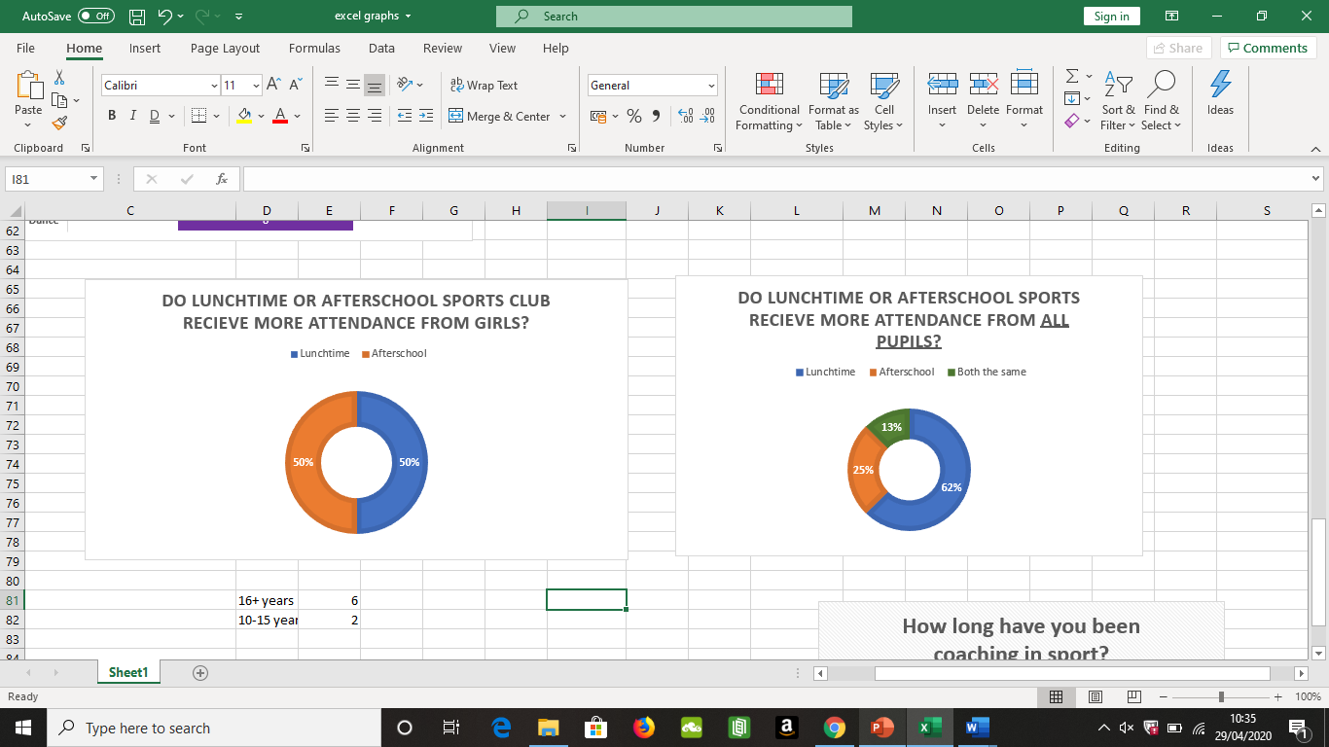
19.0 Figure 4 - Question 8
This pie chart shows that there is not much research or evidence to show if there is any difference between ks3 and ks4 girls attending lunchtime or afterschool sports clubs. If there was a significant difference in the chart then it could have provided useful information for coaches to plan future clubs for girls, to ensure a high attendance in the club. (See appendix 5 for comparison)

20.0 Question 9
This question compared to a study from the literature review stating that high parental and peer role models made a significant positive impact on adolescent girl’s (ks3/ks4) physical activity, they were asked if they agree or disagree and 100% of the participants agreed with the statement. For all of the participants to agree, this shows the level of importance parents and friends make in encouraging them to try new sports.

21.0 Question 10
“Do you think gender stereotyping in ks3 and ks4 still exists?”, unfortunately 88% of the participants said yes and 12% said they do not know, this has always been a problem in schools but especially girls. When girls get stereotyped into only having to play “girls sports” such as netball for example it can in fact repel them away from wanting to do that, this might be a factor into why girls are wanting to try football more often as it is a sport which isn’t necessarily classed as a “girls sport”.

22.0 Figure 6- Most common topics mentioned (Focus Group)
This funnel chart also supports the data regarding teachers being a barrier or an impact on sports participation. This chart shows how many times the topics on the left were mentioned throughout the focus group. Teachers were mentioned with positive and negative critiques but more so the PASS team were suggesting ways the teachers could improve. As seen above parents are essential as role models and to give encouragement for the girls to try new sports or stay behind after school for example offering their child a lift home if available will avoid the barrier of transport.
Football was a surprised result as Youth Sport Trust (2017) stated that only 18% of less active girls enjoy football in comparison to 26% more active girls, therefore football being the most mentioned sport is a big difference in opinions.
One issue that was mentioned 10 times but also often in the one-ended questions in questionnaires, was that transport is a huge problem for students, especially in Wales as some schools are in Valleys and hard to get to areas with students bused in, this creates a problem of offering afterschool clubs as attendance is very low.

23.0 Question 11.1
75% of the participants said that sufficient funding was not provided to this target group, but all participants suggested what more funding could go towards. Suggestions included: training up more female coaches who are up to date with modern games and sports, alternative activities to suit more girls, cheaper gym memberships for ks3/ks4 students, increased incentives and specific equipment, transport costs and larger variety of sports were mentioned. These findings show good suggestions that could target barriers previously mentioned such as teacher influence and lack of sports offered. Alternative modern sports that could be offered could include hula hoops, girls only gym-based sessions, spin classes or mini-trampoline classes.

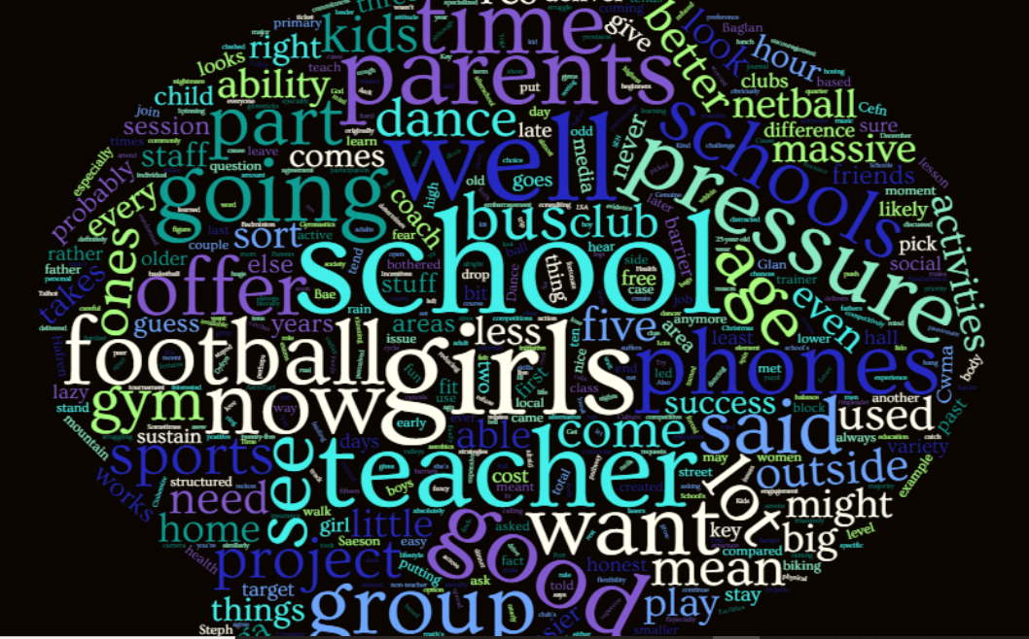
24.0 Figure 7- Word cloud from Focus Group
The word cloud above highlights the most said words from the focus group, the most said would be the biggest font size in the bubble, this is a visual way to view a large amount of qualitative data. The words that are standing out include: school, football, time, parents, pressure, phones, teacher and time etc (see appendix 6).
These all have a meaning behind why it relates to the project, for example football was mentioned as it is not offered to girls often in school, but research in the Literature review showed to be popular. Parental role models have proven to be important especially ks3 girls as they are at a vulnerable and difficult time in school where they need encouragement. There are smaller words which aren’t mentioned as often but were still very relevant, for example, ability was spoke about in the response of children getting treated differently based upon their sporting ability, the more sporty children would receive more attention, then the less sporty, according to what the PASS team have seen and experienced within schools.

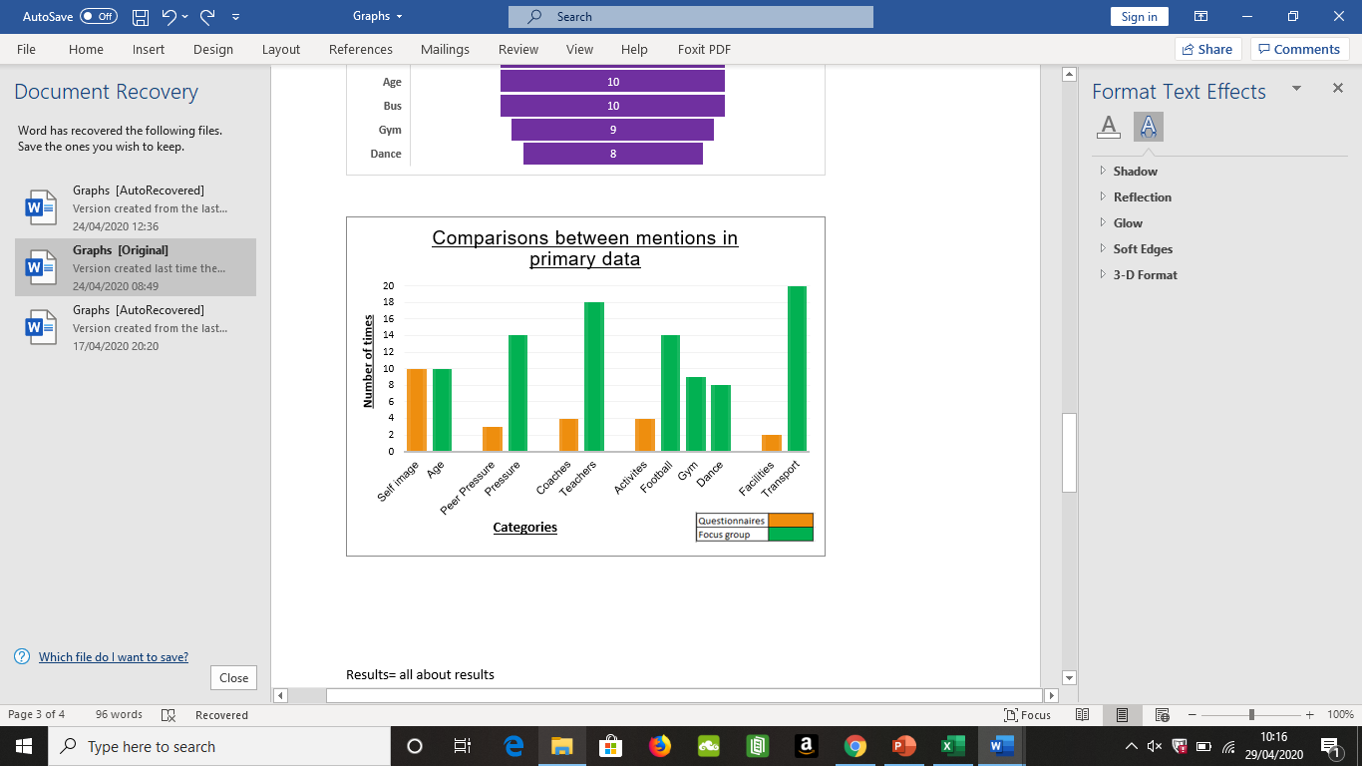
24.1 Figure 8- Cluster graph

This clustered column graph shows the correlation between the questionnaires and focus group, the categories listed were ones that can be easily compared. The biggest difference was the mention of facilities (including transport and school facilities) within the questionnaires, and the significant increase from focus groups. In the focus group, the participants had the chance to explain why transport is a issue, this may be the reason behind the difference, as they can go in-depth and explore their answers in the focus group, whereas a questionnaire can seem like a quick to fill in alternative.

The focus group has shown that the participants felt more comfortable speaking about barriers such as pressure and teachers as they could also explain their answers. Teachers can be a difficult topic for the team to discuss as they work with them on a daily basis and do not want to speak negatively, however due to the study being anonymous it gave them the chance to speak. The team expressed their opinion and their main concern was that teachers are sometimes unlikely to change their traditional ways to modern new games and methods of teaching.

This graph highlights that when given the chance the team spoke honestly and openly about important topics, for example self-image, age, body conscious and confidence has always been a ‘clear/obvious’ answer into why girls at that age do not participate as often, whereas this graph is showing barriers that could potentially have solutions to.

25.0 Secondary data

The School Sport Survey (2018) shows evidence that the SDO and the girls have disconnections in some areas but also that they provide similarities of opinions in others.

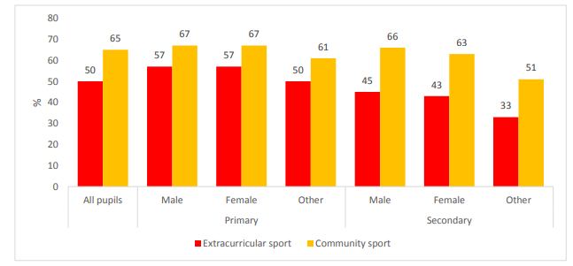
25.1 Figure 9
Participation at least once a week in extracurricular and community sports, by gender and age.

This graph shows that females in secondary school have low participation rates comparing to females doing community sports, which is sports done outside of school for a club etc. Females at primary school level still participated heavily in extracurricular sports, therefore it is likely the drop-off rate is around key stage 3 and key 4 towards the end of secondary school years.

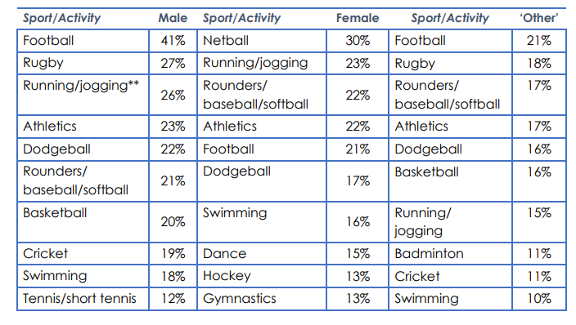
25.2 Figure 10
Top 10 extracurricular activities likely to be participated in from year groups 3-11 by gender.

It is prominent that running/jogging is one the highest participation sports as it is a common sport for people to do individually without any equipment therefore an easy to start sport. However, netball, rounders and athletics are high percentages for females but that is expected due to it be a traditional sport for schools to offer. Swimming is a difficult sport to offer unless they have a swimming pool or are close to a swimming facility for the school to utilise.

Main body – Conclusion
26.0 Introduction
To conclude this research project, the research from the literature review and primary data collected will be compared to find a general conclusion. My aim for this project is to critically analyse the challenges that sports development officers in the PASS team identified for key stage 3 and key stage 4 girls to participate physical activity.

26.1 Objective 1
One of the objectives that I set out to achieve was to identify why the drop-out rate was so apparent from ks3 to ks4 girls. From the primary research but also research from Youth Sport Trust (2017), the drop-out rate is most likely down to personal factors such as body image as the girls are getting older they feel more conscious about how they look and them feelings are heighten when participating in sport as you start to sweat and are in sports kit.
26.2 Objective 2
Objective two was aiming to find out what existing barriers there are, from comparing primary and secondary data, the most common barriers were body/self-related (confidence, body image) and lack of sports variety offered to the girls.
26.3 Objective 3
Objective three was to find solutions to these barriers, one solution was to target other areas that were seen as barriers but contribute towards confidence, these include school uniform, facilities and running girls only classes whilst trying to ensure friends can be kept together, only if possible. Lack of sports offered will involve the change of suggesting new sports to ks3 and ks4 girls in PE lessons not just offering it as extracurricular as they might feel the need to try the sport/activity first to see if they like it before they attend club.
26.4 Objective 4
Objective four was to create a plan to suggest most popular sports and the research will provide the SDO with different information on current barriers and trends.
27.0 General barriers
The general barriers stated in the literature review that correspond well with what the questionnaires and focus group found, include: confidence, teachers, lack of time, school uniform, stereotyping and peer pressure/teasing. The other barriers that were stated in the literature review may still be issues and relevant in current times however the PASS team did not state them so have not experienced these issues or found them to be the major barriers.

28.0 Parental support
Question 9 had a 100% agreeance with the study, concluding that the researched data and primary data have made a positive correlation, parents and friends are a barrier but can also be the solution. Parental support can be a difficult challenge for the SDO as they will need the support from the parents to encourage their child to stay behind after school and if they pick the child up or meet the child if they have to walk home from school in the dark, its showing support and makes the SDO job easier.
29.0 What to offer
A challenge for SDO is offering a sport that all pupils are happy to do, as figure 10 shows dodgeball is an average high participation rate amongst all; fun based competition games are becoming more popular as it is best suited to make everyone enjoy, in comparison to traditional sports such as basketball or netball, even though these have a high percentage it is not compatible amongst all.
29.1 Lack of variety
Lack of variety in sports offered is a major issue for ks3 and ks4 girls as it was mentioned numerous times throughout the literature review but also throughout the questionnaires and the focus group. For the SDO this is an issue because they do offer a range of activities to pupils, however they can only provide activities that are suitable with the facilities they’ve got but also what the coaches are able to deliver, for example it would be a challenge to provide gymnastics sessions as a trained coach and a suitable facility is difficult to get. Specialised coaches are more expensive in delivering the sport, therefore require more funding to pay them.
29.2 Preferred sports
The literature review states that girls preferred sports in Wales include dance, football and basketball as the top three on the list, however the bottom three on the list include badminton, hockey and netball but these three are the most commonly taught sports in schools to girls in ks3 and ks4. Supporting the previous studies, the focus group stated that the most popular sports with this target group is football, dance and gym/fitness. Controversially, School Sport Survey (2019) states that netball is still the most popular extracurricular activity for females in year groups 3-11. However, because it is not specified which year groups like which sport it is difficult to tell, but dance and football still have a high percentage in their research.
29.3 Dance and Football
This provides a strong argument that SDO and schools need to start providing dance and football girls-only sessions more commonly, as it is proven to be popular from 3 different sources of information.

30.0 Transport
Figure 6, Figure 8 and question 11.1, show a strong correlation that transport is affecting this target groups participation within sports. As stated previously, in Wales there are several areas and schools which are difficult or far to get to, therefore if a pupil stays behind for an afterschool club and there is not bus offered they could potentially not get home. Some pupils have free bus passes which works on the coaches that enables them to get to and from school, however not all bus passes provide free transport on normal public transport which would mean the pupil has to pay. This creates a problem for SDO as they need to find ways of offering transport to pupils so they can stay and attend the club. The PASS team have a minibus which they sometimes use to take school pupils to competitions, and transporting to go to other venues, however not all schools provide this opportunity so they can only offer sports and activities that can be done in school facilities.
31.0 Conclusion
To conclude this project, the main barriers that SDO need to target is offering a range of new sports or variations of current sports to engage girls to stop the lack of boredom. Facilities should be separate from any other clubs going on, the room should have privacy for the girls to prevent boys watching/entering the room during club.

Main body – Recommendations
32.0 Objective 2 and 3
Objective two and three could be achieved for SDO by establishing terms with schools and teachers about the facilities that they provide for the session, for example the room should have a door, does not have access points open that people could walk through (e.g. students have to walk through club to get to room), ability to block windows if needed as some girls have low confidence especially in dance.
The coach delivering session needs to have knowledge on how to deal with girls in this target group, how to encourage them to join in, keep them interested and be able to act professional if they start answering coach back. Coaches should also be trained how to deal with difficult scenarios as it will make situations easier for coach and students. The coach should also know variations of sport or game they are coaching, for example if teaching dance then a back-up option should be prepared or if it is football then mini games to keep girls interested should be thought out.
32.1 Objective 4
Objective four involves showing the most popular sports and variations for the SDO to use for the girls. Coaches need to start delivering more current sports trends such as spin classes, dance/Zumba, fitness, football, as jogging was popular in the School Sport Survey; cross-country might be a popular option which was not mentioned by the participants.

33.0 Parents
A way the parents could support their child in sport could be offering lifts home if possible, or looking into community clubs, some clubs are free which eliminates the cost barrier. Parents need to be encouraging towards the girls as they might need the extra support to suggest from them to stay on afterschool or give the positive reinforcement, so it gives them confidence.

34.0 Lack of variety
To overcome boredom from lack of variety, coaches and teachers need to start offering a wider range of activities to ks3 and ks4 girls. A way to do this is to provide workshops for coaches on new games or different modern adaptations of traditional sports to make it new and exciting for the pupils.
34.1 Football
The SDO could start asking the girls their opinion on what they would like to do, and to break the stigma of stereotyping “feminine and masculine” sports, when boys play football and girls play netball, teachers and coaches could try switching it up and the boys try netball and girls try football to see how they find it. The more schools and clubs that offer for this change to happen can break the stereotyping towards the girls and will make it easier for them to enjoy a variety of sports without worrying what people think. Football has already seen to be very wanted by ks3 and ks4 girls, therefore it needs to be provided but an alternative of boys playing netball could be successful too.
For the SDO to start providing more dance, football and basketball sessions to support the data found that these are the most preferred sports, they will have to train or employ more dance coaches, and provide football and basketball coaching sessions to all coaches to ensure they are all trained at a suitable standard to teach the girls. It is stereotypically known that male coaches will conduct football sessions, whereas ks3 and ks4 girls may prefer being taught by a female coach.
35.0 Body image
Figure 3 shows how much of a major barrier body image, self-confidence and the embarrassment of sweating is to this target group. This barrier relates to facilities that schools have and if they are a separate room for the activity for the girls to take place it can give them privacy. If the girls class have a separate room just for them and the teacher/coach then they will not have the worry of boys coming in/watching (as previously stated in questionnaire).
They will have less of a worry about body image if all girls are doing the same sport, and therefore if they begin to sweat it might make them feel at ease if their whole class isn’t there and they have friends/a friend there doing the same activity not being completely spilt up.
35.1 PE kit
School PE kit can make a massive difference to the girls, if it is the right kit then it can stop them feeling conscious in their kit (especially if they have to wear skirts), it could be a kit that doesn’t show sweat very clearly for example if they had to wear light grey polos then it could cause big embarrassment for girls and boys, so could be an option for schools to consider which will in turn benefit the SDO and the girls.

36.0 Core PE
A participant also stated that PE and sports are not seen as a main priority and core subject so when exams for other subjects take place for ks3 and ks4, PE is the subject that suffers from students being told to go elsewhere to get extra lessons. Other core subjects are important, but it is important for all pupils to still get exercise and knowledge about how to stay fit for the future. As core PE only takes place around 3 times every 2 weeks, which is not much compared to other subjects so should not have students going elsewhere.

37.0 Transport
Transport has proved to be a big issue so schools and sports clubs need more help and funding to go towards this problem. The PASS team have a minibus that is used but not all staff are trained to drive it, therefore a recommendation is to invest in all staff being able to use minibus so when they have lunchtime or afterschool clubs they could transport the pupils either to other venues e.g. a gym, swimming pool, beach etc, or home if there wasn’t a high number of children.
Another alternative which is more expensive but could be beneficial in the long-term is investing in another minibus so that it opens more opportunities for it to be used. If children had a secure way of getting to and from extra-curricular activities and not having to walk home on their own, then it will certainly bring a higher attendance of girls to the sports clubs.
37.1 Bus pass
A recommendation which PASS could work towards is providing the pupils that attend the afterschool club with a free public bus pass home. If PASS can work with the council to get a daily free pass for the girls then transport home will not become a major barrier. The bus pass can only be given to the girls if they attend the full afterschool session, and the club will be capped at a certain amount to stop over-crowding.

Reference List
Allison, R., L. Bird, E. and McClean, S. (2017). Is Team Sport the Key to Getting Everybody Active, Every Day? A Systematic Review of Physical Activity Interventions Aimed at Increasing Girls’ Participation in Team Sport. [online] 4(2). Available at: https://doaj.org/article/d3da60098e7f44c8b3dee1ef3cde941e [Accessed 11 Dec. 2019].

Azzarito, L. & Solmon (2009). An Investigation of Students' Embodied Discourses in Physical Education: A Gender Project. Journal of Teaching in Physical Education, 28, 173-191

Barbour, R., 2008. Doing Focus Groups. London: Sage Publications, p.5.

Benn, T. 2000. “Towards inclusion in education and physical education”. In Primary school physical education, research into practice, pp 118–135. London: Routledge.

Blaikie, N. (2010) “Designing Social Research”. 2nd ed

Bryman, A. 2004. Social Research Methods. Second Edition. London: Oxford University

Butcher, J. (1985). Longitudinal Analysis of Adolescent Girls’ Participation in Physical Activity. Sociology of Sport Journal, [online] 2(2), pp.130-143. Available at: https://journals.humankinetics.com/view/journals/ssj/2/2/article-p130.xml [Accessed 11 Dec. 2019].

Casey, M., Eime, R., Harvey, J., Sawyer, N., Craike, M., Symons, C. and Payne, W. (2017). The influence of a Healthy Welcoming Environment on participation in club sport by adolescent girls: a longitudinal study. BMC Sports Science, Medicine and Rehabilitation, 9(1).
Casey, M., Eime, R., Payne, W. and Harvey, J. (2009). Using a Socioecological Approach to Examine Participation in Sport and Physical Activity Among Rural Adolescent Girls. Qualitative Health Research, [online] 19(7), pp.881-893. Available at: https://journals.sagepub.com/doi/abs/10.1177/1049732309338198 [Accessed 10 Dec. 2019].
Collinsdictionary.com. 2020. Validity Definition And Meaning | Collins English Dictionary. [online] Available at: <https://www.collinsdictionary.com/dictionary/english/validity> [Accessed 20 April 2020].

Creswell, J. W. 2003. Research Design: Qualitative, Quantitative, and Mixed Methods Approaches. Thousand Oaks: Sage Publications.

Crosnoe, R. (2001). The social world of male and female athletes in high school. Sociological Studies of Children and Youth, 8, 89-110

Crossfield, L., 2020. Focus Groups Advantages & Disadvantages - Expert Market. [online] Expert Market. Available at: <https://www.expertmarket.co.uk/market-research/focus-groups-advantages-disadvantages> [Accessed 12 April 2020].

Dagkas, S., & Hunter, L. (2015). ‘Racialised’ pedagogic practices influencing young Muslims' physical culture. Physical Education and Sport Pedagogy, 20(5).
Dagkas, S., Benn, T. and Jawad, H. (2011). Multiple voices: improving participation of Muslim girls in physical education and school sport. Sport, Education and Society, [online] 16(2), pp.223-239. Available at: https://www-tandfonline-com.ezproxy.uwtsd.ac.uk/doi/full/10.1080/13573322.2011.540427 [Accessed 10 Dec. 2019].
Dagkas, S. and Benn, T. 2006. Young Muslim women's experience of Islam and physical education in Greece and Britain: a comparative study. Sport Education and Society, 11(1): 21–38. Taylor & Francis [Accessed, 10/12/2019)

Devault, G., 2019. Tame Your Focus Groups and Get Useful Insights. [online] The Balance Small Business. Available at: <https://www.thebalancesmb.com/what-is-a-market-research-focus-group-2296907> [Accessed 11 April 2020].

Eime, R., Payne, W., Casey, M. and Harvey, J. (2008). Transition in participation in sport and unstructured physical activity for rural living adolescent girls. Health Education Research, [online] 25(2), pp.282-293. Available at: https://academic.oup.com/her/article/25/2/282/667285 [Accessed 13 Nov. 2019].

Enago Academy. 2019. The Importance Of Sampling Methods In Research Design - Enago Academy. [online] Available at: <https://www.enago.com/academy/the-importance-of-sampling-methods-in-research-design/> [Accessed 14 April 2020].

Fatimah Bahari, S., 2010. Contrasting epistemological and ontological assumptions. Qualitative versus quantitative research strategies, [online] 52(1), pp.2-4. Available at: <https://sainshumanika.utm.my/index.php/sainshumanika/article/view/256/253> [Accessed 6 April 2020].

Given, L., 2008. Emic/Etic Distinction. [online] SAGE Research Methods. Available at: <https://methods.sagepub.com/reference/sage-encyc-qualitative-research-methods/n130.xml> [Accessed 10 April 2020].

Holloway, I., 2007. Qualitative Research in Health Care. 2nd ed. Maidenhead: McGraw-Hill International (UK) Ltd., p.77.

Kilpatric, M.; Hebert, E. & Bartholomew, J. (2005). College students' motivation for physical activity: differentiating men's and women's motives for sport participation and exercise. Journal of American College Health,

Kirk, D. 2000. “A task-based approach to critical pedagogy in sport and physical education”. In Sociology of sport: theory and practice. Pearson Education pp 201.
Lincoln, Y. and Guba, E., 2020. The Reliability Of Qualitative Research. [online] Nsfconsulting.com.au. Available at: <http://nsfconsulting.com.au/qualitative-research-reliability/> [Accessed 20 April 2020].

Muslim Council of Britain. 2007 Towards greater understanding: meeting the needs of Muslim pupils in state schools: information and guidance for schools Muslim Council of Britain, London. Available online at: www.mcb.org.uk (Accessed, 10/12/2019)

nhs.uk. 2020. Obesity. [online] Available at: <https://www.nhs.uk/conditions/obesity/> [Accessed 30 April 2020].
nhsdirectwales.wales.nhs.uk. 2020. Neath Port Talbot Physical Activity And Sport Service - PASS. [online] Available at: <https://www.nhsdirect.wales.nhs.uk/LocalServices/ViewLocalService.aspx?id=1416> [Accessed 30 April 2020].
Npt.gov.uk. 2020. About P.A.S.S.. [online] Available at: <https://www.npt.gov.uk/17518> [Accessed 30 April 2020].
Okely, A., Lubans, D., Morgan, P., Cotton, W., Peralta, L., Miller, J., Batterham, M. and Janssen, X. (2017). Promoting physical activity among adolescent girls: the Girls in Sport group randomized trial. International Journal of Behavioral Nutrition and Physical Activity, 14(1).
O'Reilly, N., Brunette, M. and Bradish, C. (2018). Lifelong Female Engagement in Sport: A Framework for Advancing Girls’ and Women’s Participation. Journal of Applied Sport Management, [online] 10(3), pp.15-30. Available at: https://search-proquest-com.ezproxy.uwtsd.ac.uk/docview/2137528348/fulltextPDF/3992E096C1174D03PQ/1?accountid=130472 [Accessed 11 Dec. 2019].
Patten, M., 2014. Questionnaire Research. 4th ed. New York: Routledge, pp.3-20.

Philosophynow.org. 2020. Ontology for beginners | Issue 16 | Philosophy Now. [online] Available at: <https://philosophynow.org/issues/16/Ontology_for_Beginners> [Accessed 10 April 2020].

Physical Activity among Adolescent Girls with a Lower Educational Level. [online] 11(6). Available at: https://journals.plos.org/plosone/article?id=10.1371/journal.pone.0157216 [Accessed 11 Dec. 2019].

Quain, S., 2019. The Focus Group Research Method. [online] Smallbusiness.chron.com. Available at: <https://smallbusiness.chron.com/focus-group-research-method-17464.html> [Accessed 11 April 2020].

Questionpro.com. 2019. Types Of Questions: Sample Question Types With Examples | Questionpro. [online] Available at: <https://www.questionpro.com/article/types-of-questions-question-types.html> [Accessed 15 April 2020].

Research Articles, 2017. The Concept Of Validity In Qualitative Research - Helping Research Writing For Student & Professional Researchers. [online] Available at: <http://researcharticles.com/index.php/the-concept-validity-qualitative-research/> [Accessed 20 April 2020].

Research-Methodology. 2019. Ontology - Research-Methodology. [online] Available at: <https://research-methodology.net/research-philosophy/ontology/> [Accessed 6 April 2020].

Sarwar, G. 1994. British Muslims and schools, London: Muslim Education Trust

Scraton, S. (1990). Gender and Physical Education. Geelong, Deakin University Press. Siedentop, D.
(2002) Sport Education: A retrospective. Journal of Teaching in Physical Education, 21

Sport Wales, 2018. School Sport Survey. State of the Nation. [online] Sport Wales, pp.5-14. Available at: <https://www.sport.wales/files/f16771b9041ecbd847704e346c9e15bc.pdf> [Accessed 1 May 2020].

Sport.wales. (2019). Sport and active lifestyles- State of nation report. [online] Available at: http://www.sport.wales/media/2018123/full_state_of_the_nation_report_2018_19_eng.pdf [Accessed 11 Dec. 2019].
Statistics Canada. (2013). Sport Participation 2010. Published Research Report, February, Government of Canada
Strandbu, Å., Bakken, A. and Sletten, M. (2017). Exploring the minority–majority gap in sport participation: different patterns for boys and girls?. Sport in Society, 22(4).
Verloigne, M., Cardon, G., De Craemer, M., D’Haese, S. and De Bourdeaudhuij, I. (2016). Mediating Effects of Self-Efficacy, Benefits and Barriers on the Association between Peer and Parental Factors and
Walseth, K. (2006). Young Muslim Women and sport: The impact of identity work. Journal of Leisure Studies, 25(1), 75-94.
Watson, A., Eliott, J. and Mehta, K. (2015). Perceived barriers and facilitators to participation in physical activity during the school lunch break for girls aged 12–13 years. European Physical Education Review, [online] 21(2), pp.257-271. Available at: https://journals.sagepub.com/doi/abs/10.1177/1356336X14567545 [Accessed 11 Nov. 2019].
Wetton, A., Radley, R., Jones, A. and Pearce, M. (2013). What Are the Barriers Which Discourage 15-16 Year-Old Girls from Participating in Team Sports and How Can We Overcome Them?. BioMed Research International, [online] 2013, pp.1-8. Available at: https://doaj.org/article/22f6303d5f9d4f7d871117b098a55a8e [Accessed 11 Dec. 2019].
Women in Sport, 2017. Key Findings From Girls Active Survey. Girls Active. [online] London: Youth Sport Trust. Available at: <https://www.womeninsport.org/wp-content/uploads/2017/11/Girls-Active-statistics-1.pdf?x99836> [Accessed 27 April 2020].
Womeninsport.org. (2017). Key findings from Girls Active Survey. [online] Available at: https://www.womeninsport.org/wp-content/uploads/2017/11/Girls-Active-statistics-1.pdf?x99836 [Accessed 11 Dec. 2019].
wordclouds.com. 2020. Free Online Word Cloud Generator And Tag Cloud Creator. [online] Available at: <https://www.wordclouds.com/> [Accessed 24 April 2020].
Youth Sport Trust, 2017. Pre-Intervention Survey Report. Girls Active. [online] London: Youth Sport Trust, pp.3-8. Available at: <https://www.youthsporttrust.org/system/files/resources/documents/Gairls%20Active%20Survey.pdf> [Accessed 27 April 2020].

Appendices (use relevant number of pages)
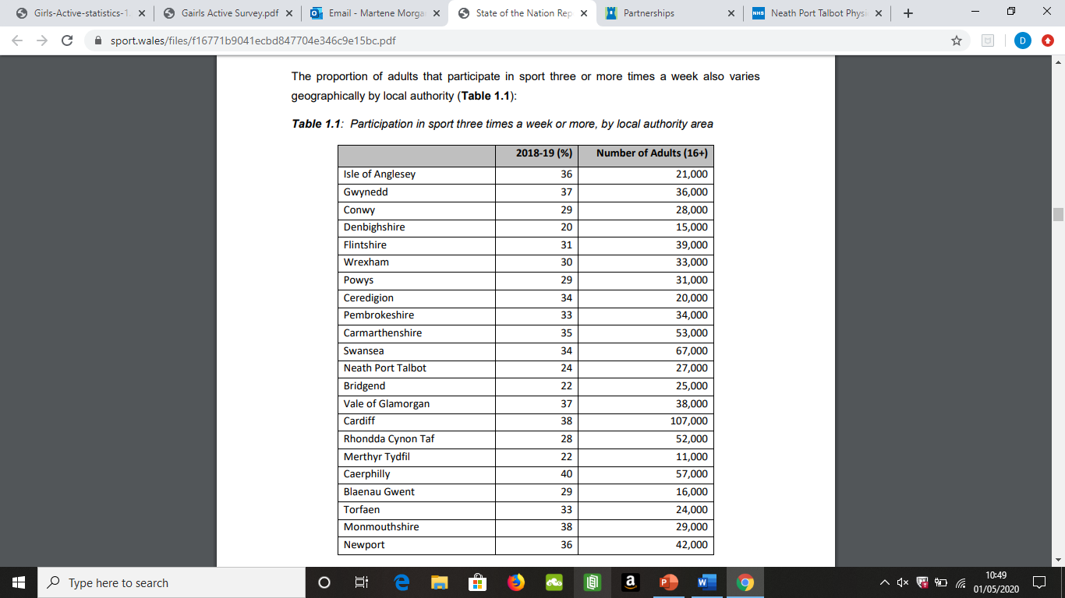
Appendix 1- Participation in adults 3 or more times a week.

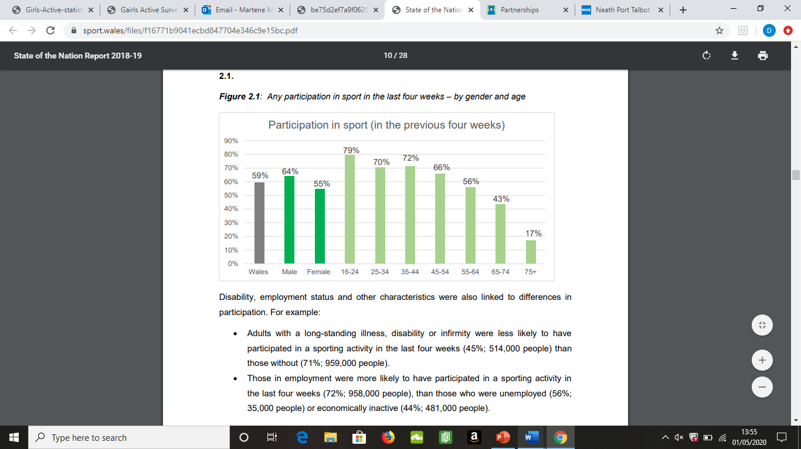
Appendix 2- Any participation in sports from adults within last 4 weeks.
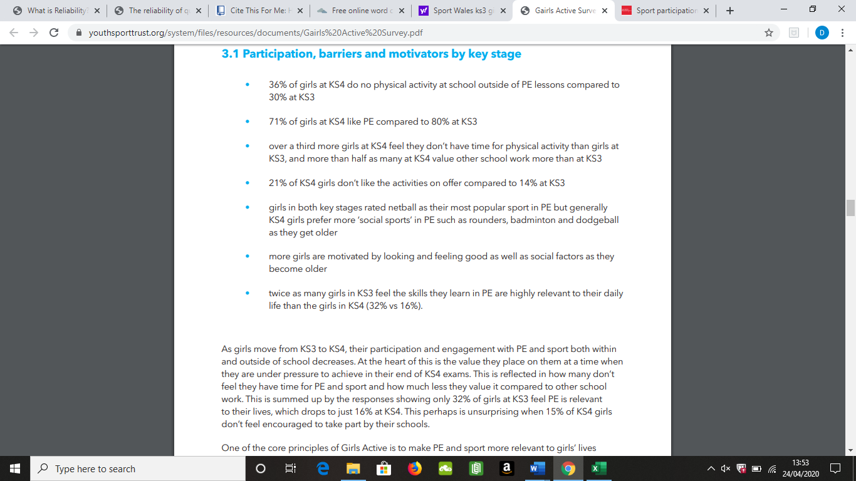
Appendix 2- Key statistics that related to KS3 and KS4. More information regarding participation, barriers and motivation as stated in introduction.

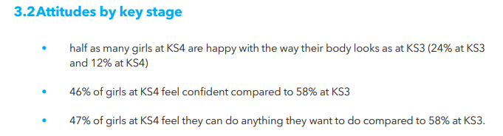
Appendix 3- Key statistics on girls’ attitude about themselves.
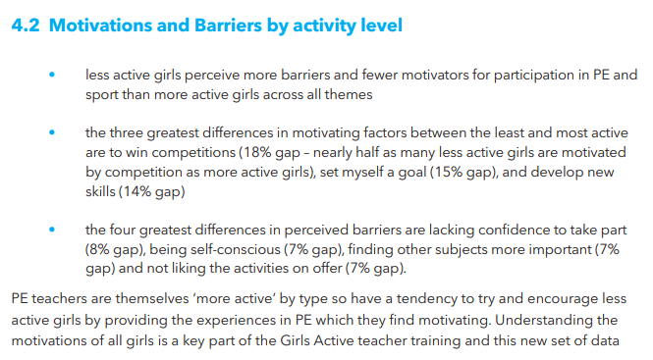
Appendix 4- Girls Active Survey, more statistics on perceived barriers.

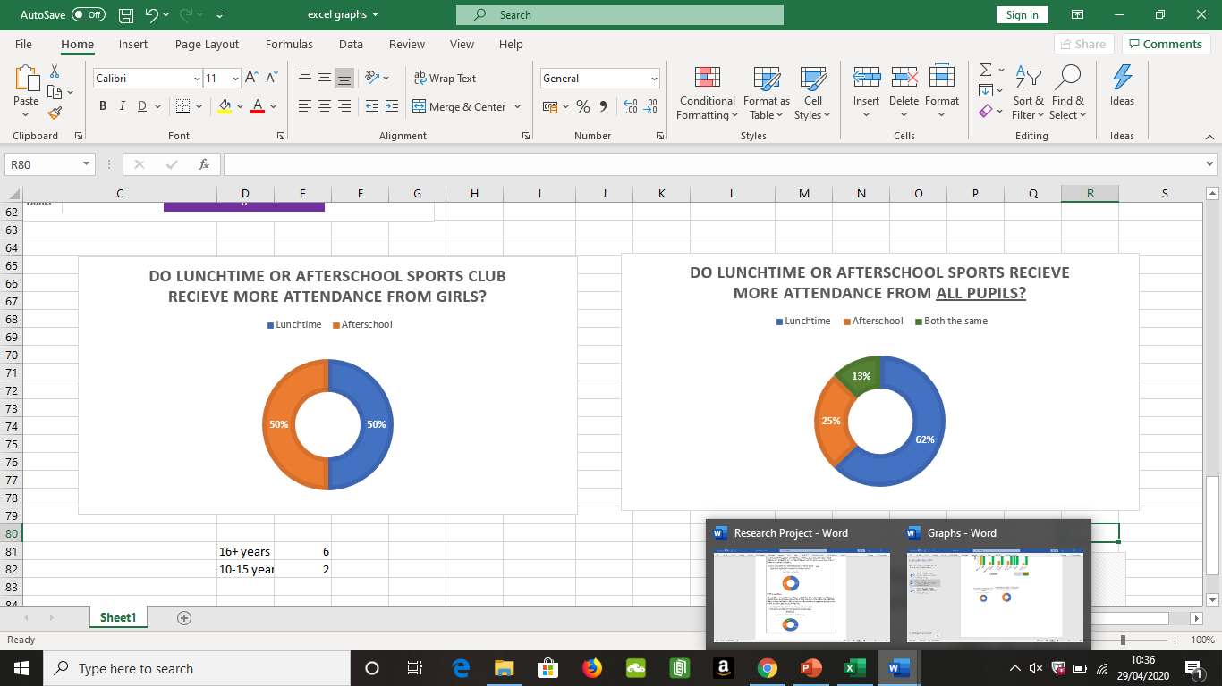
Appendix 5- doughnut graph
This doughnut chart shows a similar question to previous chart, question 8; however it shows results of opinion on all ks3 and ks4 pupils instead of just girls. This chart is different to figure 4 as there was a complete spilt of answers between lunchtime and afterschool, whereas these different results found that the participants show that they’ve experienced boys to attend more lunchtime clubs then afterschool, a reason that’s been suggested why girls do not attend lunchtime clubs is that some schools do not have the facilities for privacy, for example one school had to use half of a drama studio which also had other children in there having lunch, so girls stopped attending the club as other boys/pupils were watching.

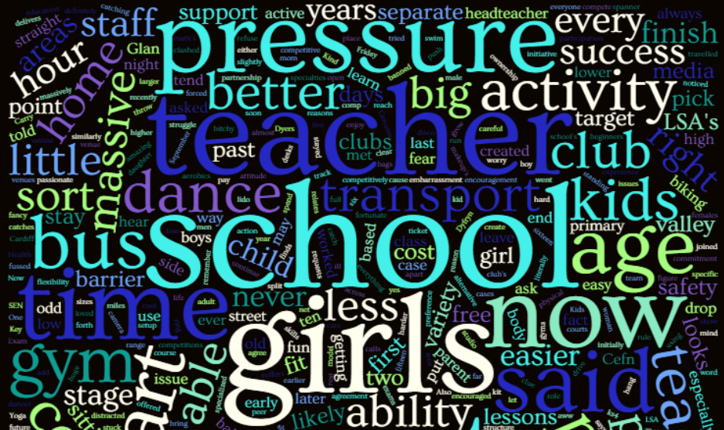
Appendix 6- Another zoomed in version of word cloud, showing words which were not able to be seen in first version. Words such as LSA’s, cost, headteacher are still important but not as bold as larger words due to not being mentioned freqeuntly.

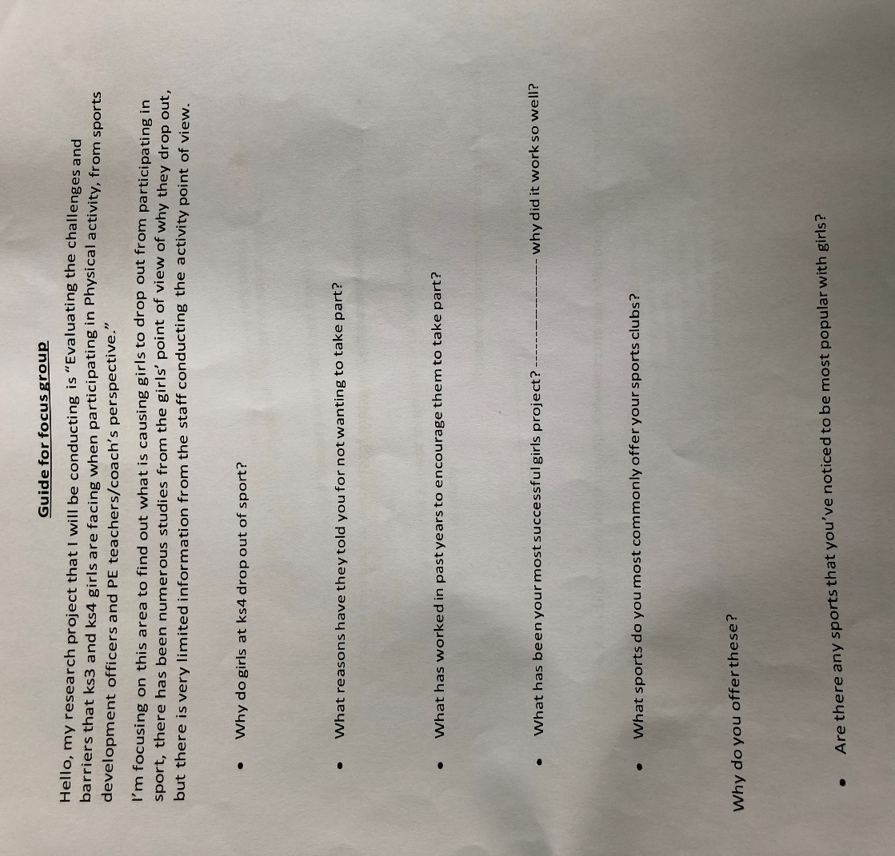

Appendix 7- Question guide for focus group interview
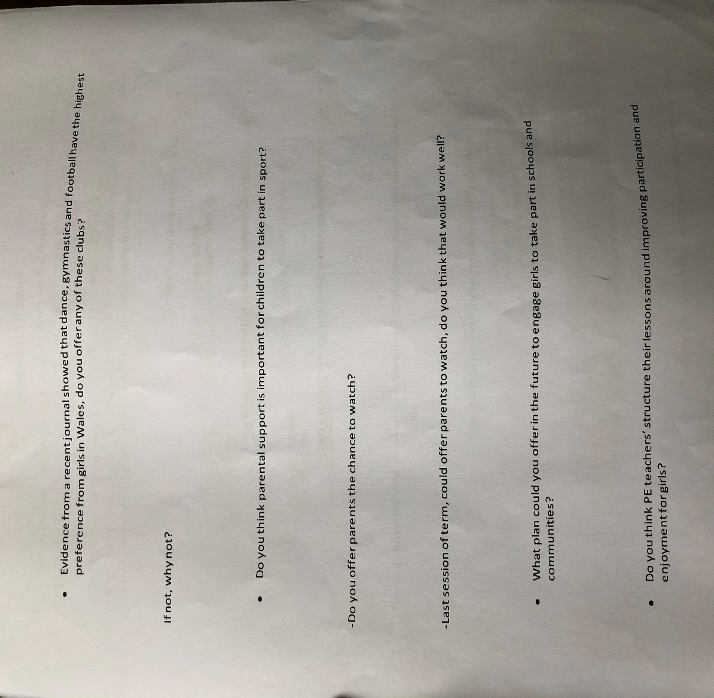
Appendix 8- Page 2 of question guide for focus group interview

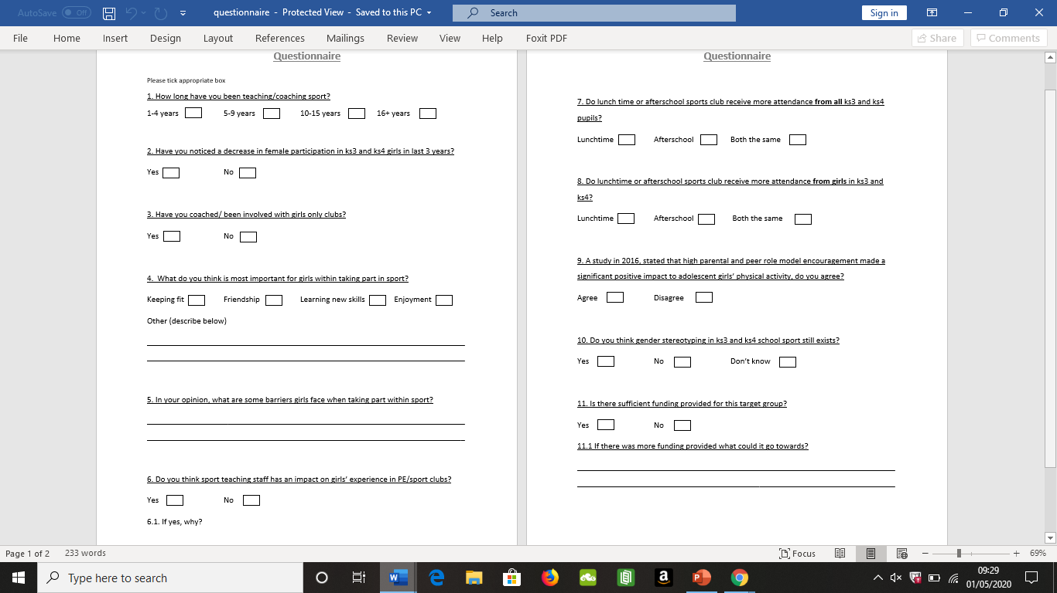

Appendix 9- Page 1 of blank questionnaire given to Sport Development Officers

Appendix 10- Page 2 of blank questionnaire given to Sport Development Officers

Submission Evidence

Faculty Office (1 x Paper Copy, Bind Professionally)
+
Online Turnitin Submission (prior to Deadline)



BA Sports Management Portfolio

Research Project
Report

UWTSDSport

