ADVANCED CYBERSECURITY ASSIGNMENT 1
Module Code: ACCB6000
Student NAME: Anthony N. EKPERECHI
Student ID: 2318045
Submission date: December 14, 2025
Lecturer: Dr Mohamed Ghanem
University of Wales TRINITY SAINT DAVID (London Campus)

Table of Contents
Title: 3
Introduction 3
Task 1. 4
IPCONFIG /ALL 4
IFCONFIG /ALL 5
IP Address 6
Ping Command 7
Task 2 15
2.1. Set up a Security-focused Operating System of your choice and ping. 15
2.2 Vulnerability Assessment 17
Vulnerabilities 2.3 25
CVSS 26
Automated Report 32
Task 3 Ethical Hacking2 34
2.1 Exploitation 34
2.2 Post-Exploitation Process 37
Task 4: Network Security Measures for SWANSEA.ACCA Network 37
4.1. Preventive Security Measures 37
Summary and Conclusion 41
References 41

Title: Analysing, Ethically Hacking and Securing an Enterprise Network

Introduction

SOAC Inc. operates in two locations - one in Swansea with a domain Active Directory and a Debian server in the London site or location. The Swansea network is configured as Domain Active Directory – Swansea. acca. It has a domain controller, which is S-DC1, which is configured with Windows 2022 Server and a Windows 10 client in the network [1].
The London site operates a Debian server, L-DC, which is a member of the Swansea ACCA. The network has a Debian GUI client attached to it, and both are linked to each other through a virtual private network (VPN). The London server is L-DC and is a member of the S-DC1 [1].
I am a cybersecurity consultant engaged by SOAC Inc. to conduct a vulnerability assessment for the Swansean.ACCA Network. This has become necessary as every individual and organisation relies heavily on digital infrastructure. With the rise or increase of AI, OT, IT, IoT, home working, cloud computing and the development of new digital gadgets, continuous remote access/connectivity, the need to comply with privacy laws, ethical, and professional frameworks, like the NIST, there is a greater need to assess and secure the digital assets of SOAC Inc [2].
More so, as data and information have become organisational critical resources, there is a need to assess, analyse SOAC Inc's critical digital infrastructure to mitigate them from malicious attacks, including theft. Train employees to be security-conscious, because there could be an internal attack in addition to an external attack. This is necessary to promote business continuity, sustainability, enhance confidence and trust, reputation and competitive advantage. As more and more people are entering the digital world and the incessant sophistication of cybercriminals, it is our responsibility to mitigate them. Yes, it is my duty to assess those vulnerabilities with NMAP, Wireshark, Nessus, OpenVAS, and any tools I deem fit to secure SOAC Inc [2].

Task 1.

IPCONFIG /ALL
IPCONFIG stand for ‘Internet Protocol Configuration’. It is a command-line utility used on the Windows Operating System to identify a unique identification number or address of digital devices such as laptops, desktops, mobile phones and other devices. There is also a similar utility for Linux OS – ifconfig [3].
They are used to troubleshoot, manage and display Subnet Mask, IP addresses, Default Gateways, and release or renew IP addresses and enable DNS cache to be flushed in a network environment. It is a fundamental utility in a communication setting [3].
IPCONFIG /ALL displays more detailed information, such as physical addresses like (MAC), DHCP and DNS servers [3].

Screenshot of S-DC – IPCONFIG /ALL

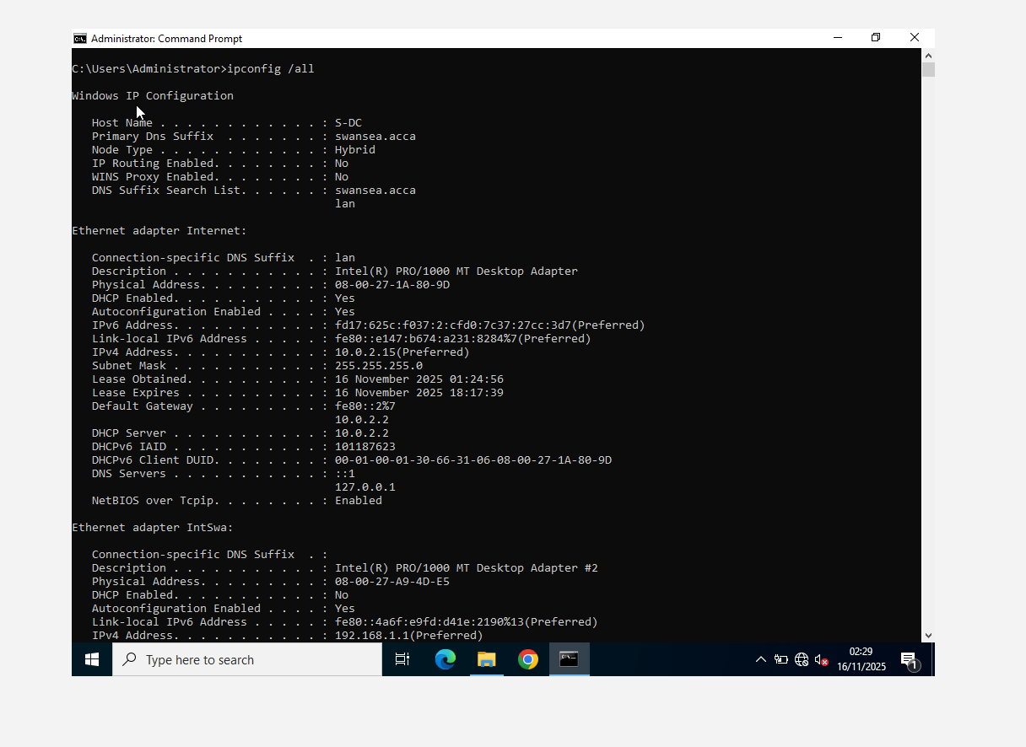

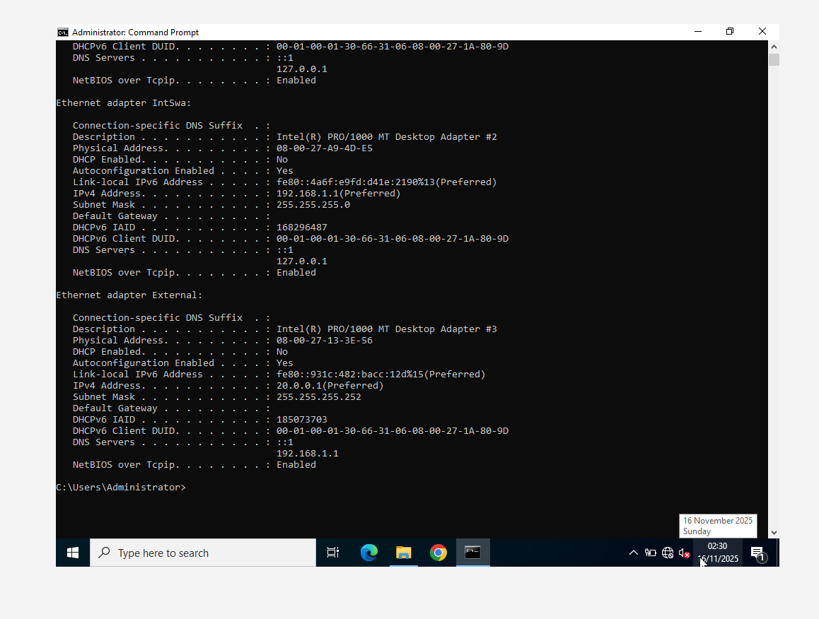

IFCONFIG /ALL
This command was not recognised on the CLI, but I attribute the error to misconfiguration [3].
However, I issued an ‘ip addr’ command, and it offered me all that I needed [3].
Screenshot of L-CD IFCONFIG /ALL
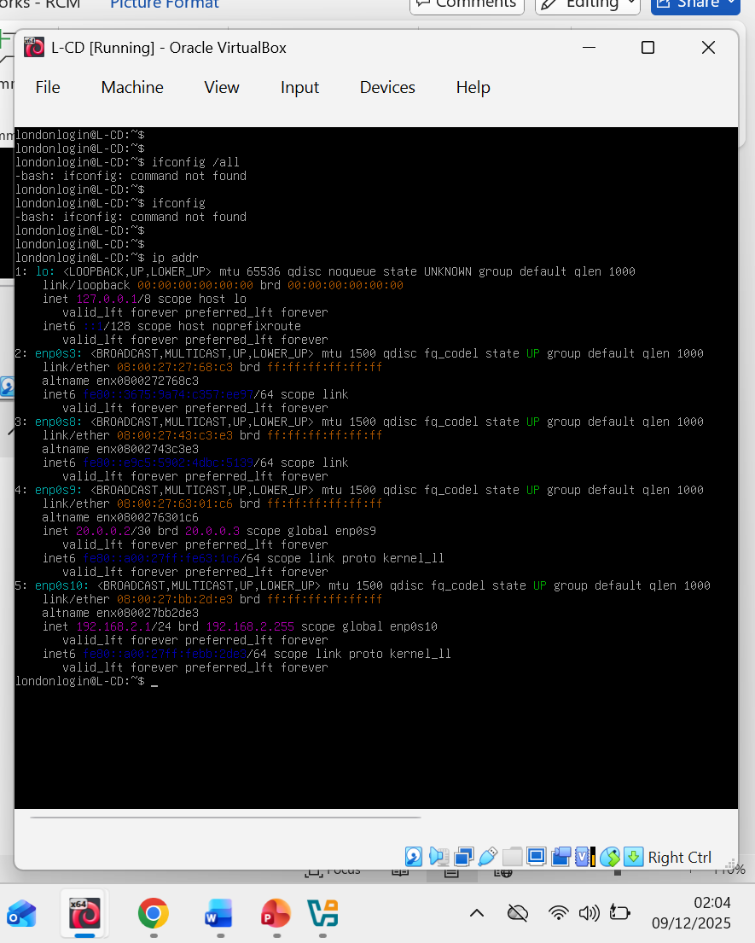

IP Address
An IP stands for Internet Protocol Address. It is a unique numerical address assigned to all devices that enables them to be identified and communicated with in a network system, including the internet. Data or information sent over a network is called a packet. When data is to be sent to a device, the device will be identified by its unique IP address [4]. Communication between the devices is a three-way handshake – the device communicates to the other, which is known as SYN, and the device acknowledges (ACK), and willingness to receive, and the packet is sent. A device can receive a packet or reject it if it is considered unsafe [4].
There are two types of IP: IPv4 (192.168.1.1) and IPv6 (2001:db8::8a2e:370:7334). IPv6 is developed to cope with the ever-increasing devices in the global network. IPv4 is 32 bits and uses numbers, while IPv6 is 128 bits and uses hexadecimal [4].
However, there are public IP addresses that are supplied by the ISPs, which are unique to the global network and private IP addresses that are supplied by the WiFi network providers. IP addresses can be static that are assigned manually. Most servers use them. It can also be dynamically issued by a DHCP Server. The DHCP server hosts a range of IP addresses (192.192.1.1 – 50) and leases them to any device that is linked to the network. It is the common form of IP address management, automatic and easy to manage [4].

Ping Command
This command is a critical network utility in establishing connectivity between IP addresses in a network system. It tests reachability or connectivity of an IP network by sending requests through ICMP and echo requests, and measures round-trip latency for replies, diagnosing the network, resolving issues and reporting on packets received or lost [5].
It sends the signal and listens for a reply to determine if the host is alive or how far away. It is used to troubleshoot connectivity, latency in milliseconds, and packets lost [5].
Pinging of S-DC1
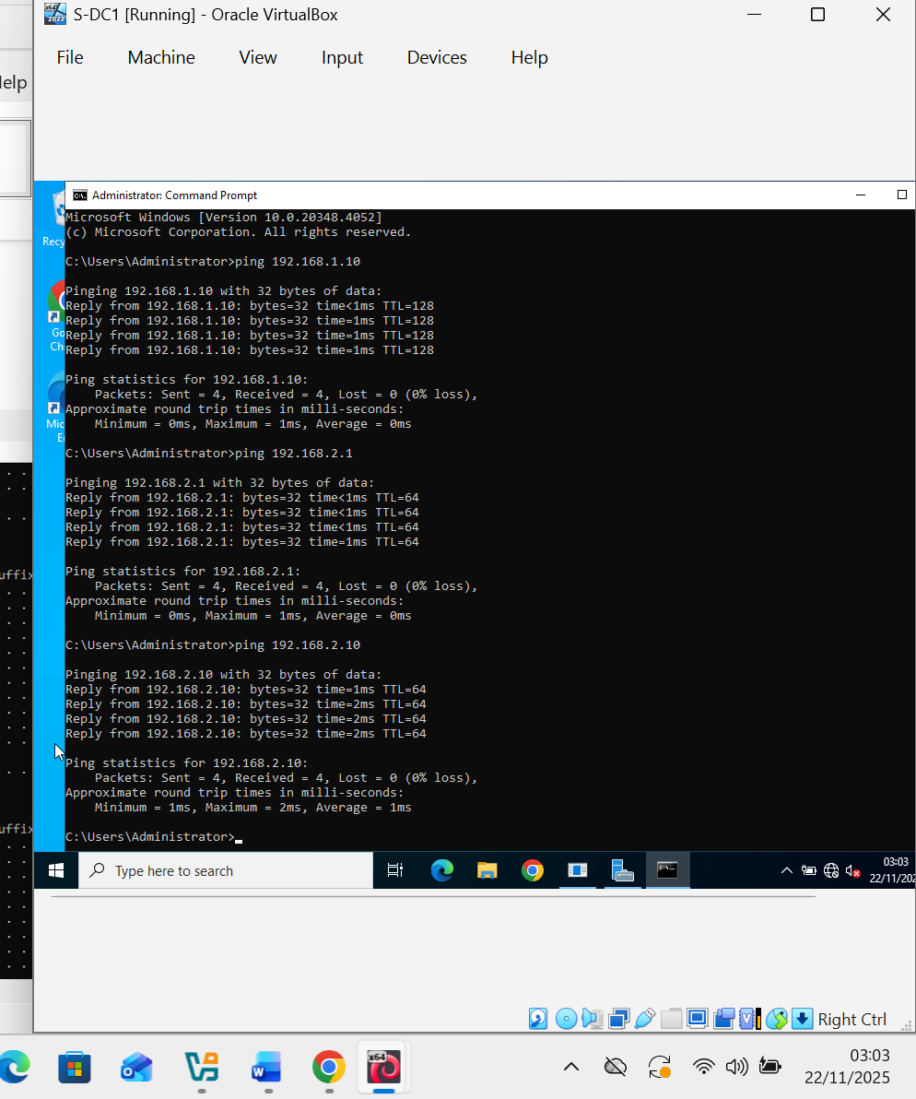

Pinging of S-DC1
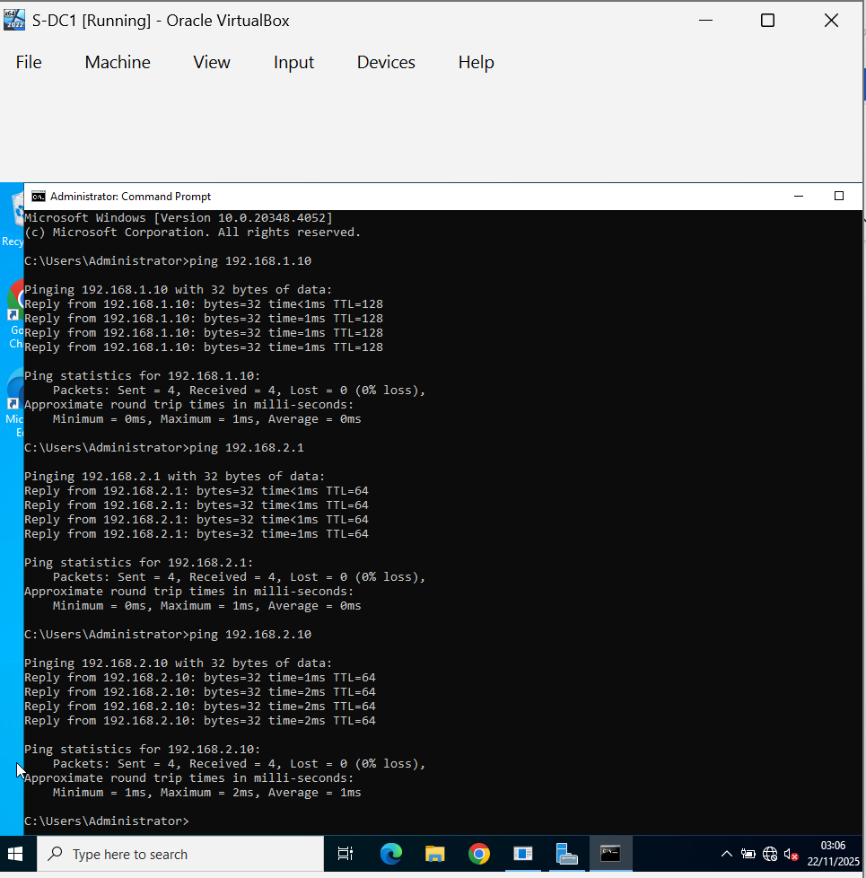

Pinging of Windows Client.
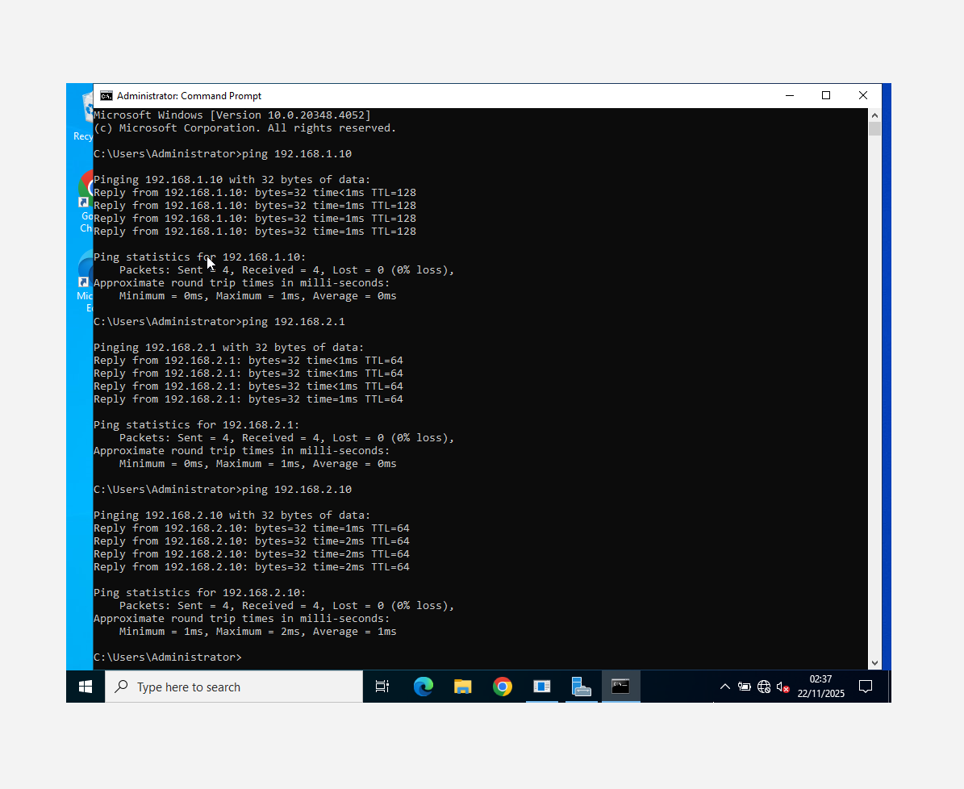

Pinging of L-CD
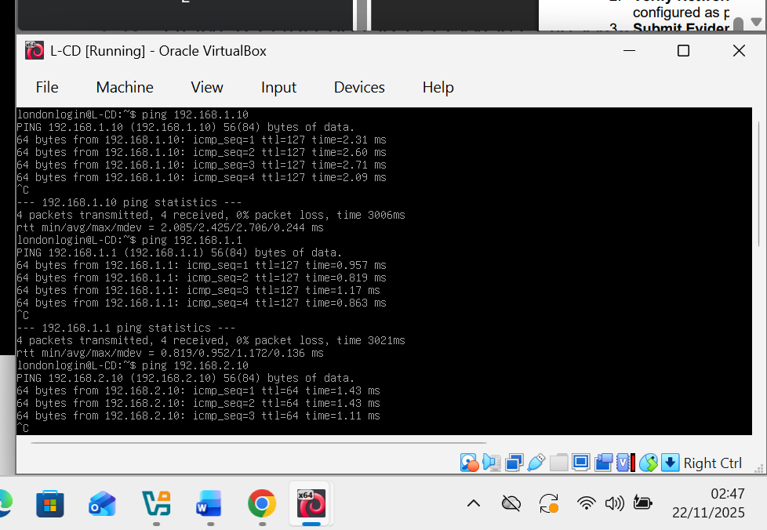
Window Client
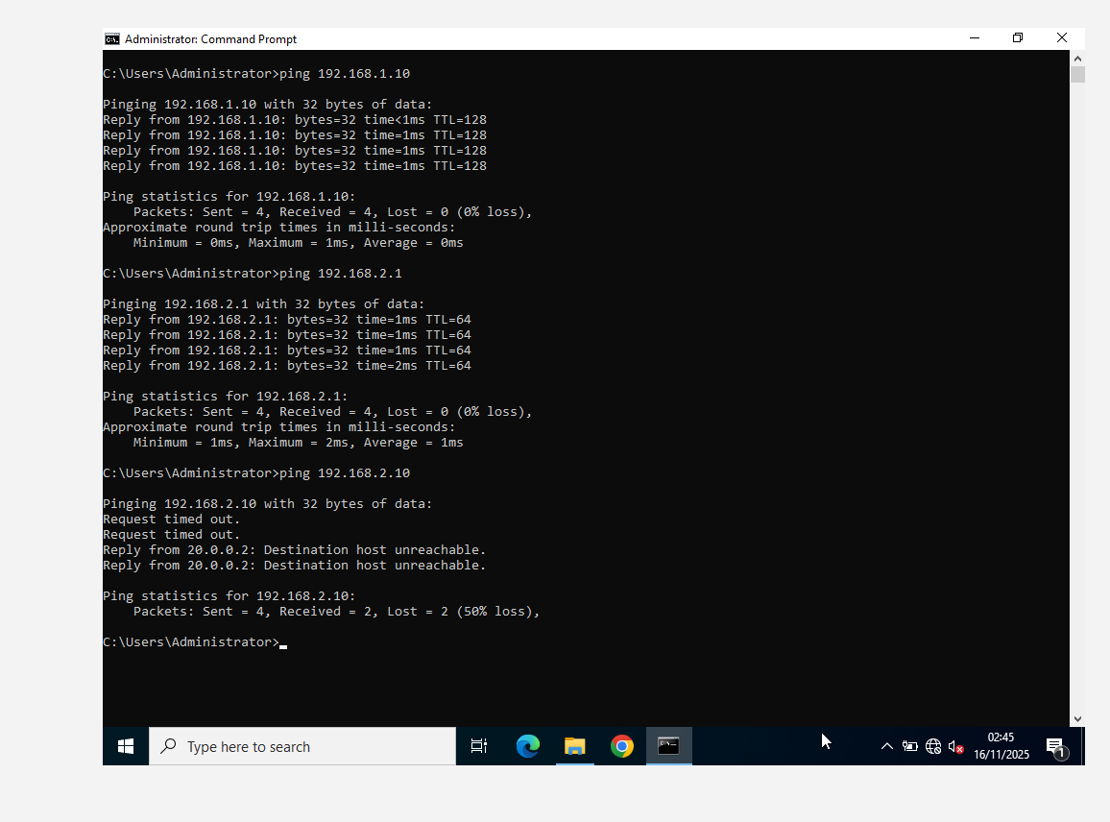
L-CD - Ping

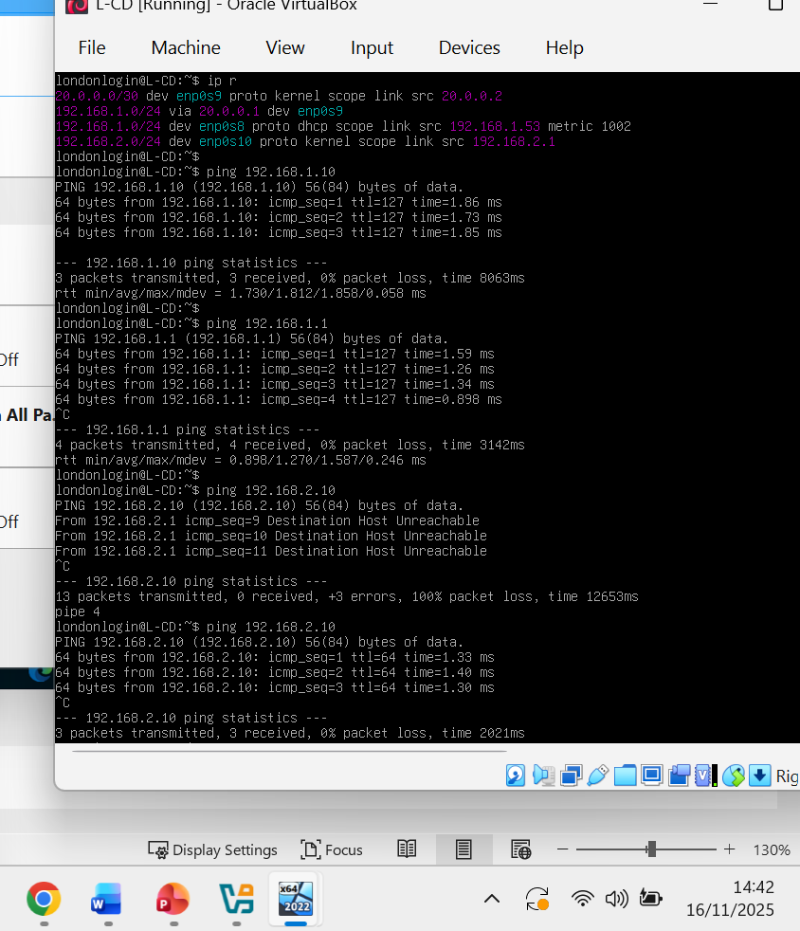

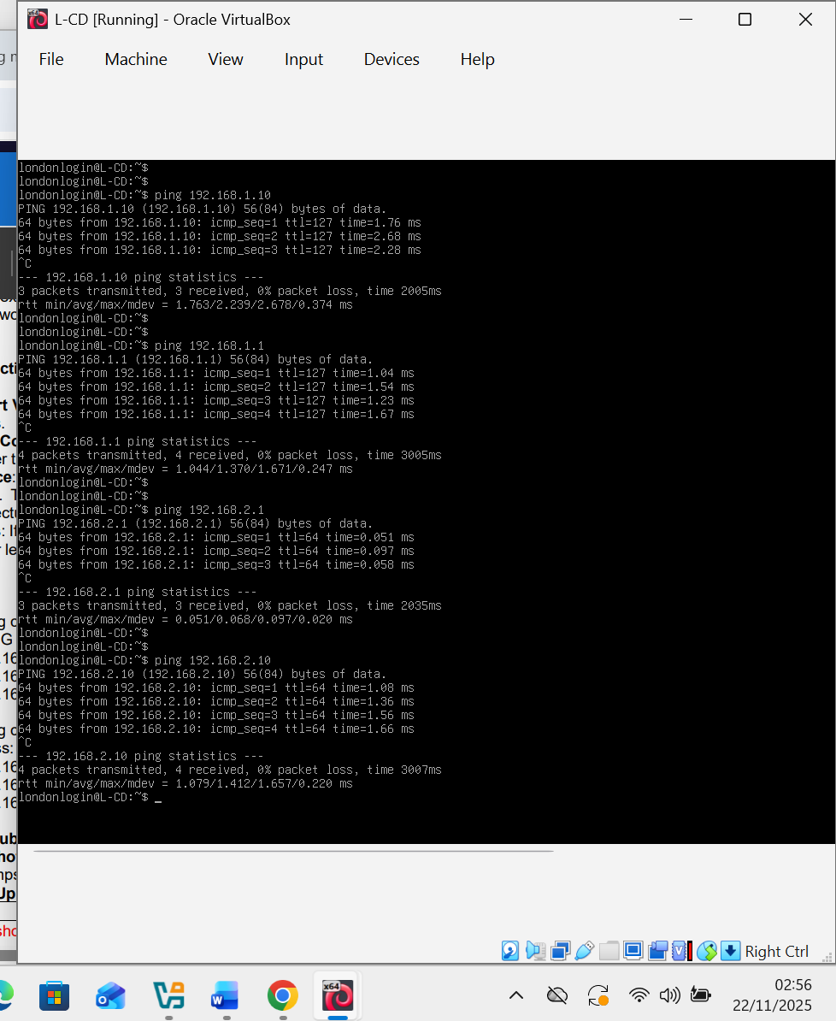

Task 2

2.1. Set up a Security-focused Operating System of your choice and ping.
Ping other network systems with Debian.
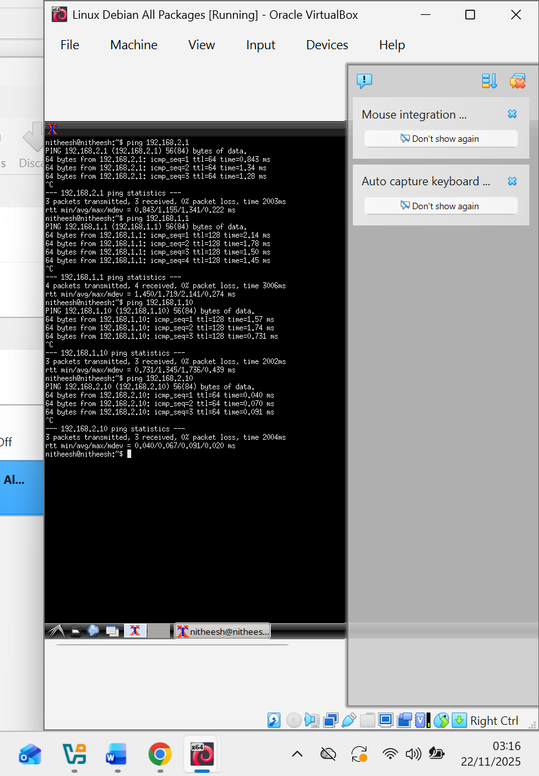 [6]

Hping3
The Hping3 is a powerful command-line interface tool used in cybersecurity to test connectivity over the network. It is used for sending and receiving packets across TCP/IP, acting as an advanced tool for protocols like ICMP, UDP, and TCP. It acts as DoS testing, firewall testing, port scanning, OS fingerprinting and is invaluable for security auditing. I used it to ping from Kali Linux to all the computers in the network, including the servers [6].
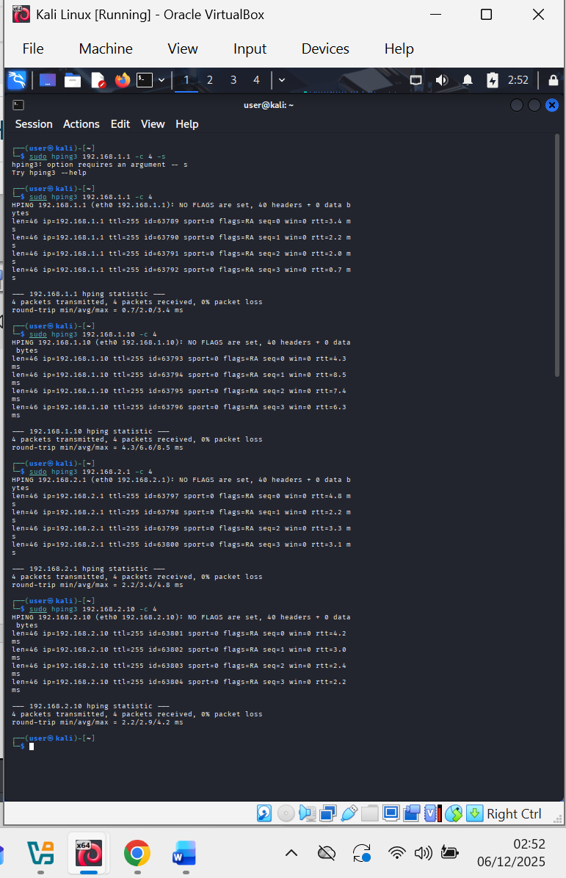 [6]

Scanned other systems with NMAP
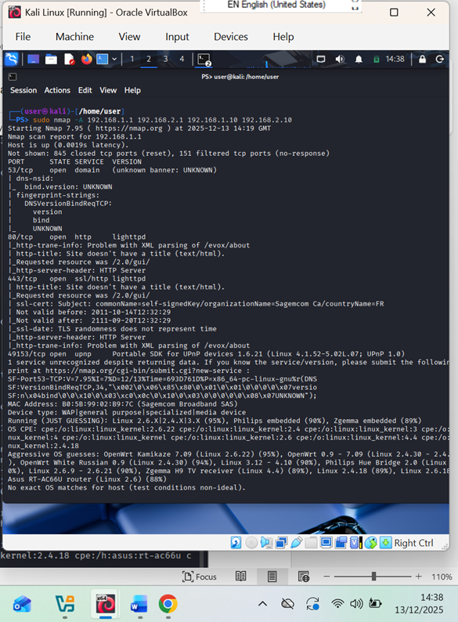

2.2 Vulnerability Assessment
Vulnerability Assessment is a systematic approach to identifying, classifying, and prioritising security measures in an organisation. Security weaknesses are mitigated according to ranking, as critical assets weigh more or carry priority. In most digital infrastructures, like the IT systems, networks, and applications, tools are used to conduct ethical hacking, identify and fix vulnerabilities in the systems. Such tools can identify vulnerabilities through misconfiguration, weak passwords, out-of-date software, broken authentical or security links, broken protocols or ports, and services, and assign severity to them and recommend mitigation [7].
The tools identify vulnerabilities, rank the most critical first, document them and recommend solutions [7].

Vulnerability testing with OpenVAS with severity ranking, protocols and ports.

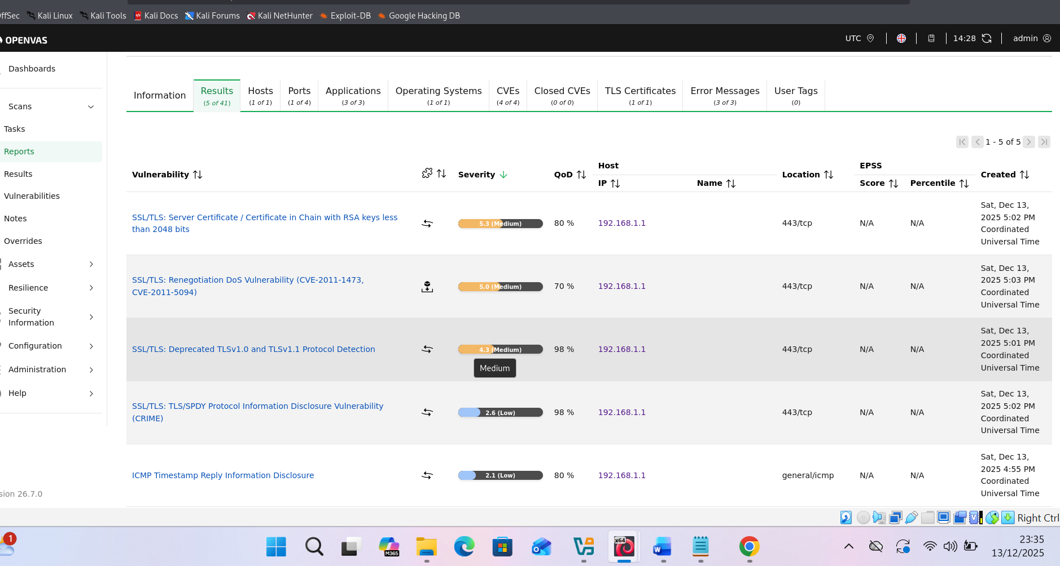

Vulnerability testing with NMP in Kali Linux also displayed protocols. Ports and vulnerabilities. However, there are many vulnerabilities, but warned that a password is not required, meaning that anybody can access the system easily.

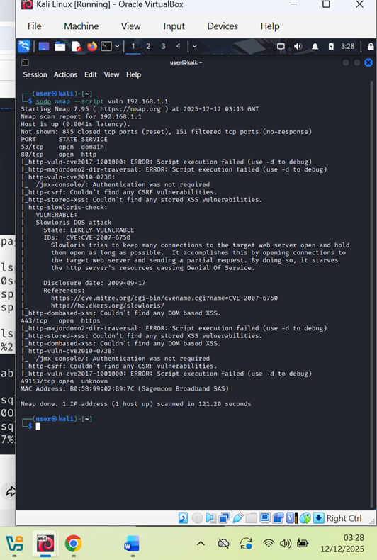

After running vulnerabilities with NMAP, the tool asserts that authentication was not required, which is a weakness in the system.

Vulnerability scanning with Tenable Nessus.
The result is self-explanatory. Highlighting with colours the severity, protocols and highlighting what the problems are.

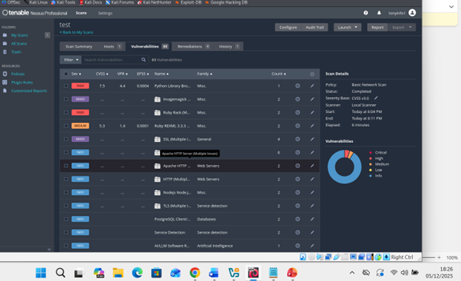

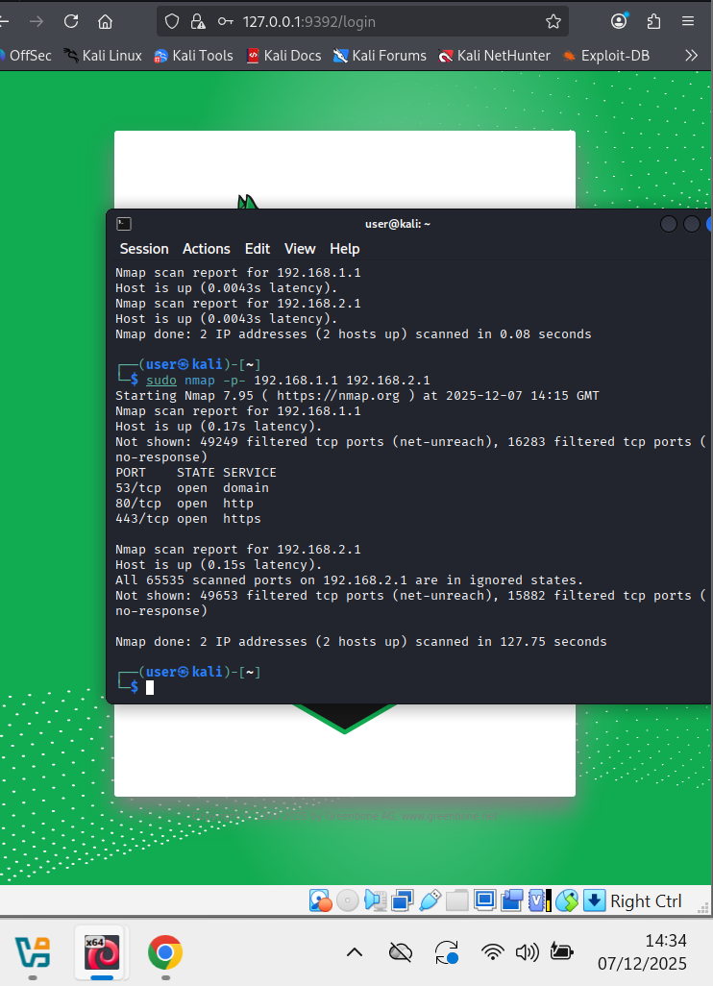
The figures show the result of ports scanned with NMAP with different algorithms.
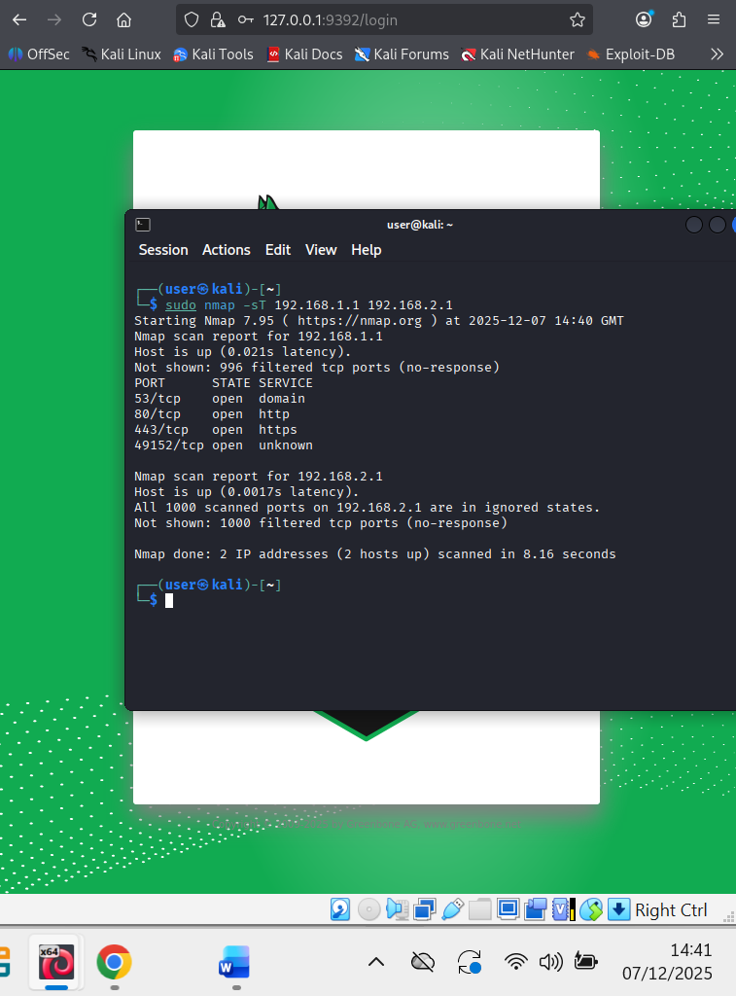

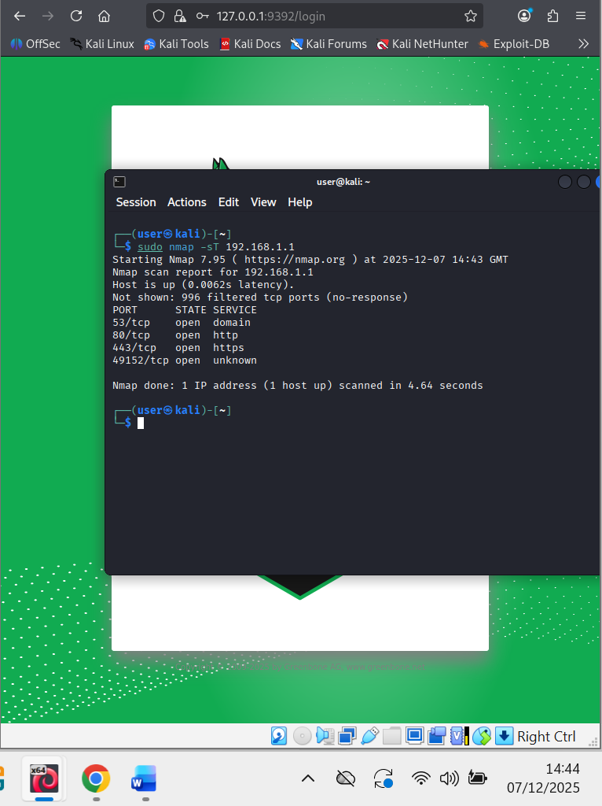

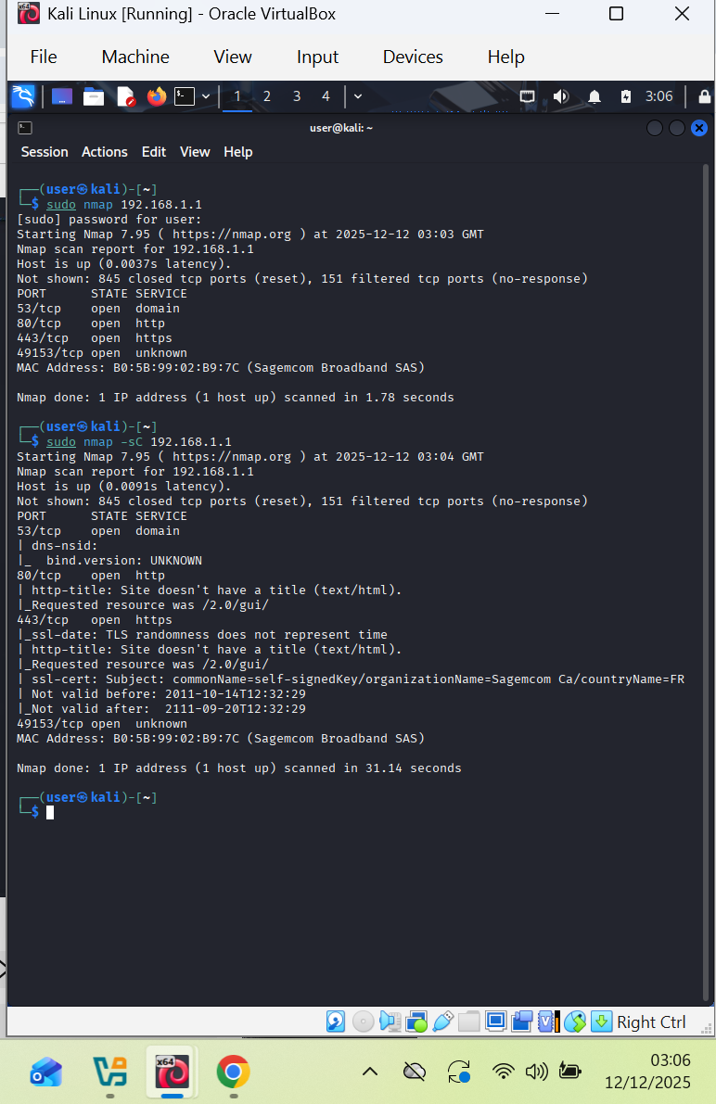

Vulnerabilities 2.3

Vulnerability is a flaw, weakness or defect in the network, software, process or system that attackers can exploit to gain access to disrupt the network or system, steal data, or cause other damage [8].
Vulnerabilities often stem from software flaws, such as bugs, buffer overflows, or SQL injection, that allow unintended actions—using outdated software/hardware without applying up-to-date security patches or plugins. Misconfiguration or wrong setting of a software, network or system can inadvertently pose the risk of exposing sensitive data or exposing the system to hackers [8].
Design flaws bring weaknesses to the systems and open to cyber attackers. They are vulnerabilities that attackers are scanning for. Insecure settings or default settings give room for security exploitation. Users must be trained to minimise human errors, including complex and strong passwords, phishing scams, other security issues, and MFA [8].

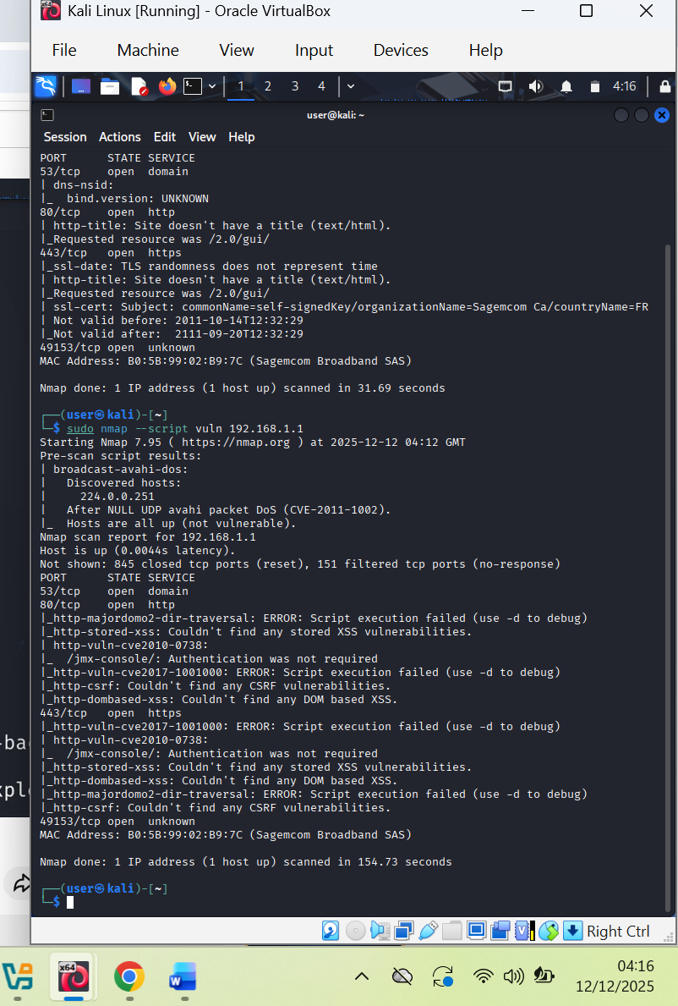 [8]

CVSS
Common Vulnerability Scoring System is a framework that is used in cybersecurity to scan system vulnerabilities or weaknesses and score them according to the severity of the vulnerability of the system. There is a standardised rating or scoring of High, Medium or Low or a numerical rating of between 0 and 10, of which 10 is High and critical [9].
OpenVAS stand for Open Vulnerability Assessment System. It is an open-source framework for scanning and managing vulnerabilities in the cybersecurity system. It can identify vulnerabilities caused by misconfiguration, bugs, weak passwords, outdated hardware or software and generate automated reports and even propose mitigation. The Greenbone Vulnerability Management (GVM) suite. Tenable Nessus is also one of the leading Cybersecurity Vulnerability Software [9].
CVSS with report
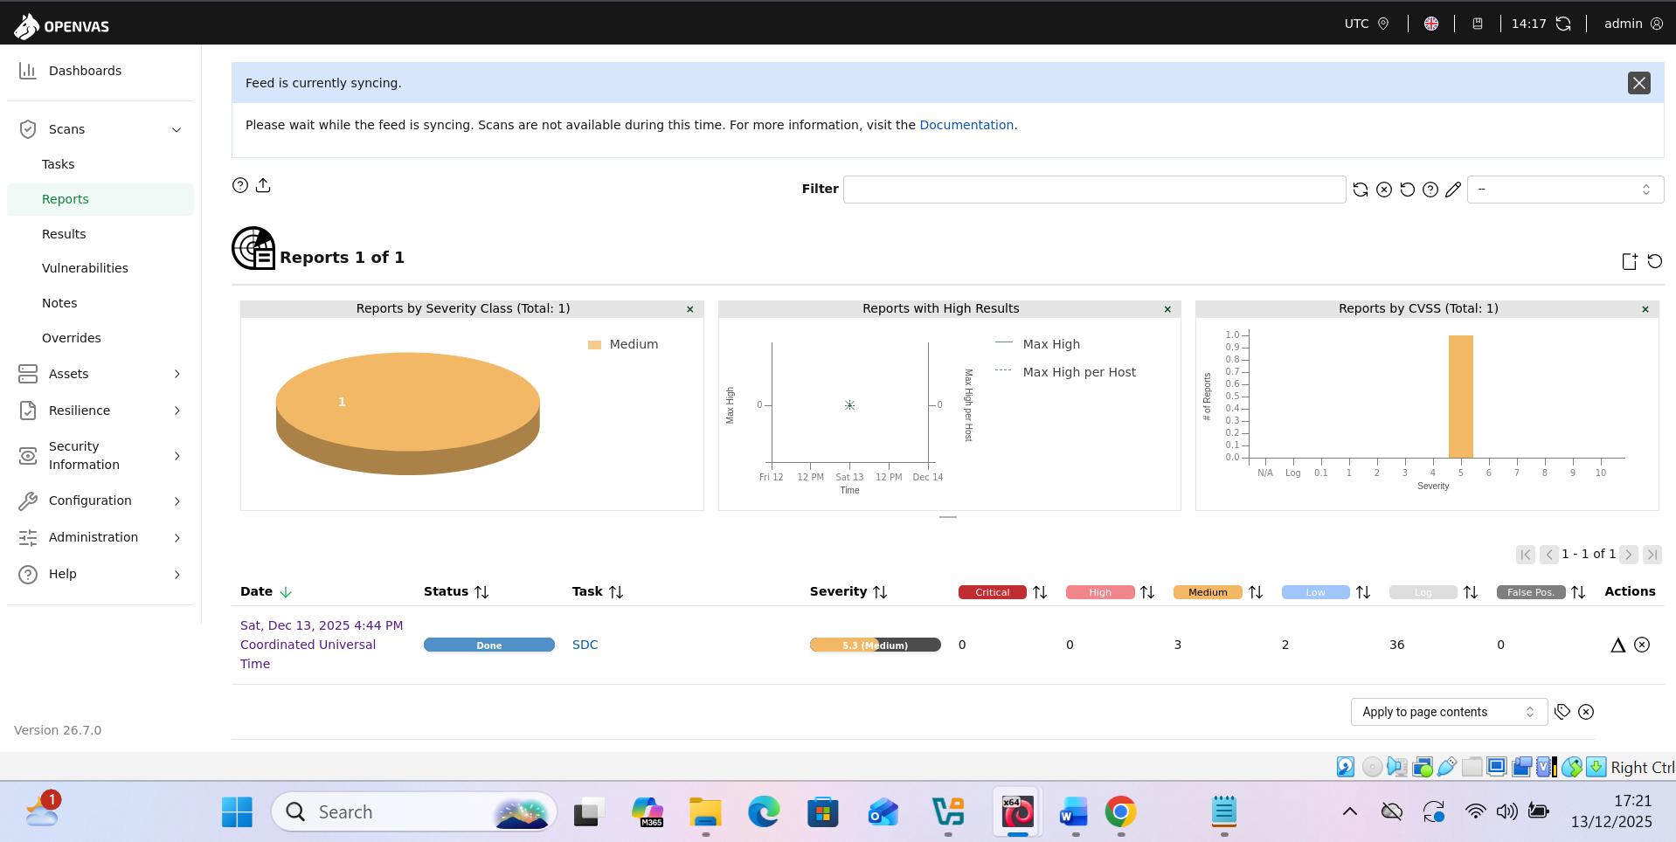

High Vulnerability

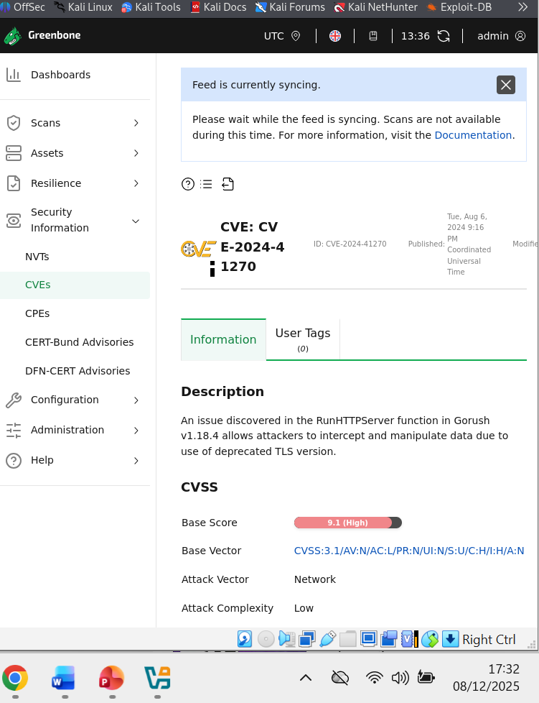

High Vulnerability

High Vulnerability
Application: Transport Layer Security
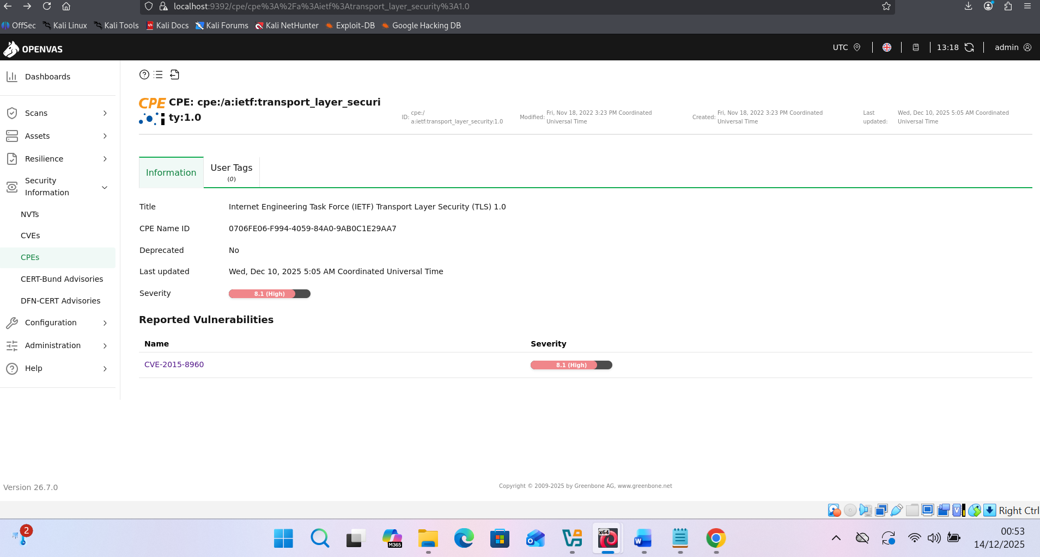
It is prone to a man-in-the-middle attack because it cannot compute the master secret key, client key and the public secret key in certain situations. That’s why the risk is high [9].

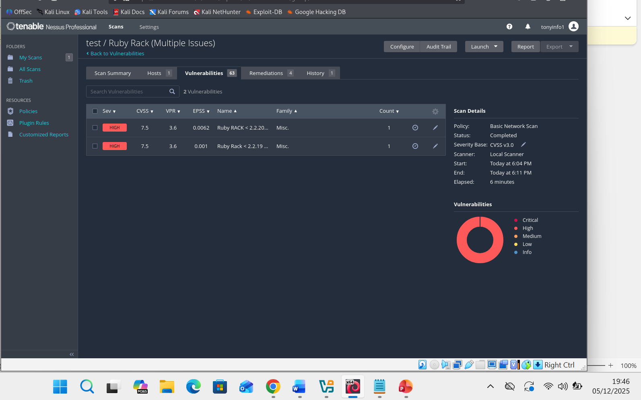
Medium Vulnerability

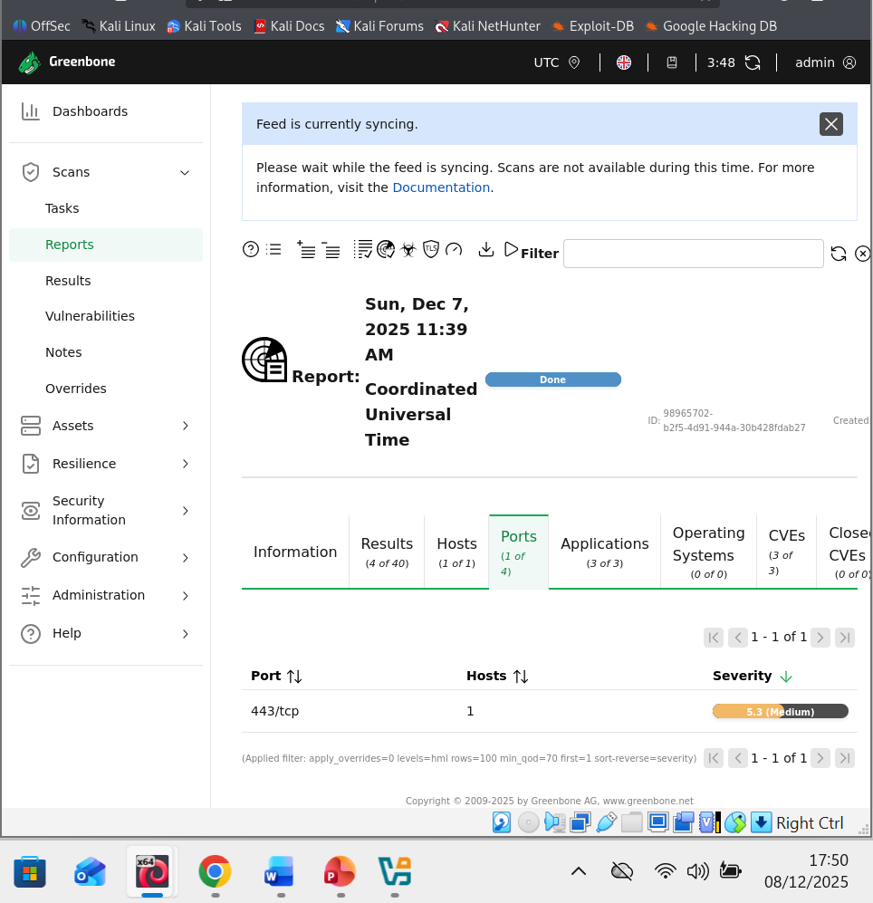

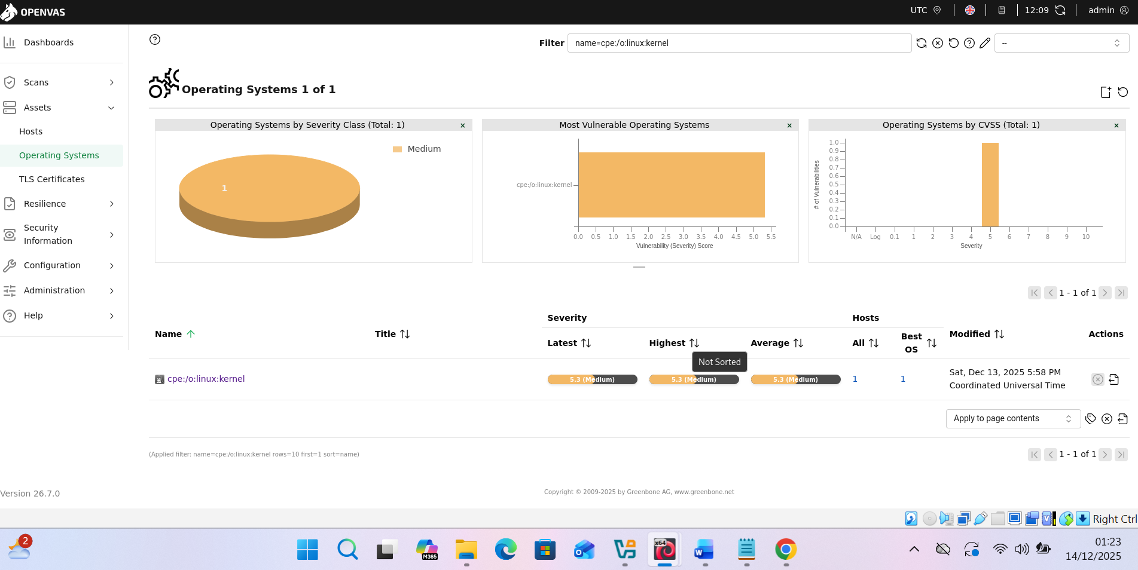

Low Vulnerabilities
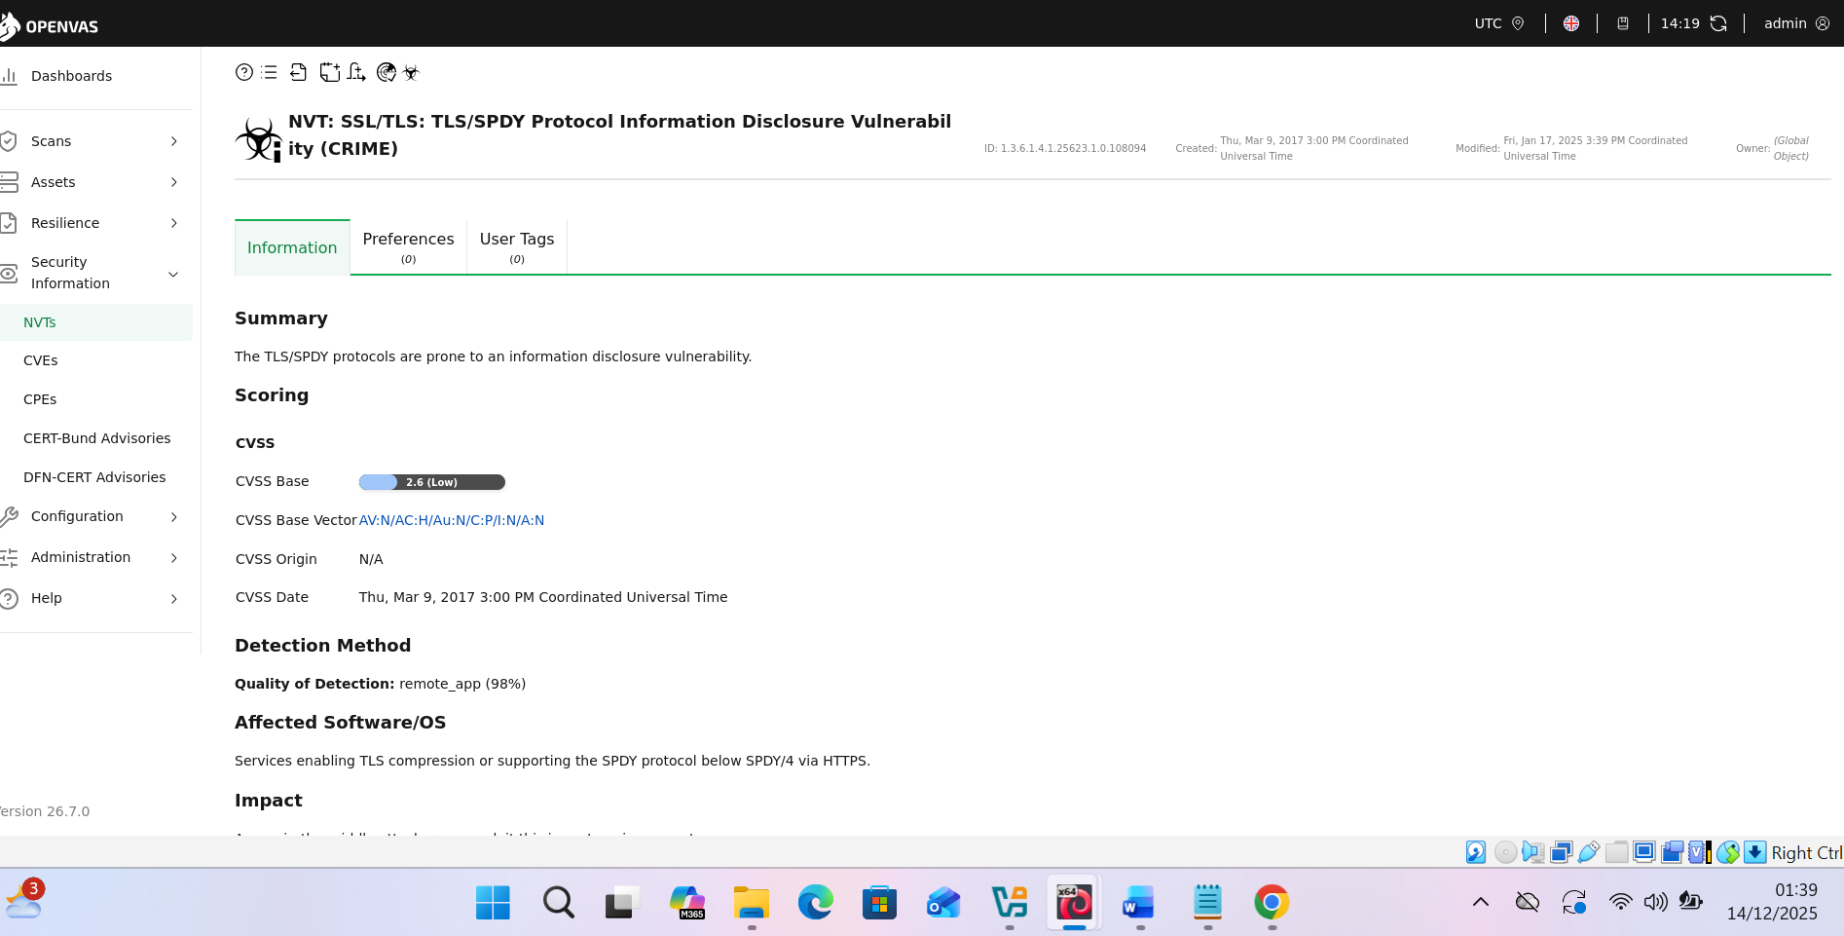
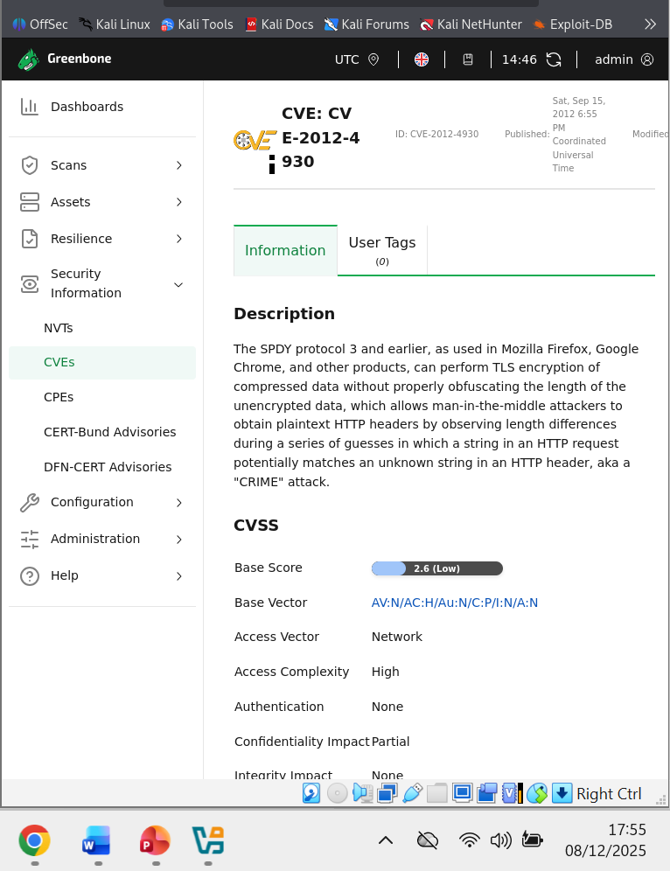

Automated Report
An automated OpenVAS report is a machine-generated, comprehensive report that details the security issues of the infrastructure and lists all identified flaws, their severity and recommends mechanisms to combat them [10]. This report provides a structural overview of the vulnerability assessment. It will provide a summary of any vulnerability, including severity, host details, findings, and remedies. It filters and prioritises results as high, medium and low [10].

Automated Report

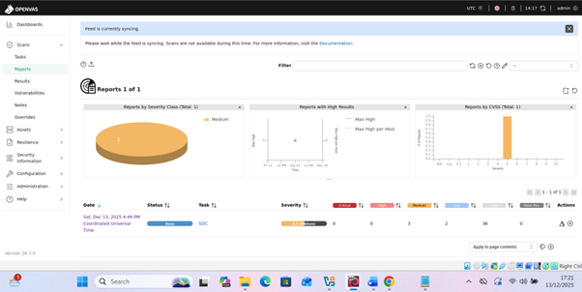

More comprehensive report
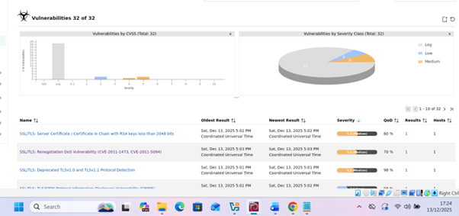
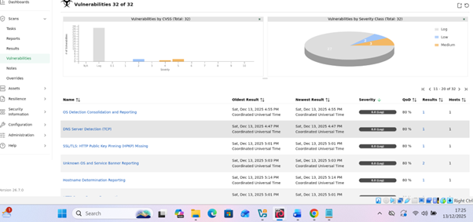
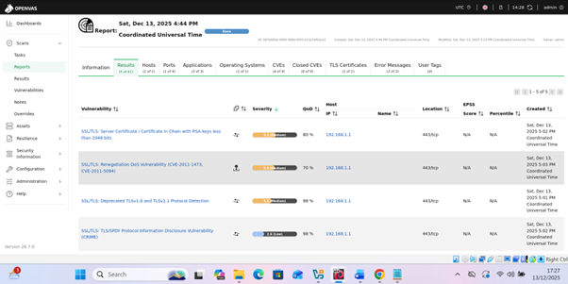

Task 3 Ethical Hacking2

2.1 Exploitation
Unauthorised access in cybersecurity is gaining access or entry to a network, system, or data without authorisation or permission by exploiting vulnerabilities in the system, thereby bypassing security measures. There are vulnerability frameworks such as MITRE ATT, CVSS and CK. These frameworks will access vulnerabilities in the configuration, database, and flaws in software for attackers to exploit [11].
This is also referred to as penetration testing or pen test, where an authorised attack is made on a network, database, or application to find security flaws in the system that attackers could exploit. They test the system's defences before attacking it. It highlights weaknesses in the structures or infrastructure. A pen tester, acting like an ethical hacker, will identify the vulnerabilities and give solutions [11].
In this case, I used NMAP to diagnose and determine open ports and Metasploit to assess S-DC, 192.168.1.1, to bypass all security on the Domain Controller. I even logged into Downloads [11].

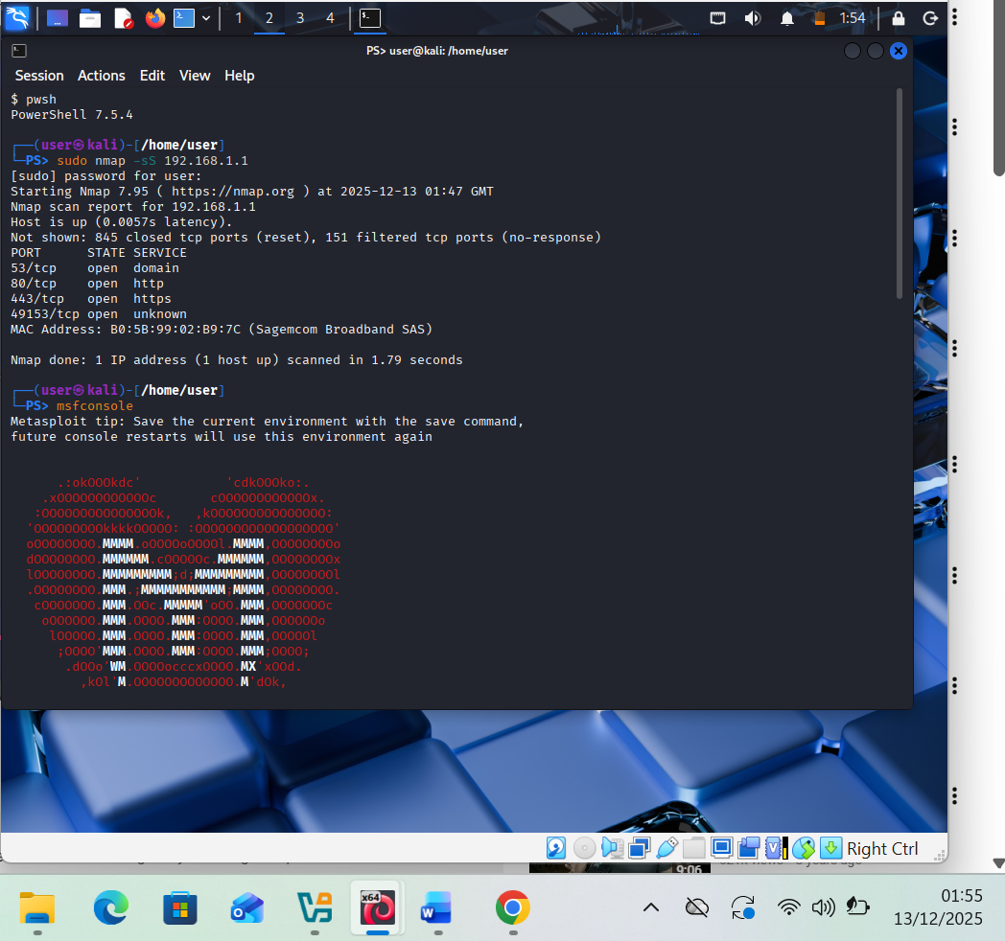

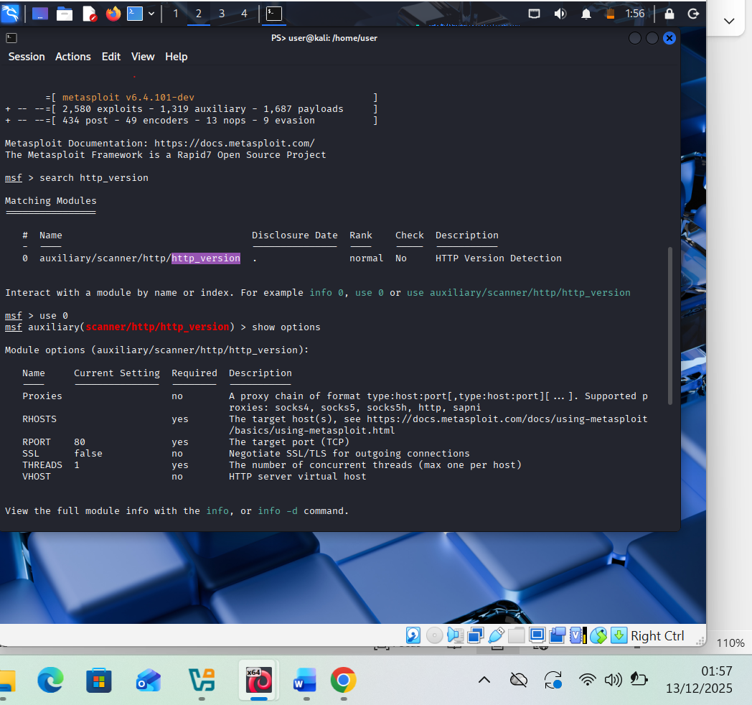

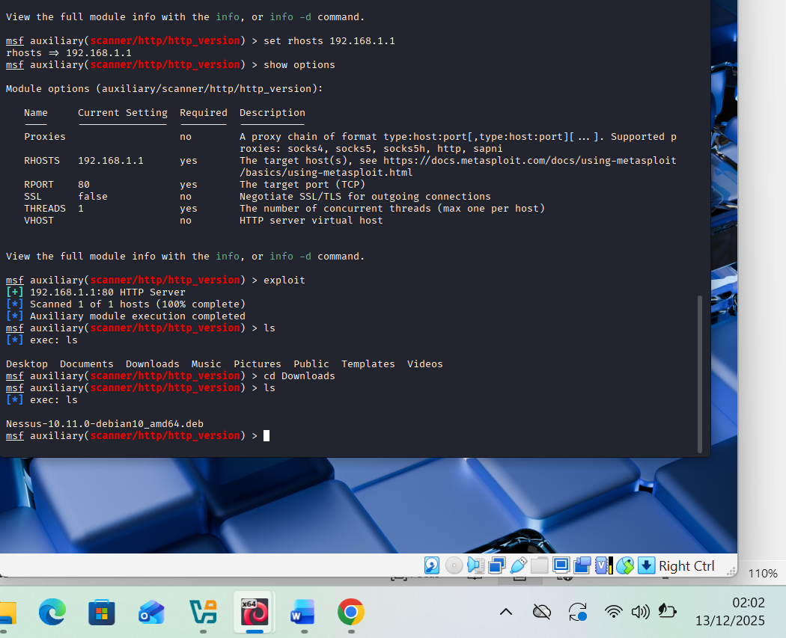

2.2 Post-Exploitation Process
Actually, I had mixed feelings because I was not sure if that was what the lecturer was looking for. However, I followed the algorithm to the end for the result to be achieved. It is a good experience for an ethical hacker; therefore, I need more practice. I was also impressed to learn that people are developing apps for such activities [11].

Task 4: Network Security Measures for SWANSEA.ACCA Network

4.1. Preventive Security Measures

Harden server configurations.
Server hardening is a system or approach to reducing vulnerabilities and minimising attacks on the server. Key strategies are [12]:
Applying regular security patches. Removing and/or disabling unused services and software. Ensure protocols like FTP and Telnet are disabled [12].
Implement host-based firewalls like UFW or Firewalld in Linux to block unauthorised outbound and inbound traffic. Manage system configuration and ensure all default settings are disabled. Misconfigurations are vulnerable to attacks [12].
Ensure security of user account by applying strong passwords plus history, with complexity, 2FA or MFA for remote access, like VPN and SSH. Remove or disable dormant accounts [12].
[12]Monitor and control access to physical servers and endpoints. Continuous monitoring of system activities and logs. Employ defensive mechanisms like IDS, IPS and the hybrid, which I will recommend [12].
Configure firewalls and access control lists (ACLs).
The key point or objective is to define role-based polices of who can and cannot be allowed to use the system. The Access Control List (ACL) and firewall configuration enable network/security managers to create rules that specifies source and destination IPs, (TCP/UDP). Ports and applying them to interfaces [13].
Very critical to identifying essential network resources, users, and creating access levels. HTTPS can be allocated port 80/443, while DNS is allocated port 53. Use the least privilege principle and remove unnecessary access. Deny TCP access to known malicious ports like 23 for Telnet and FTP 21 [13].
Test and validate that the rules are working using ping, traceroute and other applications to ensure that the rules are working. Enable monitoring and logging on the firewall and ACL to ensure that the system is working correctly [13].
Enable encryption for data in transit .
Data transmission of HTTPS (TLS/SSL) is encrypted. It is a critical security protocol that ensures end-to-end encrypted data is transmitted, ensuring integrity, privacy and authentication. The URL start with https:// and showing a padlock indicates that the site is encrypted with a TLS/SSL connection [14].
A Virtual Private Network (VPN) is a secure, encrypted tunnel over the public internet, thereby connecting a device to a remote server. The strategy hides the IP address of the client, thereby preventing him from being identified and allowing him to bypass the geo-restriction. The VPN uses secure file transfer protocols (SFTP), which provide end-to-end encryption. Some apps like WhatsApp and Signal are using it [14].

Set up monitoring with Wireshark to log and analyse
Wireshark is an open-source network analyser that captures protocols, network traffic and saves packet details in a file called PCAPs. It helps users to monitor network performance, identify bottlenecks, troubleshoot network issues, investigate security issues and reveal flaws in the system. It allows users and learners to see what is going on behind the network. It is a favourite tool for ethical hackers [15].
Wireshark runs on all platforms, live and offline and is rich in filter display. Packets can be filtered and displayed according to IP address, DNS, protocols and as required. It aids in detecting malicious software, malicious activities, malicious packet behaviour and unauthorised access [15].

Packet Capture &The Analysis

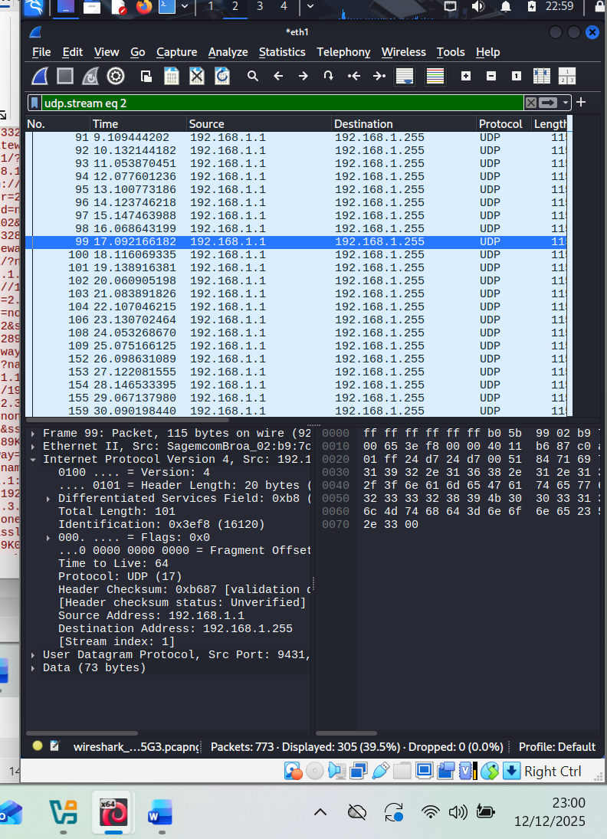

The captured image contains packets captured by Wireshark. The system has a total of 773 packets, and they all have their number, time, source, destination, protocol and other information. Analysing packet 99, on the bottom left is details of what transpired, including the interface, ports, frame, Internet Protocol Version, source and destination IP addresses. On the right are bits displayed in packet bytes – raw hex/ASCII. It can be further analysed with tools [15].
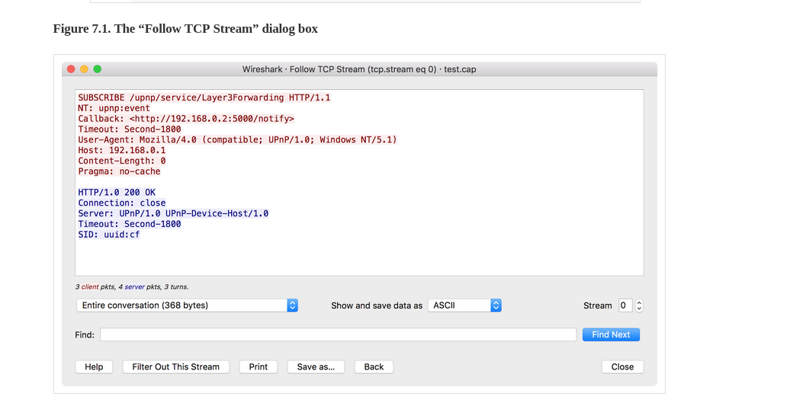
The above data on red are the data sent, and the blue data below it is the response.
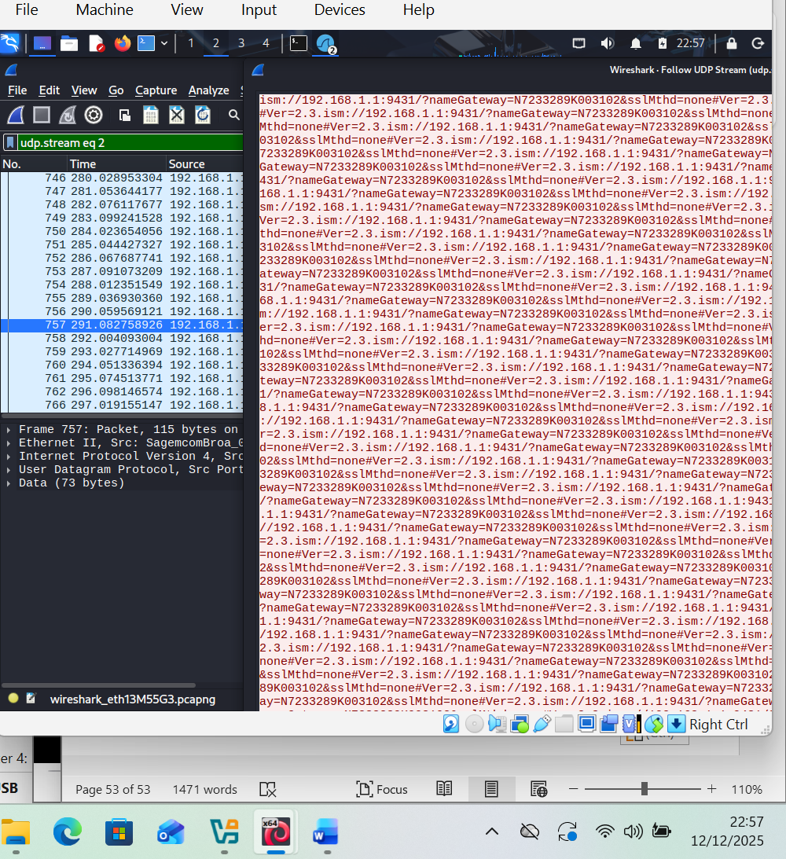
The above data are the fingerprint and can be analysed.

Summary and Conclusion
Digital infrastructures are now part of this modern world; there is a greater need to be aware of the threats posed by cyberattackers. With more reliance on device connectivity all over the world, there is a great need for us to secure our lives and data because we do not know who the attackers are [16].
Effective cybersecurity is being proactive and ahead of the attackers by being ahead of them and taking all precautions in security measures, which includes logging events, continuous systems updates and employee awareness training. Employing detection and prevention systems. It was a great opportunity for me not only to consolidate my networking skills but also to learned important skills for ethical hacking [16].

References

[1] | D. Dunn, “Cybersecurity and privacy,” F.T.I. Consulting, 2025. [Online]. Available: https://www.fticonsulting.com/services/cybersecurity. [Accessed 10 25 2025].
[2] | N. Sonkar, “ESTABLISHING A CYBERSECURITY & PRIVACY PRACTICE IN MID-SIZED CONSULTING: A BLUEPRINT FOR SCALABLE RISK ADVISORY SERVICES,” Cisco Systems, p. 508, 2025.
[3] | S. K. Vishwakarma, Network Issues & High-Level Communications Tools in Distributed Computing, Ghaziabad, India: Wiley Press, 2025.
[4] | M. D. Timothy Renooy, IP Address Management, New Jersey: John Wiley & Sons, 2021.
[5] | R. Rojas-Cessa, “Experiments on Computer Network: Quickly Knowinf the Protocols in TCP/IP Suite,” Computer Science: Networking and Internet Architecture , vol. 1, 2023.
[6] | “Defining Hping Packet Generator as a Security Tool,” Okta, 30 August 2024. [Online]. Available: https://www.okta.com/identity-101/hping/. [Accessed 12 11 2025].
[7] | B. Y. H. Y. L. X. H. J. a. Y. Z. Y. Wang, “Automotive Cybersecurity Vulnerability Assessment Using the Common Vulnerability Scoring System and Bayesian Network Model,” IEEE System Journal, vol. 17, no. 1, pp. 2880-2891, 2023.
[8] | I. Babeshko and F. D. Giandomenico, “Safety and Cybersecurity Assessment Techniques for Critical Industries: A Mapping Study,” IEEE Access, vol. 11, no. 10, pp. 83781-83793, 2023.
[9] | M. N. M. W. J. O. a. S. S. A. Balsam, “Comprehensive comparison between versions CVSS v2.0, CVSS v3.x and CVSS v4.0 as vulnerability severity measures,” in 24th International Conference on Transparent Optical Networks (ICTON),, Bari, Italy, 2024.
[10] | D. A. K. a. R. C. P. I. Chalvatzis, “Evaluation of Security Vulnerability Scanners for Small and Medium Enterprises Business Networks Resilience towards Risk Assessment,” in 2019 IEEE International Conference on Artificial Intelligence and Computer Applications (ICAICA),, Dalian, China, 2019 .
[11] | K. Vimala and S. Fugkeaw, “VAPE-BRIDGE: Bridging OpenVAS Results for Automating Metasploit Framework,,” in 14th International Conference on Knowledge and Smart Technology (KST, Chon buri, Thailand, 2022.
[12] | K. N. S. M. R. N. E. A. H. Bambang Irawan, “Evaluating the Effectiveness of Center of Internet Security Benchmark for Hardening Linux Servers Against Cyber Attacks,” vol. 4, no. 6, 2025,.
[13] | R. VandenBrink, Linux for Networking Professionals: Securely configure and operate Linux network services for the enterprise, Packt Publishing, 2021.
[14] | Y. P. R. A. N. H. R. G. M. V. R. S. a. K. A. U. Reddy, “Enabling Rapid Data Transfer in Medical IoT Systems with a High-Throughput PRESENT Cipher Hardware Framework,” in 1st International Conference on Sustainable Computing and Integrated Communication in Changing Landscape of AI (ICSCAI), , Greater Noida, India,, 2024.
[15] | ". T. i. N. T. A. S. Chowhan and A. K. Saxena, “Utilizing Wireshark For In-Depth Live Data Packet Inspection And Information Capture,,” in International Conference on Communication, Security and Artificial Intelligence (ICCSAI),, Greater Noida, India, 2023.
[16] | X. Gao and X. Chang, “A Retrieval-Augmented Generation Framework Based on a Knowledge Graph of Cybersecurity Vulnerabilities in Power Networks,,” in IEEE Access, 2025.

