University of Wales Trinity Saint David
Wales Institute of Science & Art



Engineering Skills Technical Report
Engineering Skills (ACHA4022A)

Aidan O’Brien
2500916
December 2025
Contents
1. Introduction 3
2. Health & Safety with Risk Assessments 4
2.1 – Brief 4
2.2- Health and safety acts related to an activity 4
2.2.1 – Engineering Activity 4
2.2.2 – Correct Health and safety legislation that relates to the activity 4
2.3 – Risk Assessment 4
3. Security Risk Matrix 6
3.1 – Brief 6
3.2 – Security threats to the automotive industry. 6
3.3 – Security Risk Matrix 7
3.4 – Response to highest risk 7
4. Engineering roles in society 8
4.1 – Brief 8
4.2 – Engineering companies that publish a code of conduct and relation to sustainability 8
5. Problem solving 9
5.1 - Brief 9
5.2 – Problem solving method 9
5.3 – Flow chart 9
6. Team structure 11
6.1 – Brief 11
6.2 – Activity 11
6.3 – Team Structure 11
6.4 – How to improve structure 12
7. Conclusion 13
Reference List 14

1. Introduction
This technical report is aimed at investigating the different areas of engineering skills that are used in Motorsport, Automotive and Motorcycle engineering applications. The report gives an overview of the key factors related with engineering, starting with Health and safety, researching legislation, identifying risks within a workspace and creating a risk assessment for an activity. This is then followed by Security Risk Matrix. The report will look into identifying threats within the automotive industry and backed by a simple security risk matrix. The report then delves into Engineer’s Role in Society, this is researched and discussed to evaluate the role of engineers and their impact on society in the form of sustainability and environmental impact in Motorsport. Following up, Problem solving is discussed to identify the problems faced in the industry and using a flow diagram, how these problems can be combated. Finally, the report looks into Team structure. By conducting a review into a situation involving 3 or more team members, structure is researched and discussed to show how a team can be structed and the optimal structure for an application.

2. Health & Safety with Risk Assessments

2.1 – Brief
In this segment, an activity that has been undertaken in the university workshop is considered. This section covers the correct Health & Safety acts and legislation for the activity. This is then backed up by a risk assessment for the activity.

2.2- Health and safety acts related to an activity

2.2.1 – Engineering Activity
The activity being investigated is the use of the Lathe to create a workpiece. A worker operates a machine lathe to produce a component. Using the lathe comes with a lot of risks, including mis operation of the machine, catching hair or limbs in chuck and ejection of swarf. For these reasons, the correct legislations have been selected.

2.2.2 – Correct Health and safety legislation that relates to the activity
Personal Protective Equipment - PPE At Work (1992) – The PPE Act (1992) focuses on ensuring appropriate clothing provided, maintained and stored for workers. Training and instruction of how to appropriately use PPE also needs to take place. In terms of the activity, PPE is required to protect the worker from swarf ejection (Overcoat & Goggles) and dropping tools (Boots).
Health And Safety At Work Act - HASAWA (1974) – HASAWA is designed to protect workers from hazards within the workplace. This is enforced primarily through correct training on how to use equipment, activity and workspace risk assessments and managing and reporting incidents. Through training and risk assessments, incidents can be prevented or made far less severe while reporting incidents that occur can help prevent future accidents.
Provision and Use of Work Equipment Regulations - PUWER (1998) - The PUWER act is key in H&S law as it is designed to keep machines and tools in the workshop in a safe state to use to ensure the safety of workers. This is done by following machine maintenance guidelines and implementing safety features to machines such as guards and emergency stops and how to use them.

2.3 – Risk Assessment
Shown Below is a risk assessment taken for operating the lathe in the workshop.

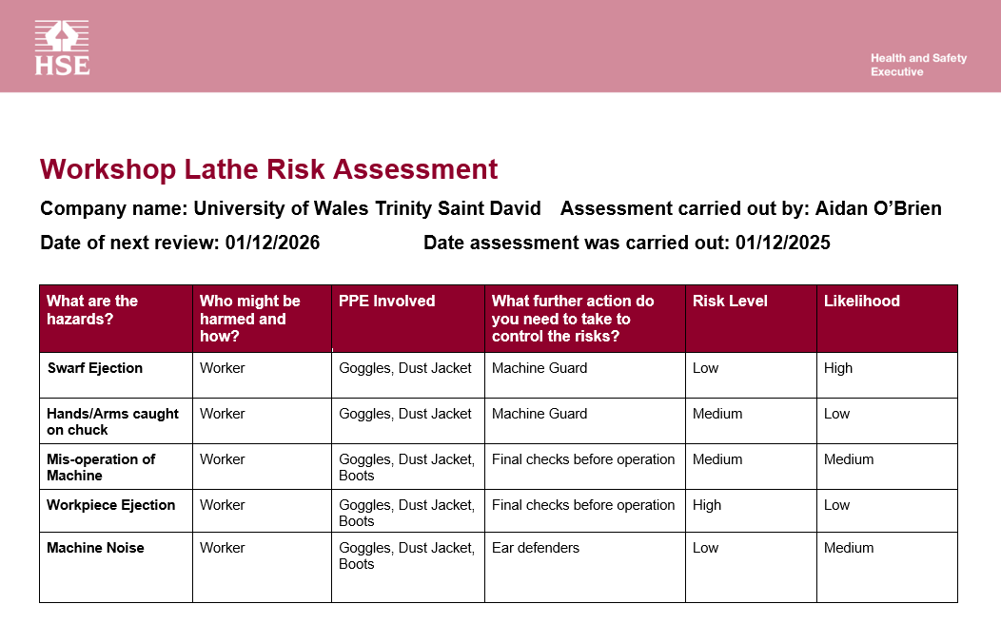
Figure 2.3 – Risk assessment

3. Security Risk Matrix

3.1 – Brief
In this segment, 4 security risks to the automotive industry are considered. This section 4 different ways an automotive system or supply chain can be affected by hacking, and then backed up by a security risk matrix and how the factor with the highest combined risk and likelihood can be combated.

3.2 – Security threats to the automotive industry.
There are many security threats to the automotive industry, the four I have selected are:
Attacking the supply chain – Supply chains are attacked by hackers targeting IT systems. By targeting these systems, hackers can steal manufacture information and halt the production of parts and vehicles by targeting key systems. This has started occurring more often in recent years and can cause high risk to systems and products.
Key Fob hacking – Key fob hacking is a manual form of hacking where a keyless cars fob code can be manipulated and allow access to a car. This form of hacking is very technical so does not occur often, but can be very serious when the car is manipulated and stolen.
ECU Hacking – ECU hacking involves exploiting the ECU to manipulate its functions and control over certain parts of the vehicle. The ECU can be physically or electronically hacked through manual access or wireless connection. Gaining access to the ECU cab be catastrophic as features such as brakes can be disabled via ECU.
Autonomous car hacking – Autonomous car hacking is another form of hacking that targets manipulation elements of an autonomous car such as communication network and sensors by gaining access via networks and personal information linked to the car. If access to the car is gained, the car can be manipulated to crash or have features fail, posing a high risk.

3.3 – Security Risk Matrix
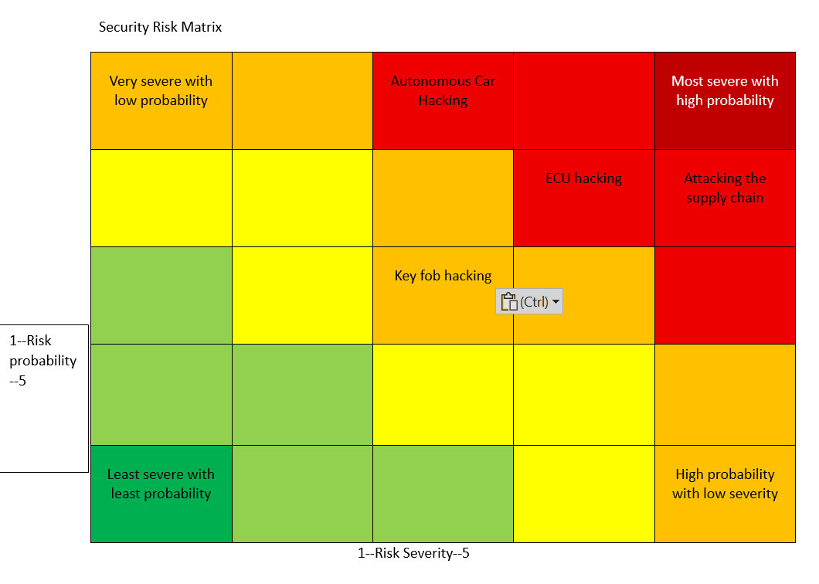
Figure 3.3 – Security Risk Matrix
Shown above is a security risk matrix displaying the four risk factors and how they weigh up on a risk matrix. The further right on the matrix means the factor has a high probability, the further up on the matrix, the higher the severity of the factor is. All 4 factors display a high level of risk, with attacking supply chain being the highest combined.

3.4 – Response to highest risk
A way to respond to and reduce the risk of supply chain attacks is to implement security features such as multifactor authentication for threat detection, Staff training to have better awareness when sharing data and better communication between different parts of the supply chain as well as cybersecurity protocols to protect the sensitive data. This helps protect against common attacks like phishing and ransomware attacks.

4. Engineering roles in society

4.1 – Brief
In this segment, Engineering code of conducts are considered. This section covers 2 different code of conducts for engineering companies and how it relates to an engineer’s responsibility towards sustainability.

4.2 – Engineering companies that publish a code of conduct and relation to sustainability
Engineering Council – The engineering council’s code of conduct focuses on the responsibilities and ethical principles to be followed by engineers. The code of conduct sets out guidelines for engineers to follow such as emphasising alertness and respecting confidentiality as well as avoiding conflicting interests. In terms of sustainability, the engineering council’s code of conduct focuses on requiring engineers to consider and improve the impact that their work has on the environment by protecting the area being worked in and maximizing the use of resources provided. In terms of Motorsport, this can be linked to factors such as fuel efficiency during races and using newer sustainable manufacturing methods for production.
Formula 1 – The formula 1 Engineers code of conduct focuses on a wide range of factors to help create the spectacle of the sport. The engineers are bound by similar ethics to all similar code of conducts, emphasising factors such as safety within the sport, integrity and the major new factor of increasing sustainability. Formula 1 has set out the guidelines of being net zero by 2030, the main factors that contribute to this are the use of new sustainable fuels in the new 2026 regulations that also include revised power units for more hybrid technologies and a revised calendar that reduces the amount of distance travel over a season from race to race. These are followed by all engineers to comply with the code of conduct and the regulations. This shows the Formula 1’s code of conduct is aimed at increasing sustainability throughout the sport.

5. Problem solving

5.1 - Brief
In this segment, a problem solving method for an engineering problem is considered. This section covers a problem solving method, how it helps solve a problem and then further improve the product.

5.2 – Problem solving method
The problem solving method in question is Failure Mode and Effective Analysis (FMEA). FEMA is a step by step approach aimed at recognising and evaluating the potential for failure in multiple processes in engineering such as the design, manufacture and the final product and spotting defects in the product before manufacture and preventing the defect.
There are three main aspects to problem scoring when using FMEA:
Failure Mode, Impact Analysis and Point scoring
Failure Mode is used to identify a problem that concerns the products, Impact Analysis is assessing the severity that the defect can cause and how it affects the product. Point scoring is then scoring the defect and its effect against certain measures.

5.3 – Flow chart
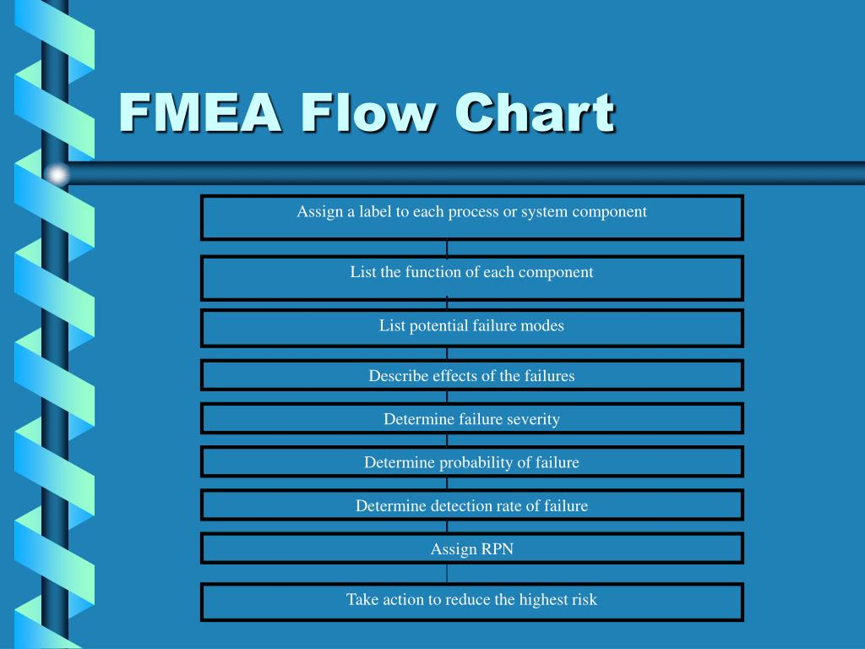
Figure 5.3 – FMEA Flow diagram
Shown above is a flow chart of how the FMEA system is used to solve an engineering problem. It starts by labelling and assessing component functions. Once assessed, potential failures are identified, listed and described on how they can affect the product and how severe this failure can be. The failure is then further assessed on the probability and detection rate. A risk priority number (RPN) is then given before taking action on how to remove or eliminate the risk of the failure.

6. Team structure

6.1 – Brief
In this segment, I am discussing team structure in an activity. This section covers the activity and how structure is used to optimise it. Followed by how team structure can be improved to optimise the activity

6.2 – Activity
The activity I am discussing is when I work at my local go-karting track. In a group of 3/4 Track marshals, we choose an area of the track to cover for a 10 minute session. Sessions are started by two marshals starting the karts while another marshal takes place at the sequence of corners after the pit to cover for early incidents, once the last kart leaves the pits, the timer for the session starts.

6.3 – Team Structure
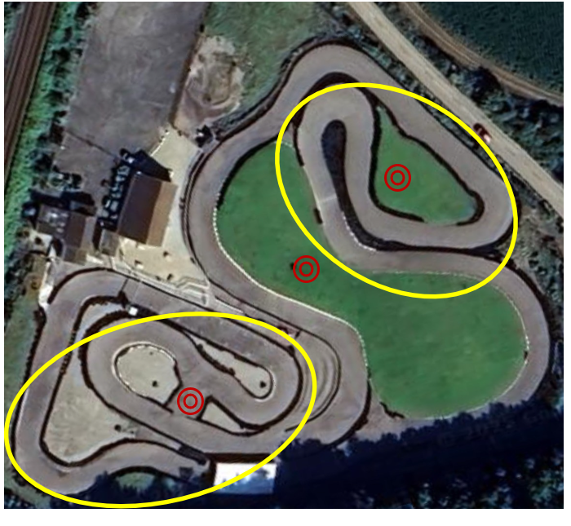
Figure 6.3 – Track map with action areas and marshal placement
Shown in yellow – Main action / crash corners.
Shown in red – Placement of marshals
As shown above, there are highlighted areas of the track where a higher rate of on track action, overtakes and most importantly, crashes happen. This means that marshal placement is key to ensure that areas with high action are covered and incidents can be cleared quickly. The marshals are placed evenly across the track so that if an incident occurs, a marshal is there to attend to the incident, and a second marshal is there to cover with yellow flags. In terms of team structure, a head marshal is always present either on track or in clubhouse to help orchestrate the on track operation. This forms a simple hierarchy structure within the team which helps to maintain efficiency. The positive of this is a simple leadership structure within the team, the negative of the structure can be lower quality of communication between the lower segments if the hierarchy resulting in slower decision making.

6.4 – How to improve structure
An improvement to the team structure would be implementing cross functional team structure as it allows the team to be structured around specific functions such as on track incidents and off track efficiency. This works by combining indoor staff and track marshals to work together in different roles to maintain efficiency. For example, if an incident is noticed by indoor staff, using radio other marshals and I can be alerted to the incident and clear it up quicker. Another example is marshal helping indoor staff with debrief and kitting up new sessions to get the sessions out quicker.
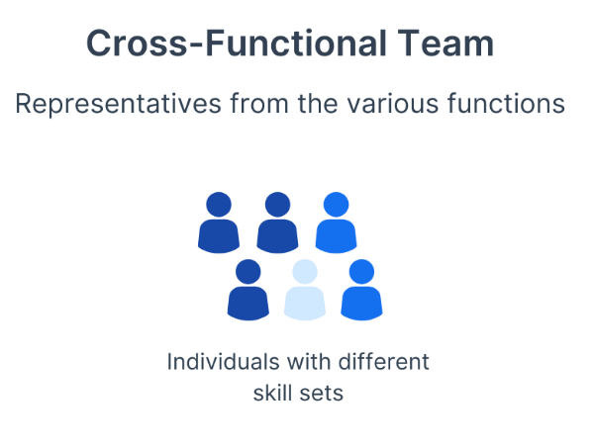
Figure 6.4 – Cross functional team structure

7. Conclusion
In conclusion, this report covers different areas of engineering skills that are used in Motorsport, Automotive and Motorcycle engineering applications. Health and Safety is investigated and backed up by a risk assessment for a certain activity. Security threats are evaluated and represented on a risk matrix. Engineers roles in society are researched through codes of conduct and how they relate to sustainability. Problem solving methods are researched to how problems can be identified and solved while team structure for an activity are assessed and discussed on how it can be improved.

Reference List
DO THE RIGHT THING CODE OF CONDUCT. (n.d.). Available at: https://media.formula1.com/image/upload/v1701969109/content/dam/fom-website/manual/Misc/f1_code_of_conduct/F1_Code_of_Conduct_7_December_2023.pdf.
ecu (2023). Can a car ECU be hacked? – Engine Control Units (ECU) Guide. [online] Atpelectronics.co.uk. Available at: https://atpelectronics.co.uk/can-a-car-ecu-be-hacked/ [Accessed 7 Dec. 2025].
Engc.org.uk. (2017). Guidance on ethical practices. [online] Available at: https://www.engc.org.uk/resources-and-guidance/guidance-for-the-profession/ethical-principles.
Health and Safety Executive (2019). Risk assessment: Template and examples - HSE. [online] Health and Safety Executive. Available at: https://www.hse.gov.uk/simple-health-safety/risk/risk-assessment-template-and-examples.htm.
Health and Safety Executive (2022). Personal Protective Equipment (PPE) at Work Regulations from 6 April 2022. [online] www.hse.gov.uk. Available at: https://www.hse.gov.uk/ppe/ppe-regulations-2022.htm.
Health and Safety Executive (2024). Provision and Use of Work Equipment Regulations 1998 (PUWER) - overview - HSE. [online] Hse.gov.uk. Available at: https://www.hse.gov.uk/work-equipment-machinery/puwer-overview.htm.
Health and safety Executive (2024). Health and safety at work act 1974. [online] Hse.gov.uk. Available at: https://www.hse.gov.uk/legislation/hswa.htm.
HSE (2023). HSE: Information about health and safety at work. [online] Hse.gov.uk. Available at: https://www.hse.gov.uk/.
SOCRadar® Cyber Intelligence Inc. (2025). Major Cyber Attacks Targeting the Automotive Industry 2025. [online] Available at: https://socradar.io/blog/major-cyber-attacks-targeting-automotive-industry-2025/ [Accessed 7 Dec. 2025].
Tortai (2025). Exploring Defect Rate Control Measures for PCB Assembly ManufacturersThe Role of FMEA (Failure Mode and Effects Analysis) in Quality Management for PCB Assembly Manufacturers. [online] Tortai Technologies Co., Ltd. Available at: https://www.tortai-tech.com/the-role-of-fmea-failure-mode-and-effects-analysis-in-quality-management-for-pcb-assembly-manufacturers/?msclkid=9b57684a2a1511c928e0017e7d37990c&utm_source=bing&utm_medium=cpc&utm_campaign=PCB%20Assembly&utm_term=tortai-tech&utm_content=All%20Webpages%20DSA [Accessed 7 Dec. 2025].
Vakulov, A. (2025). Cybersecurity Threats To Modern Cars: How Hackers Are Taking Control. Forbes. [online] 25 Jan. Available at: https://www.forbes.com/sites/alexvakulov/2025/01/25/cybersecurity-threats-to-modern-cars-how-hackers-are-taking-control/.
Walsh, A. (2025). Engineering Organization Structure: Best Models, Metrics & How to Scale. [online] Axify.io. Available at: https://axify.io/blog/engineering-organization-structure.

