ECPT6005: Managing Behaviour and Supporting Learner Engagement

Part 1 – Essay

The current academic thinking and guidance on behaviour management and effective learner engagement necessarily focuses on compulsory education (Lebor, 2017). The right to education is enshrined in the Human Rights Act 1998. Primary education is compulsory under Article 28 of the UN Convention on the Rights of the Child (1990), which also requires that secondary education be available and accessible, and that measures be enacted to encourage regular attendance. UK law states that children must attend school between the ages of 5 and 16 (Dewis Cymru, 2018), and parents can be punished for failing to ensure that their child receives full-time education (Education Act 1996, cited in Welsh Government, 2013). Therefore, the majority of current research on behaviour management and learner engagement is focused on compulsory education, not only because such students provide a captive and easily accessible group for academic research, but also because of the legal obligation to keep younger learners in full-time education. The Welsh Government (2019, p. 6) goes so far as to advise that behaviour and attendance policies should be seen as ‘an integral part’ of a school’s curriculum.
The challenges in post-compulsory education are somewhat different, but there can be similar problems with learner engagement. While there is an assumption that post-compulsory learners have actively chosen to undertake further study, this is not necessarily the case. Wallace (2013, pp. 5–6) highlighted the illusion of ‘choice’ and observed that students in post-compulsory education might be demotivated by a lack of choice or minimal range of choices. This is particularly apparent in England where 16–18 year-olds must be in full- or part-time education (UK Government, n.d.). Even if learners are there by choice, there may be external factors which impact upon behaviour and engagement. Adult learners might be ‘achievement oriented, highly motivated, and relatively independent’ (Wyatt, 2011) but, as Cowley (2010) observed, their motivation can also be detrimentally affected by their previous dissatisfaction with compulsory education. Haywood et al. (2009) also noted that disengagement is a cumulative process which can begin in primary school and become more entrenched in secondary school. Adult learners may re-enter education because ‘earlier attempts at gaining useful qualifications have ended in failure and defeat’, and thus stepping back into the classroom is a daunting prospect (Wallace, 2013, p. 69). Such learners may well require additional support. Monk (2021, p. 94) found that external factors, such as family responsibilities or financial issues, had less impact on student satisfaction and retention than internal factors such as academic support. This corroborates earlier studies which found that if teachers were perceived to be approachable, supportive and well-prepared then students would be more committed to work harder and ‘get more out of the session’ (Mearns, Meyer and Bharadwaj, 2007 and Bryson and Hand, 2007, both cited in Zepke and Leach, 2010, p. 7). The importance of support services was also noted by Haywood et al. (2009) and Caleb (2020), and might be particularly important for students with additional learning needs (ALN). The Tertiary Education and Research (Wales) Act 2022 aims to promote opportunities for tertiary education with a particular emphasis on encouraging participation from individuals with ALN. These learners might require additional individualised support (Learning and Skills Development Agency, 2007).
Low-level disruption or poor behaviour can be indicative of poor engagement, and therefore some experts recommend creating a positive atmosphere which prevents problems from occurring (Jones, 2007 and Petty, 2014, both cited in Lebor, 2017). In any learning environment, behaviour issues disrupt the flow of the lesson and conflict with the learning objectives and process of learning. As Parsonson (2012) noted, targeting interventions on individual learners does not necessarily resolve the problem, and Welsh Government (2015) research highlighted that constant disruptions have a detrimental effect on engaged learners too. Some studies have indicated that ‘whole school’ behaviour programmes might be beneficial although more robust research is needed (Haywood, et al., 2011). What is clear is that consistency is a key contributing factor in managing behaviour effectively (Learning and Skills Development Agency, 2007; Parsonson, 2012; Welsh Government, 2012; Ofsted, 2014; Welsh Government, 2015; Estyn, 2018; Learning by Questions, 2022), and this is just as true in post-compulsory education. Wlodkowski (2008, p. 164) notes that adults will ‘more actively accept [behavioural] norms they have helped establish’, as ownership gives a sense of personal choice, and Wallace (2013) also advises that it can be more productive to discuss and negotiate, rather than simply imposing, rules. This might be particularly pertinent for disengaged or ALN students (Leadbeater, 2005, cited in Learning and Skills Development Agency, 2007). This approach would not necessarily be appropriate in a compulsory education environment, where there may be a school-wide behaviour policy, but Wallace (2013) stresses that adult learners should feel a sense of ownership over their learning, and emphasises the importance of ‘adult-to-adult’ communication as identified in Berne’s theory of Transactional Analysis (Berne, 1964, cited in Napper and Newton, 2018). Nevertheless, if a collaborative approach is used to set expectations, learners must know and see that their views are listened to and acted upon otherwise any consultation will lack integrity (Lyle, Hendley and Newcomb, 2010).
Gibbs (1998) suggested that behaviour and engagement can be improved by transforming the classroom environment rather than ‘fixing kids’. Learners who do not feel included within a group act out to gain attention (Gibbs, 1998, p. 4), or it might indicate an underlying problem such as feeling overwhelmed (Learning and Skills Development Agency, 2007, p. 13). Gibbs’ ‘Tribes’ approach encourages ‘kindness, respect for diversity and social support’ by organising classes into small, inclusive groups. The positive impact of smaller class sizes on behaviour and engagement was noted by Finn, Pannozzo and Achilles (2003), but the connection is more apparent in younger learners (ibid.; Bourke, 1986, cited in Blatchford, Bassett and Brown, 2011). Studies in compulsory education settings found that small class sizes generally seemed to improve behaviour and engagement due to learners’ increased visibility and sense of belonging (Finn, Pannozzo and Achilles, 2003). However, statistical analysis suggests that the ‘Tribes’ approach has little impact on rule-breaking or other problem behaviours, and could actually exacerbate such problems in primary education (Hanson et al., 2012, p. 86–87). Lebor (2017) also raised concerns that it could lead to ‘rivalry, competition and hatred’, as well as creating resource issues due to the number of teaching staff required. Nevertheless, the underlying concept of co-operation among students has also been recognised as a principle of good practice in HE (Kandiko Howson, 2020), and it would perhaps be more effective among adult learners where personal experience can be used as a resource (Wallace, 2013).
Serious behavioural issues may necessitate removing the learner from education. In compulsory education, this has a legal basis in the Education Act 2002, which gives head teachers the power to exclude pupils from school for a fixed period or permanently. In compulsory education, the bar for exclusion is necessarily high as removal from education constitutes a breach of the Human Rights Act 1998. The Welsh Government (2019) advises that learners should only be excluded ‘in response to serious breaches of the school’s behaviour policy and if allowing [them] to remain in school would seriously harm the education or welfare of the learner or others’. Exclusion should not be used as a means of punishing poor engagement (for example poor academic performance, lateness, or poor attendance). Similar guidelines exist in post-compulsory education, albeit without the supporting legislative framework. UWTSD has both a Support for Study policy (2022a) and a Non-Academic Misconduct policy (2022b), both of which provide a means of managing poor behaviour and engagement. The Support for Study Policy, is ‘intended to be supportive rather than disciplinary’ and alongside the Non-Academic Misconduct policy, aims to facilitate a learning environment where ‘students can flourish and fulfil their personal potential’ (UWTSD, 2022a; UWTSD, 2022b). Support, rather than punishment, is the overarching theme of the current guidance on managing behaviour and encouraging learner engagement in post-compulsory education.
(1325 words)

Part 2 – Reflective account
I observed my colleagues ‘Ruth’ and ‘Rebecca’, on the BSc Professional Policing course. Ruth’s class consisted of 13 level 6 students. Rebecca’s class was smaller, with seven level 5 students. I did not observe any significant behaviour or engagement issues in either class; small class sizes can increase learners’ visibility and belonging, and thus behaviour and engagement (Finn, Pannozzo and Achilles, 2013). The lack of issues is notable, and provides several considerations for my personal development. I used the ERA cycle (Jasper, 2013, cited in University of Hull, 2022) to reflect on my observation.
Ruth and Rebecca both set clear expectations for the lesson, highlighting links between the content and upcoming assessment. For example, Rebecca told the students ‘the notes you take today will help you next week’, encouraging them to engage and listen. Similarly, Ruth explained the assessment in detail, and provided preparation advice. Ruth’s students were actively engaged, able to see how the information was relevant, and asked a number of relevant questions. Rebecca’s students were quieter, but took notes and demonstrated active listening through non-verbal cues (Weger et al., 2014). I noted that both Rebecca and Ruth employed active listening techniques when students were speaking. Respecting individual learners is part of the professional standards (AdvanceHE, 2011), and also improves learner behaviour and engagement. Students are more likely to strive to please a teacher who values them as an individual and treats them with dignity and respect (Boynton and Boynton, 2005, cited in Thompson, 2018). I already undertake this in my own professional practice, but it was interesting to see the effectiveness in in-person, small group teaching.
It was nearly the end of term, and both Ruth and Rebecca had built a rapport with the students and established formal authority (Petty, 2014). When the class paused for a short break, Ruth stated what time they would resume, with an unspoken expectation of punctuality. I related this strategy to Wallace’s (2013) suggestion of signalling positive expectations. All students returned on time; this demonstrated their engagement and respect for the class, and indicated well-established parameters of acceptable behaviour. I was impressed by the control Ruth had over the class, and I aim to emulate this in my professional practice. Organised lessons and good time-keeping can help to gain respect in the classroom (Petty, 2014), and it is important to inculcate norms and shared expectations (Wlodkowski, 2008). However, Ruth has taught this group for several years, and I feel I will struggle to achieve such rapport and control in one semester, especially as tardiness is less obvious online.
A positive classroom culture can be characterised as a non-threatening atmosphere where students can contribute without fear, cultivated through consistent application of rules (Blake, 2023). This aligns with several professional standards, not least respect for learners, promotion of participation and equality of opportunity, and development of an effective learning environment (AdvanceHE, 2011). Both Rebecca and Ruth fostered a positive classroom culture. Rebecca’s class was quiet, but she praised students who contributed to encourage further participation from the group. Rebecca generally asked direct questions (‘two weeks ago we looked at trigger incidents; can you tell me what they are?’), rather than prompting wider discussion. While it can help students develop critical understanding and appreciate others perspectives, it can be difficult to generate effective discussion and universal participation (Dallimore, Hertenstein and Platt, 2004). Asking direct questions allowed Rebecca to effectively assess students’ understanding, and was therefore an appropriate method for evaluating the effectiveness of teaching (AdvanceHE, 2011). Ruth’s class participated more actively. Ruth would ask a question like ‘what do you think that means?’ and multiple students would shout out answers. While this demonstrated a positive culture of participation, it meant that students talked over each other and had to repeat their answers. This did not seem to create any animosity as the students were familiar with each other, but I find this approach chaotic (particularly in online teaching) and therefore will look to enforce a ‘hands up’ rule going forward. Petty (2014) suggests making this a ‘ground rule’.
As both Parsonson (2012) and Welsh Government (2015) observed, addressing individual disruption detrimentally affects engaged learners. There was some low-level disruption in Ruth’s class, which was not addressed if unintentionally disruptive – for example, a student trying to borrow a pen. However, Ruth asked ‘is everybody listening?’ before moving on, to indicate that all students should be engaged. Again, Ruth’s obvious rapport with the class helped encourage engagement, but it also accorded with behaviour management research. Madsen, Becker and Thomas (1968, cited in Petty, 2014, p. 107) found that ignoring inappropriate behaviour and praising appropriate behaviour resulted in improvements in consistently disruptive students. In other words, positive reinforcement is more effective than punishment (Wallace, 2013). While I have previously noted the benefits of positive reinforcement to encourage participation, my professional experience is predominantly online (where students are generally muted), so I have had little opportunity to deal with low-level disruption, and thus observed Ruth’s methods with interest.
I will now briefly reflect on my own teaching using Driscoll’s (2007, cited in University of Cambridge, n.d.) reflective model. This was my first online session with a group of 39 level 4 students. Both the class size and online environment presented problems. García-Morales, Garrido-Moreno and Martín-Rojas (2021) highlighted the need to use appropriate methodologies alongside technology ‘to maintain students’ attention and keep them involved’. Kern and Clemens (2007, cited in Parsonson, 2012) identified the need to consistently apply clear, simple rules and expectations in the classroom. I decided to work collaboratively with the students to establish basic classroom etiquette and set expectations to develop an effective learning environment and promote participation (AdvanceHE, 2011). Both Wallace (2013) and Wlodkowski (2018) emphasise the importance of involving adult learners in this process. I put the students into breakout rooms and gave them a few minutes to discuss their expectations, then we returned to the main room for discussion.
The activity did not go as planned, and I was surprised by some responses. Instead of the mentioning behaviour, punctuality, communication etc., the students wanted confirmation that we would cover Harvard referencing. This helpfully highlighted an area of concern, but it forced me to steer discussion towards behaviour and engagement expectations. I was also disappointed by an evidence gap between attendance and engagement, as one student complained that no one spoke in their breakout room. Another student rejected my request that all students have their cameras on, considering this disrespectful. I found this attitude surprising and rather disappointing, and it made it impossible to enforce a ‘cameras on’ rule. I also felt it detrimentally affected engagement. Giesbers et al. (2013) found a link between webcam use and educational attainment, while Nilsen et al. (2013, cited in Händel et al., 2022) observed that students with cameras on were more engaged. Nevertheless, a recent study at a German university found that only 7% of students ‘always’ had their camera on, while 22% ‘never’ did (Bedenlier, et al., 2021), despite concerns that lack of ‘social presence’ can make students feel isolated and, thus, disengaged (Luo et al., 2021). Moreover, Gigliotti (2016) noted that peer support contributes to a collaborative and harmonious learning environment, which also encourages engagement (Luo et al., 2021). While it is comforting to know this experience is widespread, I felt daunted when trying to engage learners I could not see. This became even more apparent during a Vevox activity, where only 25 students were actively engaged at any point.
The final stage of Driscoll’s model is ‘now what’ – this is outlined in my Action Plan (see Appendix C).
(1263 words)

Appendix A
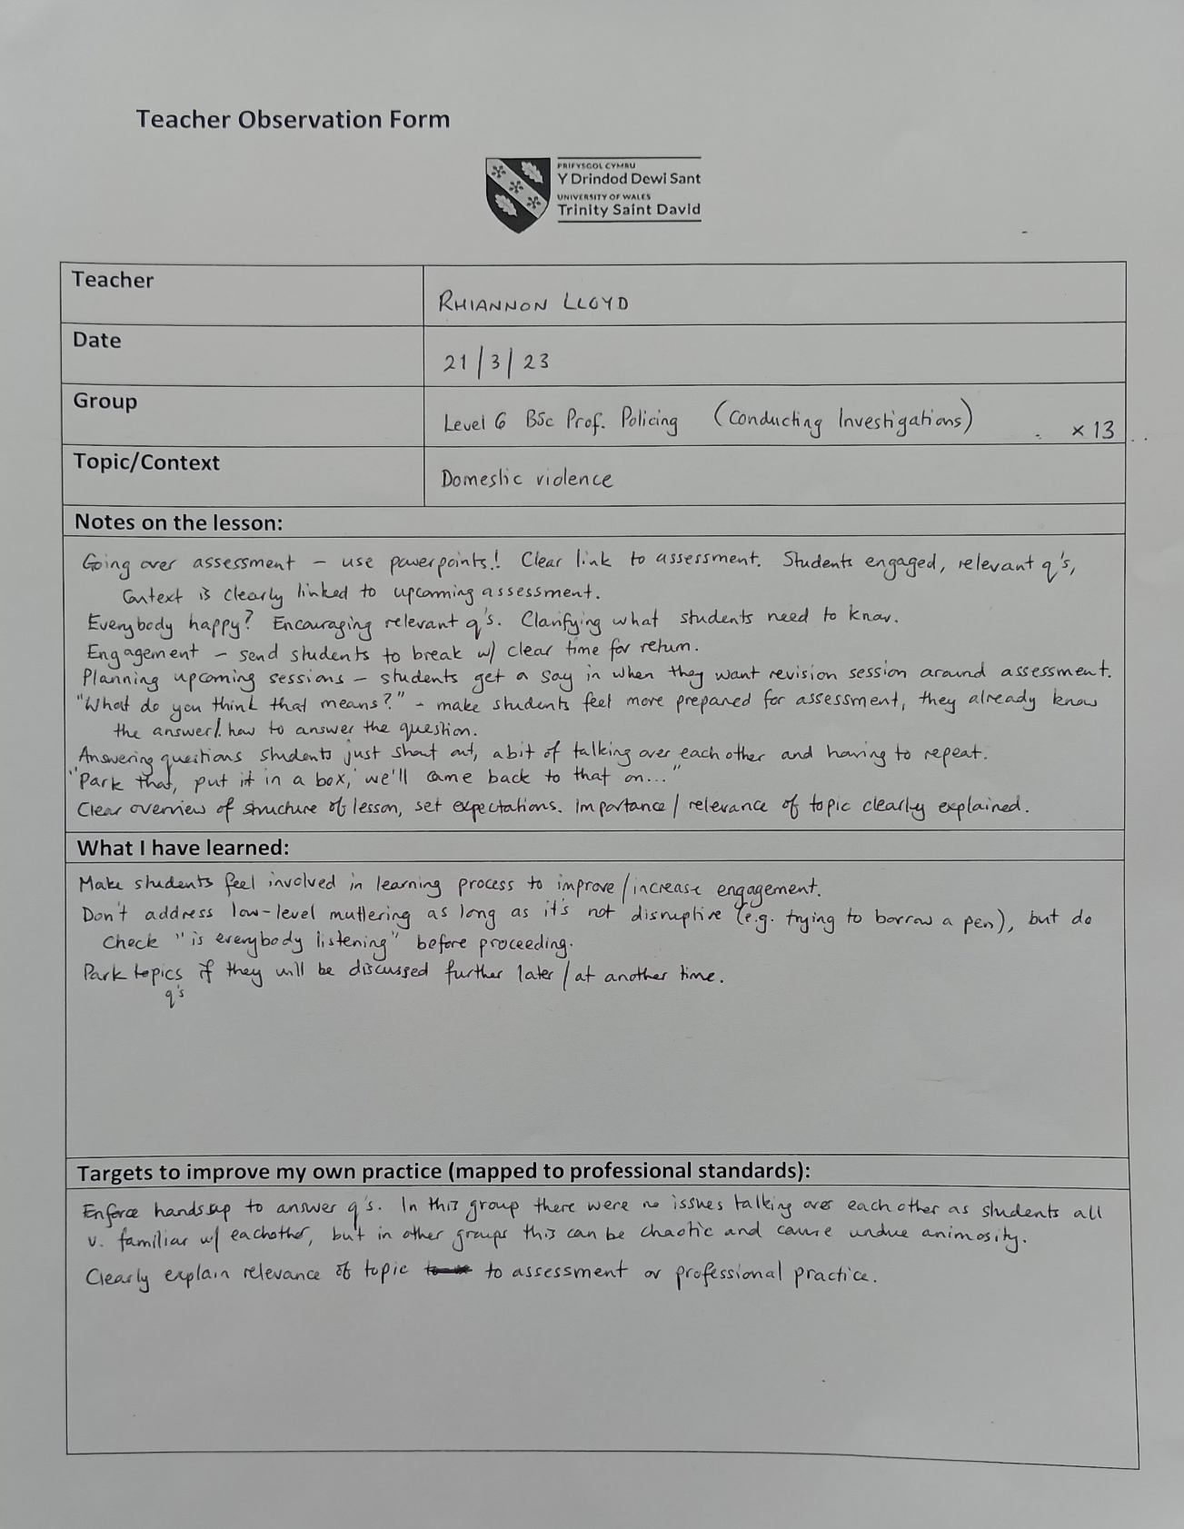

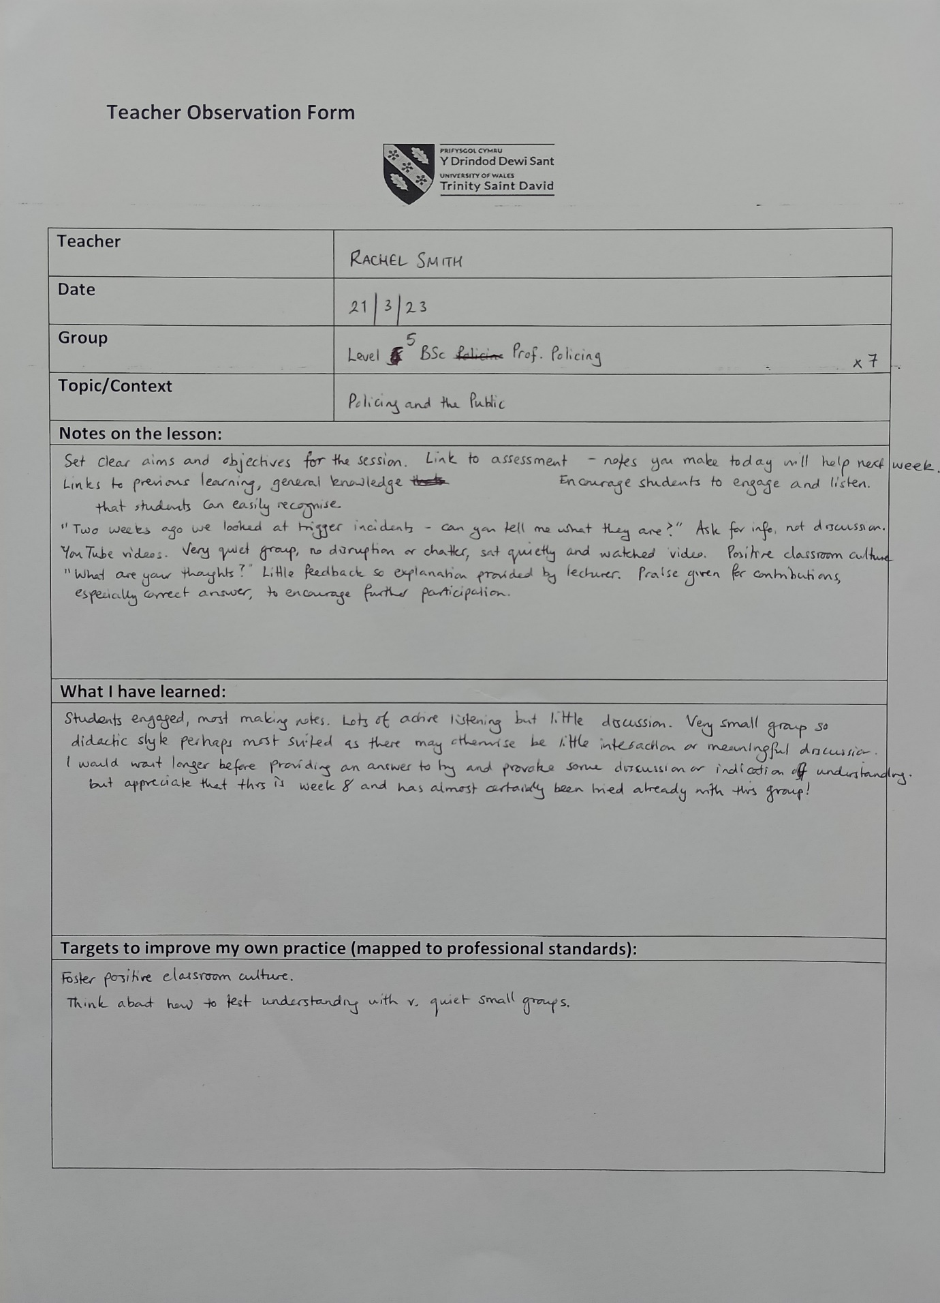

Appendix B



Lesson Plan

Topic: Introductory session |  | Class: BMPS4009 Learning in the Digital Era
Date: 30/01/2023 | Length of lesson: 2 hours |  | Number of students: 56
Resources required:
PowerPoint, Moodle, Teams
Aim of Lesson:
- Introduce students to the module.
- Outline key dates and modes of assessment.
- Set expectations for behaviour and communication.
- Familiarise students with Moodle and direct them to online learning.
- Discuss study environments and time management.

Learning Outcomes – The Learners Should Be Able To:
- Demonstrate awareness of the expectations of the module (assessment, attendance etc.).
- Find the online learning and weekly forums on the Moodle page.
- Identify an appropriate study location in their home/place of learning.
- Create a basic study plan following the Eisenhower Principle.

Previous student knowledge required for the session:
Ability to access Teams and log into Moodle.

Anticipated difficulties (if applicable):
- Poor IT skills, problems logging into Teams, accessing Moodle etc. on different devices.
- Number of students – this is a very large group.
- Lack of participation.

Professional Standards (where are these being met within the session)

I intend to meet the following UK PSF key standards during the session:
- A1 – I will plan learning activities which are relevant to the lesson and the course.
- A2 – I will teach and support learning throughout the session by providing foundational information and encouraging students to use this to reach logical conclusions.
- A4 – I will develop an effective learning environment by setting core expectations from the outset.
- K2 – I will employ an appropriate method of teaching, learning and assessment for this level of academic study.
- K4 – I will use appropriate learning technologies (in this case, PowerPoint and MS Teams) to support learning
- K5 – I will set an independent task to evaluate the effectiveness of my teaching by asking students to access Moodle and complete a short task during the break, as well as by setting a homework task requiring the same steps.
- V1 – I will respect individual learners and diverse learning communities by both respecting and acknowledging their views and needs.
- V2 – I will promote participation and equality of opportunity by providing a range of activities and providing as much support as is necessary and reasonable.
- V4 – I will acknowledge the wider context in which higher education operates by identifying links between the module and the students’ professional practice.

Lesson Detail:

Stage | Focus | Strategy | Time
Introduction  Development  Plenary/conclusion | 1. Module introduction  2. Setting expectations; build rapport with students  3. Key assessment information  4. Test of learning  1. Studying effectively  2. Time management  3. Prioritising your time – the Eisenhower Principle  4. Procrastination  Homework | 1.1 Introduce myself.  1.2 Outline module content – what will we learn over the course of this module?  2.1 Set my expectations – attendance, communication, behaviour.  2.2 Breakout room task – what are your expectations? Ask students to think about what they expect of me, and what they expect to learn during the module.  2.3 Discussion – ask groups to share their expectations and create a list of our mutual expectations.  3.1 Outline assessment dates – ask students to make a note of these.  3.2 Demonstrate how to find Moodle by going through Hwb, and how to navigate to the module tile.  3.3. Demonstrate to the students how to find the assessment tile, and how to access the assignment brief.  Ask students to navigate to the assignment brief and download it onto their device during the break. Completion will be tracked on Moodle. This will indicate whether or not they have understood the instructions, and are able to successfully navigate Moodle. Any issues will be addressed at the end of the class.  1.1 Class discussion - what do you think makes a good study space?  1.2 Evaluating potential study spaces – ask students as a group to suggest three potential study spaces and evaluate it together. Discuss the outcome; do we agree?  1.3 When to study – find a time with less distractions that fits within your own pattern of productivity. Importance of routine.  2.1 Importance of managing time, planning and prioritizing  2.2 Vevox quiz – how well do you manage your time?  2.3 Conclusion – what do your answers mean? Lots of nevers = you probably find it difficult to manage your time. Time management is a skill you can develop.  3.1 Introduce the Eisenhower matrix. Important is not the same as urgent; difference between important and urgent.  3.2 Group activity – give 5 activities, and ask students to discuss and fit these into the Matrix.  - Return overdue library books  - Book dentist appointment for toothache  - Finish watching Game of Thrones  - Make sure I can log into Moodle  - Homework for next week’s class  3.3 Show students how I fit these task into the Matrix. Do they agree? Discuss.  3.4 Tips for successful planning – resources, conditions, flexibility.  4.1 Discussion – what is procrastination? Why do we do it?  Direct students to TED Talk video for more information (in their own time).  4.2 Overcoming procrastination.  4.3 Overcoming perfectionism.  1. For next week write a short introduction – who are you and why are you studying this course? Opportunity for students to let me know their preferred name/pronouns, and for me to get an insight into their motivations.  Post to the forum on Moodle.  2. Please go through Unit 0 Topic 2 – Essential digital skills ready for next week, and complete the tasks there. | 5 mins  5 mins  3 mins  20 mins  3 mins  2 mins  4 mins  2 mins  = 44 mins  10 minute break  3 mins  5 mins  5 mins  2 mins  10 mins  5 minutes  4 minutes  3 mins  3 mins  5 mins  3 mins  3 mins  = 51 mins

Assessment Strategies: when and how are they included within the lesson?

There is no formal assessment in this lesson, as it’s an introductory lesson. However, I have set a brief task for students to complete in the break, to test their understanding of my instructions of how to access Moodle and access the assignment brief. I have also set a short piece of homework which requires them to access Moodle and post on a forum. This should allow students to self-assess their ability to navigate Moodle, and seek assistance if required (IT support has been signposted).

Informal reflection (to be completed after the session)

I think the session went quite well. A number of the students were very engaged. I over-planned this session and it went right to the wire, because I didn’t expect so many questions from the students – I should have anticipated this, as it was their first lesson.
The expectation-setting activity did not go as I anticipated; instead of what I expected, the students’ responses were things that they wanted me to cover e.g. referencing. This was helpful to me, as it has highlighted what I need topics need emphasis in the coming weeks. There was also some pushback from one student about my request that students have their camera on, which they seemingly perceived as a lack of respect on my part.
The size of the group caused some issues, as they all wanted to talk at once. Going forward I will need to enforce the “hands up” rule, to ensure that I can hear everyone who wishes to contribute.
Conversely, one of the students reported that no one spoke in the breakout room, so there was clearly a gap between attendance and engagement. The Vevox activity indicated that only some of the students were actually engaging. At most, 25 students engaged with this, although there were 39 in attendance.

Overall I think this went well, and it has enabled me to identify some points for my own improvement and given an indication of how best to engage the group.

Appendix C

Objective 1
Specific objective | Improve punctuality, both starting the class on time and resuming after a break. I could see how effective this was in Ruth’s class to develop an effective learning environment (A4: AdvanceHE, 2011). This is intended to support the students’ learning (A2: AdvanceHE, 2011) to ensure that class runs smoothly (as I will not have to provide a recap for latecomers), and that students become aware of the importance of punctuality.
Measurable | I will monitor the number of students actively engaging at the commencement or resumption of class. This can be easily achieved at the beginning of the class, as I can see how many students are present. I will begin the class on the hour, rather than waiting for more students to arrive. Consistency is key (Kern and Clemens, 2007, cited in Parsonson, 2012), and I hope that this will encourage students who are regularly late to make an effort to attend on time if they can see that they are missing parts of the class.
Achievable | With my current classes, I will notify them that punctuality is important, and will look to start/resume class on time with immediate effect. Going forward, I will impress the importance of punctuality from the beginning, as part of the process of setting ground rules for the class. In the interests of positive reinforcement (Moore et al., 2019) , I will briefly acknowledge any student who draws attention to themselves when arriving late, but focus mainly on praising the students who arrived on time.
Relevant | As Wallace (2013) noted, rules are more likely to be successful when they support learning rather than simply benefitting the teacher. I feel that punctuality is important to make sure that the class runs smoothly, and good time-keeping can promote respect (Petty, 2014) and encourage a positive classroom culture. Good time management is also a key transferable skill which is important for wider employment as well as academic study, so I feel it is important to encourage the students to develop this as part of the module.
Timeframe | I aim to implement this with immediate effect.
Objective 2
Specific objective | Become more confident in enforcing rules to improve engagement in class, by asking students to have their cameras on.
Measurable | I will be able to see how many students have their camera on during the class, and will keep track of any increase/decrease in the number who respond to my requests that they have their cameras on.
Achievable | I need to speak to the Academic Director in my institute to find out whether there is a policy in place for online classes, and look to creating one if not. Consistency is key for managing behaviour (Parsonson, 2012; Welsh Government, 2012; Ofsted, 2014; Welsh Government, 2015) and therefore I will need to work cooperatively with my colleagues on the programme to seek to apply this.
Relevant | Multiple studies have observed the benefits to students of having their cameras on in online learning environments (Giesbers et al., 2013; Gigliotti, 2016; Luo, et al., 2021; Händel, et al., 2022), and this is something that I will impress upon the students as part of the module. At present I find it difficult to apply this consistently due to pushback from some students. While I am aware of the importance of respecting learners (V1: AdvanceHE, 2011), and appreciate that some do have legitimate reasons for not turning their camera on, I have concerns about the subsequent lack of engagement from some students. The absence of body language and non-verbal cues makes it very difficult to assess understanding (K5: AdvanceHE, 2011), and there are also issues with poor engagement and attendance which cannot be addressed if the students are not visible.
Timeframe | As a whole school (or, in this case, whole programme) approach is the most effective way to change the classroom culture (Bennett, 2017, cited in Moore et al., 2019), I will need to work with colleagues and the Academic Director to implement this effectively. Therefore I look to work towards this over the course of semester 3, with the intention of having a more concrete policy in place for the next academic year.
Objective 3
Specific objective | Improve knowledge of best practice in relation to improving engagement in an online learning environment.
Measurable | I will look to attend training and achieve a relevant digital badge as part of the university’s Digital Skills training programme (UWTSD, 2023). I will also self-assess my knowledge and ability to apply best practice to my teaching.
Achievable | The university’s Digital Skills training programme will be my starting point here. I will also investigate the availability of relevant training courses, workshops, or conferences. In addition, I will also seek out relevant published research, particularly recent journal articles, to try and identify ways to improve my teaching.
Relevant | Online students are less likely to complete their studies than those studying on campus (Department of Education and Training, 2017, cited in Brown, et al., 2020), and poor engagement – caused in part by the attenuation present in an online classroom – no doubt plays a part in this. Therefore I will look to improve my own professional practice by engaging in CPD and seeking out examples of best practice. This also aligns with professional standards in acknowledging the context of higher education and implications for professional practice, quality enhancement for professional practice, and the use and value of appropriate learning technologies (V4, K6, K4: AdvanceHE, 2011).
Timeframe | This will form part of my ongoing personal development, but I intend to seek out some initial examples of best practice which I can implement in the next academic year.

Reference list

AdvanceHE (2011) The UK Professional Standards Framework for teaching and supporting learning in higher education. Available at: https://www.advance-he.ac.uk/knowledge-hub/uk-professional-standards-framework-ukpsf (Accessed: 22 April 2023).

Bedenlier, S., et al. (2021) ‘Generation invisible? Higher education students’ (non)use of webcams in synchronous online learning’, International journal of Educational Research Open, 2, article 100068. DOI: 10.1016/j.ijedro.2021.100068

Blake, C. (2023) ‘C’mon get happy: How to create a positive classroom culture’, Resilient Educator. Available at: https://resilienteducator.com/classroom-resources/create-positive-classroom-culture (Accessed: 22 April 2023).

Blatchford, P., Bassett, P. and Brown, P. (2011) ‘Examining the effect of class size on classroom engagement and teacher-pupil interaction: Differences in relation to pupil prior attainment and primary vs. secondary schools’, Learning and Instruction, 21(6), pp. 715–730. DOI: 10.1016/j.learninstruc.2011.04.001

Brown, A., et al. (2021) ‘A conceptual framework to enhance student online learning and engagement in higher education’, Higher Education Research & Development, 41(2), pp. 284–299. DOI: 0.1080/07294360.2020.1860912

Caleb, R. (2020) ‘Student well-being’, in Marshall, S. (ed.) A handbook for teaching and learning in higher education: Enhancing academic practice. London and New York: Routledge, pp. 156–164.

Cowley, S. (2010) Getting the buggers to behave. 4th ed. London and New York: Continuum.

Curriculum and Assessment (Wales) Act 2021. Available at: https://www.legislation.gov.uk/asc/2021/4/contents/enacted (Accessed: 12 April 2023).

Dallimore, E., Hertenstein, J. and Platt, M. (2004) ‘Classroom participation and discussion effectiveness: Student-generated strategies’, Communication Education, 53(1), pp. 103–115. DOI: 0.10/0363452032000135805

Dewis Cymru (2018) Learning – compulsory education. Available at: https://www.dewis.wales/learning-compulsory-education (Accessed: 12 April 2023).

Estyn (2018) ‘Reducing challenging behaviour through positive management strategy’, Effective practice, 26 October. Available at: https://www.estyn.gov.wales/effective-practice/reducing-challenging-behaviour-through-positive-management-strategy (Accessed: 12 April 2023).

Finn, J., Pannozzo, G. and Achilles, C. (2003) ‘The “why’s” of class size: Student behavior in small classes’, Review of Educational Research, 73(3), pp. 321–368. DOI: 10.3102/00346543073003321

García-Morales, V., Garrido-Moreno, A. and Martín-Rojas, R. (2021) ‘The transformation of higher education after the COVID disruption: Emerging challenges in an online learning scenario’, Frontiers in Psychology, 12, article 616059. DOI: 10.3389/fpsyg.2021.616059

Gibbs, J. (1998) Rather than ‘fixing kids’ – Transform the environment. Sausalito: CentreSource Systems. Available at: https://files.eric.ed.gov/fulltext/ED430177.pdf (Accessed: 13 April 2023).

Giesbers, B. et al. (2013) ‘Investigating the relations between motivation, tool use, participation, and performance in an e-learning course using web-videoconferencing’, Computers in Human Behavior, 29(1), pp. 285–292. DOI: 10.1016/j.chb.2012.09.005

Gigliotti, R. (2016) ‘Institutional identification and sense of community: Analysis of a new online graduate public administration program’, Journal of Public Affairs Education, 22(3), pp. 399–414. DOI: 10.1080/15236803.2016.12002255

Händel, M., et al. (2022) ‘The webcam and student engagement in synchronous online learning: visually or verbally?’, Education and Information Technologies, 27, pp. 10405–10428. DOI: 10.1007/s10639-022-11050-3

Hanson, T., et al. (2012) A randomized experimental evaluation of the Tribes Learning Communities Prevention Program. WestEd final report. Available at: https://www.ojp.gov/pdffiles1/nij/grants/237958.pdf (Accessed: 13 April 2023).

Haywood, N. et al. (2009) Engaging all young people in meaningful learning after 16: A review. Manchester: Equality and Human Rights Commission. Available at: https://www.equalityhumanrights.com/sites/default/files/research_report_25_engaging_all_young_people_in_meaningful_learning_after_16_a_review.pdf (Accessed: 12 April 2023).

Human Rights Act 1998. Available at: https://www.legislation.gov.uk/ukpga/1998/42/schedule/1 (Accessed: 13 April 2023).

Kandiko Howson, C. (2020) ‘Maximising student learning gain’, in Marshall, S. (ed.) A handbook for teaching and learning in higher education: Enhancing academic practice. London and New York: Routledge, pp. 145–155.

Learning by Questions (2022) ‘Behaviour management in the classroom: a guide to 9 strategies you can use today’, LbQ Hub, 19 July. Available at: https://www.lbq.org/hub/post/?posttitle=behaviour-management-classroom-strategies (Accessed: 12 April 2023).

Learning and Skills Development Agency (2007) What’s your problem? Working with learners with challenging behaviour. London: Learning and Skills Network. Available at: http://www.itslifejimbutnotasweknowit.org.uk/files/LSDA_WhatsyourProblem.pdf (Accessed: 19 April 2023).

Lebor, M. (2017) Classroom behaviour management in the post-school sector: Student and teacher perspectives on the battle against being educated. Cham: Palgrave Macmillan.

Luo, N., et al. (2021) ‘Promoting student engagement in online learning through harmonious classroom environment’, The Asia-Pacific Education Researcher, 31(5), pp. 541–551. DOI: 10.1007/s40299-021-00606-5

Lyle, S., Hendley, D. and Newcomb, J. (2010) The Teaching and Learning Research Programme in Wales: Improving learning by taking account of learners’ perspectives. Available at: https://www.gov.wales/sites/default/files/statistics-and-research/2019-09/101206-improving-learning-taking-account-learners-perspectives-briefing-en.pdf (Accessed: 12 April 2023).

Monk, W.M. (2021) ‘Factors influencing adult learners’ satisfaction and retention’, Unpublished MM thesis. Toi Ohomai Institute of Technology. Available at: https://www.researchbank.ac.nz/bitstream/handle/10652/5472/MMagt_2021_Wendy_Mae_Monk.pdf?sequence=1&isAllowed=y (Accessed: 12 April 2023).

Moore, D. et al. (2019) Improving behaviour in schools: Evidence review. London: Education Endowment Foundation. Available at: https://educationendowmentfoundation.org.uk/public/files/Improving_Behaviour_in_Schools_Evidence_Review.pdf (Accessed: 12 April 2023).

Napper, R. and Newton, T. (2018) ‘Transactional Analysis and coaching’, in Cox, E., Bachkirova, T., and Clutterbuck, D. (eds.) The complete handbook of coaching. London: SAGE, pp. 167–183.

Ofsted (2014) Below the radar: Low-level disruption in the country’s classrooms. Available at: https://assets.publishing.service.gov.uk/government/uploads/system/uploads/attachment_data/file/379249/Below_20the_20radar_20-_20low-level_20disruption_20in_20the_20country_E2_80_99s_20classrooms.pdf (Accessed: 12 April 2023).

Parsonson, B. (2012) ‘Evidence-based classroom behaviour management strategies’, Kairaranga, 13(1), pp. 16–23. Available at: https://files.eric.ed.gov/fulltext/EJ976654.pdf (Accessed: 12 April 2023).

Petty, G. (2014) Teaching today: A practical guide. 5th edn. Oxford: Oxford University Press.

Tertiary Education and Research (Wales) Act 2022. Available at: https://www.legislation.gov.uk/asc/2022/1/contents (Accessed: 12 April 2023).

Thompson, C. (2018) ‘The construct of ‘respect’ in teacher-student relationships: Exploring dimensions of ethics of care and sustainable development’, Journal of Leadership Education, 17(3), pp. 42–60. DOI: 10.12806/V17/I3/R3

UK Government (no date) School leaving age. Available at: https://www.gov.uk/know-when-you-can-leave-school (Accessed: 13 April 2023).

UN Convention on the Rights of the Child (1990) Available at: https://www.ohchr.org/en/instruments-mechanisms/instruments/convention-rights-child (Accessed: 19 April 2023).

University of Cambridge (n.d.) Study skills: Reflective practice toolkit. Available at: https://libguides.cam.ac.uk/reflectivepracticetoolkit/models (Accessed: 23 April 2023).

University of Hull (2022) Reflective writing: ERA. Available at: https://libguides.hull.ac.uk/reflectivewriting/era (Accessed: 22 April 2023).

UWTSD (2022a) Support for study policy and procedure. Available at: https://uwtsd.ac.uk/media/uwtsd-website/content-assets/documents/academic-office/misc-forms/Support_for_Study_Policy_2022-23.pdf (Accessed: 12 April 2023).

UWTSD (2022b) Non-academic misconduct policy. Available at: https://www.pcydds.ac.uk/media/uwtsd-website/content-assets/documents/accommodation/non-academic-misconduct-policy-2022-2023.pdf (Accessed: 12 April 2023).

UWTSD (2021) Digital skills for teaching staff. Available at: https://digitalskills.uwtsd.ac.uk/teaching-staff/ (Accessed: 23 April 2023).

Wallace, S. (2013) Managing behaviour in further and adult education. 3rd ed. London: Learning Matters.

Weger, H., et al. (2014) ‘The relative effectiveness of active listening in initial interactions’, International Journal of Listening, 24(1), pp. 13–31. DOI: 10.1080/10904018.2013.813234

Welsh Assembly Government (2010) Learner involvement strategies: Guidance for lifelong learning and skills providers in Wales. Circular no: 002/2010. Available at: https://www.gov.wales/sites/default/files/publications/2018-02/learner-involvement-strategy-guidance.pdf (Accessed: 12 April 2023).

Welsh Government (2012) Practical approaches to behaviour management in the classroom: A handbook for classroom teachers in primary schools. Information document no: 117/2012. Available at: https://www.gov.wales/sites/default/files/publications/2018-12/practical-approaches-to-behaviour-management-in-the-classroom-a-handbook-for-classroom-teachers-in-primary-schools.pdf (Accessed: 12 April 2023).

Welsh Government (2013) Guidance on penalty notices for regular non-attendance at school. Guidance document no: 116/2013. Available at: https://www.gov.wales/sites/default/files/publications/2018-03/guidance-on-penalty-notices-for-regular-non-attendance-at-school.pdf (Accessed: 12 April 2023).

Welsh Government (2015) Learner Voice Wales research briefing 02: Managing challenging behaviour. Available at: https://www.gov.wales/sites/default/files/publications/2018-11/learner-voice-wales-research-briefing-02-managing-challenging-behaviour.pdf (Accessed: 12 April 2023).

Welsh Government (2019a) Exclusion from schools and pupil referral units. Guidance document no: 255/2019. Available at: https://www.gov.wales/sites/default/files/publications/2019-11/exclusion-from-schools-pupil-referral-units.pdf (Accessed: 12 April 2023).

Welsh Government (2019b) Professional standards for teaching and leadership. Available at: https://hwb.gov.wales/api/storage/19bc948b-8a3f-41e0-944a-7bf2cadf7d18/professional-standards-for-teaching-and-leadership-interactive-pdf-for-pc.pdf (Available at: 12 April 2023).

Welsh Government (2021) The curriculum for Wales – Statements of What Matters Code. Available at: https://www.gov.wales/sites/default/files/publications/2021-11/curriculum-for-wales-statements-of-what-matters-code.pdf (Accessed: 12 April 2023).

Wlodkowski, R. (2008) Enhancing adult motivation to learn: A comprehensive guide for teaching all adults. 3rd edn. San Francisco: Jossey-Bass.

Wyatt, L. (2011) ‘Nontraditional student engagement: Increasing adult student success and retention’, Journal of Continuing Higher Education, 59(1), pp. 10–20. DOI: 10.1080/07377363.2011.544977

Zepke, N. and Leach, L. (2010) Improving student engagement in post-compulsory education: A synthesis of research literature. Wellington: Teaching and Learning Research Initiative. Available at: http://test.tlri.org.nz/sites/default/files/projects/9261-Literature-review.pdf (Accessed: 12 April 2023).

