Assessing numeracy formatively:Key Stage 2
For each example below, consider:
- The way the numeracy has been incorporated as a learning opportunity
- The way it might relate to the new curriculum
- The opportunity for assessment of numeracy skills
- What the example shows you about the child’s numeracy skills and what you would do to ensure further progress

Example 1: Rationing
While studying the Second World War as a cross-curricular topic, the learners were asked to complete a task about food rationing. They were provided with data showing the weekly ration allowance for an individual person. Initially, learners were invited to work out how much of each item of food their own family would have received per week, if they were on this rationing system. The data for the food was in grams and pints. A display of many of these items in class helped the learners to gain an understanding of what a family ration for a week looked like. Learners were then asked to work out the weekly allowance for 10 and 15 people.
Then, for a ‘Victory street party’, they were asked to work out how many tokens they would need to make five Madeira cakes and how long it would take them to save enough tokens to do so. The teacher gave them the recipe for one Madeira cake.
This is Tom’s work:
When the teacher asked him how he’d worked out how long it would take him to save enough tokens for a Madeira cake, he described the steps he had taken and explained why he had used them. When asked whether his answers were reasonable, he said, “Yes, because I knew there would be enough sugar but in the war there was a shortage of eggs so taking three weeks to collect the eggs seemed about right”. The teacher asked Tom about the checking strategies he had used. Tom replied that he had added in two ways, conventionally and then by just ‘tens’ and then ‘units’ before combining them. For the multiplications, he had estimated by rounding up the figures before actually working them out.

Notes:

Example 2: Growing Up
Learners had been working on the theme of ‘Growing up’. They were tasked with conducting a survey of the height of learners in Year 6. They started with their own class and then moved on to a larger sample size.
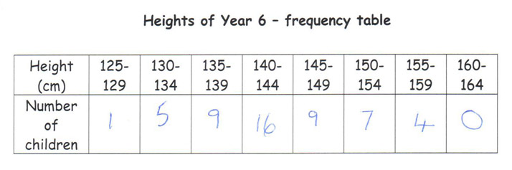
Blake worked with his partner to measure the height of four of his classmates, to the nearest centimetre. The teacher collated the heights of the class and added them to the heights of another Year 6 class. She presented them as a simple table headed ‘name’ and ‘height’. She asked whether the results were clear. Blake replied, “Not really. I can’t see a pattern.” The teacher asked what information Blake could get from the table. Blake answered, “Ben is the tallest and Georgia is the shortest.” The teacher asked Blake the heights of these pupils. Blake said “Ben is 157cm and Georgia is 126cm.” The teacher discussed with the class what they could do with the data to try and make sense of it. Working in pairs, the class were asked to sort the data to see if they could discover any further information. Blake decided to work out the mean height. On paper he correctly added all the heights, and then using a calculator divided by the number of people. The teacher asked Blake if there was anything else he could think of to do with the data. Blake said, “It might be better if we looked at the boys and girls separately. I think the girls are taller than the boys.” Blake went on to correctly work out the mean height of the boys and the girls, stating to the teacher, “I was right, the girls’ mean height is more than the boys’ by 6cm.”
Blake asked his teacher whether he could draw a bar chart of the heights, noting, “This might not work – I’m not sure if it will tell us anything else.” The teacher then gave Blake a grouped data table and explained to him that by grouping the data in this way it might be easier to see any patterns. Blake correctly completed the grouped data table, counting the number of children in each category. He described the pattern to his teacher: “It goes up and down and there are less shorter and taller children with more in the middle – around the mean.”

Notes:

Example 3: Bullying
Learners had been looking at examples of bias in reporting and considering the reliability of data and drawing valid conclusions. As learners had been working on a topic of ‘Friendship’, the teacher presented the class with the question ‘Is bullying more of a problem now in schools in Wales than before?’. The teacher used this activity as a stimulus for a follow-up discussion. Learners worked individually with the data provided and were tasked with presenting their arguments to a small group of learners. The teacher asked learners to record how they were using the information provided to make their decisions, in any way that they wished. This is Caitlin’s work:
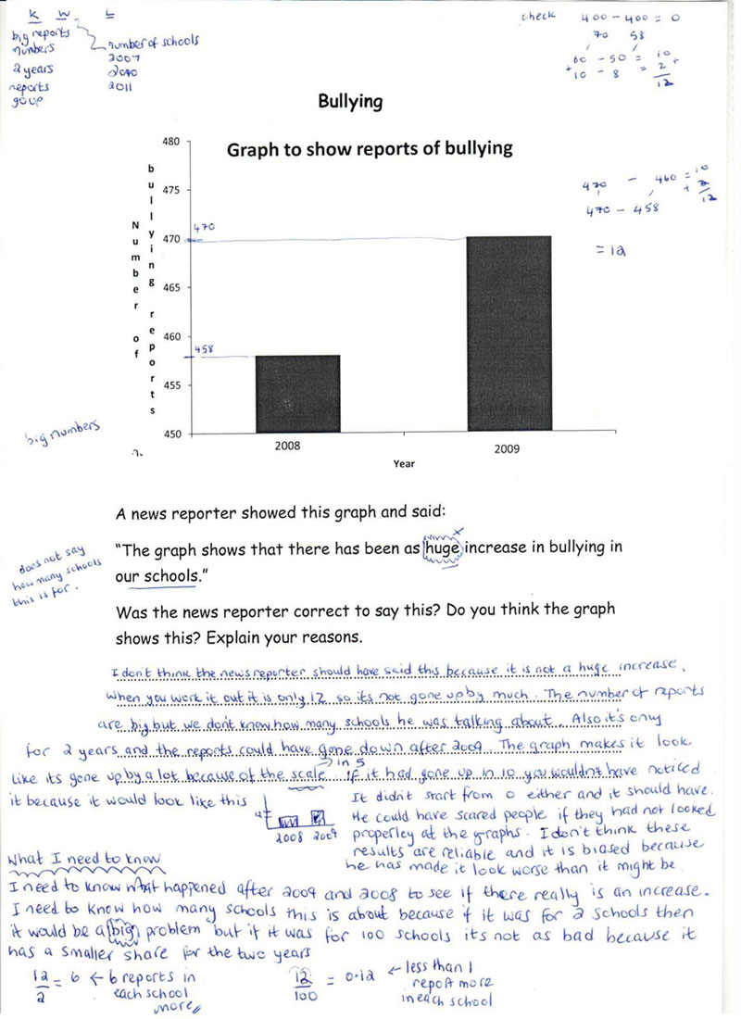
Notes:

Example 4: Solar Panels
Learners in a mixed Year 3/4 class were exploring the theme ‘Sustainable Earth’. Their challenge was to identify ways to reduce the school’s energy consumption and, in consequence, its bills. After reviewing the school’s gas and electricity bills, initially they mindmapped their ideas to see how they could reduce them. Learners then did research to develop further ideas.
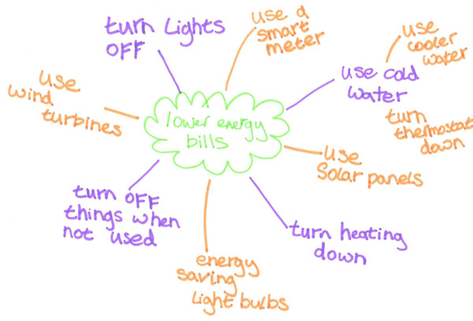
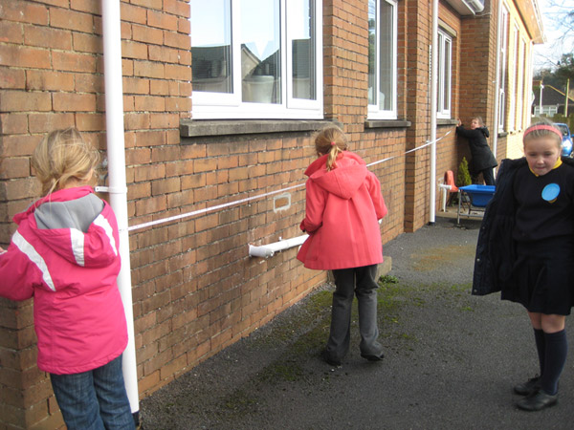
Lily led the group and asked four members to survey the school grounds to find the best place to put the panel in terms of shelter and sunlight. She worked with the rest of the group to stick paper together that was the same overall size as a standard solar panel, as a template. She measured to the nearest millimetre. The whole group then reviewed the ‘best places’ and checked that a solar panel would fit in that area. Lily and Rosie then decided that three solar panels would be sufficient for the school’s hot water (from their research) and therefore the group were tasked with looking for the best place in the school grounds for the three panels together, using the paper template and a tape measure (photograph).

Notes:

Example 5: Church Visit
As part of work on Christianity, learners had recently visited a local church and interviewed the vicar about her job. The teacher had taken photographs of their visit in order to discuss the visit and what the learners had found out. They reviewed these and talked about the visit back in class.
After returning to school, the teacher asked the learners how many people they thought the church might hold and how they might estimate this. Daniel suggested that they could look at the photographs they had taken and count the number of pews. When questioned further, he said that if he knew how many pews there were and how many people could sit in a pew then he could calculate how many people there would be in total by multiplying the two numbers.

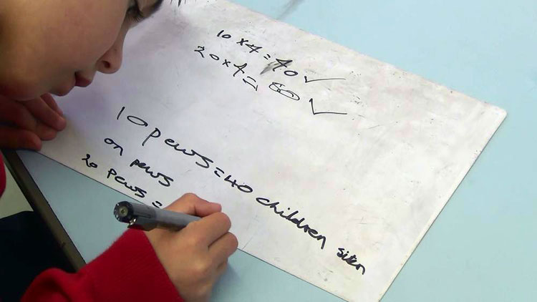
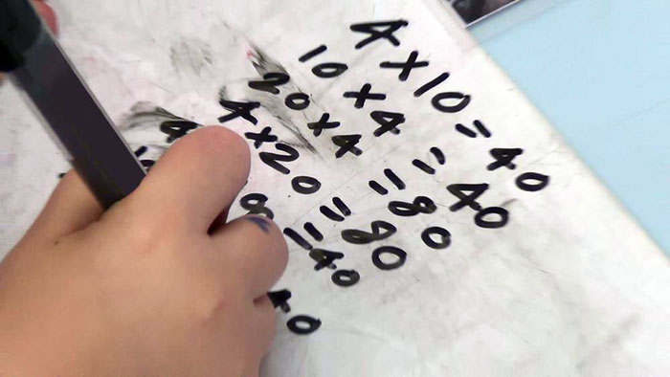

Photograph 1 shows how Daniel performed a calculation to give a correct answer of 40. His teacher asked Daniel to explain his reasoning. Daniel explained, “Four people can sit in one pew so I need to do that 10 times because there are 10 pews in the church in the pictures. I need to multiply and you use your four times table”
Daniel then showed his teacher an alternative calculation independently recognising that 10 x 4 was equivalent to 4 x 10 and showing an understanding of how two multiplication tables can give the same answer. The teacher then posed the question, “If there had been 20 pews instead, how would the total number of people who could attend change?”.
He explained that he could use the same calculation as previously and double the number of pews, “So double 10 is 20”. Daniel explained that he checked his calculation, “Doubling the number of pews means that the answer should double too. Double 40 is the same as 40 x 2 which is 80. Half of 80 is 40 too. So my answer was right”.
Notes:

