Structures | Role
Vena Cava
Right Atrium
Right Ventricle
Pulmonary Artery
Aorta
Pulmonary Vein
Left Atrium
Left Ventricle
Septum
Valves
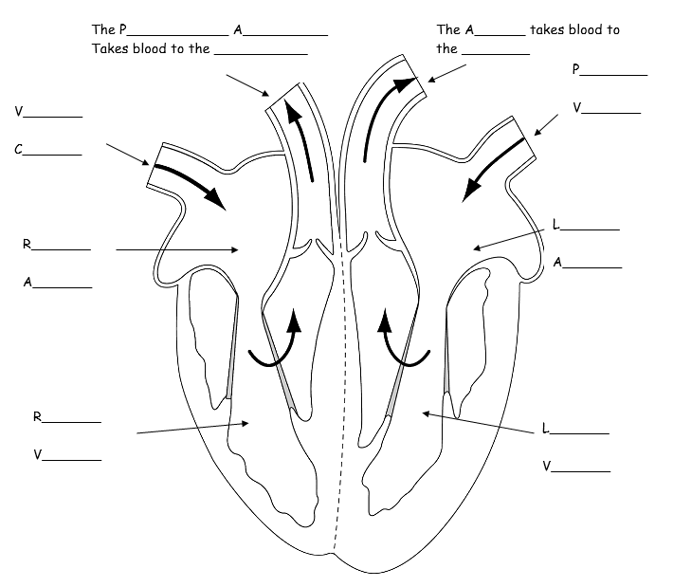
What are the long and short term effects of exercise on the heart?
Short Term | Long Term

Colour the side of the heart that carries deoxygenated blood blue, and colour the side of the heart that carries oxygenated blood red.
How blood moves through the Heart.
- Deoxygenated blood enters the heart through the . .
- . . blood flows into the right atrium.
- Deoxygenated blood is pumped into the right . .
- Deoxygenated blood is pumped out of the heart, along the . . to the lungs.
- Oxygenated blood arrives back at the heart.
- It enters the heart through the . . vein.
- . . blood flows into the left atrium.
- Oxygenated blood is pumped into the left ventricle.
- Blood is pumped out of the heart, along the . . to the rest of the body.

The left side of the heart has thicker muscle than the right side. Why?

Cardiac Output = X .
Stroke Volume means…….
Heart Rate means……
The heart is made of a unique muscle type known as . . and it never tires.

The heart is called a double pump and part of two circuits:
- P . circulation carries blood to the . . to be oxygenated and then back to the heart. In the lungs,
. . is removed from the blood, and . . taken up by the haemoglobin in the red blood cells.
- S . circulation carries blood around the body to deliver the oxygen and returns de-oxygenated blood to the heart. Blood also carries . . and waste.

The Heart

