
BA (Hons) Education Studies
BA (Hons) Education Studies: Primary
Module Handbook 2020/2021
M5X01522
The Enquiring Mind: Creative Approaches
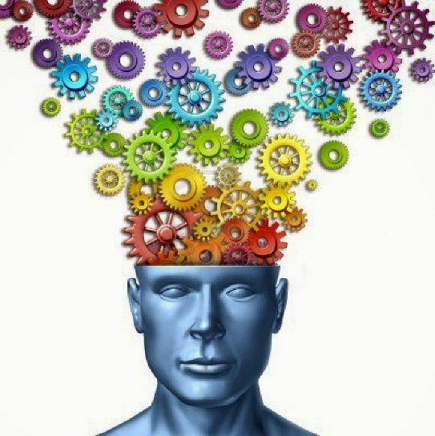

HOW TO CONTACT YOUR TUTOR
Module leader: Laura Hutchings
Lecturer : Laura Hutchings and Helen Griffiths
HOW TO CONTACT
Laura Hutchings
Office: Dylan Thomas Centre
Telephone: 01792 482099

AIMS AND LEARNING OUTCOMES

The aims of the module are to:
- To develop a good knowledge and understanding of the principal features, aims, concepts and values of scientific and creative enquiry

The outcomes of this module are that you will be able to:
- Engage with and have a broad and balanced knowledge of the fundamental aims, concepts, values and contexts of scientific and creative enquiry

- Reflect upon current research and developments into the role of scientific and creative enquiry in society

- Demonstrate a well-developed knowledge and understanding of the complexity of the interaction between enquiry and learning, and the range of contexts in which it takes place

- Recognise and reflect upon the cultural context of scientific and creative enquiry

Schedule of sessions

Week 1
Session 1 – Introduction to the module

Learning Outcomes:
- To recognise the purpose of creative approaches in education
- To begin to develop an understanding of the concepts of scientific and creative inquiry in education

Session 2 – The Rhetoric’s of creativity

Learning Outcomes:
- To identify the ‘rhetorics’ of creativity which can be used in the field of creative learning
- To explore the history of creative approaches in education

Asynchronous session - Creativity in today’s curriculum

Learning Outcomes:
- To establish the purpose of scientific and creative enquiry in the current curriculum
- To evaluate the classic and contemporary perspectives of creative approaches in education

Week 2

Session 1 – Creative approaches and Curriculum Design

Learning Outcomes:
- To develop an awareness of how creativity can be introduced to the curriculum design
- To evaluate the differences between two creative methods of learning

Session 2– Thinking like a Scientist – Supporting Scientific Play

Learning Outcomes:
- To critically explore the role of investigation and observation in scientific enquiry
- Evaluate the use of play as a way to promote scientific learning

Asynchronous Session The Art Vs Science debate

Learning Outcomes:
- To critique the creative and scientific approaches used in education
- To critically compare the similarities and differences between scientific enquiry and creative inquiry

Week 3

Session 1 – Let’s get creative – Supporting creative play

Learning Outcomes:
- To consider a range of play strategies that support creative enquiry
- To analyse the efficiency of creative play as a tool for learning in education

Session 2 - The outdoor classroom

Learning Outcomes:
- Critically compare the pedagogy of the indoor and outdoor learning environment in relation to creativity in the classroom
- Examine how the outdoor learning environment can promote creativity

Asynchronous Session – How Minecraft Education promotes creativity in schools

ASSESSMENT OUTLINE

Assessment Component 100%

E-portfolio (4000 words equivalent)
Produce a portfolio that reflects upon 5 key concepts studied in the module and their significance for 21st century education (See assignment specification for further details)

READINGS

Essential

Leimanis-Wyatt, M. (2010) A Practical Step-by-step Guide to Setting up a Creative Learning Environment, London: Routledge.

Cropley, A.J. (2008) Creativity in Education and Learning: a Guide for Teachers and Educators. London: Kogan Page.

Craft, A. (2005) Creativity in Schools: Tensions and Dilemmas. London: Routledge Falmer.

Recommended

Creative Partnerships (2008) Arts in Education and Creativity: a Review of the Literature. London: Arts Council England.

Creative Partnerships (2006) The Rhetorics of Creativity: A Review of the Literature. London: Arts Council England.

NACCCE (1999) All our Futures: Creativity, Culture and Education. London: DFEE

Smith, D. (2013) An Independent Report for the Welsh Government
into Arts in Education in the Schools of Wales. Available at: http://wales.gov.uk/topics/educationandskills/publications/wagreviews/arts-in-education-review/?lang=en

Connery, C., John-Steiner, V. and Marjanovic-Shane, A. (2012) Vygotsky and Creativity: A Cultural-historical Approach to Play, Meaning Making, and the Arts. New York: Peter Lang Publishing.

Moyles, J. (2010) The Excellence of Play, Berkshire: Open University Press.

Throne, K. (2007) Essential Creativity in the Classroom, London: Routledge

Background

Arthur, J. And Davies, I. (2010) (eds) Education Studies Textbook, Abingdon: Routledge

Bartlett, S. and Burton, D. (2012) Introduction to Education Studies, London: Sage

Journals

Cambridge Journal of Education
Journal of Artistic and Creative Education
International Journal of Innovation, Creativity and Change

Websites

http://wales.gov.uk (Welsh Government)
http://www.creativitycultureeducation.org/creative-partnerships

