

EVALUATING THE EFFECTIVENESS OF LEADERSHIP IN MANAGING ORGANISATIONAL CHANGE IN THE AUTOMOTIVE INDUSTRY IN THE UK

Student name: Mirela Oprea
Student ID: 2107120
LCBB6000
University of Wales Trinity Saint David
Submission date: 21 November 2025

TABLE OF CONTENTS

1. Introduction 4
1.1 Key concepts 4
1.2 Significance of the Study 4
1.3 Purpose of the research 4
1.4 Research Aim 4
1.5 Objectives 4
1.6 Research Questions 5
1.7 Hypotheses 5
2. Literature Review 5
2.1 Definition and significance 5
2.2 Characteristics of leadership and types 5
2.2.1 Transformational and Transactional Leadership 5
2.2.2 Situational Leadership 5
2.3 Models and theories 6
2.3.1 Lewin’s Three-Stage Model 6
2.3.2 Kotter’s Eight-Step Change Model 6
2.3.3 McKinsey 7-S Framework 7
2.4 Literature gap 8
2.5 Conceptual Framework 9
2.6 Hypotheses Development 10
3. Research Methods and Methodology 10
3.1 Research philosophy and paradigm 10
3.2 Research approach 11
3.3 Research Methodology 11
3.4 Research Strategy 11
3.5 Sampling Methods 11
3.6 Data collection tools 11
3.7 Data Interpretation 11
3.8 Timeframe prospects of the research (Gantt Chart) 12
3.9 Ethical Considerations of the research 12
4. Conclusion 12
References 13

1. Introduction

1.1 Key concepts
Leadership is the capacity of people to influence and direct others towards the achievement of organisational objectives and organisational change is the organised alteration of structure, culture or strategy to fit the internal and external pressures (Lima Rodrigues et al., 2022). In the UK automotive industry, companies often face issues due to globalisation, electrification, digitalisation, which leads to instability and hindrance in the organisations. In the ever-developing business environments, leaders are crucial in every organisation to navigate through complex transitions while maintaining the workforce stability in the company.

1.2 Significance of the Study
The purpose of this study is to address the increasing necessity to learn about the connection between leadership competency and the successful implementation of changes. The automotive sector is undergoing major transformations, particularly with the introduction of electrification, decarbonisation, and global competition.

1.3 Purpose of the research
Background of the Study
The automotive industry of the United Kingdom is one of the most vibrant and internationally oriented industries of the country in terms of its contribution to the economic output, innovation, and employment (Sun et al., 2024).
Problem Statement
Organisational change is a complicated process that requires strong leadership to bring change and overcome employee resistance. In the UK automotive sector, high demand for adaptive leadership is associated with a high rate of technological innovation (Nantunda and Zhu, 2025).

1.4 Research Aim
The research aims to evaluate the effectiveness of leadership in managing organisational change in the automotive industry in the UK.

1.5 Objectives
- To discuss important leadership theories applicable in managing change in organisations.
- To determine the impact of leadership styles on the change results of the automotive companies.
- To identify challenges and barriers faced by leaders in implementing change in the automotive organisations.

1.6 Research Questions
- What are the important leadership theories applicable in managing change in organisations?
- What is the impact of leadership styles on the change results of the automotive companies?
- What are the challenges and barriers faced by leaders in implementing change in the automotive organisations?

1.7 Hypotheses
- Transformational leadership is a positive factor leading to successful organisational change in UK automotive companies.
- The absence of adaptive leadership leads to employee resistance to organisational change.

2. Literature Review

2.1 Definition and significance
Leadership is a key factor that helps in achieving successful organisational change, mostly in the dynamic and technologically driven industries like the automotive industry. In this literature review, significant theories of leadership and change management models are critically analysed, which form the basis of the study of the effectiveness of a leader.

2.2 Characteristics of leadership and types

2.2.1 Transformational and Transactional Leadership
According to Klein (2023), amongst other theories, transformational leadership is one of the most effective theories. Transformational leadership is defined by the power to influence, inspire, and stimulate the followers to achieve common aims. The transformational leaders develop trust, creativity and commitment, which are essential in steering organisational transition. Transformational leaders are also considered more successful in the context of organisational change since they form an attractive vision and promote innovation (Jasiński et al., 2021).

2.2.2 Situational Leadership
According to Munir and Akhter (2021), the Situational Leadership Theory proposed by Hersey and Blanchard (1982) assumes that the efficiency of the leadership is determined by how the leader can change leadership style based on the readiness of followers and the requirements of the situation. According to this model, four major styles are directing, coaching, supporting, and delegating, which are all applicable at varying levels of follower competence and commitment.

2.3 Models and theories

2.3.1 Lewin’s Three-Stage Model
According to Vasel (2025), the model of Kurt Lewin (1947) is one of the key models of comprehending change. It involves three phases, namely unfreezing (before change), changing (new processes), and refreezing (stabilising the new state). This model emphasizes the psychological and behavioural dimensions of the change, with the focus on communication and motivation. Indicatively, during the process of reorganising its production process, when Ford UK offered a new structure, leadership communication was important in unfreezing the previous mindset and enabling the acceptance of new digital manufacturing systems.
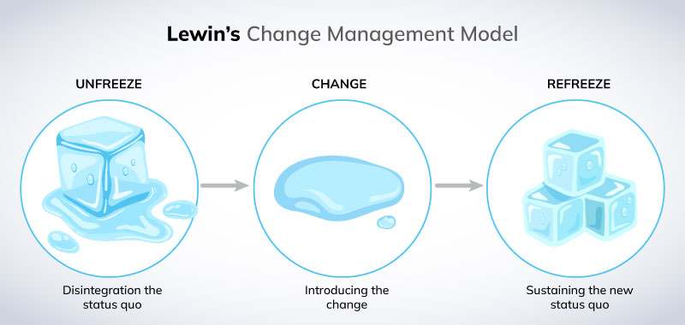

Figure 1: Lewin’s Three-Stage Model
(Source: Miller, 2022)

2.3.2 Kotter’s Eight-Step Change Model
According to Mancini (2023), Kotter (1996) builds upon the concepts developed by Lewin and elaborates a more specific process of leading change, which has eight steps, namely: establishing urgency, forming a guiding coalition, creating and communicating a vision, empowering employees, generating short-term wins, consolidating gains, and anchoring changes in organisational culture.
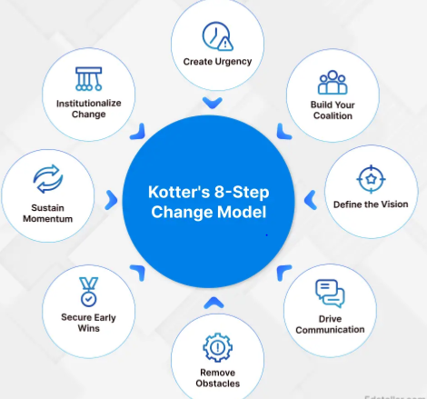

Figure 2: Kotter’s Eight-Step Change Model
(Source: Baker, 2025)
The model developed by Kotter has been popular to use in large corporations due to its focus on the involvement of leaders and communication. Kotter's approach in relation to the UK automotive industry can be a useful roadmap to the complex transitions, such as sustainable technologies. As an illustration, the implementation of the post-Brexit trade changes in Nissan Sunderland entailed the introduction of cross-functional work units and the solidification of the common vision of resilience and competitiveness.

2.3.3 McKinsey 7-S Framework
According to Chmielewska et al., (2022), McKinsey 7-S Framework (Waterman, Peters, and Phillips, 1980), the effective change requires the alignment of seven interdependent organisational components, which are strategy, structure, systems, shared values, skills, style, and staff. This model views leadership as being core in ensuring that there is alignment between these components.
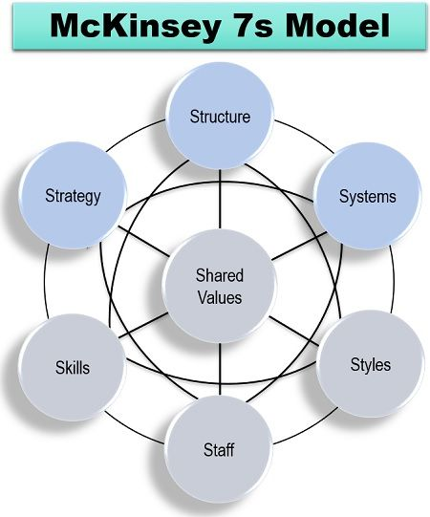

Figure 3: McKinsey 7-S Framework
(Source: Priya, 2020)
The Reports data highlights the fact that the effectiveness of leadership plays an important role in determining how successful organisational change is in the automotive industry (Le and Le, 2021). The ambidextrous leadership with operational efficiency and innovation is important. As the case of Jaguar Land Rover with its Reimagine Strategy evidences, visionary leadership can help a rather conservative manufacturer to navigate the process of electrification and sustainability.

2.4 Literature gap
The literature under review indicates that no leadership theory or model can ensure effective organisational change. Transformational leadership creates vision and motivation but might lack operational control, whereas transactional leadership creates stability but might strangle creativity (Rodríguez‐González et al., 2022). Situational leadership offers flexibility but is restricted by the factors of context. In the same manner, change management paradigms Lewin, Kotter and McKinsey provide useful frameworks that vary in terms of flexibility and applicability. The current data has evaluated enough information on how leadership has been somewhat effective in bringing change and growth to organisations in the automotive industry in the UK. However, there is still not enough information on how multiple leadership styles can be implemented by organisations to effectively omit the existing challenges the leaders are currently facing.

2.5 Conceptual Framework
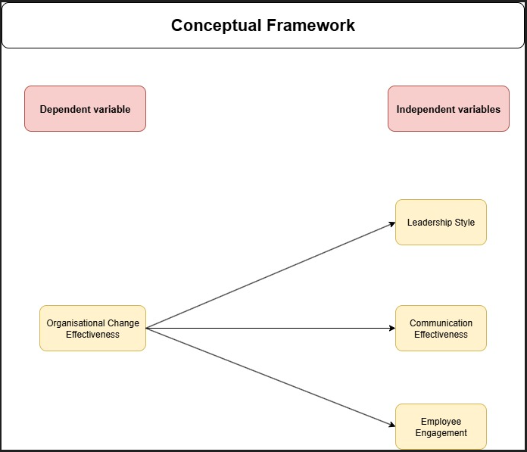
Figure 4: Conceptual Framework
(Source: Self-Created)
Organisational Change Effectiveness is the dependent variable in this study, which assesses the success of an organisation in the implementation and maintenance of change initiatives. It may be measured by the results like commitment of the employees, operational enhancement, and flexibility with innovation. The independent variables are Leadership Style, Communication Effectiveness and Employee Engagement. Leadership style (transformational, transactional or situational) directly affects the way leaders motivate employees in the context of change. Effective communication helps to foster transparency, minimise uncertainty and resistance, and employee engagement is what defines how much people are involved and agree with new practices.
Such variables can be used to identify the strongest predictors of successful change in terms of leadership factors. The positive correlation between transformational leadership, open communication, and high engagement is anticipated to improve organisational adaptability and performance in the UK automotive industry, which is undergoing technological and structural change.

2.6 Hypotheses Development
The hypotheses that will be used in this research are guided by the reviewed literature and the conceptual framework, and the following competitions can be formulated:
H1: Transformational leadership positively affects successful change in organisations in the UK automotive industry.
H2: Lack of adaptive leadership is connected with the increased resistance rates among the employees in the case of change.
These hypotheses bring out the relationship of the leadership style, adaptability, and change outcomes that are discussed in the former research, and it is upon which the research is analysed in the study.

3. Research Methods and Methodology

3.1 Research philosophy and paradigm
The philosophy used in the research is the Interpretivism philosophy. It allows the research to expand more in comprehending how leaders can successfully handle change and introduce growth to the organisation. It is subjective and addresses social phenomena, hence it is appropriate to the qualitative research in the automotive industry of UK.
The qualitative paradigm is suitable to the research because the study is exploratory. This paradigm focuses on the recognition of meanings, patterns and relationships of real-life organisational contexts, as opposed to measuring variables.

3.2 Research approach
An inductive approach is most appropriate for this study. It enables that exploratory research to
explore the emergent issues and has flexibility in interpreting underlying patterns, relationships
and meanings. It also aids in the further analysis of the impact of leadership behaviours,
strategies, and circumstances to the change outcomes in the UK automotive market by
development of strategic themes and not just rely on hypotheses

3.3 Research Methodology
The research design and method used is qualitative and exploratory with secondary data being used to study the leadership effectiveness and change management in UK automotive organisations. This approach suits research of complex social phenomena because it provides the opportunity to conduct in-depth interpretation and thematic analysis.

3.4 Research Strategy
The research design is based on a secondary data analysis method, with reliance on organisational case studies, scholarly sources, industry reports, and government documents. Such a strategy allows achieving a general picture of leadership practices without the direct gathering of data.

3.5 Sampling Methods
The research uses purposive sampling as a secondary data source. Peer-reviewed journals, authoritative books, company reports, and industry publications about leadership and change management in the UK automotive industry are considered to be credible.

3.6 Data collection tools
The existing study is based only on secondary data sources, which are summarised based on reputable academic and industrial sources. Secondary data is the information that has been previously compiled to use in other studies but relates to the aims of the current study (Jungkunz et al., 2021).

3.7 Data Interpretation
Data will be interpreted using thematic analysis. The data will be coded based on the repetitive themes, which are presented in the following: leadership style, effectiveness of communication, employee resistance, change success factors as well as the organisational outcomes. This enables the realisation of patterns, relationships, and the analysis of effective leadership practices. Thematic analysis is a method that helps to discover, categorise and make sense of common themes and trends in qualitative data (Braun and Clarke, 2024).

3.8 Timeframe prospects of the research (Gantt Chart)
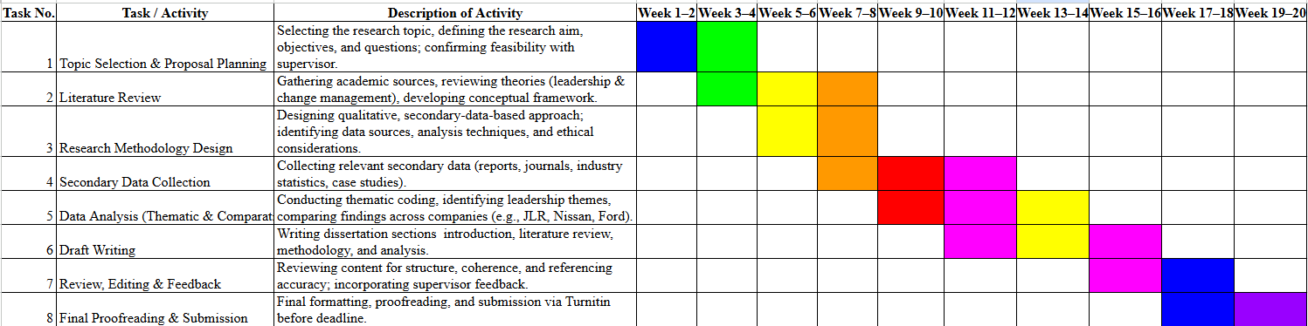

Figure 5: Gantt Chart
(Source: Self-Created)

3.9 Ethical Considerations of the research
The ethical integrity should be considered in the research even though the study is based on secondary data (Muthanna and Alduais, 2020). The researcher will ensure that the sources of data are all credible, cited and used according to academia. No confidential or proprietary information will be accessible.

4. Conclusion
The study highlights the primary role of leadership in facilitating effective organisational change in the UK automotive industry. According to the examination of the leadership theories, change management models, and the secondary information, it is possible to note that transformational, situational, and transactional leadership styles have varying implications on the outcome of the change. It is observed that effective communication, participation among employees, and dynamic leadership are substantial in the face of resistance and eventual successful implementation of change initiatives. The research confirms that there is no single leadership style that guarantees success and that the direction must be founded on the flexibility and location of different strategies to enhance the flexibility and performance of organisations.

References
Baker, Z. (2025). A Complete Guide to Kotter’s 8-Step Change Model in 2025. [online] Edstellar.com. Available at: https://www.edstellar.com/blog/kotters-8-step-change-model.
Braun, V. and Clarke, V. (2024). Supporting best practice in reflexive thematic analysis reporting in palliative medicine: A review of published research and introduction to the reflexive thematic analysis reporting guidelines (RTARG). Palliative Medicine, 38(6), pp.608–616. doi:https://doi.org/10.1177/02692163241234800.
Chmielewska, M., Stokwiszewski, J., Markowska, J. and Hermanowski, T. (2022). Evaluating Organizational Performance of Public Hospitals using the McKinsey 7-S Framework. BMC Health Services Research, [online] 22(1). doi:https://doi.org/10.1186/s12913-021-07402-3.
de Lima Rodrigues, A., Conceicao, J.P., Ribeiro, H.N.R. and Alves, S.R., 2022. THE RELATIONSHIP BETWEEN LEADERSHIP AND RESULTS IN THE AUTOMOTIVE SECTOR. Economic and Social Development: Book of Proceedings, pp.388-396.
Jasiński, D., Meredith, J. and Kirwan, K. (2021). Sustainable Development Model for Measuring and Managing Sustainability in the Automotive Sector. Sustainable Development, 29(6). doi:https://doi.org/10.1002/sd.2207.
Jungkunz, M., Köngeter, A., Mehlis, K., Winkler, E.C. and Schickhardt, C. (2021). Secondary Use of Clinical Data in Data-Gathering, Non-Interventional Research or Learning Activities: Definition, Types, and a Framework for Risk Assessment. Journal of Medical Internet Research, [online] 23(6), p.e26631. doi:https://doi.org/10.2196/26631.
Klein, G. (2023). Transformational and Transactional Leadership, Organizational Support and Environmental Competition Intensity as Antecedents of Intrapreneurial Behaviors. European Research on Management and Business Economics, [online] 29(2), pp.1–11. doi:https://doi.org/10.1016/j.iedeen.2023.100215.
Le, T.T. and Le, B.P. (2021). Mediating Role of Change Capability in the Relationship Between Transformational Leadership and Organizational Performance: An Empirical Research. Psychology Research and Behavior Management, [online] 14, pp.1747–1759. doi:https://doi.org/10.2147/PRBM.S333515.
Makri, C. and Neely, A. (2021). Grounded Theory: A Guide for Exploratory Studies in Management Research. International Journal of Qualitative Methods, [online] 20(1), pp.1–14. doi:https://doi.org/10.1177/16094069211013654.
Mancini, L.A. (2023). The Role of Change Management in Corporate Digitalization: The Relevance of Kotter’s Eight-step Change Model Within It/digitalization Projects - ProQuest. [online] Proquest.com. Available at: https://search.proquest.com/openview/f1d50c39e54d077dbf2875852c3a83f1/1?pq-origsite=gscholar&cbl=2026366&diss=y.
Miller, K. (2022). A Practical Explanation of Lewin’s Change Management Model. [online] Crowjack. Available at: https://crowjack.com/blog/strategy/change-management-models/lewins-model.
Munir, H. and Akhter, M. (2021). A Study on Association between the Perceptions of Principals and Teachers Regarding College Principals’ Leadership Style in Perspective of Situational Leadership Theory. Journal of Arts and Social sciences, 8(1). doi:https://doi.org/10.46662/jass-vol8-iss1-2021(147-155).
Muthanna, A. and Alduais, A. (2020). A thematic review on research integrity and research supervision: Relationships, crises and critical messages. Journal of Academic Ethics, 19, pp.95–113. doi:https://doi.org/10.1007/s10805-020-09368-z.
Nantunda, L. and Zhu, X. (2025). Igniting executives through reflective development with the composite leadership innovation and change model: a UK automotive manufacturing longitudinal study. Journal of Work-Applied Management. doi:https://doi.org/10.1108/jwam-02-2025-0041.
Priya C (2020). What is McKinsey 7s Model? Definition, Elements, Application, Advantages, Disadvantages - The Investors Book. [online] The Investors Book. Available at: https://theinvestorsbook.com/mckinsey-7s-model.html.
Rodríguez‐González, R.M., Maldonado‐Guzman, G. and Madrid‐Guijarro, A. (2022). The effect of green strategies and eco‐innovation on Mexican automotive industry sustainable and financial performance: Sustainable supply chains as a mediating variable. Corporate Social Responsibility and Environmental Management, 29(4). doi:https://doi.org/10.1002/csr.2233.
Sun, J., Sun, S., Chen, B. and Hu, Y. (2024). Charging change: Analysing the UK’s electric vehicle infrastructure policies and market dynamics. Energy Policy, [online] 191, p.114178. doi: https://doi.org/10.1016/j.enpol.2024.114178.
Vasel, H. (2025). Factors shaping the implementation of educational organizational change: An analysis of Lewin’s model in the context of teaching innovations. Social Sciences & Humanities Open, [online] 11(1), p.101599. doi:https://doi.org/10.1016/j.ssaho.2025.101599.

