REport: Airbnb
Natalie Emma Male 1702161


Dr Roisin Mullins

Contents

Executive Summary 1
Introduction 1
Business Model Canvas 2
Strategic Formulation Framework 6
Tools / systems 8
Conclusion 9

Executive Summary

The purpose of this report is to critically examine Airbnb as an example of the sharing economy. Evaluating the financial landscape, business model and strategy. The report will look at the organisations current challenges and suggest areas for future growth.

Introduction

Airbnb was established in 2008 as a peer-to-peer accommodation network provider. The organisation is part of the sharing economy, providing access to products and services. (Richardson, 2016) proposes “The sharing economy converges around activities facilitated through digital platforms that enable peer-to peer access to goods and services”. Airbnb’s business model has been successful, as it has promoted underutilised resources. (Schor, 2014) states that the “Sharing economy activities fall into four broad categories: recirculation of goods, increased utilization of durable assets, exchange of services, and sharing of productive assets”. Airbnb has achieved rapid growth and success due to the large pool of hosts and guests. There are many other Peer to Peer accommodation network providers, However Airbnb have established a competitive advantage.

Airbnb landscape
Air bnb has a multi sided marketplace business model, acting as an infomediary between suppliers and customers. Assisting to connect hosts and experience providers with travellers. The organisation generates income by receiving a commission from both parties. Airbnb is part of the sharing economy; their platform allows travellers to experience renting homes, in areas previously unattainable (Vann DeLoach, 2018) states that “The travel sharing economy has unique potential in developing markets. According to the United Nations World Tourism Organization, tourist arrivals in emerging economies are projected to grow by 4.4 percent annually”.
Due to the Covid-19 pandemic Airbnb’s operations have been seriously affected; the organisation faced difficult challenges. Their income is generated from rentals ,with the lockdown stopping all but essential, travel this presented a substantial crisis. This reduces the ability of promoting collaborative consumption “The COVID-19 crisis hit Airbnb just as badly as the rest of the hospitality industry: a quarter of its workforce had to be let go and the company expects 2020's results to be less than half of those of 2019”. Airbnb diversified into online experiences as a unique way of bringing its community of users together. They have also moved to long term rentals. The ability to change their business model so effectively, displays the organisations flexibility and adaptability in complex situations.
Analysis from UNWTO, shows the impact of Covid 19 on International tourism, displayed in image 1 below.
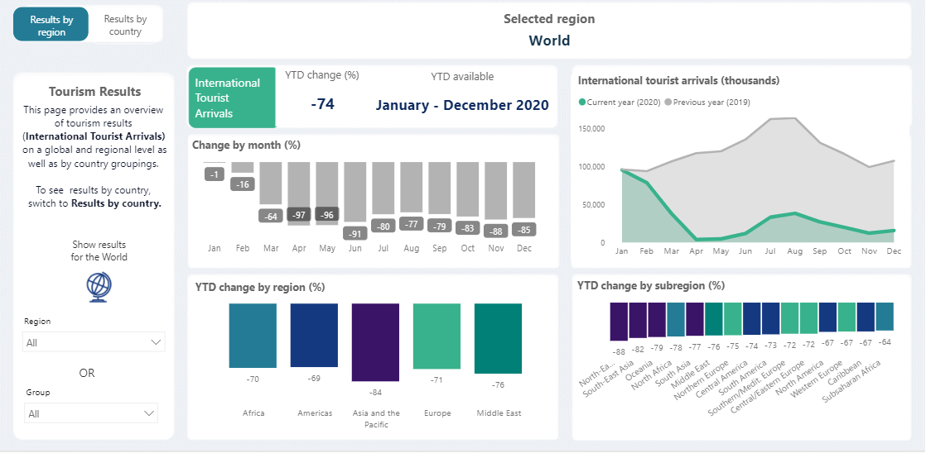
Image 1 (UNWTO, 2020)

Business Model Canvas

Developed by Osterwalder and Pigneur 2012, the business model canvas assists the organisation to create value. The business model canvas is a tool that assists organisations to gain an overall picture of their business. (Ojasalo & Ojasalo, 2018) proposes that “To be useful, a business model framework must be reasonably simple, logical, measurable, comprehensive and operationally meaningful”. However, it is not a strategy but determines how value will be created, captured, and distributed. It is a practical tool for strategic analysis and a snapshot of value offered. (Joyce & Paquin, 2016) propose that “The wide adoption and use of Osterwalder and Pigneur (2010) business model canvas suggests it is valuable for understanding and communicating an organization's business model and creatively supporting business innovation”. Although, it can be argued that the model does not focus on sustainability practises rather its emphasis is on profit and economic value.
Consisting of nine building blocks that structure how the organisation plan to generates income and in turn create value. An example of an already completed BMC for Air Bnb, is displayed in image 2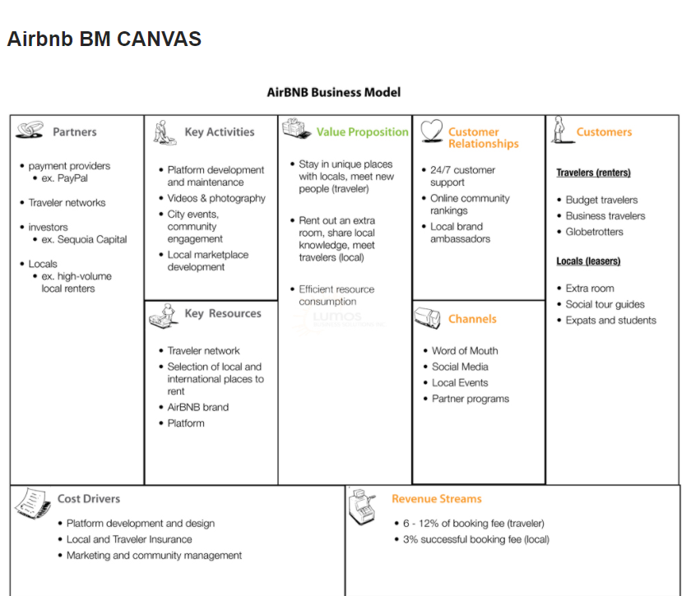

Image 2 (Business Model Canvas – Airbnb, 2019)
This BMC was developed in 2019, the following areas have been identified as relevant in 2021.

Value Propositions.
For the host risk is minimised, there are simple management tools, including a mini reservation system. The Airbnb platform is easy to join and utilise.
Guests are able to access to online experiences. Airbnb are providing long term accommodation to assist in the Covid-19 pandemic .

Key partners
Airbnb has partnerships with tourism bodies and communities. Technology companies, software partners are platforms used by the organisation. Although, they are also used other accommodation providers. Hosts that provide online experiences are offering an alternative option due to travel restrictions. New investment from the stock market will enable further growth.
Key activities
Continuing to improve on existing value propositions. The Launch of new products such as online experiences due to Covid -19 pandemic. New continued areas of expansion include Air bnb plus listings and diversifying into emerging markets.
Key Resources/ Assets
Capture of external data and user data with analytical capabilities .Strong brand image, Acquisitions of small start up companies and continued expansion.
Revenue streams
(Osterwalder & Pigneur, 2010) propose that “If customers comprise the heart of the business model, Revenue streams are its arteries”. Air bnb have recently sought investment as a way to grow the business. As a technical company they have started trading on the Nasdaq. Engaging in market placed growth will ensure a fluid income, a much-needed separate income stream given the current climate. Airbnb shares on the IPO have recently doubled in value. (Rushe, 2020) states that ” The share sale was priced at $68 a share but the company started trading at over $150 a share amid fierce bidding and closed the day at $144.70”. Investment creates a fluid income, engaging in marketplace means the organisation is seeking to grow creating a separate income stream.
Cost structure
Cost considerations include IT infrastructure and continued maintenance. Research and development, marketing, and advertisement. Payment processing and insurance.
Channels
Airbnb is promoted through word-of-mouth recommendation, digital marketing, advertising
Customer relationships
Customer relationships includes responsibility to hosts, guests and third -party providers. The wider community is also an important consideration for Airbnb.
Customer segments
There are many potential ways to segment both guests and hosts. As Airbnb is a multisided platform business, it is essential to segment both sides. Guests can be segmented by demographic, behaviour, motivation, and interest. Hosts can be segmented by experiences provided, location and accommodation type.
The business model canvas is a tool that needs to be continually updated. It offers a strong visual representation of current operations. Although, the market is constantly changing, the BMC requires constant review and modification. (Dolnicar, 2017) suggests that “In practice, the concept of a business model offers an additional advantage: while every firm has a business model because every firm creates value, not every firm has its future mapped out in a strategy”.

Strategic Formulation Framework

The Strategic Formulation Framework (SFF) is a three-stage framework. It was developed by Fred David in 2009. Kaplan and Norton’s score card model assisted the development of the SFF which was more comprehensive strategic tool. The framework provides a step-by-step model for organisations who perhaps cannot see what is of high importance. This aids strategic thinking and implementation and improves decision making. The stages are as follows:
Stage 1- The input stage, Similar to using Pestel, this stage summarises the basic information required to map out the strategies. Consisting of the External Evaluation Factor (EFE) the Internal Factor evaluation (IFE), similar to a swot analysis and the Competitive Profile Matrix (CPM).
Stage 2- The matching Stage, the focus is developing realistic alternatives strategies by coordinating key internal and external components. Consisting of Swot matrix. BCG Matrix and the Grand Strategy Matrix
Stage 3 -The decision phase requires Quantitative Strategic Planning Matrix (QSPM) Divulges the alure of alternative strategies, with an objective to selecting appropriate strategies.
The model has limitations for Airbnb as it cannot pinpoint value. It relies on internal knowledge, which is constantly changing. For those reasons, the model needs constant revision although it provides a snapshot of the value offer. The benefit of the model is that conversation opens areas for recognition .

The grand strategy matrix outlines two capacities- Market growth versus competitive location. There are four quadrants with strategic options. Large organisations use this model as it is designed to facilitate the evaluation and potential direction of an organisation . An example of the GSM is displayed in image 3.

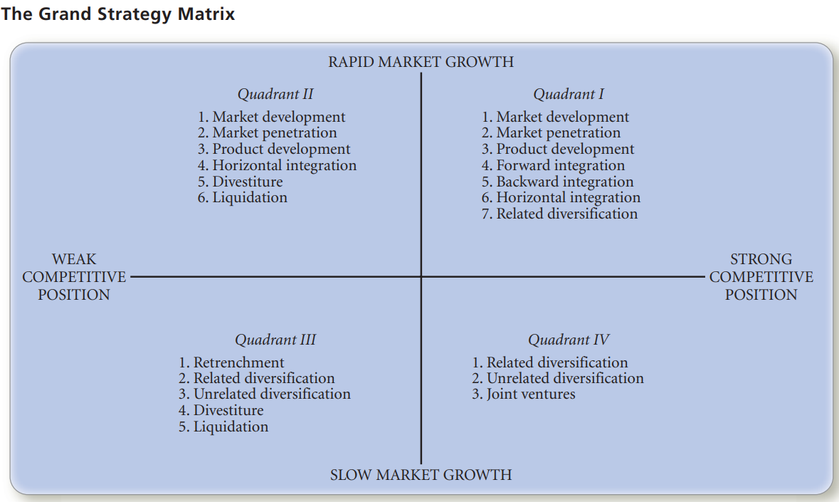
Image 3 (David, 2011)
Airbnb fits in Quadrant 1. The organisation has a strong competitive position with rapid market growth. Airbnb can utilise their strong market position to ensure continued growth. (Sanal & Torlak, 2007) state that “Firms located in Quadrant I of the Grand Strategy Matrix have a strong competitive position in a rapid growth industry. These firms should concentrate continuously on market penetration, market development, and product development strategies”.
Horizontal integration – Airbnb’s product development provides value with online and personalised experiences.
Forward integration- Air bnb’s strategy assists the business to expand, as it directly distributes its products and services.
Backward integration- Airbnb has purchased many small peer to peer providers who were in direct competition “Companies also use backward integration as a way of gaining competitive advantage and creating barriers to entry to new industry entrants”. (Backward Integration, 2015)

Tools / systems

As a multisided e- commerce platform, the organisation uses Amazon Web services “Instead of buying, owning and maintaining physical data centres and server, you can access technology services, such as computing power, storage, and databases, on an as-needed basis”. (What is cloud computing , 2021) This enables connection of all parties, C2C, B2B and B2C. The platform has a calendar to assists management of bookings, it also facilitates a large number of reviews.
There are many key tools and systems used by Airbnb :
Enterprise Resource Planning (ERP) systems connect all of the functional areas. It operates as a sole software programme running from a single database. (Dulebohn & Hoch, 2013) state that “ERPs are information systems that manage the business and consist of integrated software applications such customer relations and supply chain management, manufacturing, finance and human resources”. Airbnb purchases the modules they need including invoicing from host to customer. Inventory in this case property advertised. There is the capability to analyse data from customers. These modules are stored on AWS. The advantage of ERP is that it allows information to be shared across all departments of the organisation. Streamlining the everyday operation of the organisation. The benefit of cloud services allows Airbnb to free up resources. This can prove a more cost-effective way of accessing key resources. .

Customer relationship management systems (CRM) looks to form sustained long-term business with customers. (Chaffey, 2011) argues that “A customer relationship management system would increase customer loyalty, resulting in additional sales from existing customers.” Airbnb uses digital technology including Web 2.0 social media technologies to increase sales to new and existing customers. (Buttle & MaKlan, 2015) suggest that “Information technology companies have tended to use the term CRM to describe the software applications that are used to support the marketing, selling and service functions of businesses”. The organisation uses data mining, capturing information about customers and the discussions they are having. Algorithms-negotiate the coding-find elements . Adding value to their purchase partnership between host and guest, reviews determine conversations captured.
Airbnb uses the internet to push their campaigns and market their products. Pull is where customers establish contact with the platform seeking information. Sell side implementation builds customer relationships. Airbnb looks to build its network of hosts and client base. The organisations customers in Sell-side e commerce are B2C and B2B.
Supply Chain Management (SCM) coordinates Airbnb’s network links from the supply chain partners, and customers. Airbnb’s inventory is its booking system which contains all the information pertaining to its hosts and customers. (Lambert & Cooper, 2000) state that “Strictly speaking, the supply chain is not a chain of businesses with one-to-one, business-to-business relationships, but a network of multiple businesses and relationships”. The organisations Upstream supply chain is its network of hosts and example of Buy side e-commerce. The Downstream supply chain delivers products such as the booking system bringing customer to supplier and example of Sell side e-commerce.
It is difficult to recommend areas for future growth, the organisation appears to be a step ahead of other P2P accommodation network providers. Related diversification may be a consideration. The organisation has proved to be successful, and this could transfer to other business opportunities, penetrating other markets. However, this may not be successful, Airbnb may not have the same success in other markets they are not familiar with.

Conclusion

Airbnb has faced many challenges due to the Covid-19 pandemic. However, the organisation has maintained a strong market position and diversified into other products, such as online experiences and long- term rentals. Investment from the stock market has ensured a fluid income, enabling continued growth. This has proved invaluable in the current climate, in an industry that relies on the ability to travel. There is an opportunity for further expansion and to enter new markets outside of its current operations. Airbnb’s business model and application of relevant tools has proved to be successful. Other Peer to Peer accommodation network providers may look at Airbnb, as the template to follow in the future. W
References
Vann DeLoach, S. (2018, February 22nd). Airbnb is Just the Beginning: The Sharing Economy Comes to Emerging Markets. (W. D. Institute, Editor) Retrieved March 4th, 2021, from Next Billion: https://nextbillion.net/airbnb-just-beginning-sharing-economy-comes-emerging-markets/#:~:text=Airbnb%20is%20a%20prime%20example,an%20unused%20room%20or%20property.&text=Seventy%2Dsix%20percent%20of%20all,are%20outside%20traditional%20hotel%20sectors.
Backward Integration. (2015). Retrieved March 7th, 2021, from Corporate Finance Institute: https://corporatefinanceinstitute.com/resources/knowledge/strategy/backward-integration/
Business Model Canvas – Airbnb. (2019, May 6th). Retrieved March 3rd, 2021, from Lumo Business: http://lumosbusiness.com/business-model-canvas-airbnb/
Buttle, F., & MaKlan, S. (2015). Customer Relationship Management; Concepts and Technologies (3rd ed.). London : Routledge. Retrieved March 7th, 2021, from http://etonline-digitallibrary.com/bitstream/123456789/2802/1/1595.pdf
Chaffey, D. (2011). E-Business & E-Commerce Management: Strategy, Implementationand Practice (5th ed.). London : Pearson Prentice Hall. Retrieved March 7th, 2021, from https://r2.vlereader.com/Reader?ean=9780273752066#
David, F. R. (2011). Strategic Management : Concepts and Cases. Boston: Prentice Hall. Retrieved March 3rd, 2021, from http://www.mim.ac.mw/books/David's%20Strategic%20Management%20Concepts%20and%20Cases%2013e%20.pdf
Dolnicar, S. (2017). Peer to Peer accomodation Networks Pushing the Boundaries. Goodfellow Publishers Ltd. Retrieved March 7th, 2021, from OR https://library.oapen.org/bitstream/id/8c26ef66-8bbd-4aa2-ad44-e0e47d3bcc9e/640674.pdf )
Dulebohn, J. E., & Hoch, J. H. (2013). Shared leadership in enterprise resource planning and human resource. Human Resource Management Review, 114-125. Retrieved March 7th, 2021, from https://d1wqtxts1xzle7.cloudfront.net/51753999/Hoch_Dulebohn_HRMR_2013.pdf?1486852135=&response-content-disposition=inline%3B+filename%3DShared_leadership_in_enterprise_resource.pdf&Expires=1615159492&Signature=AfnlCpWOcgbVo3wHpYDjTP1SWHeNimef1h4l60Kdd8Zb
Joyce , A., & Paquin, R. L. (2016). The triple layered business model canvas: A tool to design more sustainable business models. Journal of Cleaner Production, 135, 1474-1486. Retrieved from https://www-sciencedirect-com.ezproxy.uwtsd.ac.uk/science/article/pii/S0959652616307442#sec2
Lambert, D. M., & Cooper, M. C. (2000). Issues in suply chain management. Industrial marketing management, 1-19. Retrieved March 7th, 2021, from https://d1wqtxts1xzle7.cloudfront.net/48847578/Issues_in_Supply_Chain_Management20160914-10065-5of6wa.pdf?1473916906=&response-content-disposition=inline%3B+filename%3DIssues_in_Supply_Chain_Management.pdf&Expires=1615160465&Signature=VpwM~1fN3Na9XXA49F4F
Ojasalo, J., & Ojasalo, K. (2018). Service Logic Business Model Canvas. Journal of Research in Marketing and Entrepreneurship, 1-30. Retrieved March 7th, 2021, from https://d1wqtxts1xzle7.cloudfront.net/56232219/Ojasalo.Ojasalo.JRME.2018.pdf?1522818549=&response-content-disposition=inline%3B+filename%3DService_Logic_Business_Model_Canvas.pdf&Expires=1615148279&Signature=SnTfZKwDUQRX~rw481MaHO2~ugmLFkHVTTLbmGyV1MfXm5M
Osterwalder, A., & Pigneur, Y. (2010). Business Model Generation.com: A Handbook for Visionaires, Game Changers and Challengers. New Jersey: John WILLEY & Sons. Retrieved March 5th, 2021, from https://r2.vlereader.com/Reader?ean=9780470901038#
Richardson, L. (2016). Performing the Sharing Economy. Durham: Durham Research Online. Retrieved March 7th, 2021, from https://dro.dur.ac.uk/20234/1/20234.pdf
Rushe, D. (2020, December 10th). Airbnb soars to near $100bn valuation as shares more than double in IPO. Retrieved March 5th, 2021, from The Guardian: https://www.theguardian.com/technology/2020/dec/10/airbnb-ipo-wall-street-share-sale
Sanal, M., & Torlak, N. (2007). DAVID’S STRATEGY FORMULATION FRAMEWORK IN ACTION:THE EXAMPLE OF TURKISH AIRLINES ON DOMESTIC AIR TRANSPORTATION. Istanbul: İstanbul Ticaret Üniversites. Retrieved March 7th, 2021, from https://moodle.uwtsd.ac.uk/pluginfile.php/473110/mod_resource/content/1/Strategic%20Formulation%20Frmaework%20Paper%20-%20Turkish%20Airlines%20implement%20Strategic%20formulation%20framework.pdf?redirect=1
Schor, J. (2014). Debating the Sharing Economy. Journal of Self-Governance and Management, 1-15. Retrieved March 7th, 2021, from https://www.icscarsharing.it/wp-content/uploads/2019/02/2014-Schor-Debating-the-Sharing-Economy.pdf
UNWTO. (2020, December). International Tourism and Covid-19. Retrieved March 7th, 2021, from World Tourism Organization: https://www.unwto.org/international-tourism-and-covid-19
What is cloud computing . (2021, March 7th). Retrieved from AWS: https://aws.amazon.com/what-is-cloud-computing/?trkCampaign=acq_paid_search_brand&sc_channel=ps&sc_campaign=acquisition_UK&sc_publisher=Google&sc_category=Core-Main&sc_country=UK&sc_geo=EMEA&sc_outcome=acq&sc_detail=amazon%20web%20services&sc_content={adg

