Learning Log Report
During this Learning log report there will be information regarding the Industrial revolution, the process of the formation and the history of Coal and Limestone. Also, there will be images and description about the University’s trip to Blaenavon, Big Pit.
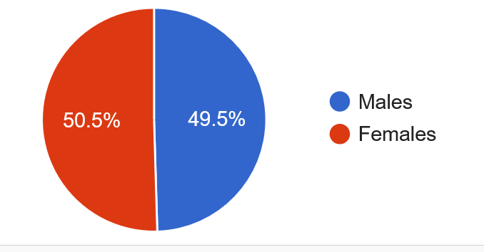
Blaenavon in English means ‘front of the river.’ Blaenavon grew around the Ironworks and coal mines heritage which is based just a small walk outside of Blaenavon town. Blaenavon as a town has a population of 2,958 males and 3,013 females. (Population, 2018)
Blaenavon Iron Works
Blaenavon Ironworks is one of the heritage sites in Blaenavon and is one of the main features which is on the Industrial landscape. The ironworks which commenced production in 1789, is the one of the best-preserved blast furnace complexes of its period and type in the world. Blaenavon Ironworks is historically significant as during the early nineteenth century the ironworks was one of the most important producers of iron in the world. Now, you can go to Blaenavon Iron Works and view the remains of the blast furnaces, the cast houses and impressively restored Water Balance Tower. There are exhibitions, interpretation features and reconstructions. This is a fascinating insight into the social history or industrial Britain. The Iron works is now managed by Cadw Welsh Historic Monuments, because of the work which the site has received record breaking numbers. (Wales, 2020)
Limestone is a hard-sedimentary rock composed mainly of calcium carbonate or dolomite used as building material and in the making of cement. Limestone is used as a building material. (King, 2005)
Coal Mine – Big Pit
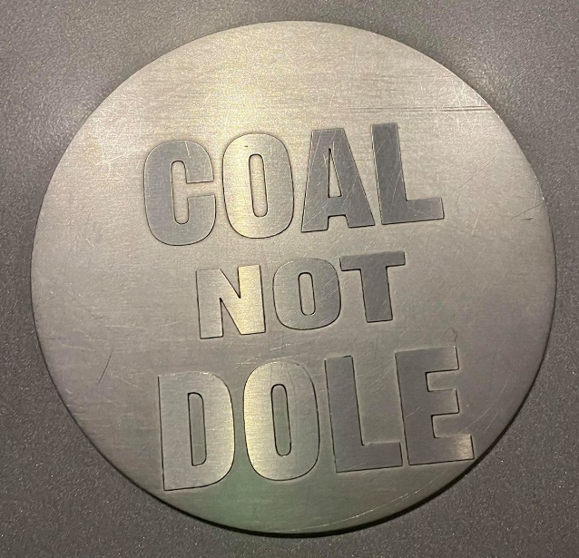
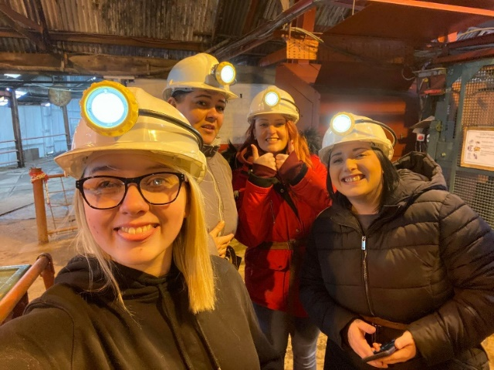
Big Pit, otherwise known as The National Coal Museum of Wales, this is one of the industrial landscapes in Blaenavon. Big Pit was a working coal mine from 1880-1980m it was opened to the public in 1983, this was under the watch of National Museum of Wales. Since the over three million people have been welcomed to the site and with the ever-growing popularity Big Pit will continue to bring global attention. (PIT, 2018)
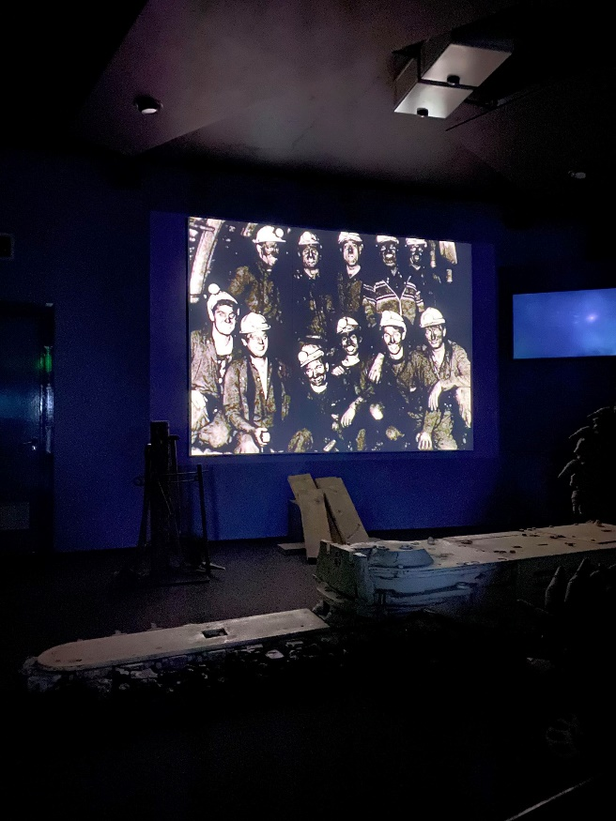
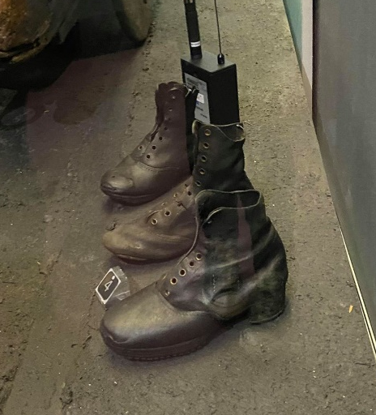
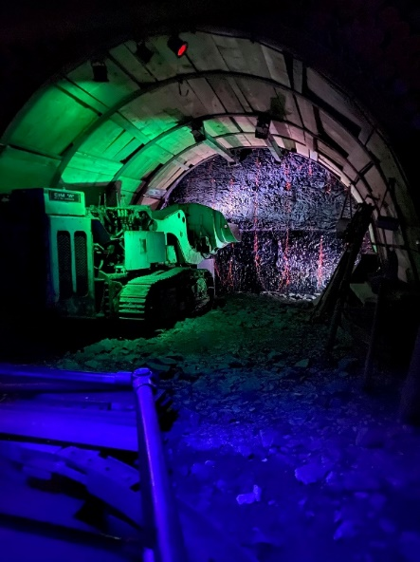
During a University of Wales Trinity St David trip to Big Pit, coal mine in Blaenavon we found out that Big Pit is a network of coal workings which were established in Blaenavon.
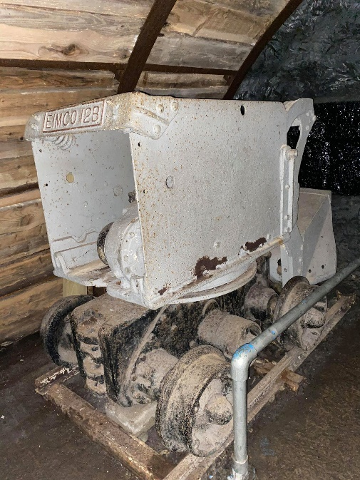
When we were at Big Pit first of all we all got given hard hats, torches and a small amount of oxygen for if anything bad was to happen to underneath in the pit. (In the photo is me and 3 other university students ready) During the time underneath the pit we weren’t allowed to bring any form of technology, smoking supplies, keys or jewellery. This is because of the different types of gases which are underground and any spark which may come off of these items. Whilst we were underneath, we were shown what conditions which the miners would have to work in, some would have to work on their stomach, eat their lunch on their stomachs and they wouldn’t move until they have completed their 12-hour day. In the mines there would be children aged 4 and above working on the doors and listening out for the horses to be able to open the doors to let the horses come through and also to let the workers to come through too. The child on the doors had the most important role in the whole of the mining community, if the child left a door unattended/opened it would mean that there was more likelihood of the air in the mines to become carbon dioxide and for their to be lack of or if any oxygen for the working miners. Before the 12-hour shifts would start, it would be 2 miners would volunteer, at the time of the mining days everyone would volunteer as they all felt part of a family and they all wanted to risk their own lives for the other miners. So, these miners would go under with a small bird, usually a canary and if the canary started to weaken the they knew there was lack of oxygen so they would get out of the mine and go and report back.
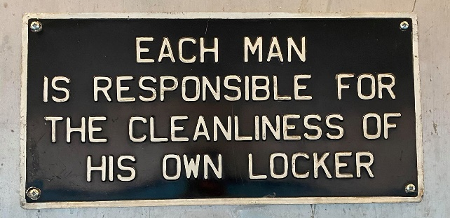
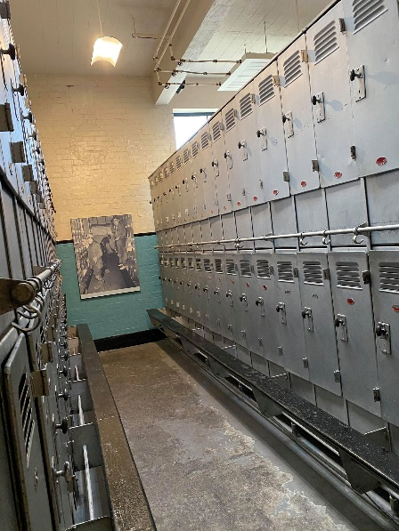
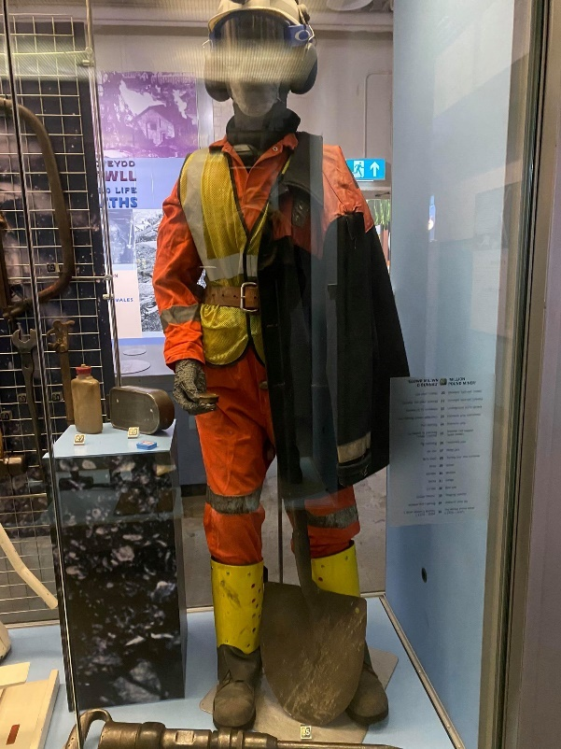
After the tour was done, we went into the virtual museum and we saw how they used to drill through the limestone to be able to get to the coal. We also saw how they would look when they went down the mines. Once this was done then we went to the museum when they showed us how the miners would wear, would signage would be around even down to the lockers. Society down the mine was very much a family spirit everyone was there for the same reason, everyone was there to dig coal, and all go home hopefully the way they went to work, if there was any injuries down the mine then it is was a big family again because everyone wanted to look after everyone.
Summary
In conclusion, it is so important that society remember the pain, blood and the warrior ways of the mining community. During the experience of going under in the mines in Big Pit. I felt emotional knowing children the age of younger family members would be in the mines in the wet and cold probably picking up all of sorts of diseases. I think it is important that everyone needs to remember the struggles that miners go through even today to be able to give people the coal they needed and still need today in some cases to be able to heat their homes.

Bibliography
King, H. M. (2005). Limestone. Retrieved from Geology.
PIT, B. (2018). BIG PIT - Brief History . Retrieved from Visit Blaenavon: https://www.visitblaenavon.co.uk/en/Publications/Blaenavon-Story/Big-Pit.pdf
Population, C. (2018, December 30). City Population - Blaenavon, Torfean. Retrieved from City Population: https://www.citypopulation.de/php/uk-wales.php?cityid=W37000366
Wales, C. (2020, Janurary 2nd ). Blaenavon Ironworks. Retrieved from Visit Blaenavon : https://www.visitblaenavon.co.uk/en/VisitBlaenavon/ThingsToDo/BlaenavonIronworks.aspx

