UWTSD
Matthew Jay
2516508
Preliminary Site Investigation Case Study
Proposed Restaurant and Mixed-Use Development

Contents
1.0 Introduction & Proposed Development 3
1.1 Background 3
1.2 Objectives 3
1.3 Information Sources 3
1.3 Physical Setting & Current Site Use 4
3.0 Historical Background of the Site 5
4.0 Recommendations for Detailed Site 8
4.1 Geological Appraisal 8
4.1.1 BGS Borehole Information 8
4.1.2 Ground Subsidence (High Risk) 9
4.1.3 Mining Remediation Authority and Mining Data (Low Risk) 9
4.2 Environmental Appraisal 10
4.2.1 Contamination Testing (High Risk) 10
4.2.2 Groundwater (High Risk) 10
4.3 Fauna (Low Risk) 11
4.2.4 Radon Gas (Low Risk) 11
4.2.5 Site of Special Scientific Interest (Low Risk) 11
4.3 Archaeological Appraisal 13
4.3.1 Geophysical Survey (High Risk) 13
6.0 Conceptual Ground Model 14
8.0 Site Summary 15
8.1 Proposed Foundation Type 16
10.0 Bibliography 17
10.1 Standard Publications 17
10.2 References 18

Executive Summary
Site Location and Proposed Development | Swansea City Council and Marriott Hotels (the Clients) are proposing the construction of a new residential development between county hall and The Marriott Hotel.  The site centres on an approximate national grid reference of SS 65384 92328, occupying a plan area of approximately 2000m2
Site History | The majority of the site was once consisted of mudflats, saltmarsh and dunes. There was a dock introduced in 1852 and then heavy industrial units followed including railways.
Geology | The underlying geology comprises of made ground, and boulder clay. There is no indication of coal seams with the nearest located circa 500m north of the proposed site.
Radon | The UK Radon maps indicate that there is <1% Radon potential.
Coal Mining Risk Assessment | The site is not deemed to be at risk from past mining.
Ground Conditions | Shallow ground conditions are likely to comprise made ground, likely from buildings destroyed in WWII bombing events.
Contamination of Concern | Due to the former industrial use of the land, it is deemed likely that there is some form of contamination with the likes of heavy metals, Hydrocarbons, sulphates and Asbestos being present.
Foundation Solution | Based upon the desk study information, it is advised that the site is piled to provide the structural integrity from tidal influences with a reinforced raft to evenly distribute load over soft ground to avoid subsidence.
Recommended Site Investigation | It is recommended that an intrusive investigation comprising trial pitting should be completed to determine the shallow ground conditions and to take soil samples for contamination and geotechnical testing.

Introduction & Proposed Development

1.1 Background
The City and County of Swansea plan to partner with Marriott Hotels (The Clients) to build a new restaurant and ice-cream parlour on the Swansea foreshore, between County Hall and the Marriott Hotel. The building will have a ground floor area of about 2,000 m² and include a restaurant, café bar, ice-cream parlour, kitchen and storage facilities. The second floor will feature a manager’s apartment, meeting rooms and staff facilities. The design includes a glass façade and opens onto the promenade.
This report comprises a Tier 1 (Desk Study) including a Preliminary Geoenvironmental, Geotechnical and Coal Mining Risk Assessment.

1.2 Objectives
The preliminary geotechnical assessment aims to review the site’s history and surroundings, identify potential contamination risks (soil, groundwater, gas), assess ground conditions, develop an initial conceptual site model, carry out a preliminary risk assessment and guide further site investigations The assessment focuses on identifying potential ground-related risks to the development, including any hazards from past coal mining activity (Austruy, 2022).

1.3 Information Sources
The following sources of information have been referenced in this report:
- British Geological Map Sheet
- Coal Authority Website
- Data Map.Gov.Wales
- Google Maps
- Freemap tools
- National Grid
- Zetica map

1.3 Physical Setting & Current Site Use
The site is located on Dunvant Place, Waterfront, Swansea, Wales, SA1 3SA, United Kingdom. The site centres on the approximates National grid reference SS 65384 92328.
The local authority is: City and County of Swansea, The Guildhall, Swansea SA1 4PE - Email: bcon@swansea.gov.uk /Telephone: 01792 636000
Its current use is for car parking, with an access point for vehicles to the promenade.
The site borders with the Swansea Council Civic Centre and the Marriott Hotel.
There are residential properties and a tower block to the east of the development, the only access road to these properties is running along the northern border the of the site.
The site elevation is approximately 9m AOD.
The site itself has good access just off Oystermouth Road, however, building works may cause disruption for residents of Swansea Marina with the possibility of road closures needed. It removes a large portion of the parking available to neighbouring buildings.
The site location can be seen on the map provided below:
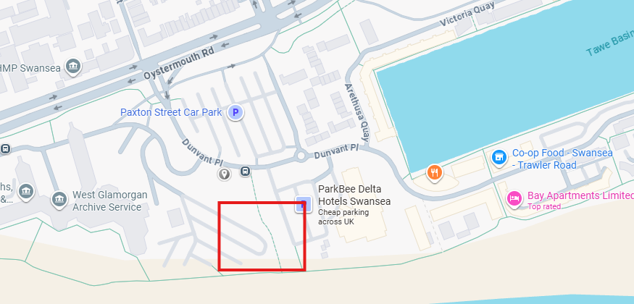
(Google maps)

3.0 Historical Background of the Site
Historical maps of the site have been obtained via the ordnance survey and the Welsh government website.
Early mapping from the ordnance survey indicates that prior to the construction of the dock, the land was mainly made up of mudflats, Salt Marsh and dunes running adjacent to the River Tawe.
The south dock was constructed between 1852-1859 as part of the expansion of Swansea’s role in global shipping of copper and coal (Hughes, 2000). Key features that are shown on the ordnance survey maps are the formation of an enclosed dock basin and dock walls.
In the late 19th - early 20th Century was when Swansea hit its industrial peak. The OS maps show the transformation into a highly industrialised landscape with rail networks feeding into the large industrial buildings and surrounding dockland area. There is also evidence of coal storage facilities and increased dockland.
During 1941-1943 because of its standing in world trade at the time, Swansea was targeted by enemies of the UK. There were over 1200 high explosive and 56,000 incendiary devises dropped which destroyed over 40 acres of land. Whilst the town recovered it is plausible that the fill as made up of rubble from the destroyed buildings (Swansea.gov, 2026). The Zetica map below provided shows the risk of finding an un exploded bomb.
During the mid-late 20th Century, the OS maps show the gradual decline in industrial activity including the removal of coal tips and rail infrastructure. This represented the shift to general cargo handling rather than the large exports that used to take place in Swansea (Hughes, 2000).
Following the close of the dock in 1971 the area went under extensive redevelopment, the process involved the demolition of warehouses, rail yards and industrial buildings. Many features that were once visible on the OS mapping were therefore completely erased or buried such as coal tip foundations, rail track bed, earlier lock structures and previous industrial building footprints (Glamorgan Archives, 2010).
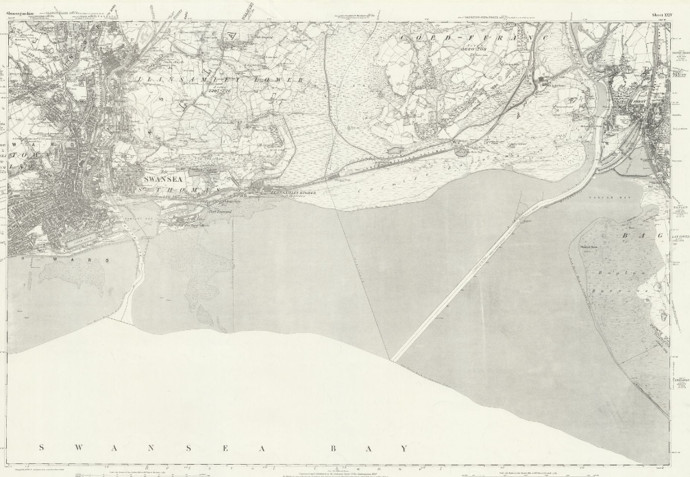
(Ordnance Survey, 1850, cited in Swansea Archives, 2024)

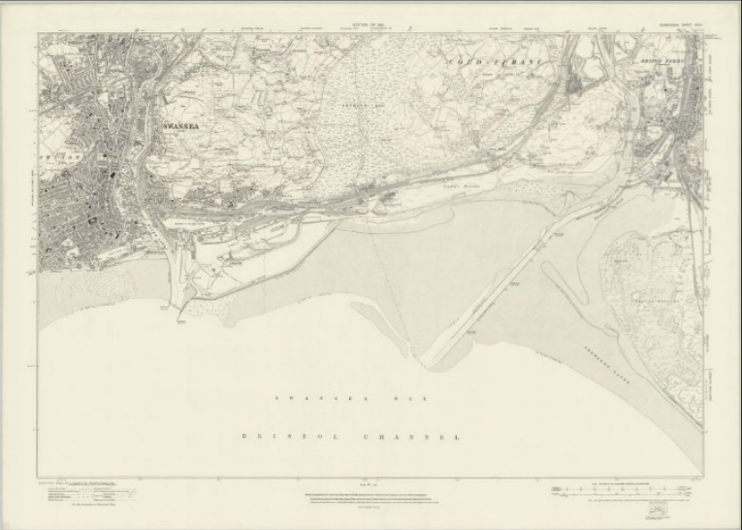
(https://maps.nls.uk/os/townplans-england/swansea.html)
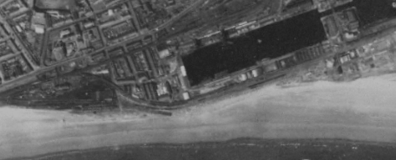
(Swansea, 1947) – Data Map Wales - https://datamap.gov.wales/maps/apu-welsh-government-aerial-photography/view#/

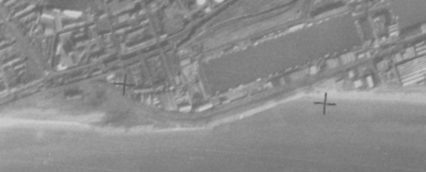
(Swansea, 1969) – Data Maps Wales https://datamap.gov.wales/maps/apu-welsh-government-aerial-photography/view#/

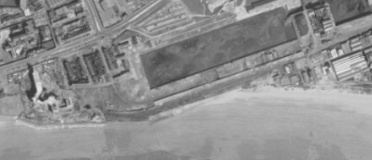
(Swansea, 1981) - Data Maps Wales https://datamap.gov.wales/maps/apu-welsh-government-aerial-photography/view#/

4.0 Recommendations for Detailed Site

4.1 Geological Appraisal
The site investigation should comply with BS 5930:2015 (BSI, 2015) and Eurocode 7 (BSI, 2004).

4.1.1 BGS Borehole Information
A search of the British Geological Survey (BGS) GeoIndex has been undertaken for available borehole records on, or in proximity to the site.
The Meridian Tower development provided borehole data that is very close to the development site ref: SS69SE345. The borehole was 22m deep and indicates the following representative stratigraphy:
- Made Ground (0-5m)
- Sand and gravel layers (5-8m)
- Boulder Clay (8-22m)

4.1.2 Ground Subsidence (High Risk)
Based on the information provided by the borehole logs, it can be assumed the risk of ground subsidence is high. Soft alluvial clay is compressible and prone to movement under load. Due to the made ground and clay elements there is risk of geotechnical settlement (Craig, 2004). It is therefore recommended that further borehole investigations completed of the site to confirm the strata makeup.

4.1.3 Mining Remediation Authority and Mining Data (Low Risk)
The Mining Remediation Authority online viewer indicates the site is located within a coal mining reporting area, but not within a development high risk area.
Mine Entries
The closest mine entry site is circa 2km north of the proposed development.
Outcrops
No outcrops are shown crossing the site.
High Risk Areas
There is a high-risk development area around 500m north of the site.
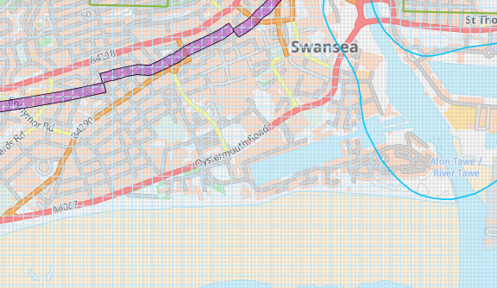
(Mining Remediation Authority, 2026)

4.2 Environmental Appraisal

4.2.1 Contamination Testing (High Risk)
In accordance with BS 10175 (BSI, 2011) soil sampling should test for:
- Heavy Metals
- Hydrocarbons
- Sulphates
- Asbestos
Due to the heavy industry that was situated on or close to the site and the nature of the proposed development being a food service, it is particularly significant that the contamination testing is completed.

4.2.2 Groundwater (High Risk)
Assessing the groundwater risk is vital as it can directly affect the safety and structural integrity of the proposed development. Failure to properly assess the potential groundwater levels, flow and quality before and during the construction phase can lead to severe issues such as excavation collapse (sink holes), flooded worksites, damage to neighbouring structures and project delays (Richardson and Thomas, 2016).
According to the Natural Resources Wales website, there is small patch of high-risk flooding near the development due to surface water and small watercourses. This type of flooding usually occurs when water does not drain or soak away. Given the current site is partially a car park it could explain the gathering of water (Natural Resources Wales, 2026).
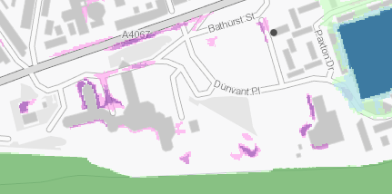 (NRW)
Due to the closeness of the proposed development to the estuary it is advised that further analysis is completed to ascertain the risk. Groundwater is influenced by tidal variation due to proximity to the estuary (BGS, 2023).

4.3 Fauna (Low Risk)
The risk is low due the site already being used as a car park. The amount of animal life that could be found within the vicinity is minimal.

4.2.4 Radon Gas (Low Risk)
According to the UK radon maps, the risk associated with radon on this site is <1% therefore deemed low risk.
Further guidance on reducing the concentration of radon in new buildings, extensions, conversions and refurbishment projects, in order to reduce the risk to occupants, is provided in BR:211:2023.
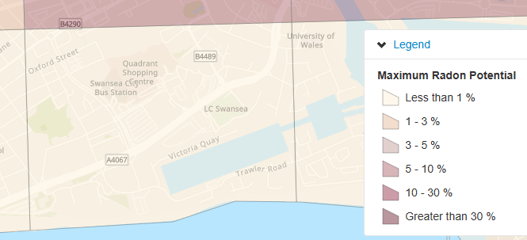
(https://www.ukradon.org/information/ukmaps)

4.2.5 Site of Special Scientific Interest (Low Risk)
The closest SSSI to the proposed development is Blackpill beach situated around 3 miles away. It is recognised for its importance for migratory birds. The Mud and sand provide the suitable habitat for many marine invertebrates which supplying a good food source.
An activity that may cause disturbance to this site is the potential vibrations piling that will need to be complete. Due to the distance from the development this has been categorised as low risk.

4.3 Archaeological Appraisal

4.3.1 Geophysical Survey (High Risk)
What lies beneath the sit has the potential to cause significant disruption to the building schedule. Using a penetrating radar, it could identify the location of a buried dock wall, obstructions or service remnants. It is quite possible that as the site is reclaimed docklands that there are undocumented buried structures (Smith, 2008)
Due to the number of explosives that were dropped over Swansea during WWII and the risk map provided by Zetica, it can be assumed the risk of finding an unexploded bomb is fairly high. It is advised that specialised geophysical survey is completed to mitigate risks. A non-intrusive UXO survey should be completed before works begin (RICS, 2026)
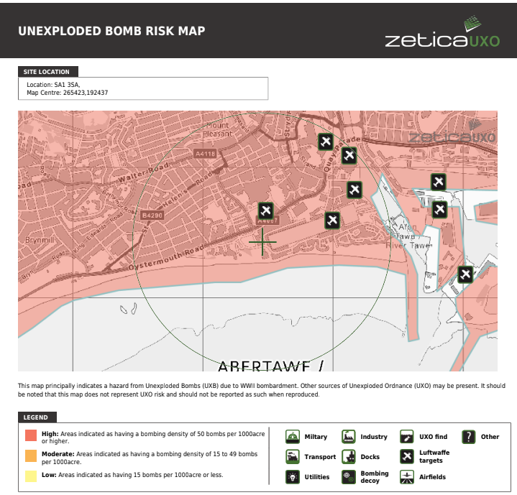(Zetica, 2026)

6.0 Conceptual Ground Model
The below table represents the potential contaminant linkages between contaminants, pathways and receptors that have been released during this preliminary assessment.
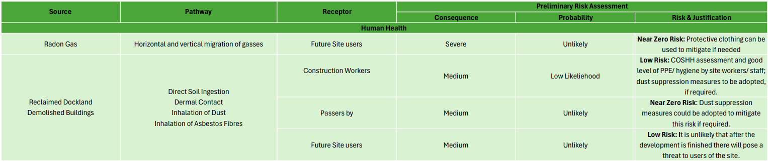

8.0 Site Summary
This preliminary desktop investigation has identified that the proposed development site is located on historically reclaimed dockland formed from tidal estuary deposits and industrial infill dating back to the nineteenth century. Archival mapping and geological data indicate the presence of made ground overlying deep boulder clay, with tidal groundwater influence.
The principal geotechnical risks include differential settlement, high groundwater levels and potential land contamination. Of these, the most risk-significant issue is compressible alluvial clay underlying variable made ground, which presents a high probability of long-term settlement if shallow foundations were adopted.
A detailed site investigation in accordance with BS 5930:2015 and Eurocode 7 is essential prior to detailed design. Particular emphasis should be placed on borehole investigation, groundwater monitoring and contamination testing.
Early identification and management of these geotechnical risks will reduce construction uncertainty, control costs and ensure compliance with Building Regulations and environmental requirements.

8.1 Proposed Foundation Type
For this development it is advised that the ground is first piled to ensure stability and combined with a reinforced raft foundation. Justification for this type of foundation is that:
- Borehole information suggests there is soft clay under the site this type of foundation transfer’s load
- Minimises the settlement risk
- Suitable in High Groundwater
- Comes with low vibrations to protect the nearby hotel structure.
This is also a common solution across the Swansea marina developments. Shallow foundations are not recommended due to compressible alluvial clay (Craig, 2004).
Building Footprint: 2,000m²
Assume pile grid at 3.0m centres.
Pile diameter: 450mm
Pile spacing: 3.0m centres
Ground beam: 600mm depth x 600mm width
Slab thickness: 200mm reinforced
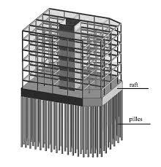
(Szołomicki and Golasz-Szołomicka, 2021)

10.0 Bibliography

10.1 Standard Publications
British Standards Institute, 1990. BS 1377-9: Methods of test for soils for civil engineering purposes - In-situ tests. London: BSI.
British Standards Institute, 2013. BS 8576. Guidance on investigations for ground gas. Permanent gases and Volatile Organic Compounds (VOCs). London: BSI
British Standards Institute, 2013. BS EN 1997-1:2004+A1. Eurocode 7. Geotechnical design – General rules. London: BSI.
British Standards Institute, 2015. BS EN ISO 14001: Environmental management systems. Requirements with guidance for use. London: BSI.
British Standards Institute, 2017. BS 10175:2011+A2: Investigation of potentially contaminated sites. Code of practice. London: BSI.
British Standards Institute, 2018. BS EN ISO 45001: Occupational health and safety management systems. Requirements with guidance for use. London: BSI.
British Standards Institute, 2019. BS 8485:2015+A1. Code of practice for the design of protective measures for methane and carbon dioxide ground gases for new buildings. London: BSI.
British Standards Institute, 2020. BS 5930:2015+A1: Code of practice for ground investigations. London: BSI.

10.2 References
Austruy, S. (2022). What does a geotechnical report tell you? [online] Douglas Partners. Available at: https://www.douglaspartners.com.au/knowledge-sharing/what-does-a-geotechnical-report-tell-you/. [Accessed April 2026]
British Geological Survey. GeoIndex Onshore. Available at: https://mapapps2.bgs.ac.uk/geoindex/home.html [Accessed April 2026]
Craig, R.F. (2004) Craig’s Soil Mechanics. 7th edn. London: Spon Press.
The Coal Authority. Interactive Viewer. Available at: https://mapapps2.bgs.ac.uk/coalauthority/home.html [Accessed April 2026]
Environment Agency. Land contamination risk management (LCRM). Last updated 20 July 2023. https://www.gov.uk/government/publications/land-contamination-risk-managementlcrm [Accessed April 2026]
Environmental Protection Act 1990. c.43. Part IIA Contaminated Land. Available at: https://www.legislation.gov.uk/ukpga/1990/43/contents [Accessed April 2026]
Google Maps. Available at: https://www.google.com/maps [Accessed April 2026]
History Points. “History Points - Swansea Marina.” Historypoints.org, 2012, historypoints.org/index.php?page=swansea-marina. [Accessed April 2026]
Hughes, S. (2000) Copperopolis: Landscapes of the Early Industrial Period in Swansea. Aberystwyth: Royal Commission on the Ancient and Historical Monuments of Wales.
Naturalresources.wales. (2026). Natural Resources Wales / Different types of flood risk. [online] Available at: https://naturalresources.wales/evidence-and-data/maps/different-types-of-flood-risk/?lang=en#risk-of-flooding-from-surface-water-and-small-watercourses [Accessed 11 Apr. 2026].
RCAHMW. “English – Coflein.” Coflein.gov.uk, 2021, coflein.gov.uk/en/sites/300024. [Accessed April 2026]
Richardson, D.G. and Thomas, D.S. (2016). Management of Groundwater Risks to the Water Industry (2016) |. [online] Waterprojectsonline.com. Available at: https://waterprojectsonline.com/case-studies/management-of-groundwater-risks-to-the-water-industry/ [Accessed April 2026]
RICS (2026). Surveyor’s guide to unexploded ordnance. [online] ww3.rics.org. Available at: https://ww3.rics.org/uk/en/journals/land-journal/surveyors-guide-to-unexploded-ordnance.html. [Accessed April 2026]
Smith, J. (2008) ‘Reclaimed Docklands and Foundation Engineering’, ICE Proceedings Geotechnical Engineering, 161(3), pp.145–154.
Swansea. (2023). Remembering the Swansea Blitz - Swansea. [online] Available at: https://www.swansea.gov.uk/article/7102/Remembering-the-Swansea-Blitz [Accessed April 2026]
Szołomicki, J. and Golasz-Szołomicka, H. (2021). The Modern Trend of Super Slender Residential Buildings. Budownictwo i Architektura, 20(1), pp.083-116. doi:https://doi.org/10.35784/bud-arch.2068.
Zetica UXB Risk Maps. Available at: https://zeticauxo.com/guidance/risk-maps/ [Accessed April 2026]

