Site investigation case study
By Victoria Weeks

Table of Contents
1 Introduction 2
1.1 General 2
1.2 Development Proposals 2
1.3 Objectives 3
1.4 Scope of Works 3
2 Summary of Desk Study Report 4
2.1 Site Location and Description 4
2.2 Site Walk Over 4
2.3 Site History 5
2.4 Special considerations 5
2.5 Unexploded Ordnance 6
2.6 Geo-Environmental Setting 6
3 Recommendations for intrusive investigation report 9
4 Building Regulations/ Codes of Practice 10
5 Indicative foundation solution sketch 11

Introduction

General

City and County of Swansea are entering into a joint agreement with Marriot Hotels to create a new restaurant and ice-cream parlour, with manager’s apartment, on Swansea foreshore. This desk study for the proposed site was prepared by Victoria Weeks.

See image below from UK Grid Reference Finder (Grid Reference Finder), of proposed site. Grid reference- SS653923.

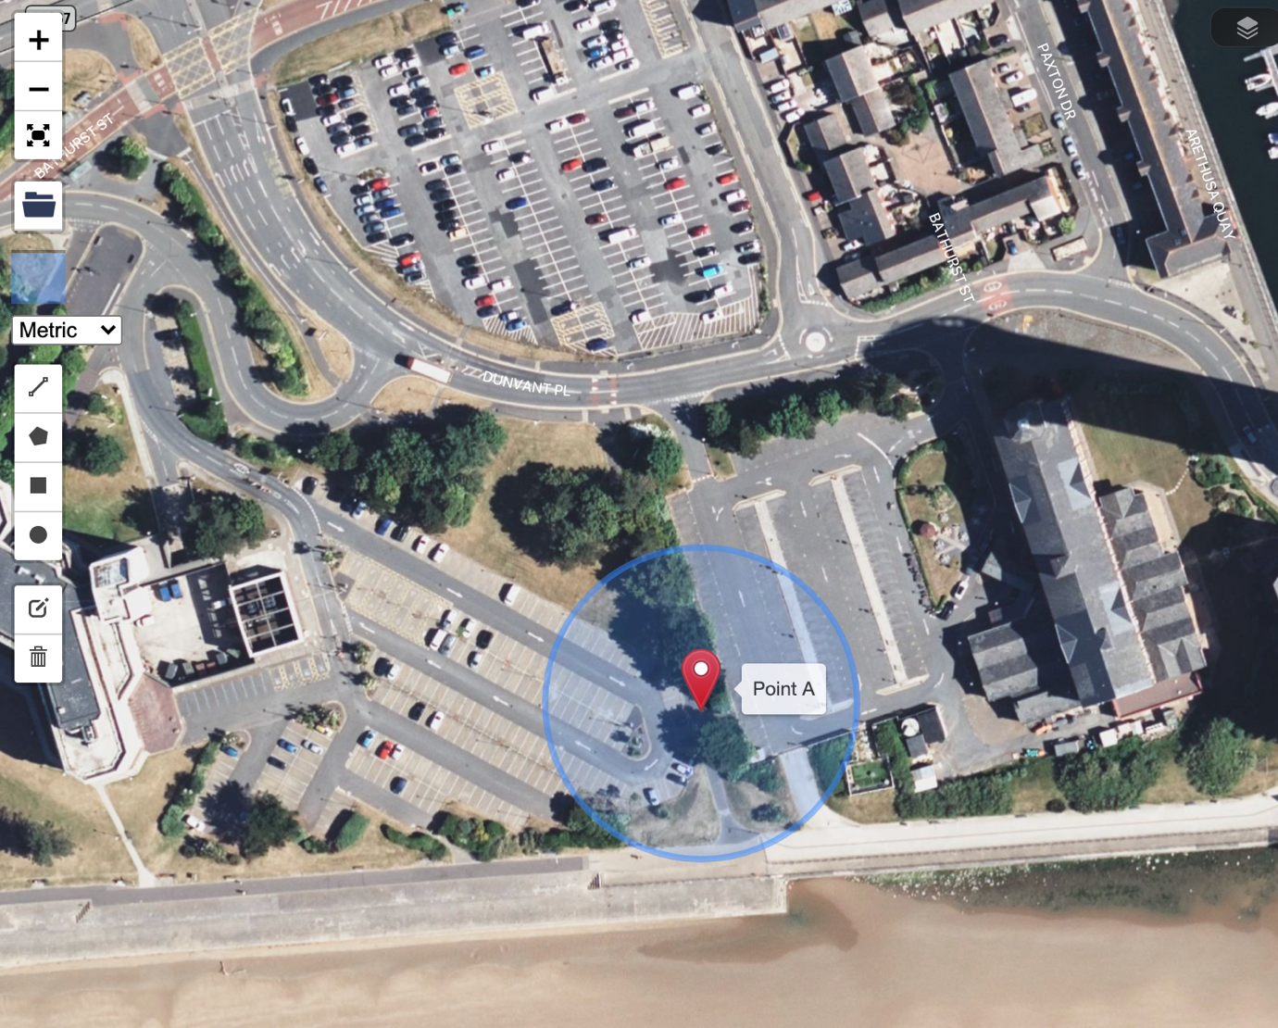
Image 1- Location tag from grid reference finder.

Development Proposals

The site is located between County Hall and the Marriot Hotel. The building, which is to share parts of the car park of both existing adjacent facilities, is to have a GIA at ground floor level of approximately 300 square metres. The building is to contain the restaurant, café bar, ice-cream parlour, kitchen, food-stores etc. At second floor level, there is to be a self-contained manager’s apartment and staff welfare facilities. This project is procured via a Design and Build contract.

Objectives

The objective of this desk study is to present the findings from historical maps and borehole data to provide further recommendations for a detailed ground investigation to characterise the site ground conditions. The results of the desk study reviewing existing data for; environmental, geotechnical, ground gas and groundwater, archive materials have been used to support this assessment and develop preliminary geotechnical parameters to highlight any potential geo-environmental constraints and direct preliminary designs.

Scope of Works

The scope of this report includes the following:
• Description of historical map data
• A review of historical land use to characterise possible ground conditions and potential areas of contamination
• A preliminary ground gas risk assessment
• Completion of a preliminary geotechnical assessment
• Development considerations and recommendations for mitigation measures and/or remedial works required as part of the proposed development (if any)
•Provide further recommendations for intrusive ground investigation to support conclusions made within this report

Summary of Desk Study Report

Site Location and Description
The following table provides a summary of the site conditions and layout of the site:

Table 2.1
Site Information | Details
Description | The proposed site is square on plan and straddles both the boundaries. Adjacent is the promenade along Swansea bay’s foreshore. The site is a combination of hard surfaced impermeable paving (tarmac) for car parking and soft landscaping features with large trees and viewing platform area for the hotel.
Surrounding Area | The site is bounded to the north by Dunvant Place, to the east by The Marriott Hotel, to the south by the coastline and promenade and to the west, by County Hall.
Known Services | From a site walk over, there were existing electrical, water, mains and fowl services. It is likely that there will be data cables under the road, on the north boundary of the site. There were large manhole chambers within the site boundary that may need to be altered or moved, for the proposed works.

Images depicting the proposed site are shown in Appendices 1 and 2.

The archived borehole log obtained (shown in Appendix 3), show that the natural tidal flat deposits are beneath approximately seven metres of made ground. The made ground comprises of multiple variations and different types of made ground, which may be attributed to the site’s former use as an engine house and railway line. It can also be assumed that the made ground assists with tidal defence and helps to support the promenade.

It may also be assumed that the current site level, meets the minimum requirements for any planning consent stipulations, to suit any 1-to-100-year storm or sea flood events. This is assumed, as both the County Hall and Marriott Hotel are both situated closely to the site, with very similar levels. This would need to be confirmed and verified with the local authority and relevant parties.

Site Walk Over

A site walkover was conducted to identify any noticeable limitations or issues. The site has good accessibility through the carpark of the Marriott Hotel, with enough space for large machinery to obtain access to the proposed site (See Appendix 4). There is also access available through the County Hall car park, however, entry is restricted by small winding roads and barriers, so would not be suited for lorry deliveries or large machinery (See Appendices 5 and 6).

From the site walk over, the site appears to be covered by a mixture of permeable and impermeable parking surfaces. There is soft landscaping in the centre of the site and around its perimeter. There is existing street lighting for the promenade, as well as for the car parks, which would indicate that there are working electricity cables, close to the site. Also, several manhole chambers and road gulleys could be seen, which indicates that surface water and fowl drainage services are nearby and can be accessed for the site, subject to assessment and with the relevant permissions. The soft landscaping holds large trees and vegetation and is near the sea, therefore a further ecology survey should be undertaken.

From a health and safety point of view, the site would need to be well enclosed with suitable fencing, due to its proximity to the promenade which is in daily use by the public. Spill kits are also recommended, to protect the sea from potential site works pollution. There is also sufficient room in the car park(s) for typical site cabins and welfare units to be provided for workmen.

Site History

Copies of historical maps are presented as part of this desk study report. These indicate the site, and surrounding area, to have been home to a hospital, in 1879. Maps dated between 1899 and 1960 show that the area had been developed over the years into a large Engine House, with railway lines, that were extended during WW2. By 1979, the railways lines and Engine House were removed, making room for a new development, County Hall. County Hall, first appeared in historical maps, dated in 1984 and this building remains in use, today. (Ordnance Street Survey Office, Southampton, 1879, 1899, 1960, 1979 and 1984).
See Appendix 7 for maps 1-5

Special considerations

The historical maps (already referenced in Appendix 7), show that the area had significant railway tracks, these could potentially still be buried on site and could affect the installation of the chosen foundation solution, such as piled foundations.

The engine house may have left buried contaminants behind, from these time periods. It is not expected that the contaminates would have been remediated or removed from the site. Due to the close proximity to the sea and changing water levels, there is potential to cause environmental problems for the local ecology; if there are buried contaminants and they are disturbed, the further damage could take place, not only to the sea, but to the surrounding area. Further testing to confirm the presence of possible contamination is recommended.

Unexploded Ordnance

The area had a high density of bombing, in WW2, with a UXB Risk Map shown in Appendix 8, for reference. Any area shown to have a bombing density of 50 bombs per 1000 acre or higher, is considered a high-density area. The risk map shows that the proposed site is near two designated Luftwaffe Targets, suggesting that additional detailed research would be recommended to be carried out by a qualified UXO specialist, ahead of any intrusive works being carried out. Risk Maps (Zetica UXO).

Geo-Environmental Setting

The following table gives a summary of the key information of the geo environmental setting of the site-

 | Details
Made Ground | Ashes 0-0.5m, light grey fine-medium sand 0.5-1.5m, grey sand with layers of soft sandy clay 1.5-2.55m, soft red/brown sand clay with brick shale 2.55-3.5m, dense bricks, ashes, sane and clay 3.5-4.95m (West Glamorgan County Council, date unknown). For borehole location, refer to Figure 2.
Superficial Deposits | Alluvium- Clay, silt, sand and gravel. Geology of Britain Viewer (British Geological Survey 2021). See Figure 3.
Bedrock | South Wales middle coal measures formation- mudstone, silt stone and sandstone. Geology of Britain Viewer (British Geological Survey 2021).
Mining | The site is not located within a coal mining reporting area, according to the Northern Mine Research Society (2021).
Radon (BRE211) | No radon protection required (BRE 211 Radon Guidance for Protective Measures for new dwellings) (Scivyer 2015).
Surface Water | The western boundary of the site is situated in a high-risk surface water flood zone. The southern boundary of the site, along the promenade, is high risk for flooding from the sea (Natural Resources Wales, 2021). See Figure 4.
Sensitive Land Uses | The site was a former industrial site, with an engine house, to support the railway.
Ground Water | Ground water level encountered, at time of borehole, was 5.7m (West Glamorgan County Council, date unknown).
Table 2.2 showing the geological properties for the proposed site based on existing archived documents and data sources.

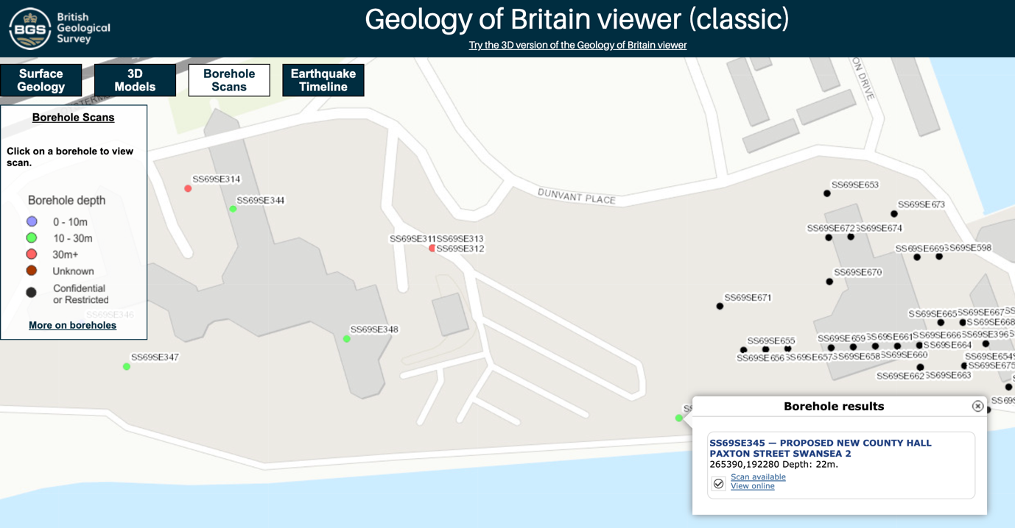
Figure 2- Borehole map from British Geological Surveys. Geology of Britain viewer (British Geological Survey, 2021). Arrow indicates position of the proposed site. The green dot, next to the arrow, indicates the position of the borehole.

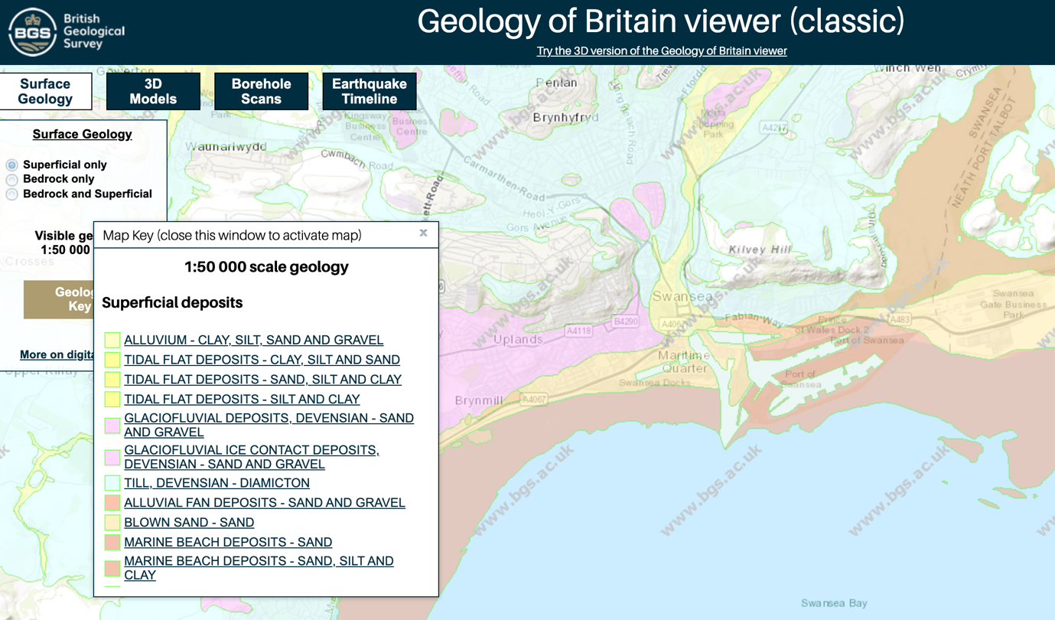
Figure 3- Map from Natural Resources Wales website, superficial soil deposits. Geology of Britain viewer (British Geological Survey, 2021). Arrow indicates position of the proposed site.

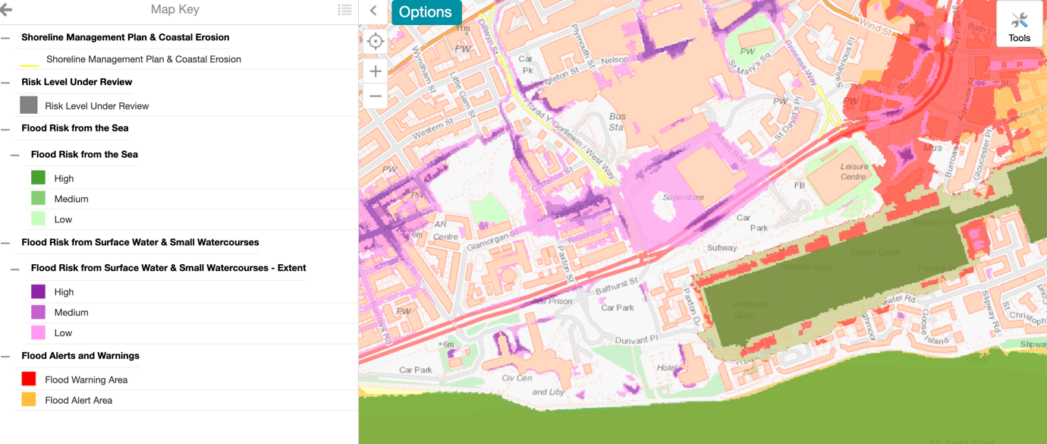
Figure 4- Map from Natural Resources Wales website, showing flood risks from surface water and sea. Flood Risk Assessment Map (Natural Resources Wales, 2021). Arrow indicates position of the proposed site.

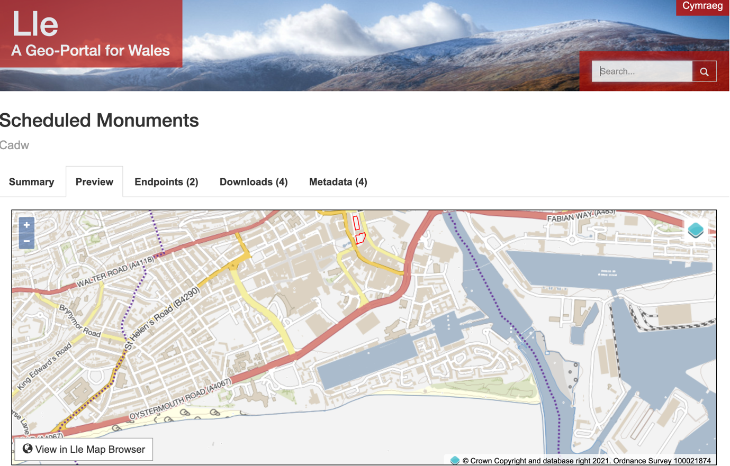
Figure 5- Map from Lle website, showing the scheduled monuments/ protected sites and/or structures. Scheduled Monuments Map (Lle, 2021). The red arrow indicates the position of the proposed site, while the blue arrow indicates the closest scheduled monument(s).

The figures above show that proposed site is situated on approximately 7 meters of deep made ground, over alluvium, silty sand tidal flat deposits and is closely situated to a high-risk flood zone from surface water. Figure 5 shows that the proposed site poses no risk to any scheduled monuments, currently listed with Lle.

Recommendations for intrusive investigation report

It is recommended an interpretive site investigation report is carried out to confirm the existing ground conditions, with recommendations for appropriate foundation solutions provided, with either the allowable ground bearing pressure or characteristic soil properties confirmed, to enable a detailed design by the foundation designers.

The presence of any contaminants must be established by means of laboratory testing, so the foundations can be specified to have the required resistances to ensure serviceability requirements are met. The presence of any buried structures left behind from the engine house or railway tracks, must also be confirmed by suitable means of investigation.

Summary of recommended intrusive investigation report requirements:
- Interpretive report
- Appropriate foundation solution
- Allowable ground bearing pressure
- Characteristic soil properties
- Suitable provisions to account for any possible settlement of the foundations
- Confirm presence of contaminants
- Confirm the presence of potential buried railway tracks
- Confirm the presence and location of existing buried services
- Conduct more borehole to confirm archive information
- Conduct two trial pits at opposite ends of the site
- Commission an ecology survey
- Additional detailed research to be carried out by a qualified UXO specialist

Building Regulations/ Codes of Practice

Below are a list of the Building Regulations and Standards that this report sought guidance from and would be recommended for future intrusive investigation works. Geotechnicaldesign.info (2021).

BS5930 (2015)- Code of Practice for Ground Investigations, British Standards Institution. (Geotechnicaldesign.info, 2015).

BS 8004:2015 (2015)- Code of Practice for Foundations, British Standards Institution. (Geotechnicaldesign.info, 2015).

BS EN 1997-2:2007 (2007)- Eurocode 7 Geotechnical design. Part 2: Ground Investigation and Testing, British Standards Institution. (Geotechnicaldesign.info, 2007).

Indicative foundation solution sketch

See hand sketches below of possible piled foundation solution, based on this desktop study. Due to the assumed low bearing capacity of the alluvium, changing water levels and subsoil that are subject to moisture movement, a piled foundation solution using precast piles, is recommended. The appropriate solution must be confirmed by the final site investigation report. (Chudley and Greeno, 2008, p. 212-229)

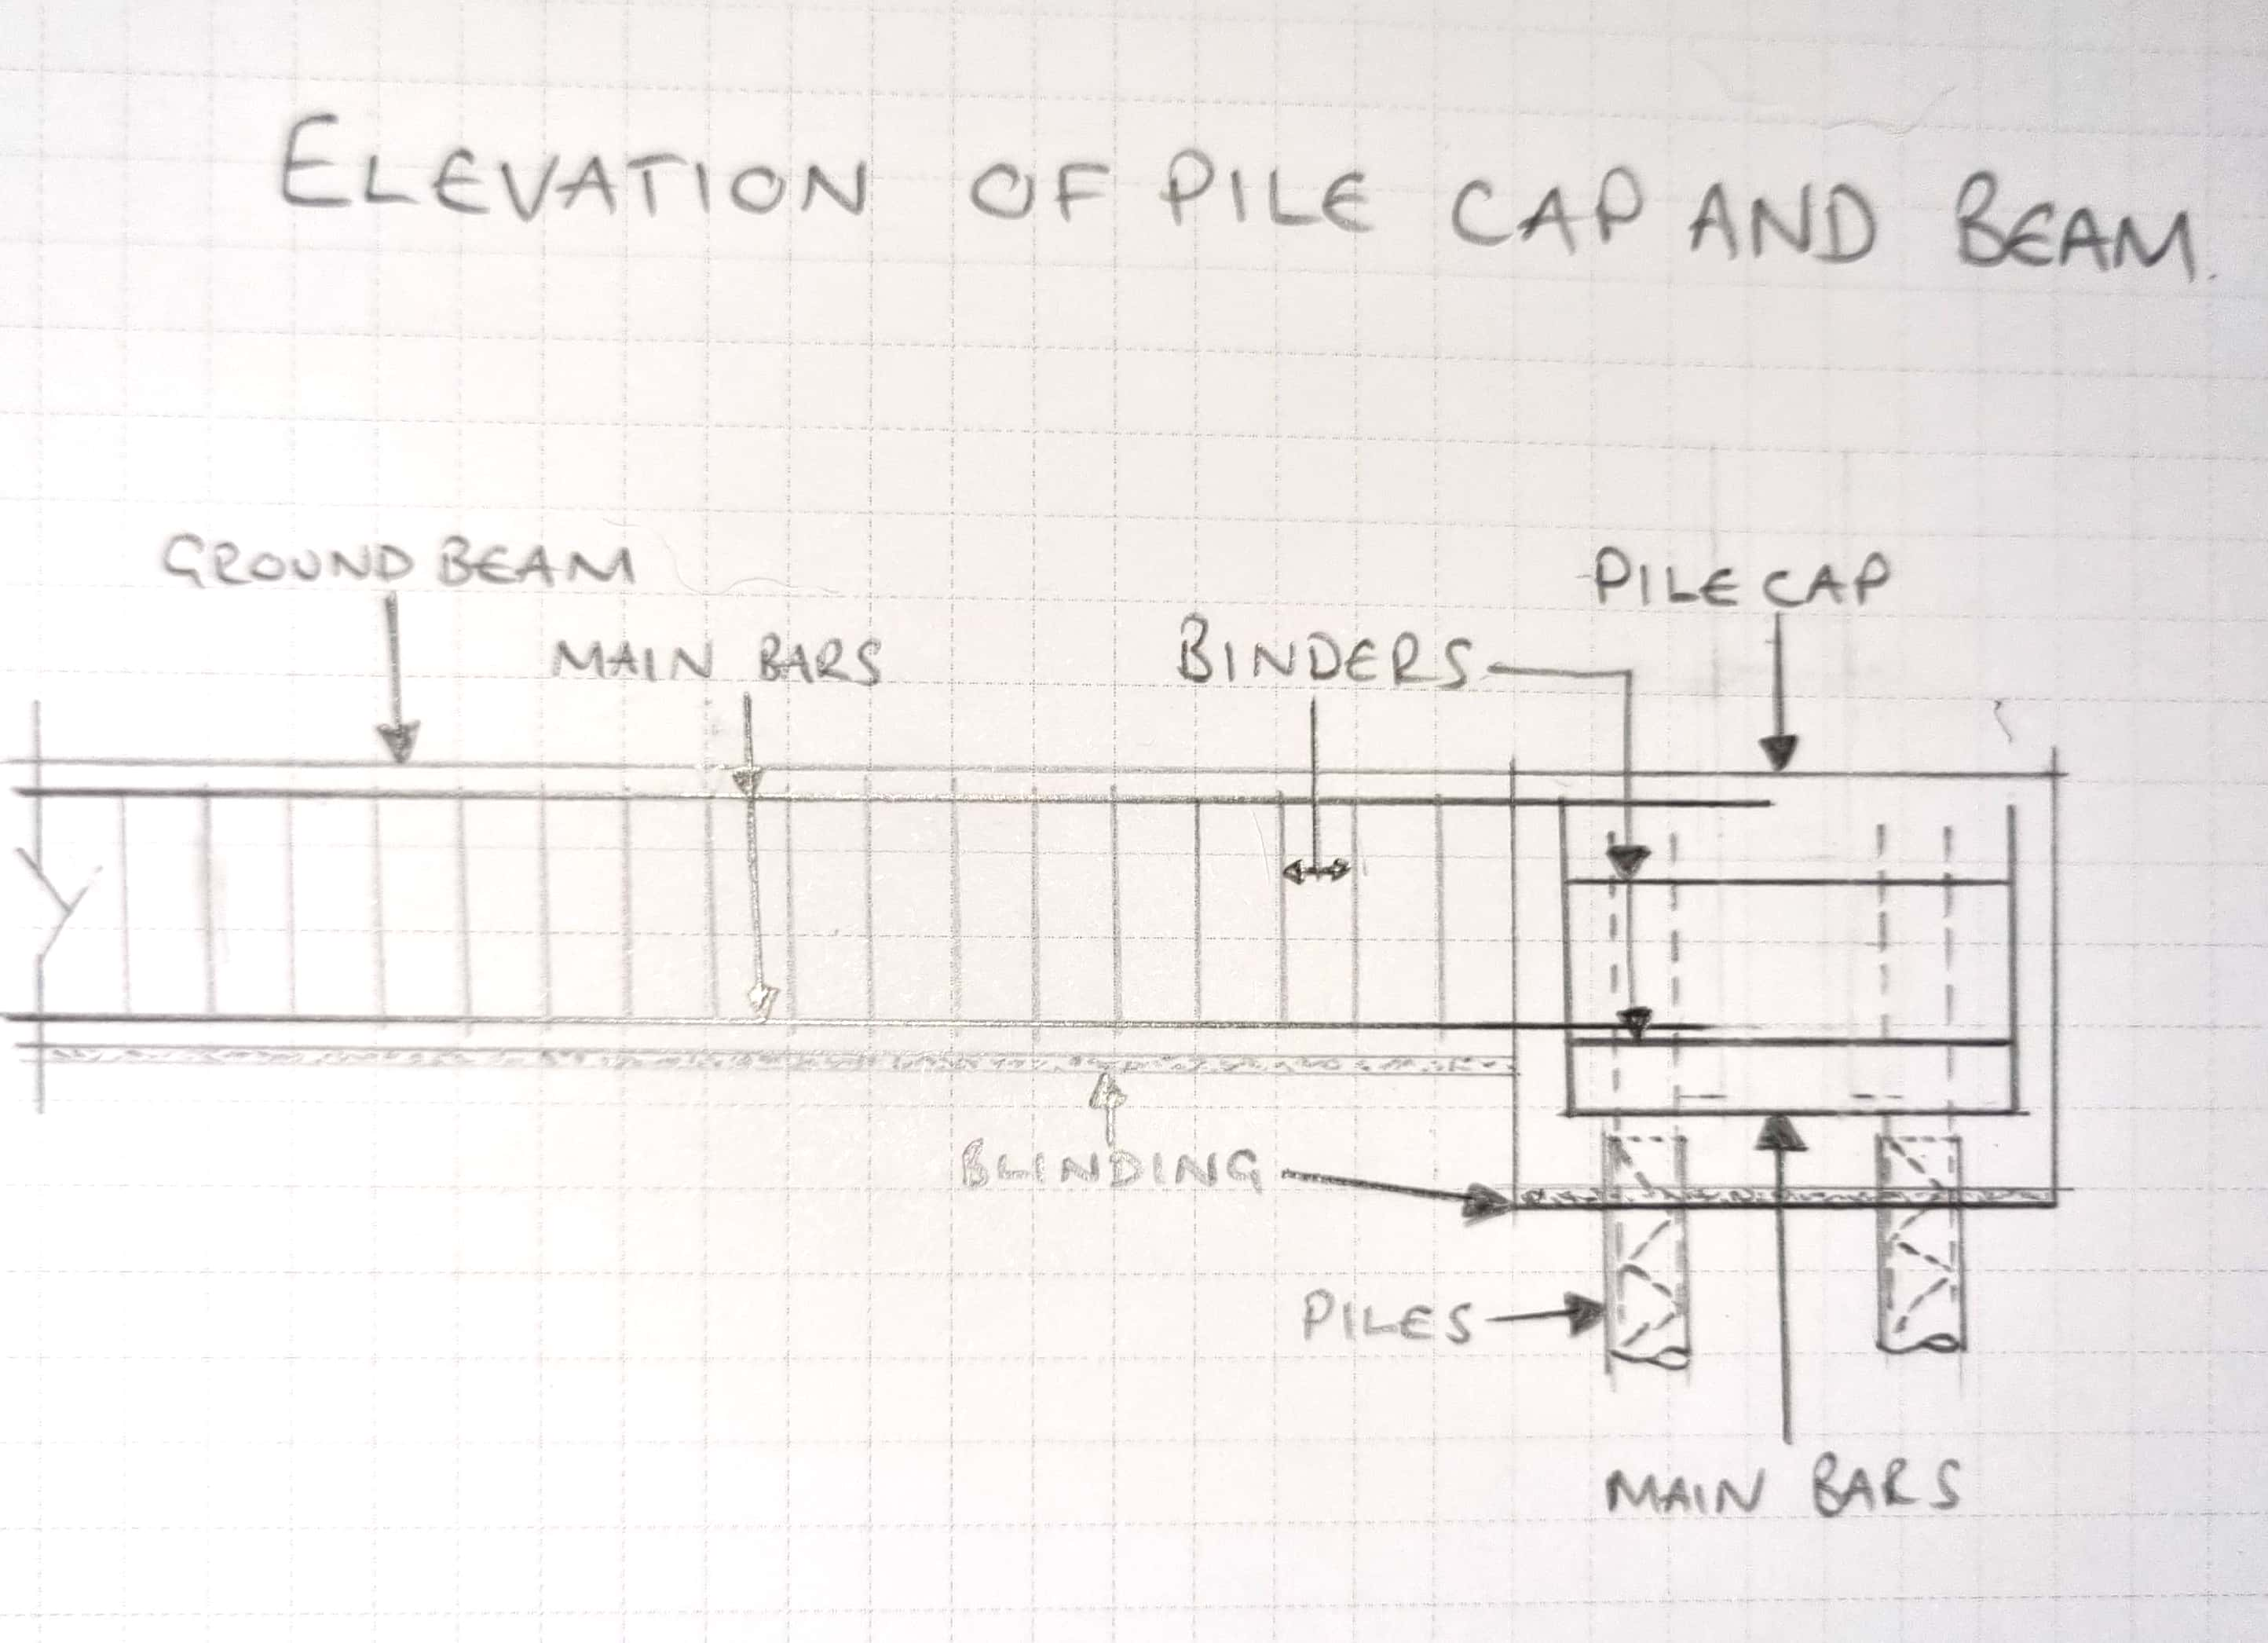
Sketch 1- Piles and ground beams

Reference list

British Geological Survey (2021) Geology of Britain Viewer. Available at: https://mapapps.bgs.ac.uk/geologyofbritain/home.html?&_ga=2.90927193.2135264919.1640281572-1714689014.1639229188 (Accessed 23 December 2021).

Chudley. R and Greeno. R (2008) Building Construction Handbook Seventh Edition. Oxford: Elsevier LTD.

Geotechnicaldesign.info (2007) BS EN 1997-2:2007 Eirocode 7 Geotechnical Design. Part 2: Ground Investigation and Testing. Available at: https://geotechnicaldesign.info/ec7p2.html (Accessed 27 December 2021)

Geotechnicaldesign.info (2015) BS 5930:2015 Code of practice for ground investigations. Available at: https://geotechnicaldesign.info/bs5930-2015.html (Accessed 27 December 2021)

Geotechnicaldesign.info (2015) BS 8004:2015 Code of practice for foundations. Available at: https://geotechnicaldesign.info/bs8004-2015.html (Accessed 27 December 2021)

Lle, A Geo Portal for Wales (2021) Scheduled Monuments. Available at: https://lle.gov.wales/catalogue/item/ScheduledAncientMonumentsInWales/?lang=en (Accessed 27 December 2021)

Natural Resources Wales (2021) Flood Risk Assessment Wales map. Available at: https://maps.cyfoethnaturiolcymru.gov.uk/Html5Viewer/Index.html?configBase=https://maps.cyfoethnaturiolcymru.gov.uk/Geocortex/Essentials/REST/sites/Flood_Risk/viewers/Flood_Risk/virtualdirectory/Resources/Config/Default&layerTheme=0 (Accessed 23 December 2021)

Northern Mine Research Society (2021) Coal Mines Wales. Available at: https://www.nmrs.org.uk/mines-map/coal-mining-in-the-british-isles/collieries-of-the-british-isles/coal-mines-wales/ (Accessed 23 December 2021).

Ordnance Street Survey Southampton (1879, 1899, 1960, 1979 and 1984) Ordnance Survey Map SS6592SW Southampton: Ordnance Survey Database

Scrivyer/ BRE (2015) Radon Guidance on protective measures for new buildings. Berkshire: IHS: BRE Press

UK Grid Reference Finder (2021) Grid Reference. Available at: https://gridreferencefinder.com/#gr=SS6538792304|Point_s_A|1&shapes=%7B%22type%22%3A%22FeatureCollection%22%2C%22features%22%3A%5B%7B%22type%22%3A%22Feature%22%2C%22properties%22%3A%7B%7D%2C%22geometry%22%3A%7B%22type%22%3A%22Point%22%2C%22coordinates%22%3A%5B-3.945559%2C51.613447%5D%7D%7D%5D%7D (Accessed 23 December 2021).

West Glamorgan County Council (date unknown) SS69SE345 — PROPOSED NEW COUNTY HALL PAXTON STREET SWANSEA 2. Internal Strata Surveys Ltd report. Unpublished.

Zetica UXO (2021) Risk Maps. Available at: https://zeticauxo.com/downloads-and-resources/risk-maps/ (Accessed 22 December 2021).

APPENDIX 1
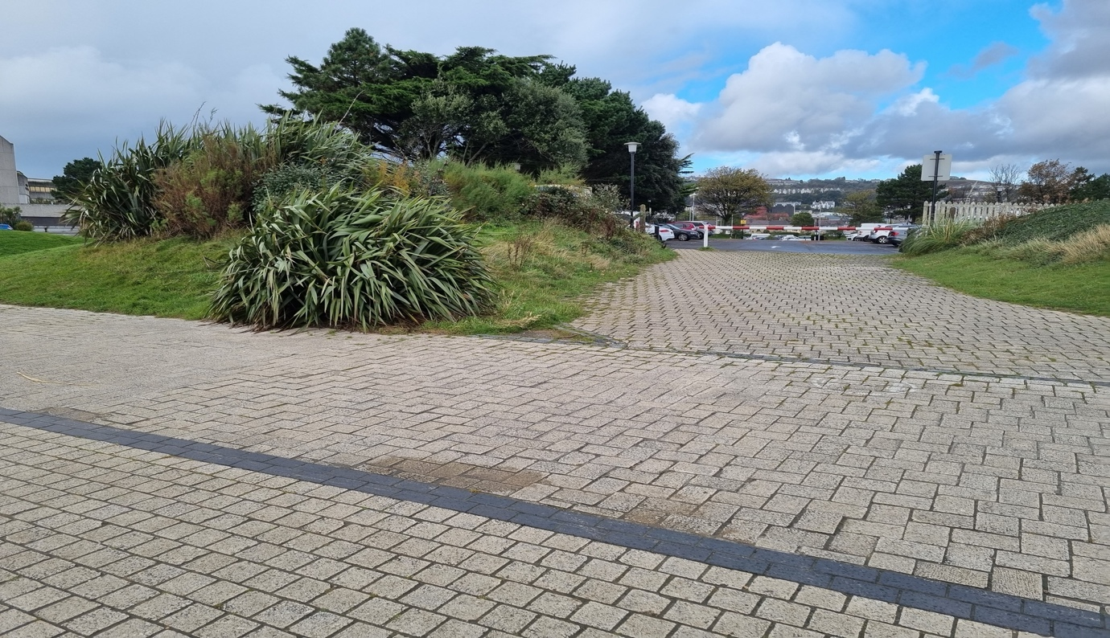
Image shows proposed site, from the promenade.

APPENDIX 2
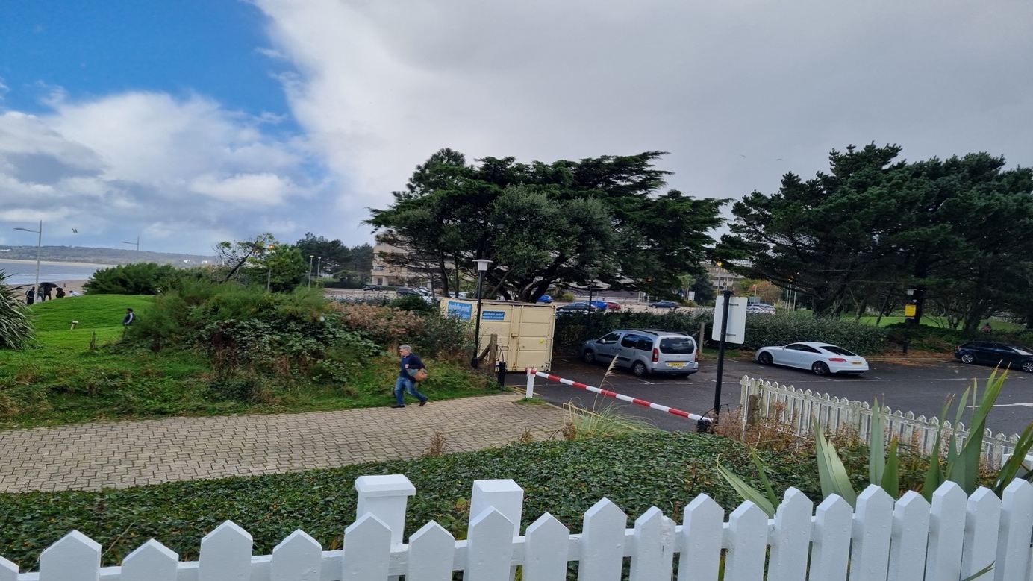
Image shows proposed site from the Marriott Hotel’s viewing balcony.

APPENDIX 3
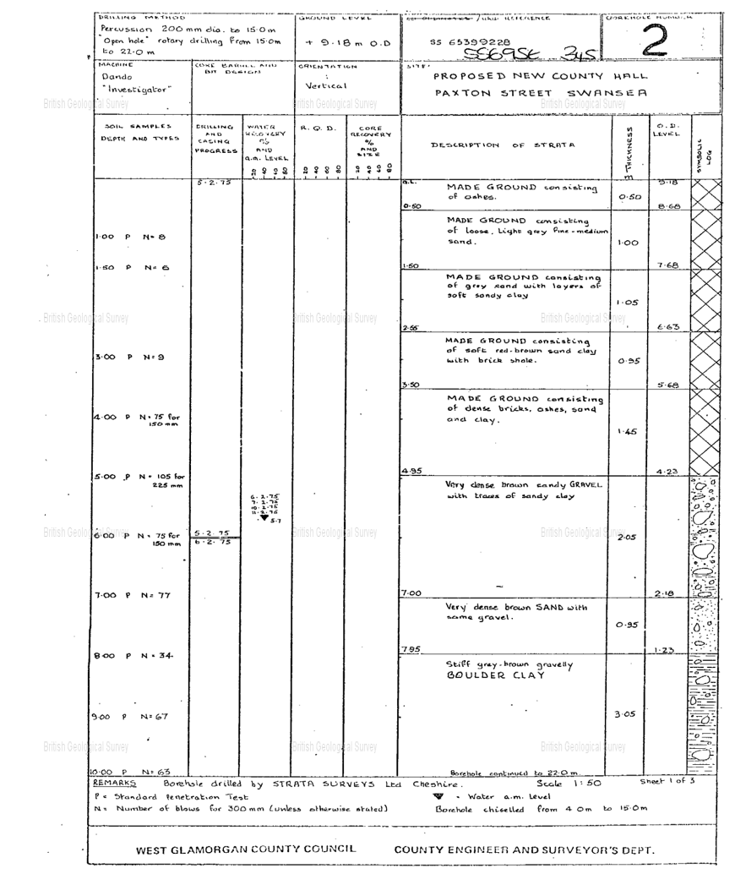
Borehole log obtained, relevant to site.

APPENDIX 4
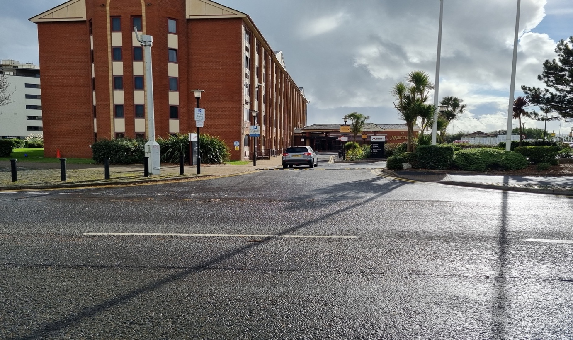
Recommended access point to site, through the Marriott Hotel carpark.

APPENDIX 5
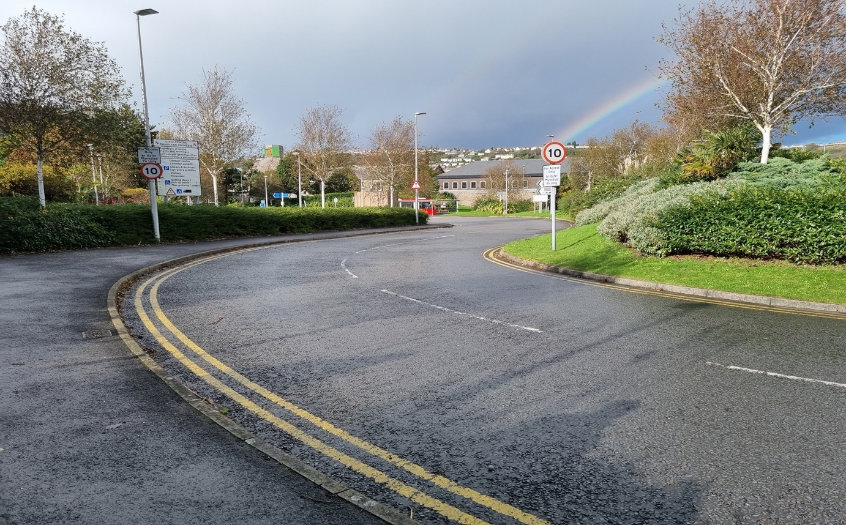
Image shows access limitations through County Hall car park entrance.

APPENDIX 6
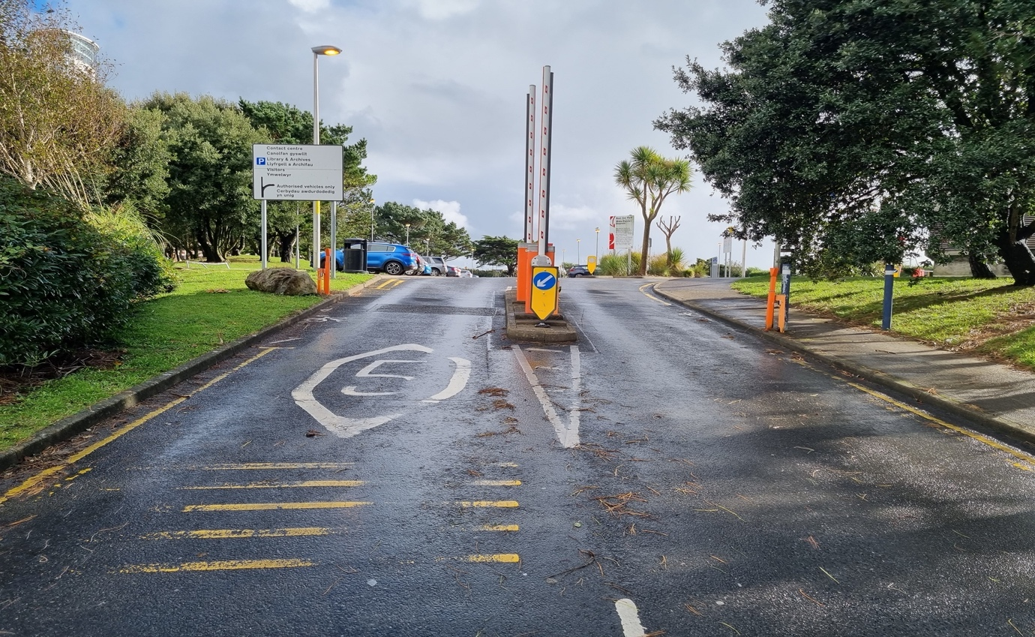
Image shows additional access limitations through County Hall car park entrance.

APPENDIX 7
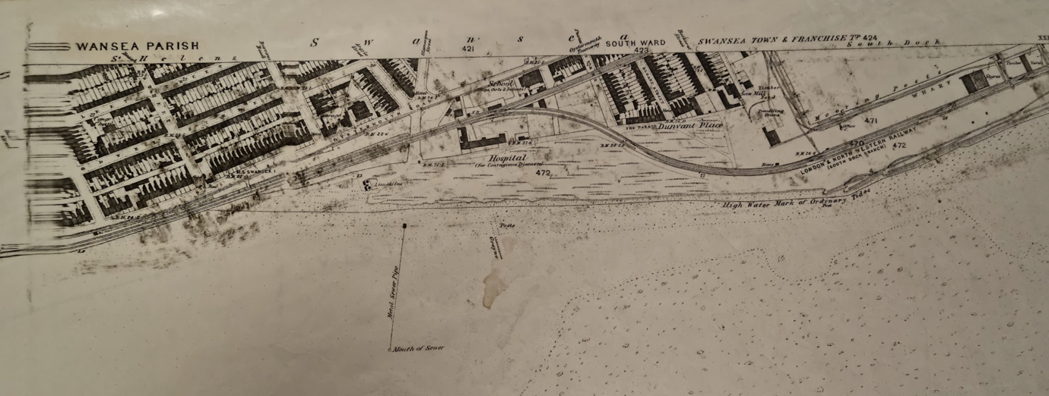
Map 1- Ordnance Survey Map showing proposed site, dated 1879

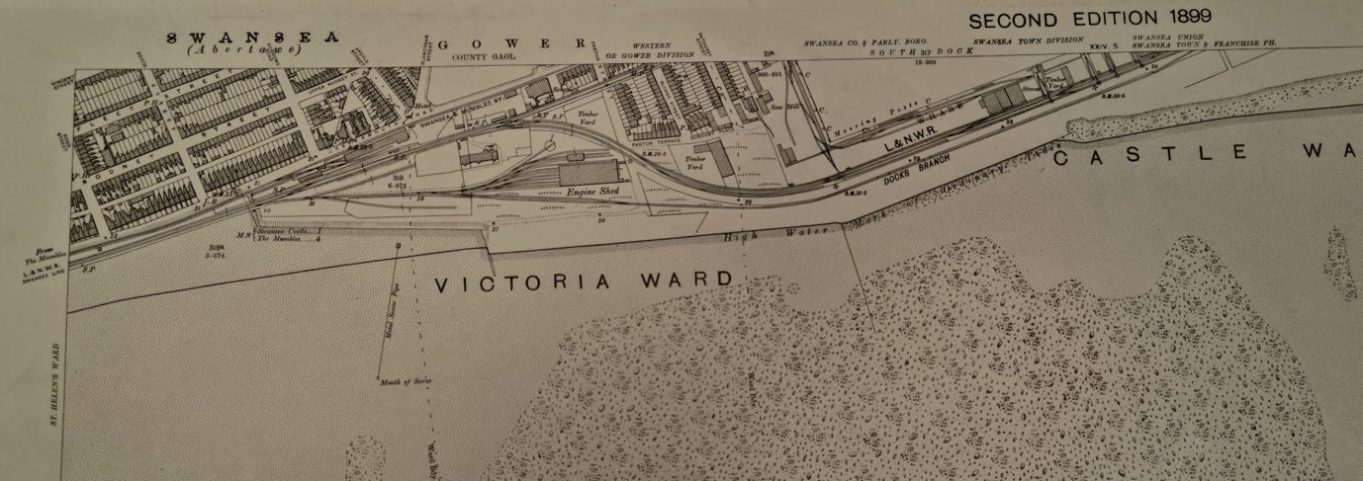
Map 2- Ordnance Survey Map showing proposed site, dated 1899

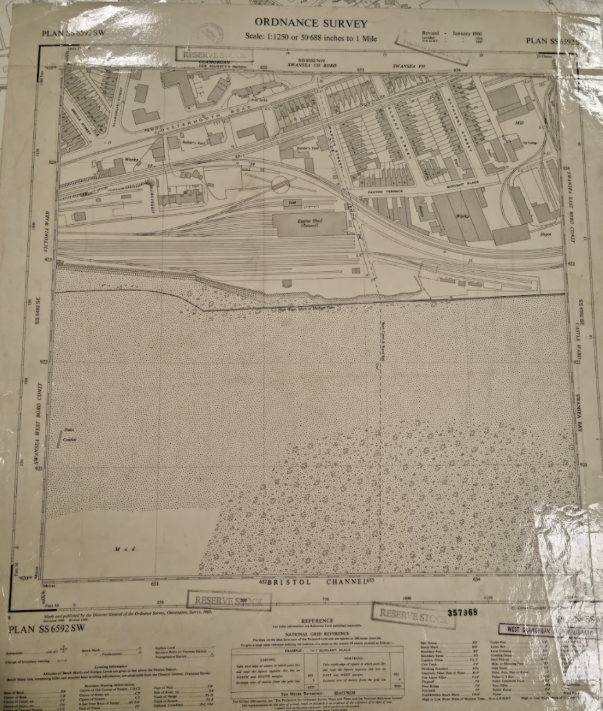
Map 3- Ordnance Survey Map showing proposed site, 1960
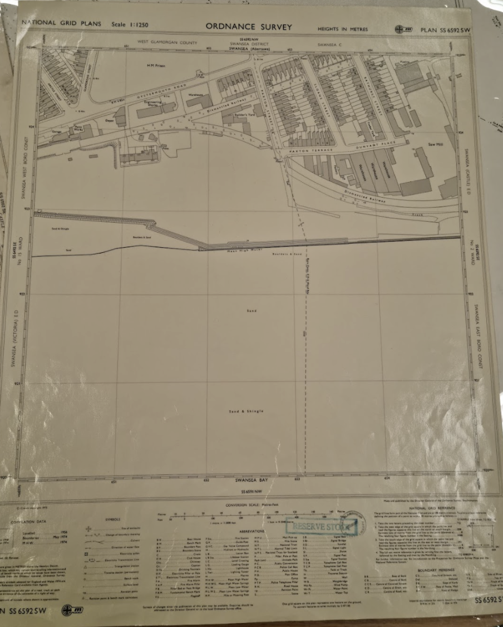
Map 4- Ordnance Survey Map showing proposed site, 1974

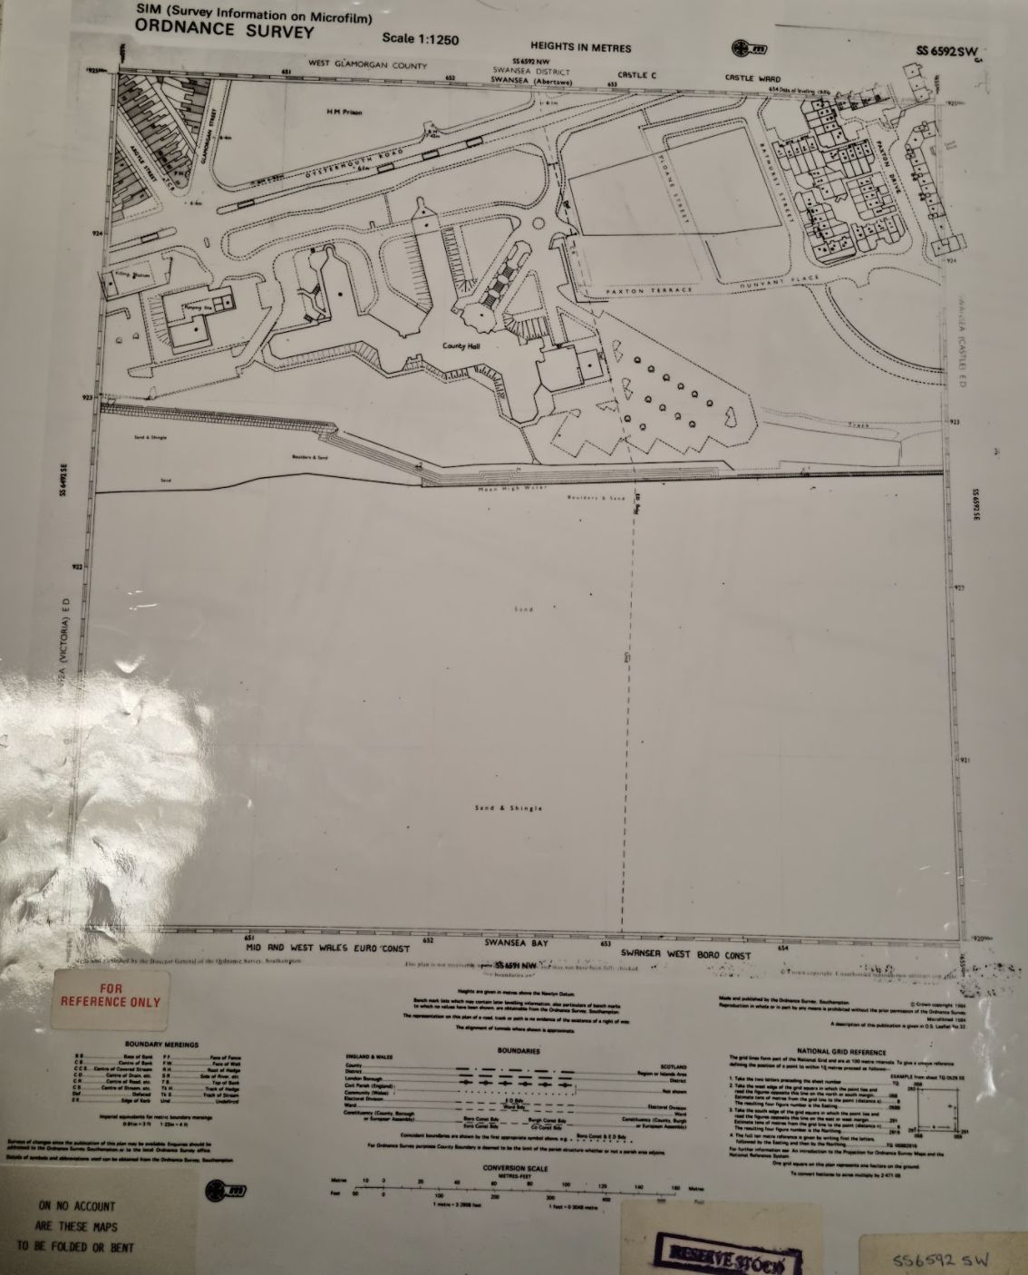
Map 5- Ordnance Survey Map showing proposed site, 1984
APPENDIX 8
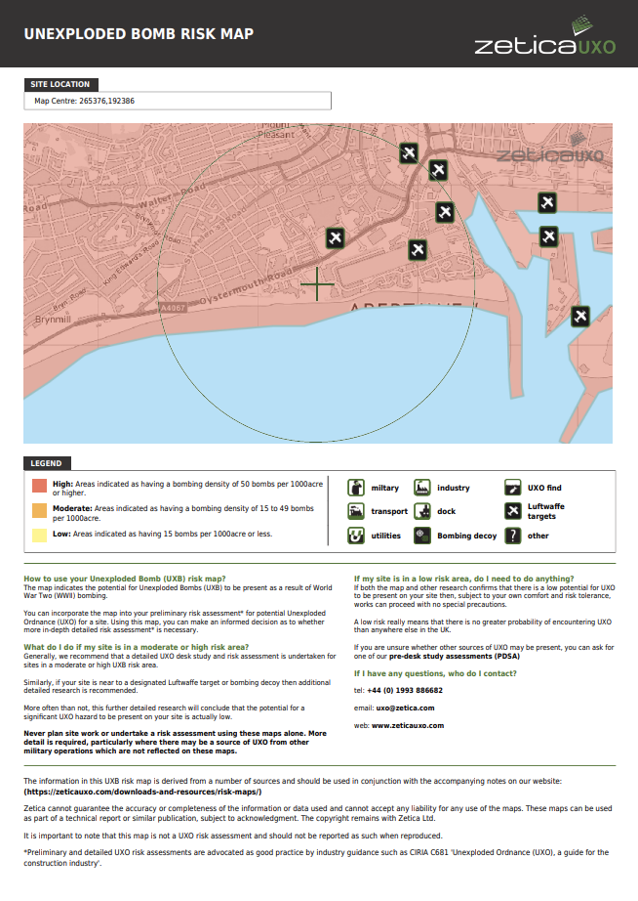
Image of UXO map, where Lutwaffe Targets are shown, in relation to proposed site.

