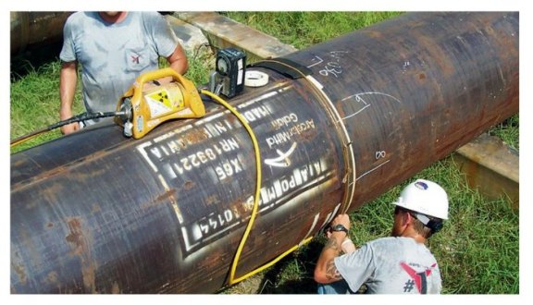
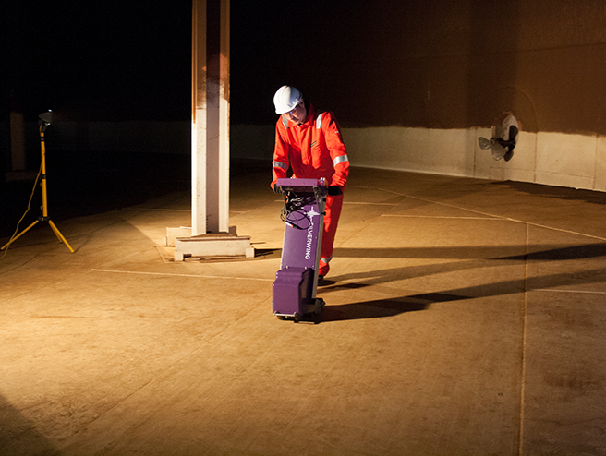
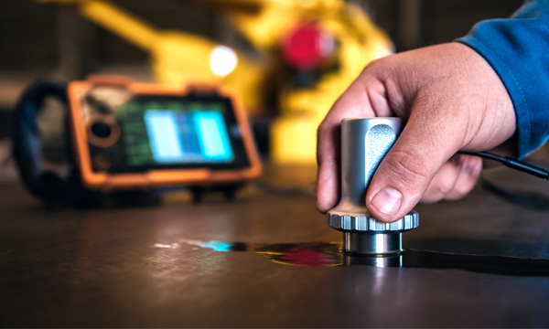

NDT Techniques and Stress Analysis

Advanced Stress Analysis & FEA Assignment for
BEng Mechanical and Manufacturing Engineering

University of Wales Trinity Saint David
Faculty of Engineering

By:
Elizabeth Roberts
P147274



Abstract

Non- destructive testing offers several advantages over conventional destructive techniques, such as component integrity, stress detection and potential increases in revenue. In recent years, academics all over the world have carried out investigations to characterize, both the mechanical and microstructural properties of materials. The issue of inspection is a very serious matter in the engineering profession and is usually carried out to determine component quality and stability.
This paper attempts to highlight the advantages and limitations of both destructive and non-destructive testing, when both methods are utilised for defect detection and characterization in engineering materials and components. The paper covers a review on each techniques capability and focuses in on three NDT applications; Ultrasonic Testing, Magnetic flux leakage and Radiography. All three techniques are widely used for the extensive study into material characterisation, defect detection, crack propagation and stress detection and analysis. Some of the assets that are inspected range from power plants, aerospace, nuclear, storage tank inspection, to pipe and material inspection. If the scope of work is simple, then one inspection is sufficient. But if one technique doesn’t provide enough data, then a combination of techniques is required.
This paper however, is focused on NDT and its contribution to stress analysis. It has been previously analysed that if the yield stress of a material is known, then it is possible to calculate the stress in a component through the use of defect detection. This approach has been adapted for ultrasonic testing, magnetic flux leakage and radiographic inspection.

Table of Contents:
Abstract 2
Table of Figures: 4
Introduction: 5
What is Non-destructive testing? 5
What is Destructive testing? 5
Advantages / Disadvantages of NDT and destructive testing: 6
Non-Destructive Testing: 6
Destructive testing: 6
Methods: 7
Ultrasonic testing: 7
The principles behind Ultrasonic testing: 7
Advantages and disadvantages of ultrasonic testing: 9
Potential errors and assumptions while using ultrasonic testing: 9
Ultrasonic testing applications: 9
Ultrasonic testing’s contribution to the improvement of stress analysis: 10
Magnetic Flux Leakage: 10
The principles of Magnetic Flux Leakage: 10
Advantages and disadvantages of magnetic flux leakage testing: 12
Potential errors and assumptions while using magnetic flux leakage: 12
Magnetic flux leakage applications: 12
Magnetic flux leakage contribution to the improvement of stress analysis: 13
Radiographic testing: 13
The principles behind radiographic testing: 13
Advantages and disadvantages of radiographic testing: 15
Potential errors and assumptions while using radiography: 15
Radiographic testing applications: 15
Radiographic testing’s and its contribution to the improvement of stress analysis: 16
Conclusion: 16
References: 17

Table of Figures: | Page:
Figure 1: Example of Ultrasonic inspection system | 9
Figure 2: Example of in service ultrasonic inspection system. | 9
Figure 3: Example of MFL inspection principle. | 12
Figure 4: Example of MFL floor scanner inspection system. | 12
Figure 5: How radiography works for NDT inspection. | 15
Figure 6: Radiographic equipment scanning a gas pipe. | 15
Figure 7: Example of radiographic image of a defected weld. | 15

Introduction:

What is Non-destructive testing?

Non-destructive testing, also referred to as NDT is a process utilised for the testing, evaluating and inspecting of various components or products to identify potential discrepancies and defects without harming, destroying or impairing the serviceability of an asset (Downes, 2003). NDT can be used to find abnormalities and defects on the surface or subsurface of components, therefore allowing manufactures to test the reliability and physical integrity of a material or asset (Jayakumar, 2001). Many of the tests carried out ensure product reliability, which aid in the prevention of accidents and catastrophic failures, helping to lower production costs and maintain a constant level of quality.
There are many different NDT methods available in industry; magnetic particle testing (MT), Visual testing (VT) and electromagnetic testing (ET) etc. The techniques which present themselves as the most significant in terms of versatility and accuracy are; ultrasonic testing (UT), radiographic testing (RT) and magnetic flux leakage (MFL). All three techniques will be examined and discussed further on in this report.

What is Destructive testing?

Destructive testing, which is also known as destructive physical analysis carries out investigations to determine a product’s loading performance, physical capability and catastrophic failure point. All investigations are generally easy to carry out, and gather more easily interpreted yield data than NDT (Usama, 2014). Destructive testing is documented using high-speed cameras that continuously record until failure is detected. Failure can be detected using sound technology or stress gauges that send signal triggers to the high-speed cameras. The captured data is replayed in slow motion, displaying precisely what happens before, during and after catastrophic failure (Godfrey, 2016).
Methods of destructive physical analysis can include; ball shear strength analysis, bond strength analysis, Die shear strength analysis, Internal visual inspection, External visual inspection, SEM, XRF and FTIR Elemental analysis and Scanning Electron Microscopy. These types of tests investigate the physical properties of the material including the ductility of the material, its ultimate tensile stress, fracture toughness, fatigue stress and impact resistance (Barkanov, 2018).

Advantages / Disadvantages of NDT and destructive testing:

Non-Destructive Testing:

NDT has many advantages for its use within engineering, one being its ability to assess, evaluate and inspect materials or components, and detect any defects or flaws, without damaging the asset being investigated says (Soni, 2018). (Gupta, 2018) also states that NDT makes it possible to check the integrity of a structure without the destruction of the component. This provides peace of mind for employees as when employees know they are safe, they feel more comfortable preforming tasks which provides improved productivity and output for the company (Soni, 2018). If a Machine has been NDT tested and is deemed safe, this provides reliability, consistency and stability in terms of quality assurance and removes the risk of potential incidents. NDT is seen as a cost-effective way of inspecting and maintaining equipment, alongside identifying possible failure and defects, it can outline any component parts that could potentially need replacing, or a problem which could lead to future malfunction aiding in preventative maintenance (Soni, 2018). However, there are many disadvantages when it comes to NDT, such as component cleaning prior to inspection, which is more downtime and cost for the customer. Some NDT techniques require an electrical source to power them, some techniques require the materials to be conductive and some techniques can be affected by surface finish, providing inaccurate results which then creates a niche bracket for some of the techniques (Brown, 1997).
he field of Non-Destructive Evaluation (NDE) or Non-Destructive Testing (NDT) involves the identification and
characterization of damages or defect on the surface and interior of materials without cutting apart or otherwise
altering the material. In other words, NDT refers to the assessment or evaluation and inspection process of materials
or components for characterization or finding defects and flaws in comparison with some standards without altering
the original attributes or harming the object being tested. NDT techniques make available or provide a cost effective
means of testing of a sample for individual investigation and examination or may be applied on the whole material
for checking in a production quality control system. [2]In many cases, the approach to finding a defect requires more
than use of a single NDT test method. It may require a combination of methods and also exploratory, invasive
openings. A better understanding of the background, advantages and limitation of each NDT method is essential in
ensuring the success of the evaluation. Understanding one NDT method alone may not be enough to ensure the
success in solving the problem at hand. [3]A wide variety of non destructive testing methods plays most important
roles in testing of composite materials. The applications of composite NDT may include in many places such as in
manufacturing, pipe and tube manufacturing, storage tanks, aerospace, military and defence, nuclear industry, and
composite defects characterization. Damage in composite materials can arise during material processing, fabrication
of the component or in-service activities among which cracks, porosity and delamination are the most common
defects. [4] Numerous techniques are used in the composite NDT field, including radiographic testing, visual testing
(VT) or visual inspection (VI), ultrasonic testing, thermographic testing, infrared thermography testing, acoustic
emission testing (AE), acoustic-ultrasonic, electromagnetic testing, shearography testing, optical testing, liquid
penetrant testing and magnetic particle testing. This paper reviews various NDT methods for defect identification
and characterization in material and composite and find out most efficient met

Destructive testing:

Destructive testing predates NDT by many years. Evidence suggest that due to this, there is more destructive methods used within industry than NDT. You may argue that this phenomenon has created a better-informed database on destructive testing in comparison to that of NDT (Barkanov, 2018). And from this database, the individual carrying out the testing will gain a better understanding on the component and its characteristics.
Destructive testing can provide an insight into the molecular structure of a material which can help determine and forecast potential failure (Services, 2017) (Sharma, 2018). It can also show how durable a product is before going out to the customer. Much like NDT, destructive testing also has its disadvantages, once a component / product has been tested by destructive means, it is then deemed not fit for purpose, which depending on the magnitude of the component could become quite costly for the company (Usama, 2014). Destructive testing can be time consuming and may take weeks/ months to arrive at a valid conclusion, whereas NDT results are almost instantaneous.

What can see, both processes have very good positive and negative points, and what is clearly depicted is that NDT has surpassed destructive testing on many levels for many reasons. For example, Destructive testing cannot be performed on parts that are already in service and if it must be tested on then the component will be permanently out of service, but, where NDT is concerned this would not be an issue. NDT tests are made directly on the in-service part, meaning the component could remain in use while the tests are undertaken, and actions could be taken immediately from the results received saving time and money (Godfrey, 2016). Many NDT methods can be used simultaneously, each measuring different properties on the product. Destructive testing can only ideally measure one variable at a time. Although NDT Does not measure load to failure or life until failure, it can still reveal defects and damages within the product before failure occurs making it a preventative method.

Methods:

In order to gain a better insight into NDT and its technologies, three techniques are explained below, which could potentially improve stress analysis within industry. Each technique has been explained in depth below along with suggestions on how each could improve stress analysis.

Ultrasonic testing:

The principles behind Ultrasonic testing:

There are several variations of Ultrasonic testing, such as; advanced ultrasonic backscatter technique, phased array ultrasonic testing, long range ultrasonic testing, internal rotating inspection system, time of flight diffraction and dry coupled ultrasonic testing. The technique discussed is dry coupled ultrasonic testing.

Dry – coupled ultrasonic testing, also known as (DCUT) uses high frequency waves (between 400 kHz and 25 MHz), which are above the human hearing range, for the purpose of inspection. High frequency waves are passed through a material or component under inspection conditions. These high frequency waves remain constant throughout the material, but can also travel at different speeds depending on the material (Sharma, 2018).
The technique utilises pulse-echo waves to ‘capture and quantify’ (Hijazi, 2015) the geometric properties of a material in order to detect and characterise surface and sub-surface inaccuracies and defects. From the pulse- echo waves, response signals are detected which provide signatures that are used to define the presence, location, and characteristics of flaws or other discontinuities (Krautkramer, 1990). (Ahmad, 2018) also states that Cracks, delamination’s, shrinkage cavities, bursts, flakes, pores, disbands, and other dis- continuities can be detected using scattered Ultrasonic waves alongside pulse- echo wave.

A typical DCUT system has a range of functional components; the pulser, receiver, transducer and display system. High frequency sound waves are sent into a material by use of a transducer (Ramesh, 2016). The pulser produces high voltage electrical pulses which feed the transducer and generate high frequency ultrasonic energy (Lester, 2016) The sound waves propagate through the material, and when a defect is detected the ultrasonic energy is reflect and transformed into and electrical signal which is detected on the digital screen. Examples of UT systems are shown in the figures below.
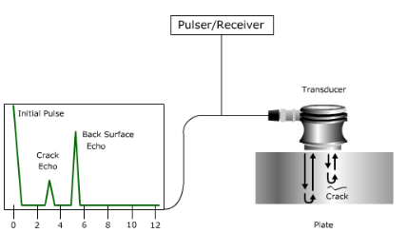
Figure 1: Example Ultrasonic inspection system (Hijazi, 2015).

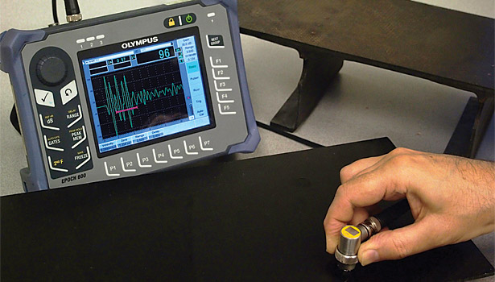
Figure 2: Example of in service ultrasonic inspection system (EU., 2014).

Advantages and disadvantages of ultrasonic testing:

The principle advantages of ultrasonic testing are; it has a superior penetrating power, which allows the detection of flaws on the surface and deep in the part (Ahmad, 2018). Only one surface needs to be accessible (TWI, 2019), and due to its high sensitivity, very small flaws can be detected within the material. UT requires minimal part preparation and is not hazardous to the operator or individuals in the vicinity (Lester, 2016), reducing asset downtime and increasing employee’s peace of mind. The technique does not damage or affect the component and inspections can be undertaken while the component is still in use, saving the customer time and money. UT can attain high accuracy when determining the magnitude and position of external and internal defects (Ahmad, 2018), reducing scan times. The equipment is fully portable, and after every scan a digital copy of the inspection is recorded and the results are available for analysis immediately. However, like any process UT has its disadvantages; the technique requires a skilled individual, with extensive inspection knowledge, (TWI, 2019) and these individuals cost high amounts of money to employ. Defects that are irregular or present in the ‘shallow layer’ are usually not detected, and certain materials will mask defects by absorbing the frequency waves, which provides inaccurate results.

Potential errors and assumptions while using ultrasonic testing:

Like any complex task, ultrasonic inspection is prone to error. It has been recognised that ultrasonic testing can be less effective than previously thought, for determining component integrity (Executive, 2008). To begin with, all operators must hold a level 3 qualification, if this is not the case, then the operator’s abilities may not be to the required standard. During UT testing there is little, if any emphasis on the measurement of defect through-wall size and more on defect detection. Thru wall sizing is necessary for accurate fit for purpose considerations (Joyce-D, 1996). Without this description, there is limited inspection confidence and if the operator does not have the necessary experience and training, then crucial defect characterisation cannot be achieved. When these considerations are not met, the UT performance decreases as the geometry becomes more complex (HSE, 2000), meaning assumptions have to be made. If the correct information isn’t retrieved then the correct probes are not used and the sounds being emitted will not reflect correctly and affect the transmission, giving inaccurate results (Executive, 2008). Other errors can include poor scanning technique, assumptions made in interpretation of flaw detector echoes and random measurement errors.

Ultrasonic testing applications:

Ultrasonic testing has been utilised for many applications, one of which is the maintenance of aircrafts and other complex structures that are typically manufactured from carbon fibre and fibre glass reinforced plastic (Sharma, 2018). UT inspects the frame sections, honeycomb assemblies and outer shell regions for cracks, fatigue and inaccuracies. The technique is also heavily utilised within the engineering industry on turbine blades, mill components, generator rotators, welds, pressure vessels, pipelines and railway tracks (Ahmad, 2018). All the components are tested for material loss and stress tested at elevated temperatures to document crack propagation, fatigued defects and to study the measurement of elastic moduli (Madhu, 2019). The tests are undertaken using high power low frequency UT waves, which have been adapted for medical applications and even in the food industry, checking for bacteria degradation, microbial activation, homogenization and crystallisation.

Ultrasonic testing’s contribution to the improvement of stress analysis:

Stresses in some materials/ components can pose a real threat to the integrity and safety of an asset. Using UT for stress measurement means you can measure the stresses in the same points many times, where the component is in service under loading or in its neutral state.
ne of the advantages of ultrasonic techniques for residual stress measurement is that they are non-destructive. Using such
techniques, one can measure the residual stresses in the same points many times, studying, for instance, the changes of re-
sidual stresses under the action of service loading or effectiveness of stress-relieving techniq
his technique is very efficient and
allows measuring the residual stresses both in laboratory conditions and in real structures for a wide range of materials
The technique allows the measuring of stresses in laboratory conditions and on in-service engineering structures, covering a wide range of materials (Madhu, 2019). Due rapid heating, melting, and cooling of most in service components, destructive testing cannot be accurately achieved by conventional methods, therefore NDT must be utilised (Cao, 2018). In order to scan for stress, the operator must first know the stress co-efficient. This can be calculated by using a component of identical characteristics and relax the residual stress in the specimen by annealing. The component can then be scanned in its neutral state and in its stressed state to determine the magnitude of stress and work out the stress co-efficient (Brodovy, 2004). This information can then be applied to the in-service component to scan for stresses, which are calculated from the stress coefficent and the results are available immediately with the advantages of safety, no destructiveness, and online detection.

Magnetic Flux Leakage:

The principles of Magnetic Flux Leakage:
Magnetic flux leakage, also known as MFL, is an inspection method that uses magnetisation to detect corrosion, pitting and defects in metallic components. The technique utilises apposing permanent magnets (north and south pole magnets) which when placed directly onto the component saturate the asset with the correct pre-determined level of magnetism. The component is then scanned in a forward motion until the component data is collected, and if a reduction in the material thickness is detected then this causes distortion of the magnetic field, allowing flux to leak out (Drury, 2012). Within the system is built-in strategically placed tri-axial hall effect sensor heads that measure the amount of flux that is leaked from the defect, it also determines how the system detects and sizes a flaw. MFL is a vector quantity, meaning the sensors can only measure in one direction, therefore multiple sensors orientated in different directions are required to measure the axial, radial and circumferential characteristics of the MFL signal (Babbar, 2005), allowing the system to gather fully detailed data. All data is displayed on the computerised visual display unit and if a defect is detected an alarm will sound, enabling it to be easily located for manual measuring (Limited, 2006). This inspection method allows for rapid scanning of components (Babbar, 2005), and does not require a high level of skill to operate although training is essential in the set-up and calibration procedures. Examples of MFL systems can be seen below:
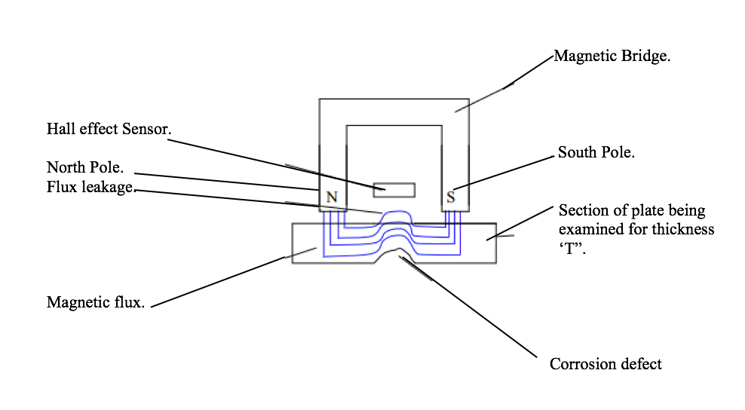
Figure 3: Example of MFL inspection principle (Limited, 2006).
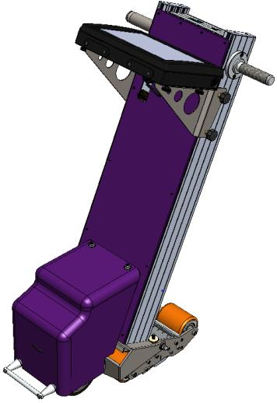
Figure 4: Example of MFL floor scanner inspection system ((Uk), 2017)

Advantages and disadvantages of magnetic flux leakage testing:

There are many advantages of MFL, one is that it has a very high sensitivity for pitting, circumferential cracks, defects and is a rapid inspection technique when compared to other steel testing techniques (LMATS, 2018). MFL has extensive defect detection capabilities, as it can detect the internal, external, axial, radial and circumferential dimensions of an anomaly on flat, complex and circular surfaces (Services, 2017). (Cai, 2015) also states that MFL can detect surface defects, stomata, scarring, shrinkage cavities, corrosion, pitting and cracking within the asset, extending its capabilities even further. Due to the use of permanent magnets the in-signal processes for MFL only incurs small amounts of high frequency interference, making the signals easy to detect and ideal for signal processing (Feng, 2013). The requirements for the detection environment are high, and are unaffected by the transportation medium. However, MFL is also not without is disadvantages, if under saturation occurs, it can affect the defect sizing and repeatability, causing false readings to occur (Cai, 2015). The system is not always able to determine the full severity of a defect, meaning the stress could cause catastrophic failure and when materials with impurities are scanned, it can also cause false data to be collected (Technologies, 2010).

Potential errors and assumptions while using magnetic flux leakage:

It has been argued that MFL’s amplitude information is potentially unreliable due to too many signal inconsistencies, preventing successful defect severity detection, causing potential errors within the data gathered (Technologies, 2010). Factors that can contribute to this issue are; surface area of the flaw, flaw orientation in respect to the magnetic flux, wavelength frequency in the material and surface roughness (Kim, 2018). Other potential errors are incurred during visual inspection, due to top surface coatings masking the defects or when examining local or internal flaws, which can lead to assumptions being made by the operator.

Magnetic flux leakage applications:

The MFL method is commonly used for in-service inspection of industrial assets. The majority of these assets are pipes, above storage tan floors, gas pipes, welds and steel plates (Bhagi, 2012). The method is also utilised for the scanning of ferromagnetic pipelines and wire ropes (He, 2018). All assets are scanned for various reasons; material loss, defect detection, corrosion investigation, fatigue stress, crack initialisation, crack propagation and variations in the magnetic permeability (Helena G. Lopes, 2014). MFL is extensively used for continuous structures that have constant cross-sections and even the mining industry, for the use on elevators and lifting equipment (Kim, 2014).

Magnetic flux leakage contribution to the improvement of stress analysis:

MFL has the ability to detect and analyse stress within a material of component. When defects are detected, they act as ‘stress raisers’ within a component, that have the potential to enhance corrosion and propagate cracking, due to its ability to exceed the materials yield stress (Atherton, 1996). There are three common stresses that can potentially develop within components; bulk stress, which is detected by the changed the magnetic properties due to stress. The second is local stress and is typically located near metal loss defects, the third is residual stress and is present after the removal of an applied load (Clapham, 2004) The three stresses mentioned can be detected, prevented and analyse stress through the use of MFL.
There are two traditional methods which MFL can help analyse stress, one is by scanning and recording the component when there is no stress applied, and another is by generating magnetism within the component in the opposite polarity with fixed stress levels, and then collecting and analysing the data to see the change in stress levels in the component between the methods to determine tensile stress and catastrophic failure (Babbar, 2003).

Radiographic testing:

The principles behind radiographic testing:
Radiography has been a of non-destructive testing method, which detects the internal soundness of a component since 1895. The technique saturates a component with x- or gamma radiation and then a detector located behind the component, captures the rays either by digital image or photographic film (Moore, 2002). For many years digital image detection has been the more commonly used technique for radiography due to very little lag being incurred. In most instances, the black and white image that is seen is a result of radiation passing through the component and then coming into contact with the fluoresces screen which gives off light after coming into contact with radiation (NSF, 2009). What can be seen from the images collected from radiography is that most of the object will absorb the radiation, but where the defected or corroded areas are within a component, is where the image is lightest (whitest). This happens because more X-rays are able to pass through that part of the object allowing more exposure to the fluorescent screen (Soni, 2018), and will provide the operator with data on the material thickness and any defects detected. As a rule, the sensitivity for x-ray is approximately 2% of an objects thickness meaning if an object is 50mm thick, the smallest defect it can detect is 1mm (Soni, 2018). Examples of the technique, system and a typical radiographic image can be seen on the next page:
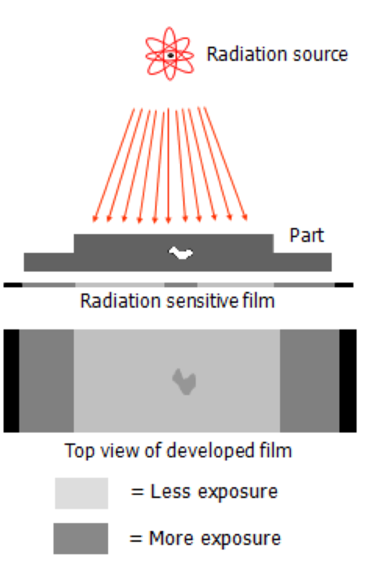

Figure 5: How radiography works for NDT inspection (Hijazi, 2015).
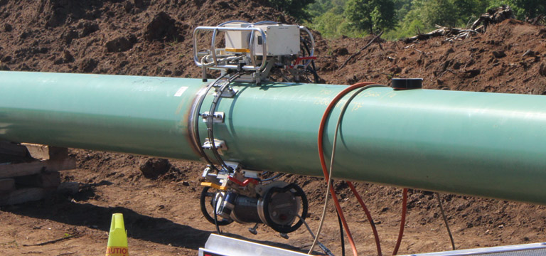
Figure 6: Radiographic equipment scanning a gas pipe (Shawcor, 2019) .
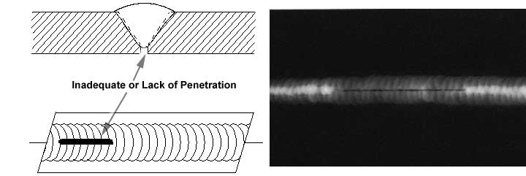
Figure 7: Example of radiographic image of a defected weld (Centre, 2017).

Advantages and disadvantages of radiographic testing:

There are many advantages of Radiography when used in conjunction with NDT. The fundamental advantages are as follows; The detection of internal and external defects during service, the detection of variations within the component and the ability to keep permanent copies of the data collected (Moore, 2002). Additional advantages include: it’s ability to scan a component without the need for component preparation or the need to apply direct loading to detect and analyse stress (Moore, 2002). The technique reveals assembly and fabrication errors, which help improve the quality of the components and indicate corrective action (Royce, 2015). The disadvantages for radiography however, have serious implications; the technique can be hazardous for the operator or personnel in the area and requires a considerable amount of safety features in place, which creates high amounts of downtime and cost. It requires operators with a full skill set and relevant experience and the process can be slow. The equipment is very expensive and needs access to at least two sides of the asset and complex geometry is not suitable for scanning (Royce, 2015) (Serman, 2000).

Potential errors and assumptions while using radiography:

During radiographic testing potential errors can occur which may lead to inaccuracies during the collection and analysis of data. For example; Blurring or distorting of images can occur due to moving or altering the film at time of exposure. Static electric of films from excessive flexing, double exposure from using the same film twice, where images become superimposed or the Under development of images that weren’t scanned long enough (Serman, 2000). Radiation fog can also case errors, when the film has previously been exposed to light before testing, which can lead to assumptions being made when analysing the images (Fujifilm, 2009). Other errors include; human error from working in low and high light environments or exposure to radiation causing fatigue and headaches. Radiation can leak from the equipment altering calibration settings, which causing inaccurate data to be collected, which could potentially lead to sever faults not being detected and eventually catastrophic failure (Series, 1998).

Radiographic testing applications:

Radiography has many applications within the engineering industry; it is used in the structural analysis of aerospace castings, welds and structures, checking for discontinuities, fatiguing and structural integrity (Moore, 2002). The technique is commonly used for the inspection of welds in components, to ensure that there is no anomalies, porosity or defects hidden within the weld which could cause degradation or crack propagation (Moore, 2002). During mass production, some companies utilises radiography to check the integrity of their castings to aid in quality control and production (Centre, 2017). The same concept has been adapted for the petrochemical industry during the manufacturing and in-service use of their storage vessels, ensuring that the assets are structural safe, there is no component degradation or defects and that when they’re in service there is no chemical leaks as radiography can check fluid movement (Babu, 2000).

Radiographic testing’s and its contribution to the improvement of stress analysis:

As previously stated, radiography utilises x-rays to penetrate to detect defects. It also has the ability to detect and diffract residual and applied stress within components (Anastasopoulos, 2015). It does this by measuring lattice deformations in the crystallographic planes and this acts as a strain gauge. The technique measures the residual and tensile stress in the component. It has been observed that when a tensile stress is applied, the lattice spacing will increase for planes perpendicular to the stress direction, and decrease for planes parallel to the stress direction (ANDEROGLU, 2004). The technique also has the ability to detected variations within the radiation via Geiger or scintillation counters that can measure the density within a component (Woodward, 1989).

Conclusion:
The use of destructive testing and NDT have been in place within industry for many years. It is therefore, concluded that destructive testing is a valid and reliable verification tool, but its damaging techniques cannot be utilised for testing on many in service and out of service components subsequently reducing its versatility within industrial inspection. The technique is also very costly and time consuming.
Modern day NDT is extensively used within all types of industry, and its capabilities are endless. It is still however, not without its limitations. The view of previous research is that no single non-destructive testing method can provide sufficient data about all potential stresses within a component, therefore the use of two or more NDT techniques would be more reliable to obtain better results and increase the effectiveness of an investigation.
Based on the literature review of ultrasonic, magnetic flux leakage and radiographic inspection, it is clear to see that all three techniques have the ability to detect, analyse and aid within stress analysis. If the yield stress of the material is known, then each technique has the ability to analyse the effects of stress on the component. It is also argued that through the data obtained from FEM and FEA. Stress can be detected and analysed from defect data collected, which if found in highly stressed areas could cause failure, or if found in less stressed areas could cause fatigue but not necessarily failure. Each technique brings a different and similar skill set to the industry, but inevitably all techniques contribute independently and as a collective for defect detection and stress analysis.

References:

(Uk), E. T., 2017. Floormap 3di. [Art] (Eddyfi ).
Ahmad, A. B., 2018. Ultrasonic Testing of Materials. Nondestructive Evaluation of Materials, 17(1), pp. 155-159.
Anastasopoulos, A. H. P. V., 2015. Emerging Technologies in Non-destructive Testing VI: Proceedings of the 6th International Conference on Emerging Technologies in Non-Destrutive Testing. Brussels: CRC Press.
ANDEROGLU, O., 2004. RESIDUAL STRESS MEASUREMENT USING X-RAY DIFFRACTION, Texas: Sematic Scholar.
Atherton, D. D. L. K., 1996. Effect of Stress Concentration on Magnetic Flux Leakage Signals from Blind-Hole Defects in Stressed Pipeline Steel. Springer Verlag, 1(1), pp. 25-36.
Babbar, V. B. C., 2005. Mechanical damage detection using magnetic flux leakage tools: modeling the effect of dent geometry and stresses. NDT & E International, 38(6), pp. 471-477.
Babbar, V. C., 2003. Residual Magnetic Flux Leakage: A Possible Tool forStudying Pipeline Defects. Journal of Nondestructive Evaluation, 4(22), pp. 117-125.
Babu, P. G. R. S. S. S., 2000. Application of NDT for In-service Inspection of pressure vessels and heat exchangers. [Online]
Available at: https://www.ndt.net/article/wcndt00/papers/idn619/idn619.htm
[Accessed 7th November 2019].
Barkanov, E. N. D. A. P. I. A., 2018. Non-destructive Testing and Repair of Pipelines. Europe: Springer.
Bhagi, P., 2012. Magnetic Flux Leakage Technique: Basics, India: Research Gate .
Brodovy, V. G. K. K. S., 2004. Ultrasonic Technique and Device for Residual Stress Measurement, Canada: Research Gate .
Brown, P. J. C. R. E. K. R. S. S. A. F. W. R., 1997. Current limitations of non-destructive testing in enineering. Philosophical transactions , 292(1390), pp. 163-174.
Cai, M. J. L. S. Z., 2015. Theory and Application of Magnetic Flux Leakage Pipeline Detection. Sensors , 2019(November ), p. 7th.
Cao, Y. D. Y. X., 2018. Progress and Challenges of Ultrasonic Testing for Stress in Remanufacturing Laser Cladding Coating , America: Multidisciplinary Digital Publishing Institute (MDPI).
Centre, N. R., 2017. Radiography Scan. [Art] (NDT ).
Clapham, L., 2004. MAGNETIC FLUX LEAKAGE INVESTIGATION OF INTERACTING DEFECTS: COMPETITIVE EFFECTS OF STRESS CONCENTRATION AND MAGNETIC SHIELDING, Canada : National Research Council .
Downes, G. W., 2003. A Brief Description of NDT Techniques, Hereford: Insight NDT Equipment Ltd.
Drury, J., 2012. MAGNETIC FLUX LEAKAGE TECHNOLOGY, Swansea: Silverwing (Uk) Limited .
EU., O. G., 2014. Ultrasonic Testing of Fiberglass and Carbon Fiber Composites. [Art] (NDT).
Executive, H. a. S., 2008. INFORMATION FOR THE PROCUREMENT AND CONDUCT OF NDT, UK: HSE.
Feng, Z. J. X. Y. Z., 2013. Three-axis magnetic flux leakage in-line inspection simulation based on finite-element analysis. School of Information Science & Engineering, Northeastern University, Shenyang 110819, China , 22(1), pp. 12-16.
Fujifilm, 2009. The fundamentals of industrial radiography. Tokyo : Fujifilm corporation .
Godfrey, E. C., 2016. Comparison of Non-Destructive and Destructive Examinations in Today ́s Inspection Practices. 19th World Conference on Non-Destructive Testing , 1(1), pp. 1-4.
Gupta, S., 2018. Comparison of Non-Destructive and Destructive Testing on Concrete: A Review. Trends in Civil Engineering and its Architecture, 1(2), pp. 7-9.
He, C. L. W. W. W. Y., 2018. Dipole modeling of stress-dependent magnetic flux leakage. NDT & E, 95(1), pp. 1-8.
Helena G. Lopes, R., 2014. Present and Future Impact of Magnetic Sensors in NDE. 1st International Conference on Structural Integrity, 86(1), pp. 408-410.
Hijazi, A., 2015. Introduction to Non- Destructive Testing Techniques, Uk: EIS.
HSE, 2000. Best practice for the procurement and conduct of non-destructive testing, uk: HSE.
Jayakumar, T. 2001. Non-destructive testing methods for investigation of SURFACES OF MATERIALS , India: Proc. International Conf on Surface Techniques .
Joyce-D, R., 1996. The Application of Ultrasonic NDT Techniques in Tribology. Journal of Tribology, 208(219), pp. 347-366.
Kim, J. L., 2014. Magnetic Flux Leakage Sensing-Based Steel Cable NDE Technique. Shock and Vibration, 14(1), pp. 10-24.
Kim, J. P., 2018. Magnetic Flux Leakage Sensing and Artificial Neural Network Pattern Recognition-Based Automated Damage Detection and Quantification for Wire Rope Non-Destructive Evaluation, India: Sensors .
Krautkramer, J. K., 1990. Ultrasonic Testing of Material. 4th edition ed. New York: Springer Berlin Heidelberg.
Lester, W. S. J., 2016. Fundamentals of Ultrasonic Nondestructive Evaluation. 2nd Edition ed. Massachusetts : Springer .
Limited, M. B. E., 2006. Recommended practice for magnetic flux leakage inspection of atmospheric storage tank floors , Renfrew: HSE.
LMATS, 2018. MFL Magnetic Flux Leakage - Tube Testing. [Online]
Available at: https://lmats.com.au/services/advanced-ndt-solutions/advanced-heat-exchanger-tube-testing/magnetic-flux-leakage-tube
[Accessed 7th November 2019].
Madhu, B. S. S. J., 2019. Ultrasonic Technology and Its Applications in Quality Control, Processing and Preservation of Food: A Review. Current Journal of Applied Science and Technology, 1(11), pp. 1-10.
Moore, P., 2002. Radiographic Testing. 3rd Edition ed. America : s.n.
NSF, 2009. Real time Radiography. Uk : NSF .
Ramesh, S., 2016. Applied Welding Engineering. 2nd Edition ed. UK: Butterworth-Heinemann.
Royce, R., 2015. An Introduction to NDT Common Methods, Uk: Bindt.
Series, S. R., 1998. International atomic energy agency. 1st edition ed. Vienna: International atomic energy agency .
Serman, N., 2000. RADIOGRAPHIC ERRORS AND ARTIFACTS., columbia : Columbia edu.
Services, A. M., 2017. MAGNETIC FLUX LEAKAGE TESTING IN OMAN. [Online]
Available at: https://www.ariesmar.com/magnetic-flux-leakage-testing-oman.html
[Accessed 7th November 2019].
Services, V. T., 2017. Metal Analysis Testing. [Online]
Available at: https://verichek.net/destructive-vs-non-destructive-metal-testing.html
[Accessed 7th November 2019].
Sharma, A. S., 2018. Ultrasonic Testing for Mechanical Engineering Domain: Present and Future Perspective. International Journal of Research in Industrial Engineering, 7(2), pp. 243-253.
Shawcor, 2019. Real Time Radiography. [Art] (Shawcor).
Soni, S. K. D. M. V. P., 2018. Advances and Researches on Non Destructive Testing: A Review, Birmingham: Elsevier.
Technologies, E., 2010. Factors that affect the defect sizing capabilities of the Magnetic Flux Leakage Technique , Swansea: Eddyfi Technologies.
Twi, 2019. What are the advantages and disadvantages of ultrasonic examination in non-destructive examination (nde)?. [online]
Available at: https://www.twi-global.com/technical-knowledge/faqs/faq-what-are-the-advantages-and-disadvantages-of-ultrasonic-examination-in-non-destructive-examination-nde
[Accessed 7th November 2019].
Usama, M., 2014. Destructive tests , Canada : Academia edu.
Woodward, R., 1989. TRANSPORT AND ROAD RESEARCH LABORATORY, Berkshire: TRL Limited .

