Learning LoG Report
Anthony Burns
BMSP4005 Distinctiveness and Regeneration
Natalie Male (1702161)

Introduction
Llanelli is a coastal town that is situated in South West Wales in the borough of Carmarthenshire. It has an interesting and somewhat unique history, from arable farming to the industrial revolution. The geography of Llanelli meant that coal mining was a rich resource waiting to be utilised. De industrialisation in the 1950’s has left the town with many difficulties. With the mines closing this left the area without major employment. Many initiatives for regenerating areas of Llanelli have proved to be successful and many areas are continuing to suffer.

The Industrial Revolution
Llanelli before the introduction of the industrial revolution had a small coal industry from the middle ages and had a strong trade with France providing sea coal. They were small privately-owned mines. Lack of new technology only brought a modest income for families. Some smelting took place however the area was mainly arable land. This land was often leased from larger estates such as Stradley and Mansell. These tenant farmers and their families had a modest but hardworking life tending the lands. Rising with the sun and finishing the days work at sundown, there was no need for clocks. Developments during the agricultural revolution such as the seed drill improved the yield of crops.
Over the course of 150 years developments in technology transformed Great Britain from a predominantly agragarian society to an industrial based one. Inventions were making jobs easier and quicker with fewer workers needed. “By 1851, however, two thirds of the families of Wales were supported by activities other than agriculture, which meant that, after the English, the Welsh were the world's second industrial nation”. (The industrial revolution, 2019)
Llanelli was an ideal area in terms of coal production due to its geology. (Bowen, 1980) states that “The geological structure of the area is dominated by the Llanelli Syncline, which, with the presumed extension of the Gowerton Syncline along the Bury Estuary, marks the western end of the main South Wales Coalfield synclinal basin”. There were vast areas of land, to rent or purchase and plenty of available workers. There began a ruthless campaign to control the coal fields, which had been largely untouched. Chauncey Townsend worked to gain the leases to as many as possible and then did nothing with the lands. This left the area behind others in its ability to mine this precious comodity.
Alexander Raby was eventually able to obtain the leases. His arrival sparked the beginning of the industrial revolution for Llanelli. He was a well respected figure and many followed him to invest. (Hannam, 2019) proposed that ”Everyone follows the money, it always happenens” He upgraded existing collieries and created several new pits. The pits mined bituminous coal which powered steam trains and engines. The infastructure of Llanelli improved with the opening of rail networks connecting to other areas. The coastal location was always a distink advantage in the export of goods. The demise of the coal mines was due mainly to the nationalisation of the coal mines and cheaper coal from china. By 1980 there were only a few mines left open.

Tata Steel
Tata steel is an Indian owned company that produces steel in its plant in Port Talbot. (Jones, 2019) reported that“The plant is ideally based for the ships delivering the coal, iron ore and limestone used in making steel. The reason for this is that it is situated on the Bristol Channel which has the second highest tidal rise and fall”. There are good road and rail links. Port talbot also recycle old steel for example pet food cans and biscuit tins. There are no more producers of steel cans in the Uk which are made from tin plate. These cans are put into a blast furnace and turned into liquid iron, then they are transferred to a torpedo that holds 300 tons of liquid iron. The steam from this process is used to heat the offices. These torpedos way up to 500 tons in total and the iron can stay hot for 16-18 hours. They are made of steel and contain refractory bricks which are periodically replaced. The torpedos are then transported by rail directly to the Trostre plant which will turn the raw material back into sheets or coils ready to be reused in the can making process.
Llanelli Wetland Centre

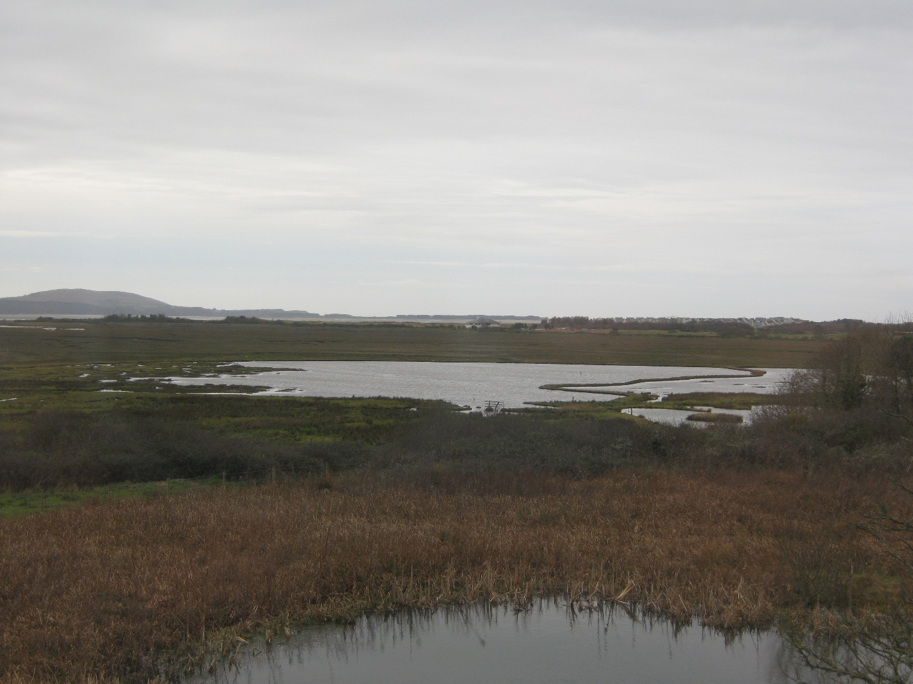
The salt marsh 19/02/2019

The Llanelli Wetland centre is an excellent example of the ability to regenerate a disused area of farmland. The initiative was developed to preserve an area of wetland and increase visitors to the area. Our guide Sarah Rees informed the group on the history of the centre. The founder of the WWT was Sir Peter Scott (one of the hides is named after him). His wish was for the public to get closer to nature. Originally, he was a duck hunter but had a change of heart one day when watching the birds with interest. The centre was looking for a new location. Trostre was chosen due to its salt marsh and the reduced risk of pollution that may occur in the Bristol Channel. The centre took seven years to build and opened its doors in 1991. In total 450 acres were developed. The centre is increasing its numbers and in 2018 had seventy thousand visitors an increase from twenty-four thousand in 2014. The centre attracts families, schools and wildlife enthusiasts. Offering education through experiences and information. Image 1 below shows the layout of the centre.

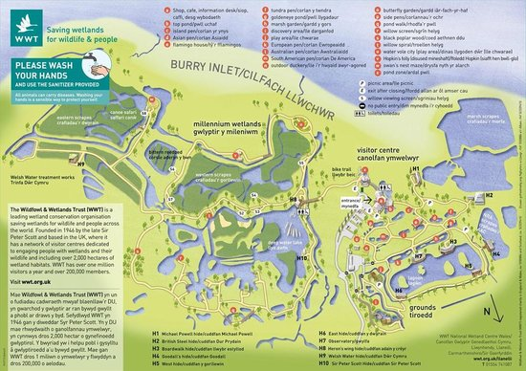
Image 1 (Welsh Wildlife Trust, 2019)

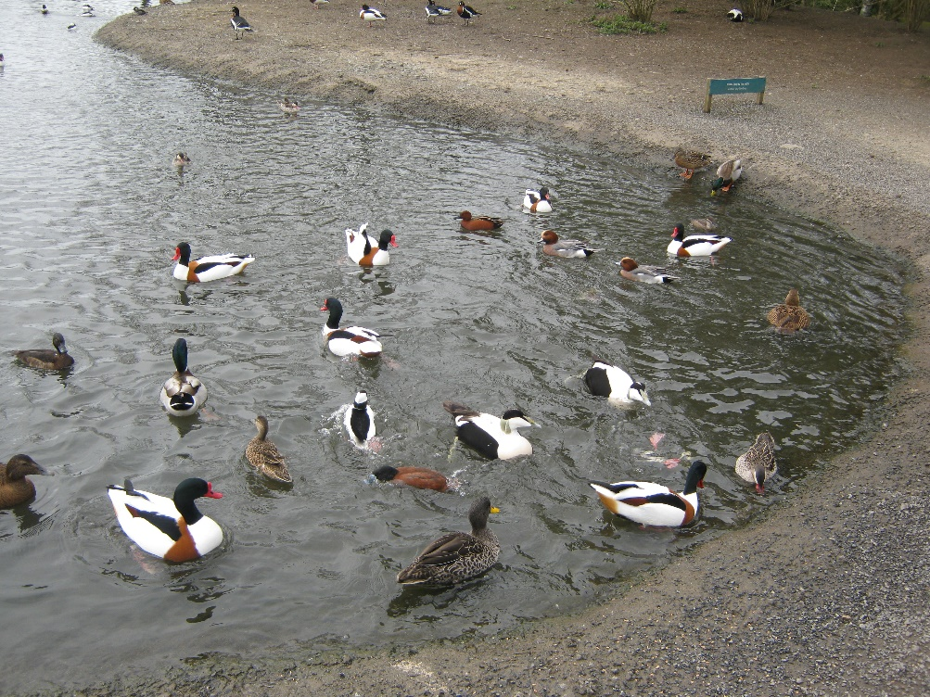
Feeding the ducks from food available to buy at the centre.

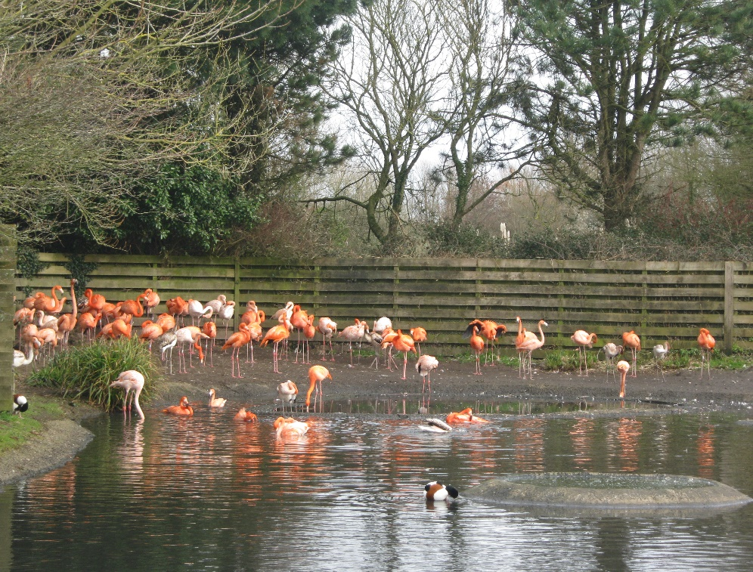

Conclusion
Llanelli is a proud community steeped in history and has seen many changes to industry. With the end of coal production and the economic decline the area was lacking opportunities. The landscape has become unstable for regeneration in parts due to open cast mining. The council has had to investigate regeneration opportunities and the creation of jobs for individuals living in the area. Tata steel’s plant at Trostre is an example of a sustainable business through the recycling of metals and the creation of jobs. The wetlands centre is continuing to grow its numbers and bringing visitors to the area. It is a real success story of how the correct investment and dedication can regenerate and educate an area. Despite these important contributions there are many further areas of Llanelli rife for regeneration. The town requires appropriate support and investment if it is to thrive going forward. The area was stripped of its valuable commodity now Llanelli needs to look at itself as a new precious commodity to regenerate.

References

Bowen, D. Q. (1980). The Llanelli Landscape. Llanelli: Llanelli Borough Council.
Hannam, J. (2019, January 29th). Guest Lecturer . The Roots of Modern Llanelli.
Jones, N. (2019, February 19th). Guest Lecturer. Trostre Tata Steel Tin plate works.
The industrial revolution. (2019, March 13th). Retrieved from BBC.co.uk: http://www.bbc.co.uk/wales/history/sites/themes/guide/ch15_industrial_revolution.shtml
Welsh Wildlife Trust. (2019, March 3rd). wetland-centres/llanelli/plan-your-visit/. Retrieved from wwt.org.uk/wetland-centres/llanelli/ : https://www.wwt.org.uk/

