
TRINITY
HOTEL
Christmas Party
MENU

MAIN COURSE

Herb and Butter Roasted Beef Tenderloin with Baked Sweet Potatoes

Glazed Ham with Truffles Puree

Red Wine Pasta with Parmesan and Pancetta

Easy-Carve Roast Lamb with Asparagus
DRINKS

Wine (Red/White/Rose)
Christmas Punch
Bisol Crede Brut Prosecco
Armand de Brignac Rose Champagne

DESSERTS

Baked Apple Cinnamon French Toast
Toffee Sticky Buns
Eggnog Bundt Cake
Dark Chocolate Honey Fig Walnut Truffles

STARTERS

Beet Hummus
Cranberry and Feta Pinwheels
Holiday Cheese Board
Baked Brie Puffs
Antipasto Skewers

TRINITY
HOTEL
PRICES

1 COURSE - £15.95
2 COURSES - £19.95
3 COURSES - £23.95
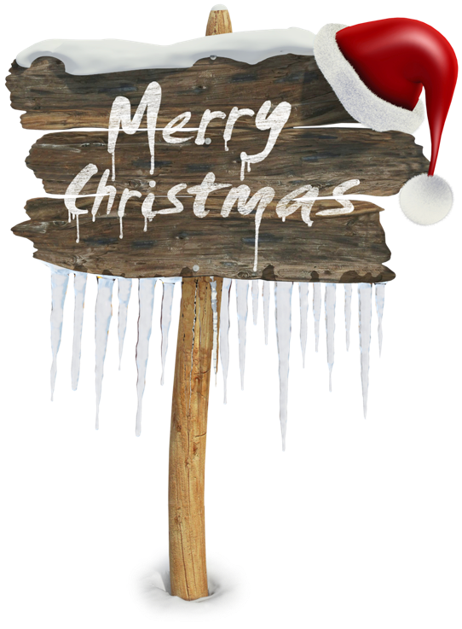
Order at

Just Eat / Uber Eats

Payment Options
Cash / Card / Contactless

QR CODE

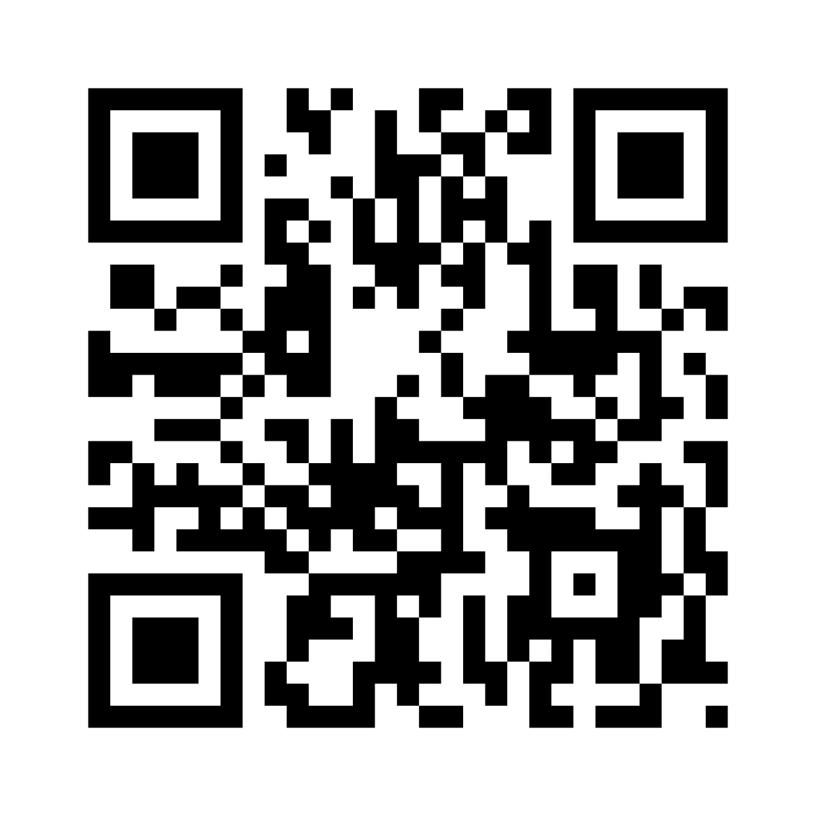

References
Images: PngEgg.com, (2022), PNG Images for designers, [Available online: https://www.pngegg.com], Accessed 09/11/2022

Menu Inspiration

Kranker D., (2021), HOW TO CREATE A RESTAURANT MENU FROM SCRATCH, [Available Online: https://budgetbranders.com/blog/how-to-create-a-restaurant-menu-from-scratch/], Accessed 09/11/2022

Easil, (2022), HOW TO DESIGN A PROFESSIONAL MENU IN UNDER 30MINS, [Available Online: https://about.easil.com/design-a-professional-menu/], Accessed 09/11/2022

Nagi C., (2021), Christmas Recipes and Menus, Posted 19/12/2021, [Available Online: https://www.recipetineats.com/christmas-recipes/], Accessed 09/11/2022

Oliver J., (2021), Christmas mains ideas, [Available Online: https://www.jamieoliver.com/christmas/collection/christmas-dinner/], Accessed 09/11/2022

