jacob nicklin
Student Number: 2305180 Course: Applied Computing
Network and Cybersecurity

Contents page
Network and Cybersecurity 0
Introduction 2
Part 1 2
A) NIST Security Framework 2
B) Reconnaissance in the “cyber kill chain” 4
C) Cyber – Attacks and Mitigations strategies 5
i) WannaCry and TeleRat 5
ii) Whaling and Pharming 6
Part 2: Network Diagram 7
Why this design? 8
Improvements 8
Certificate proof 9
Conclusion 10
Bibliography 11

Introduction
Within today’s society, cybersecurity is paramount to the protection of systems, files, data and information. A cyber intelligence engineer’s job entails protecting devices and systems from threats such as malware, ransomware, data theft and types of cyber-attacks. [1] [2]
This report will consist of two parts. The first part will look into systems for safeguarding personal data. The “Reconnaissance” stage of cyber-attacks that use Nmap and Wireshark, which are two tools used to view networks. It will also look at mitigation strategies against types of malware and phishing attacks. The second part of the report will include network topology example and a review of said example on where it could be improved with upgraded technology.

Part 1

NIST Security Framework
The NIST Security Framework [3] is a guidance document that provides information to people or organisations. The document offers information to protect, safeguard and manage cybersecurity risks as well as providing substantial information on threats that an organisation could face in the cyberspace. It is split into five organisational profiles:
- Scope the organisational profile.
- Gather the information needed to prepare the organisational profile.
- Create the organisational profile.
- Analyse the gaps between target profiles and create an action plan.
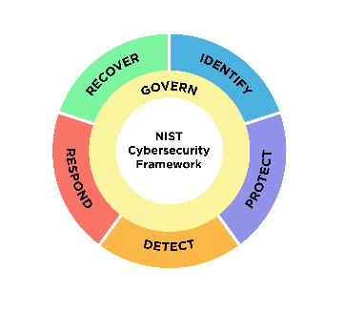
- Implement the action plan and update the organisational profile.
Figure 1: The framework summarised through an image [3]
By breaking down the framework into 5 parts, companies can easily implement these practices in order to protect their data and information. Usually, companies who don’t use the framework could inefficiently put their time and money into ineffective strategies to protect themselves, in doing so they put themselves at risk of complex cyber-attacks. The framework gives details on where a company should focus their time and money, along with teaching a company’s employees about how to protect themselves. By the end of the document, a company should be able to achieve a tier 4 “adaptive” approach to being cybersecure, in which they should be able to learn from previous mistakes, strengthen themselves and respond to evolving and more sophisticated threats. [3] [4] [5]

The framework also provides the different relationships between cybersecurity and privacy, helping a person distinguish the differences between the two, which can be difficult to a person who has never had any experience with cybersecurity and might mistake the two. [3] Cybersecurity and privacy risks do interlink, Although there is document called the “NIST privacy framework” that goes more in depth about privacy.
The organisational profiles seen above are designed to be repeatable so a person or company can use them as many times necessary to safeguard information and to escalate a company to the current global standard for cybersecurity, also making updates in future security standards easier as a company will be at the forefront of updates, meaning a company can save time by complying with the newer updates.
Reconnaissance attacks are prevented by the “protect” section of the framework, under “data security” where it is the organisation’s objective to protect the data in all forms and make sure it is maintained, thereby protecting their weaknesses from a potential reconnaissance [3]. “Weaponisation” is also prevented through protect as a company should be able to stop the installation and execution of unauthorized software [6].
The “detect” and “response” stages of the framework would also prevent any further attacks as it involves creating the final action plan and responding to the detected cybersecurity events. Going back to the “Govern” and “Protect” stages in order to successfully prevent attacks in the future. [3]
Finally, the hackers or attackers can be traced should a company follow the framework, contained within the “detect” stage as well, meaning companies can monitor anomalies, along with tracing them back to the original attacker.

Reconnaissance in the “cyber kill chain”
Nmap and Wireshark are two of the most widely available network troubleshooters and analysers. However, the tools are used by hackers worldwide in order to conduct reconnaissance on a network they want to target and attack. By conducting reconnaissance beforehand, an attacker can draw up an attack strategy. [7]
Nmap’s primary purpose is to scan large networks rapidly, making it perfect for hackers to scout organisations for an attack. Within the IP packet scan, Nmap can deduce a network’s specifications such as type of OS systems, what firewall is being used and how many users are on the network. All this information can be utilised to form an attack strategy further down the line in the “Cyber Kill Chain” [8]. However, Nmap can only interact through the execution of scripts, which is why a hacker might then swap to Wireshark. [7]
Wireshark is a network packet analyser, so rather than scanning a network to see specifications of a system, it looks at the network traffic being sent between systems. Wireshark can also capture different media types such as Ethernet, Wireless LAN and more. A sharp difference between this and Nmap is that Wireshark is unable to send packets, it can only view what is being sent to and from systems. What an attacker can do with Wireshark is intercept or gain information on more personal details, making Wireshark more suited for gaining individual information such as credit card numbers, private messages or transactions. [9] [10]
Both are equally dangerous when it comes to carrying out reconnaissance. By using both in unison, an attacker can create a coordinated and extremely thought-out strategy to attack a network using Wireshark to scan and intercept traffic, along with using Nmap to understand what kind of system, Operating system and firewalls an attacker is up against. [9] [10]

Cyber – Attacks and Mitigations strategies

WannaCry and TeleRat
One of the biggest threats to systems in today’s society is malware. Malware is a broad term that encompasses any threatening software designed to cause disruption to a computer. Two of the biggest examples are WannaCry and TeleRat, both equally destructive in their own ways. [11]
WannaCry is one of most notable malware attacks ever. In May of 2017, this ransomware was used to disable logins for over 200,000 computers, even holding the NHS hostage until they paid a ransom to reactivate the computer. WannaCry uses a system vulnerability exploit known as “EternalBlue” which was in millions of computers, holding a user’s data hostage until they paid a ransom. [12]
The most effective way to prevent “WannaCry” is to keep a system updated with the latest security updates. After the crisis in 2017, Microsoft has patched the vulnerability, although keeping up to date with the newer security means a user is more protected against this malware. Another key prevention measure is to make backups in the event a ransomware controls a user’s data and destroys it. Organisations should also isolate infected and outdated software from the network in order to contain a “WannaCry” spread. [12] [13] [14]
TeleRat is a trojan malware, particularly found on mobile devices, which disguises itself as a bot with a link. An infected phone’s data is scraped from a user’s messages and calls, which is then sold onto third party companies who can use it to advertise to a user or send even more links to a user. The easiest way to prevent Telerat is to block the bot telegram uses to advertise marketing to a user and avoiding clicking on suspicious links. The second most effective mitigation method is the more recent 2-Factor authentication (2FA), which requires a special code app to access any sensitive information. Finally, using an anti-virus or a malware report system will highlight it to a user and in some instances, removing or blocking the malware. [15] [16] [17]
Most mitigation strategies are down to a user rather than any sort of anti-virus, by keeping up with the most updated software and Operating systems, a user can ensure their computer remains secure. The addition of 2FA has prevented the leakage of vulnerable information even further. Modifying privacy settings can also increase security to avoid any suspicious links “slipping through the net” and infecting a device. [18]

Whaling and Pharming
Whaling and farming differ from a malware or virus type of attack in that they focus on primarily socially engineering a person into giving the attacker information. Both are to be considered as “phishing” attacks, meaning that they both trick a person into giving up information, although they achieve this in different ways, by still utilising malware to gather sensitive information and gain control without the user’s knowledge. [19] [20]
Whaling is an extreme form of a phishing which usually involves targeting a higher up individual within a company such as a CEO or owner. Usually coming in the form of an email, text, or phone call. These attacks tend to either deliver malware to the unsuspecting user, conveying a sense of urgency and alert to them to scare them into making unreasonable or rash decisions [21]. There is no easy way to prevent a whaling attack as it relies completely on social engineering. The best a company can do is to teach their employees and executives about what to look out for in suspicious emails and links, along with when they can expect these types of emails, such as the holiday seasons or who can expect to get them the most, such as financial workers like accountants, bankers, CEOs and owners. [22]
Pharming is a different form of a social engineering attack. It relies once again on the user opening a suspicious email or link or website. Once a user has clicked the link, a malware will “spoof” a website the user might want to reach such as a bank website. Alternatively, a “pharmer” can redirect hundreds or thousands of users and inadvertently catch users in the redirected website links. Once again, there isn’t a true way to stop being targeted, although using reliable DNS servers and website links is an excellent preventative [23]. If a user has already been caught by a pharmer then they can do a number of measures to stop it. Clearing the DNS cache is one way to stop an attack in progress, alongside this, running most antivirus software will highlight and secure a device. Due to the pharmer likely already having access to sensitive information, changing passwords and updating information afterwards will prevent any further attacks.
Overall, whaling and pharming are some of the hardest cyber-attacks to prevent, with nearly all defences relying on a user’s intuition to spot a harmful link or email.

Part 2: Network Diagram
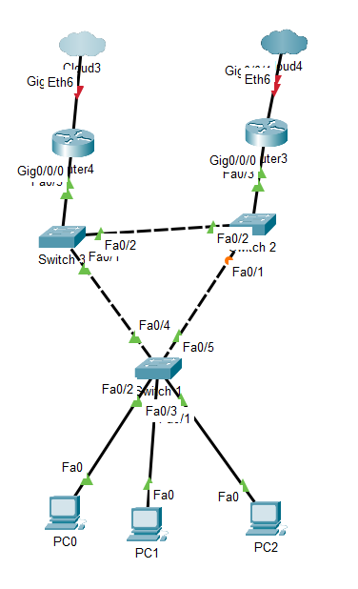

Why this design?
Seen above is a topology of a secure network that is designed to eliminate single points of failure and to provide for redundancies within a network along with accommodating high availability. Two routers have been proposed in order to eliminate a single point of failure, should one router fail, there is still another router connected to the Spanning Tree protocol (STP) interconnection of switches which would connect the pc to the internet. The switches are loop-free because of the STP and creates only one logical path to take, further improving on top of the two routers jobs to eliminate crossovers. Improvements can certainly be made to the network as the current network might be less than 99.999% available.

Improvements
The first improvement that could be made to bolster security would be the introduction of several firewalls to ensure that the traffic throughout the network remains clean and doesn’t pose a threat to the availability of the network [24], putting an extra firewall between the routers and the internet would help to filter out any more complex cyber-attacks and malware . The second improvement that could be made is to track the vulnerabilities should a router or switch go down. Having a patch management from manufacturers would help to stop any worms or virus from attacking. Alongside this, modifying the default configuration of the routers, PCs or switches would make it much more secure to any cyber-attacks. Using a VPN [25] would also be an excellent choice of defending the system uptime. VPNs encrypt personal data meaning a lot of malware becomes completely obsolete in being able to target a user, due to them being connected to a completely remote server, thereby making this one of the best methods to secure a personal network and connection to the internet. Adding a proxy server to the design between the routers and the internet would increase security monumentally. By having this server in place, the server can be used to prevent attackers from entering a private network, along with allowing a gateway between users and the internet. [26]

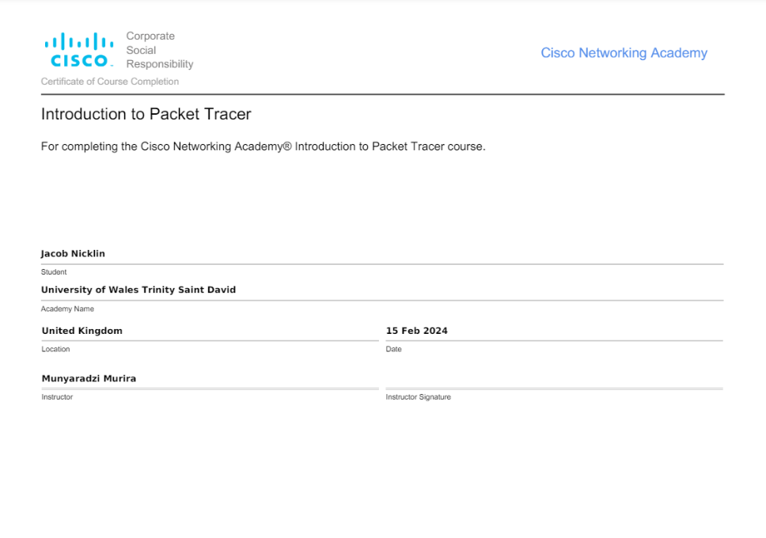
Certificate proof

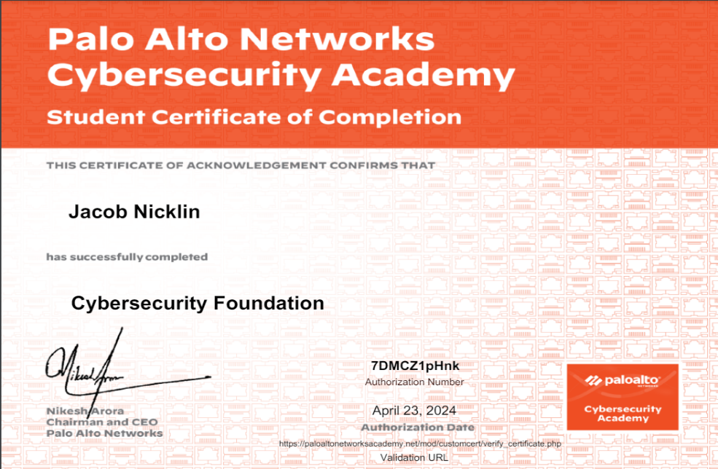
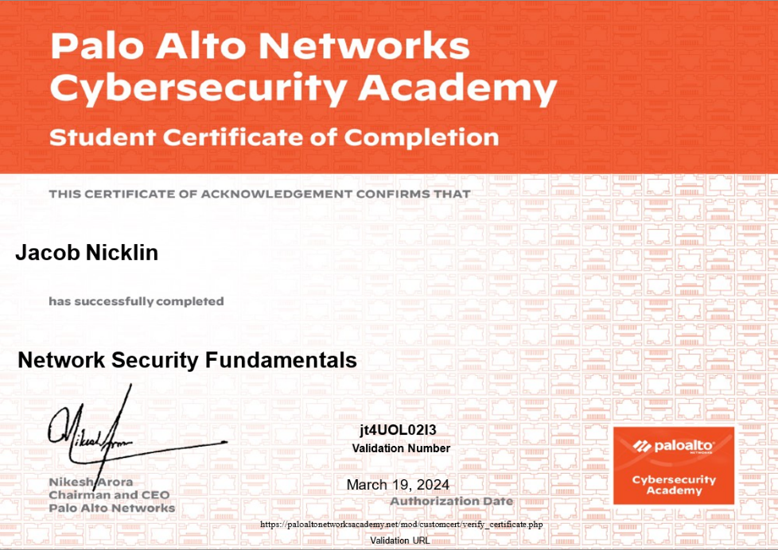

Conclusion
Cyber security is an ever growing and ever improving sector of the digital world. The risks posed by ever growing dangers such as malware, phishing, viruses and poor security continue to grow yet cyber security engineers and analysts combat it. It’s extremely important for a general user of an electronic device to ensure the safety of it, through means such as anti-virus, firewalls, changing privacy settings and being aware of the threats within the digital space and how a person can prevent it.
I believe I could improve my findings by using more sources other than books and websites. Although my references are all sourced from trustworthy and credible sources, I can improve my information by making use of journal articles, other reports or interviews. Another technique I could use to improve my findings would be to include more key terminology, although this was challenging due to the restraints on word count.

Bibliography

[1] | National Cyber Security Centre, “What is Cyber Security,” April 2024. [Online]. Available: https://www.ncsc.gov.uk/section/about-ncsc/what-is-cyber-security. [Accessed 19 April 2024].
[2] | Cisco, “What is Cybersecurity,” April 2024. [Online]. Available: https://www.cisco.com/c/en_uk/products/security/what-is-cybersecurity.html. [Accessed 19 April 2024].
[3] | NIST, “The NIST Cybersecurity Framework,” 26 February 2024. [Online]. Available: https://nvlpubs.nist.gov/nistpubs/CSWP/NIST.CSWP.29.pdf. [Accessed 23 April 2024].
[4] | FTC, “Understanding the NIST Cybersecurity Framework,” March 2024. [Online]. Available: https://www.ftc.gov/business-guidance/small-businesses/cybersecurity/nist-framework#:~:text=The%20Framework%20is%20voluntary.,Detect%2C%20Respond%2C%20and%20Recover.. [Accessed 26 April 2024].
[5] | StickmanCyber, “Cybersecurity Blog,” 16 March 2021. [Online]. Available: https://www.ftc.gov/business-guidance/small-businesses/cybersecurity/nist-framework#:~:text=The%20Framework%20is%20voluntary.,Detect%2C%20Respond%2C%20and%20Recover.. [Accessed 26 April 2024].
[6] | UWTSD, “Availibility and Defence, Network and Cybersecurity Essentials (ACCA4024),” UWTSD, Swansea, 2024.
[7] | educba, “Nmap V Wireshark,” 6 April 2023. [Online]. Available: https://www.educba.com/nmap-vs-wireshark/. [Accessed 27 April 2024].
[8] | Nmap, “Nmap Description,” Nmap, March 2022. [Online]. Available: https://nmap.org/. [Accessed 27 April 2024].
[9] | WhisperLab, “Introduction to Hacking,” WhisperLab, March 2024. [Online]. Available: https://whisperlab.org/introduction-to-hacking/notes/wireshark#:~:text=Wireshark%20can%20also%20be%20used,%2C%20financial%20transactions%2C%20and%20more.. [Accessed 27 April 2024].
[10] | Wireshark, “Chapter Introduction,” Wireshark, April 2024. [Online]. Available: https://www.wireshark.org/docs/wsug_html_chunked/ChapterIntroduction.html#ChIntroWhatIs. [Accessed 27 April 2024].
[11] | Mcafee, “Malware,” Mcafee, 2024. [Online]. Available: https://www.mcafee.com/en-gb/antivirus/malware.html#:~:text=Malware%20is%20a%20catch%2Dall,over%20victims%20for%20financial%20gain.. [Accessed 27 April 2024].
[12] | CloudFlare, “WannaCry-Ransomware,” CloudFlare, 9 January 2024. [Online]. Available: https://www.cloudflare.com/learning/security/ransomware/wannacry-ransomware/. [Accessed 27 April 2024].
[13] | Kaspersky, “Ransomware - Wannacry,” Kaspersky, 2024. [Online]. Available: https://www.kaspersky.com/resource-center/threats/ransomware-wannacry. [Accessed 27 April 2024].
[14] | N. C. Centre, “mitigating malware and ransomware attacks,” NCSC, 9 September 2021. [Online]. Available: https://www.ncsc.gov.uk/guidance/mitigating-malware-and-ransomware-attacks. [Accessed 27 April 2024].
[15] | Microsoft, “Trojan Viruses,” Microsoft, 23 July 2021. [Online]. Available: https://www.microsoft.com/en-us/wdsi/threats/malware-encyclopedia-description?Name=Trojan:AndroidOS/Telerat!mclg&ThreatID=2147786633. [Accessed 27 April 2024].
[16] | P. (Unit42), “TeleRAT: Another Android Trojan Leveraging Telegram’s Bot API to Target Iranian Users,” PaloAlto, 20 March 2018. [Online]. Available: https://unit42.paloaltonetworks.com/unit42-telerat-another-android-trojan-leveraging-telegrams-bot-api-to-target-iranian-users/. [Accessed 27 April 2024].
[17] | GBHackers, “Telegram Bot API Abused By TeleRAT Android Malware,” GBHackers, 24 March 2018. [Online]. Available: https://gbhackers.com/telerat-malware-abused-telegram-bot-api/#:~:text=TeleRAT%20is%20a%20Dubbed%20IRRAT,listings%20from%20infected%20Android%20devices.. [Accessed 27 April 2024].
[18] | Microsoft, “2FA,” Microsoft, 2024. [Online]. Available: https://www.microsoft.com/en-gb/security/business/security-101/what-is-two-factor-authentication-2fa#:~:text=Two%2Dfactor%20authentication%20(2FA),most%20vulnerable%20information%20and%20networks.. [Accessed 27 April 2024].
[19] | CloudFlare, “What is a phishing attack,” CloudFlare, 2024. [Online]. Available: https://www.cloudflare.com/learning/access-management/phishing-attack/. [Accessed 29 April 2024].
[20] | A. K. V. C. Attia Qamar, “Mobile malware attacks: Review, taxonomy & future directions,,” in Mobile malware attacks, 2019 Elsevier B.V., 2019, pp. 887-909.
[21] | N. C. Centre, “Whaling,” NCSC, 22 August 2020. [Online]. Available: https://www.ncsc.gov.uk/guidance/whaling-how-it-works-and-what-your-organisation-can-do-about-it. [Accessed 29 April 2024].
[22] | Kaspersky, “What is Whaling,” Kaspersky, 2024. [Online]. Available: https://www.kaspersky.com/resource-center/definitions/what-is-a-whaling-attack. [Accessed 29 April 2024].
[23] | Kaspersky, “Pharming,” Kaspersky, 2024. [Online]. Available: https://www.kaspersky.com/resource-center/definitions/pharming. [Accessed 29 April 2024].
[24] | CISA, “understanding Firewalls,” 23 February 2023. [Online]. Available: https://www.cisa.gov/news-events/news/understanding-firewalls-home-and-small-office-use#:~:text=Hardware%20%E2%80%94%20Typically%20called%20network%20firewalls,that%20also%20include%20firewall%20features.. [Accessed 30 April 2024].
[25] | A. Microsoft, “What is a VPN,” Microsoft, 2024. [Online]. Available: https://azure.microsoft.com/en-us/resources/cloud-computing-dictionary/what-is-vpn#:~:text=A%20VPN%2C%20which%20stands%20for,and%20firewalls%20on%20the%20internet.. [Accessed 30 April 2024].
[26] | Varonis, “What is a proxy server,” 24 June 2022. [Online]. Available: https://www.varonis.com/blog/what-is-a-proxy-server. [Accessed 30 April 2024].

