Target 1 | Ensure all points and arguments you make are supported by references to literature.
Target 2 | Engage with a more extensive range of literature which will allow you to draw on multiple sources to synthesise key arguments and points you come across.
Target 3 | Proof-read your work carefully to eliminate minor errors in spelling, punctuation and grammar.
Throughout this assignment I will aim address my targets by ensuring I have support my arguments with reference to theorists and literature through a range of sources. I will also proof read my work carefully before submission to elimate any errors.

Demonstrate how cross-curricular teaching and learning can influence in-depth skills and understanding.

Introduction
In this assignment I aim to demonstrate how cross curricular teaching and learning can influence in-depth skills and understanding. I will include a lesson plan and relevant resources with reference to the literacy, numeracy and digital competence framework within the Curriculum for Wales. According to the New Curriculum for Wales, the Curriculum must embed the mandatory cross- curricular skills (Gov.Wales, 2019). This offers a diverse range of opportunities and challenges. It could be said that some of these opportunities include a holistic approach to learning, enabling learners to make connections giving them a deeper understanding of real-world contexts (Driscoll & Lambirth, 2015, p.260). However, some challenges include aligning the Curriculum, as well as time constraints, a lack of resources and teacher expertise which could create resistance to change. In my understanding, cross-curricular teaching and learning uses a thematic approach where subject learning revolves around a central theme. In my Bridging experiences I observed learners being taught through a thematic approach. One topic I observed was superhero’s, specifically looking at real life superheroes. During a lesson under this topic the reception class I was observing had a task where they listened to real life superheroes speak. The pupils each had a tally chart on a clipboard with questions they had created in previous lessons. During the activity their task was to ask the questions to the guest speakers and tally chart their responses. After the pupils recorded these results, they then created a simple bar chart on J2e to record their information. This task demonstrates how the literacy, numeracy and digital competence framework can be incorporated within cross-curricular teaching and learning. This method of teaching and learning is supported by the Curriculum for Wales. This is also supported by Vygotsky and Dewey who further suggest moving away from traditional subject specific curriculum. Dewey believed in using real world connections in order to promote learning within the different subject areas. Alongside Vygotsky who advocated for learning environments that encouraged collaboration and scaffolding among peers, which aligns with collaborative cross-curricular learning (Aubrey & Riley, 2022, p.80). ‘Literacy, numeracy and digital competence are mandatory cross-curricular skills within the Curriculum for wales. It will be the responsibility of all practitioners, across all curriculum areas, to develop and ensure progression in these skills’ (Hwb.Gov, 2022).

Main Body
The Curriculum for Wales encourages the development of literacy, numeracy, and digital competence abilities for students in the primary age range. This approach ensures that students get the necessary skills in these areas throughout their education. While literacy, numeracy and digital competence are mandatory cross circular skills within the curriculum for Wales, they must also be integrated within the six areas of learning (Gov.Wales, 2019). The Curriculum for Wales frameworks has progression steps in place to ensure that learners are gaining the expected knowledge and skills within each area. The progression steps also provide a guide for practitioners to ensure that they are teaching the depth and breadth of the required skills. Enabling pupils to become independent, effective learners. ‘Progression steps are part of the descriptions of learning. They describe how learning should progress within each statement of what matters across the learning continuum’ (Lewis, n.d.). Cross curricular teaching and learning can provide many opportunities as well as challenges. Through a cross-curricular approach, students are provided with the opportunities to apply knowledge and skills through meaningful real-world experiences. This is is supported by (Dewey, 1938) who states that ‘learning should focus on practical life experiences and social interaction rather than the more traditional and staid manner’. Additionally, it could be said that cross curricular learning can help to increase student motivation and engagement. By integrating multiple subjects into a single task or project, teachers can create diverse learning activities and cater to different learning styles. This can assist in capturing learners' enthusiasm and engagement. Gardner’s theory of multiple intelligences suggests that individuals have different strengths and preferences in how they learn. Integrating subjects can allow for a more diverse range of learning experiences that cater to students varied preferences (Gardner, 1983). Cross curricular learning also offers a holistic approach to learning, allowing learners to gain deeper knowledge by highlighting the connections between different subjects.
It could be said that one of the challenges of cross curricular teaching and learning is ensuring that subject curriculum standards and learning objectives are covered. Lessons must be carefully planned in order to address subject content and skills within an integrated approach. Additionally, implementing cross-curricular learning can require additional time for planning and collaboration among teachers. It may also require adjustments to the traditional school schedule to accommodate interdisciplinary activities and projects, which can be challenging within the constraints of the school day. Having access to a variety of resources, such as educational materials, technological tools, and community connections, may be necessary for implementing cross-curricular learning. Practitioners may find it difficult to create and carry out multidisciplinary activities that give pupils rich and varied learning experiences if they have limited resources (Hayes, 2010). Cross curricular teaching and learning also supports enhanced provision learning as teaching through a thematic approach allows practitioners to create learning environments and experiences which are intentionally and thoughtfully designed to maximise children’s learning and development, this is referred to as enhanced provision. It entails designing spaces that are resource-rich, engaging, and sensitive to the needs, interests and skills of the learners (Forrester, et al., 2021).
For my planned learning experience, within the cross curricular topic of ‘My World’ (Appendix 1). I intend to work within the AoLE of Mathematics and Numeracy whilst incorporating elements and progression steps from the Curriculum for Wales literacy, numeracy and digital competence framework. My learning activities involve a group discussion of geometric shapes which can be found inside and outside of the classroom, after which learners will be assigned groups and resource cards (Appendix 2). They will explore their environment looking for and digitally recording geometric shapes by capturing photos. When planning this lesson, I referred to progression step 1 (Appendix 1) as this is the level of the reception class children that I will be working with. The lesson I have planned covers speaking, purpose, collaborative talk and questioning within the literacy framework. It incorporates numeracy, shape, space and measure within the numeracy framework. Finally, producing, interacting and collaboration as well as storing and sharing in the digital competence framework. By incorporating these three frameworks, the lesson links with pedagogical principle nine which states that ‘good learning and teaching means regularly reinforcing the cross-curricular skills of literacy, numeracy and digital competence, and provides opportunities to practice them’ (Hwb.Gov, 2023). During the initial discussion learners will be encouraged to describe everyday objects of different geometric shapes and their properties. This discussion will be whole class and teacher led to ensure all learners are provided with the same information to set them off within the task. This discussion could encourage pupils to build on their previous knowledge, this also links to another pedagogical principle that ‘good teaching and learning means setting tasks and selecting resources that build on previous knowledge and experience and engage interest’ (Hwb.Gov, 2023). Additionally, this relates to Piaget’s educational theory and the concept of ‘Schemas’. During the independent task, learners are encouraged and supported to explore their surroundings inside and outside of the classroom within the school grounds. This will also incorporate the Health and Well-Being AoLE through outdoor learning and exploring the environment. One challenge of this task could be a lack of diverse geometric shapes for the children to find and photograph. To overcome this potential challenge, as the practitioner I would ensure I plan materials and resources in line with enhanced provision. Providing opportunities for the full range of geometric shapes to be found by all learners. In order to conclude the lesson, the pupils will join together as a whole class again to share and discuss their findings. This will allow any misconceptions to be addressed and allow learners to retrieve their digital work linking with the DCF, as well as discussing the properties of the shapes found in their everyday learning and make meaningful links with the wider world and objects they may have seen away from the school environment. In order to further extend this lesson into progression step two, learners could sort and classify the objects they have found and present their data by creating a simple chart, for example a pictogram.

Conclusion
Through completing this assignment and looking closely at the ‘What Matters Statements’ as well as the ‘Progression Steps’ within the literacy, numeracy and digital competence framework, I am able to recognise the importance of them within the Curriculum for Wales and how they can influence the planning, teaching and learning within the school. They do this by providing clear, detailed and progressive steps to ensure continuous learning across all Areas of Learning. After this assignment I feel more able to understand why the frameworks for these three elements are at the core of cross-curricular teaching and learning. ‘The skills of literacy, numeracy and digital competence are transferable skills that learners can take into their place of work, enabling them to adapt and thrive as adults’ (EEP, 2023). This can also be seen within the four purposes of the Curriculum for Wales and guide its ambition for lifelong learning ‘with learners of all ages in all settings across all communities engaged as citizens of Wales and the world ready for life and work’ (Gov.Wales, 2023). For these reasons I believe the cross-curricular literacy, numeracy and digital competence frameworks are pivotal within school's curriculum planning.
When designing this lesson plan and creating relevant resources, initially I was worried about how I would incorporate all three elements into my planned activity. However, after familiarising myself with the ‘What Matters Statements’ as well as the ‘Progression Steps’ I now feel more confident to use and incorporate these all together within my curriculum design and future lesson planning. Having consulted the Professional Standards for Teaching and Leadership, I plan to use the cross-curricular frameworks in order to meet pedagogical principle of advancing learning through effective application of subject knowledge and discipline, exploiting subject disciples in areas of learning and set myself the target of meeting the QTS descriptor ‘The teacher demonstrates a knowledge and understanding of he relevant pedagogies an disciplines within and across subject content, areas of learning and cross-curricular themes and plans appropriately’ (Hwb.Gov, n.d.). For my second target I plan to refer to the progression steps and aim to meet the QTS descriptor ‘The teacher demonstrates and understanding of how learning develops incrementally and tangentially, building on prior experience and learning, and plans for progress in learning based on this’ (Hwb.Gov, n.d.). In final conclusion, this assignment has taught me a lot about the Professional Standards for teaching, the importance of planning for skills for life including literacy, numeracy and digital competence as well as demonstrating for me how learners can progress through the Progression Steps.

References
- Aubrey, K. and Riley, A. (2022) Understanding and using educational theories. London: SAGE.
(Accessed: 02 April 2024).
- Dewey, J. (1938). experience and education. New York Macmillan Company. - references - scientific research publishing. Available at: https://www.scirp.org/(S(351jmbntvnsjt1aadkposzje))/reference/ReferencesPapers.aspx?ReferenceID=1610444
(Accessed: 14 April 2024).
- Driscoll, P., Lambirth, A. and Roden, J. (2015) The primary curriculum: A creative approach, CA: SAGE.
(Accessed: 01 April 2024).
- EEP (2023) Curriculum for Wales: The Three cross-curricular skills, Equal Education Partners. Available at: https://equaleducationpartners.com/blog/curriculum-for-wales-the-three-cross-curricular-skills/
(Accessed: 11 April 2024).
- Forrester et al. (2021) Understanding the World in the Early Years Foundation Stage: practitioners’ perspectives of best practice and effective provision. Available at: https://www.tandfonline.com/doi/abs/10.1080/03004279.2021.1930095
(Accessed: 11 April 2024).
- Gardner (1983) Multiple intelligences - Howard Gardner, RSS. Available at: https://www.structural-learning.com/post/multiple-intelligences-howard-gardner
(Accessed: 10 April 2024).
- Gov.Wales (2023) Our national mission: High standards and aspirations for all [HTML], GOV.WALES. Available at: https://www.gov.wales/our-national-mission-high-standards-and-aspirations-all-html#:~:text=The%20four%20purposes%20of%20Curriculum,ready%20for%20life%20and%20work
(Accessed: 11 April 2024).
- Gov.Wales (2019) GOV.WALES. Available at: https://www.gov.wales/
(Accessed: 09 April 2024).
- Hayes (2010) The seductive charms of a cross-curricular approach, Education 3-13 International Journal of Primary, Elementary and Early Years Education. Available at: https://www.researchgate.net/publication/233317793_The_seductive_charms_of_a_cross-curricular_approach
(Accessed: 10 April 2024).
- Hwb.Gov.Wales (2022) Cross-curricular skills frameworks, Hwb. Available at: https://hwb.gov.wales/curriculum-for-wales/cross-curricular-skills-frameworks#overview
(Accessed: 09 April 2024).
- Hwb.Gov.Wales (2023) Pedagogy, Hwb. Available at: https://hwb.gov.wales/curriculum-for-wales/designing-your-curriculum/pedagogy
(Accessed: 11 April 2024).
- Hwb.Gov.Wales (no date) Professional standards for teaching and leadership. Available at: https://hwb.gov.wales/api/storage/19bc948b-8a3f-41e0-944a-7bf2cadf7d18/professional-standards-for-teaching-and-leadership-interactive-pdf-for-pc.pdf
(Accessed: 11 April 2024).
- Lewis (no date) Curriculum for wales assessment pack, CSC. Available at: https://www.cscjes-cronfa.co.uk/repository/resource/8073042f-422e-4c90-a284-7d5aa0d3acd8/en
(Accessed: 10 April 2024).

Appendix
Appendix 1 : Lesson Plan
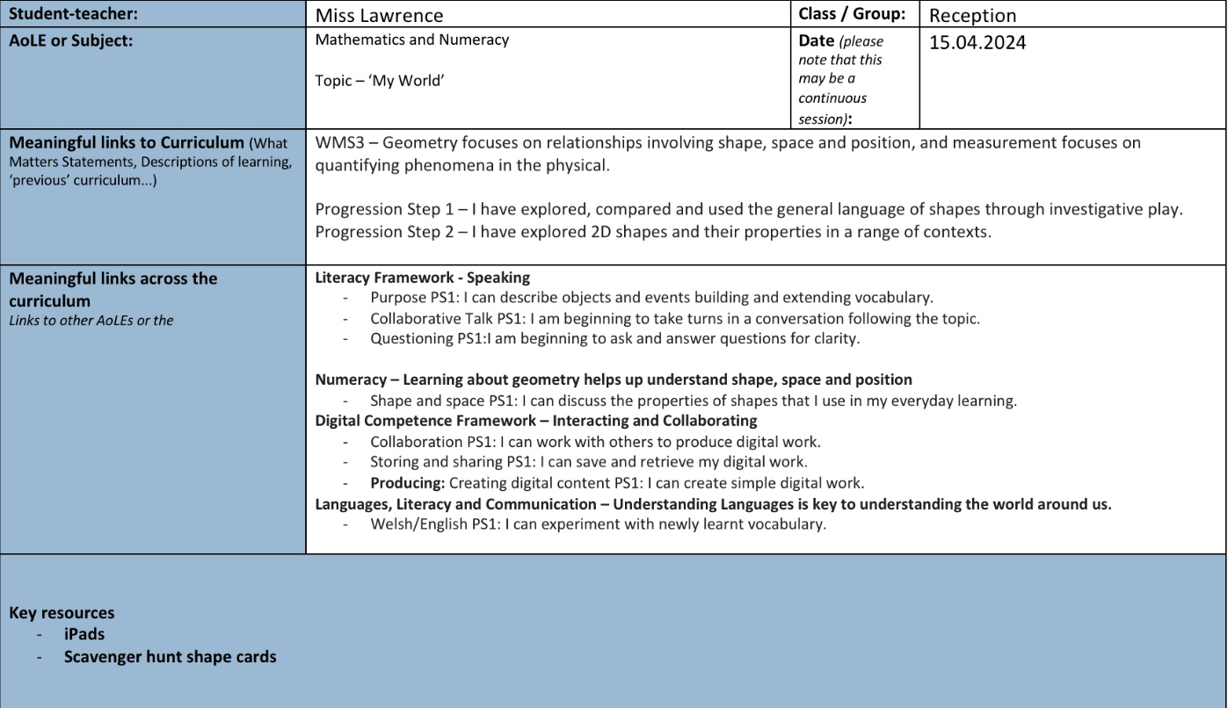

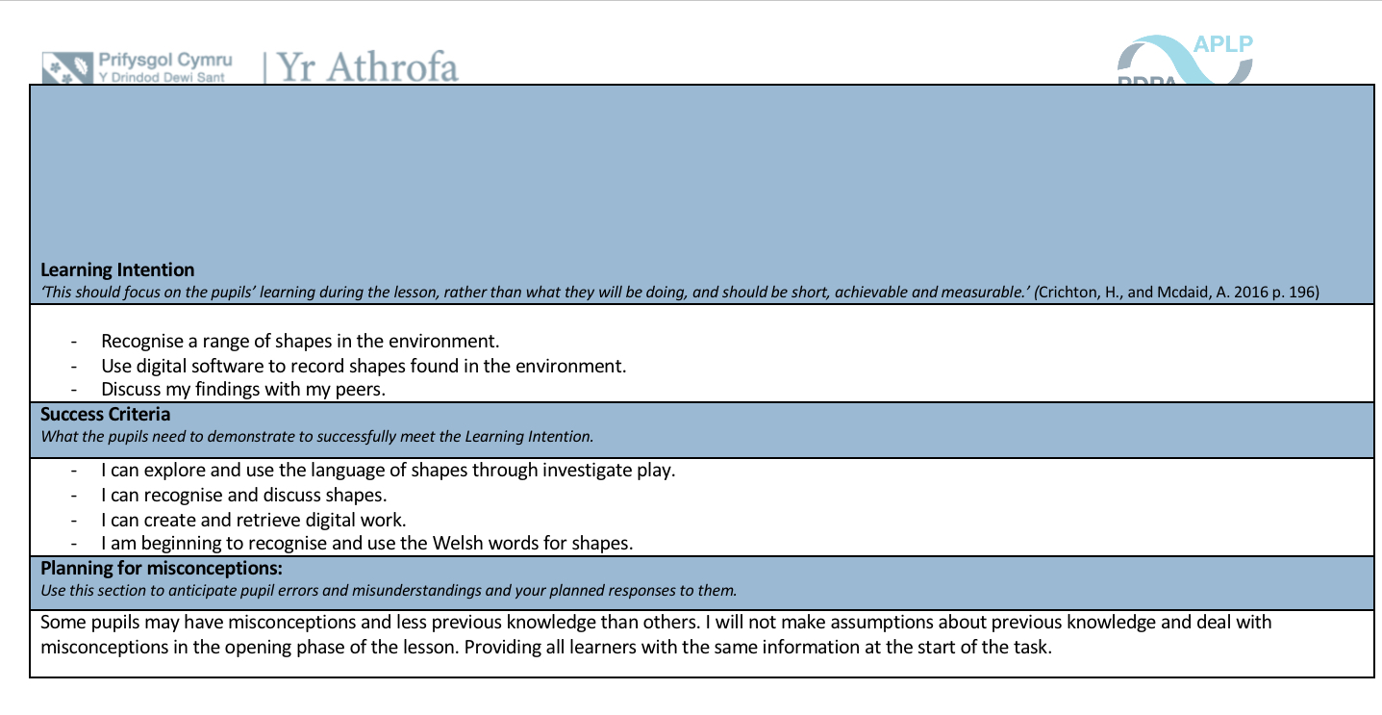
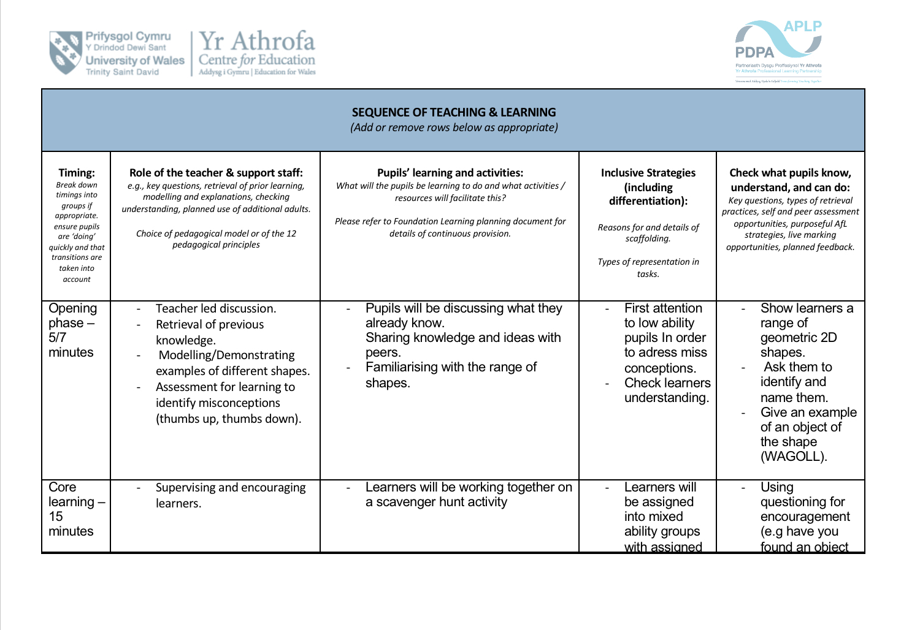
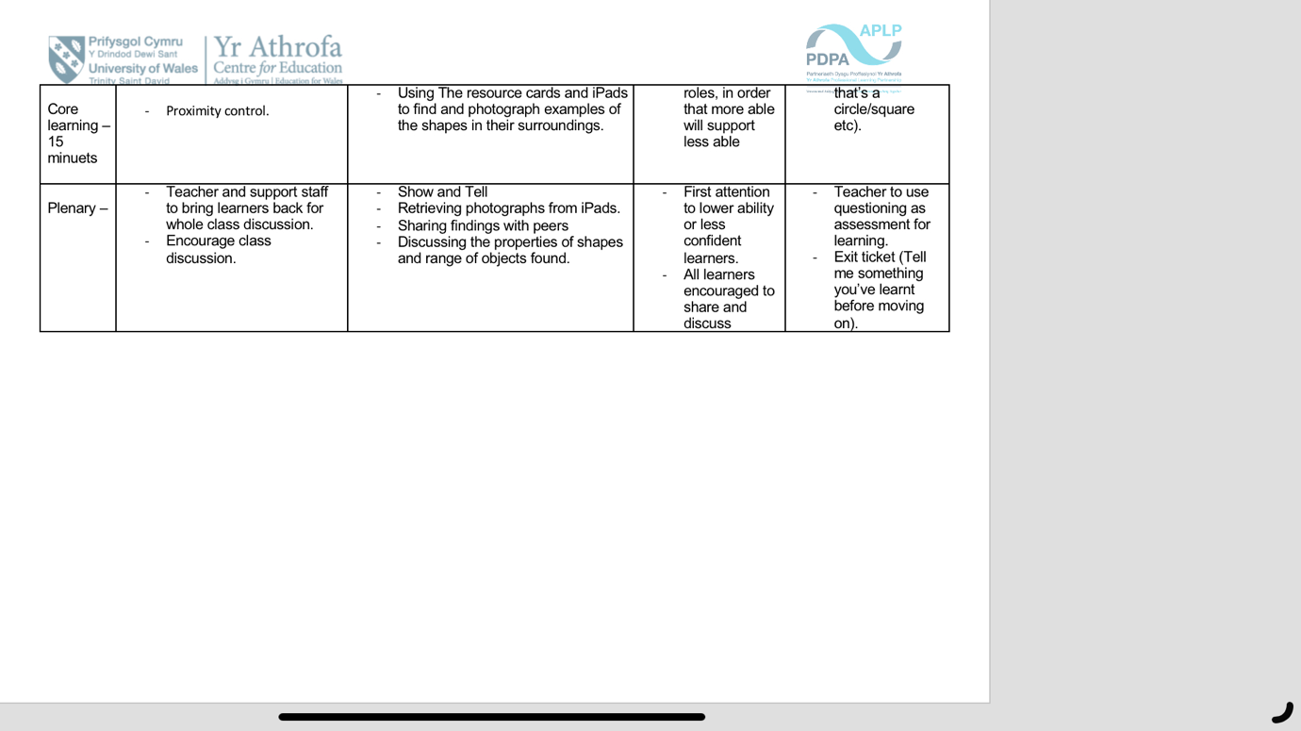

Appendix 2: Resource cards



