University of Wales Trinity Saint David

DATA HANDLING & BUSINESS INTELLIGENCE
Student nume:Daniela Gabriela Lisenche
Student Id: 2029607

Executive summary
In this report, the process of data handling is being considered the data population of a data set for different purposes as well as taking division for business. This report is also prepared to analyse fluctuation in different aspects of three products of a superstore in order to identify best sales product as well as margin based through If and PIVOT function of excel.This report mainly aims the managing the statistical data by analyzing the various analysis such as mean, median, and frequency. Along with that there is also mentioned the advantages and limitations of the SPSS and also the excel. In addition, there are mentioned the data mining methods which assist to make a better analysis. Therefore, with the effect of that, there is given a better analysis of K-clustering as per the basis of gender and ice cream which is given below.

Table of Contents
Part 1 4
Introduction 4
Body 4
Shopping costs-wise product sales 4
Quantity-wise product sales 5
Category-wise product sales 6
Unit price-wise product sales 7
Profit-wise product sales 8
Conclusion 10
Part 2 11
Introduction 11
2. BODY 11
2.1 Identify the number of respondents who like vanilla flavors ice cream 11
2.2 Majority of males and females 12
2.3 Median and Mean of the respondents who like to choose strawberry and chocolates flavored ice cream 13
2.4 variances of K-Mean 14
2.5 Data mining and text mining methods 15
2.6 Merits and Demerits of Excel and SPSS 15
Conclusion 17
Reference 18
Bibliography 20

Part 1

Introduction
Evaluation of data set on sales using excel not only assists business organisations to evaluate fluctuation in sales nevertheless but also assists them to make appropriate decisions in order to enhance sales. This report is prepared to evaluate inflation in sales of superstore due to different factors such as shipping costs, unit costs as well as the unit price of the product.

Body
Sales of any business have been influenced by different financial as well as non-financial factors such as costs of the product, transportation and product price as well as quality. This section of the report also focuses on data of different financial as well as non-financial aspects and manipulates the use of different features of excel such as IF and PIVOT. IF function of excel mainly considers applying conditions in data population as well as segregating data on different elements as well as factors.
This function of Excel has been based on the profit margin of different products as well as sales units of the company. The base profit margin of the product has been assumed at 50%. It refers to profit margin above 50% on each product that has been executed as an increment in product and below 50% in product has been considered a decline in profit margin. PIVOT of excel has been considered to filter variable such as three types of products of superstore which has been assist to evaluate inflation in profit margin of each product separately. Besides that, here different types of charts as well as tables have been prepared by using excel in order to present inflation in different variables in better ways. As argued by Yoseph et al. (2020, p.1), A popular strategy for examining the diversity of consumer purchasing behaviour and profitability is market segmentation. Here are different techniques such as regression, PIVOT and If have been considered by different researchers as well as data analysts and the model employed for gathering the sufficient data view. Data manipulation features in excel have been simpler as well as preferable compared with other manipulation techniques such as SPSS.

Shopping costs-wise product sales
Transportation cost of any product has played an important role to promote our effective sales unit in the market. An industry or organisation needs to use appropriate and suitable transportation modes for sales of products as well as promotion in other locations. Among different products, the transportation cost of furniture is more compared with the transportation cost of technology and office tools. It has been found that the transportation cost of technology is nearly too low which is incurred by the superstore in order to acquire different tools and technology for manufacturing technology category products. Transportation costs of technology are more in overall value at 5984248 due to more demand and sales units in the market. Whereas transportation costs of office supplies have existed at 3752762. It has been observed from analysis that transportation costs of those products have been highest which is more sales in the market.
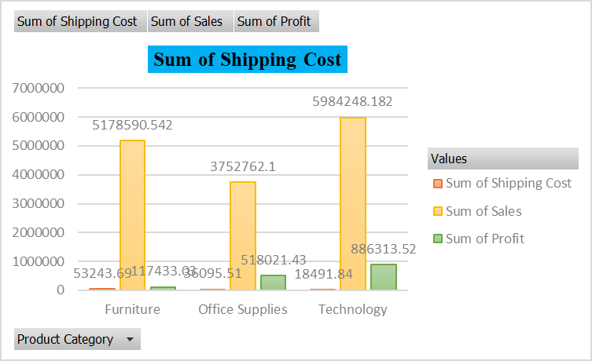
Figure 1: Sum of shipping costs
(Source: Self-created)

Quantity-wise product sales
Quantity of any product refers to the number of units which have been sold by a superstore in the market for a certain period of time. Here office suppliers exist at the highest order quality with 118281. Besides that, technology 52175 and 44324 it has been found from the analysis that furniture has more sales in the terms of units compared with other categories of the product by the superstore. The key reason for increasing sales of furniture is that it is a common product for different levels and categories of people as it is used by individuals for household purposes as well as for official use. Thus, it has been executed by considering output data on different product quantities that the superstore has acquired the highest sales volume by selling technology category products.
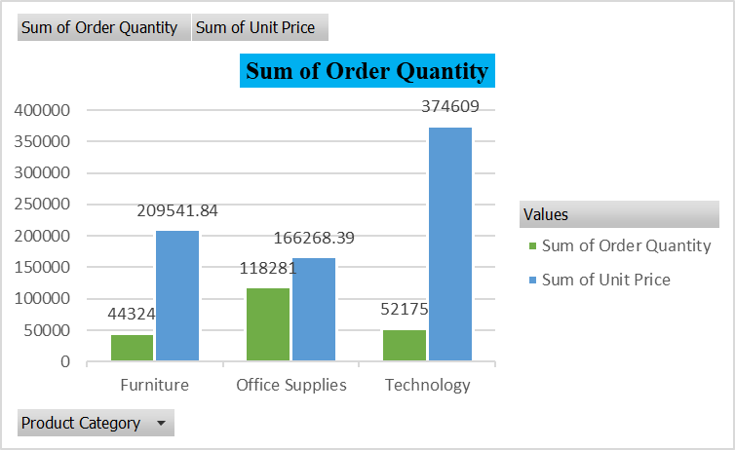
Figure 2: Sum of order quantity
(Source: Self-created)

Category-wise product sales
There are mainly three different types and category products that have been sold by superstores in the UK as well as other locations. Thus, the sales value of each product has been very high compared with other products due to demand as well as other financial aspects related to the product. The three product which have been sold by the superstore are “furniture, office suppliers and technology”. Total sales value of superstore has been observed at 14915600.82 among three product technologies that are more demandable as well as sales volume product. The total sales value of technology has been evaluated at 5984248.182 and furniture has existed at 5178590.542 2nd highest sales product category. Whereas the lowest product sales are office supplies with a sales value of 3752762.1. It has been found that the company has been able to further enhance its value through increased sales of technology compared with other product categories. As stated by Carmichael et al. (2021, p.2), the Clean Growth Strategy aims for a high renewable and flexible approach, which can present a chance to boost business sector efficiency. As it is required to perform professional and personal work, it is a key aspect behind better sales of technology in the market compared with other products.
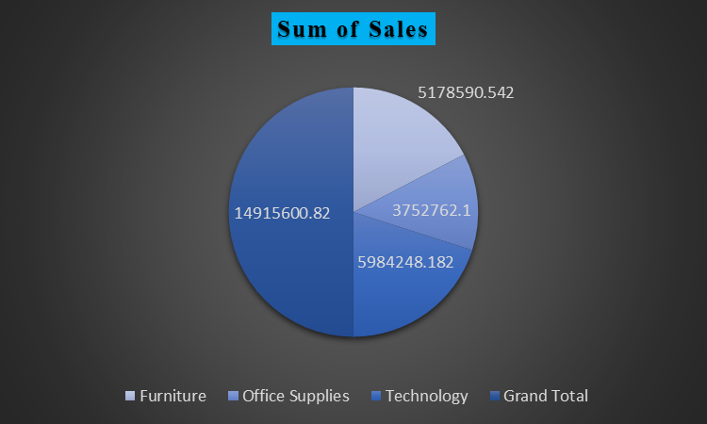
Figure 3: Sales units of three products
(Source: Self-created)

Unit price-wise product sales
The unit price of any product has also affected cells units as well as the sale volume of product and grand total sales of the superstore. Unit price of products has been also segregated using the filter feature of excel for applying If function. It has been found from the chart below that the price of a technology product has more compared with other categories and types of products. The price of the technology has been found at 374609 and the price of furniture at 209541. As technology is developed by implementing different levels of effort and skills, it is a highly demanded product in the market. It is a key reason for the high price of technology category products compared with other products. Whereas, the unit price of furniture is low compared with other products such as technology and office tools. Price of office supplies category product existed at 166268.

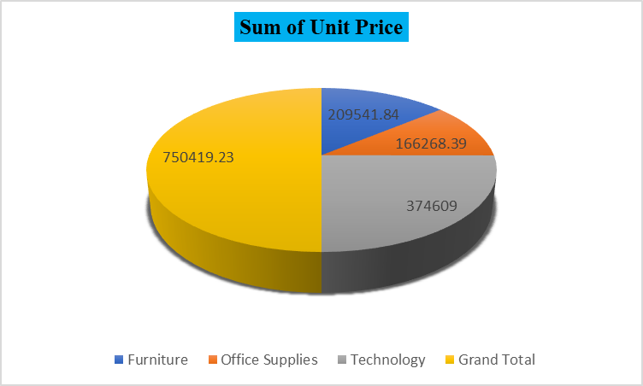
Figure 4: Sum of unit price
(Source: Self-created)

Profit-wise product sales
The profit of any product has been dependent on different financial and non-financial factors. It has been found from the analysis that profit on technology is more compared with other categories of product. As technology is in high, demand in the market as well as transportation cost of technology is low compared with other categories of the product. It is a key reason for giving more profit to the organisation through the selling of the technology compared with profitability on other products. It has been suggested to super stores that the company should be focused on more sales of technology compared with other products that exist in the organisation.
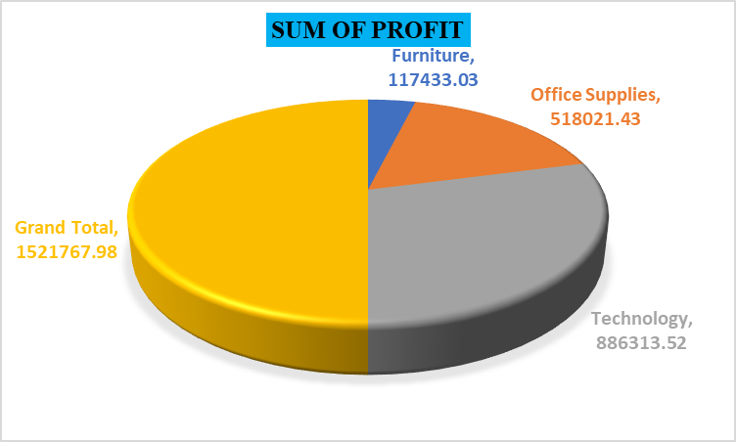
Figure 5: Sum of profit
(Source: Self-created)
It has been found from the above figure that the superstore has the highest profit from sales of technology with the value of 886313. Whereas grand total profit of the company has been observed at 1521767 and office supplies have a profit with the value of 518021. Besides that, it has been executed that furniture has low profit with a value of 117433. As stated by Massaro et al. (2021, p.2), The analysis of sales data enables the forecasting of market trends and aids businesses in adopting appropriate strategies to boost sales by becoming more competitive. Here furniture has given low profit as compared with other categories of product due to low competitive advantages in the supermarket market of the superstore.
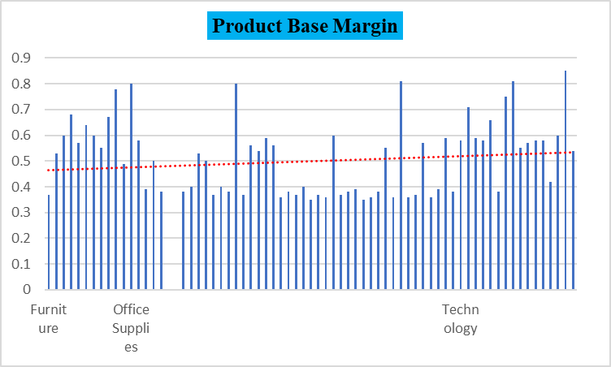
Figure 6: Product margin
(Source: Self-created)
It has been found in the above figure that the sales value of technology 5984248 has given the highest contribution in grand sales of 14915600. Whereas rest two category products such as office supplies and furniture have been given contribution by amount 3752762 and 5178590 in total sales value of superstore. The company is also able to acquire more profit from sales of technology products as compared with other products of the superstore. In this situation, the balanced scorecard plays a significant part in stating that it is a strategic performance management framework that contains measures of a company's strategies for achieving its goals (Kefe, 2019, p. 43).The trendline in the above figure has also indicated that superstore should be focused on selling technological products as compared with other products. These steps of the organisation not only assist to acquire better overall margin nevertheless but also sustain financial performance.

Conclusion
It has been concluded that superstores have been able to increase their sales units for the previous fiscal year by increasing sales of furniture as compared with other types of products. Besides that, the company has acquired the highest profit by selling technology and reducing the manufacturing or operating cost of technology and other categories of products. Nevertheless, it is observed that companies have developed strategies to enhance the demand for their technology category products compared with other products due to better profit margins of technology compared with other products.

Part 2

Introduction
This part is mainly focused on the SPSS calculation for determining the total male and female data in statistical analysis. Along with that, it has been also assisting in the sorted in ascending order for greater number values to the lowest value of numerical. This report is mainly focused on finding the total ice cream as per the basis of defining gender. It can be done only by the use of SPSS for determining the participants who like the strawberry and chocolate flavor ice-creams.

2. BODY

2.1 Identify the number of respondents who like vanilla flavors ice cream
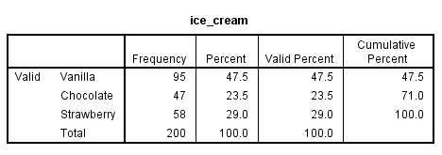
Figure 6: Participants who like Vanilla
(Source: Self-created)
It can be seen that the total number of participants who like vanilla is mentioned as 95. It has easily been determined with the help of analyzing the SPSS and also using the descriptive option which is available in the SPSS. As per the above image, it can be easily seen that the number of participants who like Vanilla is much higher than compared the rest of the ice-creams. Along with that, the percentage value of vanilla is mentioned at 47.5 which is very high as compared to the two ice creams that are strawberry, and chocolate. The total number of participants is given 200 which is also determined with the help of SPSS’s descriptive statistics option.

2.2 Majority of males and females
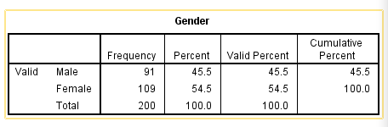
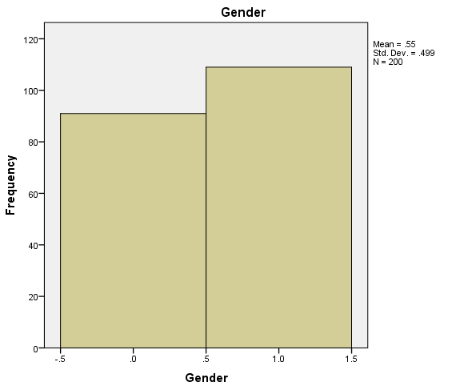
Figure 7: Total participants
(Source: Self-created)
The total number of participants is mentioned as 200 i.e., 91 males and 109 females. It can be determined with the help of SPSS’s descriptive option where it is required to choose the option of gender. There is also a need to put the numbers of variables so that it makes it easy to determine the accurate value of Gender. Thus, the effect of that, makes it easier to find the total number of participants and also easy to determine the Male and Female numbers. However, it sometimes creates challenges due to lack of data accuracy and availability. The percentage value of males is mentioned at 45.5 and the female’s percentage value is mentioned at 109. Thus, it can be seen that the number of females is much higher than the male so it can be said that the female participated much higher as compared to the male.

2.3 Median and Mean of the respondents who like to choose strawberry and chocolates flavored ice cream
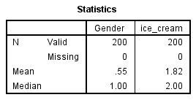
Figure 8: Participants who like chocolate and strawberry
(Source: Self-created)
In the above-mentioned image, it can be found that the mean value of the strawberry and chocolate is mentioned .55 for total gender and 1.82 for ice cream. On the other hand, the median value of the gender is mentioned as 1.00, and on the other hand, the median value of ice cream is mentioned as 2.00. Thus, with the effect of that, it can be said that the mean value is mainly showing common value. As per the information taken from Fife (2020, p.4), the data must meet four key assumptions: independence, normality, homoskedasticity, and linearity which are most important in statistical tests. The median and mean are the both central tendency measures that give the average value indication related to the figure's contributions and depicts the statistical conclusion validity of data. The average mean value related to the scores group and the scores have been added up and divided by the score’s numbers. However, there is no need to do this all because there is chosen SPSS that assists the researcher to determine the values of mean and median easily.
The median value is mainly showing the values of separating the higher half from the data’s lower half. As per the view of Grace and Irvine (2020, p.4), the inferential model and hypothesis are fundamentally different. Any given set of facts has no bearing on the hypothesis's logical requirements or structure. The median is used sometimes as opposed to the mean value which is outliers in the order of sequences. Additionally, they consistently provide a data frame that can be used later on in the workflow (Patil, 2021, p.2). The median and mean values have been mentioned with the help of SPSS analysis so the researcher can able to analyze the data. However, SPSS gives accurate and suitable data by selecting accurate data for statistical analysis.

2.4 variances of K-Mean
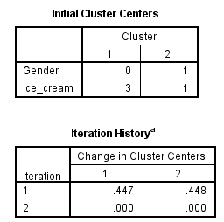
Figure 9: K-mean
(Source: Self-created)
The clustering K-mean is the simple learning of an unsupervised algorithm that has been utilized to solve the issues of clustering. Therefore, with the effect of that, it is an unsupervised algorithm data set that is shown in groups of unlabeled data sets into divergent clusters. It can be seen that the gender cluster value is mentioned as 0 and 1, and the ice cream cluster value is mentioned as 3, and 1. However, there are also mentioned the changes that happened in the cluster are also given.
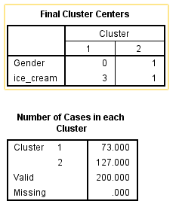
Figure 10: Final outcome of K-mean cluster
(Source: Self-created)
It can easily determine the clustering value that tries to partition on the K sets points with the help of SPSS. It has been supervised due to the points having no classification related to external analysis and it might lead to the difficulties in gathering correct information from the data set. Along with that, it has been followed with the classifying simple process which has provided with data set into the cluster number.

2.5 Data mining and text mining methods
It is the process related to the techniques which are referred to as the statistical. It is referring to the raw data which is available in the structure form and also data mining is the part. Providing finite sample constraints on the empirical nearest neighbour radii and the rates of consistency of the DTM in the supremum norm as a generic data-based functional nearest neighbours statistics. (Gu et al. 2019, p.5). Alternatively, the database of preexisting and also the excel spreadsheet is used for gathered accurate information. In the part of data mining, it is also classifying by the way of clustering the organizations.
Decision trees: At first, the data has been classified by following up with the necessary questions. The program's interactive depiction of the data utilising a variety of submenus (Line charts part) enables the experimenter to comprehend the biological outcome of the experiment (Enot et al. 2019, p.3). For example, it can be said that the organization wants to make a plan for the future for purchasing the laptop; it may ask “Is the potential for purchaser student”? That data is systematized into the decision trees such as Yes and no.
Logistic regression: It is algorithm attempts which are showing specific profitability outcomes inside the two major results. For example, the email service can be utilized in logistics to make spam on email.

2.6 Merits and Demerits of Excel and SPSS
Advantages
SPSS | EXCEL
SPSS assists the researcher to find suitable and accurate statistical value data and also decreases the error possibilities happening at the minimum assist in the way of using the SPSS. The SPSS 'understudy pack' incorporates the wide determination of a diagnostic capacity, from the essential spellbinding measurements to cutting edge general straight demonstrating abilities. | It has been utilized for analyzing mathematics and also analyzing statistical and financial data.
It can also able to create new variables which come from the already provided information. | It generated the budget plan which is related to maintaining the expenses of living.
The SPSS users are capable to choose the data freely kind which can be matched with the data distribution requirements. | It used the returns on analyzing the stock market which developed the company’s plan.
It mainly provides different types of analyzing statistical function which is not available for the other program package. | Excel have saved different version of the document and also easily runs with the use of the filter option.
The researcher can get actionable and valuable insight related to the consumer data. Moreover, it assists in gathering accurate and correct information related to the market trends. | It assists and enables the users to recognize the organization and trends and sort the data into well-defined categories.
Table 1: Advantages of SPSS and Excel
Limitation
SPSS | EXCEL
Its default format of storage is related to the data file log and output which “Software dependent” are. | The viruses have been attached with macros which are programs related to written into the excel spreadsheet.
There are lots of options available which are required to determine the process related to choosing suitable options examined. | There is the possibility of losing data due to data corruption.
It has bounded and limited visualization of data as SPSS used for data and statistical analysis. | It takes too much the apply the data dynamically.
It cannot be examined with huge data set and the researcher often gets a huge dataset in the nursing and medicine field. | Its lack of security and control is so huge that might slow down the programs excel.
Table 2: Limitation of SPSS and Excel

Conclusion
It can be concluded that this study is totally based on the use of SPSS and excel so that the statistical analysis can be done. Along with that, there is also mentioned the K-means cluster for determining values. The data and text mining has explained in-depth and also the usage of SPSS and excels advantages and disadvantages. The mean and median calculation is most important for determining the value of tendency, the represented complete data is shown with these mentioned values which are not necessary for the median and mean which have the same values. The mean value is mainly built and generated with a better sense to state better findings of the above analysis.

Reference
Journals
Carmichael, R., Gross, R., Hanna, R., Rhodes, A. and Green, T., 2021. The Demand Response Technology Cluster: Accelerating UK residential consumer engagement with time-of-use tariffs, electric vehicles and smart m0065 ters via digital comparison tools. Renewable and Sustainable Energy Reviews, 139, p.110-701.
Enot, D.P., Vacchelli, E., Jacquelot, N., Zitvogel, L. and Kroemer, G., 2018. TumGrowth: an open-access web tool for the statistical analysis of tumor growth curves. Oncoimmunology, 7(9), p.e1462431.
Fife, D., 2020. The eight steps of data analysis: A graphical framework to promote sound statistical analysis. Perspectives on Psychological Science, 15(4), pp.1054-1075.
Grace, J.B. and Irvine, K.M., 2020. Scientist’s guide to developing explanatory statistical models using causal analysis principles. Ecology, 101(4), p.e02962.
Gu, X., Akoglu, L. and Rinaldo, A., 2019. Statistical analysis of nearest neighbor methods for anomaly detection. Advances in Neural Information Processing Systems, 32.
Kefe, I., 2019. The determination of performance measures by using a balanced scorecard framework. Foundations of Management, 11(1), pp.43-56.
Massaro, A., Panarese, A., Giannone, D. and Galiano, A., 2021. Augmented Data and XGBoost Improvement for Sales Forecasting in the Large-Scale Retail Sector. Applied Sciences, 11(17), p.77-93.
Patil, I., 2021. Visualizations with statistical details: The'ggstatsplot'approach. Journal of Open Source Software, 6(61), p.3167.
Yoseph, F., Ahamed HassainMalim, N.H., Heikkilä, M., Brezulianu, A., Geman, O. and PaskhalRostam, N.A., 2020. The impact of big data market segmentation using data mining and clustering techniques. Journal of Intelligent & Fuzzy Systems, 38(5), pp.1-14.

Bibliography
Herasimov, S., Roshchupkin, E., Kutsenko, V., Riazantsev, S. and Nastishin, Y., 2020. Statistical analysis of harmonic signals for testing of Electronic Devices. International Journal of Emerging Trends in Engineering Research, 8(7).

