

Human Resource Primark

Prepared for

Charles Oham

Prepared by

Petya Nedeva
University of Wales Trinity Saint David

BABM Level 5 Term 2

Student number 1816235

Task 1 – Briefing statement on being HR
The CIPD profession map clearly highlights the knowledge, skills and behaviour that is required to work as a successful HR manager. Following is a visual presentation of this framework –
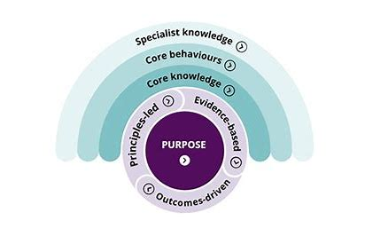
Figure 1: CIPD Profession Map (Griffin, 2018)
This framework has four main layers that guides a HR manager in reference to what to do and what to know in the HR profession. The first layer is specialist knowledge. As per this layer, a HR official should possess expert knowledge in the field of maintaining employee relations, managing diversity, reward management, talent management, people analytics, learning and development. With the help of specialized knowledge, the HR manager can take the right decisions at the right time. For instance, if the HR manager observes that the employees are unable to perform their tasks efficiently then the HR department should assess their training needs to organize training sessions for enhancing their knowledge.
The second layer is core behaviour. This layer highlights the significance of professional behaviour for a HR official. This includes undertaking ethical practices, valuing people, working inclusively, passion for learning and situation -based decision making. For instance, the HR officials should always value people by ensuring that they get a positive work environment and culture in the internal system. Relevant support is provided to them, if needed. In addition, ethical HR tactics should be undertaken to remain ethical in different aspects concerning employees such as salaries, incentives, career growth etc.
The third layer as per the CIPD profession map is core knowledge. This may include people practice, business acumen, analytics, creating value, digital working and change management. Knowledge in these areas ensure that the employees and internal management is undertaken in a proficient manner. For instance, if the organization is implementing any change related to the organizational structure or installation of a new technology then the same may result in resistance amongst the employees (Mello, 2015). This can affect the internal working of organization. The HR manager should be knowledgeable enough to ensure that employee resistance is overpowered through regular communication and the change process sis implemented proficiently.
Lastly, the HR officials should understand the purpose of the overall HR strategy of the organization and align with the same. The role and duty of the HR manager is to ensure that it supports the top management in attaining the vision and mission of the organization through effective management of employees (Armstrong & Taylor, 2014). For this, several skills and attributes are required by the HR officials. This includes detailed knowledge of the HR functions, persuasive communication skills, problem -solving skills, analytical skills and ability to motivate people to work towards the organizational goals. With the help of CIPD profession map, an individual can surely become a successful HR manager.
Part 2 – Human Resource Management at Primark
Introduction
The chosen organization for this task is Primark. Founded in the year 1969, Primark is an Irish fashion retailer that sells a huge variety of fashion products including apparels, accessories, handbags, footwear and many more to its target audience. The retailing industry is quite labour intensive as it requires people to execute the business strategies. Thus, the significance of efficient resourcing cannot be ignored. According to Morgan (2015), resourcing comprises of three main activities i.e. human resource planning, recruitments and selection. It is usually observed that if an organization is able to hire the right employees at the right position then the internal productivity can be quite high.
Manpower planning, recruitment and selection at Primark
Simmons (2014) has defined human resource planning as the act of assessing the future needs of employees in an organization. This implies that the HR department should regularly analyse whether it needs more employees in the near future. The HR department at Primark keeps a close watch on the future needs of employees in different areas such as inventory planning, supply chain management, store operations, marketing and others. For instance, if the organization is opening more retail outlets in the upcoming three months then it would surely require more employees in the near future. Relevant planning is undertaken to ensure that the best employees are hired through the most efficient means of recruitment and selection.
McGuire (2014) is a of viewpoint recruitment acts as a bridge between an organization and the potential candidates. The role of recruitment is to ensure that high number of qualified candidates apply for a job position and they can be lined up for the selection process. It is usually observed that undertaking efficient recruitment strategy may assist an organization in getting the best employees (Armstrong & Taylor, 2017). Primark focuses on internal as well external recruitment strategy to procure the most qualified employees. This acts as the main objective of the company’s recruitment process. Internal recruitment is Primark’s strategy under which the existing employees of the company are promoted or transferred to available positions in the company. On the other hand, external recruitment of the company ensures that opportunities are provided to the candidates outside the company to ensure that they are also able to get a good job and decent career. This includes recruiting employees through job portals, advertisements, educational institutes and job consultants. Both these means of recruitment ensures that the company is able procure the right candidates to apply for the job position.
Selection is also an important process that is focused on hiring the right person at the right designation to enhance the internal productivity (Torrington, Hall, Taylor & Atkinson, 2014). The selection process of an organization completely depends upon the top management. An organization may focus on a detailed selection process or may just focus on an interview to select the best employees (Taylor, 2010). Primark gives high importance to its selection process and ensures that it is able to hire the best person at the right job profile. The main objective of Primark's selection process is to hire people that have the right skills to match the job description. For instance, if the organization wants to hire sales officials for its retail stores then the focus should be in hiring people with good communication skills, positive attitude and ability to persuade the customers. Thus, this approach helps in identifying the requirements of the job and then hiring the right person.

Primark focuses on four main stages in its selection process. The first stage is an application blank. Under this stage, the candidates are required to fill an application form that has questions related to their past experiences, skills, future plans and many more. The second stage is one on one interview with the department head. This stage helps in understanding whether the reporting manager is comfortable with the new candidate or not. The third stage is panel interview that helps in understanding the candidate comprehensively and undertake a negotiation process. The last stage is to offer a job letter and encouraging the candidate to join. The focus of the company is to hire efficient people to enhance the internal productivity.
Evolution of Primark’s resourcing function
These resourcing functions have evolved over the years in Primark. Traditionally, the organization was focused on recruitment and selection through job consultants only. This implies that the manpower need was communicated to the job consultants and they used to recruit the employees. Thus, the role of the HR department was minimal in the process. The HR department was mainly focused on motivating and retaining employees to enhance the internal productivity. However, the problem was that these job consultants did not understand the job description and job specification clearly thereby resulting in inefficient recruitment. This also led to a high employee turnover rate in the organization.
In the mid -2000s, the organization mainly focused on internal recruitments rather than hiring from outside. This strategy was undertaken to ensure that the present employees of the company gets more opportunities and are retained by offering relevant growth. The main focus was to fulfil the present vacancy with the present employees of the company. However, the main problem was its inability to obtain quality candidates from outside the organization. Therefore, this system also posed many issues for the company.
In the year 2011, the organization shifted to a hybrid resourcing approach (Marchington, Wilkinson, 2012). This implies that the company has used combination of different means and methods to hire the right person in the organization. The organization uses a resourcing model to ensure that all the tasks are undertaken in a systematic manner. Following is a visual presentation of the same –
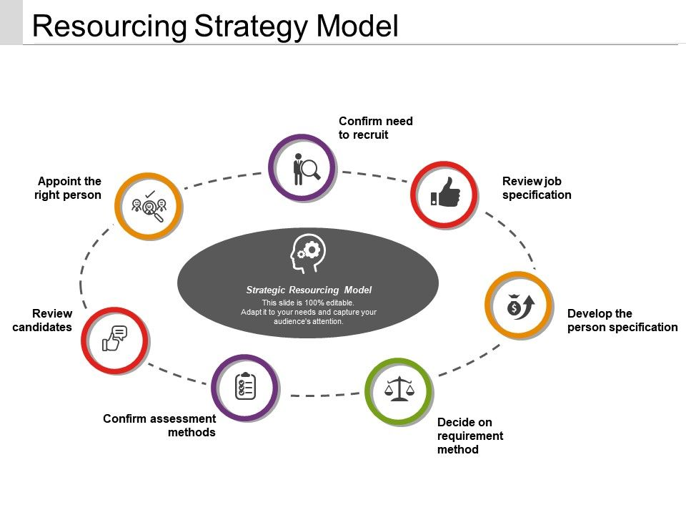
Figure 2: Resource strategy at Primark (Azad, 2018)
The above illustration model shows the different stages that Primark followed for effective planning, recruiting and selecting its employees. Following are some of the important points in the present resourcing strategy of Primark -
- The HR department focuses on confirming needs to recruit. This is done with the help of short - term and long - term forecasting to understand the manpower requirement in the near future and manpower requirement in the long future. This helps the HR department in undertaking effective plans for hiring the right person in the organization.

- Before undertaking the recruitment and selection function, it ensures that the job description, job specification and person specification is developed. They help in understanding the different tasks that are required to be done in a job profile and what kind of person or traits are required for performing these duties in a proficient manner.

- The company then decides on the recruitment method and its proper assessment. Since the company uses a wide range of recruitment methods at present, it selects the best ones that can be used for fulfilling the present vacancies in the organization. Thus, these recruitment methods may completely change every time depending upon its advantages or disadvantages (Marchington & Wilkinson, 2012).

- Recruitment is the next stage where the HR department has now started using social media and professional networking sites. This is a contemporary technique of recruitment that has evolved over time and has been utilized proficiently by the company. In addition, job sites also act as an online means where the potential candidates and HR department may interact.
- The HR department has also started using technology in the selection process. For instance, the HR department uses online tools to take written tests of potential candidates. In addition, artificial intelligence is being used to match the job description and present skills of employees. Moreover, the company also ensures that practical interviews are undertaken to test the skills and capabilities of employees.

Thus, with the help of this approach, it becomes convenient for the company to undertake a systematic process of resourcing.

Conclusion
Human resource management is one of the most important areas in Primark. This is because a retailing organization is expected to sell products to end consumers and hence efficient people are required for the same. It should also be noted that the work environment in the retail industry is very competitive and there is high pressure on employees. Thus, the significance of HR department is very high as it works in a dedicated manner to hire efficient employees.
This research work helped in comprehending how the human resource management at Primark has evolved over time. The company regularly monitored its HR activities and undertook relevant strategies to improve the same. This has assisted the company to develop standard human resource activities.

References
Armstrong, M., Taylor, S., (2017) Armstrong's Handbook of Human Resource Management Practice, 14th Edition, Kogan Page
Armstrong, S. & Taylor, M. (2014). Armstrong’s handbook of human resource management. Kogan Page
Azad, P. (2018). Strategic Management. MakMax International
Griffin, R. (2018). Fundamentals of Management. Cengage Learning
McGuire, D. (2014) Human Resource Development. 2nd Edition. Sage: London. Chapter 2: Adult Learning Theories
Marchington, M., Wilkinson, A. (2012) Human resource management at work. 5th ed. London: Chartered Institute of Personnel and Development
Mello, J. (2015). Strategic Human Resource Management (4th ed.). Stamford, CT: Cengage Learning.
Morgan, C. (2015). Human resource management (2nd ed.). San Diego, CA: Bridgepoint Education, Inc.
Simmons, B. L. (2014). Organizational characteristics. In P. Y. Chen, & C. L. Cooper (Eds.), Work and wellbeing (pp. 1-18).
Taylor, S. (2010) Resourcing and talent management. 5th ed. London: Chartered Institute of Personnel and Development.
Torrington, D., Hall, L., Taylor, S., Atkinson, C., (2014) Human Resource Management 9th Edition, Pearson

