Exercises for Functions – 1 (SOLUTIONS)

We will attempt to find the area of the following shape:

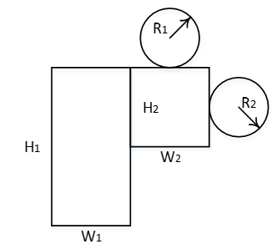

1a Start with the first circle. Write a function, calculatecircle(), to calculate the area of the circle. Call the function, and when it's finished, return the area calculated to the main program (we will need it later).

Sample output:

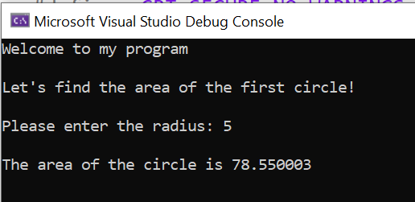
main program

calculatecircle()
(return to main())

Solution:
#define _CRT_SECURE_NO_WARNINGS
#include <stdio.h> //library
float calculatecircle();

void main()
{
float circle1;
printf("Welcome to my program\n\n");
printf("Let's find the area of the first circle!\n\n");
circle1 = calculatecircle();

}

float calculatecircle()
{
float radius, result;
printf("Please enter the radius: ");
scanf("%f", &radius);
result = radius * radius * 3.142;
printf("\nThe area of the circle is %f\n\n", result);
return result;
}

1b Calculate the area of a second circle. Re-use the function you already have.

Sample output:

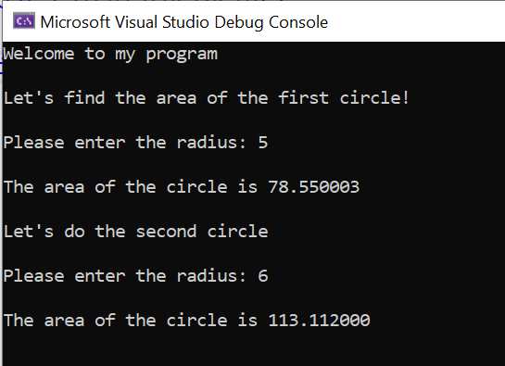

Solution:
#define _CRT_SECURE_NO_WARNINGS
#include <stdio.h> //library
float calculatecircle();

void main()
{
float circle1, circle2;
printf("Welcome to my program\n\n");
printf("Let's find the area of the first circle!\n\n");
circle1 = calculatecircle();
printf("Let's do the second circle\n\n");
circle2 = calculatecircle();
}

float calculatecircle()
{
float radius, result;
printf("Please enter the radius: ");
scanf("%f", &radius);
result = radius * radius * 3.142;
printf("\nThe area of the circle is %f\n\n", result);
return result;
}

1c. Now write a function to calculate the rectangles, and call them from main()

Sample output:

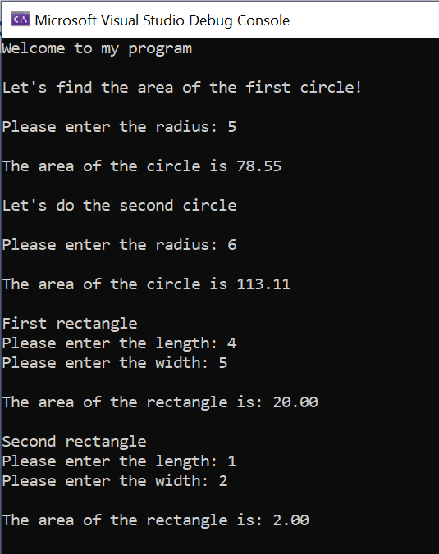

Solution:

#define _CRT_SECURE_NO_WARNINGS
#include <stdio.h> //library
float calculatecircle();
float calculaterect();

void main()
{
float circle1, circle2, rect1, rect2;
printf("Welcome to my program\n\n");
printf("Let's find the area of the first circle!\n\n");
circle1 = calculatecircle();
printf("Let's do the second circle\n\n");
circle2 = calculatecircle();
printf("First rectangle\n");
rect1 = calculaterect();
printf("Second rectangle\n");
rect2 = calculaterect();
}

float calculatecircle()
{
float radius, result;
printf("Please enter the radius: ");
scanf("%f", &radius);
result = radius * radius * 3.142;
printf("\nThe area of the circle is %.2f\n\n", result);
return result;
}

float calculaterect()
{
float total, length, width;
printf("Please enter the length: ");
scanf("%f", &length);
printf("Please enter the width: ");
scanf("%f", &width);
total = length * width;
printf("\nThe area of the rectangle is: %.2f\n\n", total);
return total;
}

1d. Providing all the returns back from the functions have been handled correctly, we should have 4 variables in main program holding the areas of the circles and rectangles. (You may need to go back and check you haven't overwritten any!)

It should now be a simple matter to add the areas, and get the final result

Sample output:

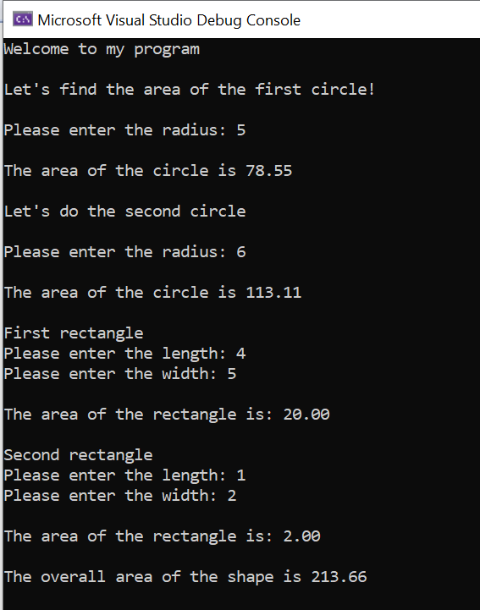

Solution:

#define _CRT_SECURE_NO_WARNINGS
#include <stdio.h> //library
float calculatecircle();
float calculaterect();

void main()
{
float circle1, circle2, rect1, rect2, overall;
printf("Welcome to my program\n\n");
printf("Let's find the area of the first circle!\n\n");
circle1 = calculatecircle();
printf("Let's do the second circle\n\n");
circle2 = calculatecircle();
printf("First rectangle\n");
rect1 = calculaterect();
printf("Second rectangle\n");
rect2 = calculaterect();

overall = circle1 + circle2 + rect1 + rect2;
printf("The overall area of the shape is %.2f\n\n", overall);
}

float calculatecircle()
{
float radius, result;
printf("Please enter the radius: ");
scanf("%f", &radius);
result = radius * radius * 3.142;
printf("\nThe area of the circle is %.2f\n\n", result);
return result;
}

float calculaterect()
{
float total, length, width;
printf("Please enter the length: ");
scanf("%f", &length);
printf("Please enter the width: ");
scanf("%f", &width);
total = length * width;
printf("\nThe area of the rectangle is: %.2f\n\n", total);
return total;
}

