5/13/2019
Callum Cross
Student number: 1705149
Smart & Connected Devices I
ACCA5005
Lecturer Name: Gaynor Thomas

Table of Contents
Introduction 1
Multi-User Web Application 2
Login System 3
Registration System 4
Data Storage 5
User Storage 6
Filters 7
Bootstrap CSS-Framework 8
phpMyGraph Library 9
Conclusion 10

Introduction (1)
In this report we will be looking at the technicalities and decisions that were made during the process of developing a web application that included collecting data from a web server from temperature sensors that are stationed around different geographical locations. We will also look at the graph library that was chosen for this web application and the types used to display the final data from the sensors.
Multi-User Web Application (2)
The website was built around being capable of allowing multiple users using the web application at one time, for this there would have needed to be a login system capable of storing user details e.g. username and passwords that would be securely stored on the web server’s database.
Allowing multiple accounts allowed users to display their own sensor data and filter it with their own web browser without any interference, this could also be expanded to allow multiple countries to manage and view their own sensor data from different parts of their region.
Login System (3)
The login system was created to allow users to log-in to their user accounts with their very own username and password this allowed for users to be unique to one another. Whilst logging if the user had typed in their details incorrectly the web server will deny them access and ask the user to retry their attempt at logging in.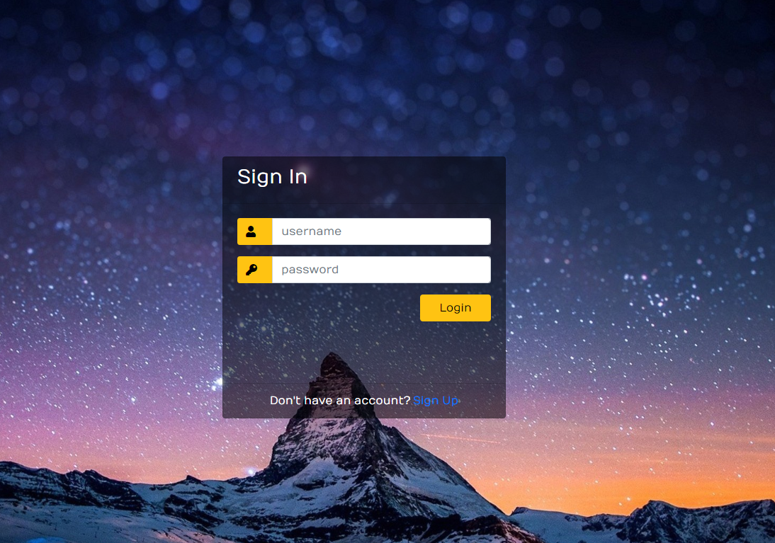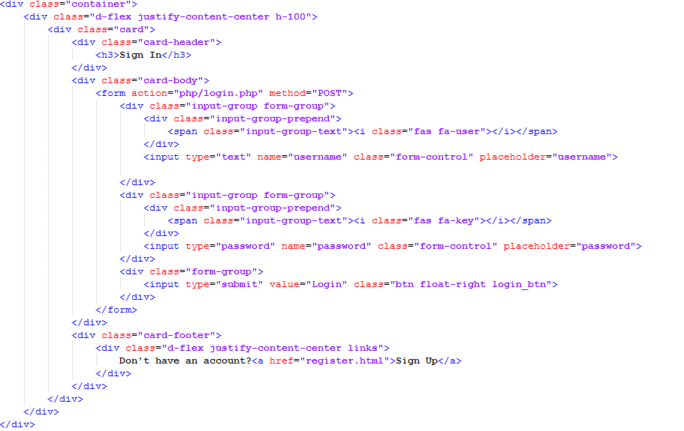
Registration System (4)
The registration system allowed the user to create their very own account that was customisable to them. The registration page would ask for both a new username and password. If the username had been taken by another user the web server would reject the request of creating a new account and send the user back to the registration page and ask them to choose a different username.

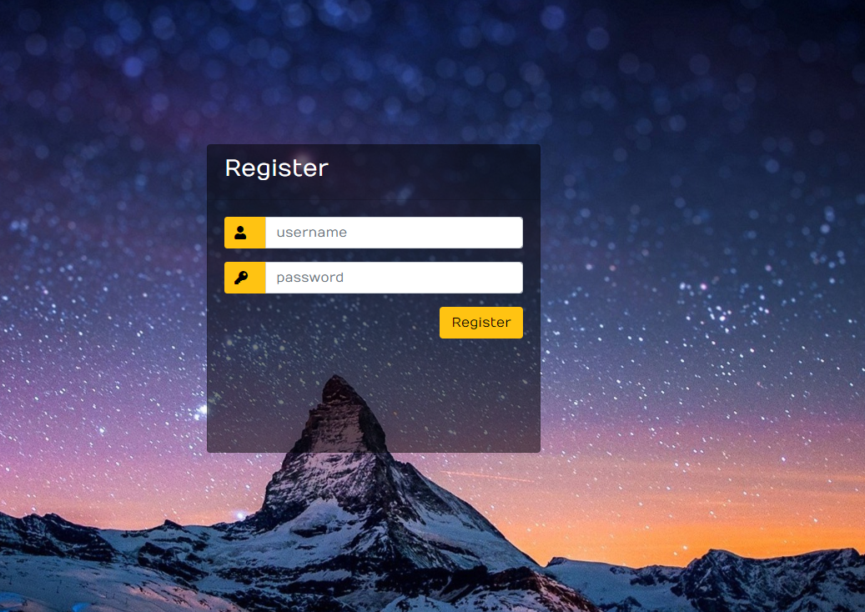
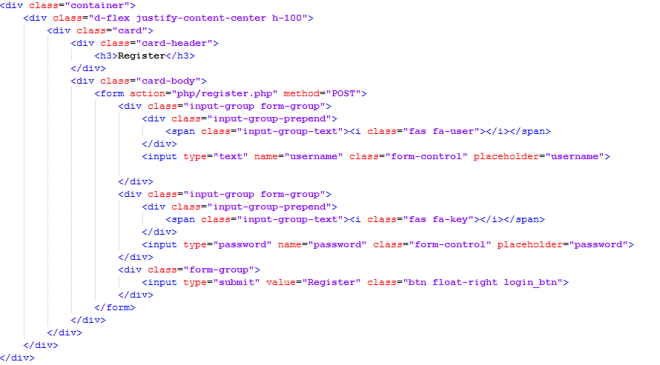
Data Storage (5)
The sensor data being stored had to have been capable of easily being read by both humans and machines, allowing it to be easily read by humans allowed for data collection by human eyes and being able to spot in-consistent data or corrupted data. Allowing the data to be easily readable by computers allowed for faster manipulation and data display without any notice of sluggishness.
The data stored on the database was split into sections of “dataID”, “username”, “temperature”, “date”, “time” and finally “sensorName”. These data storage columns were selected because it allowed the display of the data to be both easily readable and filtered by both the sensor that had taken the data or by the date that the sensor had collected the temperature.
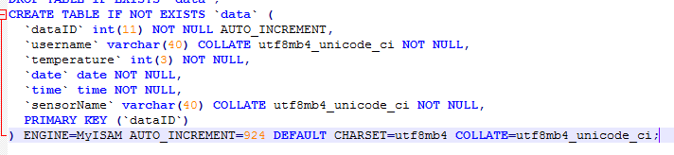
User Storage (6)
The user’s database table was split into three columns that allowed the web application to distinguish each user with their own unique “userID”, “username” and lastly “password”. The “userID” was created when the user had completed the registration process and the “password “will be hashed on registration before being sent to the web server as it allowed for secure data storage of user details and stops attackers from easily accessing unauthorised data.
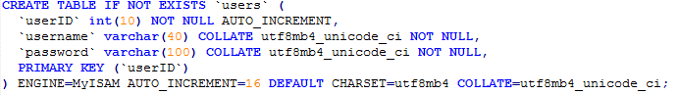
Filters (7)
The filters implemented into the web application allowed sensors to be split apart from one another allowing access to singular data collection that a device has collected. This can be crucial in data collection as it allows developers to quickly find and diagnose problems with malfunctioning sensors across the globe.
The second filter that was implemented was searching for data by the date the sensor collected that data allowing users to quickly find the average/max/min temperature on a specific day without going through thousands of entries in the database.
Bootstrap CSS-Framework (8)
The main CSS framework for the web application was bootstrap as it is capable for multiple-browser support and web application can use this framework to be capable of responsive web pages, meaning that it can be capable of displaying on several types of devices and screen sizes without any distortion of the web page.
Bootstrap was mainly used to create a grid system, this helped data to be shown in a more manageable and readable way when being created in graphs allowing groups to be made for each individual sensor. All web pages were created with bootstrap as it allowed us to be more organised when displaying elements on the database.
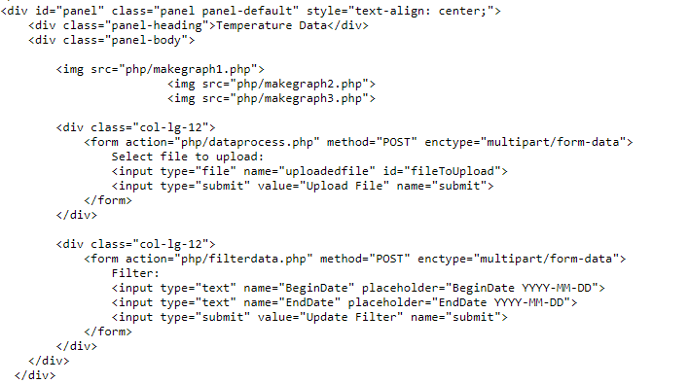
phpMyGraph Library (9)
To be able to display graphs to the user a library called “phpMyGraph” was implemented to allow use of data being displayed to the user in a more comprehensible way. Using this library allowed easier integration within the web service as the library was capable of supporting the server side language “PHP 7.0”.
The main graphs that were used with the web application were vertical and horizontal line graphs as it fitted very well with both the data being displayed to the user and the integration of CSS with bootstrap and suited the overall web page well.
The library helped with displaying easy to read graphs that were incorporated as images into the web page allowing seamless embedded graphs within the bootstrap framework.
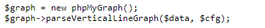
Conclusion (10)
In conclusion this report showed the scenario that had been laid out and the technicalities of the web application that had been focused on to make sure the scenario was completed to the required specification. This report also showed the reasons behind the features that were implemented and why they were chosen as the best suited features for this particular project.
Overall the developer felt that the web application was a success and had completed a fair amount of the requirements specification that had been created by the scenario of supplying users with sensor temperature data around the geo-graphical globe.

