Michael Landy’s breakdown: how far do you need to go in the Art World to make a point?

Name: Laura Grace
Course: BA Fine Art: Studio, Site and Context.
ID Number: P146766
Word Count: 4897
Dissertation Supervisor: Professor Sue Williams

Michael Landy’s breakdown: how far do you need to go in the Art World to make a point?
‘Shock art’ is a phenomenon that has started to take huge momentum in the modern Art world due to its appealing factor for the curious mind, it has existed for over a hundred years as a ‘concept’ but only recently has it really taken off, especially in the 21st century. In 2001, one art critic described shock art as “the safest kind of art that an artist can go into the business of making today", indicating the growing trend of how easy it is to become well known if the output that is produced is done with the intention to shock the audience. As the art world evolves, so too does the output that comes from Artists. Today we see new limits being reached from artistic output, and we see questions into just how far they need to go to gain a reaction. As the 21st century came in, more and more projects were produced with the intention to shock the audience, while challenging relevant issues that hounds the citizens in a society, with war being a popular piece to focus on. However, in this instance an artist rose to my attention when researching the highly relevant issue of ‘consumerism’, the basis of consuming goods for desire and greed in ever increasing numbers. Michael Landy, a British artist who rose to popularity at the turn of the Millennium for his piece ‘Breakdown’, which has been received and been viewed as controversial by some due to its destructive and careless nature. Landy managed to hit the public in a sensitive area, by challenging the consumerist nature of the public and their greedy intentions towards buying the newest or freshest items. To question the nature of his work, and the reasoning behind it; one must use ideologies to answer this. Landy in his work, flirted with some form of Buddhist reasoning behind his work, with the strong emphasis on avoiding greed and not putting a value on material possessions. Furthermore, Communism and Capitalism can be used to understand his reasoning too, with the focus of Capitalism being closely linked to Consumerism and the greedy nature of the public, but also with Communism being a relevant ideology to support Landy’s work and an equal status amongst the public he idolised instead of greedy desire for goods, Landy never explicitly stated he supported the notion of Communism over Capitalism but it can be argued that it is quite clear due to the influence he took when conducting his piece.
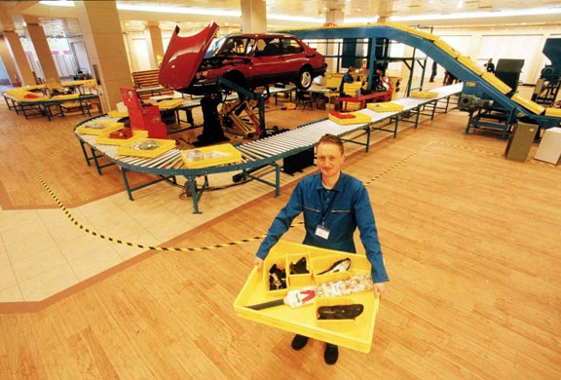
To begin, over the course of a two-week period Landy essentially disassembled, pulped and shredded all his life long belongings in a disused former shop on Oxford street on a conveyable style, performative art or contemporary art. For Landy to get rid of everything in his life, with almost no regard for anything it was certainly courageous and bold, as Landy transitioned from everything he owned to owning nothing, and almost starting life again. According to Landy himself it was a euphoric experience: “this is a celebration of life, but I’m still alive”. Landy further stated that he is happy with life and everyday but described it also as his own funeral. For one to experience this feeling, it certainly must be an indescribable experience but also a unique one. Landy stated in a 2009 interview that when asked what his proudest moment was, he replied “Break down. I'm always trying to get rid of myself. That's the closest I've ever got”. This quote certainly indicates the emotional attachment that Landy felt towards his work, the emotional side of his input towards this work is also something to consider, and why that may have pushed him towards to doing work like this. His piece ‘Everything Must Go’ or ‘Break down’ can certainly be considered a controlled act of dematerialisation of his entire belongings.
Michael Landy pictured with his ‘conveyor belt’ as part of his ‘Break down’ piece, 2001(6)
“It was a courageous and radical act that challenged the normality of contemporary consumerism. It was also, according to Landy, a euphoric experience”
Due to the notoriety of his work, Michael Landy has become well known throughout the Art world as ‘the man who destroyed all his lifelong belongings’, through research on Landy himself and knowledge on various relevant ideologies, the body of this work can be used to investigate whether Everything Must Go was Landy’s response to the economic and social rise in 2001, notably at the turn of a new century when he created the piece or whether he had been going through a life change or possibly just had enough of living in a capitalist state. There are diverse methods to look through this, as most artists tend to lean towards the left, with a lot of pieces being anti-establishment, Landy’s work was absolutely an example of this, but the extent Landy wanted to go with this is one for debate. Some of the key factors to consider are the relevant theories, which come directly from various theorists who belong to these schools of thought and fundamentally the difference in capitalism and communism, the origins of the theories and how they were in history and compared to 2001 when Landy did the original. Finally, the obvious attachment to objects and whether they have any sentimental value or just objects that we collect and buy to make ourselves happy. As previously mentioned, Consumerism is a key focus point in this research, as it answers the question as to what Landy wanted to ‘rebel’ against, and shows the associated terms that Landy refers to in his work and finally, to answer the question with what the difference between ‘wanting’ and ‘needing’ is, in the context of consumerism and the difference between a ‘necessity’ and a ‘commodity’
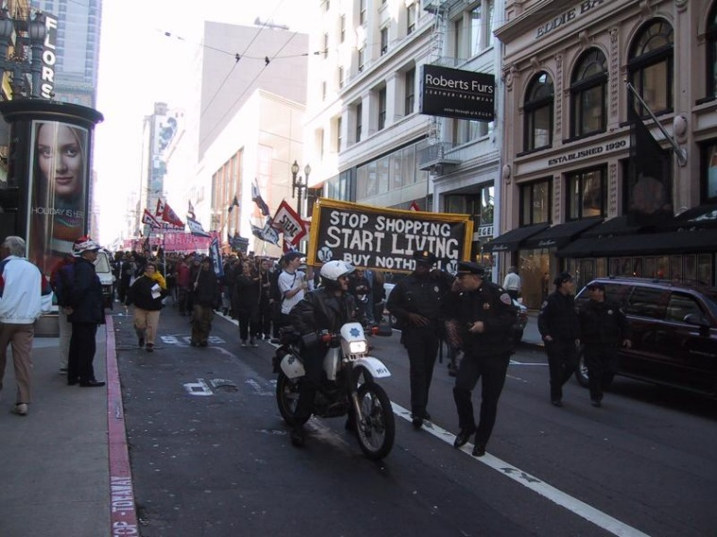
The first aspect that Landy tried to challenge with was the ideology of ‘Consumerism’. Although a broad term, in the sense of economics and production, the main definition of consumerism is the buying and ‘consuming’ of goods on a massive scale. Since the 1980’s when the stock markets rose and in Britain. The Thatcher Government, who believed strongly in business and consumerism, enabled the ‘consumers’ to buy Council Houses, Fridges, TVs and Cars and other household items on a mass scale. Britain and the western world saw Consumerism becoming a part of our everyday lives, thus these products became widely available and meant millions of products would be produced daily for the consumer to enjoy. However, with this new ideology came problems, more and more products being sold meant that the Companies who produced these items had to keep up with the demand. With this motive in mind, companies started to produce products that would become obsolete over time, that would mean consumers would need to go out and purchase the newest edition. We see this a lot more nowadays with the iPhone, whose older models become more and more obsolete as newer versions are made. Furthermore, in 2001 the year that Landy completed his breakdown piece, consumerism was still just as prevalent with modern technological products being consumed on a humungous scale. Mobile phones although in their infancy, MP3 players and Video Players were being consumed in their millions, and for example every house was starting to own a landline phone. Sixteen years later and we still see consumerism, but on more specialist items such as iPhones, smart TVs and other items that we don’t necessarily need, but still enjoy as a consumer.
‘Buy Nothing Day’ protest, to protest Consumerism (with huge Consumerist companies on display behind), 2000 (9)
In the 21st century, the difference between a commodity and a necessity has become ever more apparent. A necessity has changed from being a commodity in the Thatcherite era, such as a Microwave or Fridge and has now become a household necessity in the 21st century, in contrast to this the iPhone or an Xbox One remains a strong commodity, one of which we don’t need but something we buy because it gives us as the consumer enjoyment and satisfaction, hence why ‘Black Friday’ is popular, this is the Friday after Thanksgiving in the US which mega deals are on in a large amount of shops, this has taken off in the western world, especially in the US but also here in Britain. Consumerism can be closely related to the Buddhist train of thought that will be mentioned in detail further, about the fundamental difference between need and greed. When we look at some products as consuming individuals, we see products we need such as a Fridge and items we are greedy for, such as the newest Laptop or Games console. It is highly important to make this distinction, as some items, one would justify constitutes ‘need’ whereas others would constitute it as ‘greed’. To some individuals, Black Friday is an abhorrent show of greed, where due to the deals, then it would be a necessity. In relation to Landy, it is clear why his work shocked so many, due to his seemingly lack of emotion towards his material possessions, ones which he has bought over time and others which he may have acquired. Landy challenged the consumer ideology, and questioned the public on just how reliant they are with material goods.
One of the key aspects of Capitalism is the commonly associated term ‘Consumerism’. Due to its growth pattern that benefits businesses, it is certainly one of the functions of Capitalism. A true definition of capitalism would be ‘an economic and political system in which a country's trade and industry are controlled by private owners for profit, rather than by the state’. From this meaning, one can understand that the emphasis on Capitalism is one of capital, where consumerism ties in with this is the aspect of the influx of money from consumers on a mass scale. Capitalism has seen immense success around the World in modern times. It didn’t become entirely relevant for all until the mid-20th century, as technology was a great contributor towards helping businesses grow with the products that they sold. However, the Industrial revolution is a good area to start when analysing Capitalism, as it is the first time in history where businesses developed, and products started being produced on a mass scale, although a limited number of items started being produced, it would lay the framework for an ideology that dominates the world, over 150 years later. The Industrial Revolution was the birthplace of the factory as a place to work for most, these being the ones we associate with the Victorian era and the assembly line of production that many working class men worked on during this time. During the Victorian era, the system of nobility was still very much in place. Those born into a middle-class family or higher, would often find themselves being able to walk in top positions with little or no work, and on the other hand those who were born into poverty, would often die in poverty as although they may find work in factories, the conditions were awful, and the treatment was just as bad, as workers had no rights during this time. Social mobility, the idea of being able to move into a different social sector because of hard work and endurance was impossible around this era, wherever you were born into, you would stay there.
Since then, Capitalism has come a long way, in a post-World War two Britain there were more opportunities becoming available and individuals were starting to take note and realising that their goals and dreams were not a million miles away, and that social mobility was starting to become more of a thing for most. It would eventually be the Thatcher government that would really help anyone step into success, with the emphasis on big business, with notable figures such as Sir Alan Sugar, who was born into a working-class family in Tottenham and has since rose to glory, thanks to Capitalism and Consumerism. Fast forward to 2001, and we now live in a Capitalism dominated World, where only 4 countries still use a Communist system, although most of these flirt with the Capitalist ideology. Finally, with many of the ‘Communist powerhouses’ of the 20th century dropping Communism and embracing Capitalism, indicating a successful time for Capitalism. The highlights would indisputably be the fall of the Berlin wall, merging Communist East Germany and Capitalist West Germany back into Capitalist German Republic and of course, Russia adapting into Capitalism in the early 1990s, Capitalist brands such as Coca-Cola and McDonald’s became household names around the World, and in 2001 this was stronger than ever with brands such as Sony and Toshiba monopolising on the need to sell more products and create more products for a stronger profit and stronger business. Nowadays, this is even more stronger with companies like Apple being a key figurehead in the Capitalist world.
To contrast Capitalism, Communism offers an alternative system where the capita and business growth is shared within the Government system rather than being kept by the businesses who made the profit, it is conducted on a basis on sharing. It is an alternative to Capitalism, because it encourages the distribution of wealth in equal amounts, to benefit everyone in society rather than create a divide between the classes. Marxism is a strain of communism, which was first coined by Karl Marx during the 19th century, he was a controversial writer who first tried to challenge the class system that was in place in Europe during this time. His writing and theories caused him to be ostracised from his native Germany, causing him to relocate to London. During this time, London was very much under the influence of the Industrial Revolution, and Factory work was thriving during this time. Marx was a keen observer of this at the time, he noticed the inequalities that were occurring and wrote to challenge this, writing of a dream ideology where the workers, who he referred to as the ‘Proletariat’ would eventually resist the middle-class factory owners, known as the ‘Bourgeoise’. During this time, Marx had the right idea as the inequalities of the time related to the work was Marx was conducting on Marxism.
As Marxism developed, countries started to match and support his ideology as this idea seemed like an ideal world to live in, and most of all a fair world to combat inequality in the workplace. The main country to start this mass adaption of Communism was Russia in 1917, with the Russian revolution being a true induction of Marx’s dreams. Lenin et al overthrew the Russian monarchy and adopted a Communist government, which governed for over 80 years; with other Eastern European countries following suit and eventually forming the Communist Soviet Union. During the 20th century, the World was absolutely divided between Capitalist nations and Communist nations, there were wars over it such as the Vietnam war, a US and South Vietnam Capitalist lead force attacking North Vietnam helped by Communist allies China and the USSR, it was rare to see any country during this time adopt another ideology.
“Let the ruling classes tremble at a communist revolution. the proletarians have nothing to lose but their chains. they have a world to win. Workingmen of all countries, unite!”
However, Communism was incredibly flawed and unsurprisingly in the 21st century it has almost been removed from the World. It had many problems and led to uprisings and dictatorships, Castro’s Cuba being an example of this where political opponents were killed, people lived in poverty and unemployment was high. Although it looks nice on paper, there are reasons why all but four countries in the World have moved to Capitalism, already mentioned the Communist powerhouses all moved to this ideology before the 21st century and 2001, where Communism is more nowadays of a dirty word rather than an optimistic vision of government, due to the violent connotations associated with it, and the failed Communist countries that have existed. There is a reason why Castro’s death was celebrated rather than mourned for instance. In relation to Landy, it would certainly seem that he leant towards this ideology to emphasis his anti-Capitalist leanings, the idea of disregarding all goods and material possessions, that the world obsesses over, because they are of less worth to him than his art, and his vision of art. Due to the Capitalist dominated world that we live in, it is clear to see why his artwork in context is so controversial and iconic in the modern Art world.
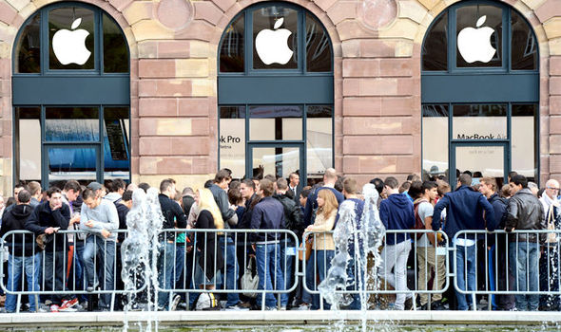
To analyze Landy’s work from all suitable areas, it would certainly be interesting to consider a religious motive behind his work. Out of them all, Buddhism is the most likely to be a source of inspiration in Landy’s work, in the teachings of Buddhism there is a significant amount of emphasis on the dangers of greed, which closely relates to the motives of consumers in the modern world. Moreover, Buddhism contains detailed teaching about the value of material possessions, and emphasizes the equal status of these. It is a different side of the spectrum when looking at an argument from a religious perspective, because as Marxism and Communism are perfectly relevant in this piece, however their origins can be traced and the authors who wrote the ideologies are known, and are able to be criticized, whereas Buddhism has been in place for thousands of years, and has been adapted many times in different styles. In the teachings of Buddhism, there are ‘three poisons’, which exist to guide followers away from committing sins such as greediness and becoming sensually attached to something or someone, this is known as ‘Raga’. There are many close links to Landy in this aspect. The overall aim and goal of ‘Break Down’ was indeed to challenge the modern consumerist society, and all the material and sensual attachment that consumers put towards the items they own. While it has never been explicitly stated, it can certainly be argued that Landy would be more likely to channel Buddhist vibes in his work, albeit intentional or unintentional, with his destruction of all his material possessions, encouraging the British public not to be greedy or to realize that there shouldn’t be a burning desire to go out and buy the latest phone or TV for instance. Buddhist ideology can certainly be viewed as the opposing ideology to Consumerism, where the basis of this is to not become sensually attached to something or someone, as previously mentioned, while Communism may not be on Landy’s ‘Wishlist’, it is with that and Buddhist ideology that Landy certainly drew influence from to counteract the Consumerist society.
A queue for the iPhone 6S, 2015. This shows the addictive and need for the newest and latest model of technology from the consumers
Furthermore, Buddhism also focuses specifically on the aspects of craving, desire and longing, which is known in the Buddhist world as Taṇhā, and naturally the dangers and the evils that come with them. This is an important area to focus on within the Buddhist teachings, as it links strongly with the main motive behind Landy’s work, the challenging of people’s perception on material goods and how much one as a consumer can desire or long for something. Taṇhā has three aspects which stem from it, and these include Kama-taṇhā, which is the notion of craving something for the pleasure and happiness it gives the consumer, and naturally this is seen significantly as a justification for the purchasing of the latest model of the iPhone for instance. It is not the sole reason for purchase, but the main motivating factor. However, this can also be dangerous as the three aspects of Taṇhā have links back to the three poisons and more specifically, Raga relating to the dangers of sensual attachment to something. The Dalai Lama, who is the spiritual leader of Buddhists states,
“We are the controller of the technology. If we become a slave of technology, then that’s not good.”
what he means by this is to not follow the latest trend in technology for instance, as it can have extremely dangerous connotations, if we become attached to technology for the wrong reasons. We can see examples of unhealthy attachment within the popularity of new releases on consoles or phones. It is usually the same people who make these purchases, for the reasoning of happiness and pleasure when purchasing.
Naturally with a piece like this, we see others take influence from it or work on something that is on the same topic. The work of Banksy is known around the world and not just within the art world, his images and work is recognized universally. Banksy’s motive for creating work is nearly always for tackling social issues that are prevalent in the news. Consumerism and the dangers of a Capitalist world are certainly issues that Banksy has tackled in the past. From this evidence, we can see links between Landy and Banksy, while Landy performs work like ‘Break down’ and whereas Banksy sticks to street art, we can still see the anti-establishment links between the two and where they are in tandem with each other. One of Banksy’s most significant pieces, ‘Consumer Jesus’ (2004) demonstrates tremendously the feeling towards the consumerist society. It depicts Jesus on the cross, with shopping bags in both hands, it was published to coincide with the Christmas holidays and portray Banksy’s outrage towards the culture of consumerism taking more of a priority over the Christian values that the country should be embracing. The message from the piece is incredibly strong as sticking from the bags are Candy canes and other Christmas related items. The clear idea here is that Christmas consumerism has essentially killed Jesus, on the holiday which is meant to celebrate his birth, for Christians to see Jesus depicted like this it is not surprising to see why this piece was controversial and more importantly why it was meaningful.
Secondly, staying on the topic of Banksy, he also produced another thought provoking piece on the topic of consumerist culture, ‘Shop till you drop’ from 2011 is another piece that tackles the limits that some pieces in art can reach. The piece depicts a shopper with a trolley literally falling from a building, because of its display on building it works so well, taking the phrase of shopping till you drop very literally. The thing about Banksy’s work is the shock-factor of it all, that is certainly what made him so well known, and when his pieces are on walls around the city, it can certainly catch the attention of any passer-by. Relating to Landy, the motivation for his ‘Break down’ could absolutely stem from Banksy and likewise, the shock-factor seems to be a popular extremity with a lot of work in the 21st century, and while ‘Break down’ may seem extreme but mild in comparison to Banksy’s work, which touches on a lot of serious issues, as a viewer of the work, you can see and understand why the appeal of the work is so infectious to the audience.
In conclusion, ‘Break down’ is a piece with many admirable qualities that do so much to make an impact in the artistic world. As ‘shock art’ becomes more popular in the 21st century, the legacy of Landy can be totally understandable and furthermore, relatable. With technology being produced on a humungous scale during the 2010s, it can provide a link as to why more and more people are becoming frustrated with the consumerist society that we absolutely live in, and pieces like ‘Break down’ and ‘Consumer Jesus’ can be seen as appropriate answers to this. However, with the piece in context, the question must be addressed as to how far artists are willing to go to make an impact? Landy went beyond the point of no return when he conducted ‘Break down’, he almost started a new life again. Yes, Landy made a significant contribution towards the issue of consumerism and capitalism and the damaging impact it has on the world as a whole, but his methods when analyzed, can be considered very extreme and almost ludicrous, just to make a point; that is a crucial differentiating factor between Landy and Banksy for instance, where one makes strong street art and the other destroys everything he owns, the quality of one piece certainly outweighs the other when considering the sacrifices that come with it.
Regarding ideological beliefs, Landy certainly adheres to a Buddhist sense of reasoning in terms of material possessions and the differences between want and desire, this is also similar to a significant amount of anti-Capitalism and anti-Consumerist thinkers, while not explicitly stating this in their work, they touch upon it on numerous occasions, thus indicating the impact of Buddhism on the world of art. This also happens with Communism, but not usually on such a large scale, but many anti-consumerist thinkers will tend towards Communist thinking in their work or ideological belief. With all things considered, Landy’s personal feelings must also be taken into account; when Landy states his pride towards ‘Break down’ because he’s always ‘trying to get rid of himself’, it indicates to the observer, that the emotions that Landy put into the piece were significant and in a way powerful, to use your own emotional issues and to input it for a wider message can have powerful qualities, which is arguably what made this piece so interesting to research. Finally, when considering this piece as an artistic-minded individual, the thought of disregarding all the items is certainly one that scares me, and naturally scare most individuals; I feel that I could never go to this point in my life, just for a piece of art; it’s just too far and there are a lot of other ways to make significant points in art, through mediums such as street art or photography. ‘Break down’ is a piece with many fascinating qualities and attributes, but for me, the method is dangerously too far for artists to go or consider going with their artistic output.

Bibliography
- Barnett, Laura; Portrait of the artist: Michael Landy, artist (The Guardian, 2009) p.1
- Buswell Jr, Robert & Lopez Jr, Donald, the Princeton Dictionary of Buddhism. Princeton University Press. (2013) pp. 546
- Fischer, David; Banksy ‘Shop Till You Drop’ in London? (2011)
- < https://www.highsnobiety.com/2011/11/24/banksy-shop-till-you-drop-in-london/> [accessed 11 Dec 2017] p.1
- Harvey, Peter; an Introduction to Buddhism: Teachings, History and Practices. Cambridge University Press. p. 53 (1990)
- ‘History of American Consumerism’, American Consumerism and the Global Environment < https://web.archive.org/web/20160521070002/http://www.mtholyoke.edu/~kelle20m/classweb/wp/page2.html> [accessed 10 Dec 2017]
- Image 1, ‘Breakdown’; https://supralimen.wordpress.com/2011/01/19/excess-michael-landy-breakdown-200/ [accessed 10 Dec 2017]
- Image 2, ‘Buy Nothing Day demonstration in San Francisco, November 2000’ < https://blog.education.nationalgeographic.org/2015/11/22/five_for_black_friday_new_traditions/> [accessed 10 Dec 2017]
- Image 3, iPhone 6s queue, <https://www.express.co.uk/life-style/science-technology/604588/iPhone-6S-Apple-Store-iOS-App-Skip-Queue-Pre-Order>
- Locke, Robert; 10 Lessons From Dalai Lama That Will Change Your Life <http://www.lifehack.org/articles/communication/10-lessons-from-dalai-lama-that-will-change-your-life.html>> [accessed 10 Dec 2017] p.1
- Marx, Karl; Chapter IV. Position of the Communists in Relation to the Various Existing Opposition Parties (1848) <https://www.marxists.org/archive/marx/works/1848/communist-manifesto/ch04.htm> [accessed 19th November 2017] p.1
- Nesbitt, Judith; Michael Landy Semi-Detached (Tate Publishing, 2004) p12
- Richardson, Rachel; Banksy’s “Consumer Jesus” 2004 < http://www.blogs.buprojects.uk/2015-2016/rachelrichardson/2015/11/16/banksys-consumer-jesus-2004/> p.1
- Silberman, Vanessa; Inside shock art. (Art Business News, March 2001) p.1
- Sooke, Alistair, The man who destroyed all his belongings (14th July 2016; BBC News) <<http://www.bbc.com/culture/story/20160713-michael-landy-the-man-who-destroyed-all-his-belongings>> [accessed 10 Dec 2017]
- Zimbalist, Sherman and Brown, Andrew, Howard J. and Stuart, Comparing Economic Systems: A Political-Economic Approach. Harcourt College Pub. (October 1988) pp. 6–7.

Silberman, Vanessa. Inside shock art. (Art Business News, March 2001).
Alastair Sooke, The man who destroyed all his belongings 14th July 2016; BBC News <<http://www.bbc.com/culture/story/20160713-michael-landy-the-man-who-destroyed-all-his-belongings>> [accessed 10 Dec 2017]
A. Sooke, BBC News p.1
Ibid, p.1
Laura Barnett, Portrait of the artist: Michael Landy, artist (The Guardian, 2009) p.1
Image 1, ‘Breakdown’; https://supralimen.wordpress.com/2011/01/19/excess-michael-landy-breakdown-200/ [accessed 10 Dec 2017]
Judith Nesbitt, Michael Landy Semi-Detatched (Tate Publishing, 2004) p12
A. Sooke, BBC News p.1
Image 2, ‘Buy Nothing Day demonstration in San Francisco, November 2000’ < https://blog.education.nationalgeographic.org/2015/11/22/five_for_black_friday_new_traditions/> [accessed 10 Dec 2017]
‘History of American Consumerism’, American Consumerism and the Global Environment < https://web.archive.org/web/20160521070002/http://www.mtholyoke.edu/~kelle20m/classweb/wp/page2.html> [accessed 10 Dec 2017]
Zimbalist, Sherman and Brown, Andrew, Howard J. and Stuart (October 1988). Comparing Economic Systems: A Political-Economic Approach. Harcourt College Pub. pp. 6–7. ISBN 978-0-15-512403-5.
Karl Marx, Chapter IV. Position of the Communists in Relation to the Various Existing Opposition Parties (1848) <https://www.marxists.org/archive/marx/works/1848/communist-manifesto/ch04.htm> [accessed 19th November 2017] p.1
Robert E. Buswell Jr.; Donald S. Lopez Jr. (2013). The Princeton Dictionary of Buddhism. Princeton University Press. pp. 546
Robert E. Buswell Jr et al, pp. 546
Peter Harvey (1990). An Introduction to Buddhism: Teachings, History and Practices. Cambridge University Press. p. 53
P. Harvey, p.53
Robert Locke, 10 Lessons From Dalai Lama That Will Change Your Life <http://www.lifehack.org/articles/communication/10-lessons-from-dalai-lama-that-will-change-your-life.html>> [accessed 10 Dec 2017] p.1
Image 3, iPhone 6s queue, <https://www.express.co.uk/life-style/science-technology/604588/iPhone-6S-Apple-Store-iOS-App-Skip-Queue-Pre-Order>
Rachel Richardson, Banksy’s “Consumer Jesus” 2004 < http://www.blogs.buprojects.uk/2015-2016/rachelrichardson/2015/11/16/banksys-consumer-jesus-2004/> p.1
Rachel Richardson, p.1
David Fischer, Banksy ‘Shop Till You Drop’ in London? (2011) < https://www.highsnobiety.com/2011/11/24/banksy-shop-till-you-drop-in-london/> [accessed 11 Dec 2017] p.1

