
Skills for the Workplace
Module Assignment Submission
Student Name: | Sadia Kiyani
Student Number: | 1711581
Module No: | BMSK4003
Module Title: | Digital Skills and Research Methods

Statement of Confirmation of Authenticity
By the act of making this submission, the student declares that this is the work of the student named above. The work has not, in whole or in part, been knowingly presented elsewhere for assessment, or where assessment has been built on a previous assessment, this has been identified. Where materials have been used from other sources it has been properly acknowledged. If this statement is untrue, the student acknowledges that an assessment offence has been committed.
Attention is drawn to the plagiarism and unfair practice policies of both the University and of ILM.

Table of Contents
Introduction 3
Understanding the Gender Pay Gap 3
Factors Affecting Gender Pay Gap 4
Difference in Work Patterns 4
Impact of Different Occupations 4
Solving the Gender Pay Gap in London 5
Data Collection 6

Introduction
The aim of this report is to discuss the gender pay gap in London through reviewing the different gender pay gap reports throughout the past few years as well as analysing and evaluating several studies conducted on this workplace issue. I will also be discussing how the pay gap affects women and men living in London and its surrounding areas differently. The gender pay gap report from March 2017 found that the mean pay gap for full time and part-time employees was as much as 9.10% (London City Hall, 2017). This figure is almost 1% higher than the previous year in which the mean pay gap for part-time and full-time employees was 8.29% (London.gov.uk, 2016). This increase in gender pay gaps can negative implications such as longer time paying off loans as well as a later retirement (Whaley, 2018).

Understanding the Gender Pay Gap
Gender pay gap is “an equality measure that shows the difference in average earnings between women and men” (GOV.UK, 2016). Large employing bodies are required by law to publish yearly reports of gender pay gaps. Employers must also follow the equal pay act 1970 which requires employers to pay equal rates to their employees regardless of their gender, race, religion or sexuality (Gender-pay-gap.service.gov.uk, n.d.). The pay gap is calculated using two measures of central tendency – the mean and the median. The mean is the average of all the values in a given set of data whereas the median is the middle value in a given set of data. There are some disputes on which measure of central tendency is more reliable; the mean is calculated using all the values available in each set of data therefore it is representative of all the values included. However, the mean can become unreliable due extreme outliers that might shift it. On the other hand, the median is not affected by any outliers therefore extreme anomalies will not affect the outcome. But, since it does not use all the values from the set of data it can be said that it is not completely representative of that data. Along with that, companies must also keep a record of the percentage of men and women receiving bonus payments as well as the ratio of men and women in each pay band (Gender-pay-gap.service.gov.uk, n.d.). Below is a table from the gender pay gap report 2017 that shows the median and mean pay gaps for full-time and part-time staff in London.
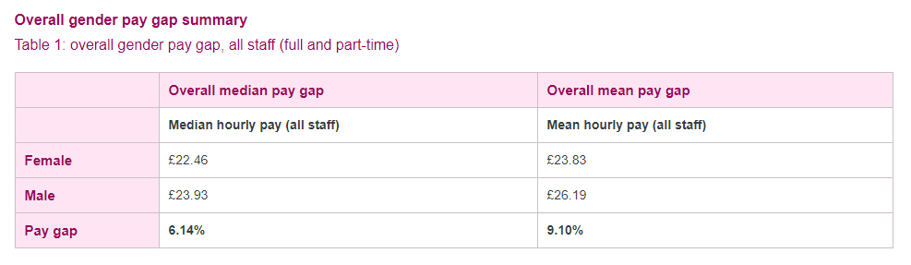 (London City Hall, 2017).

Factors Affecting Gender Pay Gap

Difference in Work Patterns
Difference in working patterns is an important factor affecting the gender pay gap. According to the bar chart below, men are at least 15% more likely to have a full-time job and 38% at maximum. The percentage of men working full time also increases from the ages 22 to 49. Whereas for women, the percentage gradually decreases after the age of 29. These differences are due to the fact that women expected to abandon or overlook their careers once they get married or decide to have kids. An implication of less women having full time jobs can result in increased financial problems for single mothers who can not afford child care and have to rely on benefits from the local counsel. Another implication of this is that women resort to working lower paying jobs that are less demanding in order to make time for family and kids (Evans, 2018).
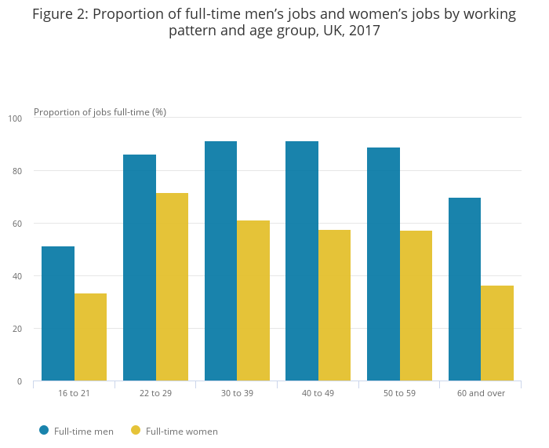 (Evans, 2018)

Impact of Different Occupations
A person’s occupation can have a considerable impact on their earnings. Jobs can range from high skill such as executives and senior officials that have higher earnings to low skill jobs such as labour work that provide a lower wage. The diagram below presents the different ratios of women and men working in the different job sectors from a 2017 occupation survey. It can be concluded that men are more likely to have senior jobs such as managers, executives and traders. Whereas, women are more likely to have jobs that provide care or assistance such as nursing, personal assistants and customer assistants. It is important to have a balance of both men and women in all areas of occupation; a high proportion of specific types of occupations are made up of one gender can lead to occupational segregation and eventually leads to the formation of stereotypes such as “men are not good carers” because a majority of carers and nurses are women (Evans, 2018).
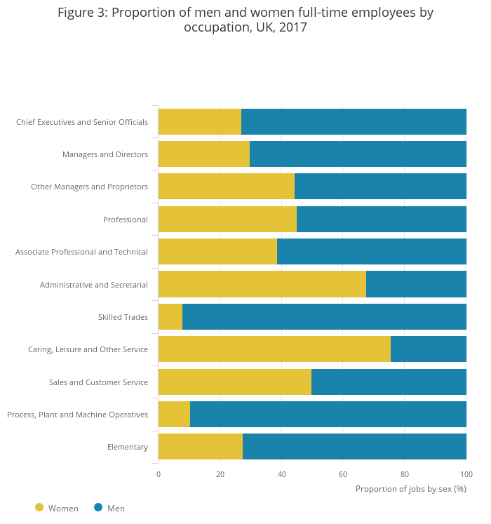
(Evans, 2018)

Solving the Gender Pay Gap in London
The Greater London Authority (GLA) aims to improve the issue of the gender pay gap in London as well as having employing people from diverse backgrounds to be representative of the multicultural community in London and its surrounding areas. The GLA has devised an action plan to tackle to complex issue of gender gap. The GLA plans on maintaining complete data transparency on the semi-annual workforce reports with detailed data on the gender pay gap as well as reviewing female staff experience to address any concerns. The Diversity and inclusion management board will also be conducting reviews on data regarding equal pay every six weeks. In addition to these, hiring managers and interview boards within companies are required to attend training to counter discrimination, bias and inappropriate behaviours. Women will also be offered extended career advice and career development programmes such as leadership and management programs to increase access for women to executive and senior level jobs through increased funding and promotions (London.gov.uk, 2018).

Data Collection and Ethics
Whilst collecting data whether it is secondary or primary it is important to be mindful of the ethical guidelines. Ethical guidelines are set in place so that the rights of the researcher or the participants are not infringed or violated in any way whatsoever. It is important to protect the privacy of the participants involved in the study; according to the data protection act, any data regarding the participants should not be published or shared with third parties without their consent. Participants should give an informed consent to what they are agreeing to. This includes that the researcher does not hide any aim of the study from the participants. If the researcher is using secondary data for the purpose of their own research, it is important to also follow the copyright laws and credit the original researcher where necessary. This is vital as passing on someone else’s findings and data as your own is plagiarism and can be prosecuted.

Conclusion
Gender pay gap is an issue that has existed since women first got the right to work and have a job. It is a complex matter that afflicts women all over the world. To solve this matter, it is essential to first deal with the factors that cause the gender pay gap to increase. Once the factors affecting this issue are eliminated, then through interventions and development programmes the gender pay gap can surely be decreased and eventually eliminated.

Bibliography
London City Hall. (2017). Gender pay gap report: March 2017 data. [online] Available at: https://www.london.gov.uk/about-us/governance-and-spending/spending-money-wisely/gender-pay-gap-report-march-2017-data [Accessed 31 Aug. 2018].
London.gov.uk. (2016). overall gender pay gap 2016. [online] Available at: https://www.london.gov.uk/sites/default/files/gla_gender_pay_gap_report_-_march_2016_data.pdf [Accessed 31 Aug. 2018].
Whaley, N. (2018). 3 long-term effects the gender pay gap has on women. [online] Mic.com. Available at: https://mic.com/articles/188833/3-long-term-effects-the-gender-pay-gap-has-on-women#.4Kve8L6jr [Accessed 31 Aug. 2018].
GOV.UK. (2016). UK Gender Pay Gap. [online] Available at: https://www.gov.uk/government/news/uk-gender-pay-gap [Accessed 31 Aug. 2018].
Gender-pay-gap.service.gov.uk. (n.d.). The Gender Pay Gap Explained. [online] Available at: https://gender-pay-gap.service.gov.uk/public/assets/pdf/gender-pay-gap-explained.pdf [Accessed 31 Aug. 2018].
Evans, T. (2018). Understanding the gender pay gap in the UK - Office for National Statistics. [online] Ons.gov.uk. Available at: https://www.ons.gov.uk/employmentandlabourmarket/peopleinwork/earningsandworkinghours/articles/understandingthegenderpaygapintheuk/2018-01-17 [Accessed 31 Aug. 2018].
London.gov.uk. (2018). Greater London Authority (GLA) Gender Pay Gap Action Plan. [online] Available at: https://www.london.gov.uk/sites/default/files/gender-pay-gap-action-plan.pdf [Accessed 31 Aug. 2018].

