ASSIGNMENT
ON

Database Systems

ACCA7002

BY

Yacha Li
2006702
UNIVERSITY OF WALES TRINITY SAINT DAVID

UNIVERSITY OF WALES TRINITY SAINT DAVID

July, 2021

Introduction
Experts say the world's information is growing at an explosive rate every day. Every day, these large websites, such as Tik tok, Facebook, twitter and even youtube, produce a lot of text, pictures, voice and video information, which is a headache for us to quickly organize information and use them. Therefore, fast and efficient storage and retrieval of these information is a huge test for each company server. Through the continuous use and improvement of different storage solutions, it is found that database is the main solution to solve the problem of information differential storage and rapid information retrieval.

This paper introduces SQL and NoSQL in detail, analyzes the differences between them, introduces their respective characteristics and advantages, and puts forward some opinions combined with specific examples, carries out analysis, design, index, query and other operations, creates the required database, which can meet the needs of Pronto package company. In addition, in order to improve the query performance of the database and improve the efficiency, the distributed database is designed and analyzed, and the solution is put forward to achieve the purpose of enhancing the effect of function.

SQL VS NoSQL

Database is a means of storing information about something. When it is stored, we can quickly store and retrieve the data when we need the information. Relational database management system (SQL) is a kind of frequently used database, which stores information in its internal tables. Because of the quickness and convenience of SQL itself, it is now often used as the most popular database structure in the daily life of major companies. Relational database can deal with a large amount of information, but also has the ability to quickly query complex information.Although relational database plays a very important and crucial role in data storage, it is difficult to meet the previous requirements due to the limitations of everything.

With the continuous expansion of Internet business, the types of business scope also continue to expand, and various applications appear one after another，So In this era of cloud services, there are more demands for technology, which are mainly from the following three aspects:

1. Low latency reading and writing speed: Quick response can make users have higher satisfaction;
2. Support main information and traffic: for large-scale applications such as search, we must use Pb level data and be able to cope with millions of traffic;
3. Cluster management: system administrator hope that distributed applications can be deployed and It's not complicated;
The consideration of huge operation cost: it managers want the hardware cost, It can reduce a lot of software and labor costs.

Although relational database plays a very important and crucial role in data storage, it is difficult to meet the previous requirements due to the limitations of everything.

1. Difficult to expand: It is difficult to expand: the multi table query mechanism makes the database expansion more unsatisfactory;
2. Reading and writing information is slow: this happens when the amount of data reaches a large scale. The composition of relational database information is so complex, it is very easy to have concurrency problems such as birth and death lock, so the reading and writing speed of relational database declines very seriously;
3. Expensive: the enterprise level database grant price is very high, and the system scale is becoming larger and larger, more and more information;
4. Poor after-sales support: the existing solutions can not support the explosive growth of data storage;

NoSQL database provides another feasible solution to solve the storage and retrieval of data outside the table relationship used in relational database. It can be said that on the other hand, the main goal of NoSQL movement is to make data storage and recovery easier. Because of their own cache can be temporarily stored, they are considered as alternative databases to solve the shortcomings of persistent storage such as SQL, also known as non relational databases. In general, NoSQL is used for massive information storage and information parallel processing on numerous servers.

2.1 Main differences
(1)Type
SQL database is mainly called relational database (RDBMS), while NoSQL database is distributed database. It means non relationship.

- Storage mode
The structure of NoSQL database is dynamic architecture. Data can be stored in multiple ways. It can be document oriented, column oriented, graph based or organized key value storage, which is very flexible. In this way, it can create documents directly. Each document can also be designed as its own structure, and fields can be added at any time.

- Scalability
In the normal use process, the vertical scalable SQL database is in the majority. Then users can add ram, CPU or SSD to increase the load on a single server. In addition, NoSQL database is horizontal and scalable. Then users can slice or add more servers to the library to process more information. It's like building higher in a tall building, rather than building more in a neighborhood. As a result, NoSQL will become more complex and powerful, and the database will have more advantages in the face of large amount of data sets.

- Structure
SQL database is directly related to tables, NoSQL database is graphic database or wide column storage, and is based on key value pair and document. In this way, relational SQL is a better choice for applications that need to process transactions in parallel.

- Follow attributes
SQL database follows acid attributes (atomicity, homogeneity and oligopoly and persistence), while NoSQL database follows the principles of consistency, availability and partition tolerance.

- Support
All SQL databases provided by manufacturers provide strong support. furthermore, There are a lot of personal advisers who can help with large-scale deployment of SQL database, There are some NoSQL databases, you still have to rely on the support of the community, and Only external experts who meet the quantitative requirements can design large NoSQL with these things.

- language
The definition and operation of SQL database are implemented by data structured SQL language with complete functions. SQL is the most common option. In the face of complex large-scale queries, it is a very safe choice at present. But on the other hand, SQL is restrictive, it requires us to use the predefined schema to determine the data structure before using data, and all data must follow the same structure. A lot of preparation makes it impossible for us to change the system easily.

2.2 Main advantages of SQL vs NoSQL
The differences are shown in Table 1：

If your data is growing dramatically, The scalability you need needs to be fast and effective, and NoSQL may be right for you. But The data structure is not added or deleted and The growth curve is smooth and controllable, SQL may be the most reasonable for you.

In the process of project development to solve the service problem of Art Center, the process will face a problem of database selection. When choosing a database type, the most important choice is choosing SQL)or NoSQL structure. Although these two databases are feasible choices, according to the characteristics of the requirements, SQL seems to be a more correct choice.

Table 1 differences between SQL and NoSQL
SQL | NOSQL
Relational database management system（RDBMS） | Non relational or distributed database system
Database with fixed, static and predefined architecture | They have a dynamic architecture
Database not suitable for hierarchical data storage | These databases are most suitable for hierarchical data storage
These databases are most suitable for complex queries | These databases are not suitable for complex queries
Vertically scalable features | Horizontally scalable

Indexes：
Index is a data structure used by storage engine to find records quickly. Index optimization is the most effective way to optimize query performance.
An index can contain the values of one or more columns. If the index contains multiple columns, the order of the columns is also very important, because SQL can only use the leftmost prefix column of the index efficiently.The structure of the index is shown in Figure 1.
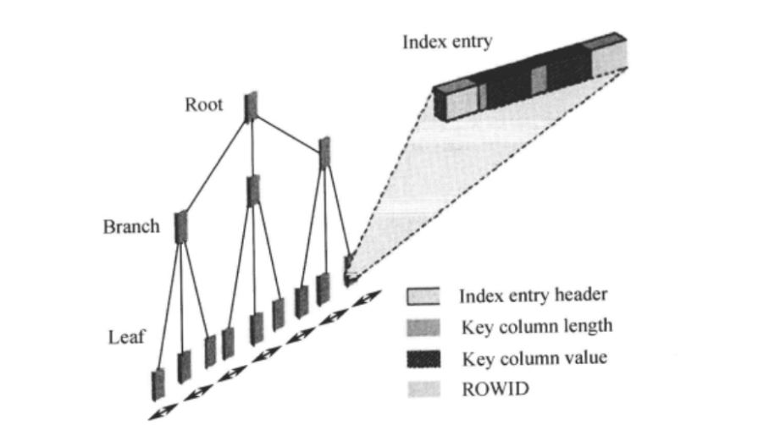

Figure 1:Index structure chart

3.1、 Advantages of indexing
In short, there are two main points:
- As for the way to find data, the index structure of B + tree balances the way of multi-channel search tree, which is fast

- In terms of query consumption, it means that the IO times of accessing data block are less, and then the scanning data block is small and less, so it is naturally faster

3.2、 Disadvantages of index
Although the index gives the query very good efficiency, it can not be abused.
By understanding the structure and principle of index, we can know that:

- Memory:The index is to get the data of the corresponding column into the memory, then arrange it in order, and build it in the free block of the disk, so as to produce the index block, which must occupy the disk space, because there will be ROWID (MySQL is the primary key) in the index, which is used to retrieve the data from the table, indicating that the space occupied by the index is larger than that of a column in the table. If every column has an index, the index will be larger A small meeting is bigger than a watch.

b.Update: after updating a field, you need to go to the index block to update the index, resulting in extra overhead. However, this update only needs to update the field of the index (for the column in the index)
Delete: it's different to delete data. To delete a piece of data, if there are too many indexes, you need to delete the values in each index, resulting in more overhead.

3.3 fields suitable for indexing:
1: Frequent search
2: Frequent sorting
3: It often follows the where statement
4: Small data type
5: Simple data type
6: Try to avoid null in columns

3.4 High performance index strategy
Independent columns:Independent columns are index columns, which cannot be part of an expression or parameters of a function. If the columns in the query are not independent, MySQL will not use indexes.

Prefix index and index selectivity:Sometimes you need to index a long column of characters, which makes the index big and slow. Usually, the characters at the beginning of the index can be indexed, which can greatly save the index space and improve the efficiency of the index. But this will reduce the selectivity of the index.

Multi column index:In MySQL or later versions, the strategy of "index merging" will be used. Queries can scan with two single column indexes at the same time and merge the results. There are three variants of this algorithm
1).Union of or conditions.
2).Intersection of and conditions.
3).Combination and intersection of the first two cases.

Select the appropriate index column order:The correct index order depends on the queries that use the index, and at the same time, we need to consider how to better meet the needs of sorting and grouping.

Cluster index:InnoDB's clustered index actually stores B-tree indexes and data rows in the same structure. Its data is actually stored In the content of the index.
Clustering "means that data rows and adjacent key values are tightly stored together. Because data rows cannot be stored in two different places at the same time, a table can only have one clustered index (primary key index).There is a big difference between clustered index and nonclustered index, that is the fundamental difference between clustered index and Nonclustered index refers to whether the context content of the table record is consistent with that of the index.

Overlay index:If an index contains (or covers) the values of all fields that need to be queried, we call it an "overlay index."

Index and lock:InnoDB locks rows only when they are accessed, and index can reduce the number of rows accessed by InnoDB, thus reducing the number of locks.

To solve this problem, the corresponding secondary index is established, the appropriate primary key value is selected, and the primary key index (including a unique index, null value is allowed) is created. ）Each time you look up the data, find In the node, the primary key value cluster index gets complete record information.

In the most important field to establish an index, from the database as a whole can know, ticket_ The booking table contains many important information, such as the location, number, program number and price of the theater. These information are frequently queried, so a non clustered index is added to the three columns of booking time, company name and theater number. In this way, the primary key value corresponding to the record can be found, and the primary key value can be clustered to the required information.

Both clustered and nonclustered indexes can be unique indexes. In SQL server, when uniqueness is the characteristic of. Data itself, a unique index can be created, but the combination of index columns is different from the primary key of a table. For example, if you want to frequently query the table employees (whose primary key is column EMP)_ Column EMP of ID)_ Name, and to ensure that the name is unique, enter the column EMP_ Create a unique index on name. If the user enters the same name for multiple employees, the database displays an error and the table cannot be saved.

3.4 Specific index analysis
Due to the change of information status in the process of package transportation, which involves different cities, different users, company employees, means of transportation and transportation price, each package transportation will experience a lot of information changes. In the whole express company system, tens of thousands of express information needs to be managed and queried correctly and quickly, At this time, we add auxiliary index in the right place, which will greatly improve the speed of our query express information.

The function of joint unique index is to associate customer information with package information, which can improve the speed of querying package logistics and information recorded by users and express companies.

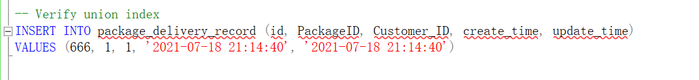
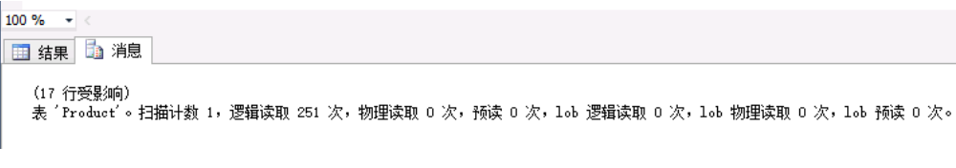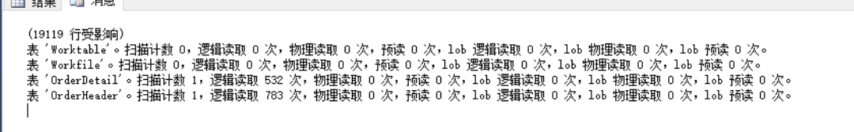
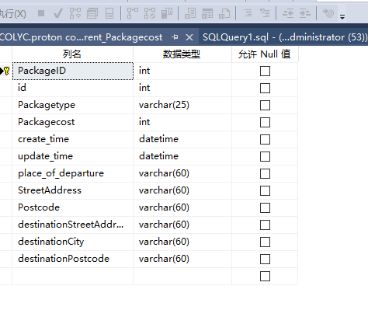

4 Transaction

4.1 Database transaction

A transaction is a single unit of work. If a transaction succeeds, all data changes made in that transaction are committed and become a permanent part of the database. If the transaction encounters an error and must be cancelled or rolled back, all data changes are cleared. The characteristics of the transaction can help us solve two problems of package transportation.

In other words, in a transaction, you need to write two SQL statements, one is to modify the order table status, the other is to modify the inventory table inventory. If there is an error when modifying the status of the order table, the transaction can be rolled back to restore the data to the state before modification, and the subsequent modification list will not be executed, so as to ensure the consistency and security of the transaction relationship logic.This is what a transaction looks like. Either all transactions are executed, or all transactions are not executed, returning to the original data state.

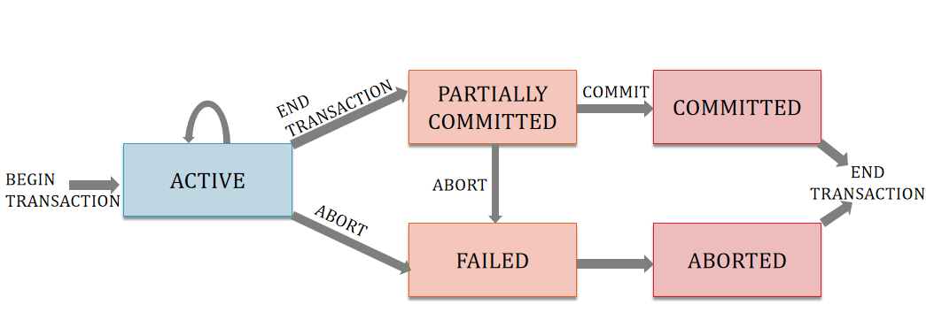
Figure 1 Transaction State Diagram

Transaction has atomicity, consistency, isolation and persistence.
- Atomicity: a transaction must be an automatic unit of work, either executed or not executed.
- Consistency: at the end of the transaction, all internal data is correct.
- Isolation: when multiple transactions are concurrent, each transaction does not interfere with internal data and processes data before or after another transaction.
- Persistence: after a transaction is committed, the data is permanent and cannot be rolled back.

4.2 Reduce deadlock and improve database performance
Deadlock is time-consuming and resource consuming. However, in large databases, deadlock caused by high concurrency is inevitable, so we can only make it less.
Accessing database resources in the same order will prevent deadlock in the above example
Keep the transaction short, and try not to let a transaction handle too complex read and write operations. If the transaction is too complex, it will occupy more resources and increase the processing time. It is easy to conflict with other transactions and increase the deadlock probability.
Try not to ask the user to respond in the transaction, for example, after modifying the new data, the whole transaction is submitted, so as to prolong the resource occupation time of the transaction and increase the deadlock probability.
Try to reduce the database concurrency.
Use partition table and partition view as much as possible, put data in different disks and file groups, and access data stored in different partitions in a decentralized way, so as to reduce the long waiting time of other transactions caused by placing locks in the table.
Avoid long-time and complex data operation of relational table.
Use a lower isolation level and hold shared locks for a shorter time than using a higher isolation level. This reduces lock contention.

4.3 Analysis and solution of parcel problem
The definition of transaction needs to be explained as follows:
1. A database transaction can operate multiple databases.
2. If it does not constitute a condition for the transaction, the transaction will fail.
3. All operations that make up a transaction either have an impact on the database or have no impact on the database. In other words, the database can always maintain a consistent state regardless of whether the transaction is successfully executed or not.
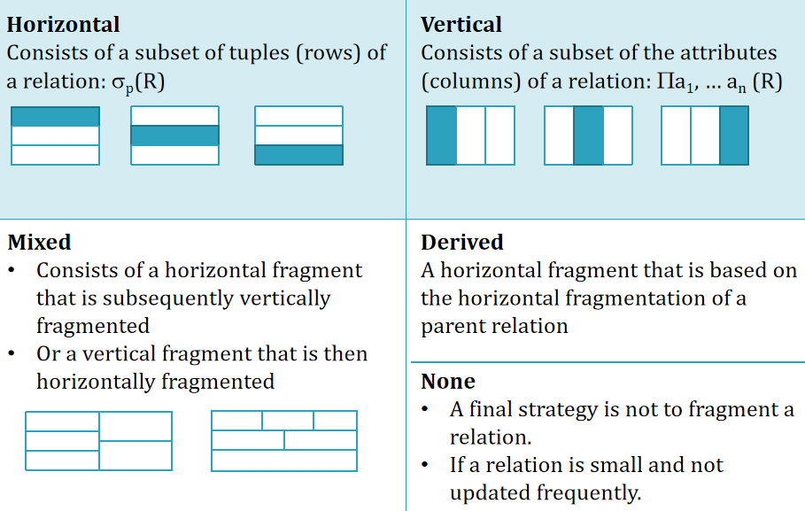
Figure 2 Types of Fragmentation

Here, database transaction provides a method for database operation to recover from failure to normal state, and also provides a method to maintain database consistency even in abnormal state. When multiple applications access the database at the same time, these applications can be isolated to avoid unexpected interference between operations.
Database transaction can solve these two problems: 1. Sometimes the booking of package delivery will be recorded, and the specific delivery information will not be registered in the system. 2. Customers can book the delivery time.

When the package is in transit but has not been delivered, the specific delivery date and other information of the package will not be executed by the office but stored in the system.

5 Distributed Database Solution
Distributed cluster can solve the problem of big data storage and access explosion. The key point of distributed system is to make multiple servers work together at the same time to complete complex tasks, especially in the face of high concurrency or large amount of data tasks.
Distributed database is the product of the combination of database technology and network technology. Through the network operation technology, the physically separated databases are connected together to form a huge data aggregation and realize the centralized management and efficient management of the logical layer.

5.1 What is a distributed database?
The distributed database system is developed on the basis of the mature technology of the centralized database system, but it does not simply implement the centralized database separately, it has its own properties and characteristics. Many concepts and technologies of centralized database system, such as data independence, data sharing and redundancy reduction, concurrency control, integrity, security and recovery, have different and richer contents in distributed database system.

(1) Data independence.

Data independence is one of the main goals of database methods. In centralized database, data independence includes two aspects: logical independence and physical independence. The significance is that the logical structure of program and data has nothing to do with the storage structure of data. In a distributed system, database independence is not only mentioned above, but also data distribution independence, also known as distribution transparency, that is, users do not have to care about the logical fragmentation of data, the details of the physical location distribution of data, and the consistency of duplicate copies (redundant data). With distributed transparency, users' applications are written as if the data is not distributed. In a centralized database, the independence of data is obtained through the three-level schema of the system and the two-level mapping between them. Distributed database, distributed transparency is due to the introduction of new patterns and mapping between patterns.

(2) A control structure combining centralization and autonomy.

Database is for users to share, in the centralized database, in order to ensure the security and integrity of data, the control of the database is centralized. The database administrator (DBA) is responsible for monitoring and maintaining the normal operation of the system. In distributed database, there are two levels of data sharing: one is local sharing, that is, storing the shared data of local users in local sites. The second is global sharing, that is to say, each site of the distributed database also stores data that can be shared by users of other sites in the network, which supports global reference. Therefore, the corresponding control structure also has two levels: centralization and autonomy. Each local DBMS can manage the local database independently and has the function of autonomy. At the same time, the system has a centralized control mechanism to coordinate the work of the local DBMS and implement the global application.

(3) Increase data redundancy appropriately.

In a centralized database, one of the goals of the system is to minimize redundancy. The reason is that redundant data wastes storage space, and it is easy to cause inconsistency between copies. The goal of reducing redundancy is achieved by data sharing. However, in distributed system, we want to add redundant data and store multiple copies of the same data in different sites. The reason is to improve the reliability and performance of the system. When a site fails, the system can operate on the same copy in another site without causing system paralysis. According to the distance, the system can select the nearest data copy to operate, which can reduce the communication cost. However, increasing redundancy will encounter the same problem of centralized database, that is, it is not conducive to update and increases the cost of system maintenance, so we need to make trade-offs in these aspects.

(4) Global consistency, serializability and recoverability.

Each local database in the distributed database should meet the consistency, serialization and recoverability of the centralized database. In addition, it is necessary to ensure the global consistency, serialization and recoverability of the database. For example, in the bank transfer transaction mentioned above, the update operation on two nodes is included. When one of the nodes fails, the global transaction should be rolled back, and the executed operation should be revoked on one node.

5.2 Our distributed design scheme

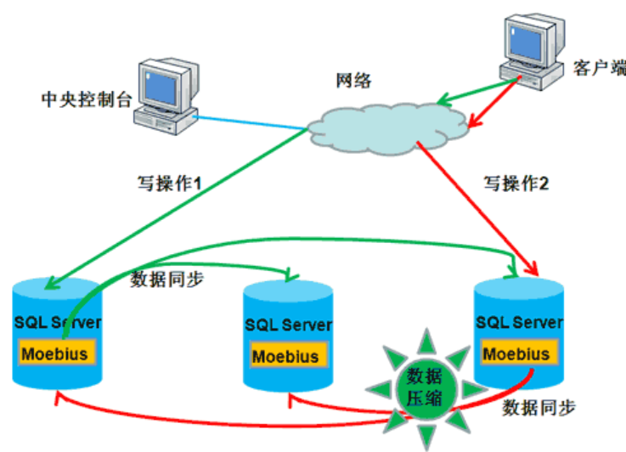
Figure 3 Load balancing cluster

- Using load balancing technology：Load balancing cluster is composed of a group of mutually independent computer systems, which are connected by conventional network or private network, and connected by routers. All nodes cooperate with each other, share load and balance pressure. For clients, the whole cluster can be regarded as an independent server with super high performance.
- Realize the read and write separation of database：Read write separation is simply to separate the read and write operations of the database, corresponding to different database servers, which can effectively reduce the pressure of the database and Io. The master database provides write operation and the slave database provides read operation. In fact, in many systems, the main operation is read operation. When the master database writes, the data should be synchronized to the slave database, so as to effectively ensure the integrity of the database.

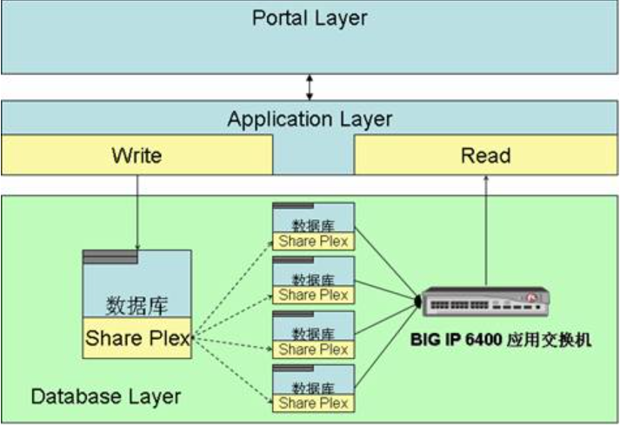
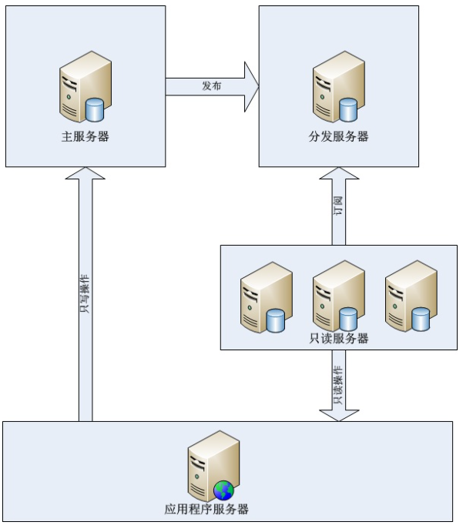
Figure 4 Overall schematic diagram

There are three types of SQL Server Replication Technology: snapshot replication, transaction replication and merge replication. SQL Server mainly uses publication and subscription to handle replication. The server where the source data is located is the publishing server, which is responsible for publishing data. The publisher copies all the changes of the data to be published to the distributor. The distributor contains a distribution database, which can receive all the changes of the data, save the changes, and then distribute the changes to the subscribers.

3、, database / data table splitting (distributed)：Through some specific conditions, the data stored in the same database is distributed to multiple databases to achieve distributed storage. The specific database is accessed through routing rules. In this way, each access is not faced with a single server, but n servers. In this way, the load pressure of a single machine can be reduced.

References
- S. Harizopoulos, et. al., "OLTP Through the Looking Glass, and What We Found There," Proc. 2008 SIGMOD Conference, Vancouver, B.C., June 2008.
- M. Stonebraker, et. al., "The End of an Architectural Era (It's Time for a Complete Rewrite)," Proc. 2007 VLDB Conference, Vienna, Austria, Sept. 2007.
[3] B. Cooper et al, "Benchmarking Cloud Serving Systems with YCSB", ACM Symposium on Cloud Computing (SoCC), Indianapolis, Indiana, June 2010.
[4] F. Chang et al, "BigTable: A Distributed Storage System for Structured Data", Seventh Symposium on Operating System Design and Implementation, November 2006.
[5]Liu ziye. Introduction and Enlightenment of major domestic micro databases 〔 J 〕. China Statistics, 2018 (7): 35-37

