TASK 1-2
ACMA4013 Assignment Tasks

Student ID:2232219
Course Name: Skills Development in Workplace
Course Code: ACMA4013
Date: 13/06/2023

Task 1: Mind Map:
In this Task, I provide a brief explanation of how the concepts covered in Unit One of the module are interconnected and how they can contribute to the development of a project idea.
- How Innovation Changes the World: Innovation is the driving force behind progress and positive change. By developing new ideas and technologies, we can tackle global challenges and improve the quality of life for people around the world. This topic covers the ways in which innovation has changed the world and how it continues to do so. It discusses the importance of innovation in driving progress and improving the quality of life. This topic can inspire project ideas that aim to address current global challenges and make a positive impact on society.
- Who Am I? My Sense of Self: Understanding our identity and values is crucial in developing project ideas that align with our personal beliefs and goals. By exploring our own identity, we can identify areas of interest and develop projects that are meaningful and fulfilling. This topic explores the concept of self-identity and how it shapes our behavior and decisions. It also discusses the role of cultural and social factors in shaping our identity. Understanding one's identity can help in developing project ideas that align with one's values and beliefs.
- Addressing Sustainability: Sustainability is essential for preserving our planet and ensuring a better future for all. By promoting sustainable practices and reducing our environmental impact, we can make a positive impact on our communities and the world. This topic covers the importance of sustainability in preserving the environment and ensuring a better future for all. It discusses the ways in which individuals and organizations can contribute to sustainable development. Project ideas that aim to promote sustainable practices and reduce environmental impact can be developed based on this topic.
- Making Statements: Effective communication is key to promoting and advocating for our project ideas. By developing clear and concise statements, we can effectively convey our ideas to others and influence positive change. This topic covers the importance of making clear and concise statements to convey ideas effectively. It discusses the role of language and communication in expressing ideas and influencing others. Developing effective communication skills can help in promoting and advocating for project ideas.
Mind Map:

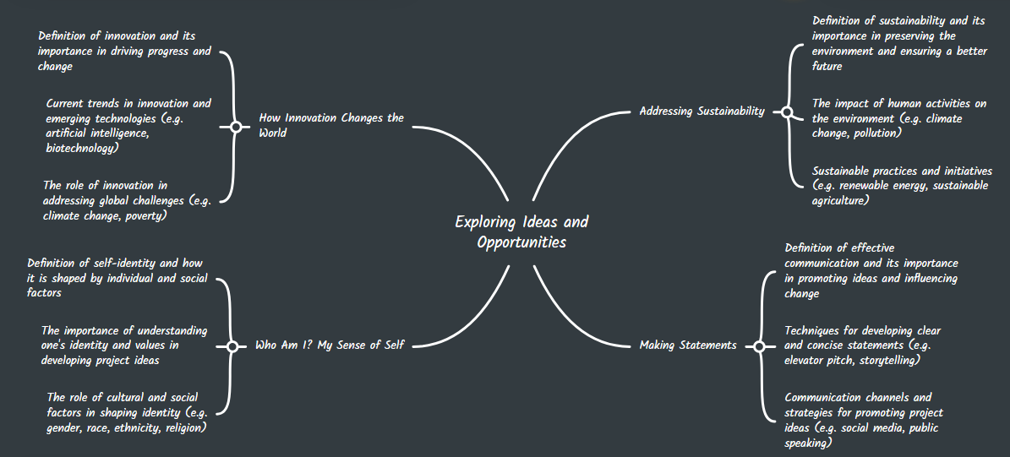

References:
Construction Industry Training Board (CITB). (2021). Digital skills in construction. Retrieved from https://www.citb.co.uk/about-citb/strategy-and-vision/digital-skills-in-construction/
Mind Meister. (n.d.). Mindmeister.com. Retrieved from https://www.mindmeister.com/

