


Wireless Networks

WC November 9, 2015

Faculty of Applied Design and Engineering
School of Applied Computing
Mount Pleasant Campus
Swansea
SA1 6ED

- INTRODUCTION AND OBJECTIVES OF THE Exercises
In the lecture, you learnt about Wireless LAN Technologies and Topologies which is an essential factor in understanding wireless communications. Apply your understanding and knowledge from what you learnt in the lecture about the topic by answering the following:

Use your lecture notes, library databases and/or the Internet to answer the questions.

- With the aid of diagram explain the wireless topologies

- You are ask to be in charge of a new WLAN that will be setup for a newly form company. Outline the requirements to be considered before the WLAN can be configured. Also describe the 802.11 topology mode that is appropriate for the WLAN design.

- Explain the three main category of Wireless LAN Technology and do a comparison of them.

- Use diagrams to illustrate and discuss the difference between Ad hoc and infrastructure topologies for WLAN (802.11)

- Explain the following terms and use diagrams where appropriate
  - Access Point
  - Extended Service Area
  - Service Set Identifiers
  - Roaming issue

- Discuss why a repeater is necessary.

- Explain your understanding of the diagrams below as it relates to WLAN
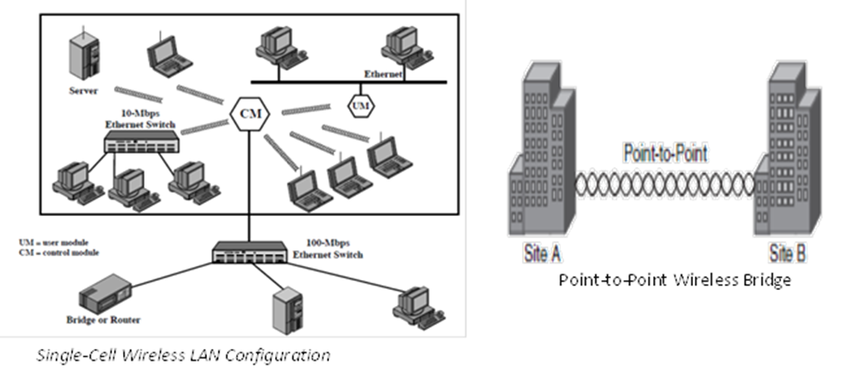

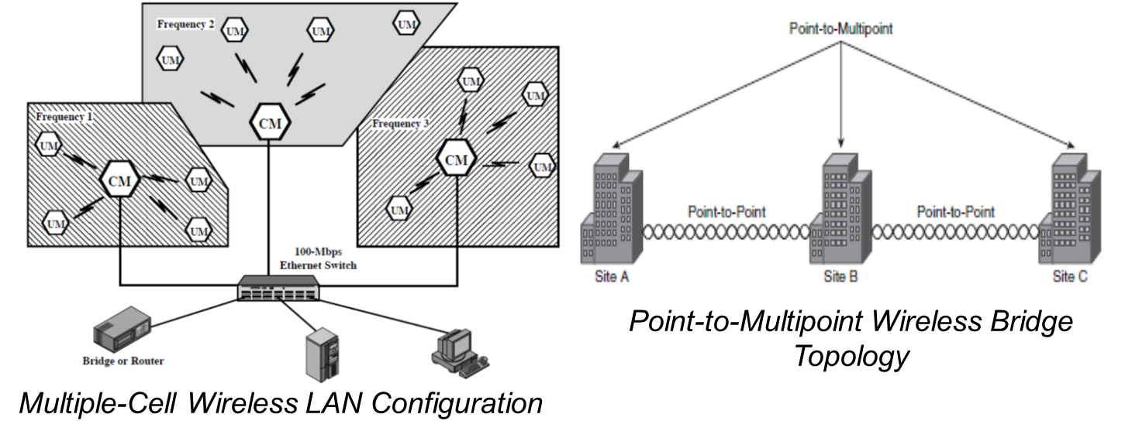

- Why a wireless mesh solution suitable for a company instead of a point to multipoint solution. Justify your answer.

- In your opinion, what is the pros and cons of using a vendor specific topology?

