

Research Methods and Professional Development
ACFA7004

Research Proposal
Analysing and Combating Deepfake Technology

Submitted to: Chris House
Submitted by: Anthony Smith 1704559

MSc Software Engineering
Semester 2

Abstract
The manipulation of videos known as deepfake has become increasingly adverse with the public, due to implications involving security, deception and public welfare. The aim of this proposed project is to create a fully functioning software application that will enable users to detect forms of manipulations, that have been inserted into certain digital media types. To ensure this plan was credible, research in to the historical nature of manipulations had to be carried out to gain a better understanding of the advancements made by present deepfake technology. The research process also required the investigation into comparable detection software currently in use or in the development stage. The outcome of this study allowed viable choices to be made dependant on which system produced more accurate results. The preferred approach would be to implement pixel correlation utilising neural network algorithms. However, further research into several other detection models will be required before development can occur, to ensure the chosen system is acceptable.

Table of Contents
Abstract 1
1. Introduction 3
1.1 Aims and objectives 3
1.2 The History of photo manipulation 3
1.3 What is deepfake? 5
1.3.1 Consequences of Deepfaking 6
2. Literature review on current studies 6
2.1 Manipulation detection and prevention 7
2.1.1 Blockchain 7
2.1.2 AI vs AI 7
2.1.2.1 DeepVision detection 8
2.1.2.2 Expectation maximization algorithm 8
2.1.2.3 future AI research topics 8
2.1.3 Microsoft detection 8
2.1.4 RAW 8
3.Design Proposal 9
3.1 Ideation 10
3.2 Comparable and Opposing technology 11
4. Methodology 12
4.1 Development Methodology 13
4.2 Research methods 14
4.3 Implemented Software 14
5.Conclusion 15
6.Appendix 16
Appendix A – GDPR (General Data Protection Regulation) 17
Appendix B – Ethics form 18
References 35

1. Introduction
The Manipulation of photographic images has been in existence since its introduction in the mid-19th century. The innocence of a picture caught in time had been taken away, only decades after the originator of photography Joseph Nicéphore Niépce captured the first image in 1826 [1]. However, with the birth of digital media, manipulations of photographs and moving images became increasingly simpler and more commonplace. As computer technology within the home increased in popularity and huge advancements in hardware and software were made, the possibilities on media control were endless. Digital photography made the access to photo images quicker, allowing users on a non-professional level to instantly download pictures and employ simply to use editing software. The latest movies that are available to consumers, can be made entirely of computer generated graphics or fabricate an illusion by utilising chroma key applications and photoshopping. The overall aim of digital media manipulations are to leave the standard observer unable to distinguish between what is real and what is not. Although enhancements to digital media can have a positive outcome, it is crucial that both real and its simulated counterpart can be severalised. As the manipulation techniques become more sophisticated due to superior performance in software, the threat of misuse becomes increasingly more probable. However, preventing individuals from abusing such advantages in technology would be futile, but creating awareness to the modifications so realistic that the naked eye is unable to tell the difference, can be achieved by implementing detection methods.

1.1 Aims and objectives
To achieve a satisfactory conclusion to the chosen project, the overall aim is to create a fully functioning software application that will enable users to detect forms of manipulations, that have been inserted into certain digital media types. The outcome will require the completion of certain objectives to ensure an in-depth analysis has been carried out to the highest standards.
Objectives:
- Examine current and historical research to gain a better understanding of the implementation and detection behind Deepfake manipulations.
- Create code that will produce satisfactory results through robust testing.
- Evaluate the effects of deepfake and produce tangible evidence that such software is required.

1.2 The History of photo manipulation
The way in which the manipulation of images could be achieved, has significantly changed since the first conceived alterations were made back in the 19th century. Louis-Jacques-Mandé Daguerre invented a silver-coated copper sheet that was inserted into a camera, which relied on a long exposure to create the image. The exposure would take so long, the subjects could not refrain from blinking. This would result in many of the pictures containing subjects with closed eyes, and to remedy this, the eye pupils would be scratched into the photo plate. In 1841 William Talbot and Calvert Jones discovered that modifications could be made to an image in a highly naïve manner. Any changes that were required would simply be painted out of the image by using Indian ink on the negative. Over the decades that followed, new photo processes and updated systems would allow the photographer to manipulate photographs in several ways:
- The invention of wet plate and gelatin-silver processes would employ glass negatives for the development process. Experienced artists would use the etching method to lighten certain sections of an image. A surgeon’s scalpel would be scratched over the dark areas of the glass negative to give the illusion of light. Graphite pencils would then be utilised to create dark areas.
- Flexible film (the negatives available today) became popular after 1913 and were retouched using paint or a turpentine-based resin. Both systems would improve facial complexions, alter exposure, and remove unwanted details. Any changes that were deemed errors could also be removed from the negative easily.
- Alternations made in the 1930’s employed a retoucher machine which used backlighting and a vibration to the negative, while the artist smoothed out any imperfections with a pencil (fig 1.1 - 1.2).
- More common practises in the mid to late 20th century utilised developing enlargers that would use the dodge and burn technique to alter the exposure and sharpness on an image. The photographer would scrutinise the original photo and mark the image with the required changes. The negative would then be put through the developing process again but this time using dodging to over expose certain areas by blocking enlarger light. The Burning process darkens areas by allowing more light to penetrate the print (fig 1.3 – 1.4) [2] [3].

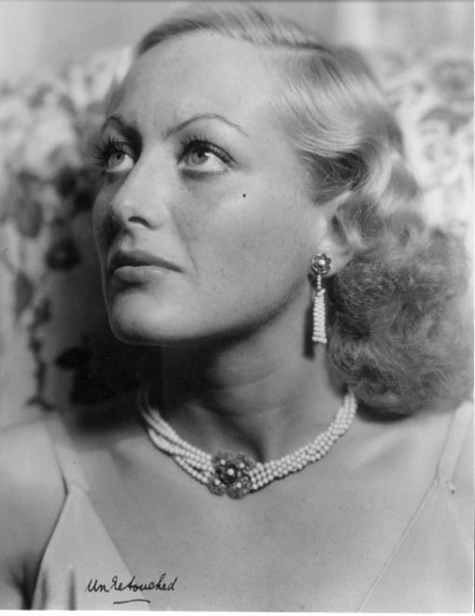
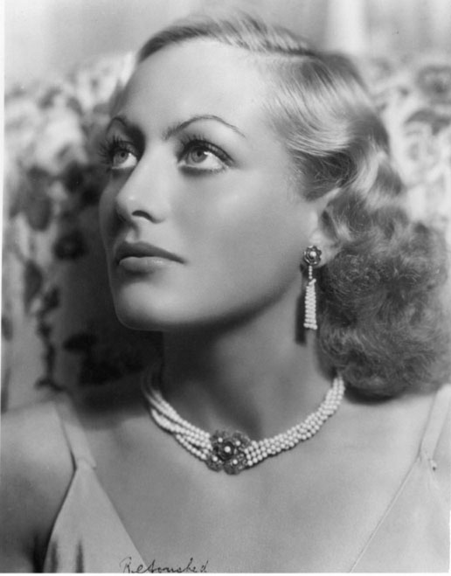

(Fig 1.1 – 1.2) Before (L) after (R) Images of Joan Crawford created by the retoucher machine [4].

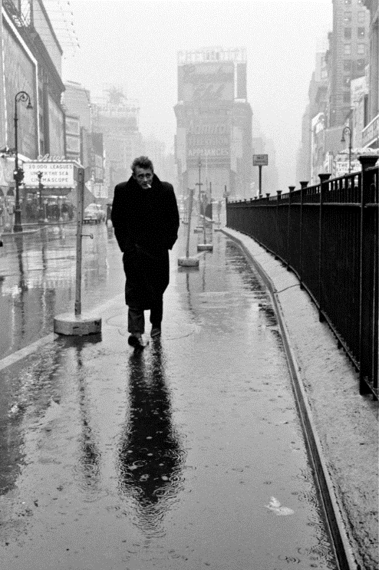
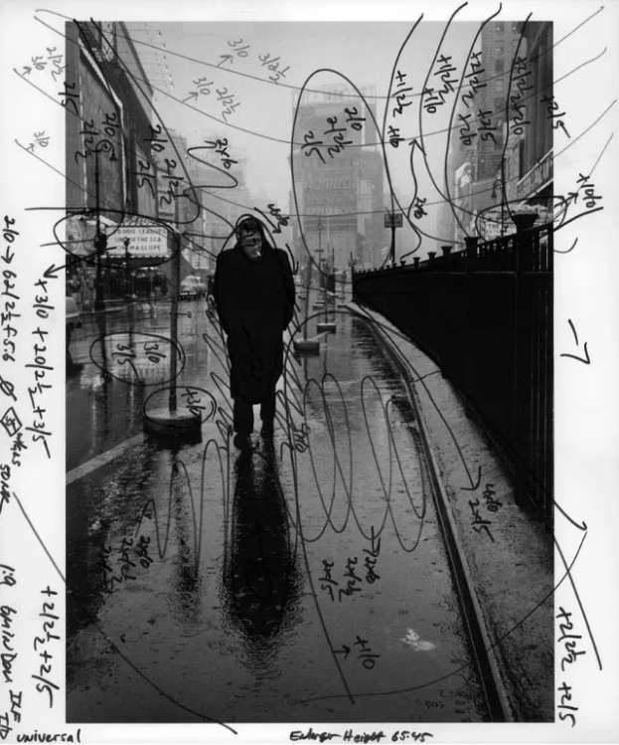

(Fig 1.3) original photograph (L) taken of James Dean shows required alterations [2].
(Fig 1.4) The Final Manipulated photograph (R) of James Dean [2].

- To manually remove a subject from a photograph, a photographer would employ double exposure. This would involve the development of a second negative with the subject missing, and then placed over the first. The negatives would then go through development in the usual way to produce a manipulated image. [5] [6] [7] [8]

Over the last three decades technology has advanced into the realm of digital imagery and has enabled users, with very little photography skills to utilise computer software and create images that look authentic to the naked eye. This simplistic approach to transform digital media has given unintentional influence to a manipulation practise known as deepfake.

1.3 What is deepfake?
A term comprising of “deep learning” and “fake”, deepfake was first coined in 2017 when a member of the Reddit network community released modified images on to the Reddit website. It employs artificial intelligence to combine already existing images or video clips and integrating them into other sources of digital media. Deepfake technology is constantly evolving to the extent that is has now become nearly impossible to tell if an image has been edited. Although the main target for deepfake manipulation has been image based, thanks to modern generative models, the capabilities of synthesizing images has now expanded to speech and music. The system of deepfake relies on the input of images into the AI encoder. To produce a near authentic video, thousands of images of subject A (target) and subject B (superimposed) must be used from multiple angles to enable the encoder to study similarities and differences between the two subjects. Subsequently, the encoder compresses the images ready for transferral to the AI decoders. To create a successful fusion, the process requires two decoders that operate deep learning algorithms. The compressed images of Subject A are entered into one decoder and subject B images into the other. The features and expressions of subject B are then reconstructed over the orientation of subject A. However, this process is required for every video frame within the duration of the movie clip. Therefore, the average movie is shot using 24 FPS (frames per second) to maintain realistic motion, requiring the decoder to assess 4,320 frames in a 3 minute clip. The whole process of self-supervised deep learning is known as Generative adversarial networks (GANs), and it is showing no signs of diminishing progress in the ability to influence programming curiosities. The only dilemma is the intended practises of such software. [9] [10] [11] [12] [13] [14] [15]

1.3.1 Consequences of Deepfaking
Open-source methods to create deepfake examples have been emerging since 2017, leading to an ever increasing GANs community. Although the volume of deepfake videos online is constantly growing, the total number measured in 2018 was 14,678, almost 100% increase from the previous year (7,964) [16]. While certain cases tend to be for private use or uploaded to the public sector for amusement purposes, deepfake can be used for alternative motives.
The implementation of deepfake can have a significant impact on the way of life for so many individuals, especially those in the public eye. The unintentional results that are associated with the upload of such videos can lead to public ridicule and display the naivety of the creator. However, the potential risks generated by criminals employing deepfake applications can include fraud, bullying or intimidation and the falsifying of evidence. The exploitation of individuals that has occurred since 2017 has had a detrimental effect on privacy, reputation, politics and security. The belief that captured video and audio are a reliable source, has now dissipated [16] [17].
There are sceptical views based on the adverse impact deepfake will cause towards public opinion, especially towards political campaigns. Security and Emerging technology researcher Tim Hwang, stated in the 2018 NewScientist, that the public are not so susceptible to deepfake propaganda as some may lead the community to believe. Although the technology is getting more advanced, the message behind the fabricated video will be insufficient to fool many people [18]. Although this view held by Tim Hwang may be partly true and the public should be more cynical to what they see and hear on social media. However, like many other methods of fraud and deception that have been successful over the decades “you can fool all the people some of the time and some of the people all of the time, but you cannot fool all the people all the time” [19]. Therefore, for deception to work successfully, fooling all the people some of the time would be all that is required.
Deepfake videos will give opportunists the means to manipulate the public on many levels, whether it is falsely employing celebrity endorsements to advertise goods and services, to implementing influence in certain broadcasting media topics. Such are the consequences produced by video manipulation, there is an urgent need to distinguish genuine content from the fake subject matter. The ideal approach would be to employ computational detection, allowing the user to identify extracted features that are unique characteristics to each individual. However, there are several other visual artifacts to consider, such as pixelization, image quality and warping.

2. Literature review on current studies
Due to the US law review limiting the availability of digital images and video submitted into court, it has become increasingly more difficult to win cases utilising this type of evidence. Unless the digital media can be 100% verified, stills and video are classed as admissible in court. Although images have been tampered with since their introduction, the opportunities to manipulate digital media has vastly increased becoming more difficult to establish the accuracy and authenticity of the image.
To combat this ever growing dilemma, manufacturers and different software companies have created detection systems that will identify the validity of an image or video. Some companies have installed measures that produce a second file that is stored for authentication purposes [20].

2.1 Manipulation detection and prevention
Relevant steps to highlight the disinformation created by deepfakes were carried out by the European Union in 2019 and included in strategy guidelines published in Brussels. Although video tampering was in early infancy, the strategy relied on public engagement rather than employ a technological solution to defend against the challenges of deepfake. The Chinese government expressed no concern about deepfake and in fact, tried to utilise digitally modified video to deliver the news [21].
To combat the ever-growing issues created by the employment of deepfakes and other modified media, computer and forensic scientist have acquired tangible solutions to the problem.

2.1.1 Blockchain
Based on the demand for (POA) proof of authenticity and the ability to track and trace the source of the original image, the implementation of blockchain has been emphasized. Blockchain has the ability to record and store information that is extremely difficult to change or hack. The tamper-proof data is stored and maintained across several computers in a decentralised network. The flexibility of blockchain allows this type of system to impact many different organisations and is poised to be the way forward in future technological endeavours. For identifying modified media, the introduction of the Ethereum blockchain has been acknowledged as having the best potential to detect deepfake. Ethereum employs smart contracts that allows the capture of historical transactions made to any digital content. The premise of using blockchain is to establish the legitimacy of digital content by following a paper-trail to the original image and to the image creator. The blockchain framework relies on key features to ensure the system is successful, notably transparency, traceability and time-sequenced data logs. The source of the information required to trace the origins of the media, stems from the capture device that is employed. All image capture devices store additional ‘Metadata’ in the form of an EXIF (Exchangeable Image File) file. The stored Metadata includes capture settings, date and time of recording, and any other data the creator of the image deems necessary. An integral element of the trace will be to combine the Ethereum address of the creator and the address of the smart contract (owners information). Every captured video will then be stored on the peer to peer network using the Interplanetary File System (IPFS). The IPFS includes a unique hash address that enables the continuing security of the file along with the path to locate the stored data. Permission to access the video content is then required by the secondary party, which can be given or declined. This system is reliant on the original artist “signing up” to the Ethereum network and is based more on preventing modifications from the beginning than analysing video that has already become victim to deepfake [22] [23].

2.1.2 AI vs AI
It has been proposed that the best defence against the Artificial intelligence algorithm used to create deepfake propaganda is to fight it with another AI algorithm. Detecting variations in the digital media can be achieved in several ways by pitting AI against AI, with varying success. However, the techniques cited in this chapter refer to DNN (Deep Neural Network) and CNN (Convolutional Neural Network) algorithms.

2.1.2.1 DeepVision detection
DeepVision is an algorithm that targets particular parts of the image to identify whether it is genuine or fake. An example approach would be to analyse the eye blinking pattern of the subject who has become victim to deepfake. Eye blinking can be an ideal measurement to record, as the features of the eye can change from person to person. The voluntary and spontaneous movement of the eye is not the only factor to consider. The age, gender, health and gene factor of the subject can have a detrimental effect on the human eye. The DeepVision algorithm measures pixel anomaly of the modified video, which can include measurements of the elapsed time between blinks from the altered source. To achieve successful detection, DeepVision utilises the eye tracker algorithm known as EAR (Eye Aspect Ratio), which incorporates Convolutional neural networks (CNN). CNN has been noted as one of the best detection algorithms against deepfake and uses face alignment and metric learning to accomplish this [24].

2.1.2.2 Expectation maximization algorithm
To create deepfakes, a version of GANs is required to generate deep convolution layers. The convolutional layers contain filters that combine to produce image lines (low level features) and shapes or objects (high level features). The layers produced, differ from image to image and when two separate images are overlaid to create deepfake, the local correlation of pixels may have slight variations. By employing the EM (Expectation Maximization) algorithm, the identity of convolutional traces left by the image generation process is possible. By examining neighbouring pixel clusters, the EM algorithm along with the k-nearest neighbour classifier can successfully identify the blend between the genuine and overlaid image [25] [26].

2.1.2.3 future AI research topics
There are several other theories that rely on artificial intelligence to successfully detect deepfake to take in to consideration. However, due to certain constraints imposed on this project proposal, further research in the field of AI will be required. The author of this report would like to acknowledge the following concepts, merited for additional research:
- Neuron behaviours
- Tensor decomposition based DNN
- Aural and Oral Dynamics
- Inconsistencies in facial symmetry and colour output

2.1.3 Microsoft detection
The advancement speed in which new deepfake technology is created, becomes increasingly difficult to combat. Microsoft have announced a system that will permit hidden code to be placed into digital media, allowing any changes to be immediately flagged. This will be possible through digital fingerprints added to metadata. The fingerprints will be in the form of certificates and hash values. To detect any alterations to images, Microsoft have created a reader that resembles a browser extension and checks the fingerprint for changes. This will verify if a file is genuine and give information on the original creator [27].

2.1.4 RAW
As a means of verifying the authenticity of an image, the negative of film cameras were employed and compared to the printed image. In digital media, no such negatives exist, instead, the RAW file acts as the alternative to a film negative. The RAW file is an uncompressed image with minimal processing attributes and allows for a higher level of image detail and quality to be stored. This type of file requires bigger memory capacity due to the larger file sizes, but the image taken will display pure likeness to the subject. The compatibility of RAW to editing software is very limited, with only certain editors allowing for RAW files to be read. A practical feature of the RAW file is that a manipulated image will leave footprints enabling software such as Adobe Photoshop to reverse engineer the modified image back to the original shot. For the detection of manipulated digital imagery, this approach is ideal, however, for the purpose of authentication the user would have to choose RAW, prior to the capture of an image. Therefore, the probability of the image being taken using the jpg file format is high. The JPG file contains modifications already imposed on the image by the processor, unlike RAW which captures the natural environment (fig 1.5) [20] [28] [29].


Fig 1.5 - comparing RAW (L) and JPG (R) images [30].

3.Design Proposal
The topic of altering video content (Deepfake) appears to be a prevalent issue in the public eye in recent times, and with public concern about the ramifications caused to individuals, opportunities to rectify the issue emerge. Through current research, it is evident that certain measures have been taken to identify the discrepancies between genuine images and the deepfake. Various organisations have chosen to reduce the confusion by inserting flags in to metadata and offering legitimate information on the image. However, other software programmers have selected to decipher prefabricated material, utilising several different approaches, some of which have been identified in this report. The current tests conducted on human subjects are based on pixel correlation or biostatistics of the human face. As all the current investigations are plausible, they have inspired the author of this report to create or enhance an idea that will aid in the identification of deepfake [25] [27] [12].

3.1 Ideation
Based on pixel correlation, the hypothesis of this project proposal, is to create deepfake detection software that can analyse video images and sufficiently detect the genuine image from the altered one. The aim of the software is to produce a high detection pass rate and supply user knowledge to instantly separate authentic visual information from propaganda.
The target signal for detection is not the facial features of the subject but based on an environmental attribute that cannot be controlled. Shadows and shade occur on every single image and are also caught on the CCD (Charge-Coupled Device) sensors of a digital movie camera. As natural light changes, then so too does the shadow/shade effect caught on camera (Fig 1.6). Most cameras today have the ability to continuously frame, this is when the camera takes shot after shot for as long as is defined by the cameras ability [31]. Every shot taken within that continuous burst will contain subtle changes in exposure and display environmental influences. For Deepfake to work successfully, the software expects hundreds of photos from the same subject to be inputted into the decoder. However, every composition will have a different light structure to the next and very different to the video the images will be superimposed on to (Fig 1.7). Therefore, it is the intention of the author to identify those subtle shade differences and deem the video as fake or genuine.

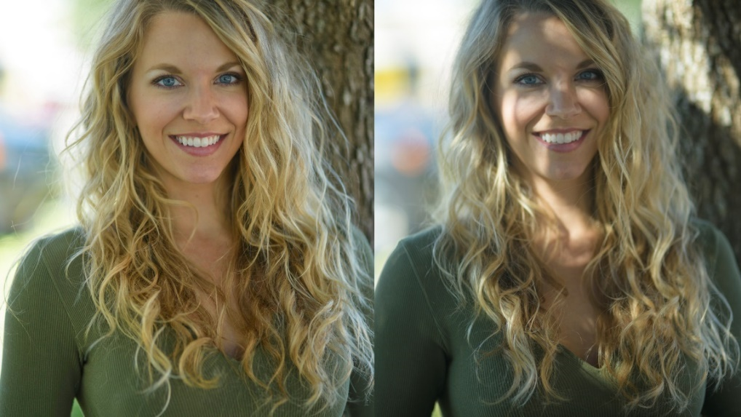

Fig 1.6 – Images shows how different consecutive images can be [32]

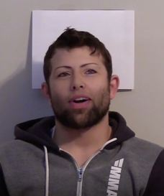
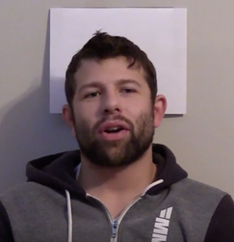

Fig 1.7 – image (L) shows original video, image (R) shows manipulated image. Notice lack of shadow detail in image [33]

3.2 Comparable and Opposing technology
To gain more of an insight into technologies that will employ similar methods of detecting deepfake, further research was conducted. The identification of opposing software would also present fundamental data, by allowing recognition to potential limitations to the proposed project.
Was highlighted in a Cornell University paper that would utilise PPG (Pixels- Photoplethysmography) to detect hidden signals within human faces. The other feature required to successfully carry out detection is auto-regressive (AR). Combined, the PPG tracks the absorption of light carried by blood cells and produces an estimation of time given by the subjects heart rate. Therefore, if the heart rate fluctuates, it can be a sign of image tampering. The AR coefficient can reflect pixel correlation which can detect unnatural smoothing generated by the superimposed face [34].
Google, MIT and the University of California have released an AI-powered shadow removal tool, that can adequately remove the harsh shadows caused by obstructions, while leaving natural shadow untouched. This is also carried out by utilising two neural networks, one to remove shadow and the other to soften the image and add a fill light. Although the harsh shadow is removed, the doctoring still relies on pixel manipulation, which can easily be identified (fig 1.8). The software tool also avoids natural shadow which can still be utilised in comparing the pixel correlation between the genuine and fake images. Therefore, this technology will have minimum bearing on the proposed project [35] [36].

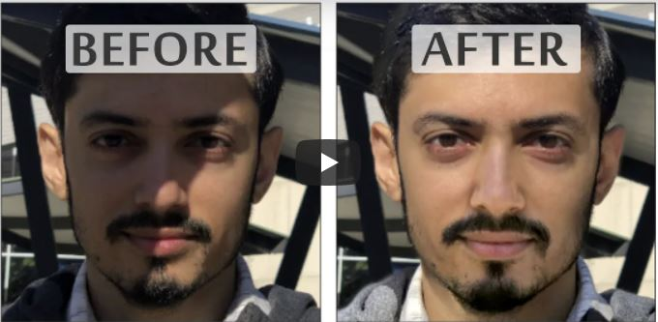
Fig 1.8 – AI-powered shadow removal tool [36].

4. Methodology
To ensure the project is achievable and completed to a realistic time frame, emphasis on time management and planning is fundamental. Throughout the key stages of the project, a Gantt chart (fig 1.9) can be utilised to assign time to the project schedule, until completion of the project. The Gantt chart is an ideal solution to help the user understand where a project has gone over time and which tasks need to be overlapped to guarantee completion [37] .

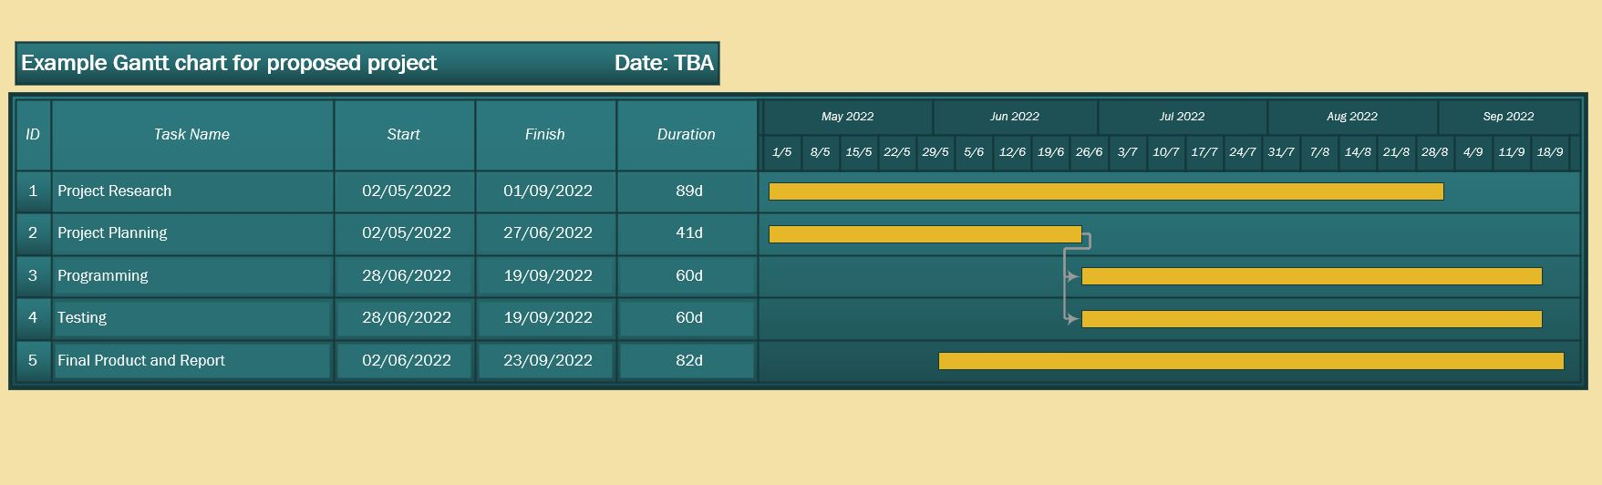
Fig 1.9 – Proposed project example of a Gantt chart.

To run concurrently with the Gantt chart, the SMART objectives will be employed. This system will assist in setting goals and objectives within the project schedule that are attainable within the specified time frame. Setting out a clear timeline will reduce procrastination and simplify the tracking of progress. If any deadlines have been overlooked, the SMART system will help improve the opportunity to get back on track.

4.1 Development Methodology
Developing software requires a process that manages the project through a product lifecycle and choosing the appropriate model depends on the project and the workforce acting upon it. As the proposed project will comprise of only one member, the apparent choice would be the Waterfall method. The Waterfall model is used to breakdown a project into sequential phases (fig 2.0), with each stage depending on the deliverables of the previous stage. It also gives the opportunity to fully research and design the project theme before advancing to the build/code phase [38]. However, elements of the Scrum methodology would be beneficial in the planning stage of the project.

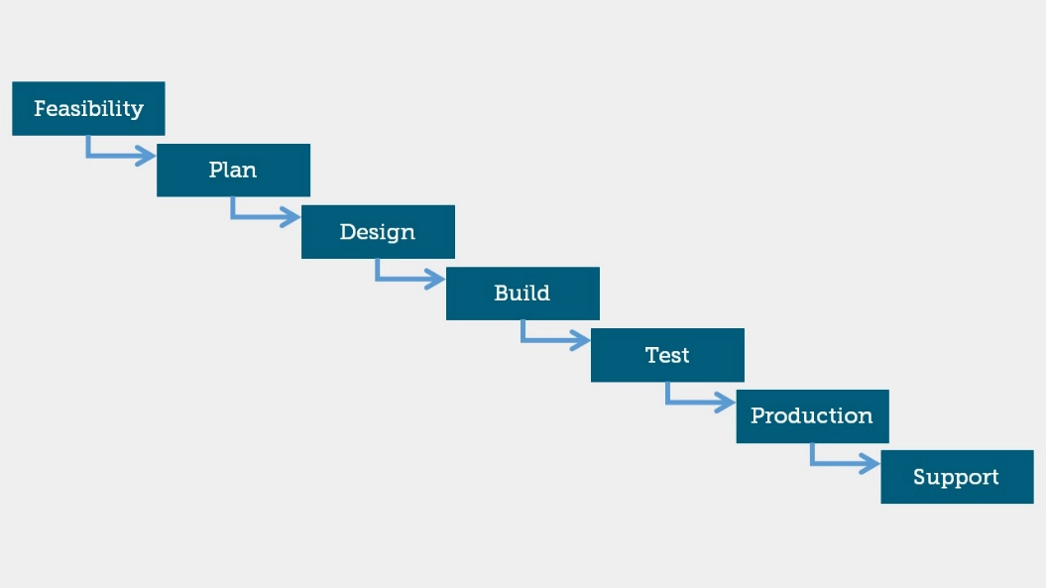

Fig 2.0 – The Waterfall method [38]


Although Scrum is a model based on team interaction and the creation of small and quick portions of work known as sprints, it is the user stories that are the most productive element of Scrum to employ. User stories highlight a general piece of information based on what software features are required (Fig 2.1).

Fig 2.1 – User Story template utilised in the Scrum methodology [39]
Written in a simplified language, the user stories can be used to remember certain tasks and can be tackled in an order of preference. To gain the advantages of implementing a project management model to the proposed project, a combination of both Waterfall and Scrum methodologies would be seen as beneficial.

4.2 Research methods
Before a product becomes available to the public, it would be pragmatic to gauge opinions and quantify the need for such a product. As deepfake does not affect every member of the public, it would be necessary to use the qualitative method of surveys and questionnaires to gather the required information. Due to current obstacles surrounding COVID, face to face communication maybe difficult, however, online resources can be utilised to access a wider audience. As the aim of the deepfake detection software requires facial examples, it may be necessary to collect visual imagery of volunteers. This will assist in further understanding the concepts involved in the chosen neural network algorithms.
The involvement of algorithms and formulae that are required to understand the potential results, will require quantitative research. Data from the subjects will need to be collected and analysed and presented in graphs. The use of charts and diagrams can aid in the understanding of the compiled data and discover patterns that can lead to code alterations or the use of different methods.

4.3 Implemented Software
The project proposal is still in the early stages of development, however, specific software that will enable the deepfake detection strategy to code successfully has been recognised. Although the employment of C++ has been the frequented coding software to date, Python has been regarded as the popular choice for artificial intelligence and machine learning. Examples for implementing Python as the language of choice are:
- Contains many libraries and frameworks to simplify coding.
- Readable code with simple syntax.
- Popular platform amongst software developers.
- Contains NumPy and SciPy for scientific calculations.
- Python projects can be integrated with other programming languages.
- Provides multiple code testing tools
Although the author has not previously used Python for any specific work, it will be a learning curve and one that will be beneficial in future coding endeavours [40] [41].
For the public to access the detection software, it will be made available through either/or a created mobile App or via a html website. This has not been fully debated as there are several factors that need to be taken in to account, such as public opinion, time frames and whether it is justifiable to create. All those questions will be answered in the planning stages of the project.

5.Conclusion
If left unchallenged, Deepfake can have a detrimental effect on integrity, trust and a major issue to political or home security. To combat the deepfake dilemma, information gathered from the research into current models of detection would allow decisions on which prognosis would be better utilised. To determine which direction to take, it was essential that the following aim and objectives of this report were considered:
Aim :- To create a fully functioning software application that will enable users to detect forms of manipulations, that have been inserted into certain digital media types.
Objectives :-
- Examine current and historical research to gain a better understanding of the implementation and detection behind Deepfake manipulations.
- Create code that will produce satisfactory results through robust testing.
- Evaluate the effects of deepfake and produce tangible evidence that such software is required.
Through the evaluation of research, three forms of detection appeared justified; pixel correlation, facial feature recognition and the implementation of blockchain. Taking in to consideration the accuracy of detection, the pixel correlation that employed the k-nearest neighbour algorithm had a successful return of 99.81% accuracy [26]. Therefore, creating software that would utilise pixel correlation which would compare shadow and shade pixel elements was the chosen algorithm.
Although the aim and objectives were not fully fulfilled, enough ground research was accomplished to create a proposed project. However, more research will need to be implemented into various other means of detection, especially into shadow pixel correlation. At present, the author of this report has been unable to find papers relating to the topic of shadow pixel correlation and has aspirations that this is a unique prospect.

6.Appendix

Appendix A – GDPR (General Data Protection Regulation)
Appendix B – Ethics Form

Appendix A – GDPR (General Data Protection Regulation)
The distribution of data has become efficient and simple due to more and more people using the internet to communicate with each other, pay financial obligations and purchase consumer goods. However, there is a continual threat to the security of transported data with the possibility of malware and other viruses attacking personal information. Data threats can occur from other means of personal interaction, not just to online transactions. Supplying information via letters and face to face communication can lead to data loss or unwanted third-party distribution [42].
The GDPR (General Data Protection Regulation) governs businesses and other parties who seek to gain data from the public domain, and how the information should be kept secure. When the data is accumulated, the purpose behind the collection must be fully disclosed to the individual. In relation to the proposed project, questionnaires and surveys will be employed to find public opinion on the dangers of deepfake. The information that will be gathered may contain personal data. However, it will be stipulated that all data will be kept secure through the process of the project and deleted once the information is no longer required. Photographs of selected subjects may also be required to test the theory behind the created code. The subject will be informed of the reasons behind the images and given the choice of whether to be involved in this section of the project or not.

Appendix B – Ethics form
APPLICATION FOR ETHICAL APPROVAL

In order for research to result in benefit and minimise risk of harm, it must be conducted ethically. A researcher may not be covered by the University’s insurance if ethical approval has not been obtained prior to commencement.

The University follows the OECD Frascati manual definition of research activity: “creative work undertaken on a systematic basis in order to increase the stock of knowledge, including knowledge of man, culture and society, and the use of this stock of knowledge to devise new applications”. As such this covers activities undertaken by members of staff, postgraduate research students, and both taught postgraduate and undergraduate students working on dissertations/projects.

The individual undertaking the research activity is known as the “principal researcher”.

Ethical approval is not required for routine audits, performance reviews, quality assurance studies, testing within normal educational requirements, and literary or artistic criticism.

Please read the notes for guidance before completing ALL sections of the form.

This form must be completed and approved prior to undertaking any research activity. Please see Checklist for details of process for different categories of application.

Delete the Guidance Notes at the end of the form BEFORE submitting your application

SECTION A: About You (Principal Researcher)
1 | Full Name: |  | Anthony Richard Smith
2 | Tick all boxes which apply: |  | Member of staff: | ☐ | Honorary research fellow: | ☐
3 | Undergraduate Student | ☐ | Taught Postgraduate Student | ☒ | Postgraduate Research Student | ☐

4 | Institute/Academic Discipline/Centre: | UWTSD Trinity St Davids
5 | Campus: | Swansea
6 | E-mail address: | 1704559@student.uwtsd.ac.uk
7 | Contact Telephone Number: | 07377 128427
 | For students:
8 | Student Number: | 1704559
9 | Programme of Study: | Software Engineering
10 | Director of Studies/Supervisor:

SECTION B: Approval for Research Activity
1 | Has the research activity received approval in principle?  (please check the Guidance Notes as to the appropriate approval process for different levels of research by different categories of individual) |  | YES | ☐ | NO | ☒
 |  |  |  |  | Date
2 | If Yes, please indicate source of approval (and date where known): Approval in principle must be obtained from the relevant source prior to seeking ethical approval | Research Degrees Committee |  | ☐
3 |  | Institute Research Committee |  | ☐
4 |  | Other (write in) |  | ☐

SECTION C: Internal and External Ethical Guidance Materials
 | Please list the core ethical guidance documents that have been referred to during the completion of this form (including any discipline-specific codes of research ethics, and also any specific ethical guidance relating to the proposed methodology). Please tick to confirm that your research proposal adheres to these codes and guidelines.
1 | UWTSD Research Ethics & Integrity Code of Practice | ☒
2 | UWTSD Research Data Management Policy | ☒
3 |  | ☐

SECTION D: External Collaborative Research Activity
1 | Does the research activity involve collaborators outside of the University? |  | YES | ☐ | NO | ☒
2 | If Yes, please provide the name of the external organisation and name and contact details for the main contact person and confirmation this person has consented to their personal data being shared.as part of this collaboration.
3 | Institution | N/A
4 | Contact person name | N/A
5 | Contact person e-mail address | N/A
6 | Has this individual consented to sharing their details on this form? |  | YES | ☐ | NO |  |  | ☒
7 | Are you in receipt of a KESS scholarship? |  | YES | ☐ | NO |  |  | ☒
8 | Is your research externally funded |  | YES | ☐ | NO |  |  | ☒
9 | Are you specifically employed to undertake this research in either a paid or voluntary capacity? | Voluntary | YES | ☐ | NO |  | ☒
10 |  | Employed | YES | ☐ | NO |  | ☒
11 | Is the research being undertaken within an existing UWTSD Athrofa Professional Learning Partnership (APLP) | If YES then the permission question below does not need to be answered. | YES | ☐ | NO |  |  | ☒
12 | Permission to undertake the research has been provided by the partner organisation | (If YES attach copy)  If NO the application cannot continue | YES | ☐ | NO |  |  | ☒

Where research activity is carried out in collaboration with an external organisation
13 | Does this organisation have its own ethics approval system? | YES | ☐ | NO | ☒
14 | If Yes, please attach a copy of any final approval (or interim approval) from the organisation

SECTION E: Details of Research Activity
1 | Indicative title: | Analysing and Combating Deepfake Technology
2 | Proposed start date: | 15 / 2 / 2022 | Proposed end date: | 29 / 3 / 2022
3 | Introduction to the Research (maximum 300 words)  Ensure that you write for a Non-Specialist Audience when outlining your response to the three points below:  - Purpose of Research Activity  - Proposed Research Question  - Aims of Research Activity  - Objectives of Research Activity  Demonstrate, briefly, how Existing Research has informed the proposed activity and explain  - What the research activity will add to the body of knowledge  - How it addresses an area of importance.
4 | Purpose of Research Activity  The purpose of the research is to ascertain the reasons and intentions of why individuals implement deepfake algorithms. The research will also identify the differences in certain media manipulations and whether photoshopping images is for recreational purposes or to infringe the privacy and security of targeted individuals. As technology has improved and software has allowed media modifications to become easier to implement, certain structures need to be recognised to allow for easier detections.  (this box should expand as you type)
5 | Research Question  The research carried out will attempt to answer the following questions:  - Can high quality, photo realistic deepfake manipulations be detected?  - Can deepfake algorithms lead to misuse and crime?  - Can facial imperfections enable deepfake detection?  - What have other researchers done to curtail the problem of deepfaking?  - What the solution to detection will be, whether it is an innovative idea or approving a system already implemented.  - Is the solution to detecting media manipulations constructive and beneficial?  - Who will gain from deepfake detection and why?  (this box should expand as you type)
6 | Aims of Research Activity  The aim of the overall project is to create and test detection software that will produce evidence of manipulated video or still imagery. This will be possible through the examination of previously created software and research carried out by others. To further reinforce the demand to expose media fabrication, the author of the report will examine software applications that supply the tools for deepfaking.  (this box should expand as you type)
7 | Objectives of Research Activity  The main objective of research is to obtain a working body of code that will aid in the identification of manipulated digital media. In addition to the code, further knowledge gained by the research required to complete the project will inspire further research possibilities and assist in discovering unknown concepts. On completion, a desired outcome would be to allow additional questions to consistently emerge that supports the evolution of the product and help the creator to gain further knowledge and understandings.  (this box should expand as you type)
8 | Proposed methods (maximum 600 words)  Provide a brief summary of all the methods that may be used in the research activity, making it clear what specific techniques may be used. If methods other than those listed in this section are deemed appropriate later, additional ethical approval for those methods will be needed.
9 | To carry out the required research needed to successfully complete the project, time management is an important factor of the research structure. The use of Gannt charts to meticulously plan each section of the project will be utilised to ensure time frames are achieved. The S.M.A.R.T objectives will also be employed to provide guidance towards specific goals and define parameters that are needed to guarantee a positive outcome. The Waterfall project management framework will be selected to encompass the work plan. As an individual working solely on the project, certain steps will need to be completed before it is possible to move to the next stage of the project. Working to a linear strategy is more logical as careful planning of each task is necessary, due to the lack of team support.  Regarding the research methods that will be employed to gather the data required for analyse will be a combination of both quantitative and qualitative sources. To research outcomes produced by neural network testing, graphs and tables would be better utilised to explain those findings. On completion of the code, tests and measurements will be carried out to define the results as successful or a failure. Gauging public opinion on the impact of deepfaking can be an ideal way to measure the need for such detection and whether the effects of manipulation will / can hinder lives. This will require the collection of specific information, developed in the form of a questionnaire. The questionnaire can either be a Likert scale or multiple choice. However, open-ended questions allow the respondents to supply actual opinions instead of being influenced by the questioner to a certain answer. To produce satisfactory results from the survey, it would require many respondents to supply information, and this can be achieved by employing online applications such as google forms or SurveyMonkey. The participants of the study would be narrowed down to Facebook friends and family and / or students and lecturers from UWSTD Trinity St Davids Swansea campus. Other methods of data collection will include case studies using volunteers to test the software, and any other non-human-input tests carried out on the code. All respondents will be over the age of 18 and will be required to sign a permission document, allowing the gathered data to be used.  After the theoretical research has been completed and considerable knowledge on the subject has been ascertained, research and choices will need to be made into the application tools that will be used to create the code. Neural networks will be playing a significant role in creating deepfake detection software especially with the involvement of GANs (Generative Adversarial Networks). C++ will be one to research, however, Python comprises of multiple libraries and frameworks that includes NumPy, SciPy and TensorFlow. Those specific libraries are utilised in scientific calculations and are essential for machine and deep learning projects. Although Python has been identified as an easier language to use and has several other benefitting characteristics like simple syntax and testing without implementation, there are still concerns. It is a software that has never been exploited before by the author of the research proposal and will require learning as the project progresses. However, further research into other programming software will be made to ensure the right application is applied to the project.  (this box should expand as you type)

10 | Location of research activity  Identify all locations where research activity will take place.
11 | - Swansea  - Carmarthen  (this box should expand as you type)
12 | Research activity outside of the UK  If research activity will take place overseas, you are responsible for ensuring that local ethical considerations are complied with and that the relevant permissions are sought. Specify any local guidelines (e.g. from local professional associations/learned societies/universities) that exist and whether these involve any ethical stipulations beyond those usual in the UK (provide details of any licenses or permissions required). Also specify whether there are any specific ethical issues raised by the local context in which the research activity is taking place, for example, particular cultural and/or legal sensitivities or vulnerabilities of participants.
13 | N/A  (this box should expand as you type)

14 | Use of documentation not in the public domain: Are any documents NOT publicly available? | NO | ☒
14 |  | YES | ☐
15 | If Yes, please provide details here of how you will gain access to specific documentation that is not in the public domain and that this is in accordance with prevailing data protection law of the country in question and England and Wales.  N/A  (this box should expand as you type)

SECTION F: Scope of Research Activity
1 | Will the research activity include: | YES | NO
2 | Use of a questionnaire or similar research instrument? | ☒ | ☐
3 | Use of interviews? | ☐ | ☒
4 | Use of diaries? | ☐ | ☒
5 | Participant observation with their knowledge? | ☒ | ☐
6 | Participant observation without their knowledge? | ☐ | ☒
7 | Use of video or audio recording? | ☒ | ☐
8 | Access to personal or confidential information without the participants’ specific consent? | ☐ | ☒
9 | Administration of any questions, test stimuli, presentation that may be experienced as physically, mentally or emotionally harmful / offensive? | ☐ | ☒
10 | Performance of any acts which may cause embarrassment or affect self-esteem? | ☐ | ☒
11 | Investigation of participants involved in illegal activities? | ☐ | ☒
12 | Use of procedures that involve deception? | ☐ | ☒
13 | Administration of any substance, agent or placebo? | ☐ | ☒
14 | Working with live vertebrate animals? | ☐ | ☒
15 | Other primary data collection methods, please explain in this box  For example, ‘focus groups’. Please indicate the type of data collection method(s) in this box and tick the accompany box. | ☐ | ☒
16 | Details of any other primary data collection method:  N/A  (this box should expand as you type) | ☐ | ☒
If NO to every question, then the research activity is (ethically) low risk and may be exempt from some of the following sections (please refer to Guidance Notes).

If YES to any question, then no research activity should be undertaken until full ethical approval has been obtained.

SECTION G: Intended Participants
1 | Who are the intended participants: | YES | NO
2 | Students or staff at the University? | ☒ | ☐
3 | Adults (over the age of 18 and competent to give consent)? | ☒ | ☐
4 | Vulnerable adults? | ☐ | ☒
5 | Children and Young People under the age of 18? (Consent from Parent, Carer or Guardian will be required) | ☐ | ☒
6 | Prisoners? | ☐ | ☒
7 | Young offenders? | ☐ | ☒
8 | Those who could be considered to have a particularly dependent relationship with the investigator or a gatekeeper? | ☐ | ☒
9 | People engaged in illegal activities? | ☐ | ☒
10 | Others (please identify specifically any group who may be unable to give consent) please indicate here and tick the appropriate box. | ☐ | ☒
11 | Other – please indicate here:  N/A  (this box should expand as you type) | ☐ | ☒

12 | Participant numbers and source  Provide an estimate of the expected number of participants. How will you identify participants and how will they be recruited?
13 | How many participants are expected? | Between 20 – 50 participants  (this box should expand as you type)
14 | Who will the participants be? | Facebook members, students and lecturers of UWTSD Swansea campus  (this box should expand as you type)
15 | How will you identify the participants? | A written form including name and age will be included.  (this box should expand as you type)

16 | Information for participants: | YES | NO | N/A
17 | Will you describe the main research procedures to participants in advance, so that they are informed about what to expect? | ☒ | ☐ | ☐
18 | Will you tell participants that their participation is voluntary? | ☒ | ☐ | ☐
19 | Will you obtain written consent for participation? | ☒ | ☐ | ☐
20 | Will you explain to participants that refusal to participate in the research will not affect their treatment or education (if relevant)? | ☒ | ☐ | ☐
21 | If the research is observational, will you ask participants for their consent to being observed? | ☒ | ☐ | ☐
22 | Will you tell participants that they may withdraw from the research at any time and for any reason? | ☒ | ☐ | ☐
23 | With questionnaires, will you give participants the option of omitting questions they do not want to answer? | ☒ | ☐ | ☐
24 | Will you tell participants that their data will be treated with full confidentiality and that, if published, it will not be identifiable as theirs? | ☒ | ☐ | ☐
25 | Will you debrief participants at the end of their participation, in a way appropriate to the type of research undertaken? | ☒ | ☐ | ☐
26 | If NO to any of above questions, please give an explanation
27 | N/A  (this box should expand as you type)

28 | Information for participants: | YES | NO | N/A
29 | Will participants be paid? | ☐ | ☒ | ☐
30 | Is specialist electrical or other equipment to be used with participants? | ☒ | ☐ | ☐
31 | Are there any financial or other interests to the investigator or University arising from this study? | ☐ | ☒ | ☐
32 | Will the research activity involve deliberately misleading participants in any way, or the partial or full concealment of the specific study aims? | ☐ | ☒ | ☐
33 | If YES to any question, please provide full details
34 | Relating to question 30 – camera or video footage may be required during practical testing to assist comparable results. Deepfake relies on photo or video manipulations and the same is required to detect it.  (this box should expand as you type)

SECTION H: Anticipated Risks
1 | Outline any anticipated risks that may adversely affect any of the participants, the researchers and/or the University, and the steps that will be taken to address them.  If you have completed a full risk assessment (for example as required by a laboratory, or external research collaborator) you may append that to this form.
2 | Full risk assessment completed and appended? |  | Yes | ☐
2 |  |  | No | ☒
3 | Risks to participants  For example: emotional distress, financial disclosure, physical harm, transfer of personal data, sensitive organisational information
4 | Risk to Participant:  N/A  (this box should expand as you type) | How will you mitigate the Risk to Participant  N/A  (this box should expand as you type)
5 | If research activity may include sensitive, embarrassing or upsetting topics (e.g. sexual activity, drug use) or issues likely to disclose information requiring further action (e.g. criminal activity), give details of the procedures to deal with these issues, including any support/advice (e.g. helpline numbers) to be offered to participants. Note that where applicable, consent procedures should make it clear that if something potentially or actually illegal is discovered in the course of a project, it may need to be disclosed to the proper authorities
N/A

(this box should expand as you type)
6 | Risks to investigator  For example: personal safety, physical harm, emotional distress, risk of accusation of harm/impropriety, conflict of interest
 | Risk to Investigator:  N/A  (this box should expand as you type) | How will you mitigate the Risk to Investigator:  N/A  (this box should expand as you type)
7 | University/institutional risks  For example: adverse publicity, financial loss, data protection
 | Risk to University:  N/A  (this box should expand as you type) | How will you mitigate the Risk to University:  N/A  (this box should expand as you type)

8 | Disclosure and Barring Service
9 | If the research activity involves children or vulnerable adults, a Disclosure and Barring Service (DBS) certificate must be obtained before any contact with such participants. | YES | NO | N/A
10 | Does your research require you to hold a current DBS Certificate? | ☐ | ☐ | ☒

SECTION I: Feedback, Consent and Confidentiality
1 | Feedback  What de-briefing and feedback will be provided to participants, how will this be done and when?
Information will be highlighted on the online survey for participants to read. Feedback and de-briefing will be given after the practical tests are concluded.

(this box should expand as you type)
2 | Informed consent  Describe the arrangements to inform potential participants, before providing consent, of what is involved in participating. Describe the arrangements for participants to provide full consent before data collection begins. If gaining consent in this way is inappropriate, explain how consent will be obtained and recorded in accordance with prevailing data protection legislation.
All information required will be on the survey and orally given at the time of the practical tests. If any participant requires further information, the chance of contact will be given via email address.

(this box should expand as you type)
3 | Confidentiality / Anonymity  Set out how anonymity of participants and confidentiality will be ensured in any outputs. If anonymity is not being offered, explain why this is the case.
Online surveys require log in to access the data, only the author of the research proposal will have the means to access this data. Practical tests will be carried out in a private room, whether on campus or at the authors residence.

(this box should expand as you type)

SECTION J: Data Protection and Storage
In completing this section refer to the University’s Research Data Management Policy and the extensive resources on the University’s Research Data Management web pages (http://uwtsd.ac.uk/library/research-data-management/).
1 | Does the research activity involve personal data (as defined by the General Data Protection Regulation 2016 “GDPR” and the Data Protection Act 2018 “DPA”)? | YES | NO
 | “Personal data” means any information relating to an identified or identifiable natural person (‘data subject’). An identifiable natural person is one who can be identified, directly or indirectly, in particular by reference to an identifier such as a name, an identification number, location data, an online identifier or to one or more factors specific to the physical, physiological, genetic, mental, economic, cultural or social identity of that natural person. | X
2 | If YES, provide a description of the data and explain why this data needs to be collected:
Only name and age are required

(this box should expand as you type)
3 | Does it involve special category data (as defined by the GDPR)? | YES | NO
 | “Special category data” means sensitive personal data consisting of information as to the data subjects’ –  (a) racial or ethnic origin,  (b) political opinions,  (c ) religious beliefs or other beliefs of a similar nature,  (d) membership of a trade union (within the meaning of the Trade Union and Labour Relations (Consolidation) Act 1992),  (e) physical or mental health or condition,  (f) sexual life,  (g) genetics,  (h) biometric data (as used for ID purposes), | ☐ | X
4 | If YES, provide a description of the special category data and explain why this data needs to be collected:
N/A

(this box should expand as you type)

5 | Will the research activity involve storing personal data and/or special category data on one of the following: | YES | NO
6 | Manual files (i.e. in paper form)? | ☐ | ☒
7 | University computers? | ☒ | ☐
8 | Private company computers? | ☐ | ☒
9 | Home or other personal computers? | ☒ | ☐
10 | Laptop computers/ CDs/ Portable disk-drives/ memory sticks? | ☐ | ☒
11 | “Cloud” storage or websites? | ☒ | ☐
12 | Other – specify: | ☐ | ☒
13 | For all stored data, explain the measures in place to ensure the security of the data collected, data confidentiality, including details of password protection, encryption, anonymisation and pseudonymisation:
All forms of data storage will be protected by passwords and user logins. University computers and personal computers will also contain firewalls and antivirus software for further data protection.
(this box should expand as you type)
14 | All Data Storage
15 | Will the research activity involve any of the following activities: | YES | NO
16 | Electronic transfer of data in any form? | ☐ | ☒
17 | Sharing of data with others at the University? | ☐ | ☒
18 | Sharing of data with other organisations? | ☐ | ☒
19 | Export of data outside the European Union or importing of data from outside the UK? | ☐ | ☒
20 | Use of personal addresses, postcodes, faxes, emails or telephone numbers? | ☐ | ☒
21 | Publication of data that might allow identification of individuals? | ☐ | ☒
22 | Use of data management system? | ☐ | ☒
23 | Data archiving? | ☐ | ☒
24 | If YES to any question, please provide full details, explaining how this will be conducted in accordance with the GDPR and DPA (and/or any international equivalent):
N/A

(this box should expand as you type)
25 | List all who will have access to the data generated by the research activity:
Only the author of the project

(this box should expand as you type)
26 | List who will have control of, and act as custodian(s) for, data generated by the research activity:
Only the author of the project

(this box should expand as you type)
27 | Give details of data storage arrangements, including security measures in place to protect the data, where data will be stored, how long for, and in what form. Will data be archived – if so how and if not why not.
Online survey will be stored via google forms and practical results will be stored via USB pen and kept in a lock box. Once data is used the pen will be completely formatted.

(this box should expand as you type)
28 | Please indicate if your data will be stored in the UWTSD Research Data Repository (see https://researchdata.uwtsd.ac.uk/ ). If so please explain. (Most relevant to academic staff)
N/A

(this box should expand as you type)
29 | Confirm that you have read the UWTSD guidance on data management (see https://www.uwtsd.ac.uk/library/research-data-management/) | YES | ☒
29 |  | NO | ☐
30 | Confirm that you are aware that you need to keep all data until after your research has completed or the end of your funding | YES | ☒
30 |  | NO | ☐

SECTION K: Declaration
31 | The information which I have provided is correct and complete to the best of my knowledge. I have attempted to identify any risks and issues related to the research activity and acknowledge my obligations and the rights of the participants.  In submitting this application I hereby confirm that I undertake to ensure that the above named research activity will meet the University’s Research Ethics and Integrity Code of Practice which is published on the website: https://www.uwtsd.ac.uk/research/research-ethics/
 | Signature of applicant: | Anthony Smith | Date:11/3/22

For STUDENT Submissions:
32 | Director of Studies/Supervisor: |  | Date:
33 | Signature: |  | Date:

For STAFF Submissions:
34 | Academic Director/ Assistant Dean: |  | Date:
35 | Signature: |  | Date:

Checklist: Please complete the checklist below to ensure that you have completed the form according to the guidelines and attached any required documentation:
☒ | I have read the guidance notes supplied before completing the form.
☒ | I have completed ALL RELEVANT sections of the form in full.
☒ | I confirm that the research activity has received approval in principle
☒ | I have attached a copy of final/interim approval from external organisation (where appropriate)
☐ | I have attached a full risk assessment (and have NOT completed Section H of this form) (where appropriate) ONLY TICK IF YOU HAVE ATTACHED A FULL RISK ASSESSMENT
☒ | I understand that it is my responsibility to ensure that the above named research activity will meet the University’s Research Ethics and Integrity Code of Practice.
☒ | I understand that before commencing data collection all documents aimed at respondents (including information sheets, consent forms, questionnaires, interview schedules etc.) must be confirmed by the DoS/Supervisor, module tutor or Academic Director.
☒ | I have deleted the guidance notes before submitting the PG2 for consideration

RESEARCH STUDENTS AND STAFF ONLY
All communications relating to this application during its processing must be in writing and emailed to pgresearch@uwtsd.ac.uk , with the title ‘Ethical Approval’ followed by your name.
You will be informed of the outcome of your claim by email; therefore it is important that you check your University and personal email accounts regularly.
STUDENTS ON UNDERGRADUATE OR TAUGHT MASTERS PROGRAMMES should submit this form (and receive the outcome) via systems explained to you by the supervisor/module leader.

References

[1] | H. Farid, “Digital Forensics: How Experts Uncover Doctored Images,” 2 Jun 2008. [Online]. Available: https://www.scientificamerican.com/article/digital-image-forensics/. [Accessed 2 Mar 2022].
[2] | M. Zhang, “Marked up photographs show how iconic prints were edited in the darkroom,” 12 Sep 2013. [Online]. Available: https://petapixel.com/2013/09/12/marked-photographs-show-iconic-prints-edited-darkroom/. [Accessed 27 Feb 2022].
[3] | S. Mukherjee, “Dodge, burn and other darkroom techniques,” 4 May 2020. [Online]. Available: https://www.35mmc.com/04/05/2020/dodge-burn-and-other-heresies-darkroom-technique-part-5-by-sroyon-mukherjee/#:~:text=Part%205%20is%20about%20two,by%20giving%20them%20additional%20exposure.. [Accessed 28 Feb 2022].
[4] | M. Zhang, “1900s: A portrait of Actress joan Crawford that's Photoshopped,” 17 Oct 2014. [Online]. Available: https://petapixel.com/2014/10/17/beauty-retouching-early-1900s-portrait-actress-joan-crawford-thats-photoshopped/. [Accessed 27 Feb 2022].
[5] | A. Young, “Brief History of Photography,” 2022. [Online]. Available: https://fixthephoto.com/blog/retouch-tips/history-of-photo-retouching.html. [Accessed 19 Feb 2022].
[6] | Reader's Digest, “History and usage of photomanipulation and Photoshop,” 2022. [Online]. Available: https://www.readersdigest.co.uk/lifestyle/technology/history-and-usage-of-photo-manipulation-and-photoshop. [Accessed 22 Feb 2022].
[7] | D. Brugioni, Photo Fakery, Virginia: Brassey's, 1999.
[8] | H. Farid, “Photo Tampering Throughout History,” American Academy of Forensic Sciences, 2008.
[9] | N. Giansiracusa, How Algorithms Create and Prevent Fake News, New York: Apress, 2021.
[10] | StudioBinder, “What is Frame Rate,” 1 feb 2021. [Online]. Available: https://www.youtube.com/watch?v=7lUFluLOh-s. [Accessed 4 Mar 2022].
[11] | K. Pandey, “Risks Posed by Deepfake Technology and How to Combat Them,” 26 Aug 2021. [Online]. Available: https://www.jumpstartmag.com/risks-posed-by-deepfake-technology-and-how-to-combat-them/. [Accessed 3 Mar 2022].
[12] | S. Nahavandi, M. C. Nguyen and et.al, “Deep Learning for Deepfakes Creation and Detection: A Survey,” arXivLabs, pp. 1-20, 2022.
[13] | J. Brownlee, “A Gentle Introduction to Generative Adversarial Networks (GANs),” 17 Jun 2019. [Online]. Available: https://machinelearningmastery.com/what-are-generative-adversarial-networks-gans/. [Accessed 5 Mar 2022].
[14] | N. Dufour, “Contributing Data to Deepfake Detection research,” 24 sept 2019. [Online]. Available: https://ai.googleblog.com/2019/09/contributing-data-to-deepfake-detection.html. [Accessed 5 Mar 2022].
[15] | E. Perot and f. Mostert, “Fake ot till you make it: an examination of the US and English approaches to persona protection as applied to deepfakes on social media,” Journal of intellectual Property Law and Practise, vol. 15, no. 1, pp. 1-8, 2020.
[16] | H. Ajder, L. Cullen and et.al, “The State of Deepfakes,” deeptracelabs, Amsterdam, 2019.
[17] | panda mediacenter, “Deepfake fraud: Security threats Behind Artificial Faces,” 10 Aug 2021. [Online]. Available: https://www.pandasecurity.com/en/mediacenter/technology/deepfake-fraud/. [Accessed 5 Mar 2022].
[18] | T. Hwang, “A Vote Against Deepfakes,” NewScientist, vol. 239, no. 3190, pp. 22-23, 2018.
[19] | T. F. Schwartz, “"You can Fool All of the People" Lincoln never said that,” 2022. [Online]. Available: https://abrahamlincolnassociation.org/you-can-fool-all-of-the-people-lincoln-never-said-that/#:~:text=Undoubtedly%20the%20most%20famous%20utterance,Lincoln%20delivered%20in%20Clinton%2C%20Illinois.. [Accessed 6 Mar 2022].
[20] | M.-H. Maras and A. Alexandrou, “Determining authenticity of video evidence in the age of artificial intelligence and in the wake of Deepfake videos,” The international journal of Evidence and proof, pp. 1-8, 2018.
[21] | C. Stanton, “How Should Counties Tackle Deepfakes?,” in Carnegie Endowment for International Peace, Washington, 2019.
[22] | H. R. Hasan and K. Salah, “Combating Deepfake Videos Using Blockchain and Smart Contracts,” IEEE Access, pp. 1-11, 18 Mar 2019.
[23] | Ethereum, “what is Ethereum?,” 2022. [Online]. Available: https://ethereum.org/en/what-is-ethereum/. [Accessed 9 Mar 2022].
[24] | S. Kim, T. Jung and et.al, “DeepVision: Deepfakes detection using human eye blinking pattern,” IEEE Access, pp. 1-13, 15 May 2020.
[25] | L. Guarnera, O. Giudice and et.al, “DeepFake Detection by Analyzing Convolutional Traces,” IEEE Conference on Computer Vision and Pattern Recognition Workshops, pp. 1-10, 2020.
[26] | R. Tolosana, J. Fierrez, A. Morales and et.al, “Deepfakes and Beyond: A survey of face Manipulation and Fake Detection,” Information Fusion, 2020.
[27] | L. Kelion, “Deepfake detection tool unveiled by Microsoft,” bbc, 1 Sep 2020. [Online]. Available: https://www.bbc.co.uk/news/technology-53984114. [Accessed 10 Mar 2022].
[28] | Adobe, “Raw files,” 2022. [Online]. Available: https://www.adobe.com/creativecloud/file-types/image/raw.html#:~:text=A%20RAW%20file%20is%20the,file%20sizes%20and%20lossless%20quality.. [Accessed 7 Mar 2022].
[29] | N. Mansurov, “Raw vs JPEG - which image format is better and why?,” 25 Apr 2020. [Online]. Available: https://photographylife.com/raw-vs-jpeg#:~:text=A%20RAW%20image%20(also%20known,from%20a%20digital%20camera's%20sensor.. [Accessed 7 Mar 2022].
[30] | Adobe, “When to use RAW vs JPEG,” 2022. [Online]. Available: https://helpx.adobe.com/uk/lightroom-cc/how-to/raw-vs-jpeg.html. [Accessed 7 Mar 2022].
[31] | J. Adams and A. James, “What are burst modes and continous shooting,” Digital Camera world, 2021.
[32] | Vanelli, “Removing harsh shadows using natural light,” 29 Nov 2018. [Online]. Available: https://photofocus.com/photography/removing-harsh-shadows-using-natural-light/. [Accessed 11 Mar 2022].
[33] | M. Groh, “Detect DeepFakes: How to counteract misinformation created by AI,” 2022. [Online]. Available: https://www.media.mit.edu/projects/detect-fakes/overview/. [Accessed 11 Mar 2022].
[34] | M. Mao and J. Yang, “Exposing Deepfake with Pixel-wise AR and PPG Correlation from Faint Signals,” Cornell University arxiv, pp. 1-9, 2021.
[35] | R. Pandey, R. Ng, D. E. Jacobs and et.al, “Portrait Shadow Manipulation,” ACM Transactions on Graphics, vol. 39, no. 4, 2020.
[36] | D. L. Cade, “This AI automatically removes harsh shadows from your portraits,” 24 Aug 2020. [Online]. Available: https://petapixel.com/2020/08/24/this-ai-automatically-removes-harsh-shadows-from-your-portraits/. [Accessed 13 Mar 2022].
[37] | Gantt.com, “What is a Gantt chart?,” 2022. [Online]. Available: https://www.gantt.com/. [Accessed 15 Mar 2022].
[38] | J. Bowes, “Agile vs Waterfall: comparing projectmanagement methods,” 17 Jul 2014. [Online]. Available: https://manifesto.co.uk/agile-vs-waterfall-comparing-project-management-methodologies/. [Accessed 15 Mar 2022].
[39] | S. Madan, “Done Understanding the definition of done,” 16 Dec 2019. [Online]. Available: https://www.scrum.org/resources/blog/done-understanding-definition-done. [Accessed 17 Mar 2022].
[40] | L. Ogoti, “Why Python is good for machine Learning,” 4 May 2021. [Online]. Available: https://www.section.io/engineering-education/why-python-is-good-for-machine-learning/#:~:text=Simplicity%3A%20Python%20code%20is%20concise,compared%20to%20many%20programming%20languages.. [Accessed 18 Mar 2022].
[41] | P. Morgan, Data Analysis from Scratch with Python, AI Sciences, 2016.
[42] | GOV.UK, “Data Protection and your Business,” 2022. [Online]. Available: https://www.gov.uk/data-protection-your-business. [Accessed 22 Mar 2022].

