Appendices

- Ethics form completed prior to this author’s research.

APPLICATION FOR ETHICAL APPROVAL

In order for research to result in benefit and minimise risk of harm, it must be conducted ethically. A researcher may not be covered by the University’s insurance if ethical approval has not been obtained prior to commencement.

The University follows the OECD Frascati manual definition of research activity: “creative work undertaken on a systematic basis in order to increase the stock of knowledge, including knowledge of man, culture and society, and the use of this stock of knowledge to devise new applications”. As such this covers activities undertaken by members of staff, postgraduate research students, and both taught postgraduate and undergraduate students working on dissertations/projects.

The individual undertaking the research activity is known as the “principal researcher”.

Ethical approval is not required for routine audits, performance reviews, quality assurance studies, testing within normal educational requirements, and literary or artistic criticism.

Please read the notes for guidance before completing ALL sections of the form.

This form must be completed and approved prior to undertaking any research activity. Please see Checklist for details of process for different categories of application.

SECTION A: About You (Principal Researcher)

Full Name: |  |  | Naomi Elspeth Fiddy
Tick all boxes which apply:
Member of staff: | ☐ | Student: |  |  | Honorary research fellow: | ☐

Faculty/School/Centre: | SWWCTE: Yr Athrofa
Campus: | Carmarthen
E-mail address: | 1502459@student.uwtsd.ac.uk
Contact Telephone Number: | 07341850075
For students:
Student Number: | 1502459 | Undergraduate
Programme of Study: | BA Primary Education (QTS) | Taught Postgraduate | ☐
Director of Studies/Supervisor: | Dr Sioned V Hughes | Research | ☐

SECTION B: Approval for Research Activity

Has the research activity received approval in principle?  (please check the Guidance Notes as to the appropriate approval process for different levels of research by different categories of individual) |  | YES |  | NO | ☐
 |  |  |  | Date
If Yes, please indicate source of approval (and date where known): | Research Degrees Committee |  | ☐
 | Faculty Research Committee |  | ☐
 | Other: Module Coordinator, ECAD6003, ITET |  |  | 08.02.2019
Approval in principle must be obtained from the relevant source prior to seeking ethical approval.

SECTION C: External Ethical Guidance Materials

Please list the core ethical guidance documents that have been referred to during the completion of this form (including any discipline-specific codes of research ethics, and also any specific ethical guidance relating to the proposed methodology). Please tick to confirm that your research proposal adheres to these codes and guidelines.
The research is within the bounds of the normal classroom and in accordance with the SWWCTE school guidelines for parental consent as per SWWCTE letter
The research will be conducted within BERA (British Educational Research Association) guidelines – Ethical Guidelines for Educational Research, 2018
The research will adhere to the University research guidelines

SECTION D: External Collaborative Research Activity

Does the research activity involve collaborators outside of the University? |  | YES | ☐ | NO
If Yes, please provide the name of the external organisation and name and contact details for the main contact person:
Institution
Contact person name
Contact person e-mail address

Where research activity is carried out in collaboration with an external organisation
Does this organisation have its own ethics approval system? | YES | ☐ | NO
If Yes, please attach a copy of any final approval (or interim approval) from the organisation

SECTION E: Details of Research Activity

Indicative title: | An exploration into the contribution of metacognition in the development of a growth mindset and resiliency within children, and the effect that this has on their learning.
Proposed start date: | 11.02.2019 | Proposed end date: | 29.04.2019
Purpose of research activity (including aims and objectives)
Outline the purpose, aims and objectives of the research activity, including key research questions. Show briefly how existing research has informed the proposed activity and explain what the research activity will add and how it addresses an area of importance. (Maximum 300 words)
- The purpose of the research activity is to explore whether using metacognition as a tool in changing children’s attitudes to learning has an effect in children’s ability to persevere with tasks that they find challenging.
- I also aim to explore whether these strategies may have any impact on a child’s overall resiliency, whilst also taking into account the vast range of factors that may also influence this, e.g. stable relationship with an adult, peer relationships, community support, cultural engagement. I will explore how a growth mindset forms one component of resiliency, and whether improving this through the use of metacognition will be sufficient in making a substantial difference to a child’s resilience.
- One author that has informed my research within this area is Carol Dweck, 2006 and her research into the development of a growth mindset. Hughes (2018) and the Welsh Government (2010) have also produced key documents that have supported my initial enquiry into resiliency in children.
- Case studies have also influenced the focus of my research. A particular case study that has been of interest is Ysgol Coed Eva’s case study, as displayed on Estyn’s website as an example of effective practice. Within this school they utilise metacognition characters to promote resiliency and a growth mindset within their pupils, with positive results being shown from such an approach. I would like to explore whether this approach in itself is adequate in achieving long term positive effects within this area.
- De Bono’s thinking hats, as a metacognition strategy has also been of interest, in particular whether the yellow hat (for positivity) may be used as a means of promoting a positive attitude to overcoming challenges.
Proposed methods
Provide a brief summary of all the methods that may be used in the research activity, making it clear what specific techniques may be used. If methods other than those listed in this section are deemed appropriate later, additional ethical approval for those methods will be needed. (Maximum 600 words)
Interviews – children from FP and KS2 may be involved in a semi-structured interview where they will be invited to respond to key questions. For example: The children will be in an informal setting and I will make a note of their responses. The children will not be forced into participating and no direct individual questioning will take place if a child does not wish to respond. EXIT: The children will have an exit strategy (traffic light fans, emojis) and if at any point they wish to leave the interview or withdraw then they may do so. I will check on the children’s feelings regularly. No names will be used in the writing.
I will interview teachers across both phases and members of the leadership team to see what strategies they use to support resiliency or the development of a growth mindset in learners, and what measures they use to assess the effectiveness of such approaches.

Observations / Field Notes – I will observe teachers and pupils as they undertake tasks. I will observe the strategies teachers use to support pupils in persevering when faced with challenges and note the impact on the students. I will also observe what strategies are used to promote resilience in pupils, including those that aim to impact upon a child’s overall wellbeing. Notes will be kept in my observational book / diary. Once again, no names shall be mentioned however, a pseudonym may be used if necessary. To further enhance my research, I may discuss my notes with the children or teachers to gather a more detailed perspective or explanation for certain actions or attributes displayed. On occasions, I may observe participants without their knowledge and make notes on their attitudes and behaviour.

Video or Audio Taping – I may record children undertaking tasks in certain situations in order to observe their approaches in overcoming these challenges. These may include recording them as they attempt to solve a difficult puzzle or other challenging learning tasks that I believe will contribute towards my research project. Video or audio taping will be used during group or individual interviews (with the interviewees prior permission) and later used to contribute to my discussion and synthesis. Recording of good practice or interviews with teachers and other members of staff may also be gathered to contribute towards the research project. Prior to recording any research participant, I will gather their permission initially and act in an ethical manner throughout. Exit: Children and teachers will not be forced to participate or respond to questions. Staff and children will be informed they can request recording to stop at any time without providing notice.

Questionnaire - Depending on the responses of children and staff throughout the research period, I may create and administer a questionnaire if I believe this will assist me to gather quality data. Throughout the creation of my questionnaire, I will adhere input provided during my second year of University, when we designed and distributed a questionnaire for a specific module. The questionnaire may focus on qualitative or quantitative date or both. The questionnaire may be administered to learners or staff or both. Questionnaire participants will not be required to list their name or personal information. However, they may be asked their status (i.e. pupil or teacher).
A cover letter will accompany the questionnaire which will explain to the participant the reason for and nature of the research questionnaire. The questionnaire will be distributed by physical means only. Once questionnaires have been completed, they will be placed within the response pool for analysis. Exit: Before participants submit their questionnaire, they have the right to retain their response. However, once I receive the response and it is added to the pool, there will be no fair means of identifying their response in order to return it to them. This will be explained in the cover letter.

(this box should expand as you type)

Location of research activity
Identify all locations where research activity will take place.
The proposed study will take place at Pembroke Dock Community school and a partnership primary school (school details have yet to be released by faculty).

(this box should expand as you type)
Research activity outside of the UK
If research activity will take place overseas, you are responsible for ensuring that local ethical considerations are complied with and that the relevant permissions are sought. Specify any local guidelines (e.g. from local professional associations/learned societies/universities) that exist and whether these involve any ethical stipulations beyond those usual in the UK (provide details of any licenses or permissions required). Also specify whether there are any specific ethical issues raised by the local context in which the research activity is taking place, for example, particular cultural sensitivities or vulnerabilities of participants.
Not applicable

(this box should expand as you type)

SECTION F: Scope of Research Activity

Will the research activity include: | YES | NO
Use of a questionnaire or similar research instrument? |  | ☐
Use of interviews? |  | ☐
Use of diaries? |  | ☐
Participant observation with their knowledge? |  | ☐
Participant observation without their knowledge? |  | ☐
Use of video or audio recording? |  | ☐
Access to personal or confidential information without the participants’ specific consent? | ☐
Administration of any questions, test stimuli, presentation that may be experienced as physically, mentally or emotionally harmful / offensive? | ☐
Performance of any acts which may cause embarrassment or affect self-esteem? | ☐
Investigation of participants involved in illegal activities? | ☐
Use of procedures that involve deception? | ☐
Administration of any substance, agent or placebo? | ☐
Working with live vertebrate animals? | ☐
Other primary data collection methods, please explain in this box | ☐

If NO to every question, then the research activity is (ethically) low risk and may be exempt from some of the following sections (please refer to Guidance Notes).

If YES to any question, then no research activity should be undertaken until full ethical approval has been obtained.

SECTION G: Intended Participants

Who are the intended participants: | YES | NO
Students or staff at the University? | ☐ | ☐
Adults (over the age of 18 and competent to give consent)? |  | ☐
Vulnerable adults? | ☐ | ☐
Children under 18? |  | ☐
Prisoners? | ☐ | ☐
Young offenders? | ☐ | ☐
Those who could be considered to have a particularly dependent relationship with the investigator or a gatekeeper? | ☐ | ☐
People engaged in illegal activities? | ☐ | ☐
Others (please identify): | ☐ | ☐

Participant numbers and source
Provide an estimate of the expected number of participants. How will you identify participants and how will they be recruited?
The estimated numbers are 60 children aged 3-11 years-old in Foundation Phase and KS2. 2 Head Teachers, 10 teachers. However, this number is subject to change.
Prior to conducting research, I will obtain consent for the head teacher or senior mentor in the school setting.

this box should expand as you type)

Information for participants: | YES | NO | N/A
Will you describe the main research procedures to participants in advance, so that they are informed about what to expect? |  | ☐ | ☐
Will you tell participants that their participation is voluntary? |  | ☐ | ☐
Will you obtain written consent for participation? |  | ☐ | ☐
Will you explain to participants that refusal to participate in the research will not affect their treatment or education (if relevant)? |  | ☐ | ☐
If the research is observational, will you ask participants for their consent to being observed? |  | ☐ | ☐
Will you tell participants that they may withdraw from the research at any time and for any reason? |  | ☐ | ☐
With questionnaires, will you give participants the option of omitting questions they do not want to answer? |  | ☐ | ☐
Will you tell participants that their data will be treated with full confidentiality and that, if published, it will not be identifiable as theirs? |  | ☐ | ☐
Will you debrief participants at the end of their participation, in a way appropriate to the type of research undertaken? |  | ☐ | ☐
If NO to any of above questions, please give an explanation
(this box should expand as you type)

Information for participants: | YES | NO | N/A
Will participants be paid? | ☐ |  | ☐
Is specialist electrical or other equipment to be used with participants? | ☐ |  | ☐
Are there any financial or other interests to the investigator or University arising from this study? | ☐ |  | ☐
Will the research activity involve deliberately misleading participants in any way, or the partial or full concealment of the specific study aims? | ☐ |  | ☐
If YES to any question, please provide full details
(this box should expand as you type)

SECTION H: Anticipated Risks

Outline any anticipated risks that may adversely affect any of the participants, the researchers and/or the University, and the steps that will be taken to address them.

If you have completed a full risk assessment (for example as required by a laboratory, or external research collaborator) you may append that to this form.

Full risk assessment completed and appended?

Yes ☐

No

Risks to participants
For example: emotional distress, financial disclosure, physical harm, transfer of personal data, sensitive organisational information
The risk to participants is that they are involved in research without their consent. Therefore, I will ensure that all consent procedures are in place by informing the children and staff of my research. I will explain to the children and staff that they have the right to withdraw and can leave the research or express that they do not wish for their data to be used at any time. For example, I will ask the children if I can use their answers from their interviews in my research and offer to share my notes. I will also monitor the children’s wellbeing and stop any activity, if children become upset / uncomfortable.

(this box should expand as you type)
If research activity may include sensitive, embarrassing or upsetting topics (e.g. sexual activity, drug use) or issues likely to disclose information requiring further action (e.g. criminal activity), give details of the procedures to deal with these issues, including any support/advice (e.g. helpline numbers) to be offered to participants. Note that where applicable, consent procedures should make it clear that if something potentially or actually illegal is discovered in the course of a project, it may need to be disclosed to the proper authorities
Not applicable.

(this box should expand as you type)
Risks to investigator
For example: personal safety, physical harm, emotional distress, risk of accusation of harm/impropriety, conflict of interest
The risk to the researcher is that I may be accused of unprofessional practice. I will manage this risk by adhering to BERA guidelines and following my plan of ethical practice.
(this box should expand as you type)
University/institutional risks
For example: adverse publicity, financial loss, data protection
There should be no risk to the University if I manage the risk to the participant and the researcher as detailed above. I will conduct the research and represent the results honestly. I will always comply with ethical, legal and professional frameworks, obligations and standards, as required by the statutory and regulatory authorities, as well as with the University’s Research Integrity and Ethics Code of Practice.

(this box should expand as you type)
Adverse outcomes
List measures put in place to limit any adverse effects or outcomes of research activity where appropriate. Include any emergency protocols.
I will manage the risk by adhering to the BERA guidelines and following my plan of ethical practice. I will always comply with ethical, legal and professional frameworks, obligations and standards, as required by the statutory and regulatory authorities, as well as with the University’s Research Integrity and Ethics Code of Practice.
Loss of data – upon collection of research I will assume full responsibility for the safekeeping of the data. To ensure the participant response is safe, it will be kept in a folder on my person until the research has been analysed and utilised at which time the data will be destroyed.

In the event that a participant’s response is lost at the fault of the author or third party then the individual will not be identifiable, as no personal details will be listed.

(this box should expand as you type)

Disclosure and Barring Service
If the research activity involves children or vulnerable adults, a Disclosure and Barring Service (DBS) certificate must be obtained before any contact with such participants. | YES | NO | N/A
Has a DBS certificate been obtained? |  | ☐ | ☐

SECTION I: Feedback, Consent and Confidentiality

Feedback
What feedback will be provided to participants, how will this be done and when?
I will not be providing feedback to participant’s as it is not relevant for the research. If participant’s request feedback from the response then I, as the author, will provide a summary of the data collected.

(this box should expand as you type)
Informed consent
Describe the arrangements to inform potential participants, before providing consent, of what is involved in participating. Describe the arrangements for participants to provide full consent before data collection begins. If gaining consent in this way is inappropriate, explain how consent will be obtained and recorded.
Participant Consent – Children
I will converse with the relevant teachers and senior mentor and inform them of the research I will be undertaking, providing reason and rationale behind the research. However, I will verbally ask children identified to participate, whether they wish to take part, e.g. use traffic light fans to support the children. If they use a green face, then I know they are happy to participate. If they show the red face, then I know they are not willing. This will be an individual exercise so that children are encouraged to respond honestly with their interest and wellbeing in mind. Children will also be informed that they can approach me at any time and discuss their contribution to the research project and explain whether they wish to participate.

Participant Consent – Teachers
For the teachers, I will ask them to sign a document if they agree to take part in the research. If they are not willing to sign the document, then I shall not use them in the research. The consent form will include a tick box for participants signal their agreement e.g. I confirm that I have read and understand the sheet dated 11.02.19 for the above study; I understand my participation is voluntary and that I am free to withdraw at any time, without giving reason; I agree to participate in the study.
(this box should expand as you type)
Confidentiality / Anonymity
Set out how anonymity of participants and confidentiality will be ensured in any outputs. If anonymity is not being offered, explain why this is the case.
I will ensure that no individual data is made available to schools/parents. Only non-identifiable summary/aggregate data can be provided in this way.

I will also place a statement on the consent form indicating that anonymity will be a priority and practical precautions will be taken to disguise identities.

(this box should expand as you type)

SECTION J: Data Protection and Storage

In completing this section refer to the University’s Research Data Management Policy and the extensive resources on the University’s Research Data Management web pages (http://uwtsd.ac.uk/library/research-data-management/).
 | YES | NO
Does the research activity involve personal data (as defined by the Data Protection Act)?  “personal data” means data which relate to a living individual who can be identified—  (a) from those data, or  (b) from those data and other information which is in the possession of, or is likely to come into the possession of, the data controller, and includes any expression of opinion about the individual and any indication of the intentions of the data controller or any other person in respect of the individual. | ☐
If YES, provide a description of the data and explain why this data needs to be collected:
(this box should expand as you type)
Does it involve sensitive personal data (as defined by the Data Protection Act)?  “Sensitive personal data” means personal data consisting of information as to –  (a) the racial or ethnic origin of the data subject,  (b) his political opinions,  (c ) his religious beliefs or other beliefs of a similar nature,  (d) whether he is a member of a trade union (within the meaning of the Trade Union and Labour Relations (Consolidation) Act 1992),  (e) his physical or mental health or condition,  (f) his sexual life,  (g) the commission or alleged commission by him of any offence, or  (h) any proceedings for any offence committed or alleged to have been committed by him, the disposal of such proceedings or the sentence of any court in such proceedings. | ☐
If YES, provide a description of the data and explain why this data needs to be collected:
(this box should expand as you type)

Will the research activity involve storing personal data on one of the following: | YES | NO
Manual files (i.e. in paper form)? |  | ☐
University computers? | ☐
Private company computers? | ☐
Home or other personal computers? | ☐
Laptop computers/ CDs/ Portable disk-drives/ memory sticks? |  | ☐
“Cloud” storage or websites? | ☐
Other – specify: | ☐
For all stored data, explain the measures in place to ensure data confidentiality, including details of password protection, encryption and anonymisation:
Confidentiality will be upheld by not requesting participant names on any piece of data collected. Data will be stored in a locked cupboard and password protected computer. Any correspondence between my tutor and myself will be through a password protected email account.
(this box should expand as you type)

Will the research activity involve any of the following activities: | YES | NO
Electronic transfer of data in any form? | ☐
Sharing of data with others at the University? | ☐
Sharing of data with other organisations? | ☐
Export of data outside the European Union or importing of data from outside the UK? | ☐
Use of personal addresses, postcodes, faxes, emails or telephone numbers? | ☐
Publication of data that might allow identification of individuals? | ☐
Use of data management system? | ☐
Data archiving? | ☐
If YES to any question, please provide full details, explaining how this will be conducted in accordance with the Data Protection Act (and/or any international equivalent):
(this box should expand as you type)

List all who will have access to the data generated by the research activity:
The researcher, supervisor and module coordinator.

(this box should expand as you type)
List who will have control of, and act as custodian(s) for, data generated by the research activity:
Naomi Fiddy – The researcher

(this box should expand as you type)
Give details of data storage arrangements, including where data will be stored, how long for, and in what form. Will data be archived – if so how and if not why not.
Participants that provide responses will have their data stored securely by the researcher. Once the data has been analysed by the researcher then it will be destroyed, so there is no physical trace of the data. This process will be in accordance with the Data Protection Act (1998).

The data collection period will range from 11.02.2019 until 29.04.2019. Following 29.04.2019, there will no longer be a use for the data and it will all be destroyed at this point in time.

(this box should expand as you type)

SECTION K: Declaration

The information which I have provided is correct and complete to the best of my knowledge. I have attempted to identify any risks and issues related to the research activity and acknowledge my obligations and the rights of the participants.

In submitting this application I hereby confirm that I undertake to ensure that the above named research activity will meet the University’s Research Ethics and Integrity Code of Practice
Signature of applicant: |  | Date: | 08.02.2019

For students:
Teacher / Senior Mentor / Headteacher:
Signature:
Date:

Supervisor:
Signature:
Date:

Checklist: Please complete the checklist below to ensure that you have completed the form according to the guidelines and attached any required documentation:
 | I have read the guidance notes supplied before completing the form.
 | I have completed ALL RELEVANT sections of the form in full.
 | I confirm that the research activity has received approval in principle
☐ | I have attached a copy of final/interim approval from external organisation (where appropriate)
☐ | I have attached a full risk assessment (and have NOT completed Section H of this form) (where appropriate)
 | I understand that it is my responsibility to ensure that the above named research activity will meet the University’s Research Ethics and Integrity Code of Practice.
 | I understand that before commencing data collection all documents aimed at respondents (including information sheets, consent forms, questionnaires, interview schedules etc.) must be confirmed by the DoS/Supervisor, module tutor or Head of School.

- Mission statement from school A

- School report created by this author during their time in school A, providing an overview of some of the strategies observed.

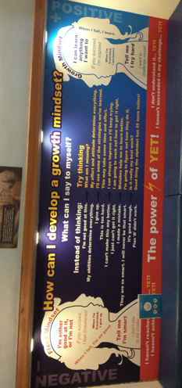
Promoting a Growth Mindset Within Learners

“For all children to strive to become assessment capable Visible Learners with a positive, healthy growth mindset where they take responsibility for their learning and steps to success” (Pembroke Dock Community School)

At Pembroke Dock Community School, a number of strategies, combined with a strong school ethos, are used effectively to develop a growth mindset within learners.

Number of Pupils: 632 (full-time pupils)
Age range: 3-11
Period of elective experience: 11.02.19 – 22.02.2019

Context and Background to sector-leading practice

Pembroke Dock Community School decided to implement strategies to develop a growth mindset in July 2015. This decision was prompted, in part, by the observation that many pupils were afraid to speak out due to the fear of making a mistake, whilst also readily accepting ideas given by adults without first questioning these ideas for themselves. The work of Carol Dweck was utilised to guide implementation, whilst initial staff training and a focus on Brainology were used to support such development. In conjunction with developing children to have growth mindsets, visible learning was promoted throughout the school, influenced by the work of John Hattie. Within this school, it is apparent that visible learning and the promotion of growth mindsets are used effectively in conjunction with each other, possibly being viewed as interdependent strategies. The complementary nature of visible learning and growth mindsets are recognised by Hattie (2014), who argues that by having both the belief that they can achieve something, and by being aware of the means by which they can achieve it, children’s motivation to learn is increased.

Strategies used to develop a growth mindset within the school:

- Learning environment – Growth mindsets are promoted throughout the school through the effective use of displays within each wing, the corridors and within classrooms (examples seen in appendix a).

- Ethos of school – The ethos of the school is one of inclusion which aims to support each learner to be the best that they can be, celebrating each child as a unique individual. This was illustrated particularly well in the outcomes of year 5’s project as part of their theme, The Greatest Showman, in which they focused on the key question, “Can being unique bring you success?”. Throughout this project, the children were also asked to share their aspirations. Encouraging children to have ambitions was outlined by the Headteacher as being important, and as such is promoted throughout the school, including within the early years provision.

- Autonomous learners – Independent learning is promoted through the use of visible learning, the use of the VIP areas and self-assessment. Pupil voice is also used throughout the school and is evident in committees such as the school eco-committee and the school council. Upon interviewing the Headteacher, it was clear that she has a vision to enable all children to become independent learners who can be their own teachers, in the sense that they are able to see where they are in the curriculum, and to possess the strategies and confidence to learn independently.

- Peer support – A strong emphasis on cooperative learning is seen throughout the school, with strategies such as “See Three before Me” and ‘Expert’ sashes, encouraging pupils to ask their peers for support before seeking help from the teacher. Upon questioning, 100% of staff said that they believe that co-operative learning is effective in developing a growth mindset. Furthermore, upon delivering a questionnaire to year 2 and year 6 pupils, 50% of year 2 pupils said that friends are the most helpful source of support when they are faced with a challenge, whilst 23% of year 6 pupils agreed with this choice. This proved an interesting finding as the year 6 pupils showed a higher degree of preference to independent problem solving than the year 2 children, with 31% of year 6 children choosing the option that states, “I like to try and help myself”, with 0% of year 2 children choosing this option. It is important to note, however, that only a sample of children from both year groups took part in the questionnaire, so it may not reflect the views of the entire year group.

- SWAG learners – Success, Willpower, Attitude, Goals. This has been observed within year two classes however does not appear to be used as often in Key Stage 2 classrooms.

- Children given roles of responsibility – children are able to apply for and be voted into roles of responsibility within the school. This has also been used previously by the school for a child who had difficulty with behaviour, in order to help overcome such behaviour. In this example the child was given a place on the council for Restorative Practice.

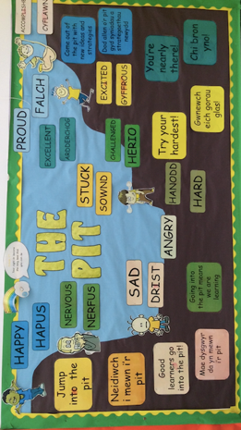
- The Pit – Provides a visual representation of how a child feels they are coping with a challenge. When in the pit they are finding a task challenging, and as they start to gain understanding or competency in the task they move gradually out of the pit. It is useful also in teaching children to value the times that they don’t know the answer, seeing mistakes and failure as part of the learning journey. It has also been adapted to support positive behaviour in pupils, as illustrated on a display within the Success room (appendix b).

- Mixed ability groupings – This innovative approach has been an area that has really impressed me as it is an approach that I have not seen before. The implementation of this strategy illustrates a willingness of the school to try new approaches in order to try to best meet learners’ needs. The Headteacher explained within an interview, that the reasons for such change in the structure of the groupings was to prevent those who lack a wide range of vocabulary from failing to progress out of the banding of ‘less able’ pupils, which is exacerbated by surrounding these children with peers who similarly lack vocabulary. Furthermore, being labelled as being in a lower level group may promote a negative self-image, which in a sense may serve as a self-fulfilling prophesy as the children don’t attempt to push themselves in their learning due to a lack of self-belief and aspiration.

- Allowing the children to choose at what level they work – This again has really impressed me and is an approach to AFL that I will be keen to implement in my own Professional Teaching Experience. Again, this approach limits damage that may occur from the teacher labelling children, as children are able to choose at what level they feel comfortable to work, and which level of challenge is suitable for them.

- Children are encouraged to be and to perceive themselves as possessing the attributes shown in Donaldson’s four purposes of the curriculum. Dispositions, such as persistence and creativity are also promoted in learners, using disposition cards that they can refer to, depicting various characters or pictures to represent each disposition. One teacher who utilises this strategy within her classroom said that she believed it has a positive effect in developing growth mindsets in her learners, in particular the use of the disposition of persistence.

- Tracking of pupils – AFL strategies are used to promote visible learning and growth mindsets– Mr Marker, self and peer-assessment, skill slips, learning ladders are examples of some of these strategies. The tracking of pupils, and assessment for learning may be central to the implementation of visible learning as children are able to assess where they are, and then determine their ‘feed forward’, or next steps in their learning.

- Visible Learning - Children are made aware of where they are, what their next steps are, and the success criteria for reaching the next steps. When asked, 100% of teachers said that they believed the development of growth mindsets and visible learning were interdependent strategies. However, it may be necessary to adapt visible learning to suit all learners, as some learners may be unable to access this strategy due to their inability to access the language used in a range of these strategies. This was observed as one year 2 girl said that her challenge was to be able to read her RAG ratings as she couldn’t read them to know which one applies to her. This may in turn limit her ability to know where she is in order to know what her next step is.

What impact has this work had on provision and learners’ standards?

Learners have a good understanding of the importance of having a growth mindset and show a positive attitude to mistakes, recognising them to be part of their learning journey. Furthermore, it has been apparent throughout this experience that the children are keen to work independently, and to give and receive support to and from their peers.

Next steps:

The school already supports the development of resilience in children in many ways, including actively promoting parental engagement, offering one-to-one support and building positive relationships between staff and pupils within the school. It would however be interesting to investigate this area further, as 8 out of 9 members of staff when asked said that they believe resilience to be a prerequisite of a growth mindset. Therefore, it may be suggested that in order to develop a growth mindset effectively, a foundation of resilience must first exist in the learner. This may have implications for those children who have experienced ACEs, as they often lack the factors that promote resilience in their lives (Hughes et al., 2018).

How will I apply this to my own practice?

I will utilise a range of the strategies observed within my own practice, in particular the use of self-assessment for groupings, and mixed ability groups. I am also interested in exploring the use of the pit further and look forward to implementing this strategy in my own future practice.

- Completed staff questionnaires
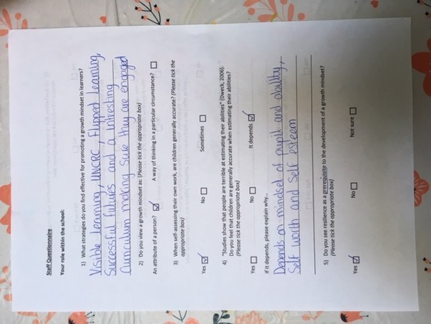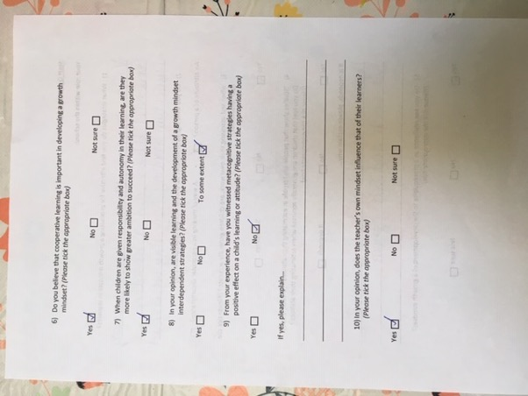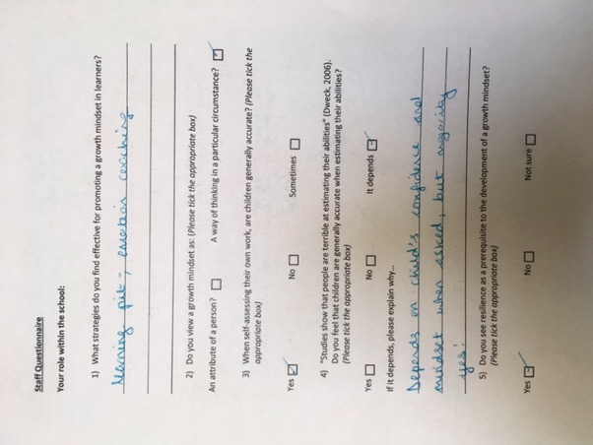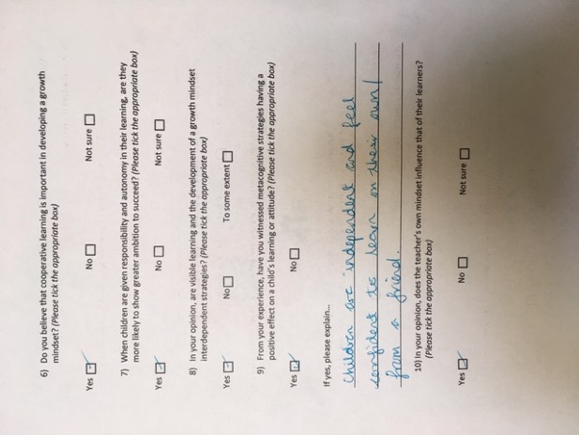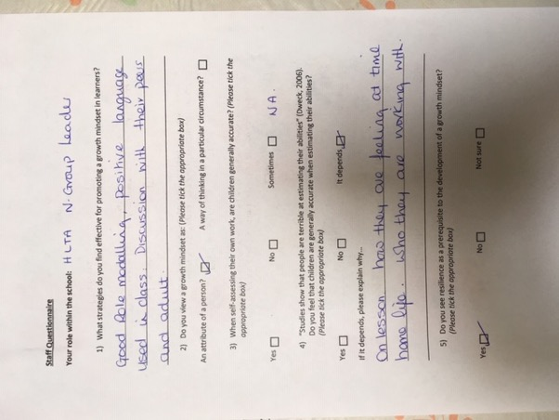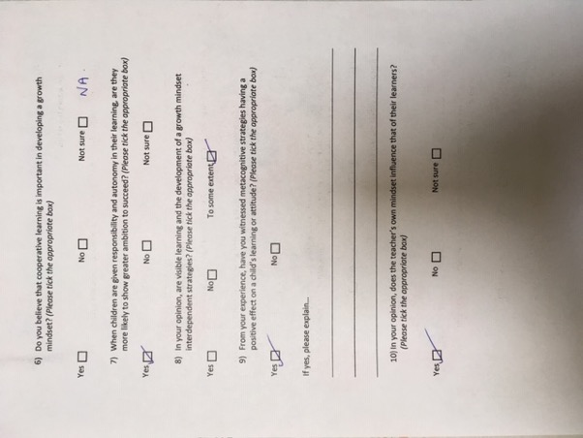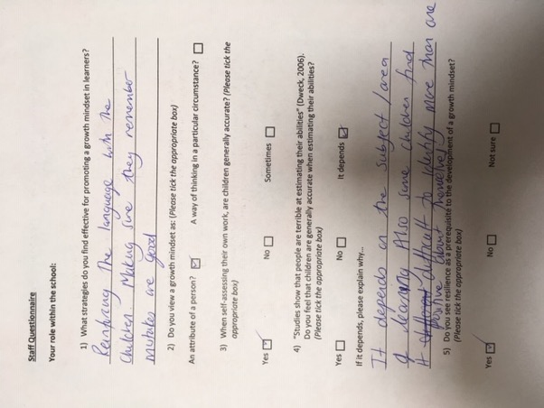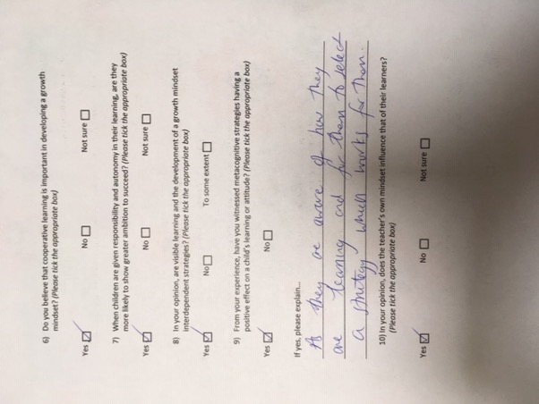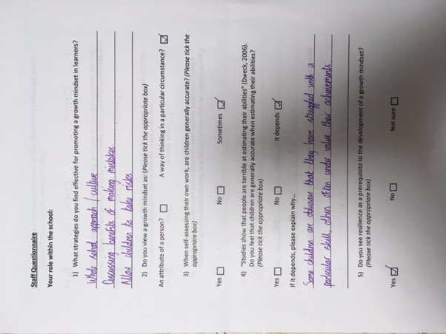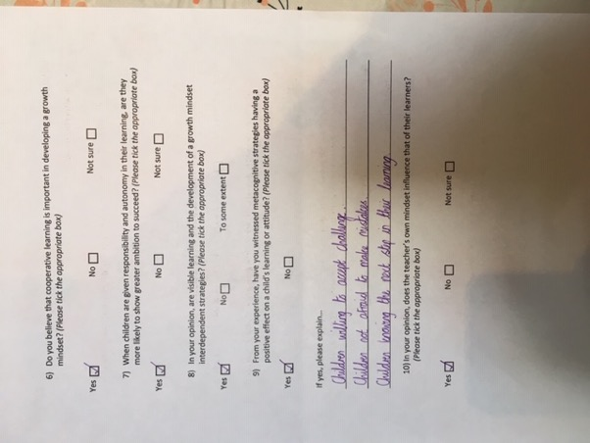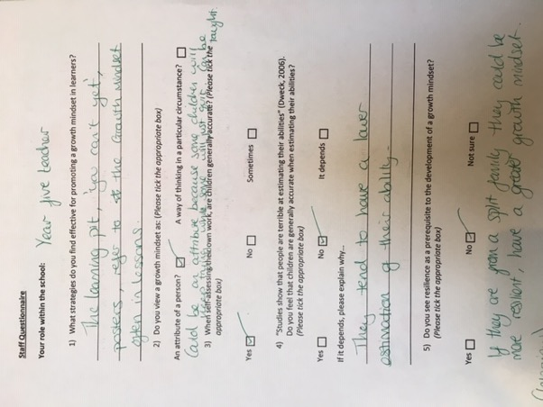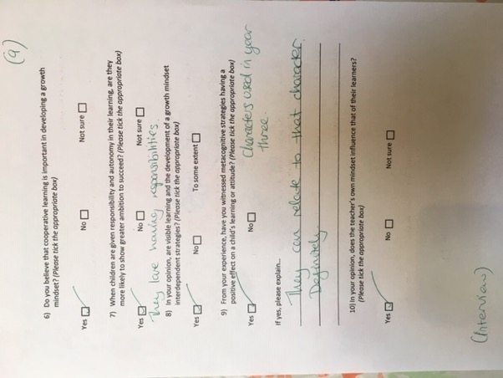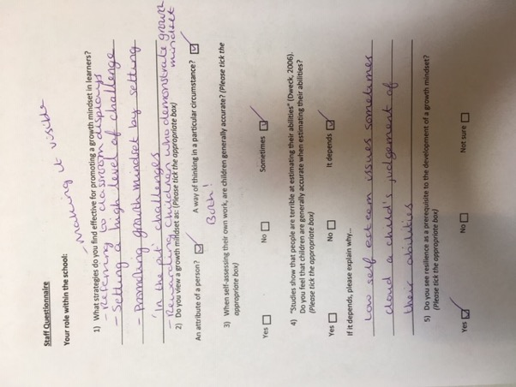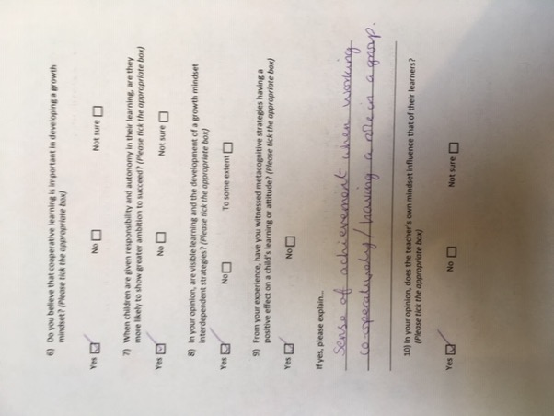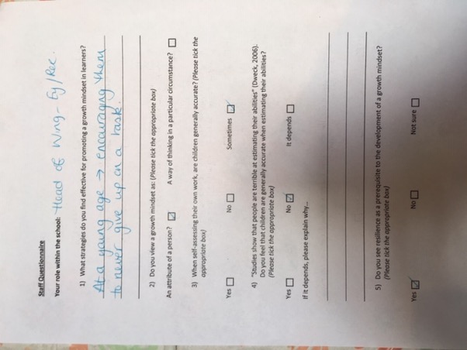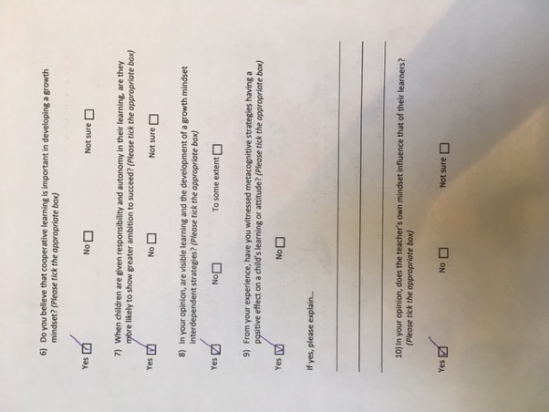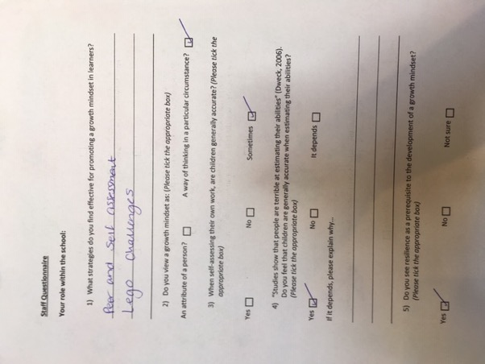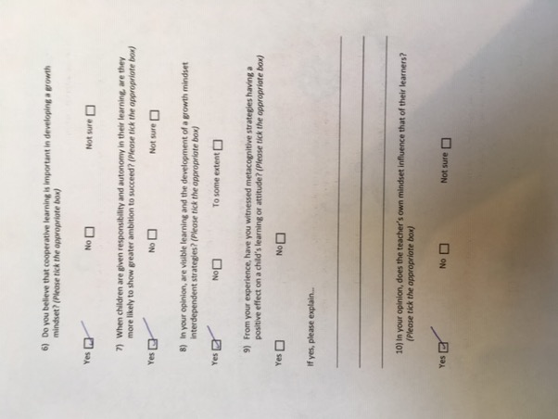

- Year two qualitative data – a mind map of a time when they were challenged. They were asked to draw and write down what the challenge was, how they felt during the challenge, what they found difficult, who helped them and how they felt after they had completed the challenge. This was one boy’s work, showing his experience in struggling to write.
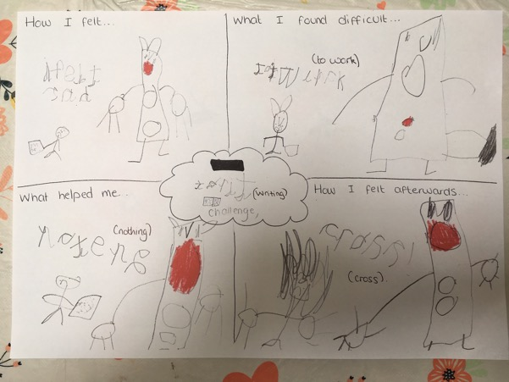

- Interview with emotional literacy support assistant (ELSA) within school B.
Interview with ELSA - 09.04.19
This author: Are there any strategies used in school to develop a growth mindset in pupils?
ELSA: Habits of mind is promoted in class and school assemblies but not continuously. Emotional literacy support sessions, and resources such as ‘My hidden chimp’ is used to support children’s emotional development and is often referred to with the older children. However, more time to use these resources are often needed to make a difference, as ELSA sessions normally only take place on a weekly basis for 6-8 weeks, which is not normally enough time. Activities such as thought for the day or week are used sometimes with children to help support positive emotions, such as “sing as loud as you can”. This can help to distract them from worries or negative thoughts.
This author: Would you say that a growth mindset is the result of nature or nurture?
ELSA: “Not sure, if you are not around the right people it is difficult”
This author: Can those children who have less resources in their lives to promote resilience benefit from these strategies to develop growth mindsets as much as those who do have these resources?
ELSA: (Pause) It is more challenging to develop a growth mindset in these children. It can be done, but it is more challenging. Boundaries are important and building confidence.
This author: Is resilience a prerequisite to developing a growth mindset?
ELSA: Part of me thinks you shouldn’t dismiss it. Despite everything there is evidence to show that these kids can overcome a lot. Habits of mind and routines can make a huge difference, routines are very important. We need to embrace differences and treat them all differently. Sometimes social media draws too much attention to issues, it can make children adopt the idea that they are anxious children. They don’t understand their feelings all the time.
This author: What resources would you say help to build resilience in a child’s life?
ELSA: Our own backgrounds – tough situations can build resilience, rather than being too sheltered (shares personal story). Resilience is a skill that you can learn. It can take a dip every now and then, but it is a skill that we can teach children. If you are not around the right people though, it is difficult.

- Group interview with the headteacher of school A.

Another student: How long have you had pupil voice here? Have you seen it have an impact?
Headteacher: Pupil voice was here before I came...I wanted to improve pupil voice to improve safeguarding so that pupils had a voice and were able to say if something wasn’t right...Then really going from that, we wanted them to be responsible for how they accessed the curriculum really. We wanted to know their interests, for children to make their own decisions about learning, really what we want to do is for everybody to have some area of responsibility, I think that’s really important, that they feel involved. I think children have more of a sense of belonging to the school if they have a voice in it.
This author: When did you introduce Visible Learning?
Headteacher: Visible Learning, we introduced about July 2015. Umm, that was for children to take more ownership of their learning and that was from the work of John Hattie. Then, we also, the growth mindset was from Carol Dweck. So, when we first introduced Visible Learning, we asked two questions, ‘what makes a good learner?’ and ‘what feedback do you get from your teacher?’. Bearing in mind that we were doing really well, we were in the top quartiles for everything. We had recently had a challenge visit where we were told our ethos was good with the children, etc, and I actually tested it and asked them directly (children who had no idea). They were saying things like, ‘be a good listener’, ‘sit quietly’. Mmm, it was quite an eye opener and initially nobody spoke, and I asked them those questions again and again, and they all took ages to answer and that is because they didn’t want to give the wrong answer. You’ve probably experienced it in your own age group through school where you would only give an answer if you knew it was going to be right. So, we had a big push about making mistakes, about fail being first attempt in learning. That mistakes were good and looking at the research which showed that the best point of learning is making a mistake and learning from it. We really pushed our MAT children to the point where they were making mistakes and they hated it because they’d never been in that situation before, they’d always got everything right. So yeah, we did a lot of work around a growth mindset, the initial stages and visible learning because they needed to believe that, umm, putting in the effort was going to bring results.
This author: How do you see Visible Learning being linked to a growth mindset?
Headteacher: Yeah, so the visible learning encompasses a number of points really. The description in a nutshell is when children become their own teachers. So, to become their own teachers they needed to know where they were in the curriculum. So instead of turning up to a lesson that didn’t appear to fit into anything, we did the children’s learning ladders, so they were able to see the skills and steps linked to the LNF, so they could see what came before and what comes next. They needed to be able to help themselves, the teacher isn’t the font of all knowledge and really, we want to encourage them to go and seek answers for themselves, through asking their neighbour, through looking through a book, through looking it up rather than just expecting to be spoon fed...you want them to be out there looking for it. And that’s because, umm, all the jobs that the children will be going into, many of them you don’t even know what they are yet. They need a different sort of skill sets then what we’ve needed historically and it’s definitely to be creative and to be able to collaborate, to be independent and self-motivated and self-teaching.
This author: Did you introduce Visible Learning and the growth mindset at the same time?
Headteacher: We did, so it was one of the first things we looked at. We drip fed it. So, we looked at the growth mindset and we looked at the strategies to develop it, so the Learning Pit.
This author: How did you find the children reacted to you introducing strategies to develop a growth mindset? Also, how did the staff react?
Headteacher: Well, first of all I spoke about it to the staff, because the staff had fixed mindsets too. They were pretty good to be fair. Mmm, I would say there was one person recently, and I asked them recently, who said they were in the middle, but if you don’t have the belief that you can make a difference to a child’s learning then you’re not in the right job because if you don’t believe then the children aren’t going to believe it. So yeah, I did some work with the staff first. We looked at Carol Dweck’s research and videos, TED talks and things like that. We had to sell it to the staff, so they could sell it to the children. And we did a questionnaire with the children and were expecting 40% to have a growth mindset, with 40% to have a fixed mindset and 20% sitting on the fence, but in one year 4 class we found that there were only 2 children who had a growth mindset. It was a massive task. The children are pretty good now, most have a growth mindset, but we drip fed that. We did a lot of work with Brainology, if you google Brainology there’s lots of lessons there. We showed the children about neural connections being made, like with learning how to swim or ride a bike, it needs repeated practise...and there were videos to show how these pathways were made, and how even at my age if I were to ride a bike or swim after not having done so for years, I could still do it because those neural pathways will still be there.
This author: Do you think that teaching them about how their brains work and getting them to think about their thinking, do you think that made a difference?
Headteacher: It definitely made a difference, also teaching what the brain needs. Even with three-year-olds we showed this using sponges that looked like brains – they didn’t even know where their brains were before this.
This author: When you introduced the Growth Mindset, did you find that the effects it had on the children were the same for the majority of children, or did you find that those children who don’t have the factors in their life, like a stable relationship with parents or an adult, peer relationships, community engagement – all those factors, do you think that those children who are missing those could still benefit from a growth mindset?
Headteacher: Definitely, and I wouldn’t have said that there was a clear break of children with regards to their home environment that had a fixed or growth mindset, but I would say that resilience is an issue. We are actually looking at how we can improve resilience and it is a problem within our area. You’ve also got both ends of the spectrum, you’ve got children who are bright and are achieving well and their resilience is poor because of the exam stress and anxiety, also the effects of social media...so resilience is a problem.
This author: Would you say that resilience and a growth mindset are linked?
Headteacher: (Pause) It is linked, it is linked. I think you can have a growth mindset and still lack resilience. It’s also linked to aspiration as well.

- Displays within school A – physical learning environment.

- An interview with one girl and one boy from a year six class within school A.

Year 6 interview:

This author: Could you tell me how you would describe a growth mindset?

Boy: A growth mindset is when say you are struggling with something. There’s one thing you could be, you could be in the pit where you would be struggling with something. Then eventually, with a growth mindset you would go out of that pit. Then with a fixed mindset you would be like, “oh I can’t do it”. You shouldn’t really have a fixed mindset, you should have a growth mindset.

This author: So, would you say a fixed mindset is ever good?

Girl: A fixed mindset is bad because you don’t really believe in yourself you think in your head you can’t do this. Like when you are doing work you think you can’t get out of the pit.

This author: So, you both mentioned the pit. What do you do when you are in the pit? What strategies do you use to get out the pit?

Boy: You see three – so you see three people before you see the teacher. So you could see your partner next to you, you could see umm your…(background noise).

This author: So, what’s that called again? See three…

Boy: See three before me.

This author: So, that’s three people before you see the teacher?

Boy: You could ask your partner next to you. So, if I was struggling with something, I could ask her (the girl) and if she knew she could help me.

This author: Ah that’s brilliant. So, does that help you?

Boy: Yeah, and sometimes we try and work together, and sometimes we try to solve our own problems.

This author: Ah, so you think to yourself sometimes too? So, with see three before me do you count as one of those people or is it inly people other than yourself?

Girl: Yeah it does (count).

This author: Ah, I’ve not heard of that before, but it sounds like a really good strategy. So, what other strategies do you have to help you have a growth mindset?

Boy: Umm (pause), well sometimes if your partner can’t help you, you can ask the teacher.

Girl: And sometimes we do independent practice, and (background noise interfering with audio – she shows me her skill slips used in class).

Boy: Uh, yeah so, we have to decide what skills we want to work on. The glas is the year seven skills and umm coch is lower year six yea, and then um, oren is like more of ...

Girl: …the medium version of year six.

Boy: And Gwyrdd is the higher version of year six. Glas would be year seven.

Girl: So, here Miss gave me a skill and I didn’t find it super easy, so I put myself as oren. And then you keep building up.

Boy: There are sometimes where you might be coch but then you get the hang of it and move up.

This author: So, can you do that when you want to?

Boy: Yeah so you choose what skill you want to work at. If you find it hard you can move down, if you’re on oren and you find it a bit easy you can move up.

This author: So, do you have to do that before the lesson, or can you move at any time.

Girl: Yeah you can move in the lesson or anytime. Because we do twenty, twenty, twenty, we can move after we complete that twenty easily. We have twenty minutes with the teacher, twenty minutes in the VIP area and twenty minutes doing independent work in class.

(Background noise)

Girl: So, these are our skill slips, we stick them in at the start of the lesson. Before the lesson we assess ourselves, to see whether we think we can do it then after the lesson we assess ourselves to see how much we have improved.

Boy: Either your peer will assess you or yourself.

This author: Do you like to have targets set by yourself?

Girl: Yeah definitely, it’s way better (both agreeing).

This author: How do you feel, if you had a target set by the teacher and one set by yourselves, how would you feel different with each one?

Boy: Well sometimes, the one set by the teacher is easier for you.

This author: So then, if you come across a target that is really difficult for you, how does that make you feel?

Boy: We would use “see three before me”.

Girl: Sometimes it’s a little bit but then you just have to think about the strategies you could use.

This author: Would you say you enjoy being challenged or do you prefer it when it’s easy, what do you prefer?

Boy and girl: Challenge.

Boy: But there’s always in a lesson some questions you find hard and some you find easy.

This author: Do you think that it makes you feel more confident when you have something easy to do or does it build your confidence more to do something challenging?

Girl: Challenging. Sometimes it won’t be the highest confidence because you can get a bit stuck but when you’ve done it you are more confident than at the start.

This author: Why do you think it is important to be challenged?

Boy: Because when you go up to comp and reach higher levels, college and stuff you will be challenged more.

This author: Do you do any sort of peer support; do you support each other learning?

Boy: Yeah when we’ve finished, we can go around and support other people and try to sort of tidy the tables.

This author: Do you find that displays around the corridors and school that say about having a growth mindset, does that help you have a growth mindset?

Girl: It can help to remind us.

Boy: It does help, but also, we have to help ourselves.

Girl: (Showing me a sticker used to reward them for going through the Learning Pit) These are our Learning Pit stickers.

Boy: If you’ve been challenged, you can stick one of these in your book and then you write underneath or by the side of it, like, how you got out of the Pit.

This author: Does that help you when you’re faced with another challenge in the future, do you think?

Boy: Yeah, because then you can go back in your book and read, like, how to get out.

- Display in school A promoting the power of language in changing a mindset.

- Qualitative data collated from staff questionnaires conducted in school A.

What strategies do you find effective for promoting a growth mindset in learners?

Nursery teacher: At a young age, encouraging them to never give up on a task.
Reception teacher: Whole school approach/culture, discussing the benefits of making mistakes, allow children to take risks.
Year one teacher: Learning pit and emotion coaching.
Year four teacher: Reinforcing the language with the children. Making sure they remember mistakes are good.
Year five teacher: The learning Pit, ‘you can’t yet’ language, posters, referring to the growth mindset often in lessons.
Year six teacher: Making it visible, referring to classroom displays, setting a high level of challenge, promoting a growth mindset by setting ‘in the pit’ challenges, rewarding children who demonstrate a growth mindset.
Nurture lead: Good role modelling, positive language used in class. Discussion with their peers and adult.
ELSA: Visible learning, UNCRC, flipped learning, successful futures and an interesting curriculum, making sure they are engaged.

- Learner dispositions used within school A.

Notes from discussion with a year four teacher, talking about the effect of using ‘dispositions’ within her lessons:

Used often during plenary - children being made aware of how they have or have not used these during that lesson, visible learning of dispositions.

- Display illustrating the Learning Pit, as used throughout school A.

- An adapted version of the Learning Pit used to support children in monitoring their emotions and behaviour.

- Interview with a school nurse from school A (this was not audio recorded, however the notes written by this author during this interview were checked by the nurse and amended accordingly to ensure that the information is valid).

Interview with a Specialist Community Public Health Nurse: School Nurse
11.40am, 14.02.19

Her primary role is to provide a public health service to all school-aged children to reduce inequalities and promote health and well-being, so the population can reach their full potential. However, within her work she also oversees seven primary schools within the area and deals with basic health issues and child protection issues. She helps to provide family support whilst engaging in multi-agency working. She works with looked after children, helping children to overcome and cope with social and communication issues, emotional health needs and complex health needs. Works a lot with children who have experienced adverse childhood experiences (ACE’s).

Main points taken from the interview:

If children don’t develop resilience and emotional (literacy & regulation) skills in primary school, then they may not have the resources to cope successfully with the transition to secondary school. This is exacerbated by the rapid brain growth that is experienced during puberty, the hormonal changes they experience and the change in their physical environment that occurs from moving from one school to another.

The children’s ability to form positive peer relationships depends greatly on whether they have a positive attachment & stable relationship with their parents, or another adult, as it forms the foundation on which their other relationships are built.

If children don’t get praise at home, then they may be all the more determined to get that praise within the classroom environment. This may result in disruptive behaviour as they seek attention and praise from the adults within the classroom.

It is important to focus more on children’s positive behaviour than their negative behaviour.

If a child isn’t taught how to receive praise and to focus on a task at home, then when they come to school they will struggle to engage in lessons. This may mean that strategies that are used to support children’s development within the classroom may not benefit them as much as other children due to their lack of engagement, as attention is the building block to all learning & language development.

Emotional literacy may be an important and useful tool in supporting children who come from difficult home environments, or have experienced ACE’s, to recognise, communicate and work through their emotions.

If the attachment between a parent and child is not a positive one then it may lead to the child exhibiting negative behaviour, low resilience and emotional difficulties.

While it is possible for schools to build resilience in learners, even without the child having the foundations of a positive attachment to their parents, it can be difficult to do so. In these circumstances, it is possible also for a teacher or adult within the school to step into this role, providing an adult whom the child can have a positive attachment to.

