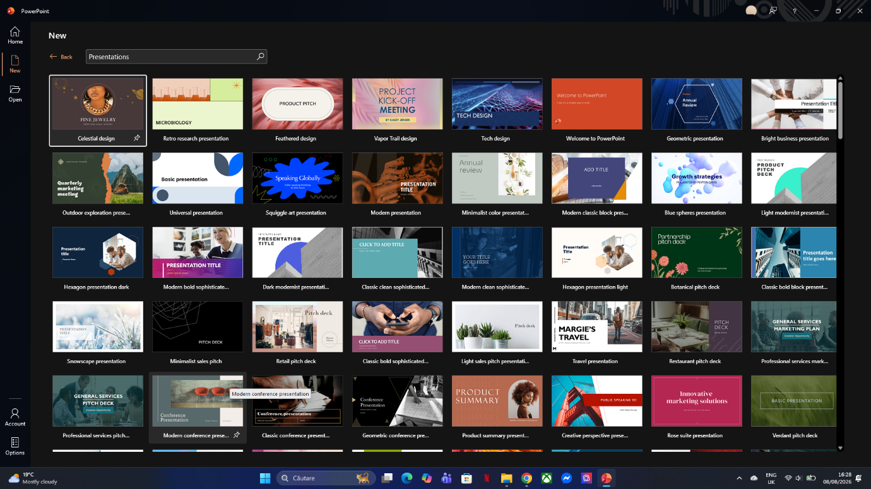

Power Point is used to organize, communicate, and present information visually .

WORD DOCUMENT

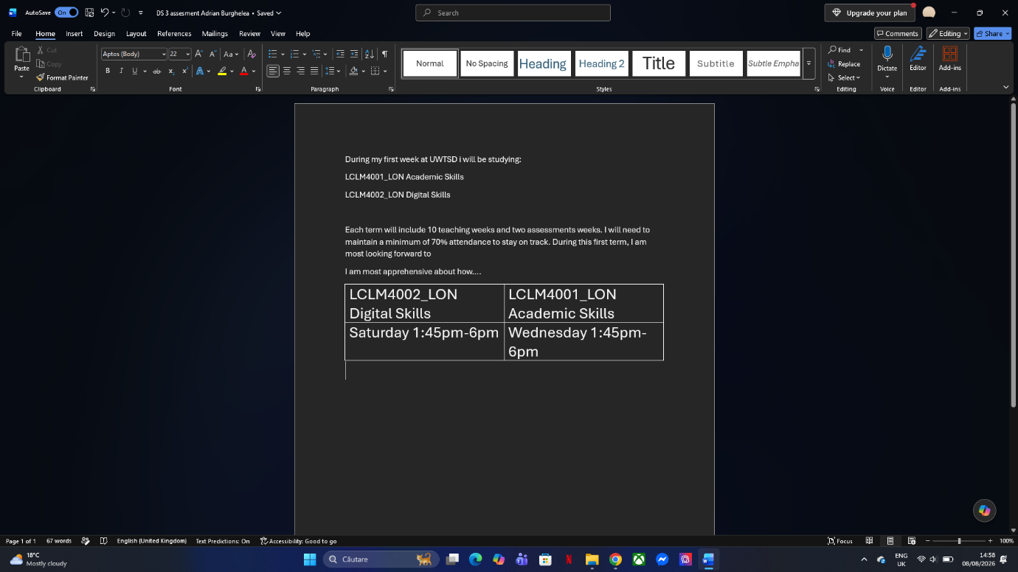

A word document is a digital text file created using Microsoft Word or compatible word processor Unlike a simple text file (like notepad), a Word document supports rich formatting including custom fonts, colours, tables, images, headers, page layouts, and media .
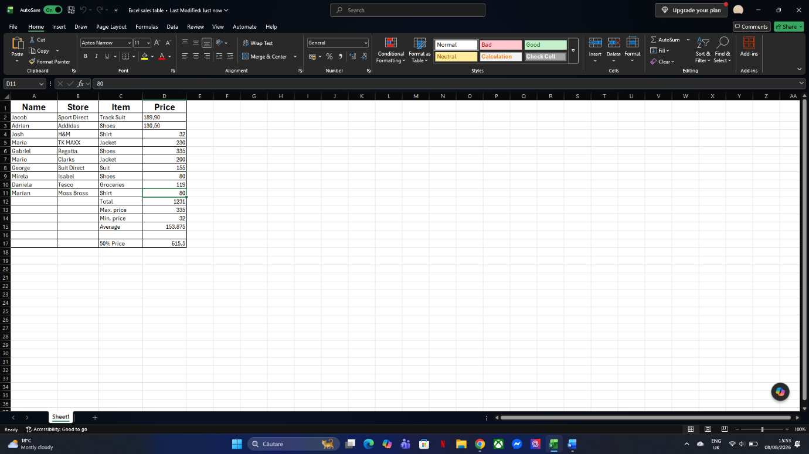 I used Excel because is a digital file created using Microsoft Excel unlike text-focused word documents Excel files are designed to organize, calculate, analyse, and visualize data arranged in a grid of rows and columns.

